SOFTENG325 – A2 Architecture for BBD

Name: Victor Lian UPI: vlia679 ID: 442213705

# Architecture Description

## Module structuresC:\Users\Victor\AppData\Local\Microsoft\Windows\INetCache\Content.Word\module-decomposition.png

Figure 1: Module - Decomposition

Figure 1 and Figure 2 shows the module structures for the Big Brother Drive (BBD) architecture. Figure 1 shows the sub-module decomposition within each of the three applications. Figure 2 shows the “uses” relationship between these sub-modules.

The **GPS locator** and **Accelerometer** modules are responsible for collecting the information from the mobile phone hardware system.

The **Data packager** module is responsible for converting the raw data into appropriate format, make calculations on speed and acceleration if needed. It uses the **GPS locator** and **Accelerometer** modules to acquire the raw data information. For the data to be sent to BBD-Ops, 4 bytes each will be used on latitude, longitude (GPS co-ordinates) and the ID of vehicle. 1 byte each will be used on speed and acceleration. (A total of 14 bytes).

The **Encoder** module is responsible for encode the formatted data into data actually being sent. For example, it could append a checksum (4 bytes), or encrypt the data (not needed for this architecture, but can be done if needed). It uses the **Data packager** module to acquire the formatted data.

The **Sender** module is responsible for actually sending the data to BBD-Ops. It will use whatever API is provided by the device OS to send data. It uses the **Encoder** module to acquire the data that needs to be sent.

The **Location / Speed Processor** module is responsible for dealing with the data received from the **Sender (of BBD-V)**. In particular, it is responsible for decoding and unpacking the packet. It is also responsible for calculating if a vehicle is speeding and/or crossing the centreline. To achieve this, it uses the **Speed limit / layout cache module** for acquiring the speed limit and road layout information. It uses the **Car real-time info repository module** to store information like location, speed, acceleration, whether it is over the centre-line and/or speeding. It can also use the repository to acquire previous behaviour of the vehicle and identify if a vehicle is continuously misbehaving.

The **Speed limit / layout cache module** and the **Speed limit / layout requestor module** are responsible for retrieving and caching the speed limit and road layout information from an external provider (WKWYL).

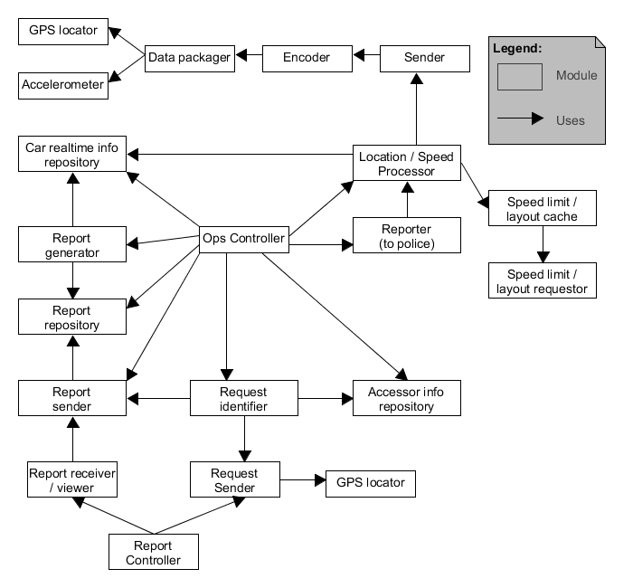

Figure 2: Module - Uses

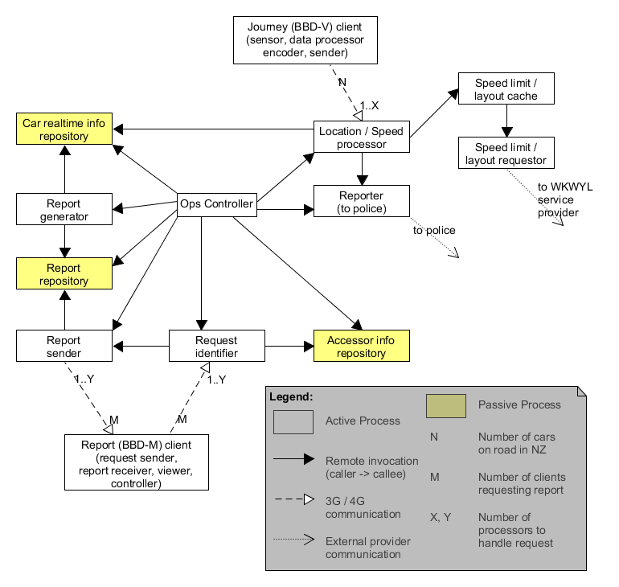

Figure 3: Component and Connector - Processes

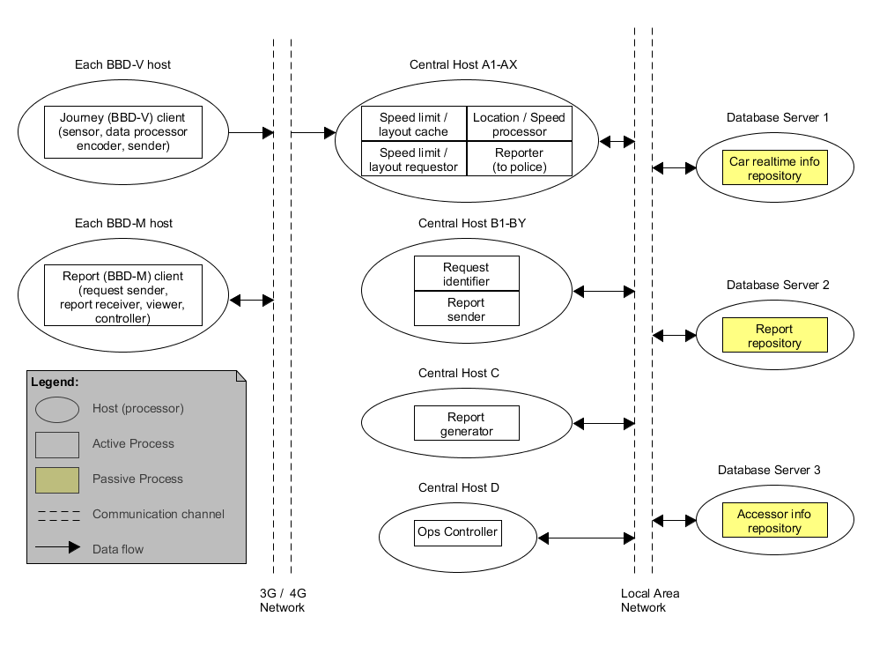

Figure 4: Allocation - Deployment