350 Assignment 3

840454023, elee353

**Task One: Design Documentation**

1. **Walkthrough:**

*Using three to five illustrative screen shots and surrounding narrative text (200-600 words [more isn’t always better!]), step the reader through how the prototype works.*

The primary stakeholders of the system are secondary school students aged between 13 and 18 (between Year 9 and Year 13). The subject domain chosen is Physical Education and the sub-domain is the role of lactic acid in exercise.

One of the two types of problem-based learning assignments selected is the case with structured questions approach. This is the main focus of this prototype.

The “case with structured questions” were interpreted as a case study followed by some short answer questions about the case. The “case with structured questions” involves the student reviewing a case and providing brief responses to a set of questions. Students can do peer discussion before attempting the questions.

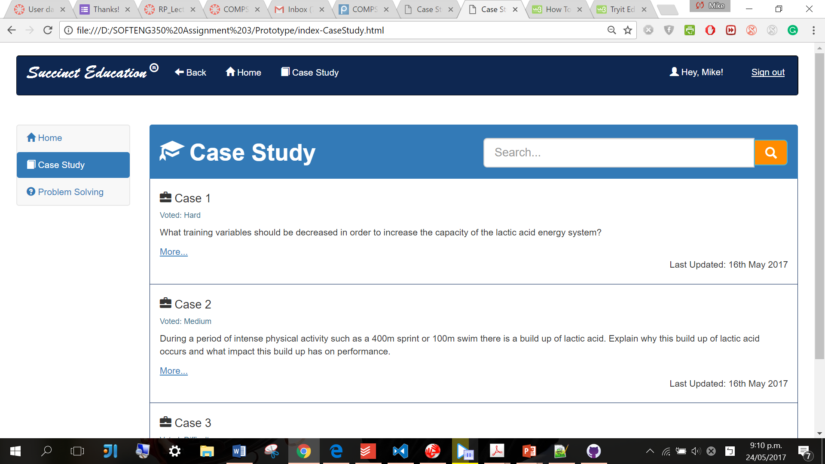

Once the user enters the case study screen, an overview panel of the available cases with brief descriptions is represented. There is a navigation bar on the top and a side menu bar on the left for navigation between different screens or for signing out. There is also a search bar right next to the header for refining the cases shown. The user can then click the ‘more…’ hyperlink for a specific case to study.



The user can type the keywords in the text field for refining the cases shown.

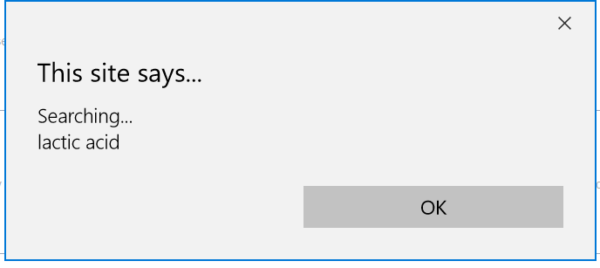

The prototype will representing an alert message while the input text is being searched.

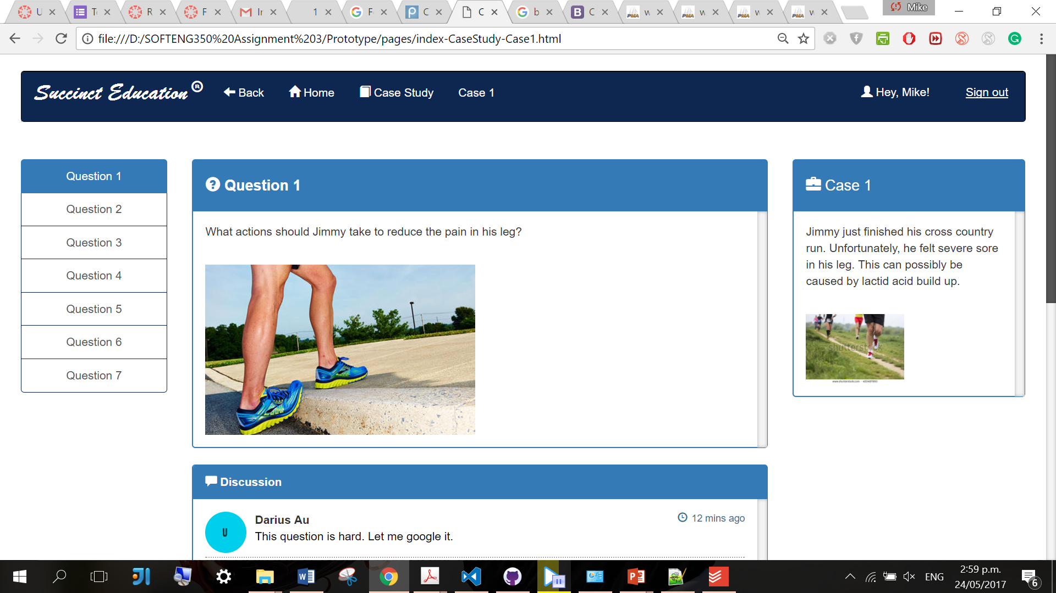

A case consists of several related questions. Similarly, there is a navigation bar on the top with the same consistent layout. In addition, there is a menu bar on the left for navigation between questions for the specific case chosen.

The case description panel is on the right, accompanied by the question panel, the discussion panel, and the answer panel in the middle.

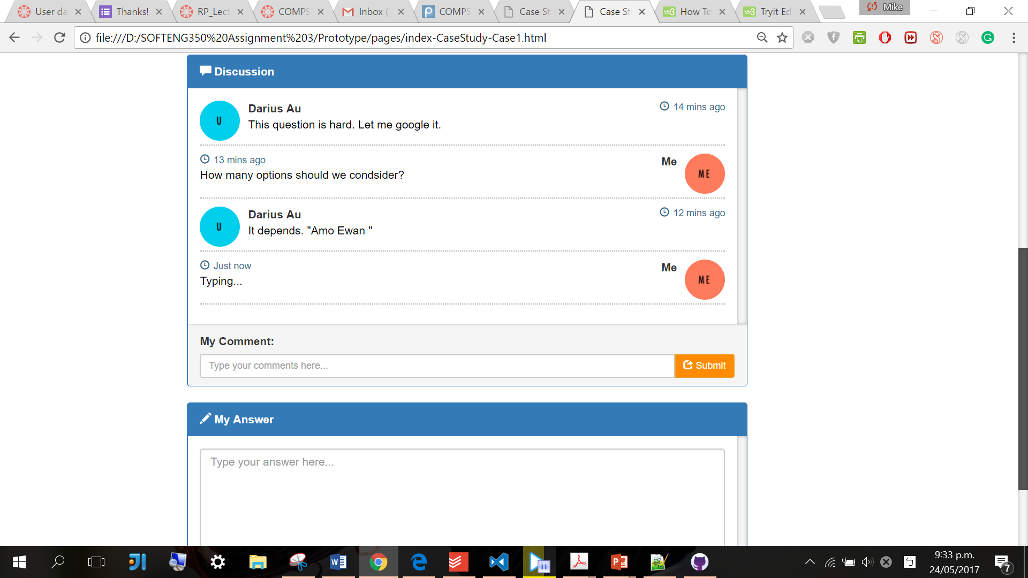

The user can view the discussion regarding a specific question and submit a new one.

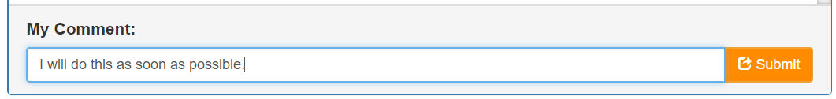

The user can type his/her comments in the text field provided and click the submit button on the right for submission.

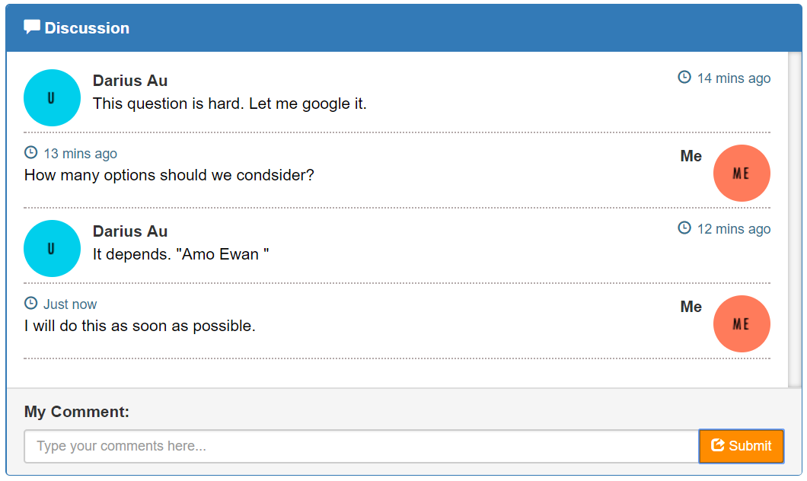

The newly submitted comment, “I will do as many options as possible.” appears in the discussion section after submission.

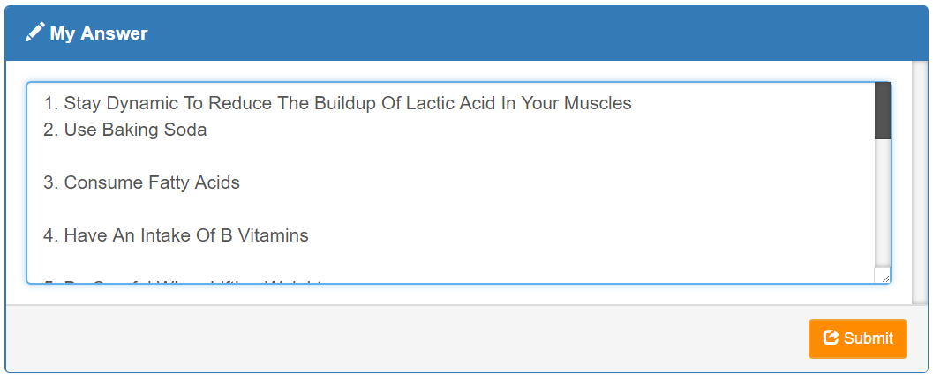

The user can then type his/her answer in the answer text area and click the submit button on the right for submission.

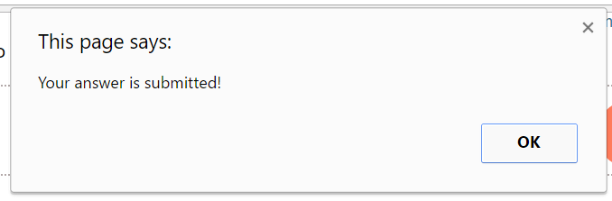

A message will appear after successful submission. The answer will stay confidential and it can only be viewed and analysed by the supervisor.

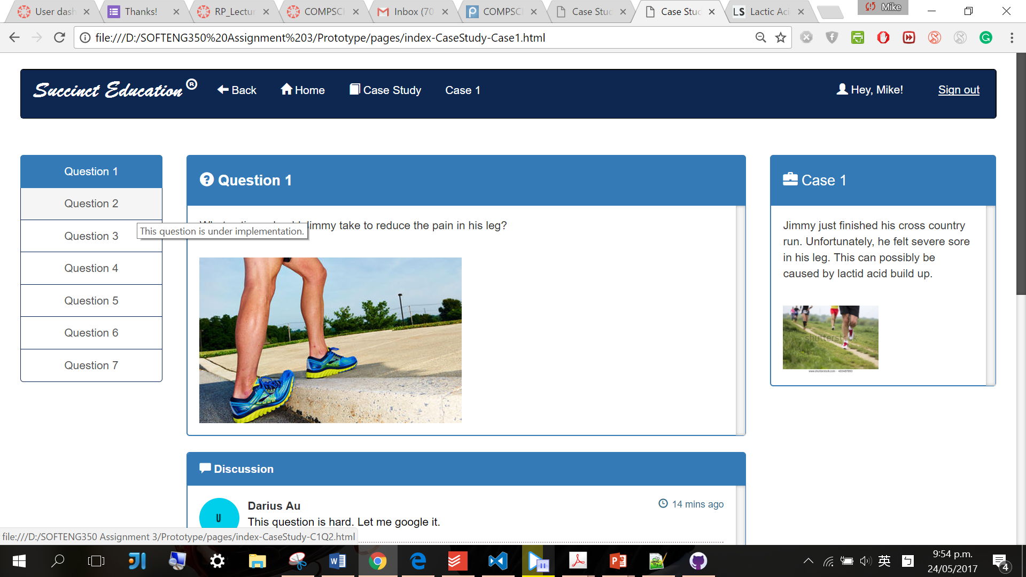

Moreover, the user can click another menu tab in the question menu bar to progress to another question within the same case.

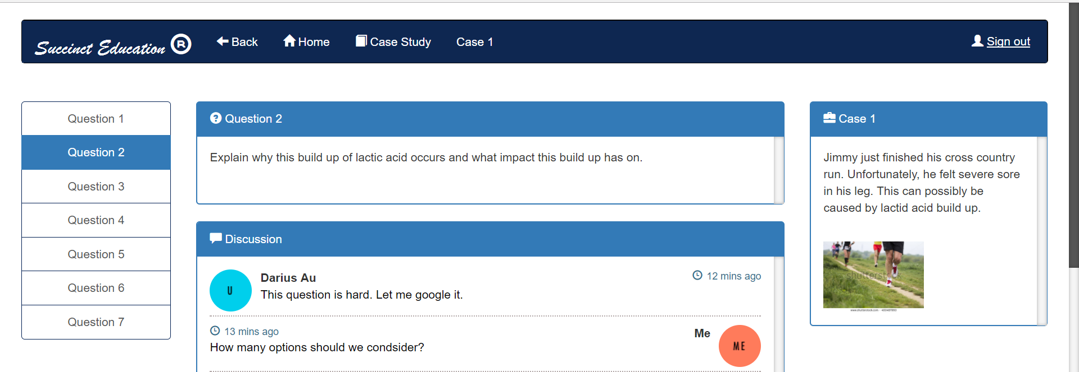

For example, by clicking the ‘Question 2’ tab, the user navigates to question 2 of case 1.



Lastly, the user can continue to answer the case questions. Alternatively, the user can also use the top navigation bar to go back to previous pages, go to the home page, or go to the overview page of case study.

**‘Out of Scope’ list:**

* The home page and problem webpage are not fully implemented.
* The direction to the company’s website is not fully implemented.
* The sign out functionality is not fully implemented.
* The other questions of Case 1 and the other cases are yet to be implemented.
* The discussion panel does not support more than one submission from the user each time. The actual peer discussion functionality yet to be implemented.
* Google Chrome is the recommended browser for this prototype. Unfortunately, there may be some technical issues with other browsers such as Microsoft Edge. The visual layout may be misplaced unpredictably in some browsers.

*things that might be expected that were not implemented (don’t be too exhaustive – just some items that might help the marker to set their expectations properly);*

*things where the UI is implemented but the functionality is not necessarily as per a full implementation (e.g. the user can enter and send peer feedback but the result isn’t added to a list of peer feedback previously sent).*

**Colour scheme:**

*Describe the basic type of your site’s colour scheme (e.g.* ***monochromatic****). List all the colours used in your prototype and their role, showing a block of colour and the RGB value.*

The overall colour scheme is blue monochromatic. The main hue of blue is less stressful to look at compared to the colours at the other end of the colour spectrum such as red. Furthermore, blue as a cool color sparks feelings of calmness and serenity. It can create a peaceful and calming environment which is vital for students to calm down and concentrate on the study tasks at hand.

The blue colour scheme of the webpage components and the white background as well as the white-coloured text form an excellent contrast. This contrast increases readability and is also used to contrast the between the ‘active’ webpage components and the ‘inactive’ ones.

Moreover, the complimentary colour scheme of dark-orange and blue is also used in specific sections within the webpages to emphasis some interaction elements such as clickable buttons. The complimentary colour scheme produces an exciting, dynamic pattern. Orange as a warm colour helps to create an environment of stimulation and helps to emphasise the existence of these components when compared to the blue background. Hence, the user is encouraged to use or explore the functionality of those interaction elements in orange colours.

|  |  |  |
| --- | --- | --- |
| Dark-orange | RGB: 255,140, 0 | The search and submission buttons |
| Dark-blue | RGB: 3, 33, 84 | The top navigation bars. |
| Navy-blue | RGB: 0, 121, 177 | The titles for each section, the ‘active’ webpage elements, the border lines, the labels for some webpage elements, some hyperlinks |
| Light-blue | RGB: 0, 211, 237 | The user avators in the discussion section |
| Orange | RGB: 255,111,76 | The user avators in the discussion section |
| Black | RGB: 0, 0, 0 | The default font colour for most of the text |

**Borders scheme:**

*Provide a description of your approach regarding choices of lines and borders, backgrounds (including images), use of white space and any other methods for* ***grouping or segmenting*** *content on your site.*

* The consistent rounded corner treatment across the interface provides consistency and unity. It gives a distinct look to the overall design. Furthermore, the public is genetically engineered to react unfavourably to sharp edges and corners. This is called the ‘primordial reaction’ in psychological terms as it is seen as threatening. An example object of this is a knife. By rounding the edges, the risk of accidently stimulating the primordial reaction is reduced.
* 
* The borders outline of each panel to distinguish them from the background and other webpage elements. The dotted separator lines in the discussion section distinguish each comment. It also reflects the visual quality of the body font of the discussion panel. The borders also work with the Bootstrap Glyphicons to increase the ‘richness’ of the overall content.
* The similarity principle is applied on the left menu bars of each screen and the card block on the case study screen. By placing elements with similar visual characteristics, such as size, shape, label, and colour, they will be seen as a group and therefore related. This enables me to group functionally related elements together.
* The proximity principle is applied for grouping. The whitespace between each panel is used in each screen to communicate my intended logical grouping. The elements that are close to each other will be seen as belonging together. There is more whitespace between the top navigation bar and the other panels in each screen. Therefore my grouping of separating the navigation from the rest of the functionality is physically revealed.
* The surroundness principle is applied in the case question screens. The question panel in the middle and the panels directly below it is physically surrounded by the question side menu bar on the left and the case panel on the right. Hence, the surrounded question panel and the panels directly below is perceived as the figure, while the surrounding panels and other elements are perceived as the ground. The question panel, discussion panel, and the answer panel as the more important elements of this webpage are therefore more noticeable and allow the students to easily visually concentrate on it.
* The company band title in the top navigation bar uses a very different and stylish font compared to the stand font used in the rest of the navigation bar. Its physical size is also significantly longer. This creates a break in similarity and emphasises the dissimilar object. Therefore, the company achieves its advertising effect and attracts more attention than the others elements on the same navigation bar. On the other hand, the similarity principle is applied to the rest of the elements on the top navigation bar to achieve unity.

*Provide a brief overall description and rationale (100-250 words) that includes three specific aspects of your strategy.*

**Fonts scheme**:

*As a table provide one row for each font used in the interface. Provide the font name (including important style aspects, like bold or italic), some example type and a description of its role in the interface. Provide a brief justification of the overall approach (100-250 words including words in the table).*

* Overall the Helvetica font is used as the standard font in the design. It provides a sense of stability.
* The Brush Script font is used to emphasise the vibrant and elegant company image.
* The fonts are all in sans-serif, which is usually view as informal and playful.
* San-serif fonts are also best suited for digital display compared to serif fonts.
* San-serif fonts is also clean and business-like, suggesting the this website will assist the users to efficiently complete their study objectives.

|  |  |  |  |
| --- | --- | --- | --- |
| Font name | Style | Role | Example type |
| Brush Script Std, Brush Script MT, cursive | Bold | The company’s brand title |  |
| Helvetica | Normal | The labels of navigation bar, the labels of the navigation bars on the left, the heading and paragraph in the Bootstrap card blocks, the heading and paragraph of each section |  |
| Helvetica | Underlined | The hyperlink to a specific case |  |

**Resources used:**

*List all external resources used for Task Two as a bulleted list or table including the source and a description of the role it plays in your design. This should include all JavaScript libraries you included and any images that you did not create yourself.*

|  |  |
| --- | --- |
| The discussion section | https://bootsnipp.com/snippets/featured/chat-widget |
| The search bar | https://bootsnipp.com/snippets/featured/expanding-search-button-in-css |
| Photo for the case | https://www.shutterstock.com/search/cross_country |