**350 Assignment 3**

840454023, elee353

**Task One: Design Documentation**

1. **Walkthrough:**

The primary stakeholders of the system are secondary school students aged between 13 and 18 (between Year 9 and Year 13). The subject domain chosen is Physical Education and the sub-domain is the role of lactic acid in exercise.

One of the two types of problem-based learning assignments selected is the case with structured questions approach. This is the main focus of this prototype.

The “case with structured questions” were interpreted as a case study followed by some short answer questions about the case. The “case with structured questions” involves the student reviewing a case and providing brief responses to a set of questions. Students can do peer discussion before attempting the questions.

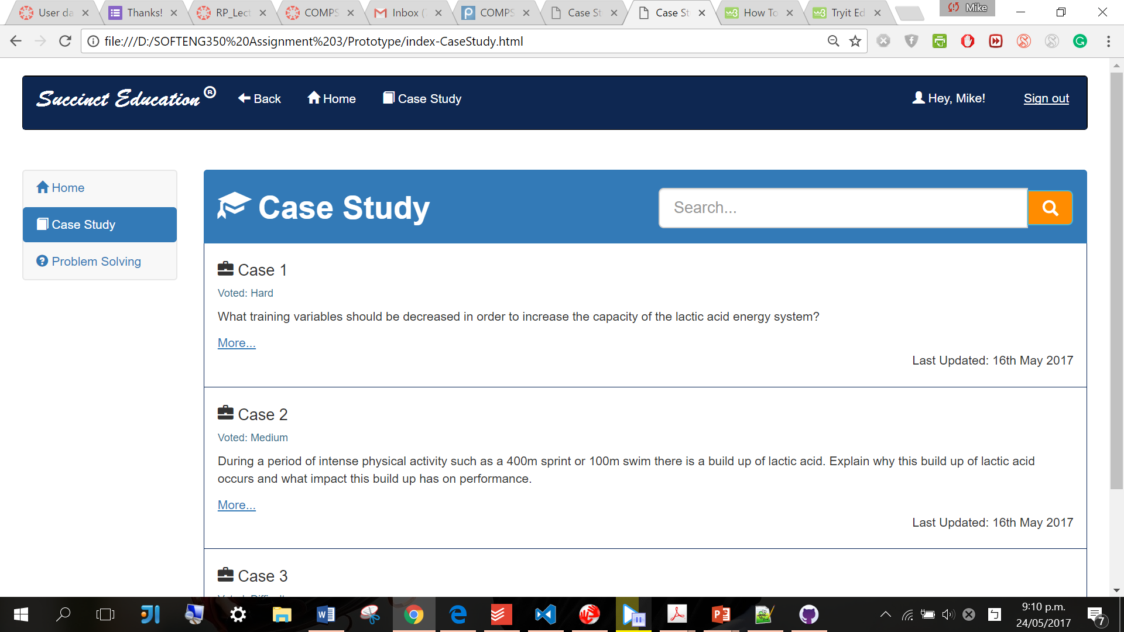

Once the user enters the case study screen, an overview panel of the available cases with brief descriptions is represented. There is a navigation bar on the top and a side menu bar on the left for navigation between different screens or for signing out. There is also a search bar right next to the header for refining the cases shown. The user can then click the ‘more…’ hyperlink for a specific case to study.



The user can type the keywords in the text field for refining the cases shown.

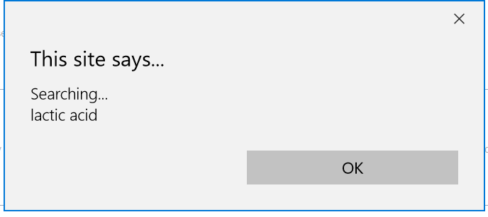

The prototype will represent an alert message while the input text is being searched.

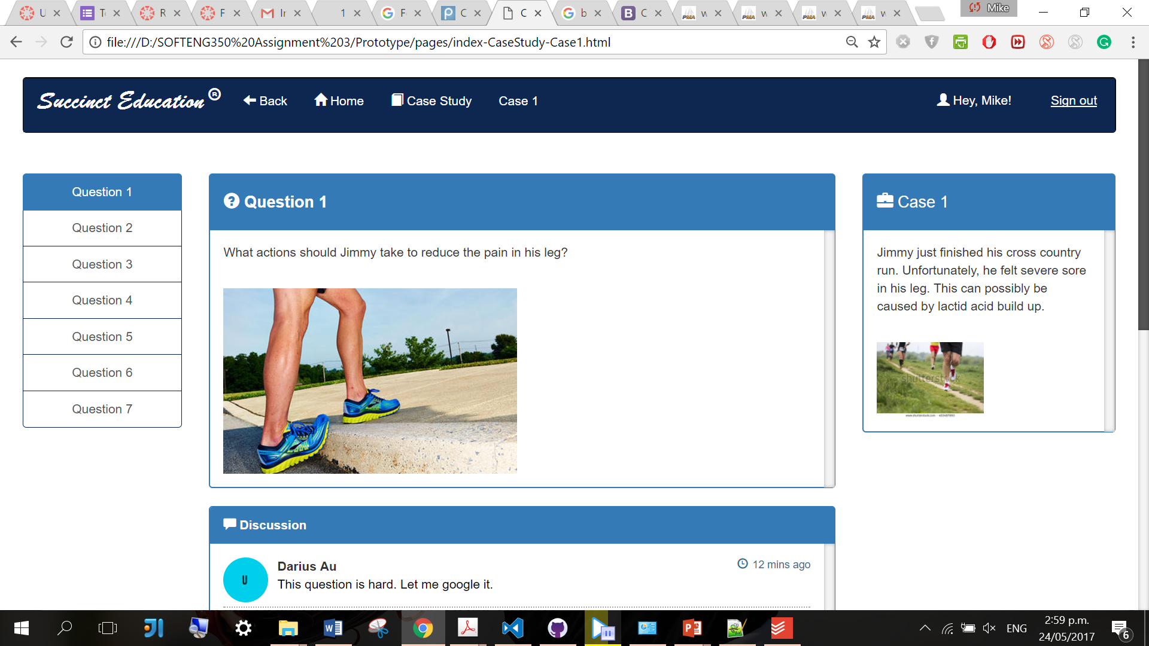

A case consists of several related questions. Similarly, there is a navigation bar on the top with the same consistent layout. In addition, there is a menu bar on the left for navigation between questions for the specific case chosen.

The case description panel is on the right, accompanied by the question panel, the discussion panel, and the answer panel in the middle.

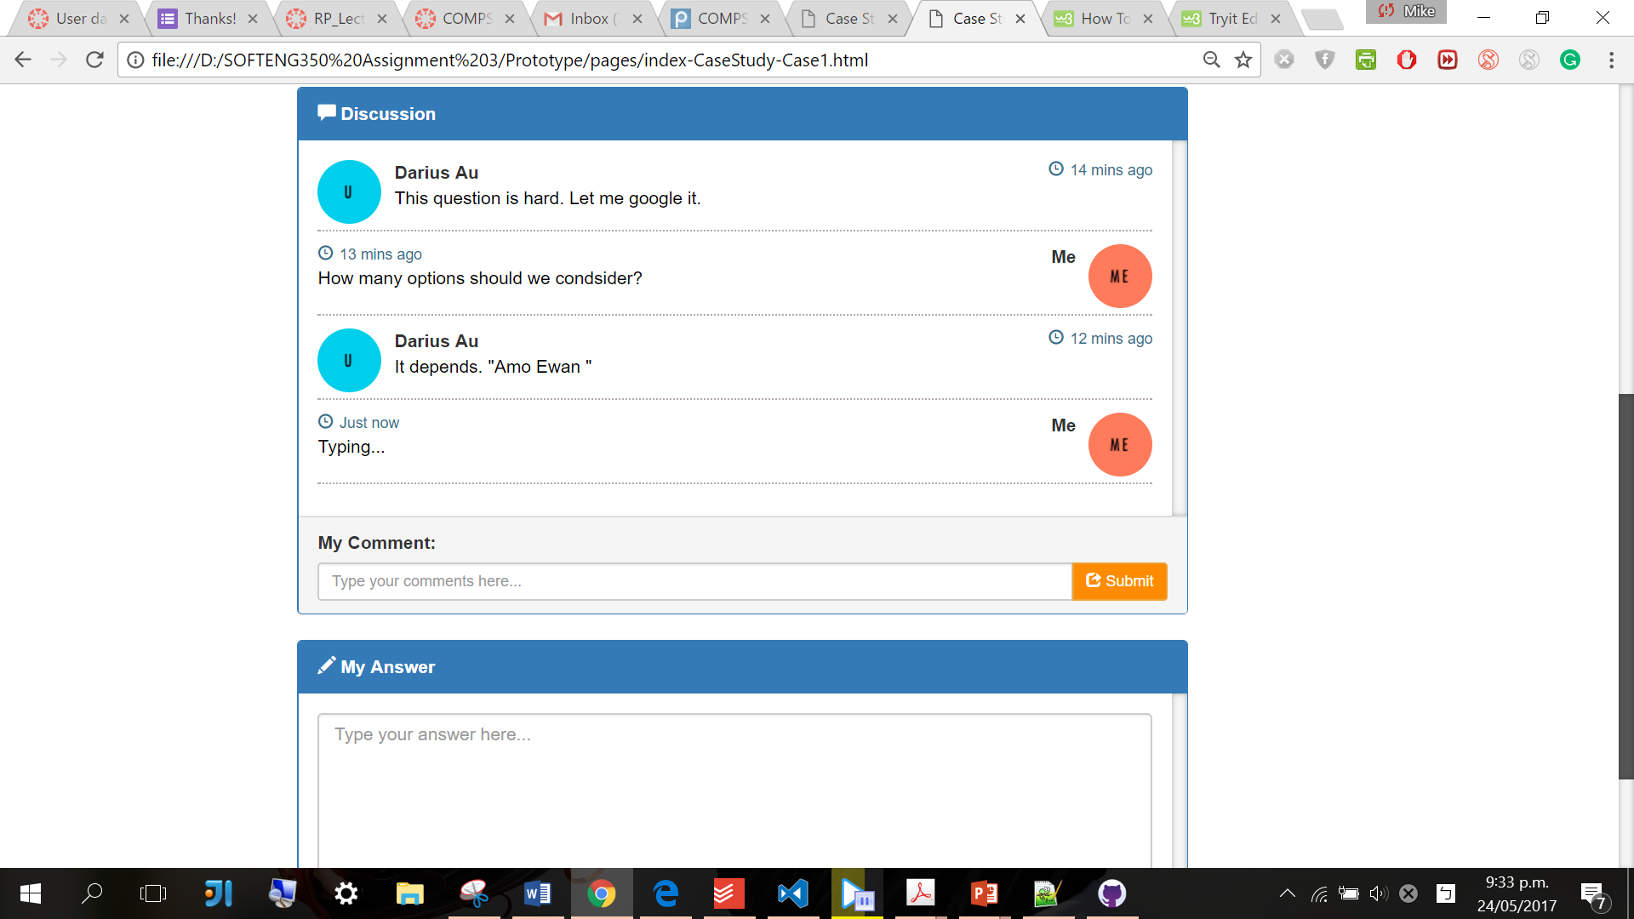

The user can view the discussion regarding a specific question and submit a new one.

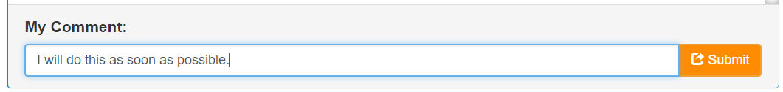

The user can type his/her comments in the text field provided and click the submit button on the right for submission.

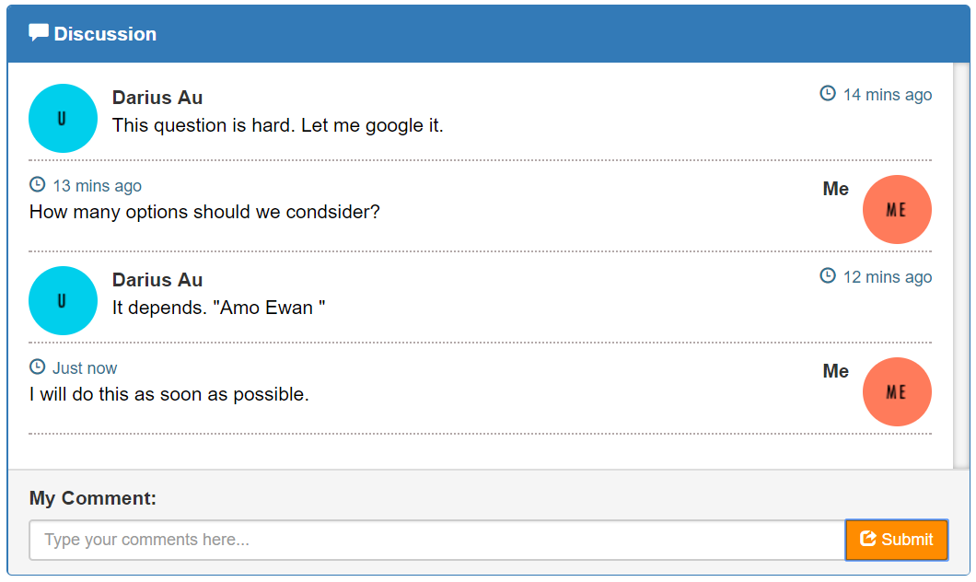

The newly submitted comment, “I will do as many options as possible.” appears in the discussion section after submission.

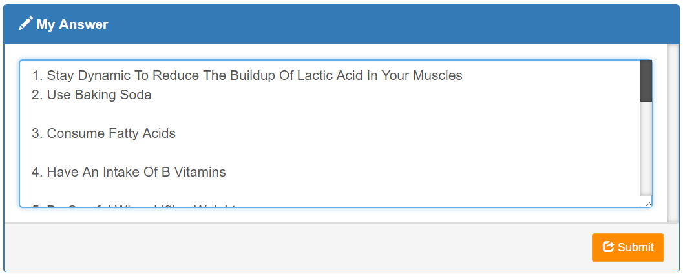

The user can then type his/her answer in the answer text area and click the submit button on the right for submission.

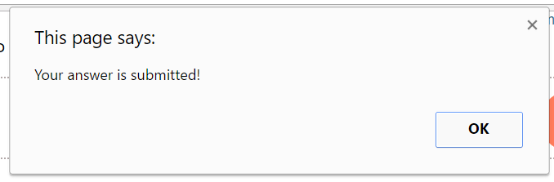

A message will appear after successful submission. The answer will stay confidential and it can only be viewed and analysed by the supervisor.

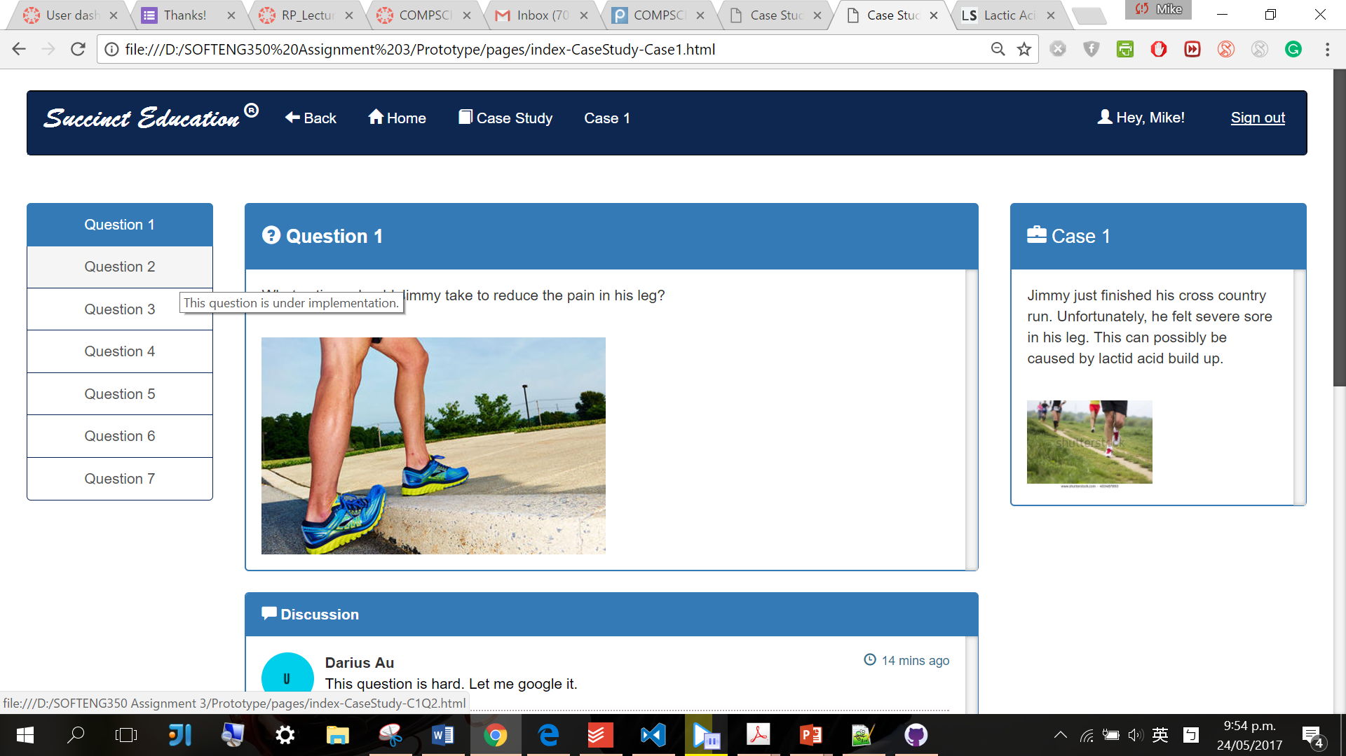

Moreover, the user can click another menu tab in the question menu bar to progress to another question within the same case.

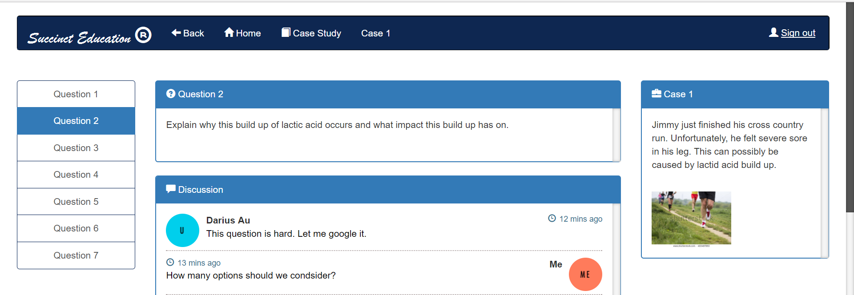

For example, by clicking the ‘Question 2’ tab, the user navigates to question 2 of case 1.



Lastly, the user can continue to answer the case questions. Alternatively, the user can also use the top navigation bar to go back to previous pages, go to the home page, or go to the overview page of the case study.

**‘Out of Scope’ list:**

* The home page and problem-solving page are not fully implemented.
* The company’s website is not fully implemented.
* The sign out functionality is not fully implemented.
* The other questions of Case 1 and the other cases are yet to be implemented.
* The discussion panel does not support more than one submission from the user each time. The actual peer discussion functionality yet to be implemented.
* The functionalities under implementation have been labelled with tooltips to notify the user.
* Google Chrome is the recommended browser for this prototype. Unfortunately, there may be some technical issues with other browsers such as Microsoft Edge. The visual layout may be misplaced unpredictably in some browsers.

**Colour scheme:**

The overall colour scheme is blue monochromatic. The main hue of blue is less stressful to look at compared to the colours at the other end of the colour spectrum such as red. Furthermore, blue as a cool colour sparks feelings of calmness and serenity. It creates a peaceful and calming environment which is vital for students to calm down and concentrate on the study tasks at hand.

The blue colour scheme of the webpage components and the white background as well as the white-coloured text form an excellent contrast. This contrast increases readability and is also used to contrast the between the ‘active’ webpage components and the ‘inactive’ ones.

Moreover, the complimentary colour scheme of dark-orange and blue is also used in specific sections within the webpages to emphasise some interaction elements such as clickable buttons. The complimentary colour scheme produces an exciting, dynamic pattern. Orange as a warm colour helps to create an environment of stimulation and helps to emphasise the existence of these components when compared to the blue background. Hence, the user is encouraged to use or explore the functionality of those interaction elements in orange colours.

|  |  |  |
| --- | --- | --- |
| Dark-orange | RGB: 255,140, 0 | The search and submission buttons. |
| Dark-blue | RGB: 3, 33, 84 | The top navigation bars. |
| Navy-blue | RGB: 0, 121, 177 | The titles for each section, the ‘active’ webpage elements, the border lines, the labels for some webpage elements, some hyperlinks. |
| Light-blue | RGB: 0, 211, 237 | The user avatars in the discussion section. |
| Orange | RGB: 255,111,76 | The user avatars in the discussion section. |
| Black | RGB: 0, 0, 0 | The default font colour for most of the text. |

**Borders scheme:**

**

The consistent rounded corner treatment across the interface provides consistency and unity. It gives a distinct look to the overall design. Furthermore, the public is genetically engineered to react unfavourably to sharp edges and corners. This is called the ‘primordial reaction’ in psychological terms as it is seen as threatening. An example object of this is a knife. By rounding the edges, the risk of accidentally stimulating the primordial reaction is decreased.

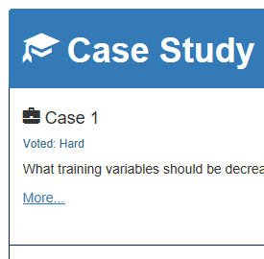

The solid border outline of each panel distinguishes them from the background and other webpage elements. The dotted separator lines in the discussion section distinguish each comment. It also reflects the visual quality of the body font of the discussion panel. The borders also work with the Bootstrap Glyphicons to increase the ‘richness’ of the overall content.

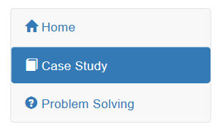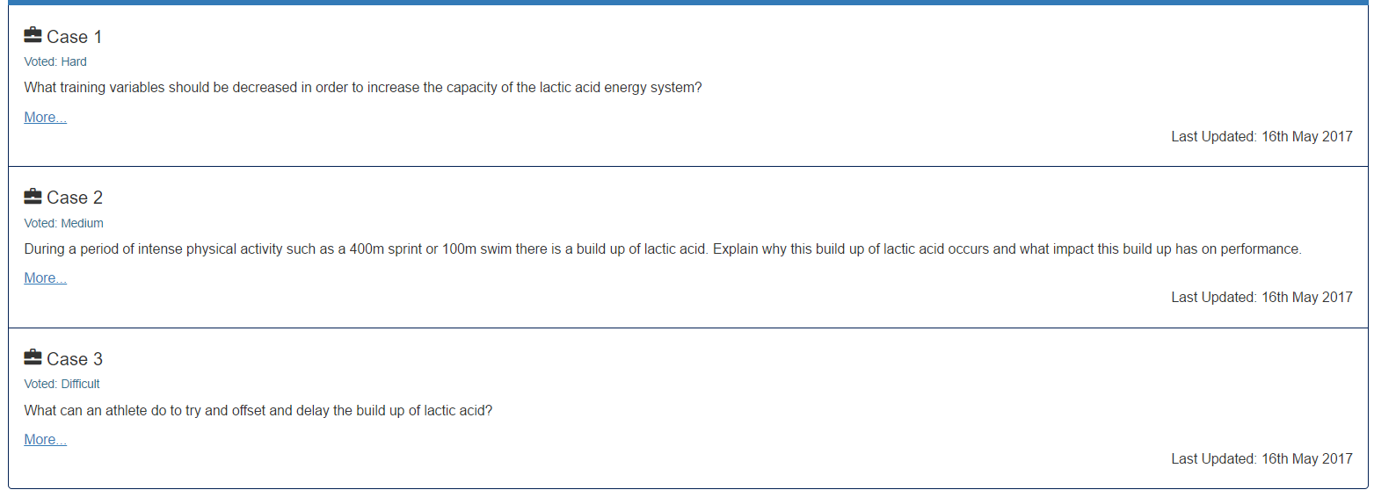

The similarity principle is applied on the left menu bars of each screen and the card block on the case study screen. By placing elements with similar visual characteristics, such as size, shape, label, and colour, they will be seen as a group and therefore related.

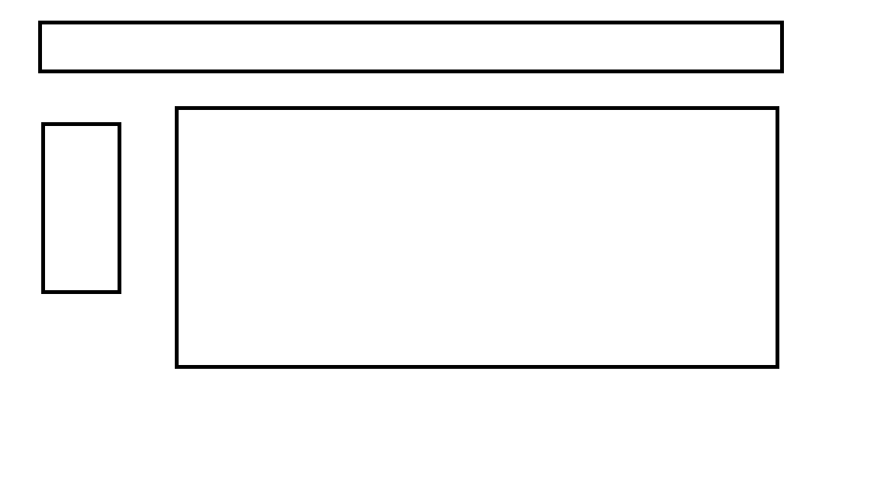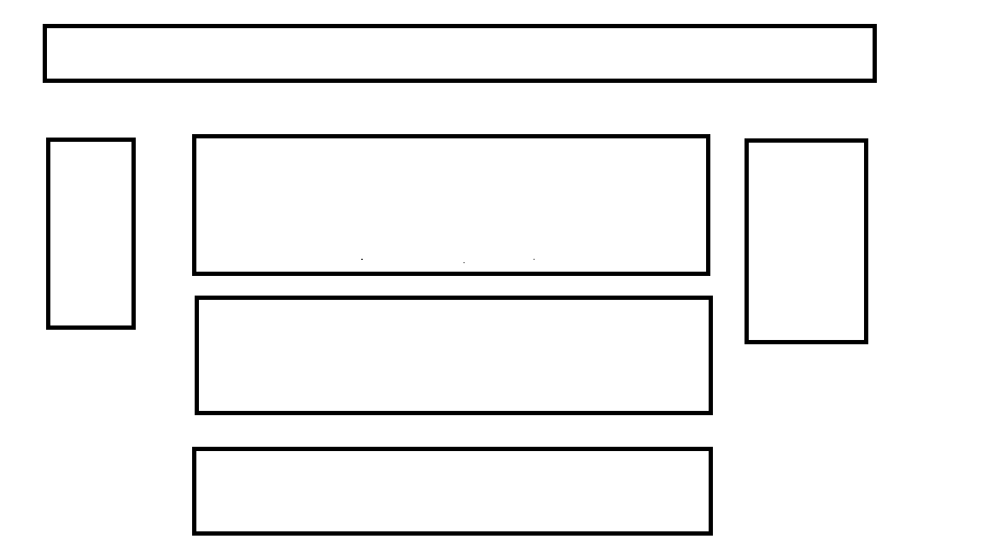

The proximity principle is applied for grouping. The whitespace between each panel is used in each screen to communicate the intended logical grouping. The elements that are close to each other will be seen as belonging together.

The surroundedness principle is applied in the case question screens. The question panel in the middle and the panels directly below it is physically surrounded by the question side menu bar on the left and the case description panel on the right. Hence, the surrounded question panel and the panels directly below are perceived as the figure, while the surrounding panels and other elements are perceived as the ground. The question panel, discussion panel, and the answer panel as the more important elements of this webpage are therefore more noticeable and allow the students to easily visually concentrate on it.



The company brand title in the top navigation bar uses a very different and stylish font compared to the standard font used in the rest of the navigation bar. Its physical length is also significantly longer. This creates a break in similarity and emphasises the dissimilar object. Therefore, the company achieves its advertising effect and attracts more attention than the other elements on the same navigation bar. On the other hand, the similarity principle is applied to the rest of the elements on the top navigation bar to achieve unity.

**Font scheme**:

Overall the Helvetica font is used as the standard font in the prototype. It provides a sense of stability and this is vital for convincing the user that the functionalities are reliable and trust-worthy. Additionally, it maintains readability without disrupting the user’s reading process. Excellent legibility is also preserved by allowing the reader to intuitively discern the letters. The Brush Script font is used to emphasise the vibrant and elegant company image.

The sans-serif typeface used is clean and business-like, which suggests this website will assist the users to efficiently complete their study objectives. The sans-serif typeface is also better suited for digital display compared to the serif typeface.

Apart from the titles, the majority of the text is in the common lower-case format. This increases the reading speed compared to all capital letters. Words in all capital letters have very similar rectangular shapes of a certain size and hence they are harder to distinguish.

|  |  |  |  |
| --- | --- | --- | --- |
| Font name | Style | Role | Example type |
| Brush Script Std | Bold | This font promotes elegance and sophistication. It also allows the application of the emphasis principle as discussed earlier. |  |
| Helvetica | Normal | This font is used for: the labels of the navigation bar, the labels of the tab menu on the left, the heading and paragraph of each panel. This font provides readability and legibility. |  |
| Helvetica | Underlined | This font is used for hyperlinks to a specific case or to sign out. The underlining matches the affordance of clicking. |  |
| Helvetica | Bold | This font is used to emphasise the title and the user names from the rest of the elements. |  |

**Resources used:**

|  |  |
| --- | --- |
| The discussion section | https://bootsnipp.com/snippets/featured/chat-widget |
| The search bar | https://bootsnipp.com/snippets/featured/expanding-search-button-in-css |
| The photo used for the example case | https://www.shutterstock.com/image-photo/young-lady-running-on-rural-road-150981035?src=CwUyv4J701PN69UJZUT9Gg-1-51 |
| The photo used for the example question | http://www.runnersworld.com/person/bicyclingcom |