Voxspell - Game Based Spelling Learning

En-Yu Mike Lee
Department of Electrical and Computer Engineering
University of Auckland
elee353@aucklanduni.ac.nz

Abstract— Game-based learning aims at getting people to learn a certain subject or to acquire certain skills by means of playing. Educational games must fulfil both recreational and didactic goals in order to succeed. This paper introduces a spelling game called Voxspell, designed especially for ESL students to learn English orthography and vocabulary. A brief description of the game is provided, along with the software development process applied.
Keywords—Game-based learning, orthography, spelling, vocabulary, English learning, software development process

Introduction
Game-based learning is an attractive alternative option particularly for a generation who has grown up digital. The success of game-based learning experiences relies on two key characteristics: an effective pedagogical background and a sound entertaining support. Learning effectiveness of the game depends directly on the former, but the latter also deeply affects student’s motivation.
In this paper, an application for game-based orthography learning aimed at second language learners between eighteen and twenty five years old is presented. Traditional spelling exercises tend to be monotonous and tedious, which represents a critical handicap for maintaining the student’s interest and motivation. Memorising the English orthography also raises similar problems.
The main advantage of game-based learning is to maintain student’s motivation by its recreational characteristics. It allows the development of repetitive learning tasks. Thus, it constitutes an ideal scenario for practicing orthography and vocabulary learning, by doing simple spelling exercises of incrementing difficulty.
The Extreme Programming (XP) technique is applied throughout the development of the program to ensure the quality is satisfying. This includes techniques such as client meeting with the lectures, peer evaluation, and pair programming.

Ease of Use

DESCRIPTION OF THE PROGRAM
The objective of any educational games is achieving a didactic goal while maintaining the entertaining value expected. When designing this application, the easiest way of ensuring its entertaining objective was to adapt an existing amusing game and a media award feature. Nevertheless, the didactic factor had to be carefully introduced to integrate both the didactic and the recreational goals without jeopardizing each other.
The objective of Voxspell consists of spelling a maximum of ten words after pronunciation and receiving a number of entertaining awards. Once each answer is submitted, the correctness of spelling is checked and the result recorded. If a satisfactory level of correct spelling is achieved, a number of awards are provided such as a Tic-Tac-Toe game and a media player to play music and videos.

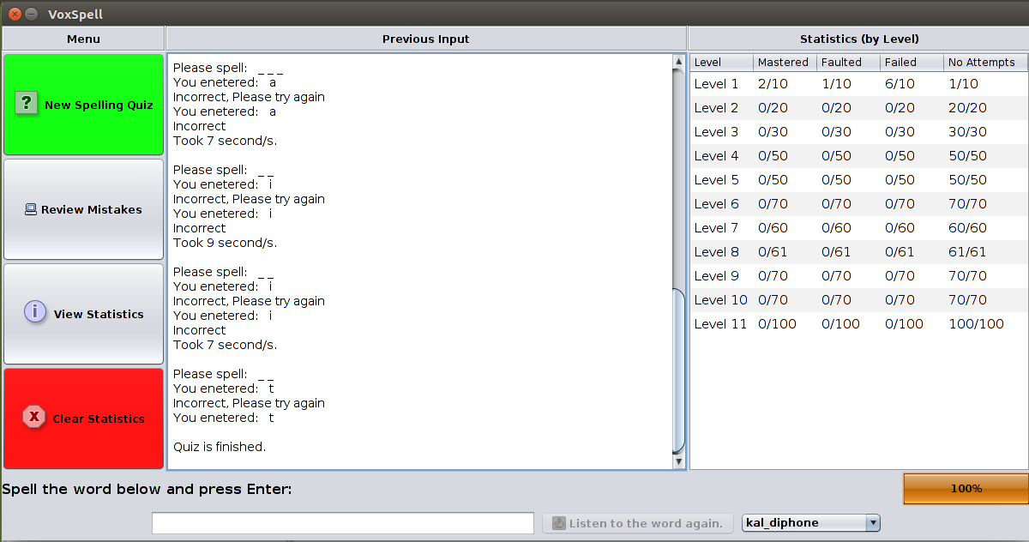
Figure 1: Screen Capture of the Program

GUI DESIGN OF THE PROGRAM
Java is used to construct the program as a result of its cross-platform capability. The Swing Framework is utilised to construct the Graphical User Interface (GUI). In addition, the VLCJ package is chosen to construct the media player as an award option.
"Colour is one of the most effective visual attributes for coding information in displays and is capable, when used correctly, of achieving powerful and memorable effects." [1] (Using Color Effectively in Computer Graphics)
The classical green and red contrast is throughout the design of the GUI. The ‘New Spelling Quiz’ and ‘Clear Statistics’ buttons contains this colour contrast to encourage selection of the former using green colour, while discouraging selecting the latter using red colour. This is also applied in the media player to distinguish the difference between replay and stop. Additionally, the hues are mainly the default grey and white colours because they make good contrasts to the black colour of the text and avoid visual fatigue of the users. The hues and the black text colour also tend to be neutral colours in most cultures. For example, the Chinese culture dislikes red as a text colour as the names of the dead were previously written in red. The Nimbus Look and Feel is chosen to increase the overall brightness of the Swing components, therefore increasing the contrast between the components and the black colour of the text. It also increases the saturation to make the colours look rich and full. Icons are also applied to most Swing buttons to address the colour vision deficiency issue by providing an alternative way to distinguish the buttons visually.
A solid effort has been made to maintain the simplicity of the GUI. The five main buttons relating to the five main functionalities are grouped to the left, while the Swing components relating to the quiz functionalities are placed at the bottom section. The grouping helps to minimize eye and hand movements since the GUI components with similar functionalities are adjacent to each other and the user can slightly move the cursor to select another option. The middle section contain a text field for outputting quiz feedback and instructions. The middle position is selected because the user has a natural tendency to focus at the middle of a window, therefore it should be prioritised to represent the most important information. On the right side of the main screen, a table is utilised to display the live progress of the current quiz including the numbers of total words as well as the mastered and failed frequencies.
The description on each button has been condensed to suite the targeted user group. The second language learners are assumed to have mediate to advance computer proficiency and no physical limitations. Concise description such as ‘New Quiz’ is used to describe the functionality of each button, in order to address the vocabulary problem. It is the scenario where “the users may know what they are looking for, but lack the knowledge needed to articulate the problem in terms and abstractions used by the information system.” [2] (Interface Issues and Interaction Strategies for Information Retrieval Systems)

FUNCTIONALITY
Voxspell has four main functionalities: New quiz, Review Quiz, View Statistics, and Clear Statistics. The user is given the flexibility to load his or her own media and word list files, in order to freely adapt and customise the content to his or her specific needs.
Both New Quiz and Review Quiz are based on the traditional question answering to remind formal educational evaluations. The New Quiz functionality provides the user a quiz with ten words from the current level to spell. With each word tested, a maximum of two attempts is provided. Similarly, the alternative Review Quiz provides a quiz with a maximum of ten words that are incorrectly spelled previously. This functionality is included because second language users may be likely to make spelling mistakes, and one of the best learning strategies is to learn from one’s own mistakes. The feature that a failed word can be reviewed again after the completion of a quiz also encourages learning by spaced repetition.
The user submits the answer by pressing the enter key after each word is pronounced. Instant response will be received for the correctness of spelling. The enter key is used for submission because most users have a natural tendency to submit inputs by press it. An error check logic has been implemented that shows an error message when it detects non English characters and ignores empty inputs. Hence, this contributes to the overall robustness to the program against various possible textual inputs.
The voice/accent and speaking rate of the Festival Synthesis System utilised can be adjusted in both the Quiz functionalities. English as a widely spoken language has many distinctive regional accents. They should not become a barrier for understanding the word pronounced in order to complete the quiz. The rate is adjustable since the English listening proficiency is highly likely to differ between individuals for second language users. Additionally, the user can heard the pronunciation of each word multiple times without penalties. This encourages repeated learning by listening to the same pronunciation multiple times. Because the user group is assumed to mostly dislike the animation and sound, no sound effect such as cheering is included in the instant feedback. 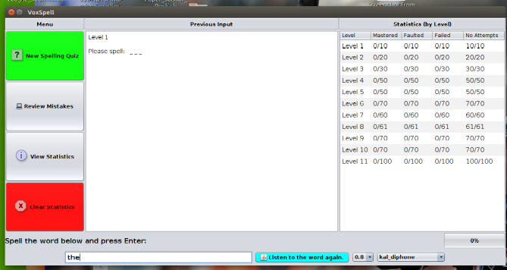
Figure 2 Screen Capture of the Basic Operation Buttons
Once the user starts a quiz, other functionalities will be disabled and he or she must finish the current quiz before using another functionality. This strategy is used to force the user to concentrate on the current quiz in progress and prevent cheating by selecting another functionality half way through a quiz.
If the user achieves a distinctive level of correctness, one of the following award options can be selected: adjust the spelling level, play a reward video with or without echo effects, or play the Tic-Tac-Toe game. The spelling level can be maintained or incremented by one. The Tic-Tac-Toe game is a single player game with a voice synthesis feature, while the media player provides controls such as pausing and replaying a video for the user. Both reward options achieve the entertaining goal and motivate the user to improve the spelling accuracy. “Motivation can precede learning and promote memory formation, independent of stimulus features or feedback.” [3] (Activation Precedes Memory Formation)
The View Statistics functionality presents the numbers of times each word is mastered, faulted, and failed individually. On the other hand, the Clear Statistics functionality clears the hidden files associated with the statistics after confirmation.
After each quiz, the user chooses one of the four main functionalities again or close the application. This strategy is intended to reinforce learning by means of repetition. When restarting after closing the application, this strategy does not apply and the words are loaded and selected randomly again.
A Help button is also provided in the main menu to assist the user. Upon selection, it opens up the user manual in PDF format.

Code Design and development of the program
Java was close to the best choice of language for this project as a result of its cross-platform capability. In comparison, C# as another popular object-oriented language is only cross-platform if used along with the third-party Mono project. The cross-platform capability is crucial as the program relies heavily on the Festival Voice Synthesis System and FFMPEG installed in Linux, making the Microsoft based C# unsuitable. However, Java does have some limitations and disadvantages. It is generally considered to run slower than the fastest 3rd generation strongly typed languages such as C and C++. Java’s file manipulation abilities are also less effective compared to the native Linux Shell scripts.
Other additional libraries utilised in this project include the Swing framework, the VLCJ framework by CAPRICA, the FFMPEG software, and the Festival Voice Synthesis System. The Swing framework is utilised to construct the GUI, while the VLCJ framework by CAPRICA was chosen to construct the media player of Voxspell. In addition, the FFMPEG software was used to process the reward video with special audio and video effects in the background. Lastly, the Festival Voice Synthesis System was used to pronounce the words to be spelled and the instructions in the background.
In the prototype phase of the project, the project was shared between a pair of two students and the Extreme Programming (XP) technique applied. The application of various XP values and practices that generally fall into the following three categories: fine scale feedback, shared understanding, continuous process, and programmer welfare.
Pair programming with an agreed coding standard was utilised to develop some implementations to balance coding efficiency with quality. During the development of the prototype, both partners had collective code ownership, maintained simple design, and an understandable system metaphor to ensure solid shared understanding. The adequate planning and scheduling have also ensured the prototype was completed with a sustainable pace for developers.
Continuous integration was also applied with version control aided by Git and GitHub. This ensured both partners work on the latest version while keeping a reliable record of all previous versions. The GitHub repository consisted of many experimental branches that were used for newly introduced features. Individual changes were committed locally using Git and then pushed to the remote GitHub repository.
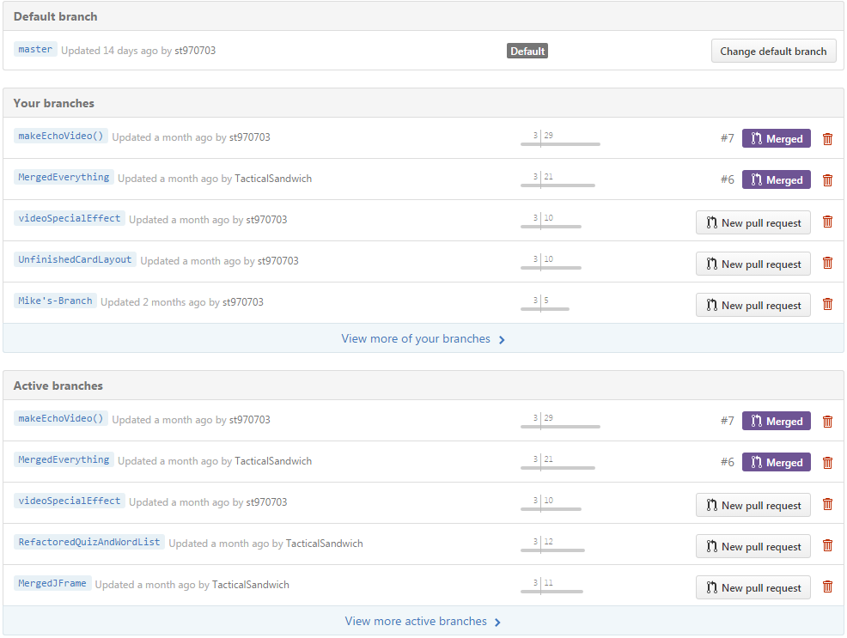
Figure 3 Screen Capture of the GitHub Repository
Apart from the commit messages, all important design decisions and implementation difficulties were recorded in a logbook to ensure flawless communication.
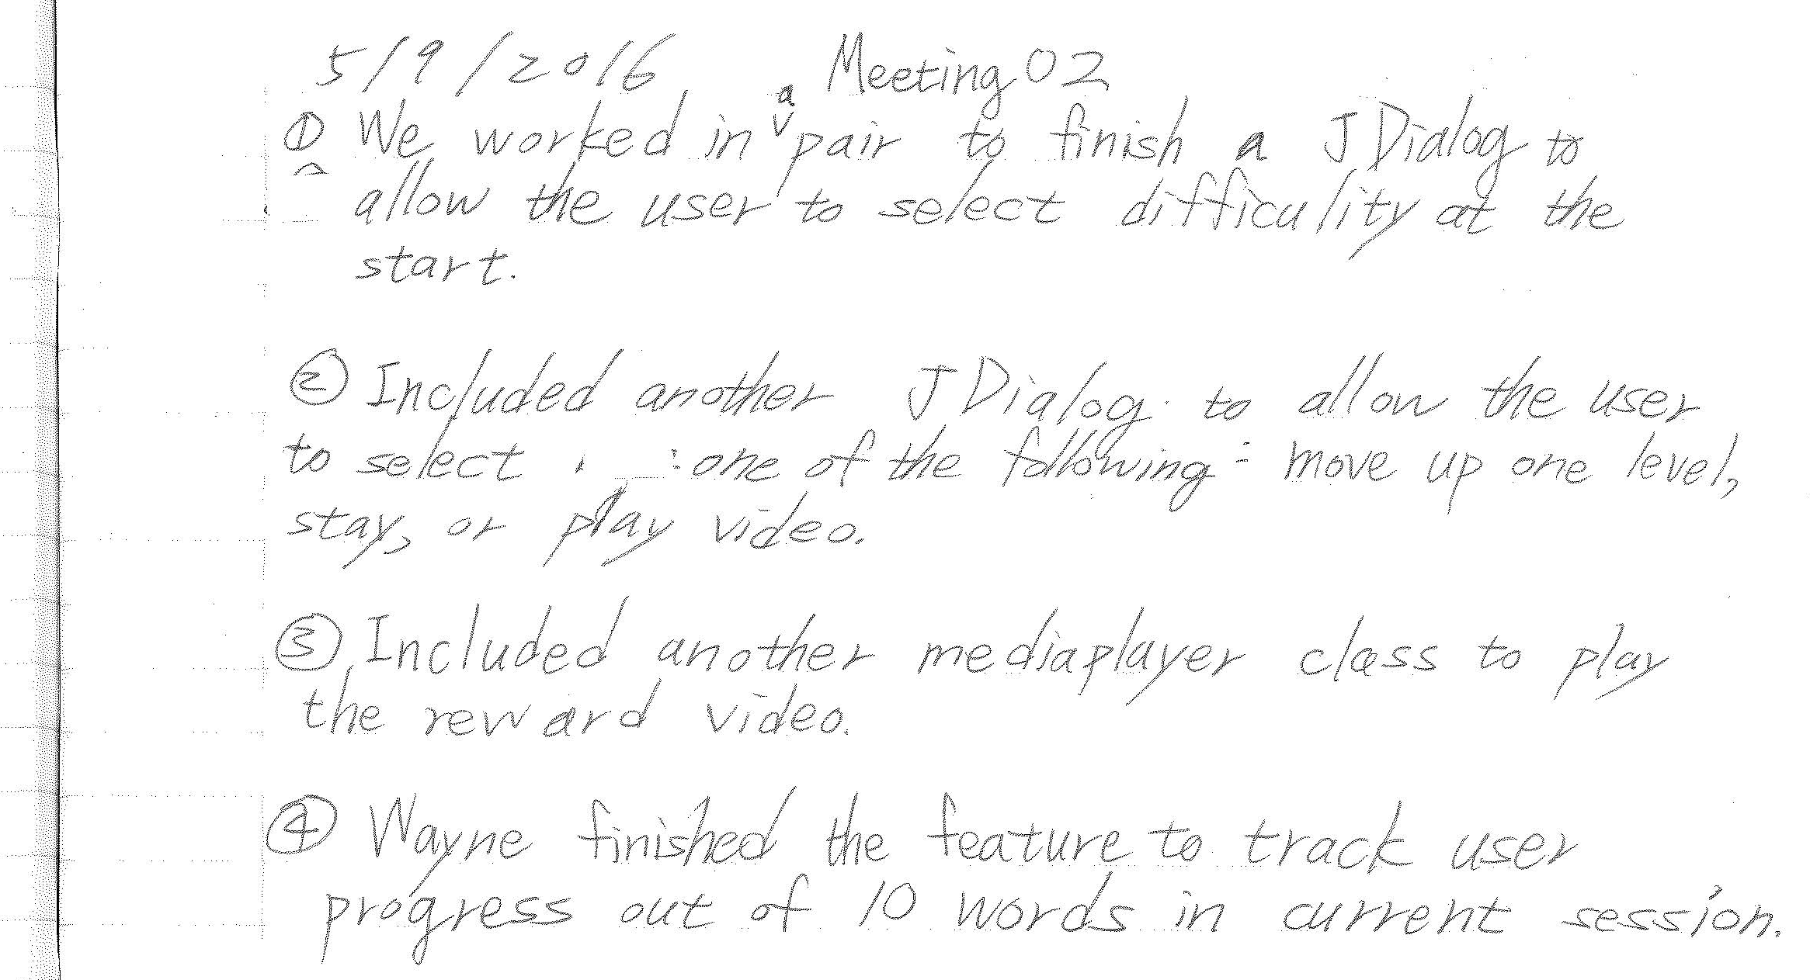
Figure 4 A Page from My Logbook
After the prototype phase, the project progressed to the final product phase. This phase involved the client meetings where the lecturers participated as clients to clarify project planning and specifications. This enables the XP practice of whole team, meaning that the project is teamwork of both the clients and developers.

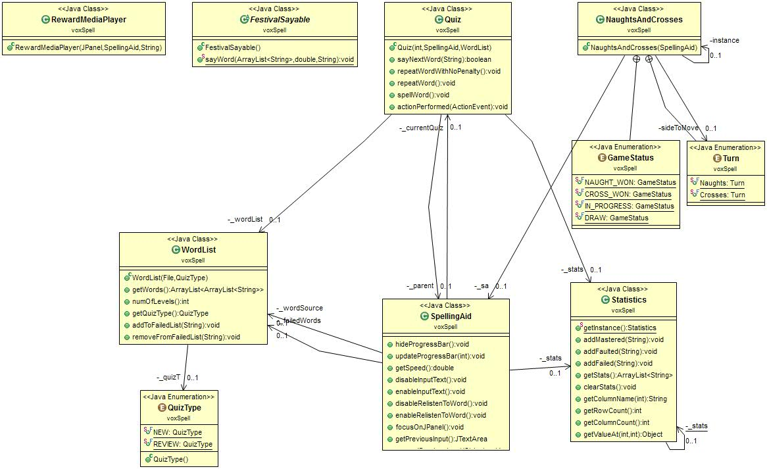
Figure 5 UML Diagram of the Implementation

Authors and Affiliations
The template is designed so that author affiliations are not repeated each time for multiple authors of the same affiliation. Please keep your affiliations as succinct as possible (for example, do not differentiate among departments of the same organization). This template was designed for two affiliations.

For author/s of only one affiliation (Heading 3): To change the default, adjust the template as follows.

Selection (Heading 4): Highlight all author and affiliation lines.

Change number of columns: Select the Columns icon from the MS Word Standard toolbar and then select “1 Column” from the selection palette.

Deletion: Delete the author and affiliation lines for the second affiliation.

For author/s of more than two affiliations: To change the default, adjust the template as follows.

Selection: Highlight all author and affiliation lines.

Change number of columns: Select the “Columns” icon from the MS Word Standard toolbar and then select “1 Column” from the selection palette.

Highlight author and affiliation lines of affiliation 1 and copy this selection.

Formatting: Insert one hard return immediately after the last character of the last affiliation line. Then paste down the copy of affiliation 1. Repeat as necessary for each additional affiliation.

Reassign number of columns: Place your cursor to the right of the last character of the last affiliation line of an even numbered affiliation (e.g., if there are five affiliations, place your cursor at end of fourth affiliation). Drag the cursor up to highlight all of the above author and affiliation lines. Go to Column icon and select “2 Columns”. If you have an odd number of affiliations, the final affiliation will be centered on the page; all previous will be in two columns.

Identify the Headings
Headings, or heads, are organizational devices that guide the reader through your paper. There are two types: component heads and text heads.
Component heads identify the different components of your paper and are not topically subordinate to each other. Examples include ACKNOWLEDGMENTS and REFERENCES, and for these, the correct style to use is “Heading 5.” Use “figure caption” for your Figure captions, and “table head” for your table title. Run-in heads, such as “Abstract,” will require you to apply a style (in this case, italic) in addition to the style provided by the drop down menu to differentiate the head from the text.
Text heads organize the topics on a relational, hierarchical basis. For example, the paper title is the primary text head because all subsequent material relates and elaborates on this one topic. If there are two or more sub-topics, the next level head (uppercase Roman numerals) should be used and, conversely, if there are not at least two sub-topics, then no subheads should be introduced. Styles named “Heading 1,” “Heading 2,” “Heading 3,” and “Heading 4” are prescribed.

Figures and Tables

Positioning Figures and Tables: Place figures and tables at the top and bottom of columns. Avoid placing them in the middle of columns. Large figures and tables may span across both columns. Figure captions should be below the figures; table heads should appear above the tables. Insert figures and tables after they are cited in the text. Use the abbreviation “Fig. 1,” even at the beginning of a sentence.
- Table Styles
Table Head | Table Column Head
Table Head | Table column subhead | Subhead | Subhead
copy | More table copyª
- Sample of a Table footnote. (Table footnote)

- Example of a figure caption. (figure caption)
Figure Labels: Use 8 point Times New Roman for Figure labels. Use words rather than symbols or abbreviations when writing Figure axis labels to avoid confusing the reader. As an example, write the quantity “Magnetization,” or “Magnetization, M,” not just “M.” If including units in the label, present them within parentheses. Do not label axes only with units. In the example, write “Magnetization (A/m)” or “Magnetization (A ( m(1),” not just “A/m.” Do not label axes with a ratio of quantities and units. For example, write “Temperature (K),” not “Temperature/K.”

Acknowledgment (Heading 5)
The preferred spelling of the word “acknowledgment” in America is without an “e” after the “g.” Avoid the stilted expression “one of us (R. B. G.) thanks ...”. Instead, try “R. B. G. thanks...”. Put sponsor acknowledgments in the unnumbered footnote on the first page.

References
The template will number citations consecutively within brackets [1]. The sentence punctuation follows the bracket [2]. Refer simply to the reference number, as in [3]—do not use “Ref. [3]” or “reference [3]” except at the beginning of a sentence: “Reference [3] was the first ...”
Number footnotes separately in superscripts. Place the actual footnote at the bottom of the column in which it was cited. Do not put footnotes in the reference list. Use letters for table footnotes.
Unless there are six authors or more give all authors’ names; do not use “et al.”. Papers that have not been published, even if they have been submitted for publication, should be cited as “unpublished” [4]. Papers that have been accepted for publication should be cited as “in press” [5]. Capitalize only the first word in a paper title, except for proper nouns and element symbols.
For papers published in translation journals, please give the English citation first, followed by the original foreign-language citation [6].

- G. Eason, B. Noble, and I.N. Sneddon, “On certain integrals of Lipschitz-Hankel type involving products of Bessel functions,” Phil. Trans. Roy. Soc. London, vol. A247, pp. 529-551, April 1955. (references)
We suggest that you use a text box to insert a graphic (which is ideally a 300 dpi resolution TIFF or EPS file with all fonts embedded) because this method is somewhat more stable than directly inserting a picture.
To have non-visible rules on your frame, use the MSWord “Format” pull-down menu, select Text Box > Colors and Lines to choose No Fill and No Line.
- J. Clerk Maxwell, A Treatise on Electricity and Magnetism, 3rd ed., vol. 2. Oxford: Clarendon, 1892, pp.68-73.
- I.S. Jacobs and C.P. Bean, “Fine particles, thin films and exchange anisotropy,” in Magnetism, vol. III, G.T. Rado and H. Suhl, Eds. New York: Academic, 1963, pp. 271-350.
- K. Elissa, “Title of paper if known,” unpublished.
- R. Nicole, “Title of paper with only first word capitalized,” J. Name Stand. Abbrev., in press.
- Y. Yorozu, M. Hirano, K. Oka, and Y. Tagawa, “Electron spectroscopy studies on magneto-optical media and plastic substrate interface,” IEEE Transl. J. Magn. Japan, vol. 2, pp. 740-741, August 1987 [Digests 9th Annual Conf. Magnetics Japan, p. 301, 1982].
- M. Young, The Technical Writer’s Handbook. Mill Valley, CA: University Science, 1989.

