0653422 科目：智慧型 HW8 林容伊

1.  
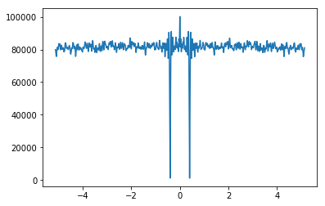

2.

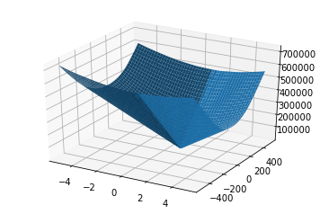

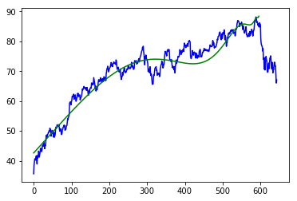3.

tc = 597

beta = 0.874023

omega = 2.280000

phi = 6.086836

A = 88.499297

B = -0.151061

C = 0.052466

Avg_error = 7501.950478