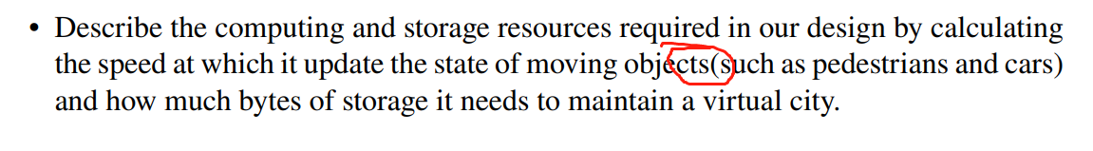

缺空格（Page 4）



Page 6

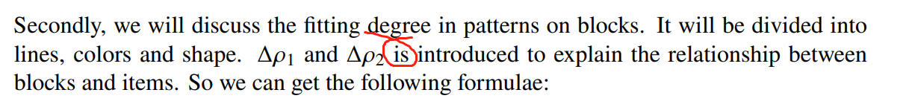

Pdf Page 8/论文Page 5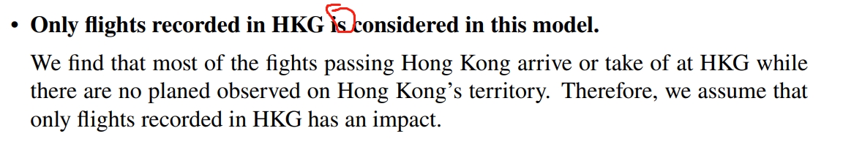

单复数 pdf Page 9/论文Page 6



应该是plain pdf Page 10/论文Page 7

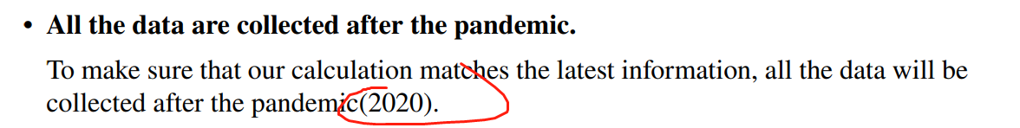

缺空格 pdf Page 11/论文Page 8



缺空格 pdf Page 12/论文Page 9

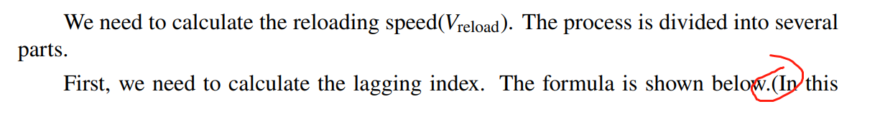

同上

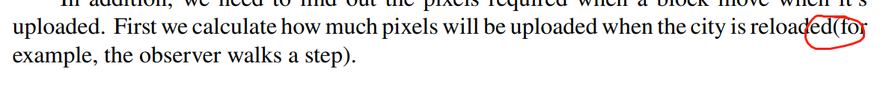

缺空格 pdf Page 13/论文Page 10

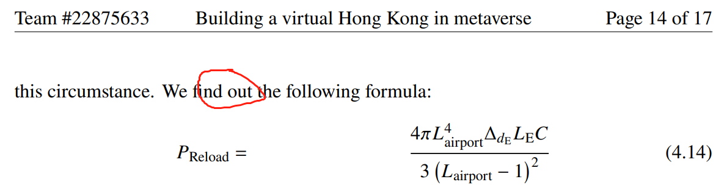

逻辑不严谨，需要增加解释部分



建议删除（并没有因果逻辑）+find out逻辑不严谨，需要增加解释部分

pdf Page17/论文Page 14

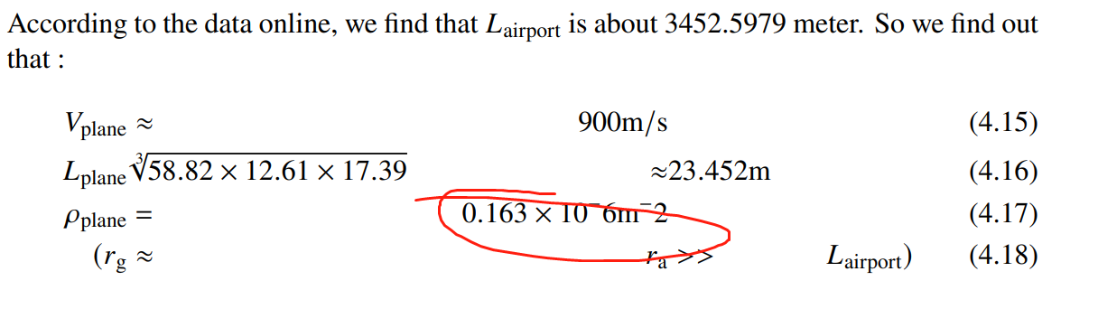

没打上标 pdf Page 17/论文Page 14

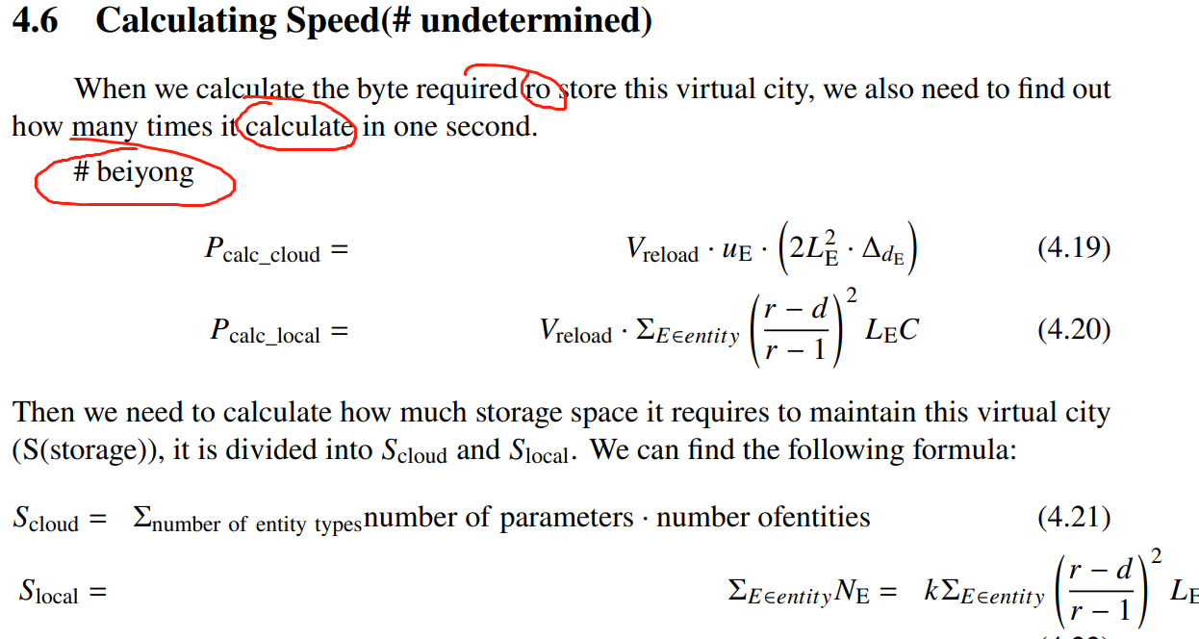

单词打错&语病&诡异的东西&两处公式的由来需要加解释部分&最下面的式子排版令人不适 pdf Page 18/论文Page 15

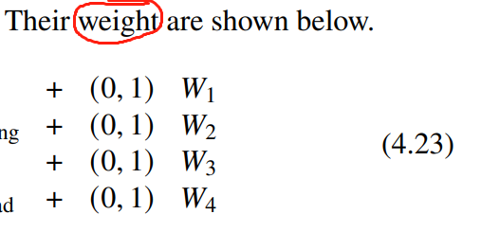

单复数问题 pdf Page 18/论文Page 15

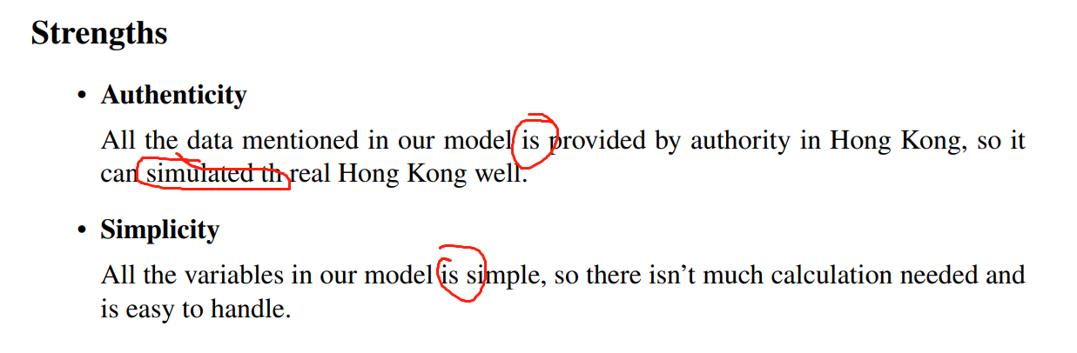

单复数问题&单词打错&时态问题 pdf Page 18/论文Page 15

缺少的各种东西：

1. 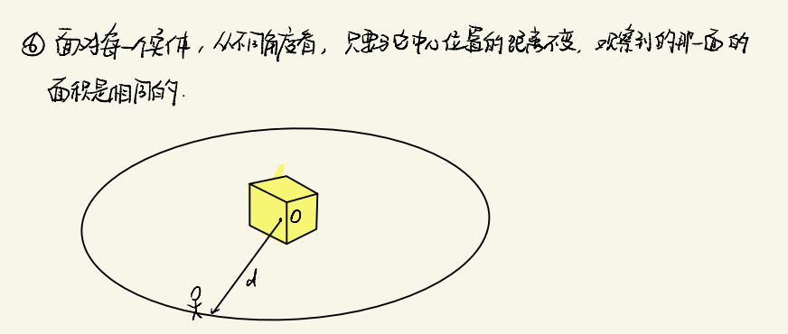

这条假设没有出现

应该出现在论文P9-10中Assumption部分

For each entity, we assume that the area an observer sees it from different angles is the same as long as the distance between the observer and the entity.

1. 结尾缺少数值精确度优化部分

As we know, the entities we see in real world is not continuous (for example, it’s impossible for you to see exactly 0.1 car every second). Because of this, we can calculate the proportion of time when we can see a kind of entity in a day to optimize the division of storage.

For ferries, the time for each ferry to be seen is equal to the visibility divided by the speed (100s) while the average time interval of department is 175.15s. So the visible proportion of ferries is 57.10%. With the same method, we can calculate that the proportion of planes is 8.10% and the proportion of subway is 13.33%.

1. 缺少对P_calc_cloud P_calc_local S_cloud S_local的解释