The area of Lake Mead is 640, 000, 000㎡ and its depth is 162m.

So the length of the top equals the square root of the area. ($l_{top}=\sqrt{6.4×{10}^{8}}m≈25298.2m$)

Assume that the shape of the lake can be simplified into a model like the pictures below:

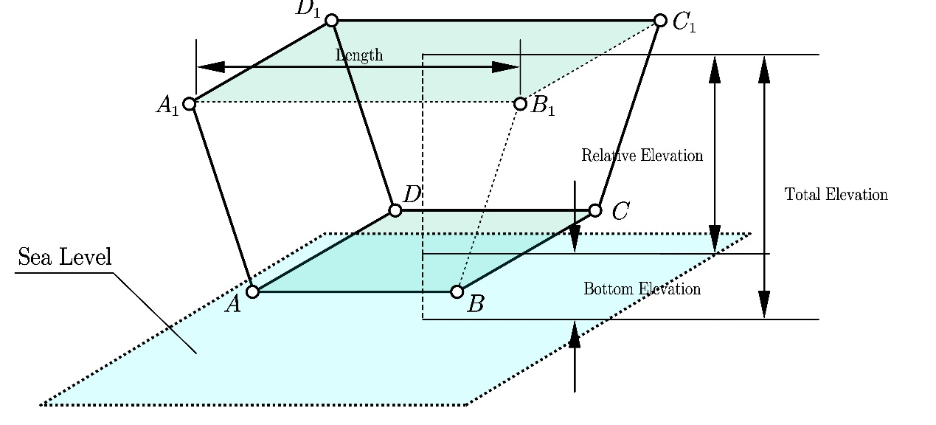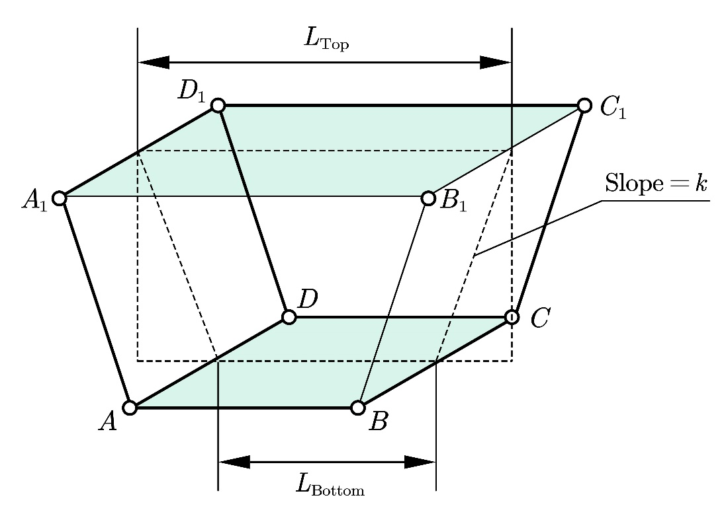-

It has been calculated that the slope of the edges $AA_{1},$ $BB_{1},$ $CC_{1} and$ $DD_{1}$ is 0.8902.

What’s more, $k=\frac{2Δh}{Δl}$.

So $k=\frac{2*162}{l_{top}-l_{bottom}}$

So $l_{bottom}$ equals 24934.258m.

So $area={(24934.258+\frac{h}{0.8902})}^{2}$, h refers to the distance between a certain depth and the bottom of the lake.