CAMARINES SUR POLYTECHNIC COLLEGES
COLLEGE OF COMPUTER STUDIES
CCCS 106: Application Development and Emerging Technologies (AY 2026-2027)
--------------------------------------------------
LABORATORY TASK REPORT 01
Environment Isolation, Modern Flet GUI & Collaborative 3-Developer Git Workflow
Group Designation: | Group No. [ 11 ] (e.g., Group 03)
Date of Submission: | [ September DD, 2026 ]
Course Instructor: | Engr. Allan Ibo Jr. | CSPC College of Computer Studies

TEAM TRIAD MEMBERS & TECHNICAL ROLES
Student Full Name | Student ID | GitHub Username | Assigned Triad Role & Branch
[ Lead Student Name ] | 2024-2411288 | @staanagelorenz-cyber | Developer 1 (Lead UI)  feature/dev1-profile
[ Renz Angelo S. Priela ] | 2024-2411282 | @rnxee | Developer 2 (State Logic)  feature/dev2-state
[ Ubante Jay Marion B ] | C20101802 | @JM-Ubante | Developer 3 (QA & Milestone)  feature/dev3-features

Section 1: GitHub Repository & Collaborator Proof
Public GitHub Repository URL: https://github.com/[developer1-username]/cccs106-group[XX]-showcase
Proof of team collaboration setup on GitHub. The screenshot below shows the repository Settings > Collaborators page confirming that Developer 1 has invited Developer 2 and Developer 3 as official contributors with accepted statuses.
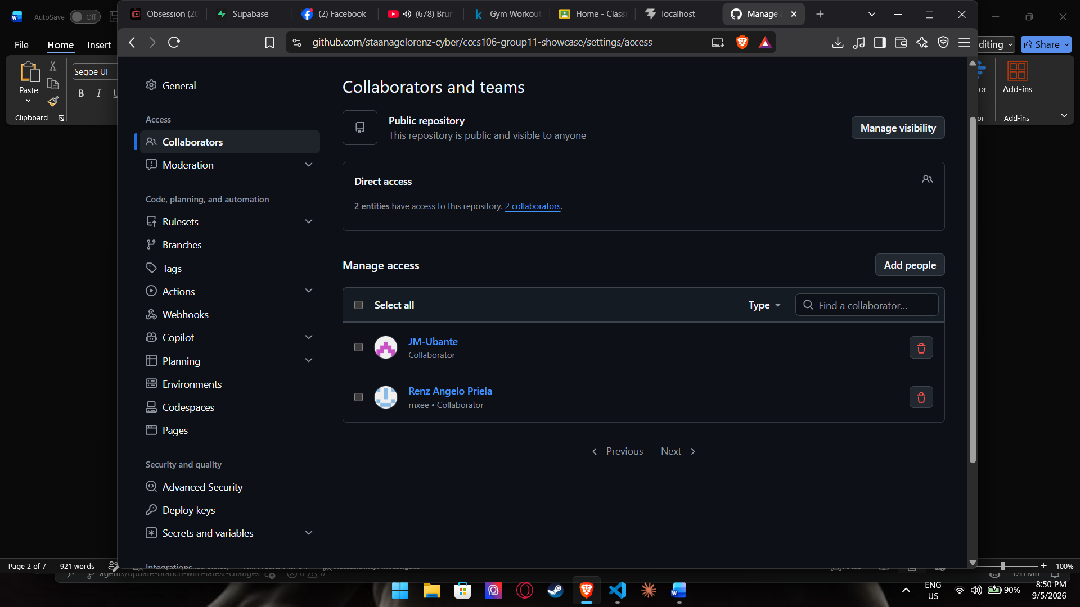
[ PASTE / INSERT SCREENSHOT IMAGE HERE ]
Reference: GitHub Collaborators Verification (Settings > Collaborators)
Requirement: Screenshot showing Developer 1 (Owner), Developer 2, and Developer 3 with accepted invitations.
Figure 1: GitHub Collaborators Verification (Settings > Collaborators)

Section 2: Automated Pre-Flight Diagnostics Audit
Pre-flight workstation audit executed via 'python verify_setup.py' inside the active virtual environment (.venv). All six (6) audit checks must report [PASS] verifying Python 3.10+, virtualenv isolation, Flet SDK v0.86.5+, Git binary detection, configured institutional user identity, and .gitignore hygiene.
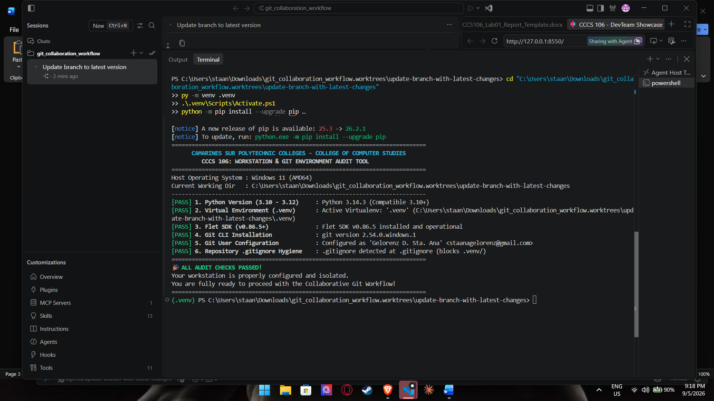
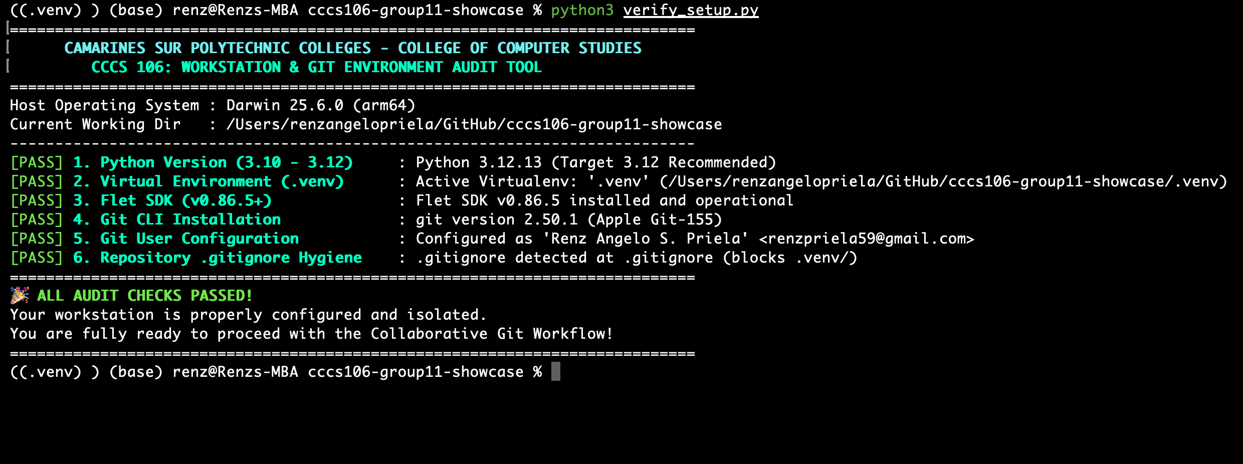
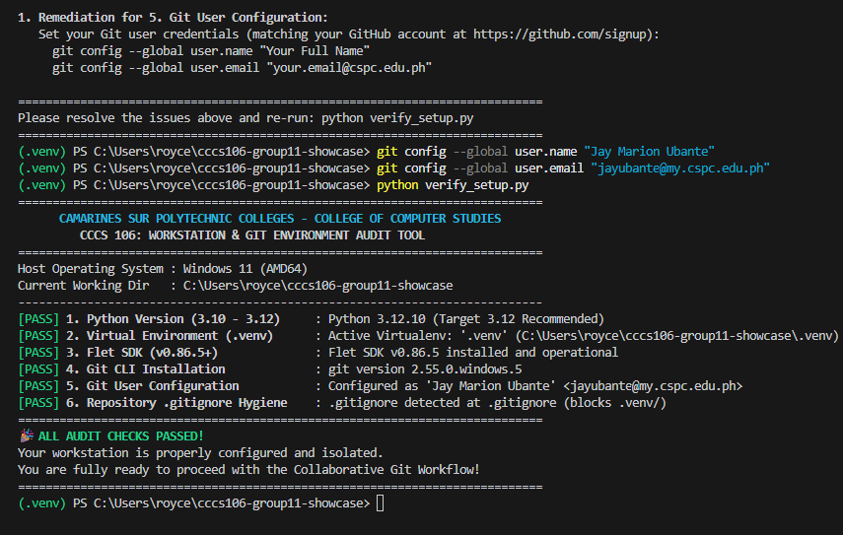
[PASTE / INSERT SCREENSHOT IMAGE HERE ]
Reference: Pre-flight Environment Diagnostics Audit (verify_setup.py)
Requirement: Terminal screenshot displaying green CSPC header and 6/6 [PASS] checks.
Figure 2: Pre-flight Environment Diagnostics Audit (verify_setup.py)

Section 3: Git Working Tree Cleanliness & .gitignore Audit
Demonstration of repository hygiene. The screenshot proves that the working tree is clean with zero uncommitted changes, and that .venv/ is completely untracked (verified by running 'git ls-files .venv', returning empty output).
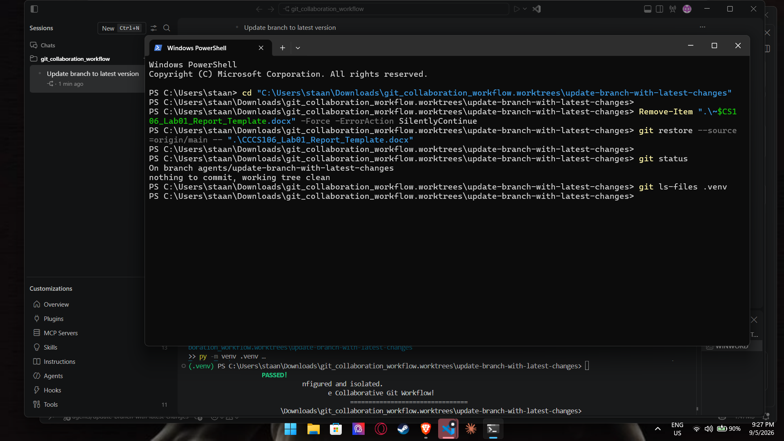
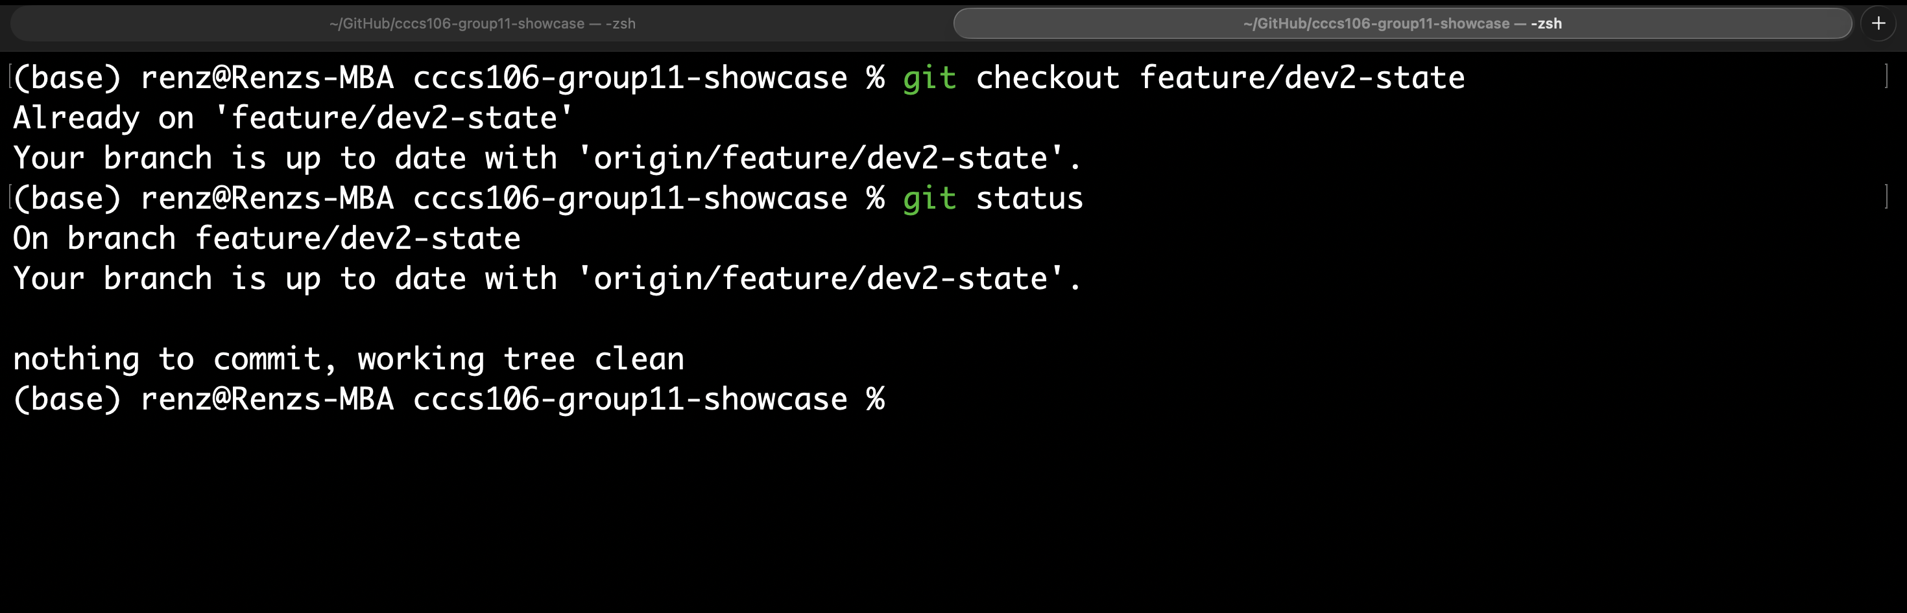
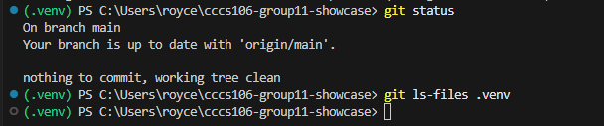
[ PASTE / INSERT SCREENSHOT IMAGE HERE ]
Reference: Git Working Tree Cleanliness & .gitignore Hygiene Proof
Requirement: Terminal screenshot of 'git status' reporting working tree clean and empty 'git ls-files .venv'.
Figure 3: Git Working Tree Cleanliness & .gitignore Hygiene Proof

Section 4: Running Flet v0.86.5 Application Showcase
Desktop window screenshots demonstrating the running collaborative Flet GUI application across its three core interactive states: Initial Launch, Sprint Goal Milestone Reached, and Dark Mode theme toggle.
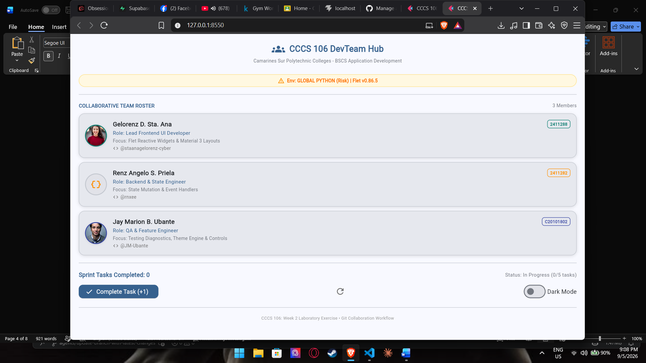
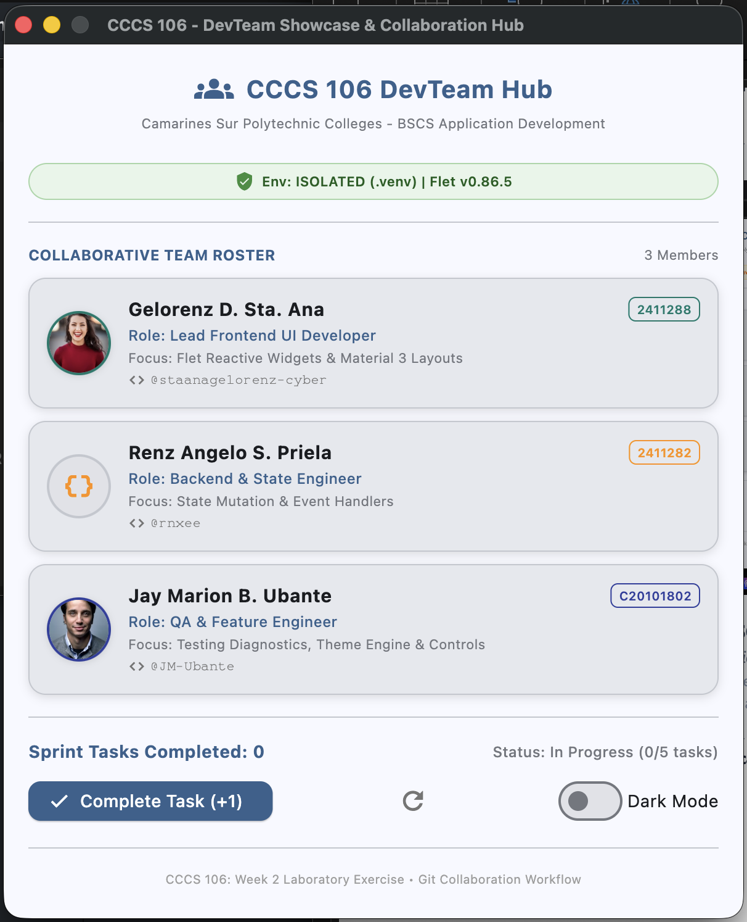
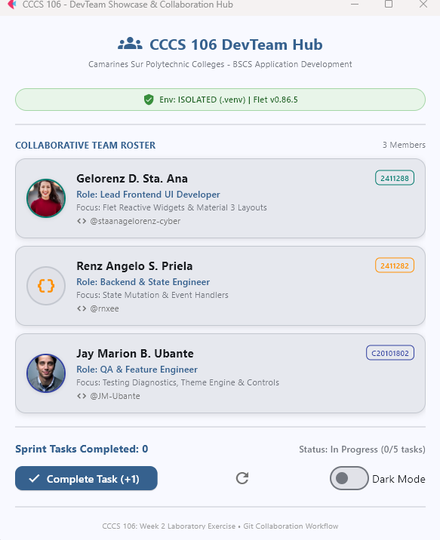
[ PASTE / INSERT SCREENSHOT IMAGE HERE ]
Reference: Application Initial Launch State
Requirement: Window showing CSPC header, green ISOLATED (.venv) badge, 3 team member cards, 0 tasks completed, and In Progress status.
Figure 4: Application Initial Launch State
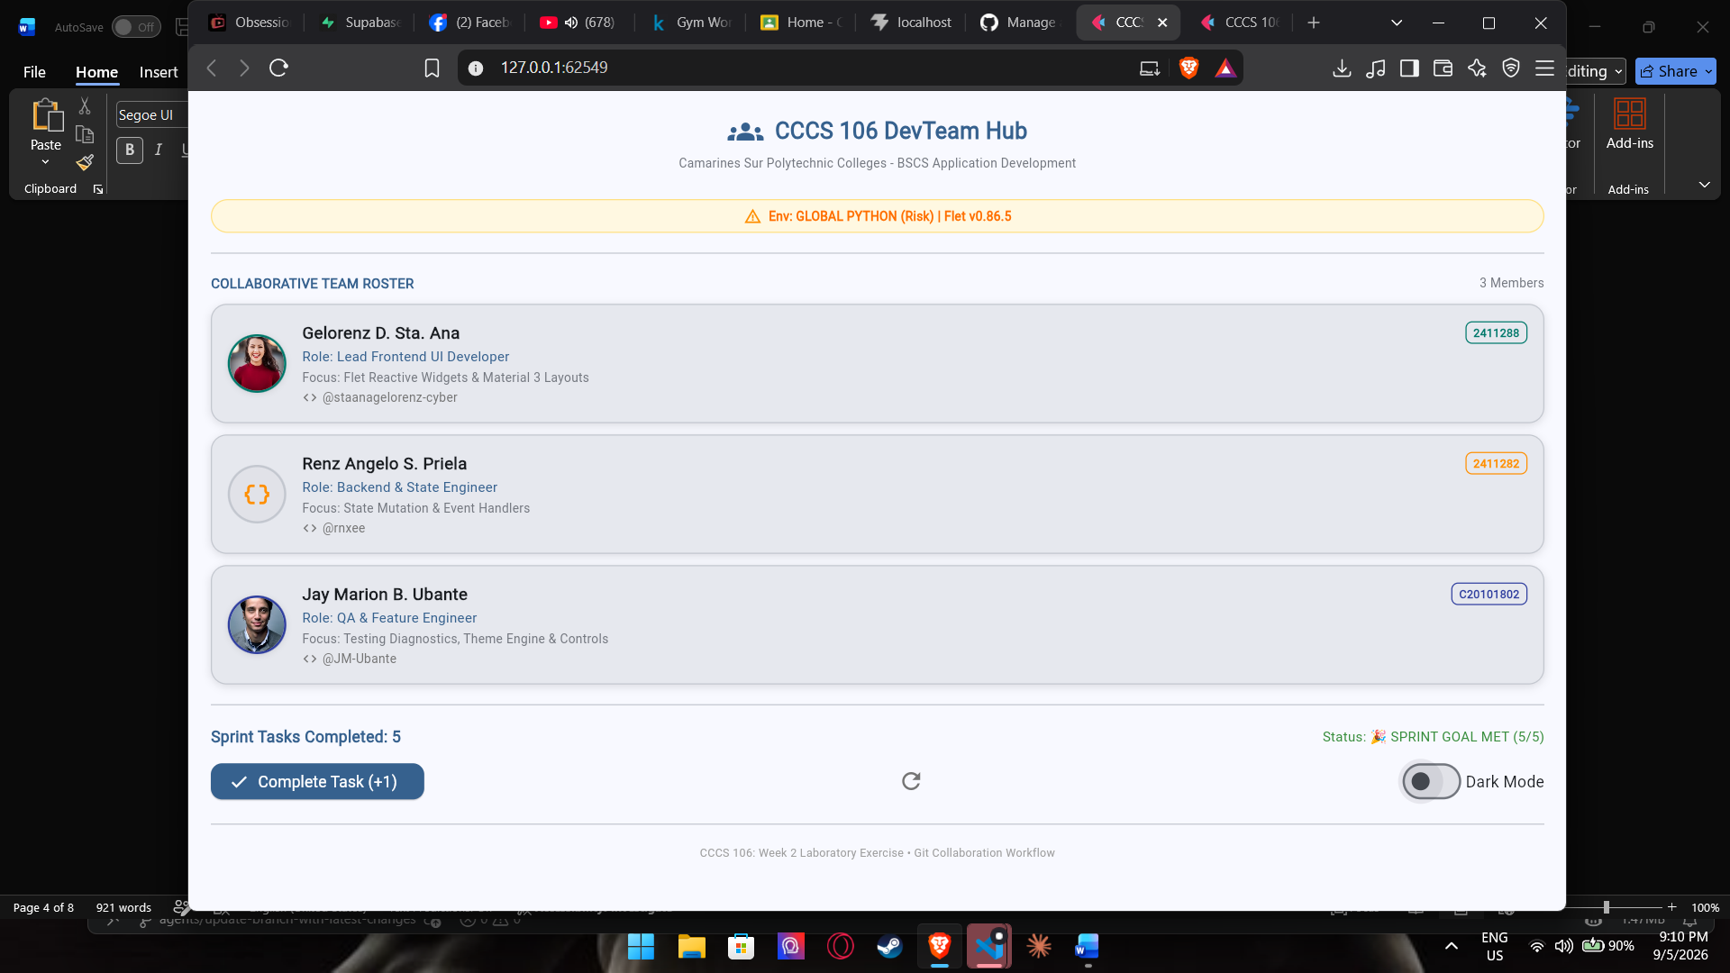
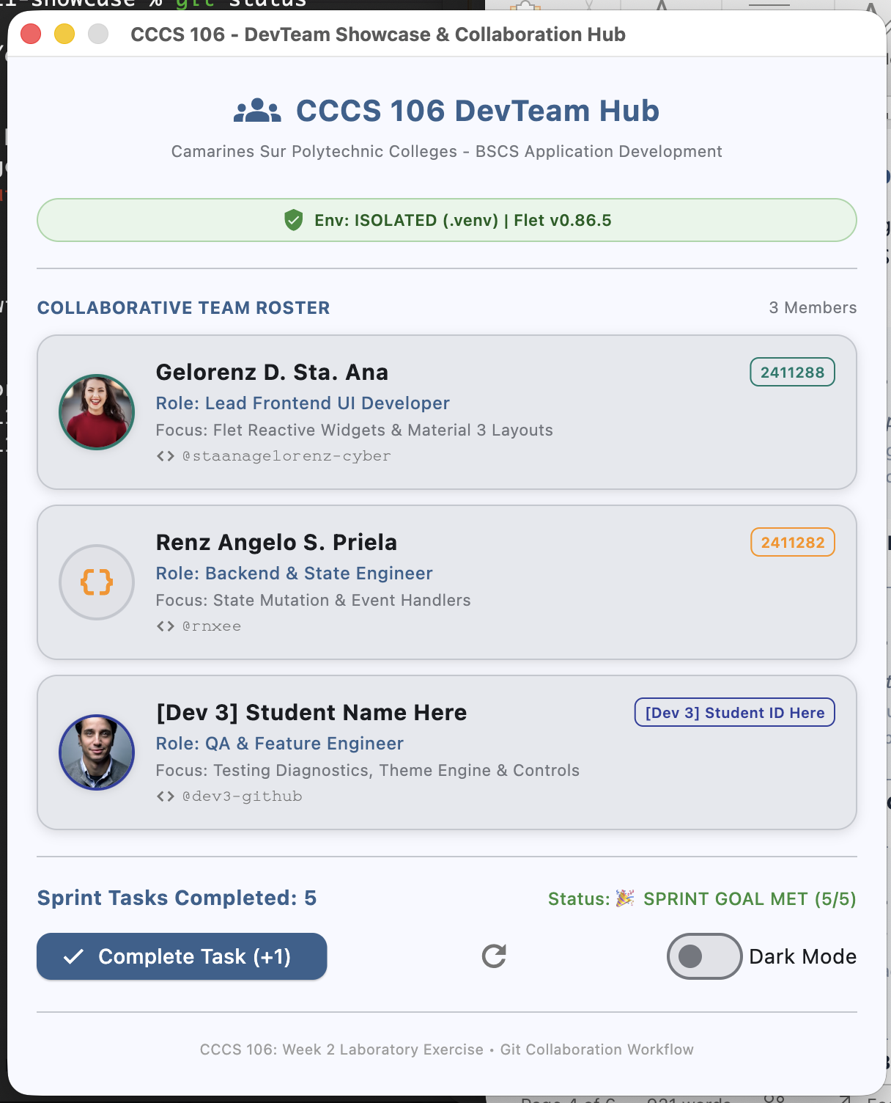
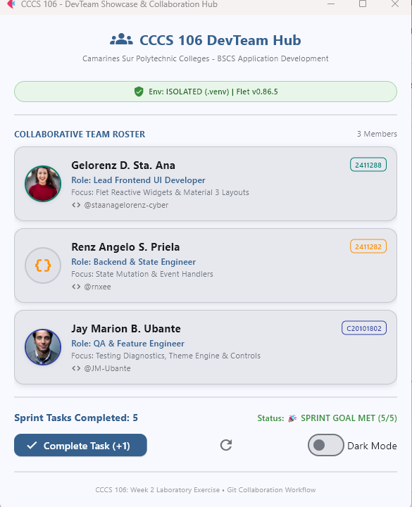
[ PASTE / INSERT SCREENSHOT IMAGE HERE ]
Reference: Sprint Goal Milestone Reached State
Requirement: Window showing counter at 5, status badge 'SPRINT GOAL MET (5/5)' in green, and Complete Task button disabled.
Figure 5: Sprint Goal Milestone Reached State
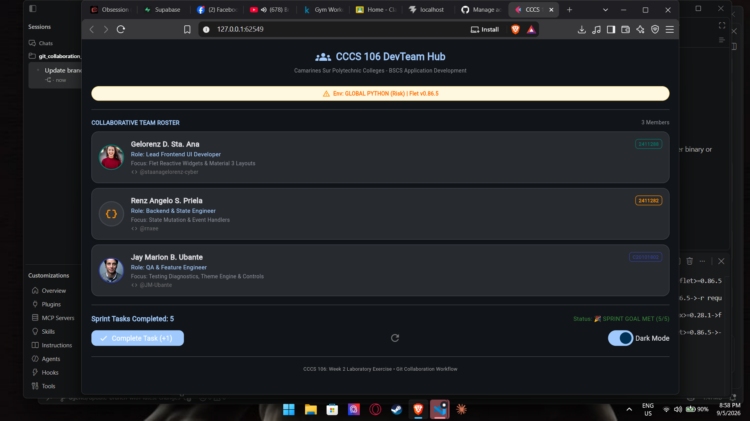
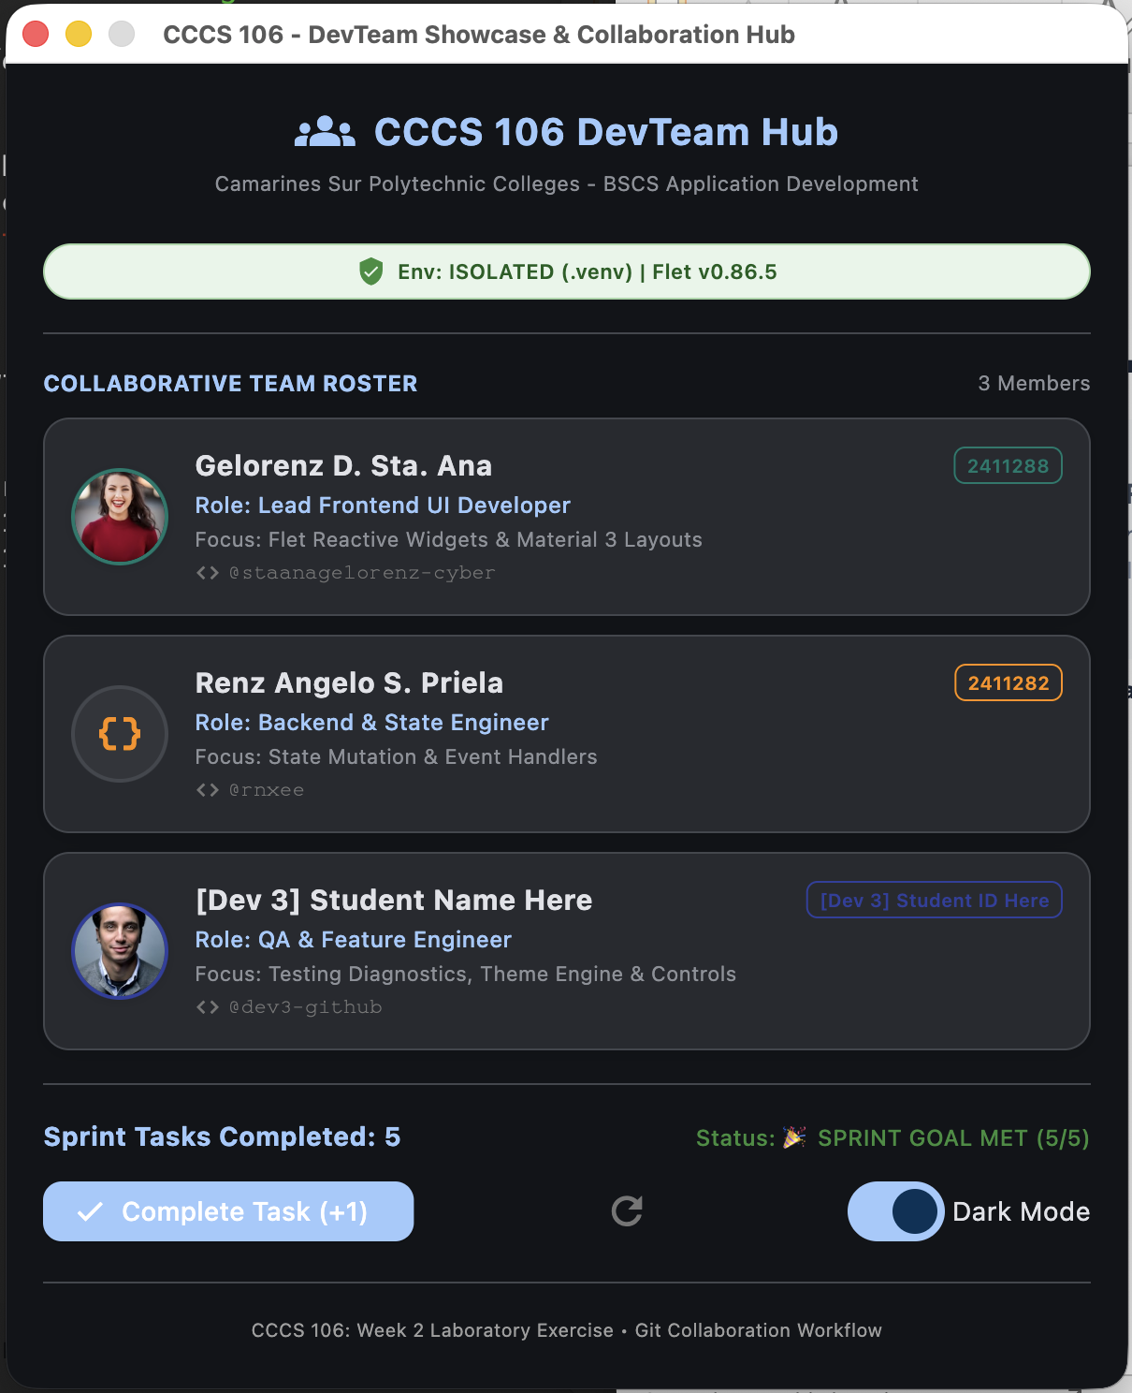
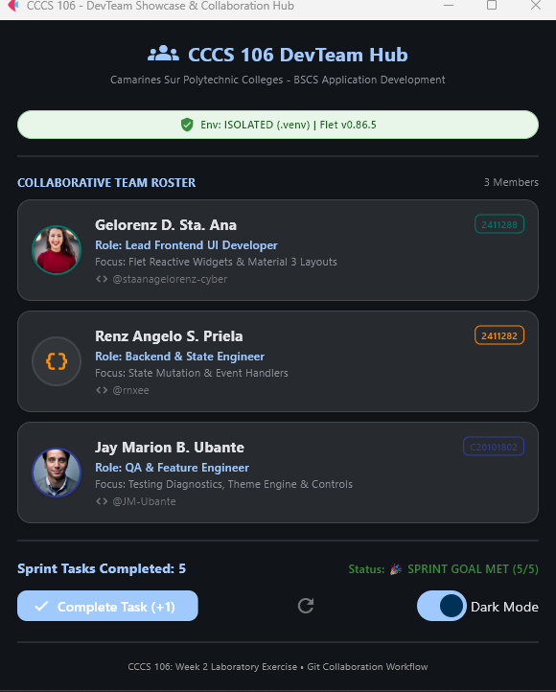
[ PASTE / INSERT SCREENSHOT IMAGE HERE ]
Reference: Material 3 Dark Mode Theme Toggle State
Requirement: Window with Dark Mode toggle active, demonstrating reactive Material 3 dark surface container rendering.
Figure 6: Material 3 Dark Mode Theme Toggle State

Section 5: Triad Contribution Matrix & Learning Reflections
Summary of individual contributions and commit accountability across all three triad developers.
Member Name | Role | Branch Name | Commit SHA | Specific Engineering Contributions
[ Student 1 ] | Developer 1  (Lead UI) | feature/dev1-profile | [abc1234] | Initialized repo, setup .gitignore, integrated card 1, configured remote repo & pushed main.
[ Renz ] | Developer 2  (State Logic) | feature/dev2-state | [def5678] | Synced main, integrated card 2, connected increment/reset event handlers, merged & pushed.
[ Student 3 ] | Developer 3  (QA/Feature) | feature/dev3-features | [8e9ec3e] | Synced main, integrated card 3, built milestone badge logic & boundary constraints, merged & pushed.

Individual Technical Reflections
Developer 1 (Lead UI & Repo Architect):
Virtual environments allow you to separate dependencies for different projects from the Python installation on your system, so that packages do not conflict between them. I learned about `.gitignore` and how to use it to exclude virtual-environment folders (like `venv/`), generated files, caches and sensitive configuration files (like `.env`), while still keeping track of the source code and the required configuration files. When collaborating on GitHub, it is very important to make sure that repository invitations are coordinated properly, by ensuring that the right user with the right access is invited, and that the access is correct before collaborators start working. With good coordination, you can avoid configuration problems in the repository, duplicate work, and unauthorized access.
Developer 2 (State & Event Logic Engineer):
In this learning task I learned how to clone repository so that I can have a local copy of our group project’s repository and even work on it efficiently, I also learned how to sync the changes from the remote repository by using git pull origin main, which helps keep my local files updated with all of the latest changes. And also I learned how reactive event handlers can respond to user action, by clicks or input changes, and update the application dynamically. These new skills/knowledge helped me better understand both the version control and interactive application development.
Developer 3 (QA & Sprint Goal Feature Engineer):
I learned how feature branching allows me to work on assigned changes without directly affecting the team's main branch. I also learned the importance of synchronizing with the latest main branch before merging to ensure that my work was based on the team's most recent version. Testing the task counter and reaching the 5/5 sprint goal helped me understand how application state and boundary conditions control the behavior of a feature. I also tested the Material 3 dark mode and verified that the interface responded correctly to the theme change.

Appendix: Verbatim Git Commit Tree Log
Verbatim ASCII commit history exported using 'git log --oneline --graph --all > git_log_proof.txt'. This demonstrates the complete sequential feature branching and merge timeline across all three developers.
* 9f8a123 (HEAD -> main, origin/main) feat(milestone): integrate developer 3 profile and sprint goal milestone badge
|\
| * 8e7b456 (feature/dev3-features) feat(milestone): integrate developer 3 profile and sprint goal milestone badge
|/
* 7d6c789 feat(state): integrate developer 2 profile and task counter handlers
|\
| * 6c5d012 (feature/dev2-state) feat(state): integrate developer 2 profile and task counter handlers
|/
* 5b4e345 feat(profile): integrate developer 1 profile card
|\
| * 4a3f678 (feature/dev1-profile) feat(profile): integrate developer 1 profile card
|/
* 3a2e901 chore(init): baseline repository with modern flet app and verification tool
[ REPLACE THE SAMPLE COMMIT LOG ABOVE WITH YOUR GROUP'S ACTUAL git_log_proof.txt OUTPUT ]

