SC

Service Connector

Configuration and Operation Guide

SC_4_Operation_E (Version V1.0)
This document describes topics related to the SC configuration, operation and troubleshooting.

This document is a spiritual ownership of STABILIT Informatik AG, and must not be used or copied without a written allowance of this company. Unauthorized usage is illegal in terms of Chapter 23 / 5 UWG / Swiss law.

The information in this document is subject to change without notice and should not be construed as a commitment by STABILIT Informatik AG.

Copyright © 2026 by STABILIT Informatik AG
All rights reserved.

All other logos, product names are trademarks of their respective owners.

Licensed under the Apache License, Version 2.0 (the "License"); you may not use this file except in compliance with the License. You may obtain a copy of the License at

http://www.apache.org/licenses/LICENSE-2.0

Unless required by applicable law or agreed to in writing, software distributed under the License is distributed on an "AS IS" BASIS, WITHOUT WARRANTIES OR CONDITIONS OF ANY KIND, either express or implied.
See the License for the specific language governing permissions and limitations under the License.

This Document has been created with Microsoft Word 2003 (11) with template file and printed at 01 July 2010 12:02.

Identification
Project: | SC
Title: | Service Connector
Subtitle: | Configuration and Operation Guide
Version: | V1.0
Reference: | SC_4_Operation_E
Classification: | Public
Keywords: | Configuration, Operation, Troubleshooting
Comment: | This document describes topics related to the SC configuration, operation and troubleshooting.
Author(s): | STABILIT Informatik AG  Jan Trnka, Daniel Schmutz, Joel Traber
Approval (Reviewed by): | Signature Jan Trnka  Signature Francisco Gonzalez  Signature Walter Mörgeli
Audience: | Project team, Eurex development team
Distribution: | Public
Filename | /tmp/lo/0000.doc
Revision History
Date | Version | Author | Description
11.02.2011 | V1.0 | Jan Trnka | Initial version

Table of Contents
1 Preface 4
1.1 Purpose & Scope of this Document 4
1.2 Definitions & Abbreviations 4
1.3 External References 5
1.4 Typographical Conventions 5
1.5 Outstanding Issues 5
2 Concepts 6
2.1 Session Service 6
2.2 Publishing Service 6
2.3 File Service 7
2.4 HTTP Redirection Service 7
2.5 SC Cascading 7
2.6 Message Caching 8
2.7 Message Fan-Out 8
2.8 Console 8
2.9 Web GUI 8
2.10 Restrictions 8
2.10.1 Load balancing 8
2.10.2 Failover 8
2.10.3 Security 9
2.10.4 Virus and Intrusion Protection 9
3 Network 10
3.1 Connection Topology 10
4 Installation, Update, Removal 12
4.1 Installation 12
4.2 Update 12
4.3 Removal 12
5 Configuration 13
6 Operations 14
6.1 Starting SC 14
6.2 Stopping SC 14
6.3 Other console operations 14
6.4 Monitoring SC with the Web GUI 15
6.5 Monitoring SC with the J-Console or Jvisualvm 15
7 Troubleshooting 16
8 Glossary 18
Appendix 20
Index 21

Tables
Table 1 Abbreviations & Definitions 4
Table 2 External references 5
Table 3 Typographical conventions 5

Figures
Figure 1 Example of a connection (simplified) 10
Figure 2 Example of a cascaded connection (simplified) 10
Figure 3 Connection Topology 11

Preface

Purpose & Scope of this Document
This document describes issues related to the configuration, operation and troubleshooting of the Service Connector. Good understanding of network communication and the Service Connector concepts is prerequisite to this reading.

The SC message protocol is described in [1].

This document is particularly important to the operation & support staff..

Definitions & Abbreviations
Item / Term | Definition / Description
DMZ | Demilitarized Zone (Network segment between two firewalls)
DNS | Domain Name Server
DOS | Denial Of Service
GUI | Graphical User Interface
HTML | Hypertext Mark-up Language
HTTP | Hypertext Transport Protocol
HTTPS | HTTP over SSL, encrypted and authenticated transport protocol
IE | Internet Explorer – Microsoft Web Browser
J2EE | Java 2 Platform Enterprise Edition
Java | Programming language and run-time environment from SUN
JDK | Java Development Kit
Linux | Unix-like operating system, open source
Log4j | Standard logging tool used in Java
OpenVMS | HP Operating system, existing platform for ERM
OSI | Open System Interconnection reference model  http://en.wikipedia.org/wiki/OSI_model
RPC | Remote Procedure Call
SCMP | SC Message Protocol
SOA | Service Oriented Architecture
SOAP | Simple Object Access Protocol
SSL | Secure Socket Layer – secure communication protocol with encryption and authentication
SC | Service Connector
TCP/IP | Transmission Control Protocol / Internet Protocol
URL | Uniform Resource Locator
Web Service | software designed to support interoperable machine-to-machine interaction over a network
Web-GUI | Graphical User Interface running in Web-Browser built with Web components. Also called Thin-Client.
Windows | Microsoft operating system family
XML | Extensible Mark-up Language
XSD | XML Schema Definition
XSLT | Extensible Style Sheet Language Transformation
Table 1 Abbreviations & Definitions

External References
References | Item / Reference to other Document
[1] | SC_1_SCMP-V1.0_E
Table 2 External references

Typographical Conventions
Convention | Meaning
text in italics | USP feature or functionality or USP related comments
text in Courier font | code example
[ phrase ] | In syntax diagrams, indicates that the enclosed values are optional
{ phrase1 | phrase2 } | In syntax diagrams, indicates that multiple possibilities exist.
… | In syntax diagrams, indicates a repetition of the previous expression

Table 3 Typographical conventions

The terminology used in this document may be somewhat different to other sources. The chapter Glossary includes a list of often used terms with the explanation of their meaning in this document.

Outstanding Issues
Following issues are outstanding at the time of the document release:

Concepts
Service Connector is a message oriented middleware connecting applications providing services to other applications consuming the services. It fits into an overall service oriented architecture.

Service Connector supports following service types

Session Service
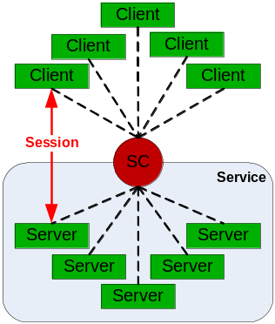Session service allows statefull message exchange between requesting client application and server application implementing the service. All actions are initiated by the client. When the client starts the session, SC allocates a server instance for this session. The server must be ready at this time. Multiple server instances serving the same service can be pre-started. Serving multiple sessions or multiple services within one server instance is possible only for multisession servers.

Clients and servers are not connected directly to each other. The client and the server are only the logical communication end-points. The SC acts like a message broker and is never a direct executor of the service. Clients and servers may be distributed across any number of nodes in the network.

All services are independent on each other. The server application may request another service and so play the client role.

Publishing Service
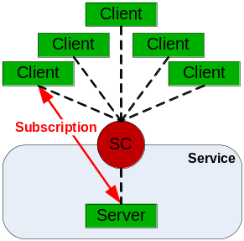Publishing service allows a server to send messages to many clients. In order to receive a published message, the client must subscribe to a service. The subscription mask allows fine granular definition of the client interest.

The application server which implements the service designates the contents of each message with a message mask and sends it to SC. When the message mask matches the client subscription mask, SC will deliver the message to the client. Multiple clients may subscribe for the same service at the same time and may get the same message. The publishing server does not know which client did will receive its messages and when. Sequence order of the published messages is preserved by SC.

Multiple server instances may publish their messages to the same service. (Not allowed when large messages are published!) Clients and servers may be distributed across any number of nodes in the network.

File Service
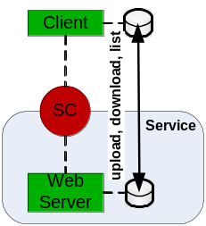File service allows file exchange between client application and a web server. All actions are initiated by the client. The client can upload to a service or download file from a service or get a list of files in this service. The web server must define one flat directory for each service. Sub-directory structure is not supported. The same directory may be used by different services.

All services are independent on each other. Clients and web servers may be distributed across any number of nodes in the network.

PHP is required on the Web Server in order to support file services. The provided PHP upload script may be adapted e.g. for sending notification mail after file upload.

HTTP Redirection Service
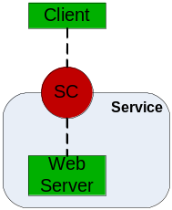SC HTTP redirection service allows redirection of http traffic through the SC infrastructure to a designated target URL (web server). This is possible without a session or subscription context. It can be used by any application also by a browser. SC receives the http requests on a dedicated port and passes it to the configured server. It does not work like a HTTP proxy.

Clients and targets (web servers) may be distributed across any number of nodes in the network. The requested target URL must be resolved (by DNS or other means) by the underlying network infrastructure. SC does not provide any name resolution.

Multiple http redirection services may be defined to different targets, each one listening on a different TCP/IP port.

SC Cascading
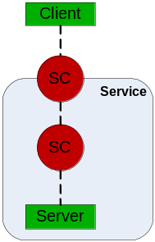Multiple SCs may be running in a network. The service may be defined as cascaded. This means that the message traffic for such service is redirected to another SC.
All SC services can be cascaded. Cascading is fully transparent to the client. Clients can use services at any cascaded level. Servers are allowed on the bottom level only.

Major benefits of cascading are:
- Improved security by using cascaded SC in a DMZ as a single access point for all local clients.
- Reduced communication costs by sharing infrastructure (VPN tunnel) by multiple clients
- Much lower outbound network traffic by utilizing message fan-out.
- Improved performance by utilizing SC cache near to the clients.
- Routing of services into other network segments.

Message Caching
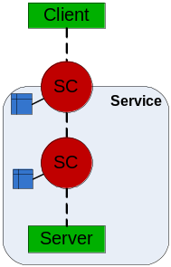For session services SC implements caching of message sent from servers to clients. The cached message is available to all clients sending a request for it. Each service has its own cache and each message has an absolute expiration date and time. The cache is loaded by the first client requesting the messages. All subsequent clients will get the message from the cache, bypassing the server processing.

The definition which messages should be cached, how they are identified and how long they are valid is matter of agreement between the communicating parties.

SC caching can be enabled or disabled per SC instance. In cascaded configurations caching is supported on cascaded session service. This allows to put the cache near to the consumer.

Message Fan-Out
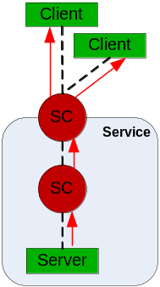For publishing services SC implements message fan-out in cascaded configurations. Message published by a server is distributed to the clients on the most upper cascade level. Between the SC nodes the message is transported only once. This allows efficient distribution of a message to large number of clients within a very short time.

The efficient usage of the fan-out is dependent on the design and structure of the subscription mask. It must contain items reflecting the cascade hierarchy.

Console
Console is an executable jar-file, which allows sending of simple management commands to SC. It may be used in scripts embedded into other management tools.

Web GUI
Web-GUI is a simple monitoring instrument showing the current SC activity. It can be disabled in the configuration.

Restrictions

Load balancing
The SC does not provide any load balancing features. Established communication session will not be redirected to another server node during its life time.

Failover
The SC does not provide any failover features. Aborted communication must be re-established by the communicating partners. The client application must find out a service which is ready.

Security
The SC does not implement any security feature. The environment where SC is used must provide all required authentication, authorization, encryption, tunneling etc. features. Message transport over https is not supported.

The IP address of the all nodes on the network path between the client and the server is available to the server when client starts a new session or the client subscribes. This can be used to authenticate and authorize the client when VPN tunnel is used.

Virus and Intrusion Protection
The entire network where SC is used is assumed to be safe and secure. No virus protection is embedded in SC. Screening firewall can be used on any segment of the network. It is recommended to use SC within a DMZ.

SC is not designed to withstand network attacks like DOS or SYNC flood, or any other.

Network
Clients and servers are not connected directly to each other. They are both connected to the SC. The Java API provided with SC and the communication between cascaded SCs uses a connection pools in order to save network resource.

Connection pool is established for each two communication end points. There is no fix allocation of a connection to a certain session or subscription within the pool. Each request may use a different connection. Connections are created on demand and closed when they are idle for longer time.

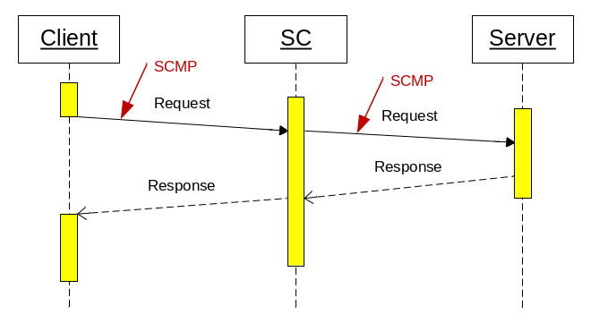
Figure 1 Example of a connection (simplified)

A cascaded SCs are connected hierarchically.
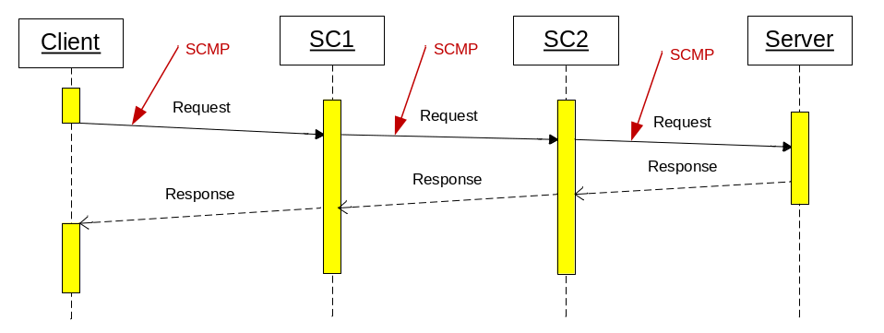
Figure 2 Example of a cascaded connection (simplified)

Connection pool can be configured to use TCP/IP or HTTP protocol. Using HTTP adds an extra overhead to SCMP but may be simpler to configure in foreign networks. SCMP over HTTP will pass a screening firewall placed between the end-points.

Sending of keep alive messages can be configured for each connection pool. This is required whenever a firewall is configured on this network segment.

Connection Topology

Tbd.

Client application, server application and the SC may reside on the same node or on separate nodes. The connection can either utilize HTTP protocol or direct TCP/IP communication. No assumption about the physical network

topology is done. Multiple firewalls can be located on the path between the communicating partners. The SC supports following connection topology:
- Client ⬄ SC ⬄ Server = Direct connection
- Client ⬄ SC ⬄ SC ⬄Server = Connection via cascaded SC.
Multiple SC may be placed on the path between the client and service.
Figure 3 Connection Topology

Different connection topology types from left to right:
- Client connected to one service
- Client connected simultaneously to SCs and two services
- Two clients connected to one service via proxy service and cascaded SC
- Two clients connected to three services via proxy service on different server nodes
- Complex configuration with three clients connected to three services on different server nodes via cascaded SCs and SC offloaded to its own node. One server can be registered to multiple services and different SCs. However this is possible for multisession servers only.

Installation, Update, Removal
SC is Open Source software under Apache License 2. It is available as a complete source code in the SVN repository http://www.stabilit.ch/svn/repos/sc and as a kit on http://www.stabilit.ch/download/sc/

The kit is available in two flavors:
Kit Structure
- sc-bin_V9.9-999.zip kit containing only binaries
- sc-src_V9.9-999.zip kit containing binaries and additional resources required for development

The structure of the kit is described in the readme.txt file included in both zip-files.

Installation
For pre-requisites and products required by the specific SC version please see the readme.txt file included in the kit. These are usually:
- Java 1.6.18 or later
- Apache 2.0 or later (on node running file services)
- PHP 4.0 or later (on node running file services)

The installation is done by extracting the kit file into a directory of your choice. After the installation a verification procedure described in readme.txt file included in both zip-files.

Update
If you made changes to the SC configuration, then preserve these files before upgrade. The upgrade is simply done by extracting the kit file into a directory of the previous installation.

If you install new SC version you may see get error message of type "Incompatible SC version nr." This may happen when you clients or server has a higher version (is newer) then the SC (is older). The opposite situation (SC version is higher than the client/ server) is valid and the software will run without change.
Version compatibility

For description of the compatibility issues please read SC_0_SCMP_E.PDF Chapter: SCMP header Attributes - scVersion.

Removal
You must stop SC before you want to remove the software.
If you made changes to the SC configuration you must find out where did you put the:
- log directory
- root.pidPath
- root.dumpPath
- cache.diskPath
and delete all these directories.

Then you can delete the directory where did you extract the SC kit file.

Configuration
The SC is configured by property files in the conf/ directory. These are:
- log4j-console.properties logging properties for sc-console
- log4j-demo-client.properties logging properties for demo-client
- log4j-demo-server.properties logging properties for demo-server
- log4j-sc.properties logging properties for sc
- sc.properties.properties sc configuration
- sc-specific.properties site specific sc configuration

Tbd.

Operations
This chapter describes the normal SC operations done by the operators.

Don't make changes to the scripts coming from the SC kit. Otherwise you will lose them after the next software update. It is recommended to wrap the scripts or to write your own scripts.

Starting SC
The Service connector is started with the script bin/start-sc.bat on Windows or start-sc.sh on unix / linux platforms.

It is possible to declare environment variables which are passes to SC where they can be used for configuration. The script shows an example how to do this. The property files in conf/ contain the description how to use the environment variables and java system properties inside the configuration files.

On Windows 32 and Windows 64 SC can be started as Windows service. The directories
bin/win32 and bin/win64 contain the necessary tools and guide.

On Unix platforms SC can be started as a deamon. The directories bin/unix contain the necessary tools and guide.

Stopping SC
The Service connector is stopped with the script bin/stop-sc.bat on Windows or stop-sc.sh on unix / linux platforms. The script invokes the sc-console which in turn sends a kill message to the SC.

Even if sc-console can connect to remote SC, stopping SC is possible only from the local node where SC is running.

Other console operations
The sc-console can be used to manage services and to get information about the SC. The syntax is:

java -jar sc-console.jar -h <host> -p <port> <<<enable|disable|state|sessions>?serviceName=[serviceName]>|
<inspectCache?serviceName=[serviceName]&cacheId=[cacheId]>|clearCache|dump|kill>

The possible commands are:

java -jar sc-console.jar -h localhost -p 7000 enable?serviceName=abc
java -jar sc-console.jar -h localhost -p 7000 disable?serviceName=abc
java -jar sc-console.jar -h localhost -p 7000 state?serviceName=abc
java -jar sc-console.jar -h localhost -p 7000 sessions?serviceName=abc
java -jar sc-console.jar -h localhost -p 7000 inspectCache?serviceName=abc&cacheId=700
java -jar sc-console.jar -h localhost -p 7000 clearCache
java -jar sc-console.jar -h localhost -p 7000 dump
java -jar sc-console.jar -h localhost -p 7000 kill

For serviceName value regular expression can be used. E.g
state?serviceName=.*
Will display state of all services.

Monitoring SC with the Web GUI
By default the mgmt-port is enabled and configured as port 81. Entering the URL http://localhost:81/ in your browser will connect you with the SC. The credentials are defined in the configuration file.

The description of the screens follows:

Tbd.

Monitoring SC with the J-Console or Jvisualvm
The script example/jconsole.bat and jvisualvm.bat show how to start jconsole or jvisualvm. When SC is running on your desktop, you can directly select the SC from the local process list. If SC is running on remote node you need to know the node, port of the node and will see SC in the remote process list.

The most interesting parameters are:
- Heap Memory Usage
- Number of Threads
- CPU usage
- VM Summary

With jconsole or jvisualvm it is also possible to set the log level of the running SC.

Troubleshooting

The most often situations:

SC does not start.
Start SC manually from the command line and see the displayed error.
If there is lot of output before SC crashes see the error in the log file.

If you encounter a problem, please work systematically through the following checklist:

- Connect to SC with the Web-GUI and check that it is responding. You can also use the console and get state of the services with state?serviceName=.* command.
- Look for ERRORs in sc.log

If you find suspicious log entries:
- Use the Web-GUI and create a dump
- Upload log files and the dump to the Web Server
- Send the zip-file to info@stabilit.ch or directly to the responsible person.

We understand the user frustration in a case of an error. However we need a precise description of the problem. In order to increase the chance to find and correct the error soon, please do:
Note:
- Keep cool, handle the case without emotions.
- Work systematically. Do not jump from one topic to other.
- Communicate precisely, use common terminology.
- Write down what you have done, later you will not remember the exact steps.
- Do not continue if not absolutely necessary. Other errors may subsequently happen.
- Do not repeat the case. It will be more difficult to read its trace.
- Save all material, logs, notes, screen shots in one place.

Glossary
Client
Piece of an application consuming services and initiating actions.
Server
Piece of an application providing services to clients.
Service
Abstract unit of work provided by the server and delivered to the client in order to implement a specific functionality. SC supports session, publishing and file services.
Session
Temporary allocation of a dedicated server to a client. Session ensures information flow between a client and the allocated server. SC supports request/response sessions and subscription sessions.
Call
A call represents a pair of a request and response.
Command
A command dispatches specific actions on a server according to the incoming request.
Request
Data structure created by the Client or SC in order to initiate an information exchange. It may contain one or more messages.
Response
Data structure created by the Server or SC in order to deliver the requested information. It may contain one or more messages.
Message
Basic transport instrument to exchange information between client, SC and the server. It belongs to a request or to a response.
Message Part
Message part is a piece of a large message. Large message is splittet into parts.
Composite
Data structure prepared to hold all message parts of a large message
Registry
Common list of known objects that ensures their uniqueness, organized in a way to find them easily.
Requester
Piece of code in SC or client initiating the information exchange
Responder
Piece of code in SC or server delivering the requested information

Connection
Network communication between client and SC or SC and the server
Endpoint
Network communication part on SC or server

Service
The term service is used as synonym for a piece of application code that implements a certain function.
Client
The term client designates the application requesting a certain service.
Client node
Client node is physical network node (machine) on which the client application resides.
Server
The term server designates the application providing a certain service.
Server node
Server node is physical network node (machine) on which the server application resides.
Message payload
Message payload is part of the transported message containing the application data. SC does not inspect, transform or interpret the payload. It is the responsibility of the communicating partners to define the format, syntax and semantic of the payload.
SCMP => SC Message Protocol
Is a publically presented protocol used for communication between client, SC and the server. In the OSI layer model, message transport protocol is immediately above the application protocol layer 7.
Message transport format
Format of messages transported messages between client, SC and the server. It consists of a header and a payload.
RR => Request / Response
This is basic communication style. The client requests an execution of a (remote) service and gets back the results in form of a response. The execution may be blocking - clients waits for the response, or non-blocking (asynchronous) – the clients does not wait for the response. Sometimes it is also called Remote Procedure Call = RPC.
SP => Subscribe / Publish
This is another popular communication style. The client tells the server what he is interested in and gets the data from the server later when a event arise. The execution is always non-blocking (asynchronous) – the client does not wait for the data receipt. This is because the event occurs on the server.

Appendix
Appendix text

M
Message
Body • 19
Payload • 19
R
RPC • 19

