SC_CC

Service Connector Cache Coherency

SC Cache Coherency Model

SC_CC-D1.0_E (Version D1.0)
This document describes the SC Cache Coherency Model.

Copyright © 2010 STABILIT Informatik AG, Switzerland

Licensed under the Apache License, Version 2.0 (the "License"); you may not use this file except in compliance with the License. You may obtain a copy of the License at

http://www.apache.org/licenses/LICENSE-2.0

Unless required by applicable law or agreed to in writing, software distributed under the License is distributed on an "AS IS" BASIS, WITHOUT WARRANTIES OR CONDITIONS OF ANY KIND, either express or implied.
See the License for the specific language governing permissions and limitations under the License.

All other logos, product names are trademarks of their respective owners.

This Document has been created with Microsoft Word 2003 (11) with template file and printed at 14 May 2012 14:40.

Identification
Project: | SC_CC
Title: | Service Connector Cache Coherency
Subtitle: | SC Cache Coherency Model
Version: | D1.0
Reference: | SC_CC-D1.0_E
Classification: | Public
Keywords: | Concept, Coherency Model
Comment: | This document describes the SC Cache Coherency Model.
Author(s): | STABILIT Informatik AG  Jan Trnka, Joël Traber
Approval (Reviewed by): | Signature Jan Trnka
Audience: | Project team, Review team
Distribution: | Public
Filename | /tmp/lo/0000.doc
Revision History
Date | Version | Author | Description
10.05.2012 | D1.0 | Joël Traber | Initial draft

Table of Contents
1 Preface 4
1.1 Purpose & Scope of this Document 4
1.2 Definitions & Abbreviations 4
1.3 External References 4
1.4 Typographical Conventions 4
1.5 Outstanding Issues 4
2 Introduction 5
2.1 Caching concept 5
2.2 Cache coherence problem 5
3 Cache Coherence Model 6
3.1 Cache Subscription Service 6
3.1.1 CacheId concept 7
3.1.2 Cache updatable SCMP Messages 7
3.1.3 Large SCMP Messages 7
3.1.4 Deletion of a cached message 7
3.1.5 Cache message update rules 8
3.1.6 Broken Cache Subscription Service on Client 8
3.1.7 Broken or inactive Cache Subscription Service on SC Proxy 8
3.1.8 Limitations 8
4 Cache Coherence - SC Client API 9
4.1 SC Client API and cache coherence 9
4.2 SC Client API – Loading of large messages 9
4.3 SC Client API – Deletion of cached Messages 9
5 Monitoring and Troubleshooting 10
5.1 Cache Coherence Logging 10
5.2 Cache Coherence Monitor 10
6 Configuration of Cache Subscription Service 11
6.1 Cache Subscription Service configuration 11
7 Best Practice of Cache Coherence Model 12
7.1 Analysis of cacheable data 12
7.2 Understanding the Topology effects 12
8 Glossary 13
Appendix 14
Index 15

Tables
Table 1 Abbreviations & Definitions 4
Table 2 External references 4
Table 3 Typographical conventions 4

Figures
Figure 1 Topology & Cache Concept of Service Connector 5
Figure 2 Cache Coherence Model 6
Figure 3 SC Caching – Concept of CacheId 7

Preface

Purpose & Scope of this Document
This document describes the SC-CC Service Connector Cache Coherency Model.

The final and approved version of this document serves as base for publication as Open Source.

This document is particularly important to all project team members and serves as communication medium between them.

Definitions & Abbreviations
Item / Term | Definition / Description
HTTP | Hypertext Transport Protocol
HTTPS | HTTP over SSL, encrypted and authenticated transport protocol
Table 1 Abbreviations & Definitions

External References
References | Item / Reference to other Document
[1] | SC_0_Specification_E – Requirement and Specifications for Service Connector
[2] | SC_0_SCMP_E – SC Message Protocol V1.2
[3] | SC_4_Operation_E – Configuration and Operation Guide
[4]
Table 2 External references

Typographical Conventions
Convention | Meaning
text in italics | features not implemented in the actual release
text in Courier font | code example
[ phrase ] | In syntax diagrams, indicates that the enclosed values are optional
{ phrase1 | phrase2 } | In syntax diagrams, indicates that multiple possibilities exists.
… | In syntax diagrams, indicates a repetition of the previous expression

Table 3 Typographical conventions

The terminology used in this document may be somewhat different from other sources. The chapter Glossary includes a list of often used terms with the explanation of their meaning in this document.

Outstanding Issues
Following issues are outstanding at the time of the document release:
- none

Introduction
The SC supports message exchange between requesting application (client) and another application providing a service (server). Caching of messages can be activated on every SC.

Cache coherency refers to the consistency of data stored in local caches of every SC node. The coherency protocol described in following sections addresses the problem of maintaining the consistency between all the caches in a system of distributed shared memory. Therefore a coherence model has been specified.

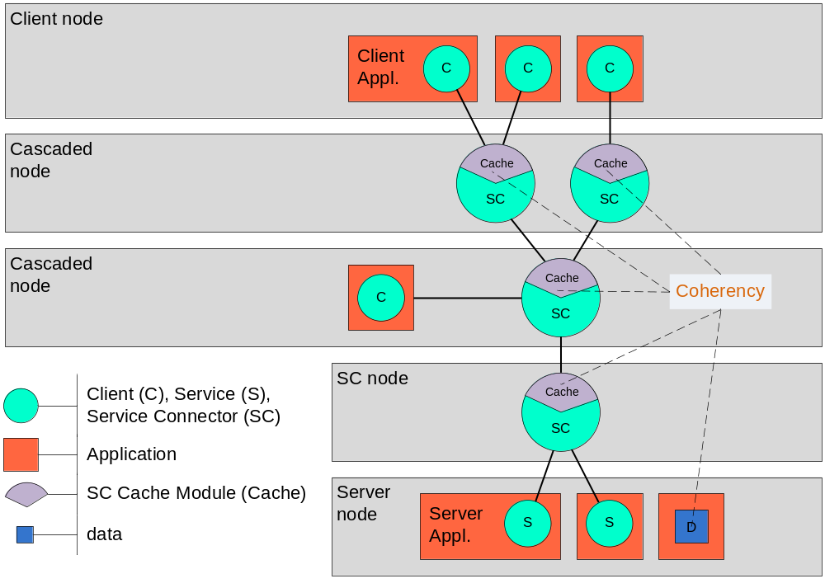
Figure 1 Topology & Cache Concept of Service Connector

Caching concept
Caching or not caching of a message (response) is an agreement of client and server. Once a message is stored in the cache there is no way to remove it. Only replacing is possible.
A cached message carries an “expire date time”. The cache module in SC is self maintaining and removes expired data itself. The expiration is given to the message by the responding server. Only the server can take this decision. Expiration of a cached message is driven by the semantic of the message content.

Cache coherence problem
The duration until expire date of a cached message describes its most common lifecycle which is the timeframe it is valid for clients.
Lots of messages don’t really have a known lifecycle or it is dependent on other client actions. Caching of this type of messages is only possible if we are having a model to keep data consistent. This simply means at the time cached data changes on server node, caches immediately need to get the new message content and stop satisfying request by handing out obsolete data. Main target of the concept is to keep time between “data change” and “cache update” as small as possible. The client’s actions shouldn’t base on obsolete data.
It is impossible to avoid the coherence problem completely. For a short time period it will always exist.

Cache Coherence Model
To assure cache consistency a service of type “CacheSubscriptionService” is supported by the SC. The main strategy of communication works like a publish service. Any changed data on a server node and known as cached content needs to be published to a “CacheSubscription” service. By using the fan out mechanism data update gets populated to the SCs. Updating the cache content is done inside the SC and works according to Cache replacing rules.

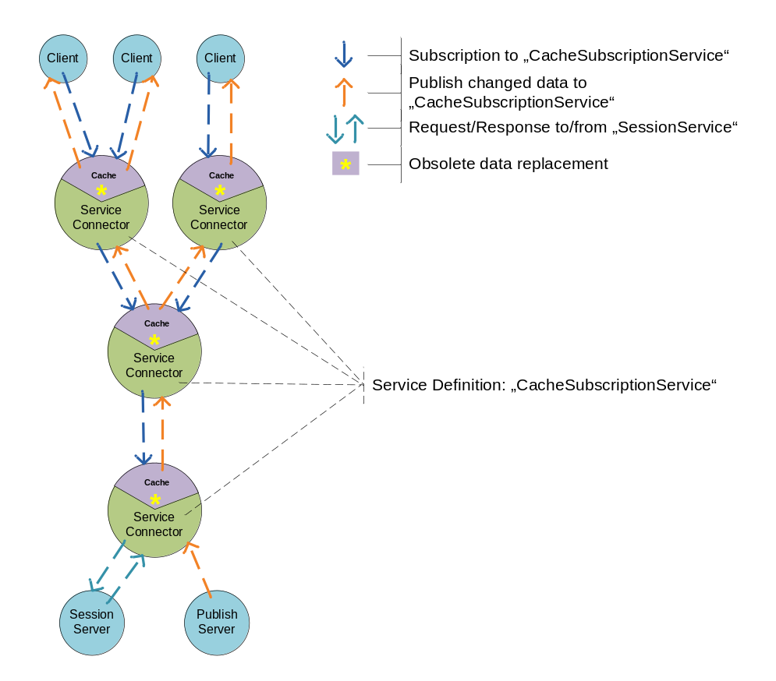
Figure 2 Cache Coherence Model

Cache Subscription Service
To get the service properly running it has to be defined on every SC. The SC Client API subscribes to the service. Any changed data published by the server will be populated up to the client.
Usually the SC Client API user sets the “cacheId” before calling execute. This indicates SC to satisfy request from cache if possible. If cache subscription service got activated by the user, inside an execution it state gets controlled. As long as service is running properly no interference is done. If for some reason (broken connection, connectivity problem) the consistency service gets broken then any “cacheId” will be removed and no request gets satisfied from the cache. A broken cache subscritpion service might cause an inconsistent cache.

CacheId concept
As mentioned earlier, caching or not caching of data is an agreement of client and server.
“serviceName” and “cacheId” identifies a message in the cache. Every cached message carries the identifiers as header attributes. The client assigns a “cacheId” to his request. This indicates the cache to get ready and watch out for the corresponding reply. The server responds the request. By adding the received “cacheId” to the reply message he makes the data cacheable. If the server disclaims returning the “cacheId” nothing gets cached.

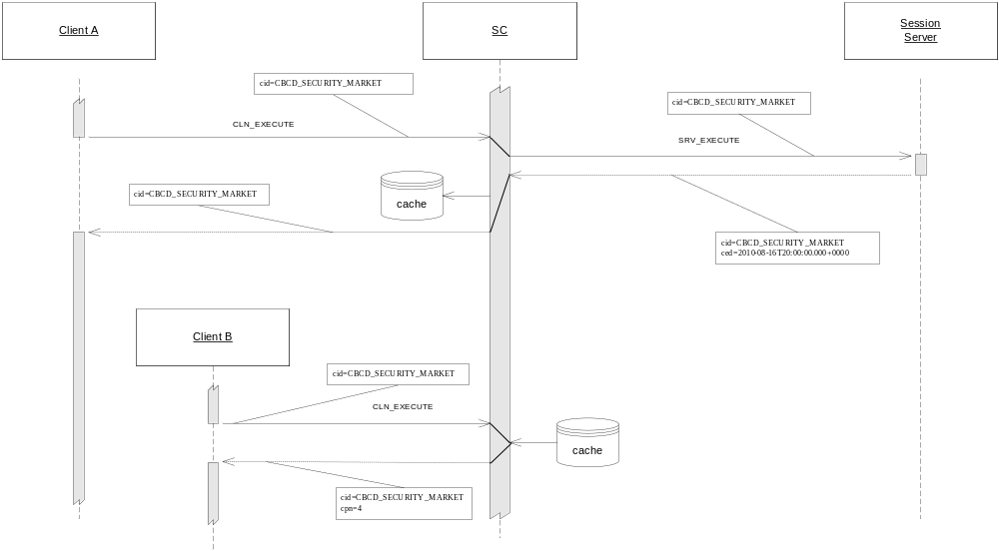
Figure 3 SC Caching – Concept of CacheId

For publishing changed data to the caches, the publish server has to know the identifiers “serviceName_cacheId” of the messages potentially being in the cache at this time. Replacement of obsolete data works according to Cache replacing rules.

Cache updatable SCMP Messages
As described in section Cache coherence problem cached messages do have a lifecycle. Some of them have a very well known lifecycle, some not at all. For a proper self maintaining mechanism the cache module in SC needs to know if a message might potentially be updated by a publish message. This type of messages is called updatable Message. An updatable message needs to carry the header attribute “cacheUpdatableMessage” beside to the “cacheId”. It’s the server’s responsibility and decision to assign “cacheUpdatableMessage” to a message or not.

Large SCMP Messages
For updating a large message in the cache the header attribute “bodyHash” must be set. The publishing server is responsible to set a hash code in every part message of the complete body. Two services might update the same large message in the same cache at the same time! So a part message can arrive two times or from different services. Knowing to body of the complete message allows the cache consuming the large message of several services.

Deletion of a cached message
Publishing a message with an already expired “expire date” causes a deletion of a cached message. Message will be published to the client any clear the caches on its paths. The SC Client API needs to recognize and inform the user about the deletion.

Cache message update rules
Updating obsolete data is based on the identifier “serviceName_cacheId”. At the time a “CacheSubscription” service receives a publish message, the SC looks up the message in cache. Below mentioned rules take place.

Cache updatable message is found
- Gets updated completely
- Even the expire date gets overwritten. If new expire date is in past whole message gets removed. That’s the way a deletion of cached message can be processed, see Deletion of a cached message.

Cache updatable message is found in loading (not complete yet) mode
- Loading actions aborts (partial data gets removed).
- Received message gets discarded after forwarding.
- The client needs to request data again.

No message with the given “cacheId” found in cache
- Nothing happens in cache.
- Received message gets discarded after forwarding.

Message is found without the “cacheUpdatableMessage” attribute set
- Existing message in cache gets updated completely.
- Current message in cache is modified to an updatable message.
- Received publish message will be discarded after forwarding.

Update of Large Messages
(Has to be done!) consuming large messages of two services.

Broken Cache Subscription Service on Client
Cache Subscription service might break on client because of connectivity problems between client and proxy. It’s up to the user how to handle the situation. As long as service stays broken no updatable messages are handed out by the cache (they are not cached anymore).

Broken or inactive Cache Subscription Service on SC Proxy
Cache Subscription service might break on SC proxy node. Cached data is not able to get updated and proxy may miss a publish message. To avoid running into coherence problem and handing out obsolete data every cache updatable message will be deleted. Non updatable messages stay in cache.

Cache Subscription service might be/get inactive on SC proxy node. This is case at the time clients are not or stopped (no more subscriptions) communicating over the proxy. The “broken service” procedure takes place as described above.

Limitations
To assure cache consistency it is necessary to publish large messages to the service. This feature is basically working. To run properly only one publish server is allowed to publish. Publishing is working with a queue. The data parts of a large message have to queue in sequence. This condition can’t be guaranteed if more than one server is publishing data to the same service.

For routing and for handling the failover problem it is allowed to define two cache subscriptions services in the property file of an SC instance. A cache might be updated by two services at the same time.

Cache Coherence - SC Client API
The SC Client API supports the proper use of the cache coherence model by the interface described in following section.

SC Client API and cache coherence
SCClient
In order to support cache coherence model SCClient introduces new methods. Method calls are synchronous and can be done after attaching SCClient successfully.

startCacheSubscription(String serviceName, int operationTimeoutSeconds, SCSubscribeMessage scSubscribeMessage, SCMessageCallback scMessageCallback, int receivePublicationTimeoutSeconds) throws SCServiceException, SCMPValidatorException

- serviceName: Identifies the CacheSubscriptionService
- operationTimeoutSeconds: Time until starting of CacheSubscriptionService aborts. (Operation timed out)
- scSubscribeMessage: Service subscribe message (see publish service for more details)
- scMessageCallback: Callback to receive cache updates.
- receivePublicationTimeoutSeconds: Time to wait for completion of a receive publication request.

It’s up to the SC Client API user to activate cache subscription service or not. There are updateable and non updatable messages in the cache. Having the cache managing updatable messages starting of the cache subscription service is necessary. If service is inactive only non updatable messages are provided by the cache.

Following method stops the cache subscription service in a shutdown scenario.

stopCacheSubscription()

SC Client API – Loading of large messages
Having an active cache subscription slightly changes loading of large messages. During the time a client loads a complete cached message a CACHE_LOADING exception can be thrown.

Given Scenario
Client reads a large message from cache. During this process the cache receives an update for exact this large message. Message state will be changed to loading. Cache stops satisfying requests on this “cacheId”. Client gets a CACHE_LOADING exception, needs to discard already loaded parts and to retry.

SC Client API – Deletion of cached Messages
(has to be done!)
SC Client API gets informed some way??... how? Special exception, special message
To be discussed with KEEL.
What about the expiration of a message. Has the cache to publish a message to the API??..Does user need to be informed of this event?

Monitoring and Troubleshooting
Base concepts of SC monitoring and troubleshooting are described in SC_4_Operation_E.pdf. Subsequent section covers monitoring and troubleshooting for the context of cache coherence.

Cache Coherence Logging
The cacheLogger is responsible for logging the events in context of caching.

Following events will be logged:
- New subscription on cache subscription service.
- New updatable message received.
- New part of updatable message received.
- Message part successfully updated.
- Large Messages completely updated.
- Message successfully updated.
- Message gets updated and deleted because of expired date.
- Message can’t be updated because no corresponding “cacheId” found.
- Message can’t be updated because corresponding message is in loading mode -> message deletion.
- Broken cache subscription service -> Updatable messages removed.
- No more subscriptions on cache subscription service -> Updatable messages removed.

Cache Coherence Monitor
WebUI has to show updatable messages, last update, and state of subscription service. Number of updated messages since ?. Number of Hits for specific messages. Number of loading messages because of published updates.

The cache form shows the state of the cache.
Cache
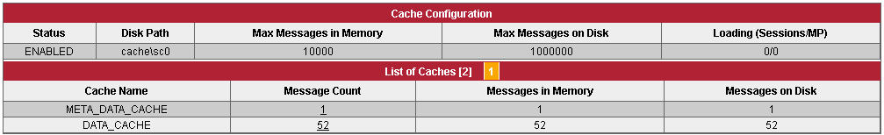

Configuration of Cache Subscription Service
The SC is configured with a single configuration file sc.properties. More details are described in the SC Operation Guide. Configuration of cache subscription service is also done in sc.properties.

Cache Subscription Service configuration
The configuration of a cache subscription service basically looks like a publish service definition. Only service type “cacheSubscription” differs and indicates SC to treat it different.

…...
sc1-cacheSubscription.type=cacheSubscription
sc1-cacheSubscription.enabled=true
sc1-cacheSubscription.remoteNode=sc1
sc1-cacheSubscription.noDataIntervalSeconds=10

sc2-cacheSubscription.type=cacheSubscription
sc2-cacheSubscription.enabled=true
sc2-cacheSubscription.remoteNode=sc2
sc2-cacheSubscription.noDataIntervalSeconds=10
…...

Best Practice of Cache Coherence Model

Analysis of cacheable data

Understanding the Topology effects
Keeping one client in RSC

Glossary
Cache Coherency
fgdfgdfg
Cache Consistency
dfgdfgdfg.

Cache Subscription Service

Appendix

C
Cache • 10

