SC

Service Connector

SC Message Protocol V1.0

SC_1_SCMP-V1.0_E (Version V2.3)
This document describes the SC Message Protocol V1.0 (SCMP).

This document is a spiritual ownership of STABILIT Informatik AG, and must not be used or copied without a written allowance of this company. Unauthorized usage is illegal in terms of Chapter 23 / 5 UWG / Swiss law.

The information in this document is subject to change without notice and should not be construed as a commitment by STABILIT Informatik AG.

Copyright © 2026 by STABILIT Informatik AG
All rights reserved.

All other logos, product names are trademarks of their respective owners.

This Document has been created with Microsoft Word 2003 (11) with template file and printed at 17 March 2010 08:54.

Identification
Project: | SC
Title: | Service Connector
Subtitle: | SC Message Protocol V1.0
Version: | V2.3
Reference: | SC_1_SCMP-V1.0_E
Classification: | Confidential
Keywords: | Concepts, Communication, Protocol
Comment: | This document describes the SC Message Protocol V1.0 (SCMP).
Author(s): | STABILIT Informatik AG  Jan Trnka, Daniel Schmutz, Joel Traber
Approval (Reviewed by): | Signature Jan Trnka  Signature Francisco Gonzalez
Audience: | Project team, Eurex IT management, Review team
Distribution: | Project team, SIX development team
Filename | /tmp/lo/0000.doc
Revision History
Date | Version | Author | Description
14.06.2009 | D1.0 | Jan Trnka | Initial draft
09.08.2009 | D1.1 | Jan Trnka | Separate specification and architecture documents. Fill information from Daniel into this document.
… | … | Jan Trnka | Many changes in between not tracked
24.2.2010 | V2.0 | Jan Trnka | Proposal for C-API
3.3.2010 | V2.1 | Jan Trnka | Remove SC architecture from this document
11.4.2010 | V2.2 | Jan Trnka | Prepare for review
14.4.2010 | V2.3 | Jan Trnka | Put API into its own document

Table of Contents
1 Preface 4
1.1 Purpose & Scope of this Document 4
1.2 Definitions & Abbreviations 4
1.3 External References 4
1.4 Typographical Conventions 4
1.5 Outstanding Issues 5
2 Communication Schema 6
2.1 Connection Topology 6
2.2 Network Security 7
3 Service Model 9
3.1 Session Services 9
3.2 Publishing Services 10
3.3 File Services 11
3.4 HTTP Redirection Services 11
4 Message Protocol 12
4.1 Headline 12
4.2 Header 13
4.3 Body 13
4.4 SCMP over TCP/IP 13
4.5 SCMP over HTTP 13
5 Semantic 14
5.1 Session Service 14
5.1.1 Asynchronous Message Exchange 16
5.1.2 Large Messages 16
5.2 Publishing Service 17
6 SCMP Messages 19
6.1 CONNECT 19
6.2 DISCONNECT 19
6.3 KEEPALIVE 19
6.4 CREATE_SESSION 20
6.5 DELETE_SESSION 20
6.6 CLN_DATA 21
6.7 SUBSCRIBE 21
6.8 UNSUBSCRIBE 22
6.9 CHANGE_SUBSCRIPTION 22
6.10 RECEIVE_PUBLICATION 22
6.11 REGISTER_SERVICE 23
6.12 DEREGISTER_SERVICE 24
6.13 ALLOCATE_SESSION 24
6.14 DEALLOCATE_SESSION 24
6.15 ABORT_SESSION 25
6.16 SRV_DATA 25
6.17 PUBLISH 25
7 SCMP Header Attributes 27
7.1 appErrorCode 27
7.2 appErrorText 27
7.3 bodyType 27
7.4 bodyLength 27
7.5 cacheSignature 28
7.6 cacheExpirationDateTime 28
7.7 compression 28
7.8 ipAddressList 28
7.9 portNr 29
7.10 keepAliveInterval 29
7.11 keepAliveTimeout 29
7.12 localDateTime 29
7.13 mask 29
7.14 maxSessions 30
7.15 messgageId 30
7.16 messgageInfo 30
7.17 msgType 31
7.18 multiThreaded 31
7.19 noData 31
7.20 rejectSession 31
7.21 scErrorCode 31
7.22 scErrorText 32
7.23 scVersion 32
7.24 sequenceNr 32
7.25 serviceName 33
7.26 sessionId 33
7.27 sessionInfo 33
8 Glossary 34
Appendix A 35
Index 36

Tables
Table 1 Abbreviations & Definitions 4
Table 2 External references 4
Table 3 Typographical conventions 5

Figures
Figure 1 Communication Layers 6
Figure 2 Connection Topology 7
Figure 3 Network Security 7
Figure 4 Synchronous Request/Response 9
Figure 5 Asynchronous Request/Response 10
Figure 6 Asynchronous Subscribe / Publish 10
Figure 7 Service Connector Message Protocol 12
Figure 8 Synchronous Message Exchange. 14
Figure 9 Asynchronous Session Service Message Exchange. 16
Figure 10 Synchronous Session Service Message Exchange for large Response. 16
Figure 11 Publishing Service 18

Preface

Purpose & Scope of this Document
This document describes the SCMP (SC Message Protocol).

The final and approved version of this document serves as base for the publication as open Source.

This document is particularly important to all project team members and serves as communication medium between them.

Definitions & Abbreviations
Item / Term | Definition / Description
HTTP | Hypertext Transport Protocol
HTTPS | HTTP over SSL, encrypted and authenticated transport protocol
Java | Programming language and run-time environment from SUN
JDK | Java Development Kit
Log4j | Standard logging tool used in Java
OpenVMS | HP Operating system, platform for ERM
RMI | Remote Method Invocation - RPC protocol used in Java
RPC | Remote Procedure Call
SOAP | Simple Object Access Protocol
SSL | Secure Socket Layer – secure communication protocol with encryption and authentication
TCP/IP | Transmission Control Protocol / Internet Protocol
SC | Service Connector
USP | Universal Service Processor – predecessor of SC
Table 1 Abbreviations & Definitions

External References
References | Item / Reference to other Document
[1] | SC_0_Specification_E – Requirement and Specifications for Service Connector
[2]
Table 2 External references

Typographical Conventions
Convention | Meaning
text in italics | features not implemented in the actual release
text in Courier font | code example
[ phrase ] | In syntax diagrams, indicates that the enclosed values are optional
{ phrase1 | phrase2 } | In syntax diagrams, indicates that multiple possibilities exists.
… | In syntax diagrams, indicates a repetition of the previous expression

Table 3 Typographical conventions

The terminology used in this document may be somewhat different from other sources. The chapter Glossary includes a list of often used terms with the explanation of their meaning in this document.

Outstanding Issues
Following issues are outstanding at the time of the document release:
- ?

Communication Schema
The SC implements peer-to-peer messaging above OSI layer-7 (application) network model between client and server applications. The SC is always in between the communicating partners, controlling the entire message flow.

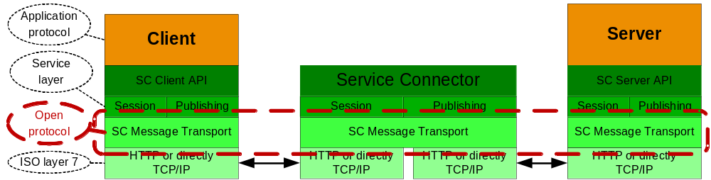
Figure 1 Communication Layers

The SC acts like a broker, passing messages between the client and the server. The communicating parties must agree on the application protocol i.e. format and content of the message payload.

Connection Topology
Client application, server application and the SC may reside on the same node or on separate nodes connected via TCP/IP network. No assumption about the physical network topology is be done. Multiple firewalls can be located on the path between the communicating partners.

The SC supports following connection topology:
- Client ⬄ SC ⬄ Server = Direct connection
- Client ⬄ SC-Proxy ⬄ SC ⬄Server = Connection via SC-Proxy.
Multiple SC-Proxies may be placed on the path between the client and service.
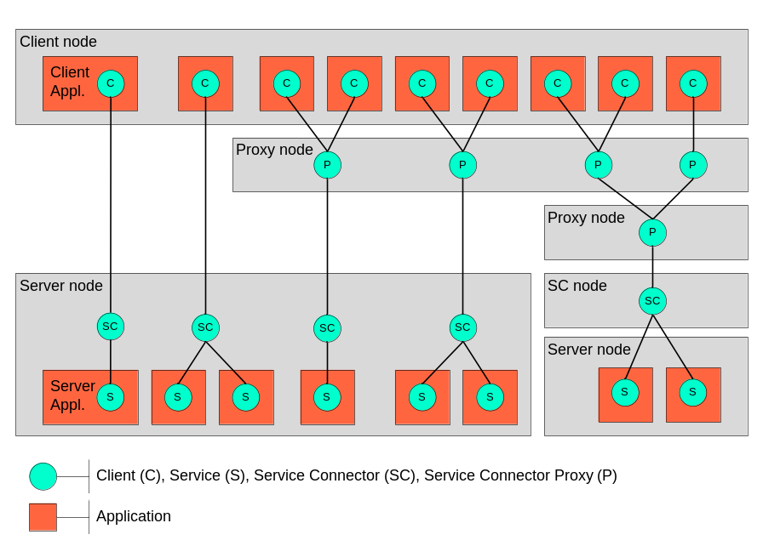
Figure 2 Connection Topology

Different connection topology types from left to right:
- Client connected to one services
- Client connected simultaneously to two services
- Two clients connected to one service via proxy
- Two clients connected to two services via proxy
- Three clients connected to two services via cascaded proxy on two separate nodes and SC offloaded to its own node.

The connection can either utilize HTTP protocol or direct TCP/IP communication.

SC Proxy is used for performance and/or for security reasons. It is transparent for the application and plays the role of the server and client at the same time.

Network Security
From the security viewpoint on the network, the number of clients or server is not relevant. Meaningful are connections between nodes and security measures taken to protect legal subjects to which the particular network segment belongs. The following schema shows some possible networks that may be configured to pass SC messages.
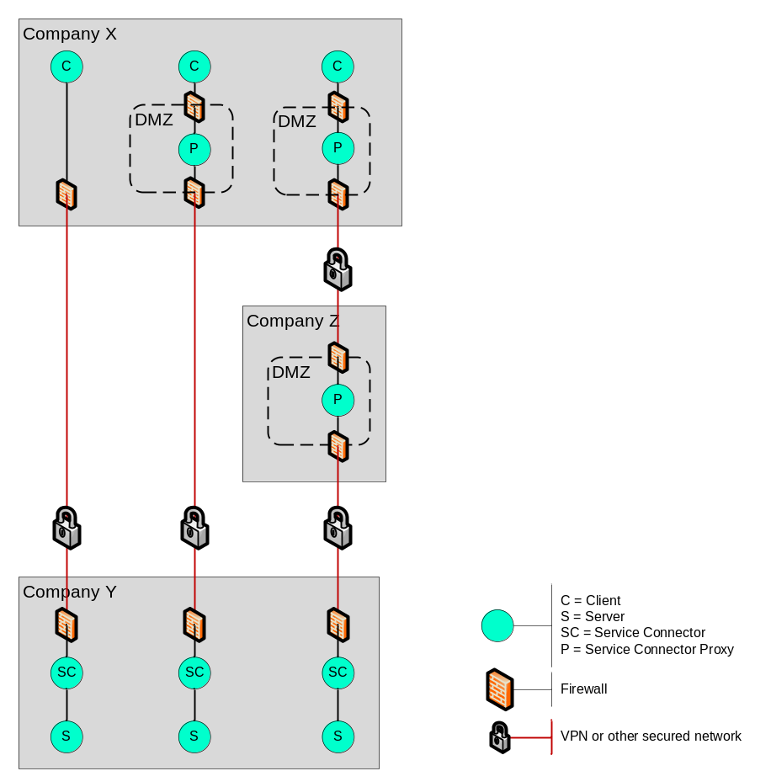
Figure 3 Network Security

The message transport between each of the SC components (green bullet) may be configured as plain TCP/IP or HTTP. The connection is always initiated by the client (top-down in the picture above). The client defines which transport (TCP/IP or HTTP) it will use. The transport protocol between Proxy and the next downstream component is configured in the SC configuration. TCP/IP is strongly recommended between SC proxy and the SC though VPN tunnels as well as between SC and the Server for performance reasons. HTTP is recommended between the client and SC proxy for SC. For connection between SC and Web Server or Application Server (Tomcat) only HTTP can be used.
Protocol

Firewall with a proper configuration may be placed on any path between two SC components. Firewall between SC and the server is possible, but not recommended for performance reasons. For HTTP protocol the firewall can be configured to perform statefull packet inspection with HTTP filtering. For TCP/IP the appropriate port must be configured in the firewall.
Firewall

When the message traffic will pass a firewall, HTTP protocol is recommended. In such case the SC can be seen as a regular Web-Server. The firewall can be configured to perform statefull packet inspection with HTTP filtering. For connection between SC and the server and for communications though VPN tunnels direct TCP/IP is recommended for performance reasons.

When HTTP connection is used and multiple parallel requests are in progress, SC will create multiple connections for each pending request in order to keep them balanced and so satisfy firewall inspection rules. (Statefull inspection rejects two subsequent GET/POST request without response from the server)

Each connection between two SC components is supervised by an algorithm using keepalive messages exchanged in regular (configurable) intervals. The sender monitors the arrival of the echoed message within a timeout; the receiver monitors the interval in which keepalive messages should arrive. These two methods allow independent detection of broken connections on both sites in case the communication will be interrupted without notice. E.g. firewall swallows the traffic. This is algorithm is essential for detection of broken sessions. Keepalive messages are very important to preserve the connection state in the firewall and reset their internal timeout. Only traffic to the outside may refresh the internal firewall timeout. That’s why keepalive message is always initiated by the client. Using of keepalive messages can be disabled.
Keepalive

Service Model
The SC supports message exchange between requesting application (client) and another application providing a service (server). The client and the server are the logical communication end-points. The SC never acts as a direct executor of a service.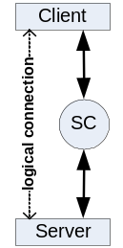 The client can to communicate to multiple services at the same time.

Server application can provide one or multiple service. Serving multiple services within one application is possible only for multithreaded or multisession servers. Multiple server applications are running on the same server node, each providing different service. All services are independent on each other. Server application may request another service and so play the client role.

Session Services
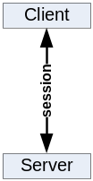Request/Response (client initiated communication). For session services the client and the server exchange messages in context of a logical session through the SC.

The client sends a request to a service that invokes an application code. Upon completion the service sends back a response message. The client waits for the arrival of the response message. The request and response message length is not limited in size.
Synchronous

The communication occurs in a scope of a logical session. SC will choose a free server and pass this and subsequent requests from this client to the same server. Session information is always passed as a part of the message header. The client may have only one outstanding request per session.
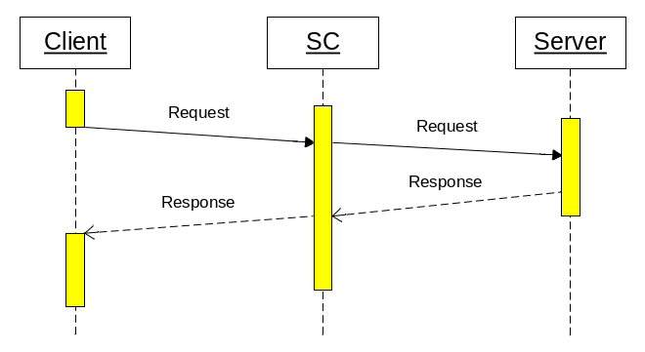
Figure 4 Synchronous Request/Response

Multiple clients may request the same service at the same time. The service execution is in parallel, each one in a separate thread or process. The server decides how many sessions it can serve.

This communication style is the most often used for getting data from the server or sending a message that triggers a transaction on the server.

Asynchronous execution is functionally equal to the synchronous case with the exception that the client does not wait for the arrival of the response message. The client must declare a notification method that is invoked when the response message arrives. The client may have only one outstanding request per session. When client issues a request before the previous one was completed, the send method blocks until the previous request is satisfied.
Asynchronous
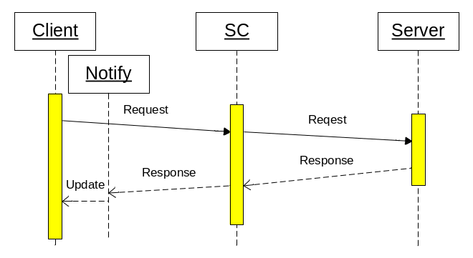
Figure 5 Asynchronous Request/Response

This communication style will be used to load data while other activities are in progress, e.g. to get large amount of static data at startup. It can be also used as fire-and-forget when the response is not meaningful.

Publishing Services
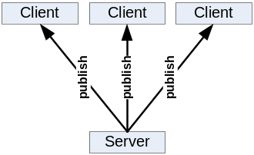Subscribe/Publish (server initiated communication). Publishing services allows the server to send single message to many clients through the SC.

The client sends a subscription mask to the service, and so declares its interest on certain type of a message. The application service providing the message contents must designate the message with a type. When the message type matches the client subscription mask, the message will be sent to the client. Multiple clients may subscribe for the same service at the same time. In such case multiple clients can get the same copy of the message. Message that does not match any client subscription is discarded.

The client must declare a notification method that is invoked when the message arrives. The client may have only one outstanding subscription per service. The message delivery must occur in guaranteed sequence. Messages from the same service will arrive in the sequence in which they have been sent.

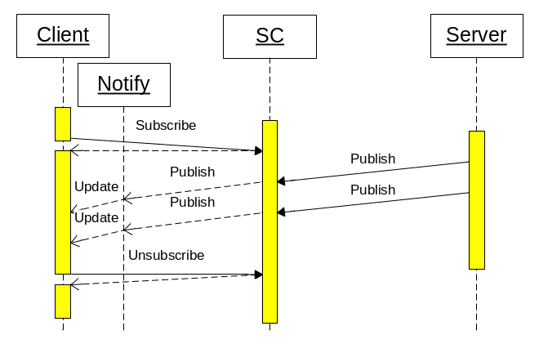
Figure 6 Asynchronous Subscribe / Publish

The client may change the subscription mask or unsubscribe. Initial subscription, subscription change or unsubscribe operation is always synchronous, even through a SC proxy.

Such communication style is used to get asynchronously events notifications or messages that are initiated on the server without an initial client action. It can be also used to distribute the same information to multiple clients.

File Services
This SC service provides API for these file operations:
- Download file from the web server to the client.
- Upload file from the client to the web server.
- List files in a file repository on the web server.

HTTP Redirection Services
The SC supports redirecting of regular HTTP traffic to another server. It is acting like normal HTTP Proxy with no caching.

Message Protocol
The Service Connector Message Protocol (SCMP) defines how the messages are transmitted. It uses a simple header – body pattern.

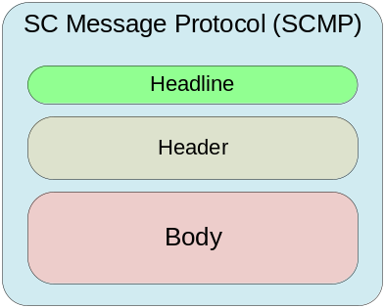
Figure 7 Service Connector Message Protocol

The headline and the message header is encoded in ISO-8859-1 (Latin 1) character set. The body itself is a binary and is under control of the applications.

Wireshark example:
REQ /s=137& SCMP/1.3
keepAliveInterval=360
keepAliveTimeout=30
localDateTime=2010-04-07T18:22:14.593+0200
compression=0
scVersion=1.0-000

RES /s=59& SCMP/1.3
msgType=CONNECT
localDateTime=2010-04-07T18:22:14.593+0200

Headline
The headline defines the SCMP version, the size and the header key. It is encoded in ISO-8859-1 (Latin 1) and terminated by <CR><LF>.

The header key of the message can be:
HeaderKey
- REQ – Request from client to SC or SC to server
- RES – Response from server to SC or SC to client
- PRQ – Part request from client to SC or SC to server (used for large messages)
- PRS – Part response from server to SC or SC to client
- EXC – Exception returned after REQ or PRQ in case of an error

The size of the message in bytes is counted from the beginning of the next line, i.e. from the first header and includes the body if present. The size is the number between /s= and &
Size

The SCMP Version of the protocol specification to which this message adheres. It has the format 9.9 and it ensures that the receiver knows to which standard this message adheres. The version number (e.g. 1.3) means: 1 = Release number, 3 = Version number.
Version
The receiver may implement multiple protocol versions and in such case this number provides the secure information how the message is structured. The following matching rules are applied:
- Message: 1.0 + receiver implements: 1.0 => compatible
- Message: 1.0 + receiver implements: 1.1 => compatible
- Message: 1.3 + receiver implements: 1.0 => not compatible
(message may have new headers unknown to the receiver)
- Message: 1.4 + receiver implements: 2.0 => not compatible
(old message structure and possibly not understood here)
- Message: 2.0+ receiver implements: 1.8 => not compatible
(new message and surely not understood here)

Header
Message header containing attributes of variable number and length each attribute is on a separate line e.g. delimited by <CR><LF>. Attributes are encoded in ISO-8859-1 (Latin 1) character set.

Body
The message body itself is binary data or ISO-8859-1 (Latin 1) encoded text. It is under control of the applications. When compression is enabled, body is ZIP-compressed during transmission.

SCMP over TCP/IP
For direct transport over TCP/IP the headline, messages header and the body is directly written to the network connection.

SCMP over HTTP
For transport over HTTP the messages header has content type text/plain and the message body the content type application/zip.

Wireshark example:
POST / HTTP/1.1
Content-Length: 178
Content-Type: text/plain

REQ /s=137& SCMP/1.3
msgType=CONNECT
keepAliveInterval=360
keepAliveTimeout=30
localDateTime=2010-04-07T18:22:14.593+0200
compression=0

HTTP/1.1 200 OK
Content-Length: 74
Content-Type: text/plain

RES /s=59& SCMP/1.3
msgType=CONNECT
localDateTime=2010-04-07T18:22:14.593+0200

Semantic
The sequence of the messages exchanged between the components is shown in the following diagrams.

Session Service
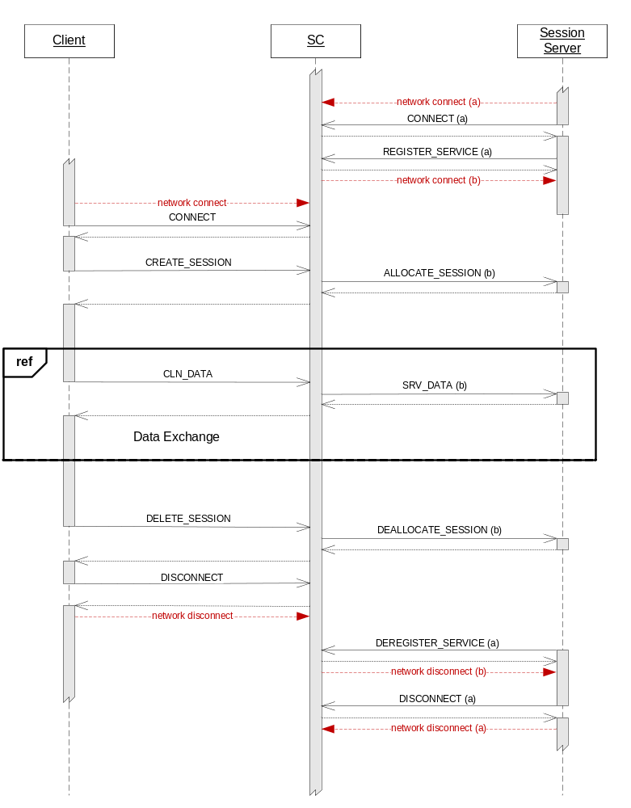
Figure 8 Synchronous Message Exchange.

- The client establishes a network connection to SC and starts communication with the CONNECT message. On this connection KEEPALIVE message can be sent.
Client
- Then it starts a session with a service with the CREATE_SESSION message
- The SC allocates a server providing this service and notifies it about the session start with the ALLOCATE_SESSION message. It also creates a unique sessionId for this session.
- Then the client can exchange messages with the server via CLN_DATA messages.
- When the session with this service is no longer needed, it will be deleted with the DELETE_SESSION message. The server is notified with the DEALLOCATE_SESSION message.
- Before the client terminates, it should send DISCONNECT message and then terminate the network connection to SC.
When session is abnormally terminated, the client is notified and will receive and error message. The reasons for this can be:
- Server sends DEREGISTER_SERVICE or DISCONNECT message
- Unexpected server exit (e.g. keepalive timeout expiration)
- Underlying communication error (e.g. keepalive timeout expiration)

The client may have multiple SCs connected at the same time. Per connected SC the client may have multiple active sessions at the same time. For each particular session only one request may be pending at any time.
Note

- Like a client, the server establishes a network connection (a) to SC and starts communication with the CONNECT message. On this connection KEEPALIVE message can be sent.
Server
- Then it registers itself as a instance of a service with the REGISTER_SERVICE message. At that time it should have a listener that will accept the connection (b) initiated by the SC to this server.
- The SC registers the server instance and will create network connection (b) to it. On this connection no KEEPALIVE message are sent.
- When a client creates a session the server is notified with the ALLOCATE_SESSION message. The message contains additional information about the client and the sessionId. The server can accept or reject the session.
- The server receives messages from the client as SRV_DATA and sends them back after execution of the service that it implements.
- When the client deletes the session, the appropriate server is notified with the DEALLOCATE_SESSION message.
- When the server is no longer needed it sends the message DEREGISTER_SERVICE. From this point the SC will not allocate it for a session and terminates the connection (b) to it.
- Before the server terminates, it should send DISCONNECT message and then terminate the network connection (a) to SC.

When the session is abnormally terminated before, the server is notified with the ABORT_SESSION message. The reasons for this can be:
- Client sends DISCONNECT message
- Unexpected client exit (e.g. keepalive timeout expiration)
- Underlying communication error (e.g. keepalive timeout expiration)

The server must be active before the client will create a session. Otherwise the client will receive a error message. The server may have only one SCs connected at the same time. The server instance may serve single or multiple sessions at the same time as described later. For each particular session only one request may be pending at any time.
Note

Asynchronous Message Exchange
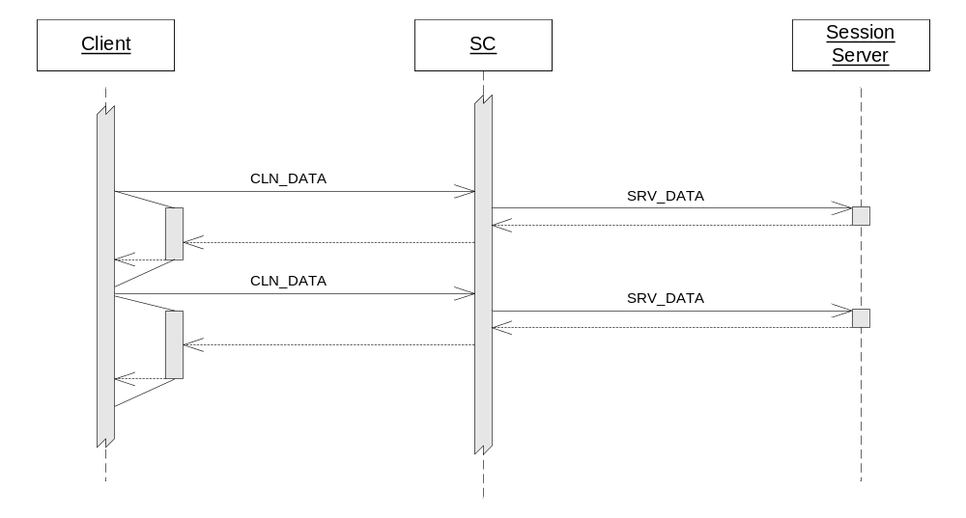
Figure 9 Asynchronous Session Service Message Exchange.

Large Messages

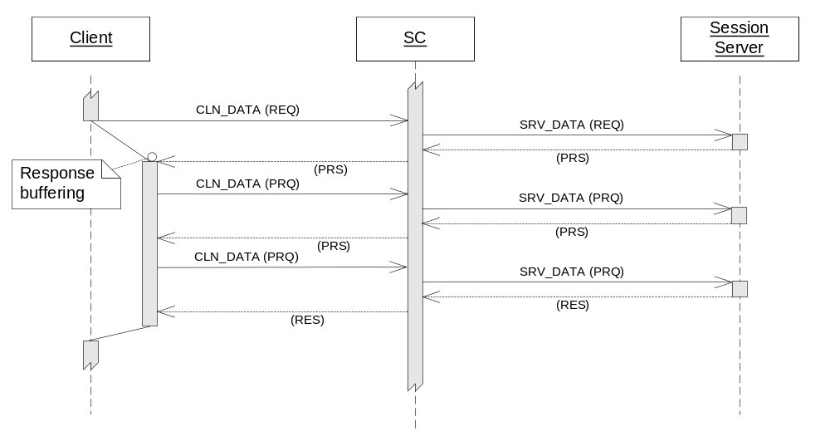
Figure 10 Synchronous Session Service Message Exchange for large Response.

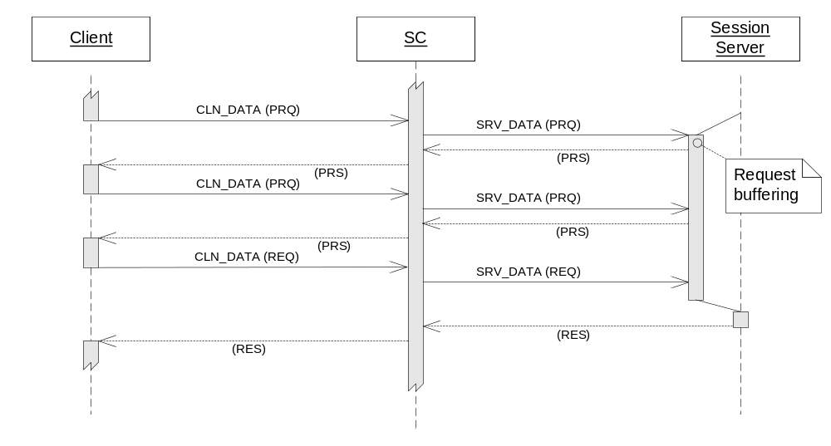

Publishing Service

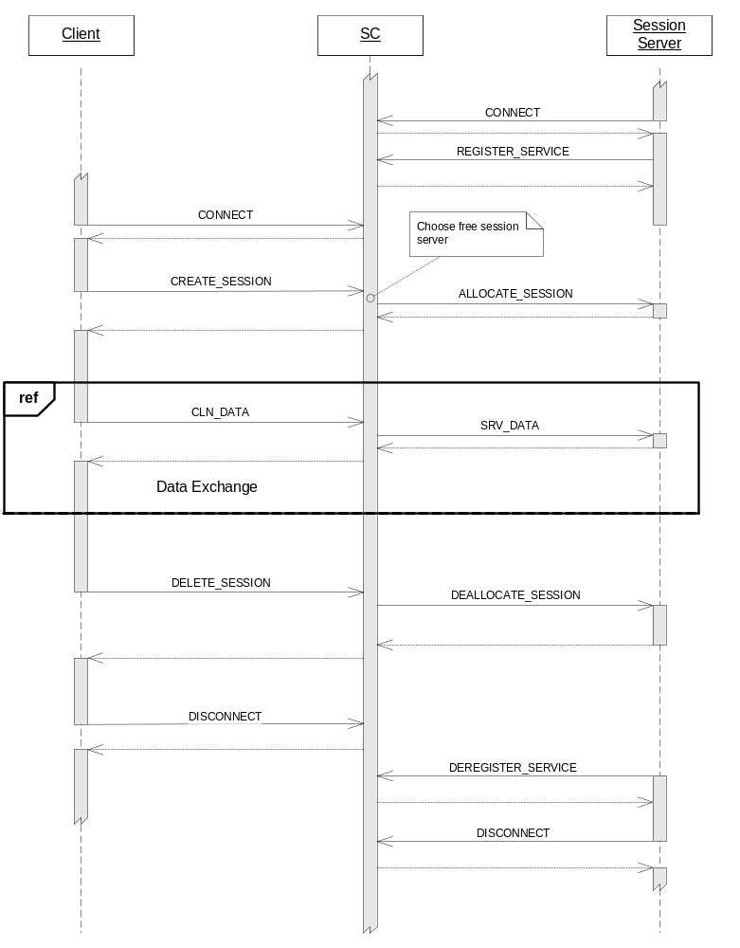
Figure 11 Publishing Service

SCMP Messages

CONNECT
This message is sent from the client to SC or from server to SC in order to initiate the communication. The message has no body and contains these attributes:
msgType=CONNECT
scVersion=1.0-023
compression=0
localDateTime=1997-07-16T19:20:30.064+0100
keepAliveTimeout=10
keepAliveInterval=60

SC receives the message, starts monitoring of the connection based on keep alive values and sends back the response:
msgType=CONNECT
localDateTime=1997-07-16T19:20:34.044+0200

When an error occurs the response message contains the attributes:
msgType=CONNECT
localDateTime=1997-07-16T19:20:30.453+0100
scErrorCode=3000
scErrorText=Service Connector Message Protocol mismatch

DISCONNECT
This message is sent from the client to SC or from server to SC in order to terminate the communication. The message has no body and contains these attributes:
msgType=DISCONNECT

SC receives the message, starts monitoring of the connection based on keep alive values and sends back the response:
msgType=DISCONNECT

When an error occurs the response message contains the attributes:
msgType=DISCONNECT
scErrorCode=3000
scErrorText=protocol mismatch

KEEPALIVE
This message is sent from the client to SC or from server to SC in order to verify the communication. The message has no body and contains these attributes:
msgType=KEEPALIVE
localDateTime=1997-07-16T19:20:30.343+0100
The sender of the keep alive message starts a timer that monitors the arrival of the response message. In case the timeout expires the connection must be aborted and cleaned up. The receiver of the keep alive message monitors the interval in which these messages arrive. In case the message does not arrive in the pre-defined interval, the connection must be aborted and cleaned up.

SC receives the message, and sends back the response:
msgType=KEEPALIVE
localDateTime=1997-07-16T19:20:34.237+0200

CREATE_SESSION
This message is sent from the client to SC in order to start a new session for a service. The message has no body and contains these attributes:
msgType=CREATE_SESSION
serviceName=P01_RTXS_RPRWS1
ipAddressList=10.0.4.32/10.2.54.12/192.243.43.1
sessionInfo=SNBZHP - TradingClientGUI 10.2.7

SC receives the message and does these actions:
- Generates a unique session id
- Chooses a free server instance from the list of available servers serving the requested service.
- Allocates the server instance to this session
- Sends the message ALLOCATE_SESSION to the allocated server
- Awaits the server response ALLOCATE_SESSION.
- If the attribute rejectFlag is missing, the SC keeps the session and sends back the message with the following attributes:
msgType=CREATE_SESSION
sessionId=cdc50b36-1fc4-4f9e-8430-d2e3d7284d9d
serviceName=P01_RTXS_RPRWS1
- If the attribute rejectFlag = yes, the SC deletes the session, de-allocates the server and sends back the message with the following attributes:
msgType=CREATE_SESSION
serviceName=P01_RTXS_RPRWS1
appErrorCode=4334591
appErrorText=%RTXS-E-NOPARTICIPANT, Authorization error – Unknown participant

When an error occurs the response message contains the attributes:
msgType=CREATE_SESSION
scErrorCode=3000
scErrorText=Unkown Service = P01_RTXS_RPRWS3

DELETE_SESSION
This message DELETE_SESSION is sent from the client to SC in order to close an existing session. The message has no body and contains these attributes:
msgType=DELETE_SESSION
sessionId= cdc50b36-1fc4-4f9e-8430-d2e3d7284d9d
serviceName=P01_RTXS_RPRWS1

SC receives the message and does these actions:
- Finds the server allocated to this session
- Sends the message DEALLOCATE_SESSION
- Awaits the response DEALLOCATE_SESSION.
- Allocates the server instance from this session
- Sends back the message DELETE_SESSION with the following attributes:
msgType=DELETE_SESSION
serviceName=P01_RTXS_RPRWS1

Due to timing issues the client may send a delete session request to a non existing session or to session that has no allocated server. The SC must handle such situation and do the appropriate clean-up actions.

When an error occurs the response message contains the attributes:
msgType=DELETE_SESSION
scErrorCode=3000
scErrorText=Session does not exist

CLN_DATA
This message is sent from the client to SC in order exchange information with the allocated server. The client may send this message only in scope of a session. The message has a body and contains these attributes:
msgType=CLN_DATA
sessionId=cdc50b36-1fc4-4f9e-8430-d2e3d7284d9d
serviceName=P01_RTXS_RPRWS1
bodyLength=2534
sequenceNr=974833
compression=0
messageInfo=SECURITY_MARKET_QUERY

Optionally these attributes can also be set when the client wants to fetch the message from the SC Proxy cache:
cacheSignature=CBCD_SECURITY_MARKET
cacheExpirationDateTime=1997-08-16T19:20:34.237+0200

SC receives the message and finds the server allocated to this session.
It sends the message SRV_DATA to the server it and awaits the response. Then it sends back a message with a body and the following attributes:
msgType=CLN_DATA
sessionId=cdc50b36-1fc4-4f9e-8430-d2e3d7284d9d
serviceName=P01_RTXS_RPRWS1
bodyLength=62454
sequenceNr=974833
compression=0
messageInfo=SECURITY_MARKET_RESULT

Optionally these attributes can also be set when the server wants to insert the message into the SC Proxy cache:
cacheSignature=CBCD_SECURITY_MARKET
cacheExpirationDateTime=1997-08-16T17:00:00.000+0100

In case of an application error these attributes can also be set.
appErrorCode=4334591
appErrorText=%RDB-F-NOTXT, no transaction open

When an error occurs the response message contains the attributes:
msgType=CLN_DATA
scErrorCode=3000
scErrorText=Session does not exist

SUBSCRIBE
This message is sent from the client to SC in order to subscribe for a publishing service. The message has no body and contains these attributes:
msgType=SUBSCRIBE
serviceName= P01_BCST_CH_RPRWS2
mask= 000012100012832102FADF--------------------------

SC receives the message and does these actions:
- Generates a unique session id
- Registers the client subscription for the service
- Sends back a message with the following attributes:
msgType=SUBSCRIBE
sessionId=cdc50b36-1fc4-4f9e-8430-d2e3d7284d9d
serviceName=P01_RTXS_RPRWS1

When an error occurs the response message contains the attributes:
msgType=SUBSCRIBE
scErrorCode=3000
scErrorText=Unkown Service = P01_BCST_CH_RPRWS2

UNSUBSCRIBE
This message is sent from the client to SC in order to delete the subscription for a publishing service. The message has no body and contains these attributes:
msgType=UNSUBSCRIBE
sessionId=cdc50b36-1fc4-4f9e-8430-d2e3d7284d9d
serviceName=P01_BCST_CH_RPRWS2

SC receives the message and does these actions:
- Deletes the client subscription for the services and deletes all pending messages for this client.
- Sends back a message with the following attributes:
msgType=UNSUBSCRIBE
serviceName=P01_RTXS_RPRWS1

When an error occurs the response message contains the attributes:
msgType=UNSUBSCRIBE
scErrorCode=3000
scErrorText=Client is not subscribed

CHANGE_SUBSCRIPTION
This message is sent from the client to SC in order to change the subscription for a publishing service. The message has no body and contains these attributes:
msgType=CHANGE_SUBSCRIPTION
sessionId=cdc50b36-1fc4-4f9e-8430-d2e3d7284d9d
serviceName=P01_BCST_CH_RPRWS2
mask= 000012100012832102FADF--------------------------

SC receives the message and does these actions:
- Changes the subscription mask of the client for the service
- Sends back a message with the following attributes:
msgType=CHANGE_SUBSCRIPTION
serviceName=P01_RTXS_RPRWS1

When an error occurs the response message contains the attributes:
msgType=CHANGE_SUBSCRIPTION
scErrorCode=3000
scErrorText=Client is not subscribed

RECEIVE_PUBLICATION
This message is sent from the client to SC in order to get data published by a server. The client may send this message only in scope of a subscription session. The message has no body and contains these attributes:
msgType=UNSUBSCRIBE
sessionId=cdc50b36-1fc4-4f9e-8430-d2e3d7284d9d
serviceName=P01_BCST_CH_RPRWS2
sequenceNr=974833

SC receives the message and does these actions:
- Finds the client subscription
- Creates a timer monitoring the response delivery
- Waits until one of these two events occurs:
  - A message that matches the client subscription arrives. Then it sends back a message with the body and the following attributes:
msgType=RECEIVE_PUBLICATION
sessionId=cdc50b36-1fc4-4f9e-8430-d2e3d7284d9d
serviceName= P01_BCST_CH_RPRWS2
bodyLength=2534
sequenceNr=974833
compression=yes
messageInfo=CH_AUCTION
mask=%%%%%%%%%%%%%%%%%%%%%%%%%%%X%%%%%%%%%%%%%%%%%%%%

  - The timeout expires. Then it sends back a message with the no body and the following attributes:
msgType=RECEIVE_PUBLICATION
sessionId=cdc50b36-1fc4-4f9e-8430-d2e3d7284d9d
serviceName=P01_BCST_CH_RPRWS2
sequenceNr=974833
noData=yes

When an error occurs the response message contains the attributes:
msgType=RECEIVE_PUBLICATION
scErrorCode=3000
scErrorText=Client is not subscribed

REGISTER_SERVICE
This message is sent from the server instance to SC in order to tell the SC which service it serves. The message has no body and contains these attributes:
msgType=REGISTER_SERVICE
serviceName=P01_RTXS_RPRWS1
maxSessions=10
multiThreaded=no
portNr=9100

SC receives the message and does these actions:
- Registers the server for this service.
- Creates the requested number of connection to the server on port that was specified.
- Sends back a message with the following attributes:
msgType=REGISTER_SERVICE
serviceName=P01_RTXS_RPRWS1

When an error occurs the response message contains the attributes:
msgType=REGISTER_SERVICE
scErrorCode=3000
scErrorText=Service name=P01_RTXS_RPRWS5 not found

DEREGISTER_SERVICE
This message is sent from the server instance to SC in order to tell the SC that the server will no longer provide the service and will perform a conscious shutdown. The message has no body and contains these attributes:
msgType=DEREGISTER_SERVICE
serviceName=P01_RTXS_RPRWS1

SC receives the message and does these actions:
- Finds the server and performs a cleanup by:
- Aborting and de-allocation all sessions of this server. If the server has allocated sessions the SC will send the ABORT_SESSION to it.
- Sends back a message with the following attributes:
msgType=DEREGISTER_SERVICE
serviceName=P01_RTXS_RPRWS1

When an error occurs the response message contains the attributes:
msgType=DEREGISTER_SERVICE
scErrorCode=3000
scErrorText=Server is not registered

After this message the server may close connection to the SC with the DISCONNECT

ALLOCATE_SESSION
This message is sent from the SC to the server when the server instance will be allocated to a session. The message has no body and contains these attributes:
msgType=ALLOCATECREATE_SESSION
serviceName=P01_RTXS_RPRWS1
sessionId=cdc50b36-1fc4-4f9e-8430-d2e3d7284d9d
ipAddressList=10.0.4.32/10.2.54.12/192.243.43.1
sessionInfo=SNBZHP - TradingClientGUI 10.2.7

The server receives the message and must decide to accept or reject this request. If it accepts , then it must return a message with the following attributes:
msgType=ALLOCATE_SESSION
serviceName=P01_RTXS_RPRWS1

If it rejects the session, then it must return a message with the following attributes:
msgType=ALLOCATE_SESSION
serviceName=P01_RTXS_RPRWS1
rejectFlag=yes
appErrorCode=4334591
appErrorText=%RTXS-E-NOPARTICIPANT, Authorization error – Unknown participant

DEALLOCATE_SESSION
This message is sent from the SC to the server when the session will be deleted by the client and the server instance will no longer be bound to it. The message has no body and contains these attributes:
msgType=DEALLOCATE_SESSION
serviceName=P01_RTXS_RPRWS1
sessionId=cdc50b36-1fc4-4f9e-8430-d2e3d7284d9d

The server must return a message with the following attributes:
msgType=DEALLOCATE_SESSION
serviceName=P01_RTXS_RPRWS1

After this message the server will not receive any data requests until the next session is started.

ABORT_SESSION
This message is sent from the SC to the server when the session is aborted do to errors of other unexpected events. The message has no body and contains these attributes:
msgType=ABORT_SESSION
serviceName=P01_RTXS_RPRWS1
sessionId=cdc50b36-1fc4-4f9e-8430-d2e3d7284d9d

The server must return a message with the following attributes:
msgType= ABORT_SESSION
serviceName=P01_RTXS_RPRWS1

After this message the server will not receive any data requests until the next session is started.

SRV_DATA
This message is sent from the SC to the server allocated to this session in order to execute the request. The SC will send this message only in scope of a session. The message has a body and contains these attributes:
msgType=SRV_DATA
sessionId=cdc50b36-1fc4-4f9e-8430-d2e3d7284d9d
serviceName=P01_RTXS_RPRWS1
bodyLength=2534
sequenceNr=974833
compression=0
messageInfo=SECURITY_MARKET_QUERY

The server receives the message extracts the body and executes the application code. It must
send back a message with a body and the following attributes:
msgType=SRV_DATA
sessionId=cdc50b36-1fc4-4f9e-8430-d2e3d7284d9d
serviceName=P01_RTXS_RPRWS1
bodyLength=62454
sequenceNr=974833
compression=0
messageInfo=SECURITY_MARKET_RESULT

Optionally these attributes can also be set when the server wants to insert the message into the SC Proxy cache:
cacheSignature=CBCD_SECURITY_MARKET
cacheExpirationDateTime=1997-08-16T17:00:00.000+0100

In case of an application error these attributes can also be set.
appErrorCode=4334591
appErrorText=%RDB-F-NOTXT, no transaction open

PUBLISH
This message is sent from the publishing server to SC in order to send this message to the subscribed clients. The message has a body and contains these attributes:
msgType=PUBLISH
serviceName= P01_BCST_CH_RPRWS2
bodyLength=2534
compression=0
routingInfo=CH_AUCTION_IOI
mask=%%%%%%%%%%%%%%%%%%%%%%%%%%%X%%%%%%%%%%%%%%%%%%%%

SC receives the message and does the following steps:
- It inserts the message on top of the message queue for this service
- Sends back to the server a message with the following attributes:
msgType=PUBLISH
serviceName=P01_BCST_CH_RPRWS2
- Starts distribution of the message to the subscribed clients based on their subscription mask and the mask of the message.

When an error occurs the response message contains the attributes:
msgType=PUBLISH
scErrorCode=3000
scErrorText=Service does not exist

SCMP Header Attributes
The following is a list of all possible attributes in a SC message header in alphabetical order. All attributes are ASCII, encoded as ISO 8859-1 (Latin-1).

You can find the matrix describing which attribute is used in which message in Error: Reference source not found.

appErrorCode
Name | appErrorCode
Description | Numeric value passed between server and the client used to implement error protocol on the application level.
Validation | Numeric value ≥ 0
Comment | This is used mainly in troubleshooting cases to identify the body content during the message transmission.
Example | appErrorCode=4334591

appErrorText
Name | appErrorText
Description | Textual value passed between server and the client used to implement error protocol on the application level. It can be the textual interpretation of the appErrorCode.
Validation | Any printable character, length > 0 and < 256Byte
Comment | This is used mainly in troubleshooting cases to identify the body content during the message transmission.
Example | appErrorText=%RDB-F-NOTXT, no transaction open

bodyType
Name | bodyType
Description | Type of the message body.
Validation | Enumeration:  - text – message body is ISO-8859-1 (Latin 1) encoded text  - message – internal SC message  - binary – binary data  - xml – XML data
Comment | According to the bodyType the content-type is set for http transmission. If missing “binary” is the default.
Example | bodyType=text

bodyLength
Name | bodyLength
Description | Number of bytes in the message body.
Validation | Positive numeric value ≥ 0 and < 65534
Comment | If missing, the message has no body. If the bodyLength = 0 then body is present but empty.
Example | bodyLength=2534

cacheSignature
Name | cacheSignature
Description | Signature agreed by the communicating applications to uniquely identify the cached content. When cacheSignature is used the attribute cacheExpirationDateTime must also be present.
Validation | Any printable character, length > 0 and < 256Byte
Comment | The client uses cacheSignature to identify which message should be retrieved from the cache. The server uses cacheSignature to designate message that should be cached.  The client will get a cached message when:  - the cacheSignatuer matches a message in the cache and  - cacheExpirationDateTime requested by the client is timely before the cacheExpirationDateTime of the cached message.
Example | cacheSignature=CBCD_SECURITY_MARKET

cacheExpirationDateTime
Name | cacheExpirationDateTime
Description | Absolute expiration date and time of a cached message.  It must be set together with cacheSignature attribute.
Validation | YYYY-MM-DDThh:mm:ss.fff+hhmm  It is UTC plus zone information.  The fff are seconds fractions and time zone offset is at the end.
Comment | The client uses cacheExpirationDateTime to tell how old the message could be. The server uses cacheExpirationDateTime to designate how long the message should be cached.
Example | cacheExpirationDateTime=1997-08-16T19:20:34.237+0200

compression
Name | compression
Description | Flag true or false describing if the message body is compressed or not. If missing the default value is true.
Validation | 0 (false) or 1 (true)
Comment | The compression is enabled or disabled on the connection level, not for an individual message or service.
Example | compression=0

ipAddressList
Name | ipAddressList
Description | List of IP addresses on the network path between the client and the session server. The first is the IP address of the client, the last is the IP address of the incoming SC connection. In between there can be any number of addresses of the intermediate SC proxies
Validation | List in format 999.999.999.999{/999.999.999.999}...
Comment | When VPN is used, the tunnel IP is part of this list. This information is used for client authentication.
Example | ipAddressList=10.0.4.32/10.2.54.12/192.243.43.1

portNr
Name | portNr
Description | Number of the TCP/IP port the session server accepts the connection(s).
Validation | Number > 0 and < 99999
Comment | When a session server registers, SC will create a connection to this server on the IP address of the server and the given port number. Multiple connections are created to the same port. The value must be > 1.
Example | portNr=9100

keepAliveInterval
Name | keepAliveInterval
Description | Interval in which the sender sends keep alive messages.  The value = 0 means no keep alive messages will be used.
Validation | Number ≥ 0 and < 3600  If keepAliveTimeout is 0 then keepAliveInterval must also be 0.  keepAliveInterval must be greater then keepAliveTimeout
Comment | This is used by the receiver to detect a broken connection. The receiver calculates the maximal time between two subsequent KEEPALIVE messages as maxTime= keepAliveInterval +( keepAliveTimeout/2)  If this time expires the connection is treated as dead and a cleanup is done.
Example | keepAliveInterval =60

keepAliveTimeout
Name | keepAliveTimeout
Description | Maximal time in seconds allowed between KEEPALIVE request and response (measures by the sender).  The value = 0 means no keep alive messages will be sent.
Validation | Number ≥ 0 and < 3600  If keepAliveTimeout is 0 then keepAliveInterval must also be 0.
Comment | This is used by the sender to detect a broken connection. When this timeout expires, the connection is treated as dead and a cleanup is done.
Example | keepAliveTimeout =10

localDateTime
Name | localDateTime
Description | String value describing the actual local date and time.
Validation | YYYY-MM-DDThh:mm:ss.fff+hhmm  It is UTC plus zone information.  The fff are seconds fractions and time zone offset is at the end.
Comment | The local date time is exchanged at the beginning of each connection and in the keep alive messages. It is used to calculate the time difference between the communicating parties and to harmonize the log for troubleshooting purposes.
Example | localDateTime=1997-07-16T19:20:30.064+0100

mask
Name | mask
Description | The mask is used in SUBSCRIBE or CHANGE_SUBSCRIPTION to express the client interest and in PUBLISH and RECEIVE_PUBLICATION to designate the message cntents. Only printable characters are allowed.
Validation | Any printable character, length < 256Byte
Comment | If the message mask matches the subscription mask, the client will get this message.  The matching rules:  - masks of unequal length do not match  - % - matches any single character at this position  - All other characters must exactly match (case sensitive)
Example | Subscription: mask= 000012100012832102FADF-----------X-----------  Matching examples:  Message: mask= 000012100012832102FADF-----------X-----------  Message: mask= 0000121%%%%%%%%%%%%%%%-----------X-----------  Not matching examples:  Message: mask= 000012100012832102FADF-----------------------  Message: mask= 0000121%%%%%%%%%%%%%%%-----------------------

maxSessions
Name | maxSessions
Description | Number of session the server instance can serve.
Validation | Number > 0
Comment | When a session server registers a service it must tell the SC how many sessions it can serve. This is necessary to know in order to maintain the count of available and free session servers in SC.  The value 1 means single session server. Value > 1 means multi-connection or multi-threaded server, depending on the parameter multiThreaded.
Example | maxSessions=10

messgageId
Name | messageId
Description | Unique identification of large message in order to put all its parts together. It must be provided by the sender of the large message.
Validation | Any printable character, length > 0 and < 64Byte
Comment | Used to identify parts of a large message which belong together.
Example | messageId=A0E9342FA

messgageInfo
Name | messageInfo
Description | Information passed together with the message body that helps the client and the server identify the body content without investigating the body.
Validation | Any printable character, length > 0 and < 256Byte
Comment | This is used mainly in troubleshooting cases to identify the body content during the message transmission.
Example | messageInfo=SECURITY_MARKET_QUERY

msgType
Name | msgType
Description | Unique message type
Validation | List of known message types
Comment | Message type that represents a certain command, and also documenting the direction of the message. The direction of the message is visible in the headline.
Example | msgType=PUBLISH

multiThreaded
Name | multiThreaded
Description | Flag true or false to designate a multithreaded server. If missing the default value is false.
Validation | 0 (false) or 1 (true)
Comment | When a session server registers and maxSession > 1, SC must know if this is a multi-connection or multi-threaded server. For multi-connection server SC will create the defined number of connections and use one connection per session, for multi-threaded servers SC will create only one connection and reuse it for all sessions.
Example | multiThreaded=1

noData
Name | noData
Description | NoData flag is used in RECEIVE_PUBLICATION to tell the subscribed client, that no data for publishing exists. The client will immediately send RECEIVE_PUBLICATION to renew the interest.
Validation | 0 (false) or 1 (true)
Comment | noData=0 is never sent.
Example | noData=1

rejectSession
Name | rejectSession
Description | Flag in ALLOCATE_SESSION message set by the server when it rejects the session. In such case the server can also set the appErrorCode and appErrorText to explain the rejection reason.
Validation | 0 (false) or 1 (true)
Comment | rejectSession=0 is never sent.
Example | rejectSession=1

scErrorCode
Name | scErrorCode
Description | Numeric error code set by SC in other to inform the communication partner about an error.
Validation | Number > 1
Comment | This is used to handle communication error.
Example | scErrorCode=4453

scErrorText
Name | scErrorText
Description | English text set by the SC in other to describing the error signalled as scErrorCode.
Validation | Any printable character, length > 0 and < 256Byte
Comment | This is used to log the communication error.
Example | scErrorText=Unknow service name = P01_RTXR_RPRWS4

scVersion
Name | scVersion
Description | SC version number of the producer of this message.
Validation | String format 9.9-999
Comment | This version number is sent in CONNECT and checked by the receiver against its own SCMP version number. This ensures that only compatible components can communicate to each other. The value is hard coded in the communication components like API, SC or SC-Proxy. The version number consist of (e.g. 1.0-023):  - 1 = Release number  - 0 = Version number  - 023 = Revision number  The matching rules are:  - Request: 1.0-023 + own: 1.0-023 => compatible  - Request: 1.0-023 + own: 1.0-025 => compatible  - Request: 1.0-025 + own: 1.0-023 => not compatible  (requestor may utilize new features unknown here)  - Request: 1.0-023 + own: 1.2-005 => compatible  - Request: 1.2-004 + own: 1.0-023 => not compatible  (requestor uses new functions unknown here)  - Request: 1.0-023 + own: 2.0-007 => not compatible  (possibly other incompatible interface)  - Request: 2.0-001 + own: 1.0-023 => not compatible  (possibly other incompatible interface)
Example | scVersion=1.0-023

sequenceNr
Name | sequenceNr
Description | Internal sequence number generated by the sender in order to identify and track messages in transmission.
Validation | Number > 0, steadily increasing
Comment | For a session service the sequenceNr is incremented by the client sending a message, and echoed by the server allocated to the session. The sessionId + the sequnceNr uniquely identify the request/response pair at any point of its transmission.  For a published service the sequenceNr is incremented by the SC when it receives the message from the publishing server. In the message fan-out on SC-proxy the sequenceNr is preserved. The client may not receive all published messages due to its subscription filter and therefore it may see gaps in the received sequenceNr.
Example | sequenceNr=974833

serviceName
Name | serviceName
Description | Name of the service
Validation | Any printable character, length > 0 and < 256Byte
Comment | The service name is an abstract name and represents the logical address of the service. It order to allow message routing the name must be unique in scope of the SC network. Service names are defined at application level and are stored in the SC configuration.
Example | serviceName=P01_RTXS_RPRWS1

sessionId
Name | sessionId
Description | Unique identification of the session
Validation | Known session,
Comment | The sessionId is allocated by SC to which the client is connected when it sends the request CREATE_SESSION. The sessionID is universally unique because multiple SC may exist in the same network. The client must set the sessionId in each message during the session.
Example | sessionId=cdc50b36-1fc4-4f9e-8430-d2e3d7284d9d

sessionInfo
Name | sessionInfo
Description | Information passed by the client to the session server when the session starts.
Validation | Any printable character, length > 0 and < 256Byte
Comment | This is used to pass additional authentication or authorization data to the server.
Example | sessionInfo=SNBZHP - TradingClientGUI 10.2.7

Glossary
Glossary item
glossary text

Appendix A

No index entries found.

