SC

Service Connector

Architecture and Design

SC_0_Architecture_E (Version D1.1)
SC is a middleware component for new Eurex IT platform. This document presents its architecture and introduces the concepts of this software. It is the starting point for the implementation phase.

This document is a spiritual ownership of STABILIT Informatik AG, and must not be used or copied without a written allowance of this company. Unauthorized usage is illegal in terms of Chapter 23 / 5 UWG / Swiss law.

The information in this document is subject to change without notice and should not be construed as a commitment by STABILIT Informatik AG.

Copyright © 2026 by STABILIT Informatik AG
All rights reserved.

All other logos, product names are trademarks of their respective owners.

This Document has been created with Microsoft Word 2003 (11) with template file and printed at 21 January 2010 14:32.

Identification
Project: | SC
Title: | Service Connector
Subtitle: | Architecture and Design
Version: | D1.1
Reference: | SC_0_Architecture_E
Classification: | Confidential
Keywords: | Architecture, Design, Concepts
Comment: | SC is a middleware component for new Eurex IT platform. This document presents its architecture and introduces the concepts of this software. It is the starting point for the implementation phase.
Author(s): | STABILIT Informatik AG  Jan Trnka, Daniel Schmutz, Mauro Ricchetti, Joel Traber
Approval (Reviewed by): | Signature Jan Trnka  Signature Francisco Gonzalez
Audience: | Project team, Eurex IT management, Review team
Distribution: | Project team, Eurex IT management, Review team
Filename | /tmp/lo/0000.doc
Revision History
Date | Version | Author | Description
14.06.2009 | D1.0 | Jan Trnka | Initial draft
09.08.2009 | D1.1 | Jan Trnka | Separate specification and architecture documents. Fill information from Dani into this document.

Table of Contents
1 Preface 4
1.1 Purpose & Scope of this Document 4
1.2 Definitions & Abbreviations 4
1.3 External References 5
1.4 Typographical Conventions 5
1.5 Outstanding Issues 5
2 Architecture 6
3 Design 7
3.1 Communication Layers 7
3.1.1 Transport Layer 7
3.1.2 Protocol Layer 7
3.1.3 Content Layer 8
3.1.4 Command Layer 8
3.1.5 Service Layer 8
3.2 Abstract Factory 8
3.3 Layers (As simple as possible) 8
3.3.1 Server Side 9
3.3.2 Client Side 10
3.3.3 Http Server (sync) 10
3.3.4 Client (sync) 11
3.4 Service Hub 11
3.4.1 Service Provider 12
3.4.2 Service Listeners 12
3.4.3 The Queue 12
3.4.4 Multiple Queues 13
3.5 Kernel 14
3.6 Deployment 14
4 Communication 16
4.1 Synchronous Communication (Request/Response) 16
4.1.1 Small/Regular Size Responses 16
4.1.2 Large Size Responses 16
4.2 Asynchronous Communication (Request/Callback) 17
4.2.1 Single Callback 17
4.2.2 Multiple Callbacks 18
4.3 Subscribe/Publish 19
4.4 Keep Alive 20
4.5 SCOP 21
4.6 Job Redirection 22
5 Application Programming Interface API 23
5.1 Proposal of Client API for C 23
5.1.1 AttachClient 23
5.1.2 DetachClient 24
5.1.3 ConnectService 24
5.1.4 DisconnectService 25
5.1.5 SendAndReceive 25
5.1.6 Send 26
5.1.7 Response Message Receiver (callback) 26
5.1.8 Subscribe 26
5.1.9 Unsubscribe 27
5.1.10 ChangeSubscription 27
5.1.11 Publish Message Receiver (callback) 28
5.1.12 getConnectionParameter 28
5.1.13 getServiceParameter 28
5.1.14 getError 29
5.2 Server API 29
5.2.1 AttachServer 29
5.2.2 DetachServer 30
5.2.3 RegisterService 30
5.2.4 Control Event Receiver (callback) 31
5.2.5 ServiceExecutor(callback) 31
5.2.6 Publish 32
5.2.7 getConnectionParameter 32
5.2.8 getServiceParameter 32
5.2.9 getError 33
6 Glossary 34
Appendix 35
Index 37

Tables
Table 1 Abbreviations & Definitions 5
Table 2 External references 5
Table 3 Typographical conventions 5

Figures
Figure 1 Communication Layers 7
Figure 2 Abstract Factory 8
Figure 3 Simplified Communication Layers 9
Figure 4 Server side class model 9
Figure 5 Client class model 10
Figure 6 http server 11
Figure 7 Client 11
Figure 8 Service Hub 11
Figure 9 Service Hub 12
Figure 10 Message Queue 13
Figure 11 Multiple Message Queue 13
Figure 12 Message Queue 14
Figure 13 Kernel 14
Figure 14 Deployment 15
Figure 15 Synchronous Request/Response 16
Figure 16 Large Response 17
Figure 17 Asynchronous Request/Response 18
Figure 18 Asynchronous Request/Response 19
Figure 19 Subscribe/Publish 20
Figure 20 Keep-alive messages 21
Figure 21 Service Connector Object Protocol 21
Figure 22 SCOP class diagram 22
Figure 23 Client-Server API for Java (Connection Overview) 33
Figure 24 Client-Server API for Java (Service Overview) 34

Preface

Purpose & Scope of this Document
This document shows and explains the design of the Service Connector. The architecture is described by means of different architectural views.

The final and approved version of this document serves as base for a binding implementation proposal.

This document is particularly important to all project team members and serves as communication medium between them.

Definitions & Abbreviations
Item / Term | Definition / Description
EBS | Elektronische Börse Schweiz – older project name for ESY
ERM | Electronic Repo Market
ESY | Exchange System – SWX trading platform
EUI | Exchange User Interface – application for static data maintenance in ESY. (Analogy of CUI in ERM)
GUI | Graphical User Interface
GWY | Gateway
HTML | Hypertext Mark-up Language
HTTP | Hypertext Transport Protocol
HTTPS | HTTP over SSL, encrypted and authenticated transport protocol
IE | Internet Explorer – Microsoft Web Browser - commercial product
J2EE | Java 2 Platform Enterprise Edition
Java | Programming language and run-time environment from SUN
JDK | Java Development Kit
JSF | Java Server Faces – open source framework for Web-GUI
LDAP | Lightweight Directory Access Protocol
Linux | Unix-like operating system, open source
Log4j | Standard logging tool used in Java
OpenVMS | HP Operating system, platform for ERM
RMI | Remote Method Invocation - RPC protocol used in Java
RPC | Remote Procedure Call
SOAP | Simple Object Access Protocol
SSL | Secure Socket Layer – secure communication protocol with encryption and authentication
SIX Exchange | Member of SIX Group, Exchange platform provider
TCP/IP | Transmission Control Protocol / Internet Protocol
SIX Telekurs | Member of SIX Group, Financial information provider
UDDI | Universal Description, Discovery and Integration – browsable registry to find a web service, its location and description. (Phonebook for Web Services)
SC | Service Connector
USP | Universal Service Processor – existing middleware used by Eurex Repo
Web Service | software designed to support interoperable machine-to-machine interaction over a network
Web-GUI | Graphical User Interface running in Web-Browser built with Web components. Also called Thin-Client.
Windows | Microsoft operating system family
XLS | File extension for MS-Excel
XML | Extensible Mark-up Language
XSD | XML Schema Definition
XSLT | Extensible Style Sheet Language Transformation
Table 1 Abbreviations & Definitions

External References
References | Item / Reference to other Document
[1] | USP Documentation  http://www.stabilit.ch/index.php?option=com_content&task=view&id=27&Itemid=60
[2] | SC_0_Architecture_E – Requirement and Specifications for Service Connector
Table 2 External references

Typographical Conventions
Convention | Meaning
text in italics | features not implemented in the actual release
text in Courier font | code example
[ phrase ] | In syntax diagrams, indicates that the enclosed values are optional
{ phrase1 | phrase2 } | In syntax diagrams, indicates that multiple possibilities exists.
… | In syntax diagrams, indicates a repetition of the previous expression

Table 3 Typographical conventions

The terminology used in this document may be somewhat different from other sources. The chapter Glossary includes a list of often used terms with the explanation of their meaning in this document.

Outstanding Issues
Following issues are outstanding at the time of the document release:
- Is load balancing between services for server farms required?
- Failover => Session context replication to other server nodes?
- Is automatic reconnect after connection loss required?
- Is SC-Proxy really required?

Architecture
the

Design

Communication Layers
Like every communication system SC works like a piping system. The transmitted messages will be processed and dumped to the sink media like sockets, files, etc.. The processing streams packs or unpacks the messages from previous layer to next stream. The top layer talks to the application or user. The following picture shows this principle.

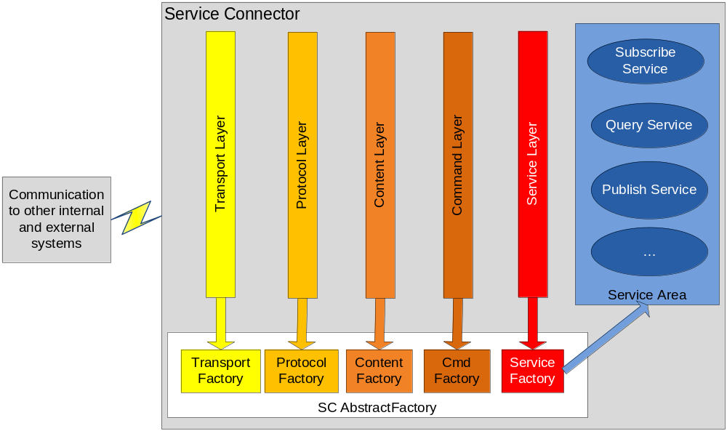
Figure 1 Communication Layers

Transport Layer
Supports several transport protocols like java object stream in a header/body instance. The header part is generic (e.g. html meta tags). The text based body part depends on its content layer each transmitted message contains the server time.

The transport layer is the only one talking to the network layer. The transport layer checks if the message structure is correct (header, body) but has no idea about the underlying protocols.

Protocol Layer
The protocol layer handles how messages between communication partners were transmitted (e.g. like http, smtp, ftp, etc.). Who starts the connection? Who talks first? How do we close an active communication? Is the communication synchronous or asynchronous? Timeout Handling?

The protocol layer has no idea about the transmitted messages. He just verifies that all defined communication rules are correct.

Content Layer
The content layers packs and unpacks messages into the basic header/body instance. The content of the body depends on the application serializer/deserializer algorithm (e.g. java object stream). All message packets belong to the same header/body form. Other forms can be supported, but this will not be the case.

Command Layer
Every message belongs to a command (command pattern). Each command has a key assigned (which is part of the message header). Each command must belong to a valid service (mapped by ServiceFactory). An exception is thrown if no command is assignable.

Service Layer
Each service belongs to a use case. A service instance implements the use case job (e.g. event notification, message handling, etc.). A unique key identifies a service. The service factory maps those key to a service instance. Multiple commands can address the same service.

A service belongs to a scope (e.g. request, session, application). A context class
is assigned for each scope. The scope is handled by the service factory.

Abstract Factory
The basic SC architecture is fully abstract. We don’t talk about any implementations or real protocols at the moment. We have an open architecture, all components or systems talk together using this abstraction layer.

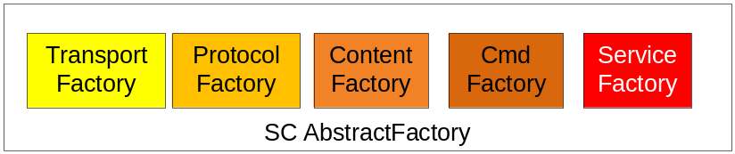
Figure 2 Abstract Factory

The SC Factory is an abstract factory. Each layer or component has a concrete factory assigned. All this factories belong to the same abstract factory interface.

The SC Abstract Factory is configurable and loads all concrete factories (transport, protocols, …).

Layers (As simple as possible)
Previous SC layers concept is nice but too academic (say too complex). A first initial prototype in Java using the http communication protocol showed this lack.

The following architecture explains a simpler solution using the http protocol:

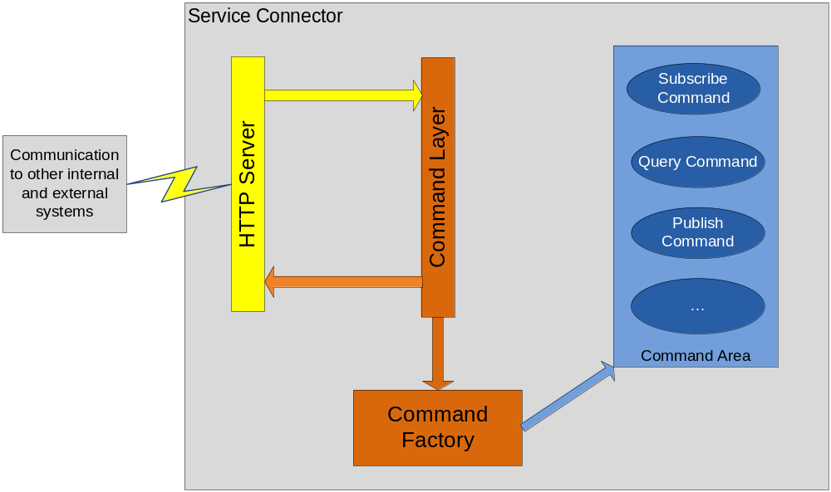
Figure 3 Simplified Communication Layers

Server Side
The following picture shows the server side class model:

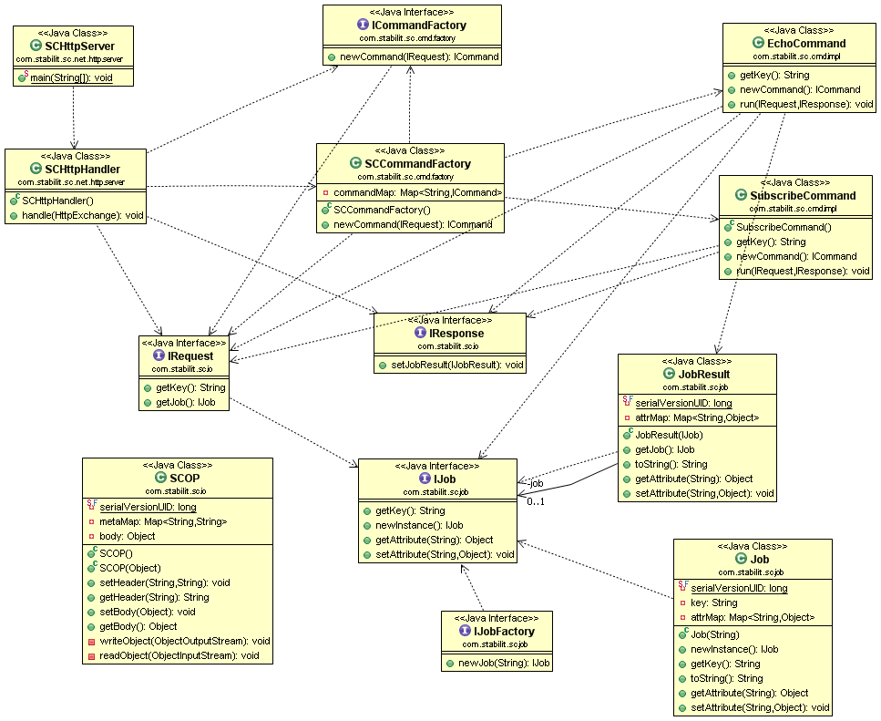
Figure 4 Server side class model

Client Side
The following picture shows the client side class model:

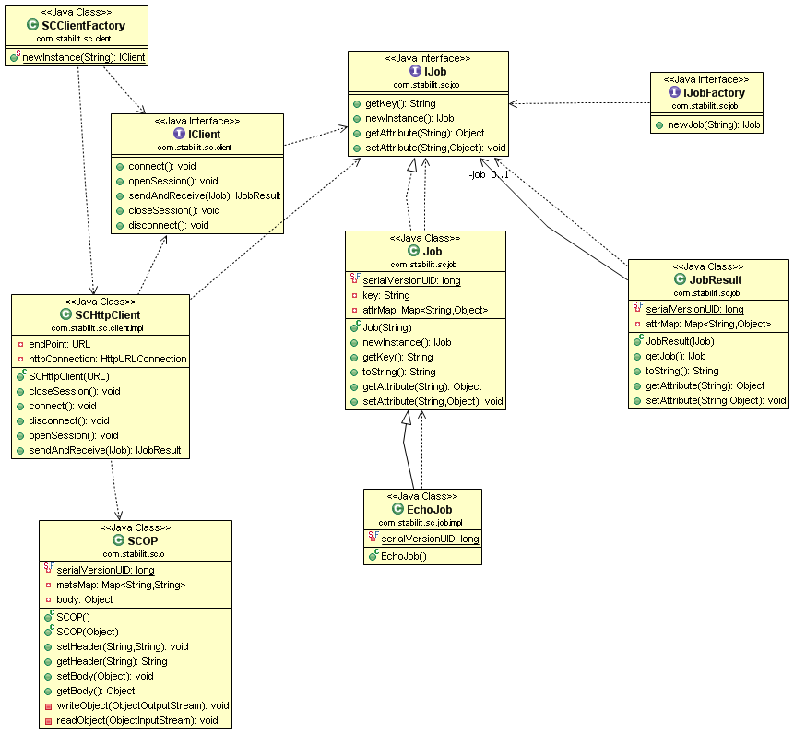
Figure 5 Client class model

Http Server (sync)
The SC Http Server is simple and easy. A SCOP instance is read (IRequest). The command factory (CommandFactory) checks if a command for given job is available and returns them. The server invokes the command and waits until the response is ready. This response will be returned to the calling client within a SCOP object containing an IJobResult instance.

package com.stabilit.sc.net.http.server;

public class SCHttpServer {

public static void main(String[] args) {
int port = 80;
HttpServer httpServer = null;
try {
httpServer = HttpServer.create(new InetSocketAddress(port), 0);
httpServer.createContext("/", new SCHttpHandler());
httpServer.start();
synchronized (httpServer) {
httpServer.wait();
}
} catch (Exception e) {
e.printStackTrace();
} finally {
httpServer.stop(0);
}

}

static class SCHttpHandler implements HttpHandler {

public SCHttpHandler() {
}

@Override
public void handle(HttpExchange httpExchange) throws IOException {
try {
IRequest request = new SCHttpRequest(httpExchange);
IResponse response = new SCHttpResponse(httpExchange);
ICommandFactory commandFactory = new SCCommandFactory();
ICommand command = commandFactory.newCommand(request);
command.run(request, response);
} catch (CommandException e) {
e.printStackTrace();
throw new IOException(e);
}
}
}
}

Figure 6 http server

Client (sync)
The client factory returns a client instance for given endpoint. In case of a http endpoint a client instance of type SCHttpClient is returned.
The client connects to the endpoint. We get the job instance from a JobFactory. A synchronized call to the server is invoked within the client sendAndReceive(job) method. The client waits until an IJobResult instance returns or an exception occurs:

IClient client = SCClientFactory.newInstance(endPoint);
client.connect();
IJobFactory jobFactory = new JobFactory();
IJob job = jobFactory.newJob("echo");
IJobResult jobResult = client.sendAndReceive(job);
IJob jobReturn = jobResult.getJob();
client.disconnect();

Figure 7 Client

Note: A session context is required in general when running a job request. No session context is required to run the simple echo job.

Service Hub
The SC Service Hub is the midpoint between message providers and listeners. We find the same concept in Eclipse RCP (Rich Client Platform):

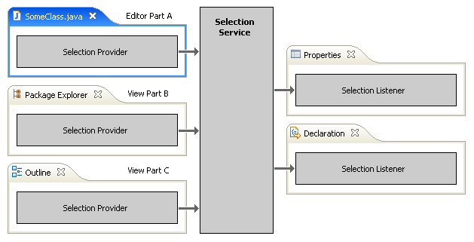

Figure 8 Service Hub

We take the same concept, but it’s a message hub and not a selection provider:

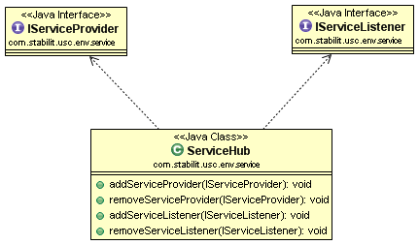
Figure 9 Service Hub

Service Provider
A service provider pushes messages of interest to the service hub. The message format is always the same (header/body (job)). A filter mask (bit mask) characterises the message content. The hub keeps all incoming messages of interest (say: a listener mask matches) in a sequencing queue.

Important: Save all messages in a single place, do not clone any messages.

In a EUREX environment the systems ROFF and RCFM are service providers.

Service Listeners
A SC client is in general a service listener. A SC proxy is a service listener too. Service listeners subscribe for published messages of interest using a filter mask. The service hub distributes any provided messages to the listeners if the mask filter matches. Every registered service listener has a pointer to the service queue, this pointer identifies the last non distributed message instance.

Important: Listeners asks itself for any new message. The service hub does not push messages to its listeners.

If a listener is dead or does not react for a given timeout, then the service hub deletes all resources for given relation (say: close the connection and free any references).

The Queue
The internal service hub message queue is the heart between the providing and listening systems. A high performance architecture is required. The filter mask algorithm must be optimized.

The following picture explains the basic principle:

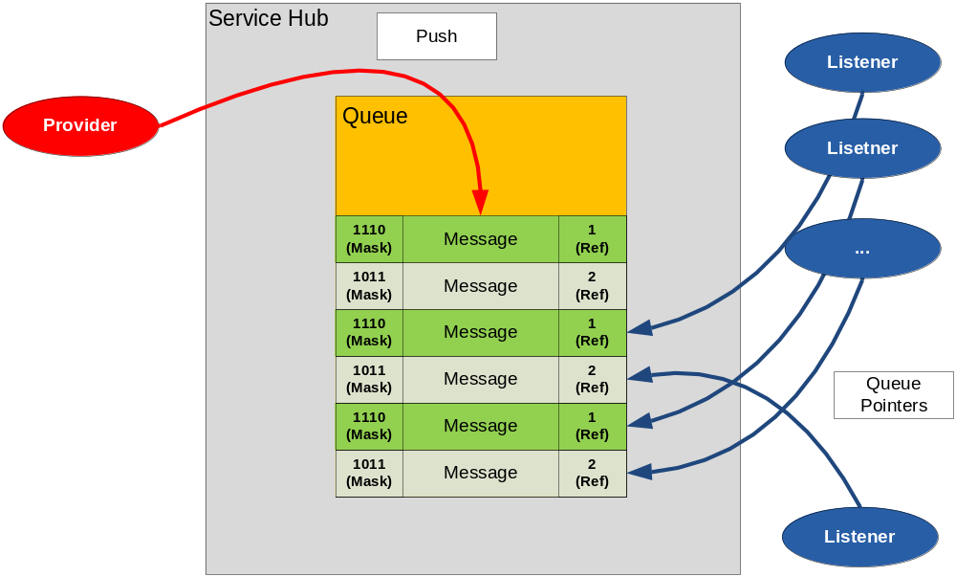
Figure 10 Message Queue

Multiple Queues
Each service hub (in general one single instance per server) can manage multiple message queues. Each queue links a set of providers together with a set of listeners of same interest. Each queue has a unique key. The service hub has a factory method creating a queue with a given key. A queue is created by another object (e.g. a service).

The service hub queue principal:

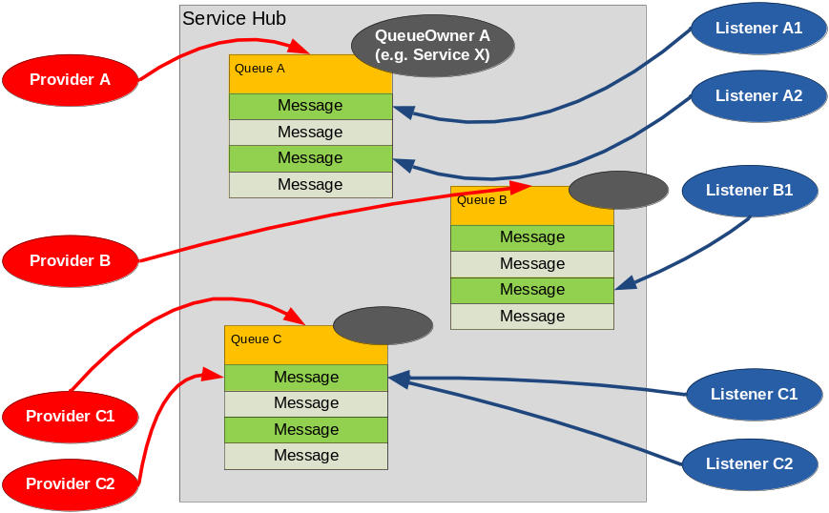
Figure 11 Multiple Message Queue

The service hub queue class model:

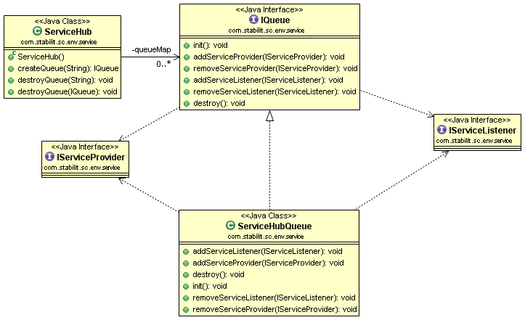
Figure 12 Message Queue

Kernel
The service connector kernel contains the central software parts like service hub, communication stack, etc. The kernel MUST be completely independent from any external requirements like specific message formats or transport protocols.

Services like publish/subscribe or query are NOT part of the kernel. All services are kept outside of the kernel area. An update of any service does not have any impact to the kernel.

The kernel MUST be highly configurable.

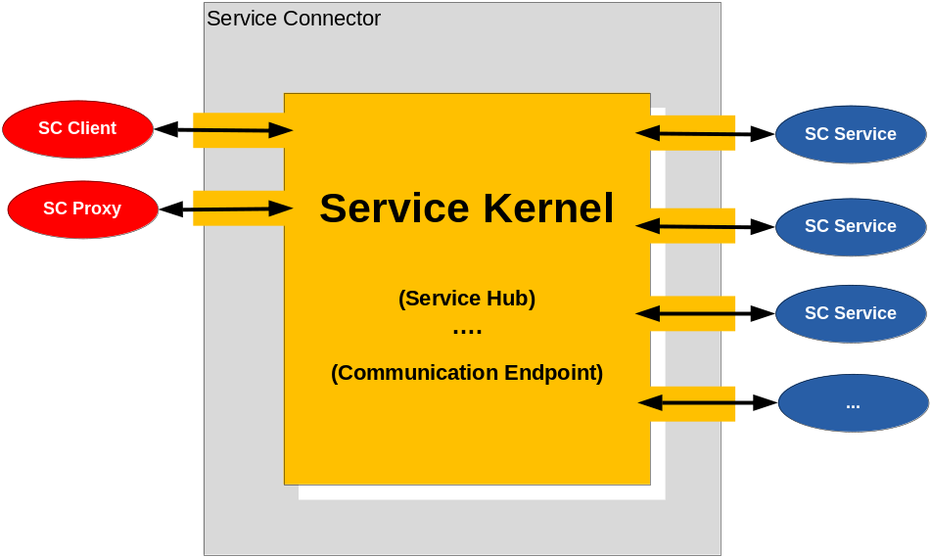
Figure 13 Kernel

Deployment
The UML deployment diagram above shows the SC deployment structure. A proprietary gateway builds the port to the external hosts (ROFF, RCFM, ICS, TXS, TXR…).

The SC Server loads any SC Services from a configuration web server. Each service belongs to a separate JAR (Java Archive). The server downloads the JAR’s from the web server and starts the services dynamic. If no web server is available, then the local previous loaded configuration is running up. The server itself does not configure any services by default except supporting services like configuration endpoints or e.g. the echo service.

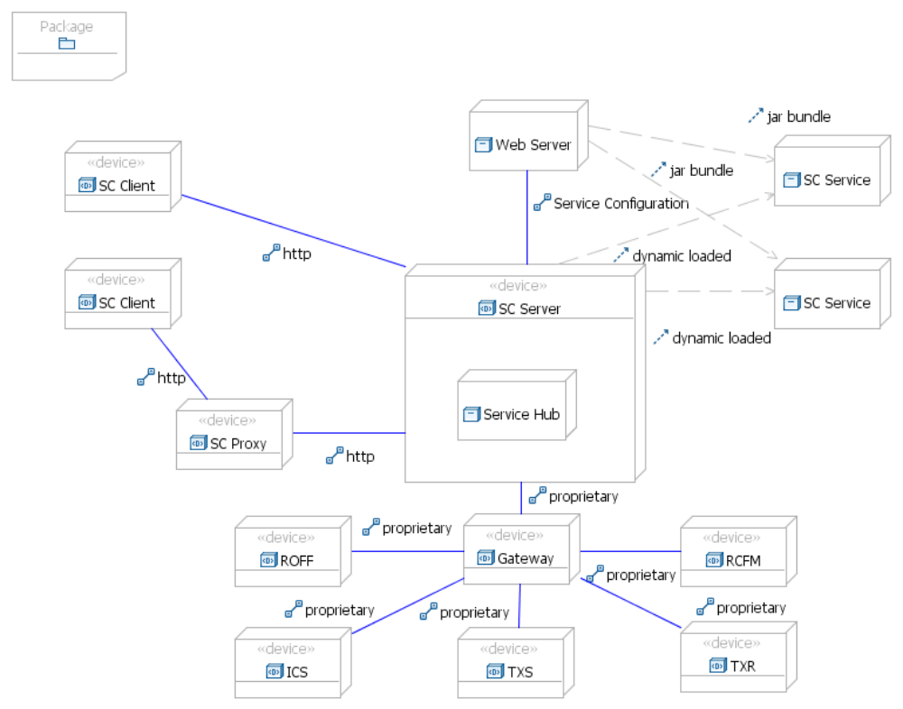
Figure 14 Deployment

Note: Local file based configurations are supported and replace any web based configuration. A basic property file (e.g. xml or system properties) defines the configuration location.

Communication
Service Connector supports synchronous and asynchronous communication protocols. Synchronous protocols should be stateless in general. Asynchronous protocols are more complex.

For better consistency a session context is necessary for all communications.

Synchronous Communication (Request/Response)
A synchronous communication between a client and a server is simple if the response is not too long. The client starts a request to the server and waits until the server returns any response. A session context is required.

Small/Regular Size Responses
In case of responses of small or regular size the following sequence diagram is valid:
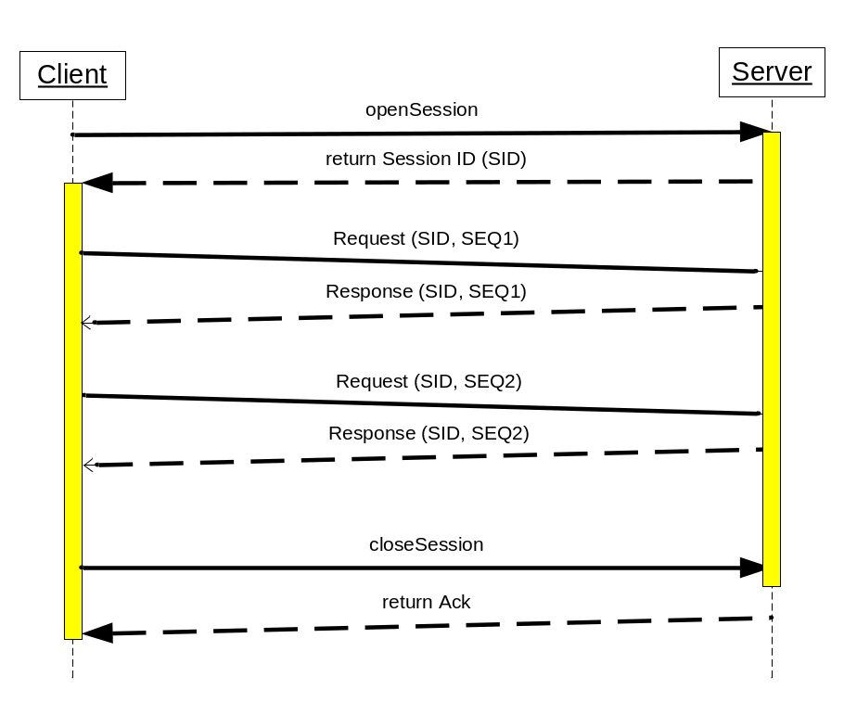
Figure 15 Synchronous Request/Response

Large Size Responses
In case of large size responses a separate channel is used to read the large response from the server. The server decides if a response is large or not. In case of a large response the server returns another location to the client addressing the huge response for download. In http we talk about redirecting to another location.

The large response will can be read in a separate session. The client API should handle this situation.

The following diagram explains how large responses work:
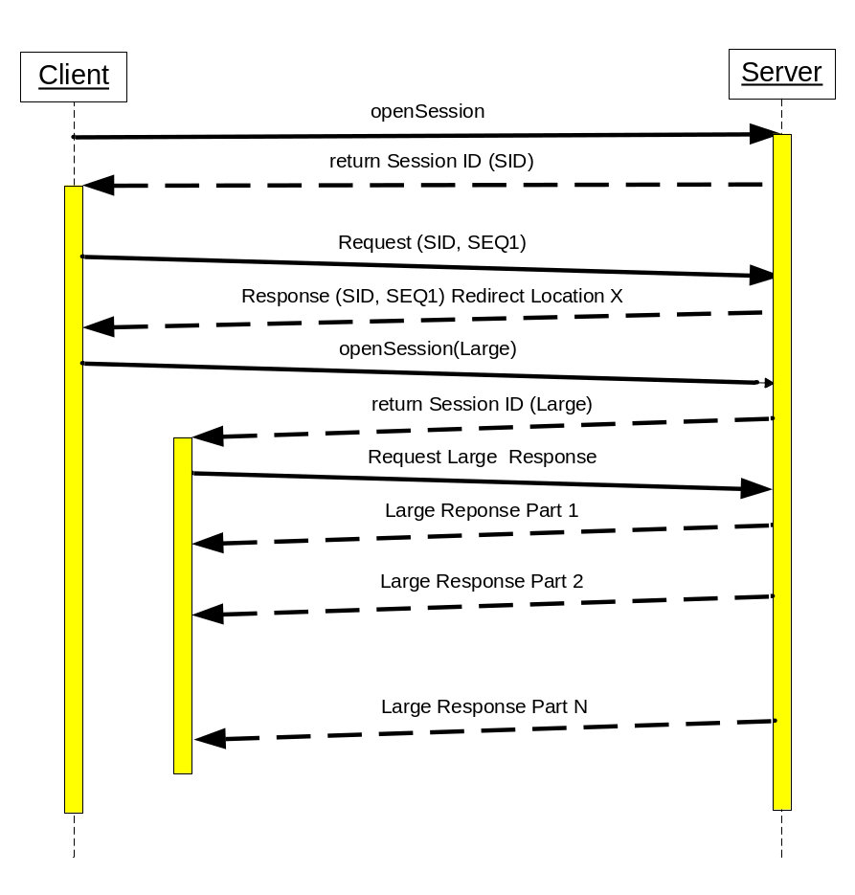
Figure 16 Large Response

But what happens if a connection failure occurs during a huge response read?

In this case the client should be able to continue reading the response from the server. Any second full read is not a good choice.

Asynchronous Communication (Request/Callback)
SC supports asynchronous communication protocols. In this case the request does not wait for the response. The response is returned to the caller via callback. There can be one or more callbacks for a given request.

Single Callback
Single callback means that for a request only one single response is returned asynchronous:
The session remains open until the callback returns or a failure occurs:
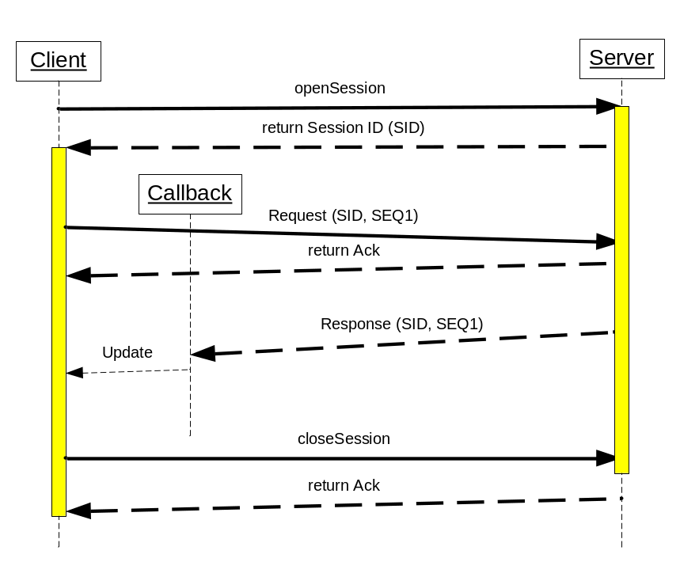
Figure 17 Asynchronous Request/Response

Important: No physical connection is required for the whole connection cycle. The client can reconnect anytime and continue reading the message from the server.

Multiple Callbacks
Publish/Subscribe results in multiple callbacks. The client receives messages from the server as long as the server is alive and the client does not unsubscribe. Any reconnect for both connection points is possible and has no impact.
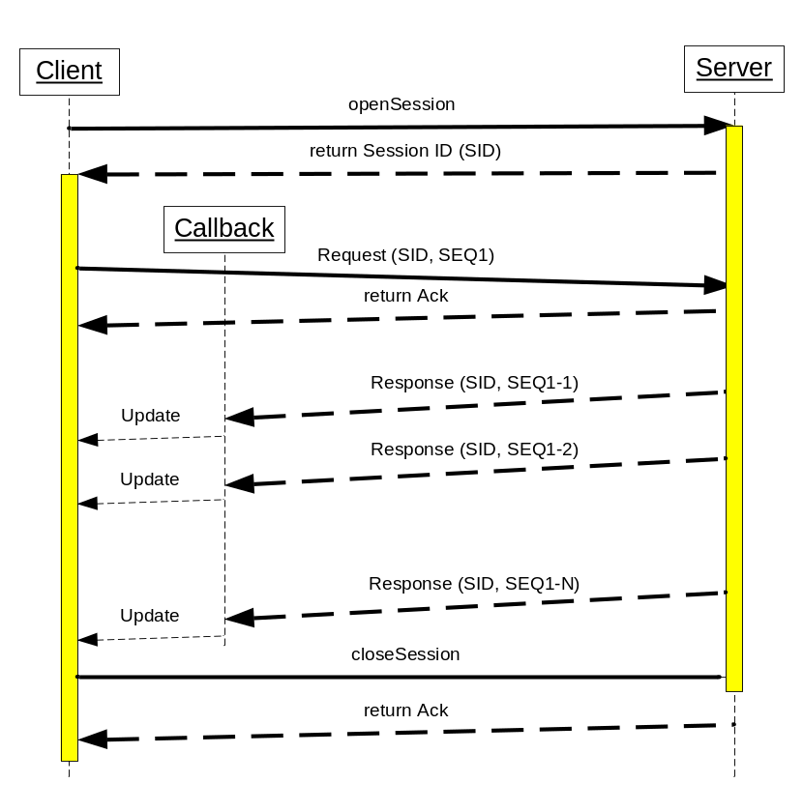
Figure 18 Asynchronous Request/Response

Subscribe/Publish
A client subscribes for an existing service hub queue. After successful subscription the client receives any provided messages matching the clients filter mask. Provided messages are only sent to the subscribed client if he asks for them.
Publishing of messages ends when the client unsubscribes or any failure occurs.
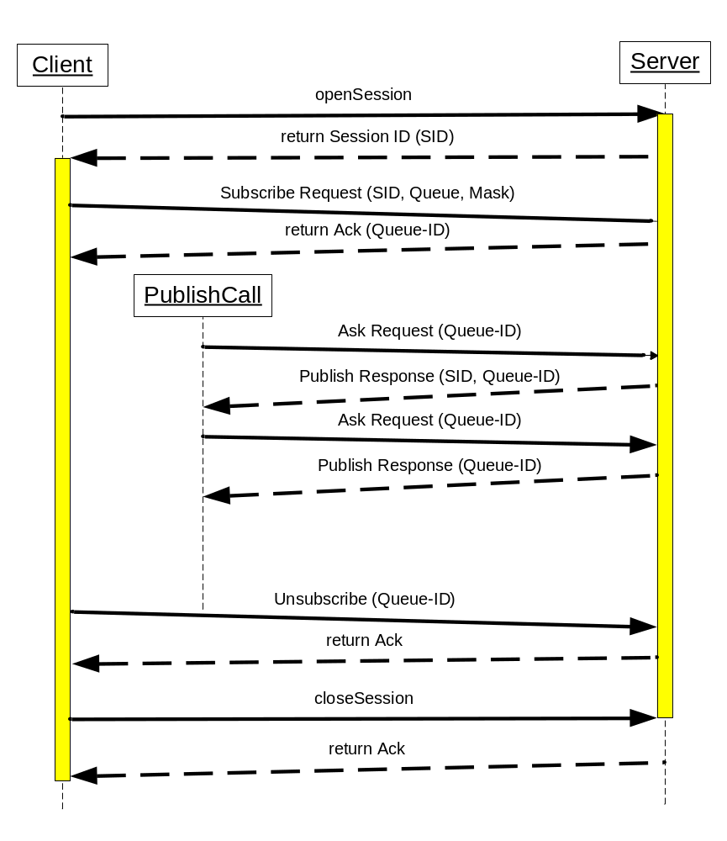
Figure 19 Subscribe/Publish

Note: A server restart resets all queues and subscriptions. The client must subscribe again.

Keep Alive
The customer network infrastructure consists multiple network zones separated by firewalls. Those firewalls close inactive (say: no transfer) connections after a given timeout. Longtime responses and asynchronous protocols can be interrupted if they don’t respect this timeout.

An application protocol should be independent of any underlying network rules. The application assumes that everything goes well. Network dependent timeouts MUST be handled on the underlying transport layer. A keep alive mechanism, which is part of the transport layer keeps open connections alive:

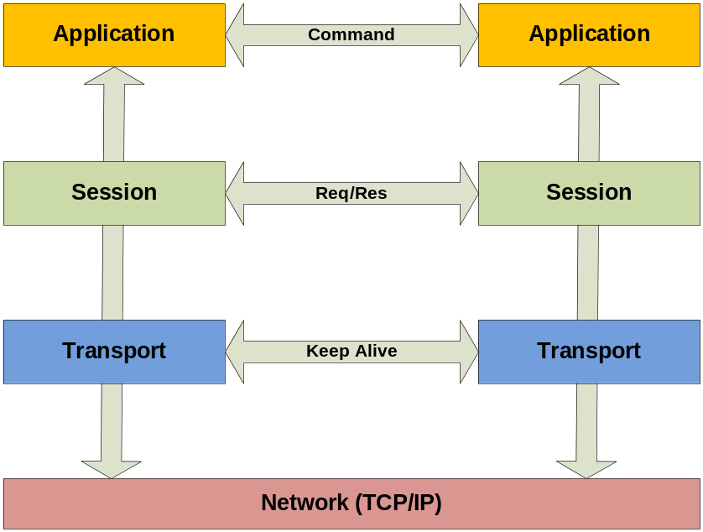
Figure 20 Keep-alive messages

SCOP
The Service Connector Object Protocol (SCOP) standardizes how a message is transmitted between connection endpoints. SCOP uses a simple HEAD-BODY pattern. The header contains textual meta info specifying the body content. The body itself is a binary and keeps one single job object. The job instance is application specific and only readable by the application layer. SCOP does not define how a Job is rendered.

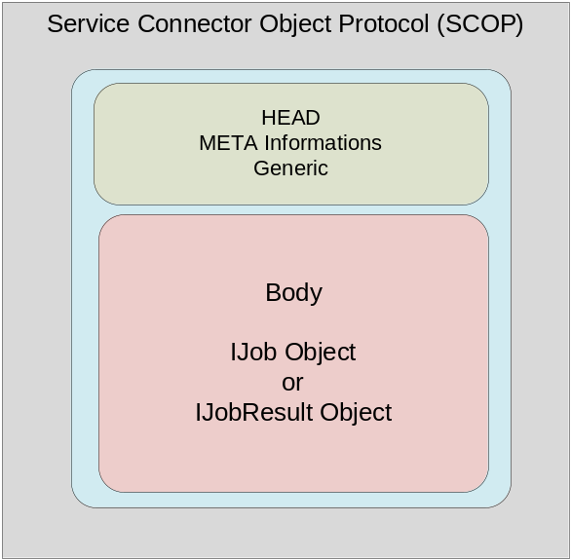
Figure 21 Service Connector Object Protocol

Per default a job instance is serializable using the standard java object serialization mechanism. In case of performance issues an application specific serialization is possible.

The SCOP class diagram:

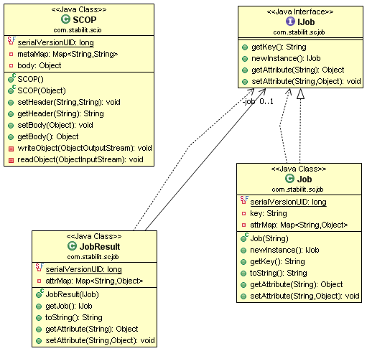
Figure 22 SCOP class diagram

Job Redirection
When a client tries to run a job on a server then the server may reply with a redirect location to another server. In this case the client switches to this new server location and tries to run the same job on this redirected server. Future jobs will be invoked on this new server location until another redirect response is returned.

A client can call to multiple servers. An active connection is only supported for one server at the same time.

Application Programming Interface API
The java SC API is deployed as JAR file. Both server and client API are in the same JAR.

Proposal of Client API for C

The semantic of the client interface for request / response services type has the following sequence:
Semantics
- AttachClient
- ConnectService A
- SendAndReceive or Send to service A
...
- ConnectService B
- SendAndReceive or Send to service B
...
- DisconnectService A
- DisconnectService B
- DetachClient

The semantic of the client interface for the subscribe / publish services type has the following sequence:
- AttachClient
- Subscribe service A
... receiving messages via MessageReceiver to service A
- Subscribe service B
... receiving messages via MessageReceiver to service B
- Unsubscribe service A
- Unsubscribe service B
- DetachClient

AttachClient
AttachClient(
OUT ConnectionCtx: connection context
IN String: SC address,
IN Integer: SC port number,
IN String: SC protocol,
IN Integer: timeout,
IN Integer: keep alive interval,
IN Integer: keep alive timeout
IN Integer: connection pool size)
Connects the client to the SC. From now on keep alive messages are sent between the client and the SC in order to detect broken connection. This method gets the control back when the connection to SC is established.
Parameters:
- Handle to the connection context. This context handle must be used in subsequent calls. The client may have multiple SCs attached at the same time. This connection context must be kept unique.
- SC IP address or DNS name of the node on which the CS is running
- Port number the SC expects the connection (default is 80)
- Communication protocol to be used (HTTP = Default or TCP/IP)
- Timeout in seconds for this operation (default = 60). Value = 0 means no timeout.
- Interval in which keep alive messages are sent to SC. (default = 300). Value = 0 means no keep alive.
- Timeout in seconds for receipt of the keep alive response (default = 60)
- Connection pool size, number of connection that will be maximally used to communicate to SC.
Possible errors:
- SC is not available
- Communication error
- Timeout expired

DetachClient
DetachClient(
IN ConnectionCtx: connection context
IN Integer: timeout)
Disconnects the client from the SC. This method gets the control back when the connection is discarded.
Parameters:
- Context of the connection to be destroyed.
- Timeout in seconds for this operation (default = 60). Value = 0 means no timeout.
Possible errors:
- Communication error
- Timeout expired

ConnectService
ConnectService (
IN ConnectionCtx: connection context
OUT ServiceCtx: service context
IN String: service name,
IN String: connection information
IN Address: response message receiver
IN Integer: timeout,)
Connects the client to a request/response service. One free server is allocated and a logical session between the client and the server is established. On the server the ControlEventReceiver gets control with the event = Connect. This method gets the control back when the allocated server accepts the new session.
Parameters:
- Context of the connection to be used.
- Handle to the service context. This context handle must be used in subsequent calls. The client may have multiple services on the same SC connected at the same time.
- Name of the service the client wants to connect to.
- Connection information passed to the server (e.g. used for authentication)
- Address of the asynchronous response receiver
- Timeout in seconds for this operation (default = 60). Value = 0 means no timeout.
Possible errors:
- Service does not exist
- Service is not Request/Response type
- No free server is available
- Server rejects connection
- Communication error
- Timeout expired

DisconnectService
DisconnectService (
IN ServiceCtx: service context
IN Integer: timeout)
Disconnects the client from the request/response service and closes the logical session. On server the ControlEventReceiver gets control with the event = Disconnect. This method gets the control back when the session is closed.
Parameters:
- Context of the service to be destroyed.
- Timeout in seconds for this operation
Possible errors:
- Communication error
- Timeout expired

SendAndReceive
SendAndReceive(
IN ServiceCtx: service context
IN String: routing information,
IN String: request message,
OUT String: response message,
OUT Integer: error code
OUT String: error message
IN Integer: timeout
IN Boolean: compress flag)
Sends a synchronous request to the service identified by the context and waits for the arrival of the response message. On server the ServiceExecutor gets control with request message and performs the service. This method gets the control back when the response message arrives.
Parameters:
- Context of this service.
- Routing information passed to the server (e.g. message type)
- Request message passed to the server
- Response message received from the server
- Error code filled by the server
- Error message filled by the server
- Timeout in seconds for this operation (default = 60). Value = 0 means no timeout.
- Compression flag to enable or disable message compression during the transport (default = true)
Possible errors:
- Communication error
- Timeout expired

Send
Send(
IN ServiceCtx: service context
IN String: routing information,
IN String: request message,
IN Boolean: compress flag)
Sends request message to the service identified by given context. The registered response receiver that will get control when the response message arrives. On server the ServiceExecutor gets control with request message and performs the service. This method gets the control back when request message was sent.
Parameters:
- Context of this service.
- Routing information passed to the server (e.g. message type)
- Request message passed to the server
- Compression flag to enable or disable message compression during the transport (default = true)
Possible errors:
- Communication error

Response Message Receiver (callback)
ResponseMessageReceiver (
OUT ServiceCtx: service context
OUT String: response message,
OUT Integer: error code
OUT String: error message)
Function that receives an asynchronous response message from the server. This method gets control when the response message arrives.
Parameters:
- Context of this service.
- Response message received from the server
- Error code filled by the server
- Error message filled by the server
Possible errors:
- Communication error

Subscribe
Subscribe (
IN ConnectionCtx: connection context
OUT ServiceCtx: service context
IN String: service name,
IN String: subscription mask
IN Integer: timeout,
IN Address: publish message receiver)
Subscribes the client on a subscribe/publish service. From now on keep alive messages are sent to the SC in order to detect broken connection. When a message is published and matches the client subscription mask, the registered publish message receiver routine will get control and the published message. This method gets the control back when the subscription becomes effective.
Parameters:
- Context of the connection to be used.
- Handle to the service context. This context handle must be used in subsequent calls.
- Name of the service the client wants to subscribe to.
- Subscription mask used to designate interest on certain published messages
- Timeout in seconds for this operation (default = 60). Value = 0 means no timeout.
- Address of the message receiver that gets control when a published message arrives.
Possible errors:
- Service does not exist
- Service is not Subscribe/Publish type
- Communication error
- Timeout expired

Unsubscribe
Unsubscribe (
IN ServiceCtx: service context
IN Integer: timeout)
Removes the client subscription and disconnects the client from the subscribe/publish service on SC. From now on the client will not receive any more messages. This method gets the control back when the connection is closed.
Parameters:
- Handle to the service context.
- Timeout in seconds for this operation (default = 60). Value = 0 means no timeout.
Possible errors:
- Communication error
- Timeout expired

ChangeSubscription
ChangeSubscription (
IN ServiceCtx: service context
IN String: subscription mask
IN Integer: timeout)
Changes the client subscription. Old subscription is discarded. This method gets control back to the client when the new subscription becomes effective.

Parameters:
- Handle to the service context.
- New subscription mask used to designate interest on certain published messages
- Timeout in seconds for this operation (default = 60). Value = 0 means no timeout.
Possible errors:
- Communication error
- Timeout expired

Publish Message Receiver (callback)
PublishMessageReceiver (
OUT ServiceCtx: service context
OUT String: routing information,
OUT String: published message,
OUT String: message mask)
Routine that receives the messages published by the server to the service. This method gets control when the published message arrives.
Parameters:
- Context of this service. (contains the service name)
- Routing information filled by the server (e.g. message type)
- Message published by the server
- Effective mask of the message
Possible errors:
- Communication error

getConnectionParameter
getConnectionParameter (
IN ConnectionCtx: connection context
IN String: parameter name,
OUT String: parameter value)
Returns various connection parameters. This method gets control back immediately.
Parameters:
- Context of the connection.
- Name of the parameter
- Parameter value
Possible errors:
- Unknown parameter

getServiceParameter
getServiceParameter (
IN ServiceCtx: service context
IN String: parameter name,
OUT String: parameter value)
Returns various service parameters. This method gets control back immediately.
Parameters:
- Context of this service.
- Name of the parameter
- Parameter value
Possible errors:
- Unknown parameter

getError
getError (
IN ServiceCtx: service context
OUT String: error message)
Returns the last error for this service. This method gets control back immediately.
Parameters:
- Context of this service.
- Last error message

Server API

The semantic of the server interface for request / response services type has the following sequence:
Semantics
- AttachServer
- RegisterService
- ... executing either ControlEventReceiver or ServiceExecutor
ServiceExecutor may publish message via Publish

The semantic of the client interface for the subscribe / publish services type has the following sequence:
- AttachServer
- Publish
... publish more messages
- DetachServer

The server API provides the following functions:

AttachServer
Attachserver(
OUT ConnectionCtx: connection context
IN String: SC address,
IN Integer: SC port number,
IN String: SC protocol,
IN Integer: timeout,
IN Integer: keep alive interval,
IN Integer: keep alive timeout)
Connects the server to the SC. This method gets the control back when the connection to SC is established.
Parameters:
- Handle to the connection context. This context handle must be used in subsequent calls. The server must NOT have multiple SCs attached at the same time!
- SC IP address or DNS name of the node on which the CS is running
- Port number the SC expects the connection (default is 80)
- Communication protocol to be used (HTTP = Default or TCP/IP)
- Timeout in seconds for this operation (default = 60). Value = 0 means no timeout.
- Interval in which keep alive messages are sent to SC. (default = 300). Value = 0 means no keep alive.
- Timeout in seconds for receipt of the keep alive response (default = 60)
Possible errors:
- SC is not available
- Communication error
- Timeout expired

DetachServer
DetachServer(
IN ConnectionCtx: connection context
IN Integer: timeout)
Disconnects the server from the SC. This method is used only by publishing servers. Other servers will be notified via event to perform a shutdown. This method gets the control back when the connection is discarded.
Parameters:
- Context of the connection to be destroyed.
- Timeout in seconds for this operation (default = 60). Value = 0 means no timeout.
Possible errors:
- Communication error
- Timeout expired

RegisterService
RegisterService(
IN ConnectionCtx: connection context
IN String: service name,
IN Integer: max sessions
IN Integer: idle session timeout
IN Address: control event receiver
IN Address: service executor;
IN Integer: timeout)
Connects the server to a service. This method must be called before the first client will connect to this service. This method gets control back when the control event receives the shutdown event.
Parameters:
- Handle to the connection context.
- Name of the service the server will serve.
- Maximal number of concurrent sessions this server will serve. (Value > 1 requires a multithreaded server!)
- Timeout defining how long a session can be idle. (When this timeout expires, the control message receiver is invoked with event = timeout)
- Address of the control message receiver method
- Address of the executor method
- Timeout in seconds for this operation (default = 60)
Possible errors:
- Service does not exist
- Service is not Request/Response type
- Communication error
- Timeout expired

Control Event Receiver (callback)
ControlEventReceiver (
OUT ConnectionCtx: connection context
OUT String: event,
OUT String: event information
IN Boolean: accept event)
Server method that receives control messages from SC.
Parameters:
- Context of the connection.
- Event that occurred. The possible events are:
Connect – the client has connected and a logical session was established.
Disconnect – the client has disconnected from this server
Timeout – the connection is idle longer then the negotiated timeout
Abort – the logical session was aborted
Shutdown – The server should shut down
- Event information passed by the client (only Connect event) (e.g. used for authentication)
- The accept event flag is passed back to SC. True means the server accepts the event, false means the server rejects the event.
Possible errors:
- Communication error

ServiceExecutor(callback)
ServiceExecutor (
OUT ConnectionCtx: connection context
OUT String: routing information,
OUT String: request message,
IN String: response message,
IN Integer: error code
IN String: error message)
Server routine that implements the service.
Parameters:
- Context of this connection.
- Routing information passed by the client (e.g. message type)
- Request message passed from the client
- Response message returned by the server
- Error code passed to the client
- Error message passed to the client
Possible errors:
- Communication error

Publish
Publish(
IN ConnectionCtx: connection context
IN String: service name
IN String: message mask,
IN String: routing information,
IN String: publish message,
IN Boolean: compress flag
IN Integer: timeout)
Sends a publish message to a service. This message is then distributed to the subscribed clients. On client the PublishMessageReceiver gets control and this message. This method gets the control back when the message was received by SC (not when it was distributed!).
Parameters:
- Context of this connection.
- Name of the service
- Message mask designating its type)
- Routing information passed to the client (e.g. message type)
- Message to be published to subscribed clients
- Compression flag to enable or disable message compression during the transport (default = true)
- Timeout in seconds for this operation (default = 60). Value = 0 means no timeout.
Possible errors:
- Service is not Subscribe/Publish
- Communication error

getConnectionParameter
getConnectionParameter (
IN ConnectionCtx: connection context
IN String: parameter name,
OUT String: parameter value)
Returns various connection parameters. This method gets control back immediately.
Parameters:
- Context of the connection.
- Name of the parameter
- Parameter value
Possible errors:
- Unknown parameter

getServiceParameter
getServiceParameter (
IN ServiceCtx: service context
IN String: parameter name,
OUT String: parameter value)
Returns various service parameters. This method gets control back immediately.
Parameters:
- Context of this service.
- Name of the parameter
- Parameter value
Possible errors:
- Unknown parameter

getError
getError (
IN ServiceCtx: service context
OUT String: error message)
Returns the last error for this service. This method gets control back immediately.
Parameters:
- Context of this service.
- Last error message

Proposal of Client-Server API for Java
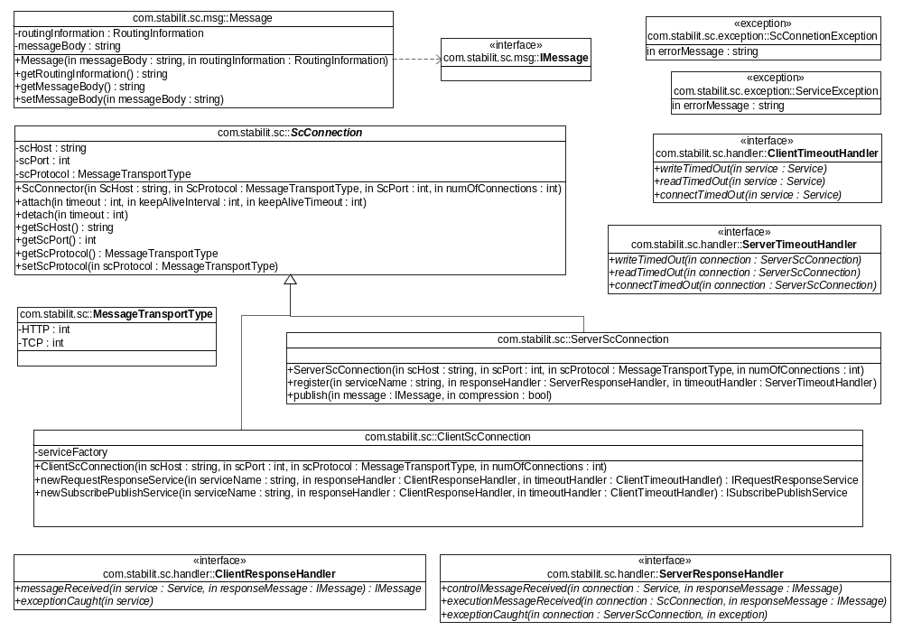
Figure 23 Client-Server API for Java (Connection Overview)
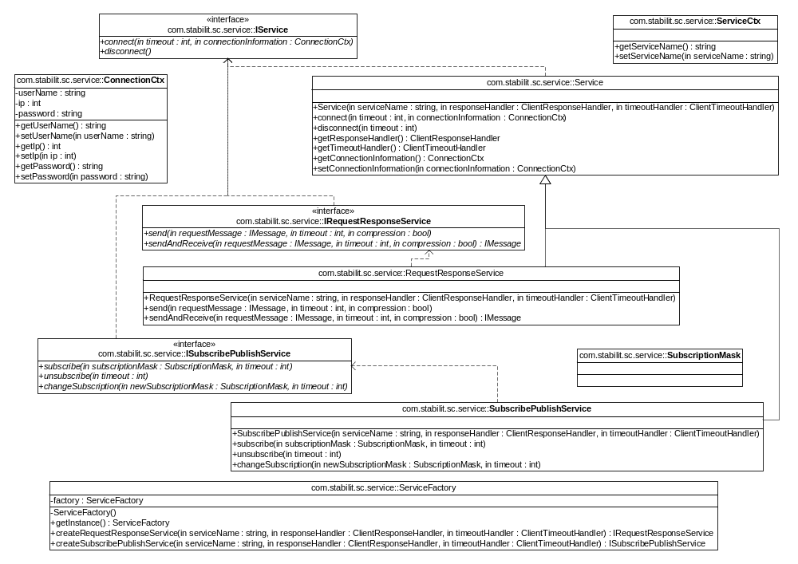
Figure 24 Client-Server API for Java (Service Overview)

The semantic of the client interface for request / response services type has the following sequence:
Semantics
- Instantiate ClientScConnection (Connection from Client to SC)
- Attach Client
- Create new RequestResponseService A
- ConnectService A
- SendAndReceive or Send to service A
...
- ConnectService B
- SendAndReceive or Send to service B
...
- DisconnectService A
- DisconnectService B
- DetachClient

The semantic of the client interface for the subscribe / publish services type has the following sequence:
- Instantiate ClientScConnection (Connection from client to SC)
- Attach Client
- Create new SubscribePublishService A
- Subscribe service A
... receiving messages via ClienResponseHandler to service A
- Create new SubscribePublishService B
- Subscribe service B
... receiving messages via ClienResponseHandler to service B
- Unsubscribe service A
- Unsubscribe service B
- DetachClient

Glossary
Glossary item
glossary text

Appendix
text

No index entries found.

