SC

Service Connector

SC Message Protocol V1.0 and SC Application Programming Interface

SC_1_SCMP-V1.0_E (Version V2.2)
This document describes the SC Message Protocol V1.0 (SCMP) and presents a proposal for Application Programming Interface (API).

This document is a spiritual ownership of STABILIT Informatik AG, and must not be used or copied without a written allowance of this company. Unauthorized usage is illegal in terms of Chapter 23 / 5 UWG / Swiss law.

The information in this document is subject to change without notice and should not be construed as a commitment by STABILIT Informatik AG.

Copyright © 2026 by STABILIT Informatik AG
All rights reserved.

All other logos, product names are trademarks of their respective owners.

This Document has been created with Microsoft Word 2003 (11) with template file and printed at 17 March 2010 08:54.

Identification
Project: | SC
Title: | Service Connector
Subtitle: | SC Message Protocol V1.0 and SC Application Programming Interface
Version: | V2.2
Reference: | SC_1_SCMP-V1.0_E
Classification: | Confidential
Keywords: | Concepts, Communication, Protocol, Programming Interface
Comment: | This document describes the SC Message Protocol V1.0 (SCMP) and presents a proposal for Application Programming Interface (API).
Author(s): | STABILIT Informatik AG  Jan Trnka, Daniel Schmutz, Joel Traber
Approval (Reviewed by): | Signature Jan Trnka  Signature Francisco Gonzalez
Audience: | Project team, Eurex IT management, Review team
Distribution: | Project team, SIX development team
Filename | /tmp/lo/0000.doc
Revision History
Date | Version | Author | Description
14.06.2009 | D1.0 | Jan Trnka | Initial draft
09.08.2009 | D1.1 | Jan Trnka | Separate specification and architecture documents. Fill information from Daniel into this document.
… | … | Jan Trnka | Many changes in between not tracked
24.2.2010 | V2.0 | Jan Trnka | Proposal for C-API
3.3.2010 | V2.1 | Jan Trnka | Remove SC architecture from this document
11.4.2010 | V2.2 | Jan Trnka | Prepare for review

Table of Contents
1 Preface 5
1.1 Purpose & Scope of this Document 5
1.2 Definitions & Abbreviations 5
1.3 External References 5
1.4 Typographical Conventions 5
1.5 Outstanding Issues 6
2 Communication Schema 7
2.1 Connection Topology 7
2.2 Network Security 8
3 Service Model 10
3.1 Session Services 10
3.2 Publishing Services 11
3.3 File Services 12
3.4 HTTP Proxy Services 12
4 Semantic 13
5 Message Protocol 15
5.1 Headline 15
5.2 Header 16
5.3 Body 16
5.4 SCMP over TCP/IP 16
5.5 SCMP over HTTP 16
6 SCMP Messages 17
6.1 CONNECT 17
6.2 DISCONNECT 17
6.3 KEEPALIVE 17
6.4 CREATE_SESSION 18
6.5 DELETE_SESSION 18
6.6 CLN_DATA 19
6.7 SUBSCRIBE 20
6.8 UNSUBSCRIBE 20
6.9 CHANGE_SUBSCRIPTION 20
6.10 RECEIVE_PUBLICATION 21
6.11 REGISTER_SERVICE 21
6.12 DEREGISTER_SERVICE 22
6.13 ALLOCATE_SESSION 22
6.14 DEALLOCATE_SESSION 22
6.15 ABORT_SESSION 23
6.16 SRV_DATA 23
6.17 PUBLISH 24
7 SCMP Header Attributes 25
7.1 appErrorCode 25
7.2 appErrorText 25
7.3 bodyLength 25
7.4 cacheSignature 25
7.5 cacheExpirationDateTime 26
7.6 compression 26
7.7 ipAddressList 26
7.8 portNr 26
7.9 keepAliveInterval 26
7.10 keepAliveTimeout 27
7.11 localDateTime 27
7.12 mask 27
7.13 maxSessions 27
7.14 messgageInfo 28
7.15 msgType 28
7.16 multiThreaded 28
7.17 noData 28
7.18 rejectSession 28
7.19 scErrorCode 29
7.20 scErrorText 29
7.21 scVersion 29
7.22 sequenceNr 29
7.23 serviceName 30
7.24 sessionId 30
7.25 sessionInfo 30
8 Java – API 31
8.1 Semantics 32
9 C - API (Proposal) 34
9.1 Context hierarchy 34
9.2 Semantics 34
9.3 Connect 35
9.4 Disconnect 36
9.5 Get Connection Context Parameter 36
9.6 Set Connection Context Parameter 36
9.7 Timeout Handler (callback) 37
9.8 Error Handler (callback) 37
9.9 Create Session 37
9.10 Delete Session 38
9.11 Get Session Context Parameter 38
9.12 Send And Receive 38
9.13 Subscribe 39
9.14 Unsubscribe 39
9.15 Change Subscription 40
9.16 Publish Message Receiver (callback) 40
9.17 Publish 40
9.18 Register Service 41
9.19 Deregister Service 41
9.20 Session Handler (callback) 42
9.21 Message Handler (callback) 42
10 Glossary 43
Appendix A 44
Appendix B SCMP Header Attributes 45
Index 47

Tables
Table 1 Abbreviations & Definitions 5
Table 2 External references 5
Table 3 Typographical conventions 6

Figures
Figure 1 Communication Layers 7
Figure 2 Connection Topology 8
Figure 3 Network Security 8
Figure 4 Synchronous Request/Response 10
Figure 5 Asynchronous Request/Response 11
Figure 6 Asynchronous Subscribe / Publish 11
Figure 7 Synchronous message exchange. 13
Figure 8 Service Connector Message Protocol 15
Figure 9 Client API for Java 31
Figure 10 Server API for Java 32
Figure 11 Client sequence diagram for session services 32
Figure 12 Client sequence diagram for publishing service 33
Figure 13 ExampleServer sequence diagram for publish process 33
Figure 14 API Context Hierarchy 34

Preface

Purpose & Scope of this Document
This document describes the SCMP (SC Message Protocol) and presents a proposal for the Application Programming Interface in different programming languages.

The final and approved version of this document serves as base for the publication as open Source.

This document is particularly important to all project team members and serves as communication medium between them.

Definitions & Abbreviations
Item / Term | Definition / Description
ERM | Electronic Repo Market
GWY | Gateway
HTTP | Hypertext Transport Protocol
HTTPS | HTTP over SSL, encrypted and authenticated transport protocol
Java | Programming language and run-time environment from SUN
JDK | Java Development Kit
Log4j | Standard logging tool used in Java
OpenVMS | HP Operating system, platform for ERM
RMI | Remote Method Invocation - RPC protocol used in Java
RPC | Remote Procedure Call
SOAP | Simple Object Access Protocol
SSL | Secure Socket Layer – secure communication protocol with encryption and authentication
SIX Exchange | Member of SIX Group, Exchange platform provider
TCP/IP | Transmission Control Protocol / Internet Protocol
SIX Telekurs | Member of SIX Group, Financial information provider
SC | Service Connector
USP | Universal Service Processor – existing middleware used by Eurex Repo
Table 1 Abbreviations & Definitions

External References
References | Item / Reference to other Document
[1] | SC_0_Specification_E – Requirement and Specifications for Service Connector
[2]
Table 2 External references

Typographical Conventions
Convention | Meaning
text in italics | features not implemented in the actual release
text in Courier font | code example
[ phrase ] | In syntax diagrams, indicates that the enclosed values are optional
{ phrase1 | phrase2 } | In syntax diagrams, indicates that multiple possibilities exists.
… | In syntax diagrams, indicates a repetition of the previous expression

Table 3 Typographical conventions

The terminology used in this document may be somewhat different from other sources. The chapter Glossary includes a list of often used terms with the explanation of their meaning in this document.

Outstanding Issues
Following issues are outstanding at the time of the document release:
- ?

Communication Schema
The SC implements peer-to-peer messaging above OSI layer-7 (application) network model between client and server applications. The SC is always in between the communicating partners, controlling the entire message flow.

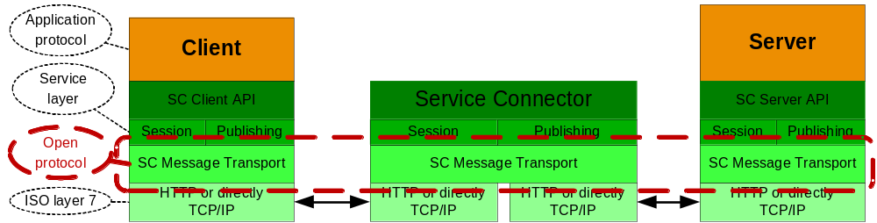
Figure 1 Communication Layers

The SC acts like a broker, passing messages between the client and the server. The communicating parties must agree on the application protocol i.e. format and content of the message payload.

Connection Topology
Client application, server application and the SC may reside on the same node or on separate nodes connected via TCP/IP network. No assumption about the physical network topology is be done. Multiple firewalls can be located on the path between the communicating partners.

The SC supports following connection topology:
- Client ⬄ SC ⬄ Server = Direct connection
- Client ⬄ SC-Proxy ⬄ SC ⬄Server = Connection via SC-Proxy.
Multiple SC-Proxies may be placed on the path between the client and service.
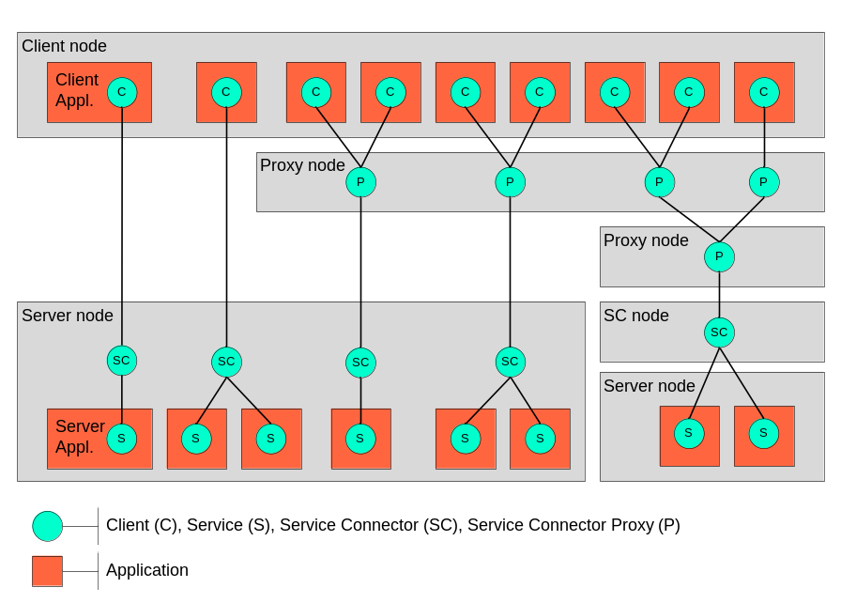
Figure 2 Connection Topology

Different connection topology types from left to right:
- Client connected to one services
- Client connected simultaneously to two services
- Two clients connected to one service via proxy
- Two clients connected to two services via proxy
- Three clients connected to two services via cascaded proxy on two separate nodes and SC offloaded to its own node.

The connection can either utilize HTTP protocol or direct TCP/IP communication.

SC Proxy is used for performance and/or for security reasons. It is transparent for the application and plays the role of the server and client at the same time.

Network Security
From the security viewpoint on the network, the number of clients or server is not relevant. Meaningful are connections between nodes and security measures taken to protect legal subjects to which the particular network segment belongs. The following schema shows some possible networks that may be configured to pass SC messages.
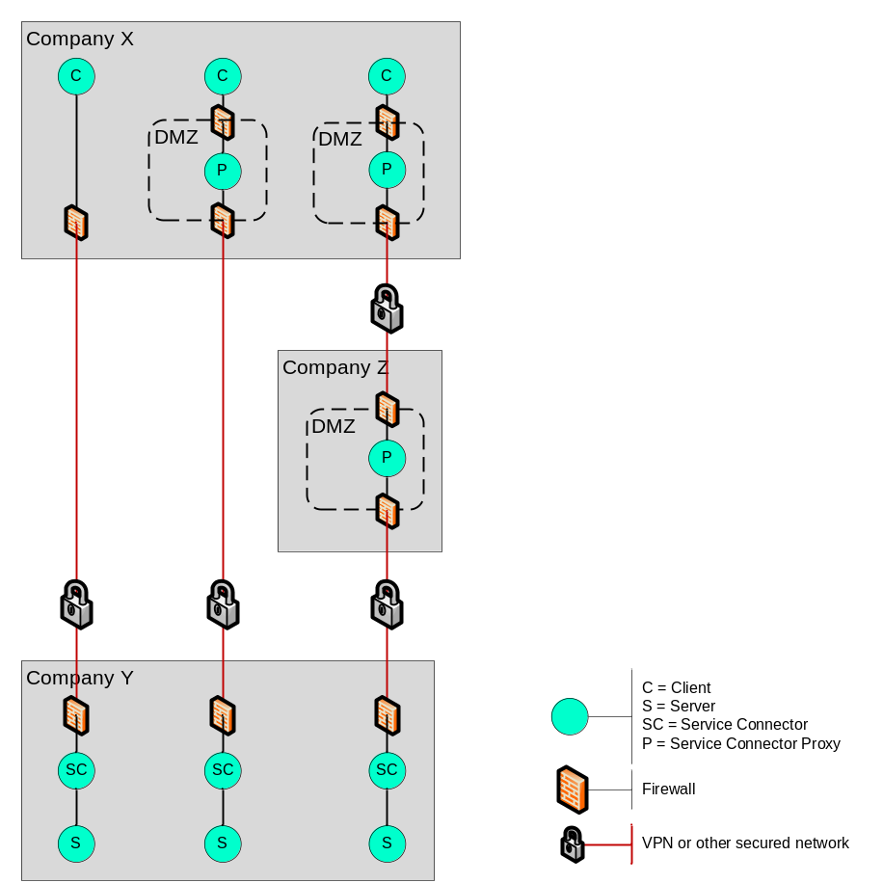
Figure 3 Network Security

The message transport between each of the SC components (green bullet) may be configured as plain TCP/IP or HTTP. The connection is always initiated by the client (top-down in the picture above). The client defines which transport (TCP/IP or HTTP) it will use. The transport protocol between Proxy and the next downstream component is configured in the SC configuration. TCP/IP is strongly recommended between SC proxy and the SC though VPN tunnels as well as between SC and the Server for performance reasons. HTTP is recommended between the client and SC proxy for SC. For connection between SC and Web Server or Application Server (Tomcat) only HTTP can be used.
Protocol

Firewall with a proper configuration may be placed on any path between two SC components. Firewall between SC and the server is possible, but not recommended for performance reasons. For HTTP protocol the firewall can be configured to perform statefull packet inspection with HTTP filtering. For TCP/IP the appropriate port must be configured in the firewall.
Firewall

When the message traffic will pass a firewall, HTTP protocol is recommended. In such case the SC can be seen as a regular Web-Server. The firewall can be configured to perform statefull packet inspection with HTTP filtering. For connection between SC and the server and for communications though VPN tunnels direct TCP/IP is recommended for performance reasons.

When HTTP connection is used and multiple parallel requests are in progress, SC will create multiple connections for each pending request in order to keep them balanced and so satisfy firewall inspection rules. (Statefull inspection rejects two subsequent GET/POST request without response from the server)

Each connection between two SC components is supervised by an algorithm using keepalive messages exchanged in regular (configurable) intervals. The sender monitors the arrival of the echoed message within a timeout; the receiver monitors the interval in which keepalive messages should arrive. These two methods allow independent detection of broken connections on both sites in case the communication will be interrupted without notice. E.g. firewall swallows the traffic. This is algorithm is essential for detection of broken sessions. Keepalive messages are very important to preserve the connection state in the firewall and reset their internal timeout. Only traffic to the outside may refresh the internal firewall timeout. That’s why keepalive message is always initiated by the client. Using of keepalive messages can be disabled.
Keepalive

Service Model
The SC supports message exchange between requesting application (client) and another application providing a service (server). The client and the server are the logical communication end-points. The SC never acts as a direct executor of a service.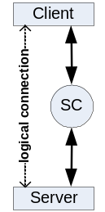 The client can to communicate to multiple services at the same time.

Server application can provide one or multiple service. Serving multiple services within one application is possible only for multithreaded or multisession servers. Multiple server applications are running on the same server node, each providing different service. All services are independent on each other. Server application may request another service and so play the client role.

Session Services
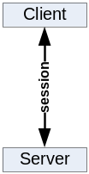Request/Response (client initiated communication). For session services the client and the server exchange messages in context of a logical session through the SC.

The client sends a request to a service that invokes an application code. Upon completion the service sends back a response message. The client waits for the arrival of the response message. The request and response message length is not limited in size.
Synchronous

The communication occurs in a scope of a logical session. SC will choose a free server and pass this and subsequent requests from this client to the same server. Session information is always passed as a part of the message header. The client may have only one outstanding request per session.
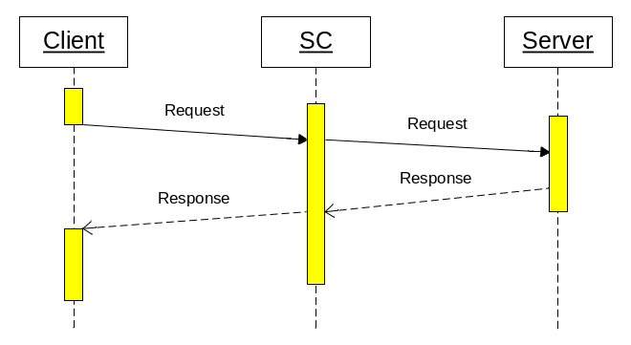
Figure 4 Synchronous Request/Response

Multiple clients may request the same service at the same time. The service execution is in parallel, each one in a separate thread or process. The server decides how many sessions it can serve.

This communication style is the most often used for getting data from the server or sending a message that triggers a transaction on the server.

Asynchronous execution is functionally equal to the synchronous case with the exception that the client does not wait for the arrival of the response message. The client must declare a notification method that is invoked when the response message arrives. The client may have only one outstanding request per session. When client issues a request before the previous one was completed, the send method blocks until the previous request is satisfied.
Asynchronous
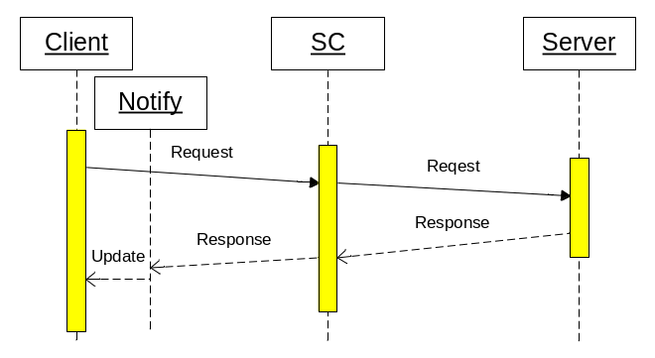
Figure 5 Asynchronous Request/Response

This communication style will be used to load data while other activities are in progress, e.g. to get large amount of static data at startup. It can be also used as fire-and-forget when the response is not meaningful.

Publishing Services
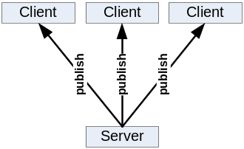Subscribe/Publish (server initiated communication). Publishing services allows the server to send single message to many clients through the SC.

The client sends a subscription mask to the service, and so declares its interest on certain type of a message. The application service providing the message contents must designate the message with a type. When the message type matches the client subscription mask, the message will be sent to the client. Multiple clients may subscribe for the same service at the same time. In such case multiple clients can get the same copy of the message. Message that does not match any client subscription is discarded.

The client must declare a notification method that is invoked when the message arrives. The client may have only one outstanding subscription per service. The message delivery must occur in guaranteed sequence. Messages from the same service will arrive in the sequence in which they have been sent.

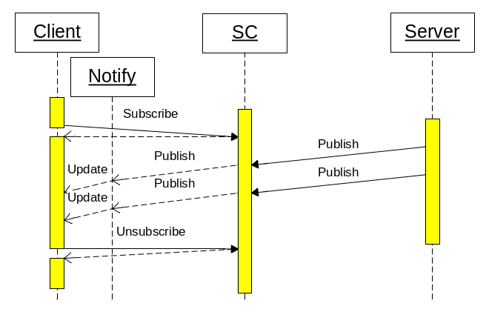
Figure 6 Asynchronous Subscribe / Publish

The client may change the subscription mask or unsubscribe. Initial subscription, subscription change or unsubscribe operation is always synchronous, even through a SC proxy.

Such communication style is used to get asynchronously events notifications or messages that are initiated on the server without an initial client action. It can be also used to distribute the same information to multiple clients.

File Services
This SC service provides API for these file operations:
- Download file from the web server to the client.
- Upload file from the client to the web server.
- List files in a file repository on the web server.

HTTP Proxy Services
The SC supports redirecting of regular HTTP traffic to another server. It is acting like normal HTTP Proxy with no caching.

Semantic
The sequence of the messages exchanged between the components is shown in the following diagram.

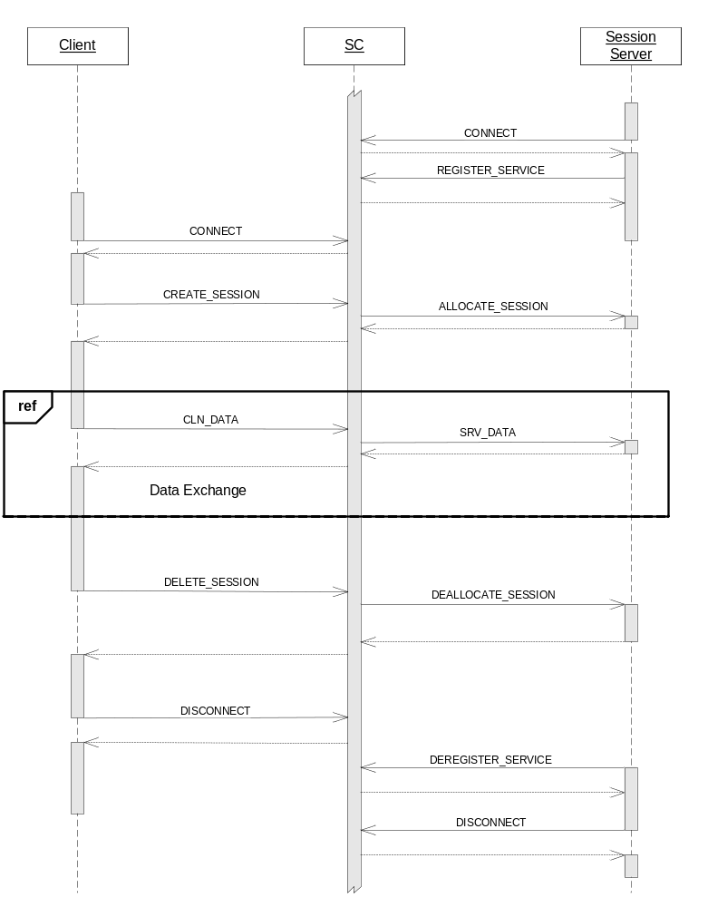
Figure 7 Synchronous message exchange.

The semantic of the session client interface has the following sequence:
Client
- SC_Connect
- SC_CreateSession A
- SC_SendAndReceive (to service A)
...
- SC_CreateSession B
- SC_SendAndReceive or Send (to service B)
...
- SC_DeleteSession A
- SC_DeleteSession B
- SC_Disconnect

The semantic of the publishing client interface has the following sequence:
- SC_Connect
- SC_Subscribe A
... receiving messages via Receiver A from service A
- SC_Subscribe B
... receiving messages via Receiver A from service A and Receiver B from service B
- SC_ChangeSubscription A
... receiving messages via Receiver A from service A and Receiver B from service B
- SC_Unsubscribe A
- SC_Unsubscribe B
- SC_Disconnect

The session services and publishing services may share the same connection, when they communicate to the same SC.

The semantic of the session server interface has the following sequence:
Server
- SC_Connect
- SC_RegisterService
- ... executing either SessionHandler or MessageHandler
- SC_DeregisterService
- SC_Disconnect

The semantic of the publishing server interface has the following sequence:
- SC_Connect
- SC_Publish
... publish messages
SC_Disconnect

Message Protocol
The Service Connector Message Protocol (SCMP) defines how the messages are transmitted. It uses a simple header – body pattern.

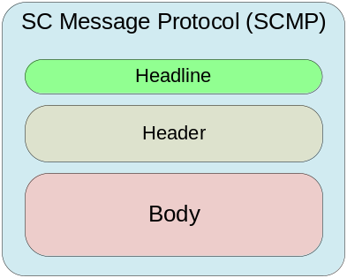
Figure 8 Service Connector Message Protocol

The headline and the message header is encoded in ISO-8859-1 (Latin 1) character set. The body itself is a binary and is under control of the applications.

Wireshark example:
SCMP/1.3 REQ/137&
keepAliveInterval=360
keepAliveTimeout=30
localDateTime=2010-04-07T18:22:14.593+0200
compression=0
scVersion=1.0-000

SCMP/1.3 RES/59&
msgType=CONNECT
localDateTime=2010-04-07T18:22:14.593+0200

Headline
The headline defines the SCMP version, the size and the header key. It is terminated by <CR><LF>.
The SCMP Version of the protocol specification to which this message adheres. It has the format 9.9 and it ensures that the receiver knows to which standard this message adheres. The version number (e.g. 1.3) means: 1 = Release number, 3 = Version number.
Version
The receiver may implement multiple protocol versions and in such case this number provides the secure information how the message is structured. The following matching rules are applied:
- Message: 1.0 + receiver implements: 1.0 => compatible
- Message: 1.0 + receiver implements: 1.1 => compatible
- Message: 1.3 + receiver implements: 1.0 => not compatible
(message may have new headers unknown to the receiver)
- Message: 1.4 + receiver implements: 2.0 => not compatible
(old message structure and possibly not understood here)
- Message: 2.0+ receiver implements: 1.8 => not compatible
(new message and surely not understood here)
The size of the message in bytes is counted from the beginning of the next line, i.e. from the first header and includes the body if present. The size is the number between /s= and &
Size

The header key of the message can be:
HeaderKey
- REQ – Request from client to SC or SC to server
- RES – Response from server to SC or SC to client
- PRQ – Part request from client to SC or SC to server (used for large messages)
- PRS – Part response from server to SC or SC to client
- EXC – Exception returned after REQ or PRQ in case of an error

Header
Message header containing attributes of variable number and length each attribute is on a separate line e.g. delimited by <CR><LF>. Attributes are encoded in ISO-8859-1 (Latin 1) character set.

Body
The message body itself is a binary and is under control of the applications. When compression is enabled, body is ZIP-compressed during transmission.

SCMP over TCP/IP
For direct transport over TCP/IP the headline, messages header and the body is directly written to the network connection.

SCMP over HTTP
For transport over HTTP the messages header has content type text/plain and the message body the content type application/zip.

Wireshark example:
POST / HTTP/1.1
Content-Length: 178
Content-Type: text/plain

SCMP/1.3 REQ/137&
msgType=CONNECT
keepAliveInterval=360
keepAliveTimeout=30
localDateTime=2010-04-07T18:22:14.593+0200
compression=0

HTTP/1.1 200 OK
Content-Length: 74
Content-Type: text/plain

SCMP/1.3 RES/59&
msgType=CONNECT
localDateTime=2010-04-07T18:22:14.593+0200

SCMP Messages

CONNECT
This message is sent from the client to SC or from server to SC in order to initiate the communication. The message has no body and contains these attributes:
msgType=CONNECT
scVersion=1.0-023
compressionEnabled=yes
localDateTime=1997-07-16T19:20:30.064+01:00
keepAliveTimeout=10
keepAliveInterval=60

If keepAliveTimeout is missing or = 0 (seconds) means no keep alive messages will be sent.
If keepAliveInterval is missing or = 0 (seconds) means SC should not monitor the keep alive interval.

SC receives the message, starts monitoring of the connection based on keep alive values and sends back the response:
msgType=CONNECT
localDateTime=1997-07-16T19:20:34.044+02:00

When an error occurs the response message contains the attributes:
msgType=CONNECT
localDateTime=1997-07-16T19:20:30.453+01:00
scErrorCode=3000
scErrorText=Service Connector Message Protocol mismatch

DISCONNECT
This message is sent from the client to SC or from server to SC in order to terminate the communication. The message has no body and contains these attributes:
msgType=DISCONNECT

keepAliveTimeout = 0 means no timeout monitoring
keepAliveInterval = 0 means no interval monitoring

SC receives the message, starts monitoring of the connection based on keep alive values and sends back the response:
msgType=DISCONNECT

When an error occurs the response message contains the attributes:
msgType=DISCONNECT
scErrorCode=3000
scErrorText=protocol mismatch

KEEPALIVE
This message is sent from the client to SC or from server to SC in order to verify the communication. The message has no body and contains these attributes:
msgType=KEEPALIVE
localDateTime=1997-07-16T19:20:30.343+0100
The sender of the keep alive message starts a timer that monitors the arrival of the response message. In case the timeout expires the connection must be aborted and cleaned up. The receiver of the keep alive message monitors the interval in which these messages arrive. In case the message does not arrive in the pre-defined interval, the connection must be aborted and cleaned up.

SC receives the message, and sends back the response:
msgType=KEEPALIVE
localDateTime=1997-07-16T19:20:34.237+0200

CREATE_SESSION
This message is sent from the client to SC in order to start a new session for a service. The message has no body and contains these attributes:
msgType=CREATE_SESSION
serviceName=P01_RTXS_RPRWS1
ipAddressList=10.0.4.32/10.2.54.12/192.243.43.1
sessionInfo=SNBZHP - TradingClientGUI 10.2.7

SC receives the message and does these actions:
- Generates a unique session id
- Chooses a free server instance from the list of available servers serving the requested service.
- Allocates the server instance to this session
- Sends the message ALLOCATE_SESSION to the allocated server
- Awaits the server response ALLOCATE_SESSION.
- If the attribute rejectFlag is missing, the SC keeps the session and sends back the message with the following attributes:
msgType=CREATE_SESSION
sessionId=cdc50b36-1fc4-4f9e-8430-d2e3d7284d9d
serviceName=P01_RTXS_RPRWS1
- If the attribute rejectFlag = yes, the SC deletes the session, de-allocates the server and sends back the message with the following attributes:
msgType=CREATE_SESSION
serviceName=P01_RTXS_RPRWS1
appErrorCode=4334591
appErrorText=%RTXS-E-NOPARTICIPANT, Authorization error – Unknown participant

When an error occurs the response message contains the attributes:
msgType=CREATE_SESSION
scErrorCode=3000
scErrorText=Unkown Service = P01_RTXS_RPRWS3

DELETE_SESSION
This message DELETE_SESSION is sent from the client to SC in order to close an existing session. The message has no body and contains these attributes:
msgType=DELETE_SESSION
sessionId= cdc50b36-1fc4-4f9e-8430-d2e3d7284d9d
serviceName=P01_RTXS_RPRWS1

SC receives the message and does these actions:
- Finds the server allocated to this session
- Sends the message DEALLOCATE_SESSION
- Awaits the response DEALLOCATE_SESSION.
- Allocates the server instance from this session
- Sends back the message DELETE_SESSION with the following attributes:
msgType=DELETE_SESSION
serviceName=P01_RTXS_RPRWS1

Due to timing issues the client may send a delete session request to a non existing session or to session that has no allocated server. The SC must handle such situation and do the appropriate clean-up actions.

When an error occurs the response message contains the attributes:
msgType=DELETE_SESSION
scErrorCode=3000
scErrorText=Session does not exist

CLN_DATA
This message is sent from the client to SC in order exchange information with the allocated server. The client may send this message only in scope of a session. The message has a body and contains these attributes:
msgType=CLN_DATA
sessionId=cdc50b36-1fc4-4f9e-8430-d2e3d7284d9d
serviceName=P01_RTXS_RPRWS1
bodyLength=2534
sequenceNr=974833
compression=yes
messageInfo=SECURITY_MARKET_QUERY

Optionally these attributes can also be set when the client wants to fetch the message from the SC Proxy cache:
cacheSignature=CBCD_SECURITY_MARKET
cacheExpirationDateTime=1997-08-16T19:20:34.237+02:00

SC receives the message and finds the server allocated to this session.
It sends the message SRV_DATA to the server it and awaits the response. Then it sends back a message with a body and the following attributes:
msgType=CLN_DATA
sessionId=cdc50b36-1fc4-4f9e-8430-d2e3d7284d9d
serviceName=P01_RTXS_RPRWS1
bodyLength=62454
sequenceNr=974833
compression=yes
messageInfo=SECURITY_MARKET_RESULT

Optionally these attributes can also be set when the server wants to insert the message into the SC Proxy cache:
cacheSignature=CBCD_SECURITY_MARKET
cacheExpirationDateTime=1997-08-16T17:00:00.000+01:00

In case of an application error these attributes can also be set.
appErrorCode=4334591
appErrorText=%RDB-F-NOTXT, no transaction open

When an error occurs the response message contains the attributes:
msgType=CLN_DATA
scErrorCode=3000
scErrorText=Session does not exist

SUBSCRIBE
This message is sent from the client to SC in order to subscribe for a publishing service. The message has no body and contains these attributes:
msgType=SUBSCRIBE
serviceName= P01_BCST_CH_RPRWS2
mask= 000012100012832102FADF--------------------------

SC receives the message and does these actions:
- Generates a unique session id
- Registers the client subscription for the service
- Sends back a message with the following attributes:
msgType=SUBSCRIBE
sessionId=cdc50b36-1fc4-4f9e-8430-d2e3d7284d9d
serviceName=P01_RTXS_RPRWS1

When an error occurs the response message contains the attributes:
msgType=SUBSCRIBE
scErrorCode=3000
scErrorText=Unkown Service = P01_BCST_CH_RPRWS2

UNSUBSCRIBE
This message is sent from the client to SC in order to delete the subscription for a publishing service. The message has no body and contains these attributes:
msgType=UNSUBSCRIBE
sessionId=cdc50b36-1fc4-4f9e-8430-d2e3d7284d9d
serviceName=P01_BCST_CH_RPRWS2

SC receives the message and does these actions:
- Deletes the client subscription for the services and deletes all pending messages for this client.
- Sends back a message with the following attributes:
msgType=UNSUBSCRIBE
serviceName=P01_RTXS_RPRWS1

When an error occurs the response message contains the attributes:
msgType=UNSUBSCRIBE
scErrorCode=3000
scErrorText=Client is not subscribed

CHANGE_SUBSCRIPTION
This message is sent from the client to SC in order to change the subscription for a publishing service. The message has no body and contains these attributes:
msgType=CHANGE_SUBSCRIPTION
sessionId=cdc50b36-1fc4-4f9e-8430-d2e3d7284d9d
serviceName=P01_BCST_CH_RPRWS2
mask= 000012100012832102FADF--------------------------

SC receives the message and does these actions:
- Changes the subscription mask of the client for the service
- Sends back a message with the following attributes:
msgType=CHANGE_SUBSCRIPTION
serviceName=P01_RTXS_RPRWS1

When an error occurs the response message contains the attributes:
msgType=CHANGE_SUBSCRIPTION
scErrorCode=3000
scErrorText=Client is not subscribed

RECEIVE_PUBLICATION
This message is sent from the client to SC in order to get data published by a server. The client may send this message only in scope of a subscription session. The message has no body and contains these attributes:
msgType=UNSUBSCRIBE
sessionId=cdc50b36-1fc4-4f9e-8430-d2e3d7284d9d
serviceName=P01_BCST_CH_RPRWS2
sequenceNr=974833

SC receives the message and does these actions:
- Finds the client subscription
- Creates a timer monitoring the response delivery
- Waits until one of these two events occurs:
  - A message that matches the client subscription arrives. Then it sends back a message with the body and the following attributes:
msgType=RECEIVE_PUBLICATION
sessionId=cdc50b36-1fc4-4f9e-8430-d2e3d7284d9d
serviceName= P01_BCST_CH_RPRWS2
bodyLength=2534
sequenceNr=974833
compression=yes
messageInfo=CH_AUCTION
mask=%%%%%%%%%%%%%%%%%%%%%%%%%%%X%%%%%%%%%%%%%%%%%%%%

  - The timeout expires. Then it sends back a message with the no body and the following attributes:
msgType=RECEIVE_PUBLICATION
sessionId=cdc50b36-1fc4-4f9e-8430-d2e3d7284d9d
serviceName=P01_BCST_CH_RPRWS2
sequenceNr=974833
noData=yes

When an error occurs the response message contains the attributes:
msgType=RECEIVE_PUBLICATION
scErrorCode=3000
scErrorText=Client is not subscribed

REGISTER_SERVICE
This message is sent from the server instance to SC in order to tell the SC which service it serves. The message has no body and contains these attributes:
msgType=REGISTER_SERVICE
serviceName=P01_RTXS_RPRWS1
maxSessions=10
multiThreaded=no
portNr=9100

SC receives the message and does these actions:
- Registers the server for this service.
- Creates the requested number of connection to the server on port that was specified.
- Sends back a message with the following attributes:
msgType=REGISTER_SERVICE
serviceName=P01_RTXS_RPRWS1

When an error occurs the response message contains the attributes:
msgType=REGISTER_SERVICE
scErrorCode=3000
scErrorText=Service name=P01_RTXS_RPRWS5 not found

DEREGISTER_SERVICE
This message is sent from the server instance to SC in order to tell the SC that the server will no longer provide the service and will perform a conscious shutdown. The message has no body and contains these attributes:
msgType=DEREGISTER_SERVICE
serviceName=P01_RTXS_RPRWS1

SC receives the message and does these actions:
- Finds the server and performs a cleanup by:
- Aborting and de-allocation all sessions of this server. If the server has allocated sessions the SC will send the ABORT_SESSION to it.
- Sends back a message with the following attributes:
msgType=DEREGISTER_SERVICE
serviceName=P01_RTXS_RPRWS1

When an error occurs the response message contains the attributes:
msgType=DEREGISTER_SERVICE
scErrorCode=3000
scErrorText=Server is not registered

After this message the server may close connection to the SC with the DISCONNECT

ALLOCATE_SESSION
This message is sent from the SC to the server when the server instance will be allocated to a session. The message has no body and contains these attributes:
msgType=ALLOCATECREATE_SESSION
serviceName=P01_RTXS_RPRWS1
sessionId=cdc50b36-1fc4-4f9e-8430-d2e3d7284d9d
ipAddressList=10.0.4.32/10.2.54.12/192.243.43.1
sessionInfo=SNBZHP - TradingClientGUI 10.2.7

The server receives the message and must decide to accept or reject this request. If it accepts , then it must return a message with the following attributes:
msgType=ALLOCATE_SESSION
serviceName=P01_RTXS_RPRWS1

If it rejects the session, then it must return a message with the following attributes:
msgType=ALLOCATE_SESSION
serviceName=P01_RTXS_RPRWS1
rejectFlag=yes
appErrorCode=4334591
appErrorText=%RTXS-E-NOPARTICIPANT, Authorization error – Unknown participant

DEALLOCATE_SESSION
This message is sent from the SC to the server when the session will be deleted by the client and the server instance will no longer be bound to it. The message has no body and contains these attributes:
msgType=DEALLOCATE_SESSION
serviceName=P01_RTXS_RPRWS1
sessionId=cdc50b36-1fc4-4f9e-8430-d2e3d7284d9d

The server must return a message with the following attributes:
msgType=DEALLOCATE_SESSION
serviceName=P01_RTXS_RPRWS1

After this message the server will not receive any data requests until the next session is started.

ABORT_SESSION
This message is sent from the SC to the server when the session is aborted do to errors of other unexpected events. The message has no body and contains these attributes:
msgType=ABORT_SESSION
serviceName=P01_RTXS_RPRWS1
sessionId=cdc50b36-1fc4-4f9e-8430-d2e3d7284d9d

The server must return a message with the following attributes:
msgType= ABORT_SESSION
serviceName=P01_RTXS_RPRWS1

After this message the server will not receive any data requests until the next session is started.

SRV_DATA
This message is sent from the SC to the server allocated to this session in order to execute the request. The SC will send this message only in scope of a session. The message has a body and contains these attributes:
msgType=SRV_DATA
sessionId=cdc50b36-1fc4-4f9e-8430-d2e3d7284d9d
serviceName=P01_RTXS_RPRWS1
bodyLength=2534
sequenceNr=974833
compression=yes
messageInfo=SECURITY_MARKET_QUERY

The server receives the message extracts the body and executes the application code. It must
send back a message with a body and the following attributes:
msgType=SRV_DATA
sessionId=cdc50b36-1fc4-4f9e-8430-d2e3d7284d9d
serviceName=P01_RTXS_RPRWS1
bodyLength=62454
sequenceNr=974833
compression=yes
messageInfo=SECURITY_MARKET_RESULT

Optionally these attributes can also be set when the server wants to insert the message into the SC Proxy cache:
cacheSignature=CBCD_SECURITY_MARKET
cacheExpirationDateTime=1997-08-16T17:00:00.000+01:00

In case of an application error these attributes can also be set.
appErrorCode=4334591
appErrorText=%RDB-F-NOTXT, no transaction open

PUBLISH
This message is sent from the publishing server to SC in order to send this message to the subscribed clients. The message has a body and contains these attributes:
msgType=PUBLISH
serviceName= P01_BCST_CH_RPRWS2
bodyLength=2534
compression=yes
routingInfo=CH_AUCTION_IOI
mask=%%%%%%%%%%%%%%%%%%%%%%%%%%%X%%%%%%%%%%%%%%%%%%%%

SC receives the message and does the following steps:
- It inserts the message on top of the message queue for this service
- Sends back to the server a message with the following attributes:
msgType=PUBLISH
serviceName=P01_BCST_CH_RPRWS2
- Starts distribution of the message to the subscribed clients based on their subscription mask and the mask of the message.

When an error occurs the response message contains the attributes:
msgType=PUBLISH
scErrorCode=3000
scErrorText=Service does not exist

SCMP Header Attributes
The following is a list of all possible attributes in a SC message header in alphabetical order. All attributes are ASCII, encoded as ISO 8859-1 (Latin-1).

You can find the matrix describing which attribute is used in which message in Appendix B SCMP Header Attributes.

appErrorCode
Name | appErrorCode
Description | Numeric value passed between server and the client used to implement error protocol on the application level.
Validation | Numeric value ≥ 0
Comment | This is used mainly in troubleshooting cases to identify the body content during the message transmission.
Example | appErrorCode=4334591

appErrorText
Name | appErrorText
Description | Textual value passed between server and the client used to implement error protocol on the application level. It can be the textual interpretation of the appErrorCode.
Validation | Any printable character, length > 0 and < 256Byte
Comment | This is used mainly in troubleshooting cases to identify the body content during the message transmission.
Example | appErrorText=%RDB-F-NOTXT, no transaction open

bodyLength
Name | bodyLength
Description | Number of bytes in the message body.
Validation | Positive numeric value ≥ 0 and < 65534
Comment | If missing, the message has no body. If the bodyLength = 0 then body is present but empty.
Example | bodyLength=2534

cacheSignature
Name | cacheSignature
Description | Signature agreed by the communicating applications to uniquely identify the cached content. When cacheSignature is used the attribute cacheExpirationDateTime must also be present.
Validation | Any printable character, length > 0 and < 256Byte
Comment | The client uses cacheSignature to identify which message should be retrieved from the cache. The server uses cacheSignature to designate message that should be cached.  The client will get a cached message when:  - the cacheSignatuer matches a message in the cache and  - cacheExpirationDateTime requested by the client is timely before the cacheExpirationDateTime of the cached message.
Example | cacheSignature=CBCD_SECURITY_MARKET

cacheExpirationDateTime
Name | cacheExpirationDateTime
Description | Absolute expiration date and time of a cached message.  It must be set together with cacheSignature attribute.
Validation | YYYY-MM-DDThh:mm:ss.fff+hhmm  It is UTC plus zone information.  The fff are seconds fractions and time zone offset is at the end.
Comment | The client uses cacheExpirationDateTime to tell how old the message could be. The server uses cacheExpirationDateTime to designate how long the message should be cached.
Example | cacheExpirationDateTime=1997-08-16T19:20:34.237+0200

compression
Name | compression
Description | Flag true or false describing if the message body is compressed or not. If missing the default value is true.
Validation | 0 (false) or 1 (true)
Comment | The compression is enabled or disabled on the connection level, not for an individual message or service.
Example | compression=0

ipAddressList
Name | ipAddressList
Description | List of IP addresses on the network path between the client and the session server. The first is the IP address of the client, the last is the IP address of the incoming SC connection. In between there can be any number of addresses of the intermediate SC proxies
Validation | List in format 999.999.999.999{/999.999.999.999}...
Comment | When VPN is used, the tunnel IP is part of this list. This information is used for client authentication.
Example | ipAddressList=10.0.4.32/10.2.54.12/192.243.43.1

portNr
Name | portNr
Description | Number of the TCP/IP port the session server accepts the connection(s).
Validation | Number > 0 and < 99999
Comment | When a session server registers, SC will create a connection to this server on the IP address of the server and the given port number. Multiple connections are created to the same port. The value must be > 1.
Example | portNr=9100

keepAliveInterval
Name | keepAliveInterval
Description | Interval in which the sender sends keep alive messages.  The value = 0 means no keep alive messages will be used.
Validation | Number ≥ 0 and < 3600  If keepAliveTimeout is 0 then keepAliveInterval must also be 0.  keepAliveInterval must be greater then keepAliveTimeout
Comment | This is used by the receiver to detect a broken connection. The receiver calculates the maximal time between two subsequent KEEPALIVE messages as maxTime= keepAliveInterval +( keepAliveTimeout/2)  If this time expires the connection is treated as dead and a cleanup is done.
Example | keepAliveInterval =60

keepAliveTimeout
Name | keepAliveTimeout
Description | Maximal time in seconds allowed between KEEPALIVE request and response (measures by the sender).  The value = 0 means no keep alive messages will be sent.
Validation | Number ≥ 0 and < 3600  If keepAliveTimeout is 0 then keepAliveInterval must also be 0.
Comment | This is used by the sender to detect a broken connection. When this timeout expires, the connection is treated as dead and a cleanup is done.
Example | keepAliveTimeout =10

localDateTime
Name | localDateTime
Description | String value describing the actual local date and time.
Validation | YYYY-MM-DDThh:mm:ss.fff+hhmm  It is UTC plus zone information.  The fff are seconds fractions and time zone offset is at the end.
Comment | The local date time is exchanged at the beginning of each connection and in the keep alive messages. It is used to calculate the time difference between the communicating parties and to harmonize the log for troubleshooting purposes.
Example | localDateTime=1997-07-16T19:20:30.064+0100

mask
Name | mask
Description | The mask is used in SUBSCRIBE or CHANGE_SUBSCRIPTION to express the client interest and in PUBLISH and RECEIVE_PUBLICATION to designate the message cntents. Only printable characters are allowed.
Validation | Any printable character, length < 256Byte
Comment | If the message mask matches the subscription mask, the client will get this message.  The matching rules:  - masks of unequal length do not match  - % - matches any single character at this position  - All other characters must exactly match (case sensitive)
Example | Subscription: mask= 000012100012832102FADF-----------X-----------  Matching examples:  Message: mask= 000012100012832102FADF-----------X-----------  Message: mask= 0000121%%%%%%%%%%%%%%%-----------X-----------  Not matching examples:  Message: mask= 000012100012832102FADF-----------------------  Message: mask= 0000121%%%%%%%%%%%%%%%-----------------------

maxSessions
Name | maxSessions
Description | Number of session the server instance can serve.
Validation | Number > 0
Comment | When a session server registers a service it must tell the SC how many sessions it can serve. This is necessary to know in order to maintain the count of available and free session servers in SC.  The value 1 means single session server. Value > 1 means multi-connection or multi-threaded server, depending on the parameter multiThreaded.
Example | maxSessions=10

messgageInfo
Name | messageInfo
Description | Information passed together with the message body that helps the client and the server identify the body content without investigating the body.
Validation | Any printable character, length > 0 and < 256Byte
Comment | This is used mainly in troubleshooting cases to identify the body content during the message transmission.
Example | messageInfo=SECURITY_MARKET_QUERY

msgType
Name | msgType
Description | Unique message type
Validation | List of known message types
Comment | Message type that represents a certain command, and also documenting the direction of the message. The direction of the message is visible in the headline.
Example | msgType=PUBLISH

multiThreaded
Name | multiThreaded
Description | Flag true or false to designate a multithreaded server. If missing the default value is false.
Validation | 0 (false) or 1 (true)
Comment | When a session server registers and maxSession > 1, SC must know if this is a multi-connection or multi-threaded server. For multi-connection server SC will create the defined number of connections and use one connection per session, for multi-threaded servers SC will create only one connection and reuse it for all sessions.
Example | multiThreaded=1

noData
Name | noData
Description | NoData flag is used in RECEIVE_PUBLICATION to tell the subscribed client, that no data for publishing exists. The client will immediately send RECEIVE_PUBLICATION to renew the interest.
Validation | 0 (false) or 1 (true)
Comment | noData=0 is never sent.
Example | noData=1

rejectSession
Name | rejectSession
Description | Flag in ALLOCATE_SESSION message set by the server when it rejects the session. In such case the server can also set the appErrorCode and appErrorText to explain the rejection reason.
Validation | 0 (false) or 1 (true)
Comment | rejectSession=0 is never sent.
Example | rejectSession=1

scErrorCode
Name | scErrorCode
Description | Numeric error code set by SC in other to inform the communication partner about an error.
Validation | Number > 1
Comment | This is used to handle communication error.
Example | scErrorCode=4453

scErrorText
Name | scErrorText
Description | English text set by the SC in other to describing the error signalled as scErrorCode.
Validation | Any printable character, length > 0 and < 256Byte
Comment | This is used to log the communication error.
Example | scErrorText=Unknow service name = P01_RTXR_RPRWS4

scVersion
Name | scVersion
Description | SC version number of the producer of this message.
Validation | String format 9.9-999
Comment | This version number is sent in CONNECT and checked by the receiver against its own SCMP version number. This ensures that only compatible components can communicate to each other. The value is hard coded in the communication components like API, SC or SC-Proxy. The version number consist of (e.g. 1.0-023):  - 1 = Release number  - 0 = Version number  - 023 = Revision number  The matching rules are:  - Request: 1.0-023 + own: 1.0-023 => compatible  - Request: 1.0-023 + own: 1.0-025 => compatible  - Request: 1.0-025 + own: 1.0-023 => not compatible  (requestor may utilize new features unknown here)  - Request: 1.0-023 + own: 1.2-005 => compatible  - Request: 1.2-004 + own: 1.0-023 => not compatible  (requestor uses new functions unknown here)  - Request: 1.0-023 + own: 2.0-007 => not compatible  (possibly other incompatible interface)  - Request: 2.0-001 + own: 1.0-023 => not compatible  (possibly other incompatible interface)
Example | scVersion=1.0-023

sequenceNr
Name | sequenceNr
Description | Internal sequence number generated by the sender in order to identify and track messages in transmission.
Validation | Number > 0, steadily increasing
Comment | For a session service the sequenceNr is incremented by the client sending a message, and echoed by the server allocated to the session. The sessionId + the sequnceNr uniquely identify the request/response pair at any point of its transmission.  For a published service the sequenceNr is incremented by the SC when it receives the message from the publishing server. In the message fan-out on SC-proxy the sequenceNr is preserved. The client may not receive all published messages due to its subscription filter and therefore it may see gaps in the received sequenceNr.
Example | sequenceNr=974833

serviceName
Name | serviceName
Description | Name of the service
Validation | Any printable character, length > 0 and < 256Byte
Comment | The service name is an abstract name and represents the logical address of the service. It order to allow message routing the name must be unique in scope of the SC network. Service names are defined at application level and are stored in the SC configuration.
Example | serviceName=P01_RTXS_RPRWS1

sessionId
Name | sessionId
Description | Unique identification of the session
Validation | Known session,
Comment | The sessionId is allocated by SC to which the client is connected when it sends the request CREATE_SESSION. The sessionID is universally unique because multiple SC may exist in the same network. The client must set the sessionId in each message during the session.
Example | sessionId=cdc50b36-1fc4-4f9e-8430-d2e3d7284d9d

sessionInfo
Name | sessionInfo
Description | Information passed by the client to the session server when the session starts.
Validation | Any printable character, length > 0 and < 256Byte
Comment | This is used to pass additional authentication or authorization data to the server.
Example | sessionInfo=SNBZHP - TradingClientGUI 10.2.7

Java – API
The java API is deployed as JAR file. Both server and client API are in the same JAR.

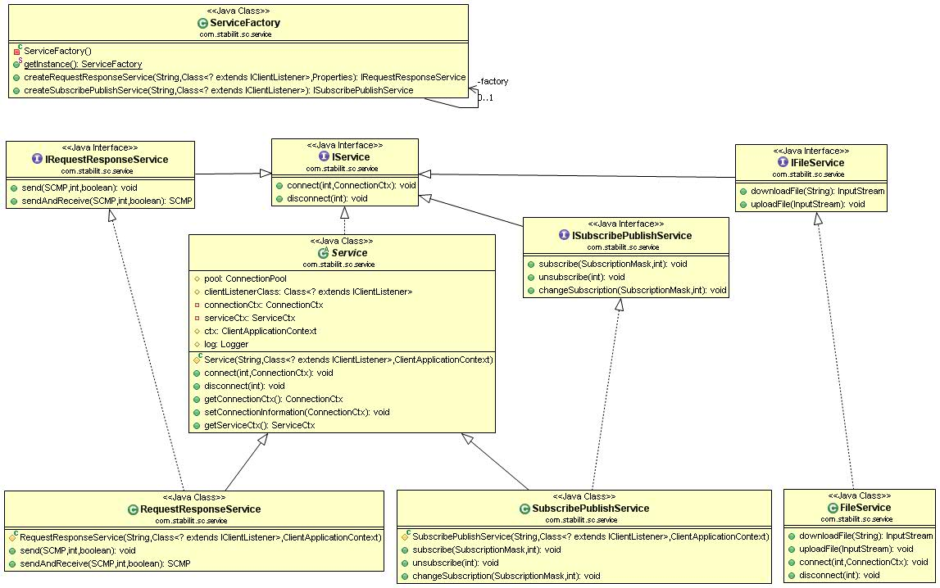
Figure 9 Client API for Java

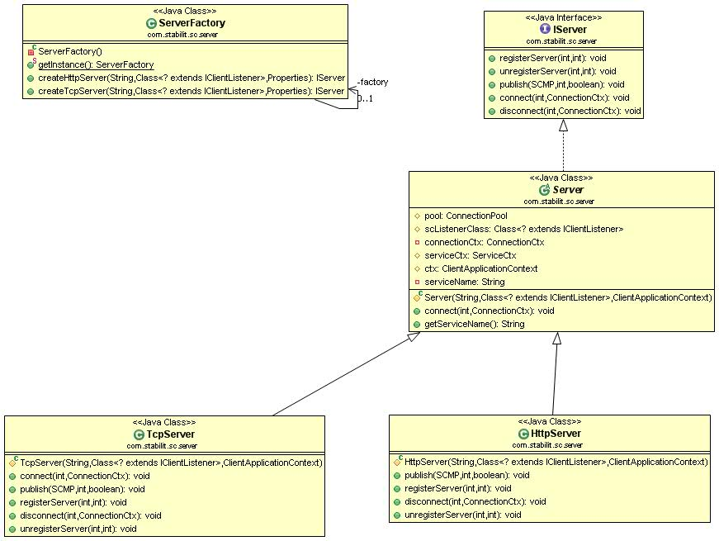
Figure 10 Server API for Java

Semantics
The semantic of the client interface for request / response services type has the following sequence:
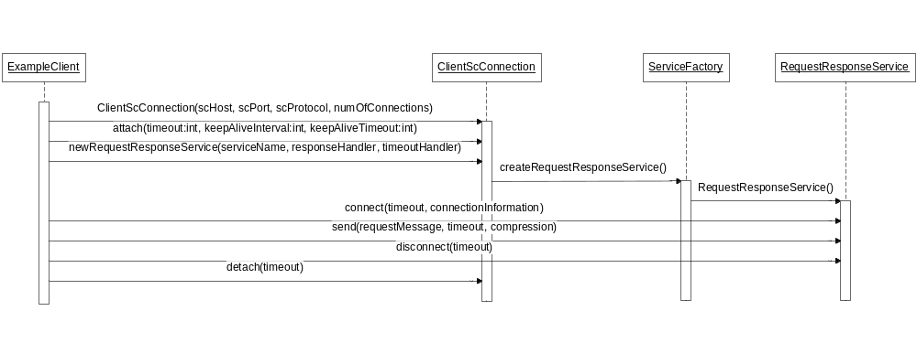
Figure 11 Client sequence diagram for session services

The semantic of the client interface for the subscribe / publish services type has the following sequence:
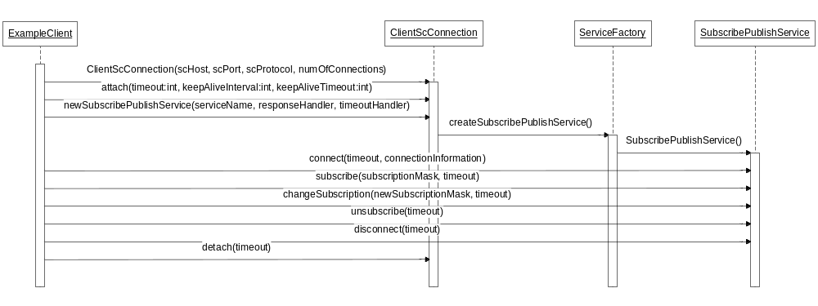
Figure 12 Client sequence diagram for publishing service

The semantic of the server interface for request / response and subscribe / publish services type has the following sequence:
Semantics
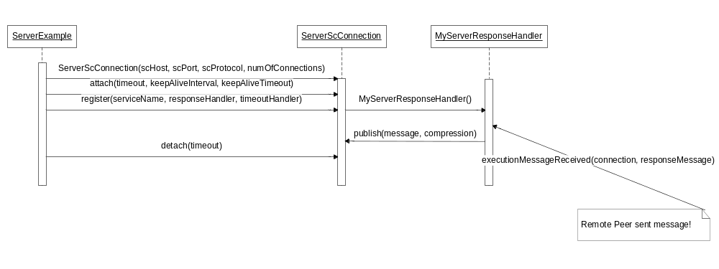
Figure 13 ExampleServer sequence diagram for publish process

C - API (Proposal)
The SC project does not implement the API for C. This is only an implementation proposal using as much analogy to the Java API as possible. When using this proposal the C and java developer will speak the similar language.

In order to make the C method names unique, a general prefix SC_ has been added.

Context hierarchy

Each object interfacing the application has an individual context. The contexts are hierarchically organised.

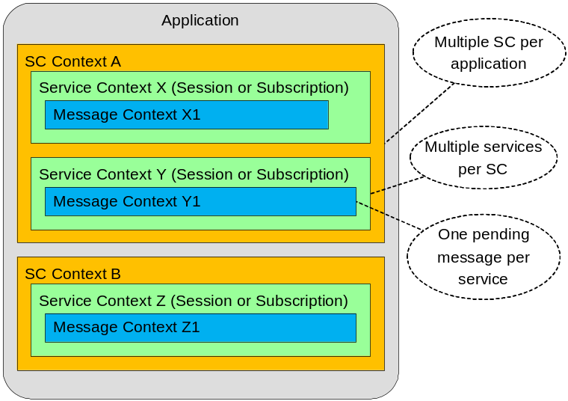
Figure 14 API Context Hierarchy

The following picture shows the API granularity

Semantics

The semantic of the session client interface has the following sequence:
Client
- SC_Connect
- SC_CreateSession A
- SC_SendAndReceive (to service A)
...
- SC_CreateSession B
- SC_SendAndReceive or Send (to service B)
...
- SC_DeleteSession A
- SC_DeleteSession B
- SC_Disconnect

The semantic of the publishing client interface has the following sequence:
- SC_Connect
- SC_Subscribe A
... receiving messages via Receiver A from service A
- SC_Subscribe B
... receiving messages via Receiver A from service A and Receiver B from service B
- SC_ChangeSubscription A
... receiving messages via Receiver A from service A and Receiver B from service B
- SC_Unsubscribe A
- SC_Unsubscribe B
- SC_Disconnect

The session services and publishing services may share the same connection, when they communicate to the same SC.

The semantic of the session server interface has the following sequence:
Server
- SC_Connect
- SC_RegisterService
- ... executing either SessionHandler or MessageHandler
- SC_DeregisterService
- SC_Disconnect

The semantic of the publishing server interface has the following sequence:
- SC_Connect
- SC_Publish
... publish messages
- SC_Disconnect

Connect
SC_Connect (
OUT ConnectionCtx: connectionContext,
IN String: IPaddress,
IN Integer: portNumber,
IN String: protocol,
IN Callback: timeoutHandler,
IN Callback: errorHandler)
Connects the client or server to the SC. From now on keep alive messages may sent between the client or server and the SC in order to detect broken connection. This method returns control when the connection to SC is established.
Parameters:
- Handle to the connection context. This connection context must be used in subsequent calls. The client or publishing server may have multiple SCs connected at the same time. Session server may have only one connection context. The properties of the connection context can be set with methods described in 9.6.
- IP address or DNS name of the node on which the CS or SC-proxy is running
- Port number the SC expects the connection
- Communication protocol to be used (HTTP or TCP/IP)
- Address of the timeout handler that is invoked when a operation timeout expires.
- Address of the error handler that is invoked when an error occurs.
Possible errors:
- SC is not available
- Communication error

Disconnect
SC_Disconnect (
IN ConnectionCtx: connectionContext)
Disconnects the client or the server from SC. No further communication with SC is possible. All existing sessions are deleted and subscriptions are cleared. The connection context cannot be reused. This method returns the control when the connection is effectively discarded.
Parameters:
- Context of the connection to be destroyed.
Possible errors:
- none

Get Connection Context Parameter
SC_GetConnectionCtxParameter (
IN ConnectionCtx: connectionContext,
IN String: parameterName,
OUT String: parameterValue)
Returns various connection parameters. This method gets control back immediately.
Parameters:
- Context of the connection.
- Name of the parameter. Possible parameter names are:
  - String: IPaddress - IP address or DNS name of the node on which the CS is running.
  - Integer: portNumber - Port number the SC took the connection
  - String: protocol - Communication protocol in use (HTTP or TCP/IP)
  - Integer: OperationTimeout – Timeout in seconds for the issued operation (default is set in Connect()). Value = 0 means no timeout.
  - Integer: keepAliveInterval - Interval in seconds in which keep alive messages are sent to SC. (default = 300). Value = 0 means no keep alive.
  - Integer: keepAliveTimeout - Timeout in seconds for receipt of the keep alive response (default = 60)
  - Boolean: Compression flag to enable or disable message compression during the transport
- Parameter value

Possible errors:
- Unknown parameter

Set Connection Context Parameter
SC_SetConnectionCtxParameter (
IN ConnectionCtx: connection context,
IN String: parameterName,
IN String: parameterValue)
Set connection parameters. This method returns control when the parameter was set.
Parameters:
- Context of the connection.
- Name of the parameter. Possible parameter names are:
  - Integer: OperationTimeout – Timeout in seconds for the issued operation (default = 60). Value = 0 means no timeout.
  - Integer: keepAliveInterval - Interval in seconds in which keep alive messages are sent to SC. (default = 300). Value = 0 means no keep alive.
  - Integer: keepAliveTimeout - Timeout in seconds for receipt of the keep alive response (default = 60)
  - Boolean: Compression flag to enable or disable message compression during the transport (default = true)
- New parameter value
Possible errors:
- Unknown parameter

Timeout Handler (callback)
SC_TimeoutHandler (
OUT ConnectionCtx: connectionContext,
OUT Integer: timeoutType)
Callback that is invoked when a timeout expires
Parameters:
- Context of the connection
- Type of the timeout (operation or keep alive)

Error Handler (callback)
SC_ErrorHandler (
OUT ConnectionCtx: connectionContext,
OUT Integer: errorCode,
OUT String: errorText)
Callback that is invoked when an error occurs.
Parameters:
- Context of the connection.
- Error code
- Error text

Create Session
SC_CreateSession (
IN ConnectionCtx: connectionContext,
OUT SessionCtx: sessionContext,
IN String: serviceName,
IN String: sessionInformation,
OUT Integer: applErrorCode
OUT String: applErrorText)
Creates virtual logical between the client and server providing a session service. One free server is allocated. On the server the SessionHandler callback is invoked with the event = SessionStart. This method returns control when the allocated server accepts the new session.
Parameters:
- Context of the connection to be used.
- Context of the session. This context handle must be used in subsequent calls. The client may have multiple services on the same SC connected at the same time.
- Optional error message filled by the server
- Name of the service the client wants to connect to.
- Session information passed to the server (e.g. used for authentication)
- Optional application error code filled by the server when the session was rejected
- Optional application error text filled by the server when the session was rejected
Possible errors:
- Service does not exist
- Service is not Request/Response type
- No free server is available
- Communication error

Delete Session
SC_DeleteSession (
IN SessionCtx: sessionContext)
Terminates the logical session between the client and server. On server the SessionHandler is invoked with the event = SessionEnd. This method returns control when the server is de-allocated and session is deleted.
Parameters:
- Context of the session to be deleted.
Possible errors:
- Communication error

Get Session Context Parameter
SC_GetSessionCtxParameter (
IN SessionCtx: sessionContext,
IN String: parameterName,
OUT String: parameterValue)
Returns various session parameters. This method returns the control immediately.
Parameters:
- Existing context of the session.
- Name of the parameter. Possible parameter names are:
  - ConnectionCtx: connectionContext – corresponding connection context
  - String: serviceName – name of the service
  - String: serviceType – type of the service
- Parameter value
Possible errors:
- Unknown parameter

Send And Receive
SC_SendAndReceive(
IN SessionCtx: sessionContext,
IN String: requestMsg,
IN/OUT String: messageInformation,
IN String: cacheSignature,
IN Timestamp: cacheExpirationDateTime,
OUT String: responseMsg,
OUT Integer: applErrorCode
OUT String: applErrorText)
Sends a synchronous request to the allocated server identified by the session context and waits for the arrival of the response message. On the server the MessageHandler callback is invoked and performs the service. This method returns control when the response message from the server arrives.
Parameters:
- Context of the existing session.
- Message information passed to and from the server (e.g. message type)
- Acceptable cache time to live
- Request message passed to the server
- Optional cache signature (empty = do not look into cache, otherwise look for cached message with this signature)
- Optional cache expiration date time of the message required by the client. When a message is found in cache, it must have expiration date time after this value.
- Response message received from the server
- Optional application error code filled by the server
- Optional application error text filled by the server
Possible errors:
- Communication error

Subscribe
SC_Subscribe (
IN ConnectionCtx: connectionContext,
OUT SessionCtx: sessionContext,
IN String: serviceName,
IN String: subscriptionMask
IN Callback: publishMsgReceiver)
Subscribes the client on a subscribe/publish service. When a message is published and matches the client subscription mask, the publish message receiver will be invoked. This method returns control when the subscription becomes effective.
Parameters:
- Context of the existing connection to be used.
- Subscription session context created for this service. This context handle must be used in subsequent calls.
- Name of the service the client wants to subscribe to.
- Subscription mask used to designate interest on certain published messages
- Address of the message receiver that is invoked when a published message arrives.
Possible errors:
- Service does not exist
- Service is not Subscribe/Publish type
- Communication error

Unsubscribe
SC_Unsubscribe (
IN SessionCtx: sessionContext)
Deletes the client subscription. From now on the client will not receive published messages from the service any longer. This method returns control when the subscription is effectively deleted in SC.
Parameters:
- Context of the existing subscription session.
- Timeout in seconds for this operation (default = 60). Value = 0 means no timeout.
Possible errors:
- Communication error

Change Subscription
SC_ChangeSubscription (
IN SessionCtx: sessionContext,
IN String: subscriptionMask)
Changes the client subscription. Old subscription is discarded. This method returns control when the new subscription becomes effective.

Parameters:
- Context of the existing subscription session.
- New subscription mask used to designate interest on certain published messages
Possible errors:
- Communication error

Publish Message Receiver (callback)
SC_PublishMessageReceiver (
OUT SessionCtx: sessionContext,
OUT String: messageInformation,
OUT String: publishedMsg,
OUT String: messageMask)
Routine that receives the messages published by the server to the service. This method gets control when the published message arrives.
Parameters:
- Context of the existing subscription session (contains the service name)
- Message information filled by the server (e.g. message type)
- Message published by the server
- Effective mask of the message
Possible errors:
- Communication error

Publish
SC_Publish(
IN ConnectionCtx: connectionContext,
IN String: serviceName,
IN String: messageMask,
IN String: messageInformation,
IN String: publishMsg)
Sends a publish message to a service. This message is then distributed to the subscribed clients when their subscription matches the message mask. On client the PublishMessageReceiver is invoked and gets this message. This method returns control when the message was accepted by SC, but before it was distributed or received by the clients.
Parameters:
- Context of this connection.
- Name of the service
- Message mask designating its contents.
- Message information passed to the client (e.g. message type)
- Message to be published to subscribed clients
Possible errors:
- Communication error

Register Service
SC_RegisterService (
IN ConnectionCtx: connectionContext,
IN Integer: portNumber,
IN String: serviceName,
IN Integer: maxSessions,
IN Callback: sessionHandler,
IN Callback: messageHandler)
Registers a server for session service. The SC will establish connection to the given IP address and port. The server must accept connection on the specified IP address and port. From now on the server can be allocated to a session and receive messages from the client.

Depending on the implementation this method can either return control immediately and handle all incoming messages in a designated handler or can declare a session and message handler and return control at server exit.
Parameters:
- Handle to the connection context. The server can register to only one service at the same time!
- Port number on which the server accepts the connection from SC
- Name of the service this server will serve
- Maximal number of concurrent sessions this server will serve. (Value > 1 requires a multithreaded server!)
- Address of the session handler that is invoked when a session event occurs.
- Address of the message handler that receives the client messages, implements the service and sends responses back to the client.
Possible errors:
- Service does not exist
- Service is not request/response type
- Communication error
- Timeout expired

Deregister Service
SC_DeregisterService (
IN ConnectionCtx: connectionContext,
IN String: serviceName)
Deregisters the server for the service. The server will no longer receive messages for this service. If the server has an active session, it will get the event SessionAbort from SC.

Parameters:
- Handle to the connection context. The server can register to only one service at the same time!
- Name of the service this server will disconnect
Possible errors:
- Service does not exist
- Service is not request/response type
- Communication error
- Timeout expired

Session Handler (callback)
SC_SessionHandler (
OUT ConnectionCtx: connectionContext,
OUT String: event,
OUT String: sessionInformation,
IN Boolean: rejectFlag,
IN Integer: applErrorCode,
IN String: applErrorText)
Server method that receives control messages from SC.
Parameters:
- Context of the connection.
- Event that occurred. The possible events are:
SessionStart – the client has connected and a logical session was established. The session information contains the information passed by the client.
SessionEnd – the client has disconnected from this service
SessionAbort – the session was aborted, due to reasons explained in session information.
- Session information passed by the client (e.g. used for authentication)
- Reject flag passed back to SC. True means the server rejects the session.
- Optional application error code passed to the client when the reject flag is true.
- Optional application error text passed to the client when the reject flag is true.
Possible errors:
- Communication error

Message Handler (callback)
SC_MessageHandler (
OUT ConnectionCtx: connectionContext,
OUT String: requestMsg,
IN/OUT String: messageInformation,
IN String: responseMsg,
IN String: cacheSignature,
IN Timestamp: cacheExpirationDateTime
IN Integer: applErrorCode,
IN String: applErrorText)
Server routine that implements the service.
Parameters:
- Context of this connection.
- Optional routing information passed by the client (e.g. message type)
- Request message information passed from and to the client
- Response message returned to the client
- Optional cache signature (empty = message is not cached, otherwise identification of the cached message)
- Optional expiration date time of the message in the cache.
- Optional application error code passed to the client
- Optional application error text passed to the client
Possible errors:
- Communication error

Glossary
Glossary item
glossary text

Appendix A

Appendix B SCMP Header Attributes
 |  | sessionId | serviceName | bodyLength | maxSessions | multiThreaded | portNr | scmpVersion | sequenceNr | compression | localDateTime | mask | noData | cacheSignature | cacheExpirationDateTime | keepAliveTimeout | keepAliveInterval | messageInfo | applErrorCode | appErrorText | ipAddressList | sessionInfo | rejectFlag | scErrorCode | scErrorText
CONNECT | REQ
CONNECT | RES
DISCONNECT | REQ
DISCONNECT | RES
KEEPALIVE | REQ
KEEPALIVE | RES
CREATE_SESSION | REQ
CREATE_SESSION | RES
DELETE_SESSION | REQ
DELETE_SESSION | RES
CLN_DATA | REQ
CLN_DATA | RES
SUBSCRIBE | REQ
SUBSCRIBE | RES
UNSUBSCRIBE | REQ
UNSUBSCRIBE | RES
CHANGE_SUBSCRIPTION | REQ
CHANGE_SUBSCRIPTION | RES
RECEIVE_PUBLICATION | REQ
RECEIVE_PUBLICATION | RES
PUBLISH | REQ
PUBLISH | RES
REGISTER_SERVICE | REQ
REGISTER_SERVICE | RES
DEREGISTER_SERVICE | REQ
DEREGISTER_SERVICE | RES
ALLOCATE_SESSION | REQ
ALLOCATE_SESSION | RES
DEALLOCATE_SESSION | REQ
DEALLOCATE_SESSION | RES
ABORT_SESSION | REQ
ABORT_SESSION | RES
SRV_DATA | REQ
SRV_DATA | RES

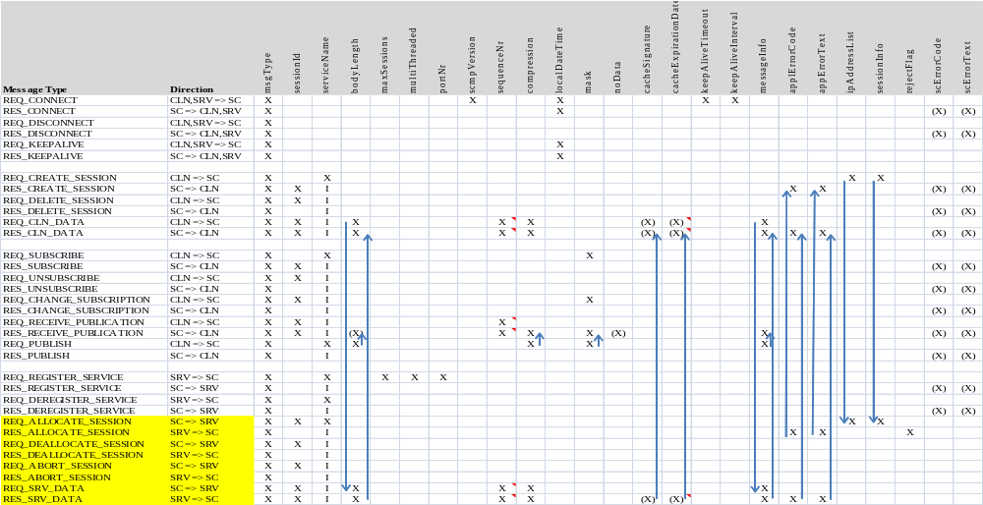

No index entries found.

