SC

Service Connector

Operation and Configuration Guide

SC_4_Oeration_E (Version V1.0)
This document describes the SC configuration, operation and troubleshooting.

The creation of this software is sponsored by a customer. Other companies may develop similar software as a commercial product and destroy this effort in the mean time. In order to protect the investment of the sponsor and the idea of open source software, this and all subsequent documents are classified as “CONFIDENTIAL” during the development phase. They may be delivered only after signing an appropriate non-disclosure agreement. They will be published when the software development is finished and the software is made available as open source software.

During the development of this software this document is a spiritual ownership of STABILIT Informatik AG, and must not be used or copied without a written allowance of this company and signing a non-disclosure agreement. Unauthorized usage is illegal in terms of Chapter 23 / 5 UWG / Swiss law.

The information in this document is subject to change without notice and should not be construed as a commitment by STABILIT Informatik AG.

Copyright © 2026 by STABILIT Informatik AG
All rights reserved.

The copyright discharges after publishing of the software to the open source community.

All other logos and product names are trademarks of their respective owners.

This Document has been created with Microsoft Word 2003 (11) with template file and printed at 01 July 2010 12:02.

Identification
Project: | SC
Title: | Service Connector
Subtitle: | Operation and Configuration Guide
Version: | V1.0
Reference: | SC_4_Oeration_E
Classification: | Public
Keywords: | Operation, configuration, troubleshooting
Comment: | This document describes the SC configuration, operation and troubleshooting.
Author(s): | STABILIT Informatik AG  Jan Trnka, Daniel Schmutz, Joel Traber
Approval (Reviewed by): | Signature Jan Trnka  Signature Francisco Gonzalez  Signature Walter Mörgeli
Audience: | Project team, Eurex development team
Distribution: | Public
Filename | /tmp/lo/0000.doc
Revision History
Date | Version | Author | Description
11.02.2011 | V1.0 | Jan Trnka | Initial version

Table of Contents
1 Preface 4
1.1 Purpose & Scope of this Document 4
1.2 Classification 4
1.3 Definitions & Abbreviations 4
1.4 External References 5
1.5 Typographical Conventions 5
1.6 Outstanding Issues 5
2 Restrictions 6
2.1 Load balancing 6
2.2 Failover 6
2.3 Security 6
2.4 Intrusion and Virus Protection 6
3 Service Model 7
3.1 Session Services 7
3.2 Publishing Services 8
3.3 File Services 9
3.4 HTTP Proxy Services 9
4 Software Layers 10
5 SC network 11
5.1 Connection Topology 11
5.2 Service Routing 12
6 Session Services 13
6.1 Session Management 13
6.2 Message Caching 13
7 Publishing Services 14
7.1 Subscription Management 14
7.2 Message Fan-Out 14
8 Proxy Services 15
9 SC Operations 16
9.1 Configuration 16
9.2 Management GUI 16
9.3 J-Console (JMX) 16
9.4 Troubleshooting 16
10 Glossary 17
Appendix 19
Index 20

Tables
Table 1 Abbreviations & Definitions 5
Table 2 External references 5
Table 3 Typographical conventions 5
Table 4 Requirement Formulations 5

Figures
Figure 1 Synchronous Request/Response 7
Figure 2 Asynchronous Request/Response 8
Figure 3 Subscribe / Publish 8
Figure 4 File service 9
Figure 5 HTTP proxy service 9
Figure 1 Software Layers 10
Figure 2 Connection Topology 11

Preface

Purpose & Scope of this Document
This document describes dedicated issues in order to document discussions and decisions taken during the design and development phase.

The SC requirements are described in [2] and the SC Message Protocol is described in [3]. Both are not scope of this document.

This document is particularly important to all project team members.

Classification
The creation of this software is sponsored by a customer. Other companies may develop similar software as a commercial product and destroy this effort in the mean time. In order to protect the investment of the sponsor and the idea of open source software, this and all subsequent documents are classified as “CONFIDENTIAL” during the development phase. They may be delivered only after signing an appropriate non-disclosure agreement. They will be published when the software development is finished and the software is made available as open source software.

Definitions & Abbreviations
Item / Term | Definition / Description
DMZ | Demilitarized Zone (Network segment between two firewalls)
DOS | Denial Of Service
EBS | Elektronische Börse Schweiz – older project name for ESY
ERM | Electronic Repo Market
ESY | Exchange System – SIX trading platform
GUI | Graphical User Interface
HTML | Hypertext Mark-up Language
HTTP | Hypertext Transport Protocol
HTTPS | HTTP over SSL, encrypted and authenticated transport protocol
IE | Internet Explorer – Microsoft Web Browser
J2EE | Java 2 Platform Enterprise Edition
Java | Programming language and run-time environment from SUN
JDK | Java Development Kit
Linux | Unix-like operating system, open source
Log4j | Standard logging tool used in Java
OpenVMS | HP Operating system, existing platform for ERM
OSI | Open System Interconnection reference model  http://en.wikipedia.org/wiki/OSI_model
RPC | Remote Procedure Call
SOAP | Simple Object Access Protocol
SSL | Secure Socket Layer – secure communication protocol with encryption and authentication
SIX Exchange | Member of SIX Group, Exchange platform provider
TCP/IP | Transmission Control Protocol / Internet Protocol
SIX Telekurs | Member of SIX Group, Financial information provider, and operational staff for ERM.
SC | Service Connector
USP | Universal Service Processor – existing middleware used by Eurex Repo
Web Service | software designed to support interoperable machine-to-machine interaction over a network
Web-GUI | Graphical User Interface running in Web-Browser built with Web components. Also called Thin-Client.
Windows | Microsoft operating system family
XML | Extensible Mark-up Language
XSD | XML Schema Definition
XSLT | Extensible Style Sheet Language Transformation
Table 1 Abbreviations & Definitions

External References
References | Item / Reference to other Document
[1] | USP Documentation  http://www.stabilit.ch/index.php?option=com_content&task=view&id=27&Itemid=60
[2] | SC_0_Specification_E
[3] | SC_1_SCMP-V1.0_E
Table 2 External references

Typographical Conventions
Convention | Meaning
text in italics | USP feature or functionality or USP related comments
text in Courier font | code example
[ phrase ] | In syntax diagrams, indicates that the enclosed values are optional
{ phrase1 | phrase2 } | In syntax diagrams, indicates that multiple possibilities exist.
… | In syntax diagrams, indicates a repetition of the previous expression

Table 3 Typographical conventions

In formulation of requirements words "must" and "should" have the following meaning:

Formulation | Meaning
must, must not | Strong, mandatory requirement.
should, may, need not | Weak, optional requirement. (Nice to have)
Table 4 Requirement Formulations

The terminology used in this document may be somewhat different to other sources. The chapter Glossary includes a list of often used terms with the explanation of their meaning in this document.

Outstanding Issues
Following issues are outstanding at the time of the document release:
- Chunked transfer encoding for SCMP over HTTP
- Pipelining for SCMP over HTTP
- Describe caching of messages

Restrictions

Load balancing
The SC does not provide any load balancing features. Established communication session will not be redirected to another server node during its life time.

Failover
The SC does not provide any failover features. Aborted communication must be re-established by the communicating partners. The client application must find out a service which is alive.

Security
The SC does not implement any security feature. The environment where SC is used must provide all required authentication, authorization, encryption, tunneling etc. features. Message transport over https will not be supported.

The IP address of the client and the IP of the incoming TCP/IP traffic will be available in the message header and can be evaluated by the server. This can be used to authenticate and authorize the client when VPN tunnel is used.

Intrusion and Virus Protection
The entire network where SC is used is assumed to be safe and secure. No virus protection is embedded in SC. The customer may use screening firewall to protect the SC components. It is recommended to use SC within a DMZ.

SC is not designed to withstand network attacks like DOS or SYNC flood, or any other.

Service Model
The SC supports message exchange between requesting application (client) and another application providing a service (server). The client and the server are the logical communication end-points. The SC never acts as a direct executor of a service.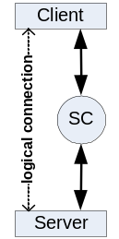 The client can to communicate to multiple services at the same time.

Server application can provide one or multiple service. Serving multiple services within one application is possible only for multithreaded or multisession servers. Multiple server applications are running on the same server node, each providing different service. All services are independent on each other. Server application may request another service and so play the client role.

Session Services
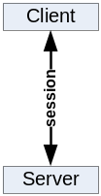Request/Response (client initiated communication). For session services the client and the server exchange messages in context of a logical session through the SC.

The client sends a request to a service that invokes an application code. Upon completion the service sends back a response message. The client waits for the arrival of the response message. The request and response message length is not limited in size.
Synchronous

The communication occurs in a scope of a logical session. SC will choose a free server and pass this and subsequent requests from this client to the same server. Session information is always passed as a part of the message header. The client may have only one outstanding request per session.
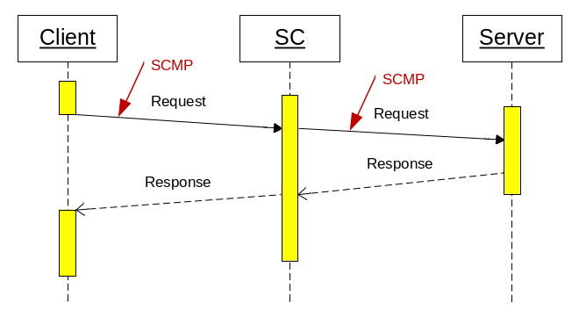
Figure 1 Synchronous Request/Response

Multiple clients may request the same service at the same time. The service execution is in parallel, each one in a separate thread or process. The server decides how many sessions it can serve.

This communication style is the most often used for getting data from the server or sending a message that triggers a transaction on the server.

Asynchronous execution is functionally equal to the synchronous case with the exception that the client does not wait for the arrival of the response message. The client must declare a notification method that is invoked when the response message arrives. The client may have only one outstanding request per session. When client issues a request before the previous one was completed, the send method blocks until the previous request is satisfied.
Asynchronous
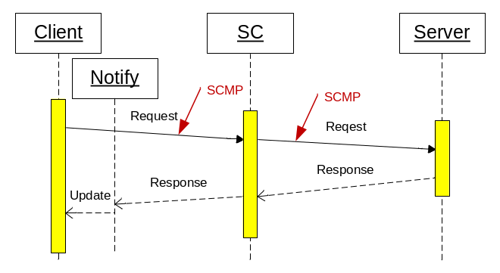
Figure 2 Asynchronous Request/Response

This communication style will be used to load data while other activities are in progress, e.g. to get large amount of static data at startup. It can be also used as fire-and-forget when the response is not meaningful.

Publishing Services
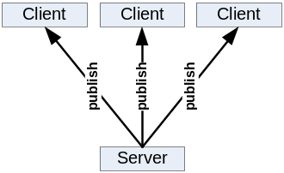Subscribe/Publish (server initiated communication). Publishing services allows the server to send single message to many clients through the SC.

The client sends a subscription mask to the service, and so declares its interest on certain type of a message. The application service providing the message contents must designate the message with a type. When the message type matches the client subscription mask, the message will be sent to the client. Multiple clients may subscribe for the same service at the same time. In such case multiple clients can get the same copy of the message. Message that does not match any client subscription is discarded.

The client must declare a notification method that is invoked when the message arrives. The client may have only one outstanding subscription per service. The message delivery must occur in guaranteed sequence. Messages from the same service will arrive in the sequence in which they have been sent.

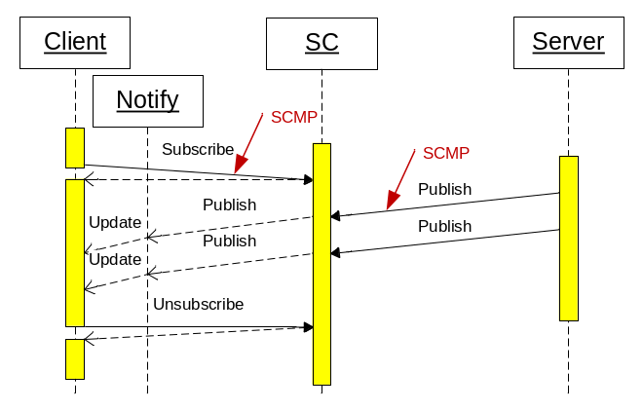
Figure 3 Subscribe / Publish

The client may change the subscription mask or unsubscribe. Initial subscription, subscription change or unsubscribe operation is always synchronous, even through a cascaded SCs.

Such communication style is used to get asynchronously events notifications or messages that are initiated on the server without an initial client action. It can be also used to distribute the same information to multiple clients.

File Services
This SC service provides API for these file operations:
- Download file from the web server to the client.
- Upload file from the client to the web server.
- List files in a file repository on the web server.

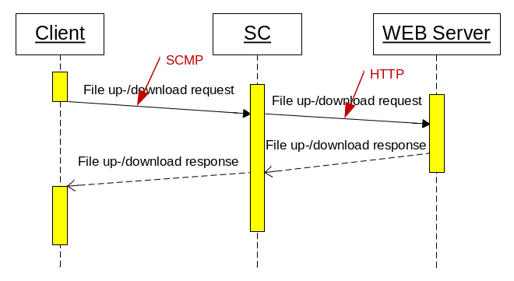
Figure 4 File service

HTTP Proxy Services
The SC supports redirecting of regular HTTP traffic to another server. It is acting like normal HTTP proxy without caching.

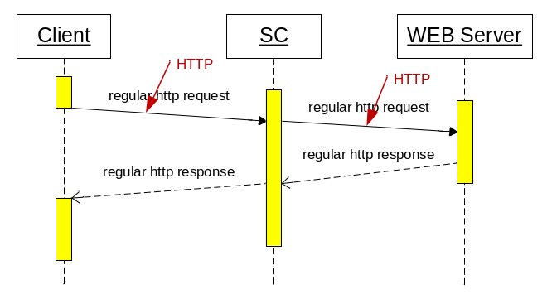
Figure 5 HTTP proxy service

Software Layers
The SC consists of four layers (top – down):
- Application layer
This layer includes the API and is the access point for client or server applications. The ServiceConnector itself (runnable) belongs also to this layer.
- Service layer
This layer implements SC services. (session service, publishing service, file service and http-proxy service)
  - http-proxy services are not relevant for client and the server. On client http-proxy service does not exist, on server it is implemented as a standard web server.
  - File services are not relevant for the server, because they are implemented as a standard web server.
- SCMP layer
This layer implements the SC messaging protocol described in [3]. Because the SCMP is open source, it is possible to access the SC on this level.
- Transport layer
This layer implements the transport of the messages via standard network protocols.

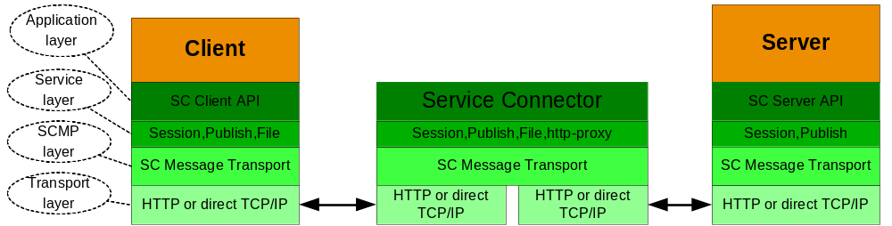
Figure 6 Software Layers

The layers are logically separated. Strong layering is enforced. Access to a layer is possible only from the next higher layer.

SC network

Connection Topology
Client application, server application and the SC may reside on the same node or on separate nodes. The connection can either utilize HTTP protocol or direct TCP/IP communication. No assumption about the physical network topology is done. Multiple firewalls can be located on the path between the communicating partners. The SC supports following connection topology:
- Client ⬄ SC ⬄ Server = Direct connection
- Client ⬄ SC ⬄ SC ⬄Server = Connection via cascaded SC.
Multiple SC may be placed on the path between the client and service.
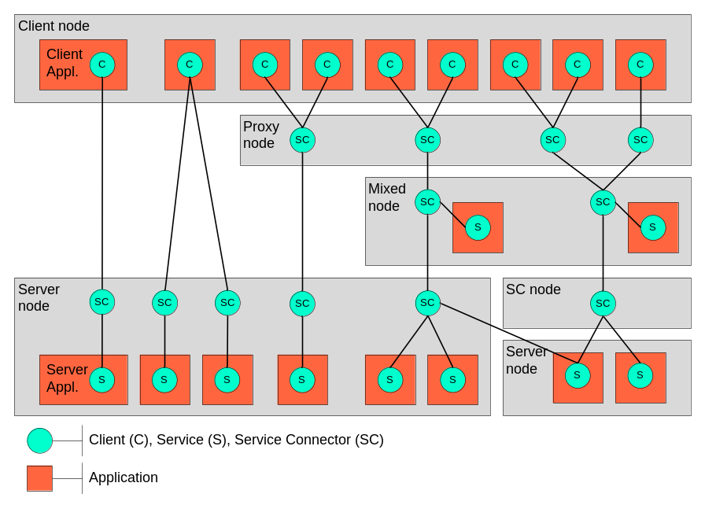
Figure 7 Connection Topology

Different connection topology types from left to right:
- Client connected to one service
- Client connected simultaneously to SCs and two services
- Two clients connected to one service via proxy service and cascaded SC
- Two clients connected to three services via proxy service on different server nodes
- Complex configuration with three clients connected to three services on different server nodes via cascaded SCs and SC offloaded to its own node. One server can be registered to multiple services and different SCs. However this is possible for multisession servers only.

Limitation: The same service can be accessed by one SC only. When the same service should be used on different nodes, it must have a different name (e.g. node suffix).

Two different transport types can be individually configured for each network segment i.e. between the Client ⬄ SC, SC ⬄ SC or SC ⬄ Server.

- HTTP
Such connection may pass screening firewalls and is appropriate for communication within the customer organization e.g. Client ⬄ SC or SC ⬄ SC.
- TCP/IP
Such connection would not pass firewalls without explicit security rules. It is useful for connection within the same node e.g. SC ⬄ Server.
SC cascading is used for performance and/or for security reasons. It is transparent for the application.

Service Routing

Session Services

Session Management
Session Echo

Message Caching

Publishing Services

Subscription Management

Message Fan-Out

Proxy Services

SC Operations

Configuration

Management GUI

J-Console (JMX)

Troubleshooting

Glossary
Client
Piece of an application consuming services and initiating actions.
Server
Piece of an application providing services to clients.
Service
Abstract unit of work provided by the server and delivered to the client in order to implement a specific functionality. SC supports session, publishing and file services.
Session
Temporary allocation of a dedicated server to a client. Session ensures information flow between a client and the allocated server. SC supports request/response sessions and subscription sessions.
Call
A call represents a pair of a request and response.
Command
A command dispatches specific actions on a server according to the incoming request.
Request
Data structure created by the Client or SC in order to initiate an information exchange. It may contain one or more messages.
Response
Data structure created by the Server or SC in order to deliver the requested information. It may contain one or more messages.
Message
Basic transport instrument to exchange information between client, SC and the server. It belongs to a request or to a response.
Message Part
Message part is a piece of a large message. Large message is splittet into parts.
Composite
Data structure prepared to hold all message parts of a large message
Registry
Common list of known objects that ensures their uniqueness, organized in a way to find them easily.
Requester
Piece of code in SC or client initiating the information exchange
Responder
Piece of code in SC or server delivering the requested information

Connection
Network communication between client and SC or SC and the server
Endpoint
Network communication part on SC or server

Service
The term service is used as synonym for a piece of application code that implements a certain function.
Client
The term client designates the application requesting a certain service.
Client node
Client node is physical network node (machine) on which the client application resides.
Server
The term server designates the application providing a certain service.
Server node
Server node is physical network node (machine) on which the server application resides.
Message payload
Message payload is part of the transported message containing the application data. SC does not inspect, transform or interpret the payload. It is the responsibility of the communicating partners to define the format, syntax and semantic of the payload.
SCMP => SC Message Protocol
Is a publically presented protocol used for communication between client, SC and the server. In the OSI layer model, message transport protocol is immediately above the application protocol layer 7.
Message transport format
Format of messages transported messages between client, SC and the server. It consists of a header and a payload.
RR => Request / Response
This is basic communication style. The client requests an execution of a (remote) service and gets back the results in form of a response. The execution may be blocking - clients waits for the response, or non-blocking (asynchronous) – the clients does not wait for the response. Sometimes it is also called Remote Procedure Call = RPC.
SP => Subscribe / Publish
This is another popular communication style. The client tells the server what he is interested in and gets the data from the server later when a event arise. The execution is always non-blocking (asynchronous) – the client does not wait for the data receipt. This is because the event occurs on the server.

Appendix
Appendix text

M
Message
Body • 18
Payload • 18
R
RPC • 18

