SC

Service Connector

Requirements and Specification

SC_0_Specification_E (Version V1.2)
SC is a middleware component for new Eurex IT platform. This document summarizes the requirements, describes specifications and defines the scope of the project. It is the starting point for the design phase.

This document is a spiritual ownership of STABILIT Informatik AG, and must not be used or copied without a written allowance of this company. Unauthorized usage is illegal in terms of Chapter 23 / 5 UWG / Swiss law.

The information in this document is subject to change without notice and should not be construed as a commitment by STABILIT Informatik AG.

Copyright © 2026 by STABILIT Informatik AG
All rights reserved.

All other logos and product names are trademarks of their respective owners.

This Document has been created with Microsoft Word 2003 (11) with template file and printed at 19 June 2009 16:07.

Identification
Project: | SC
Title: | Service Connector
Subtitle: | Requirements and Specification
Version: | V1.2
Reference: | SC_0_Specification_E
Classification: | For Internal use only
Keywords: | Requirements, Specification, Scope
Comment: | SC is a middleware component for new Eurex IT platform. This document summarizes the requirements, describes specifications and defines the scope of the project. It is the starting point for the design phase.
Author(s): | STABILIT Informatik AG  Jan Trnka, Daniel Schmutz, Mauro Ricchetti, Joel Traber
Approval (Reviewed by): | Signature Jan Trnka  Signature Francisco Gonzalez
Audience: | Project team, Eurex IT management, Review team
Distribution: | Project team, Eurex IT management, Review team
Filename | /tmp/lo/0000.doc
Revision History
Date | Version | Author | Description
14.06.2009 | D1.0 | Jan Trnka | Initial draft
09.08.2009 | D1.1 | Jan Trnka | Separate specifications and requirements into this document and move other parts to the architecture document
25.11.2009 | V1.2 | Jan Trnka | Corrections from talks with SIX
January 2010 | V1.3 | Jan Trnka | Finalizing requirements

Table of Contents
1 Preface 4
1.1 Purpose & Scope of this Document 4
1.2 Definitions & Abbreviations 4
1.3 External References 5
1.4 Typographical Conventions 5
1.5 Outstanding Issues 5
2 Project Definition 6
2.1 Existing Situation 6
2.2 Goals 6
2.3 Non-Goals 6
2.4 Scope 7
2.5 Relationships & Dependencies 7
3 Requirements 8
4 Specifications 9
4.1 Use cases 9
4.1.1 Synchronous Request/Response 9
4.1.2 Asynchronous Request/Response 9
4.1.3 Asynchronous Subscribe/Publish 10
4.1.4 List files 11
4.1.5 Download File 11
4.1.6 Upload File 11
4.1.7 Delete File 11
4.2 SC-Proxy 11
4.2.1 Request/Response 11
4.2.2 Subscribe/Publish 12
4.2.3 HTTP Proxy 12
4.3 Network 12
4.4 Connection Topology 12
4.5 Service Naming 13
4.6 Keep-alive Messages 13
4.7 Message sequencing 14
4.8 Message Format 14
4.9 Message Transport 14
4.10 Security 14
4.11 Load balancing 15
4.12 Failover 15
4.13 Deployment 15
4.14 Configuration 15
4.15 Administration 16
4.16 Operation 16
4.17 Monitoring and Troubleshooting 16
4.18 Network Size 17
4.19 Operating environment 17
4.20 Visibility 17
4.21 Availability 17
4.22 Performance 17
4.23 Language 18
4.24 Flexibility Constraints 18
5 Glossary 19
Appendix 20
Index 22

Tables
Table 1 Abbreviations & Definitions 5
Table 2 External references 5
Table 3 Typographical conventions 5
Table 4 Requirement Formulations 5
Table 5 Network Size 17

Figures
Figure 1 Synchronous Request/Response 9
Figure 2 Asynchronous Request/Response 10
Figure 3 Subscribe / Publish 10
Figure 4 Topology 13

Preface

Purpose & Scope of this Document
This document summarizes the known requirements, describes system specifications and defines the project scope.

The final and approved version of this document serves as base for the binding architecture and design, described in another document. It defines also the scope of the implementation project and is part of the contract between Eurex / SIX and Stabilit.

This document is particularly important to all project team members.

Definitions & Abbreviations
Item / Term | Definition / Description
EBS | Elektronische Börse Schweiz – older project name for ESY
ERM | Electronic Repo Market
ESY | Exchange System – SIX trading platform
EUI | Exchange User Interface – application for static data maintenance in ESY. (Analogy of CUI in ERM)
GUI | Graphical User Interface
GWY | Gateway
HTML | Hypertext Mark-up Language
HTTP | Hypertext Transport Protocol
HTTPS | HTTP over SSL, encrypted and authenticated transport protocol
IE | Internet Explorer – Microsoft Web Browser
J2EE | Java 2 Platform Enterprise Edition
Java | Programming language and run-time environment from SUN
JDK | Java Development Kit
JSF | Java Server Faces – open source framework for Web-GUI
LDAP | Lightweight Directory Access Protocol
Linux | Unix-like operating system, open source
Log4j | Standard logging tool used in Java
OpenVMS | HP Operating system, platform for ERM
RMI | Remote Method Invocation - RPC protocol used in Java
RPC | Remote Procedure Call
SOAP | Simple Object Access Protocol
SSL | Secure Socket Layer – secure communication protocol with encryption and authentication
SIX Exchange | Member of SIX Group, Exchange platform provider
TCP/IP | Transmission Control Protocol / Internet Protocol
SIX Telekurs | Member of SIX Group, Financial information provider, and operational staff for ERM.
SC | Service Connector
USP | Universal Service Processor – existing middleware used by Eurex Repo
Web Service | software designed to support interoperable machine-to-machine interaction over a network
Web-GUI | Graphical User Interface running in Web-Browser built with Web components. Also called Thin-Client.
Windows | Microsoft operating system family
XLS | File extension for MS-Excel
XML | Extensible Mark-up Language
XSD | XML Schema Definition
XSLT | Extensible Style Sheet Language Transformation
Table 1 Abbreviations & Definitions

External References
References | Item / Reference to other Document
[1] | USP Documentation  http://www.stabilit.ch/index.php?option=com_content&task=view&id=27&Itemid=60
[2]
Table 2 External references

Typographical Conventions
Convention | Meaning
text in italics | Analogous USP feature or functionality or comments
text in Courier font | code example
[ phrase ] | In syntax diagrams, indicates that the enclosed values are optional
{ phrase1 | phrase2 } | In syntax diagrams, indicates that multiple possibilities exist.
… | In syntax diagrams, indicates a repetition of the previous expression

Table 3 Typographical conventions

In formulation of requirements words "must" and "should" have the following meaning:

Formulation | Meaning
must, must not | Strong, mandatory requirement.
should, may, need not | Weak, optional requirement. (Nice to have)
Table 4 Requirement Formulations

The terminology used in this document may be somewhat different to other sources. The chapter Glossary includes a list of often used terms with the explanation of their meaning in this document.

Outstanding Issues
Following issues are outstanding at the time of the document release:
- Must SC run also on OpenVMS Alpha? => only JDK 1.5 available!
- Is automatic reconnect after connection loss required and possible?
- Are file services really required?
- Can file services utilize Apache WebDAV?
- How to deliver C-API for server on OpenVMS?

Project Definition

Existing Situation
The new EUREX IT platform needs a middleware that allows exchange of messages between its components and applications. This middleware must also allow seamless replacement of the existing USP with a new forward looking solution. Old Eurex Repo services running on OpenVMS must be able to connect via SC to the trading GUI or to other components. However SC should not be treated as a plain USP substitution. It should open new opportunities for communication of the REPO platform with new internal or external services.

Researching the market and products we found no adequate software available. The SIX Exchange is looking for USP replacement by a standard product since 5 years without any visible progress. Our sound knowledge of USP and of the EUREX computing environment leads us to the idea of developing a new solution.

Goals
The following are the overall project goals (in priority order):
- Simple messaging middleware for all new components within the Eurex platform
- Replacement of USP with a capability of access to existing Repo services.
- Design of a simple and open communication protocol that can be adopted by the companies that want build custom solutions based on it.

The principle is: “as simple as possible, serving only the real needs”.

Other goals are:
- Operating system independence (unix, linux, windows, OpenVMS Itanium)
- Use of Open Source components (all java)
- Universal API for message-based and file-based communication
- Use of standard transport protocols (http, ftp, smtp, etc.)
- API for applications written in Java (server and client) and C (server only)
- Availability equal or better then USP (> 99.90%)
- Scalability better then USP (>1’000 concurrent users)
- Manageability better then USP (Web-GUI for administration)

Non-Goals

The SC will not have any persistence and thus will not provide any transactional concepts or reliable messaging.

The SC will not implement any security feature. The environment where SC is used must provide suitable security features like authentication, authorization, encryption, tunneling etc.

The SC will not provide any load balancing features. Established communication session will not be redirected to another server node initially or during its life time.

The SC will not implement any failovers features. Aborted communication must be re-established by the communicating partners. The client application must find out a service which is alive.

SC is not intended for direct communication to external systems with other established protocols like SIS, Telekurs VDF, SMF or others. These systems use their own protocols and can be connected with other middleware or can be connected via a protocol-specific SC gateway that may be developed when necessary. However it the intention to publish the SC communication protocol and allow third-parties to connect directly to SC without any other adaptors or SC gateways.

Scope
The scope of the project is to design and develop the SC, including all interfaces to the applications that will use it, including the SC-Proxy.

Only http transport will be implemented in the first release

The migration from USP to SC is not scope of this development project. It will be planed and subsequently realized as a separate project.

Relationships & Dependencies
The USP migration to SC cannot begin before this project will finish and the acceptance test is passed. However it is possible to develop the necessary adoptions of the connecting applications as soon as the SC interface has been published.

Requirements
The SC must support peer-to-peer message exchange between requesting application and another application providing a service. The term “service” is used as synonym for a piece of application code that implements a certain function.

Service requestor (client application) and the service provider (server application) are the communication end-points. Client must be able to communicate to one or multiple service providers. This can must be possible in sequence (one connection at a time) or in parallel (two independent connections at the same time).

Server application must be able to provide one service. Serving multiple services will be handled at application level by an appropriate service dispatcher. All services are independent on each other. Cascading of services is supported by SC Proxy or can be done at application level.
The server applications are started, stopped and managed by operational facilities that are not scope of the SC. The pre-started server application registers itself as a service provider to SC.

The SC provides API and messaging for these two service types:
Messaging
Services
- Request/Response (formerly USP-RPC - remote procedure call)
See use case and 4.1.2
- Subscribe/Publish (formerly USP-BCT – broadcast)
See use case 4.1.3

The SC provides API for these service types:
File Service
- List files in the file repository (on the server).
See use case 4.1.4
- Download file (from the server)
See use case 4.1.5
- Upload file (to the server)
See use case 4.1.6
- Delete file (on the server)
See use case 4.1.7

SC-Proxy
Services
The SC-Proxy provides following services (See use case 4.2.1, 4.2.2 and 4.2.3):
- Cascading of all messaging and file services.
- Bundling of the network traffic for Request/Response services
- Message caching for Request/Response services
- Fan-out of the published messages for Subscribe/Publish services
- Redirecting of regular HTTP traffic to another server (HTTP Proxy, no caching)

Specifications

Use cases
The SC implements the use cases described here below.

Synchronous Request/Response
The client sends a request to a service that invokes an application code. Upon completion the service sends back a response message. The client waits for the arrival of the response message. The client may have only one outstanding request per service.
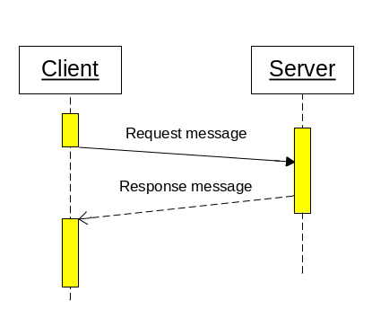
Figure 1 Synchronous Request/Response

Multiple clients may request the same service at the same time. In such case the service execution is in parallel, each one in a separate service context (thread or process).

This communication style is the most often used for getting data from the server or sending a message that triggers a transaction on the server.

USP maintains a session context. It starts and assigns a separate server process for each connected client and maintains a permanent TCP/IP connection between client, the USP and the allocated server until the client disconnects. This is very resource consuming and massively limits the scalability. Some session checks are in the server application (ICS, TXS, TXR) itself.
SC will choose a free server and pass subsequent requests from this client to the same server. The server decides how many sessions it can serve. Session information is not kept in SC but in the client and is always passed as a part of the message header.

Asynchronous Request/Response
This is functionally equal to the synchronous case with the exception that the client does not wait for the arrival of the response message. The client must declare a notification method that is invoked when the response message arrives. The client may have only one outstanding request per service.
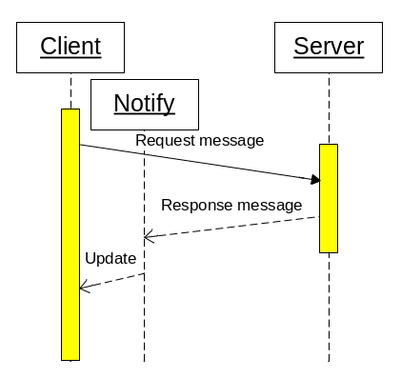
Figure 2 Asynchronous Request/Response

This communication style will be used to load data while other activities are in progress, e.g. to get large amount of static data at startup. It can be also used as fire-and-forget when the response is not meaningful.

USP does not support asynchronous request/response.

Asynchronous Subscribe/Publish
The client sends a subscription mask to the service, and so declares its interest on certain type of a message. The application service providing the message contents must designate the message with a type. When the message type matches the client subscription mask, the message will be sent to the client. Multiple clients may subscribe for the same service at the same time. In such case multiple clients can get the same copy of the message. Message that does not match any client subscription is discarded.

The client must declare a notification method that is invoked when the message arrives. The client may have only one outstanding subscription per service. The message delivery has occurs in guaranteed sequence. Messages from the same service will arrive in the sequence in which they have been sent.

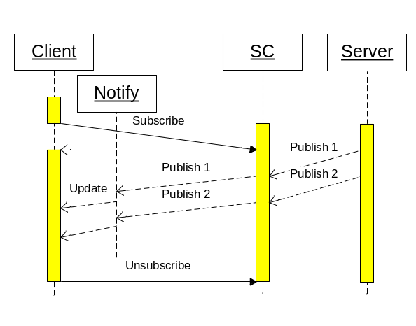
Figure 3 Subscribe / Publish

The client may change the subscription mask or unsubscribe. Initial subscription, subscription change or unsubscribe operation is always synchronous, even through a SC proxy.

Such communication style is used to get asynchronously events notifications or messages that are initiated on the server without an initial client action. It can be also used to distribute the same information to multiple clients.

USP implements a queuing of messages that should be distributed to the clients. This can cause exhausting of memory when the client is not able to receive the messages and the connection is not lost (e.g. firewall in between)

List files
The client sends a request to get information about the file area managed by a service. The service returns information about the files stored in that area.

This communication style is synchronous. This is basic file-server functionality and thus implemented in the standard software components.

USP does not support file operations

Download File
The client sends a request to a download a file from an area managed by a service. The service sends the requested file as a stream to the client.

This communication style is synchronous. This is basic file-server functionality and thus implemented in the standard software components.

USP does not support file operations

Upload File
The client sends a request to upload a file into an area managed by a service. The service receives the uploaded file as a stream and stores it on the requested location.

This communication style is synchronous. This is basic file-server functionality and thus implemented in the standard software components.

USP does not support file operations

Delete File
The client sends a request to delete a file to an area managed by a service. The service deletes the file.

This communication style is synchronous. This is basic file-server functionality and thus implemented in the standard software components.

USP does not support file operations

SC-Proxy
For the client the SC-Proxy acts as a regular service, but passes all messages to another service of the same type. This “cascading” is possible for all service types. SC-proxy resides on a proxy node or on a server node. Single SC-Proxy instance can handle multiple services.

Request/Response
For Request/Response the SC-Proxy acts as a server. It bundles requests from multiple clients and passes them to another service like a single client. Received response messages are passed back to the appropriate clients. The purpose of bundling is to use only one communication channel and so save resources on the server.

SC-Proxy should provide a message caching mechanism for dedicated server content. The client request for a cached content can differ from regular request. The purpose of the cache is to massively shorten the start-up time of the client (actually 10min.). At star-up high volume of static data must be loaded by each client. This data should be pre-fetched and stored locally. The refresh of the cache should be automatic and driven by time to live attribute assigned to the cached content.

USP-Proxy does not provide bundling of Request/Response traffic into a single connection and thus overloads the server with thousands of parallel connections. USP-Proxy does not implement message caching.

Subscribe/Publish
For Subscribe/Publish the SC-Proxy acts as a server, combines client subscriptions to a single subscription mask and provides fan-out (distribution) of response messages received from the server to the subscribed clients according to their subscription mask.

USP-Proxy implements identical fan-out features.

HTTP Proxy
SC-Proxy node is often located in DMZ at the customer site and connected via VPN with the server. Therefore it must also provide simple HTTP proxy function, because it represents the only path to the server where a regular web server (apache) is running.
No file caching will be implemented in the proxy.

USP-Proxy implements http 1.0 proxy without caching.

Network
Client and server may reside on the same node or on separate nodes connected via TCP/IP network. Server application resides on the server node. Client application resides on the client node or on the server node. No assumption about the physical network topology must be done. Multiple firewalls can be located on the path between the communicating applications.

UDP must not be used, because it will not pass firewalls and routers.
FTP should not be used because it will not pass firewalls and may cause potential problems with customer security policy.

SC is not supported on network with nodes having mixed architectures (big and little endian).
SC is supported only on nodes with ASCII character set (no support for EBCDIC).

USP has the same limitations

Connection Topology
The SC supports following connection topology:
- Client ⬄ Service = Direct connection
- Client ⬄ Proxy (n-times) ⬄ Service = Cascaded connection via SC-Proxy.
One or multiple SC-Proxies may be placed on the path between the client and service.

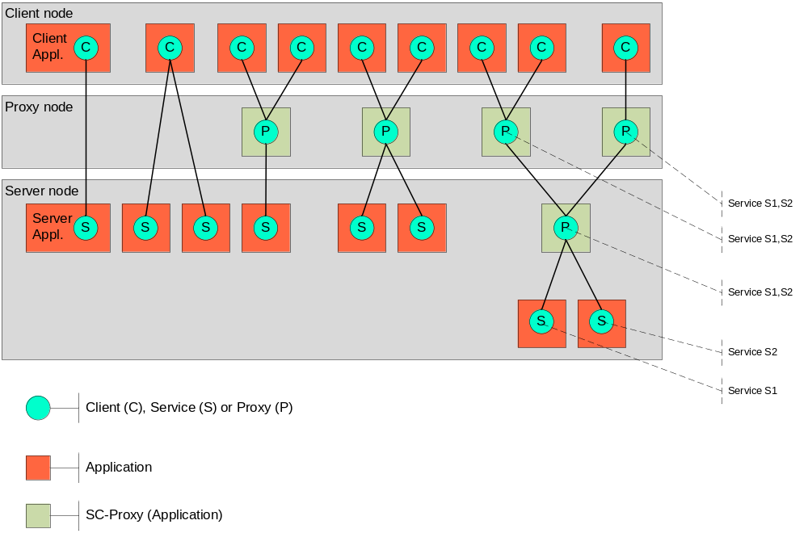
Figure 4 Topology

Different topology types from left to right:
- Client connected directly to a service
- Client connected simultaneously to two services
- Two clients connected to one service via proxy
- Two clients connected to two services via single proxy
- Three clients connected to two services via cascaded proxy

Service Naming
The network represents the namespace domain. The service names within this namespace must be unique. Therefore one service residing on different server nodes within the same network must be registered under two different names.

USP behaves the same way.

Keep-alive Messages
When no real data is exchanged, the client and the service exchanges periodically keep-alive messages that allow the detection of the connection state. In case of connection loss a reconnect occurs automatically with the next request.

The keep-alive message should be used to exchange time information between client and server. This does slightly simplify troubleshooting and operation in different time zones. It also allows the client do measure the round trip performance.

USP does implement keep-alive for request/response in V3 protocol. This is not used by SIX Group. Instead the V2 protocol is used and keep-alive is implemented on application level. For subscribe/publish complex and cumbersome keep-alive messages are implemented by USP, but this does not work reliably.

USP does not implement automatic reconnect, because the communication is statefull.

Message sequencing
The request - response message pair must have a sequence number. It is generated and steadily increased by the client. Upon arrival of the response message by the client the sequence number is checked to detect potential gaps (missed messages).

The subscribe - publish message pair must have a sequence number. It is initially generated by the client and steadily increased by the server. It determines the subscription ID and upon receipt by the client allows detection of potential gaps (missed messages).

USP does not implement message sequencing for request/response but only for subscribe/publish and in slightly different way.

Message Format
The message consists of a variable size header and variable size body. The maximum total message length is 64kB.

Message header content belongs to SC. Its structure is published. Java API will be provided to get important attributes.

Message body content belongs not to SC and is transported as a block of bytes (8bit). It is the task of the communication partners to agree on its structure and format as well as to perform appropriate marshalling or de-marshalling of data types. Message body mime type can be defined in the header to allow appropriate message trace. If not defined, message body is traced out in hex.

Message body compression and de-compression before and after the transport can be turned on or off.

USP does implement marshalling / de-marshalling of some standard data types (string, integer and float) but this is not used by SIX. Message body compression is implemented on application level and is rather cumbersome for troubleshooting, because the message content cannot be traced at the transport level.

Message Transport
All service types utilize only http protocol over TCP/IP. This guarantees that customer firewalls need not be reconfigured.

It should be possible to implement other message transport protocols later without changing the client or server API.

USP uses a proprietary binary communication protocol over TCP/IP and over DECnet.

Security
The SC does not implement any security feature. The environment where SC is used must provide all required authentication, authorization, encryption, tunneling etc. features. Message transport over https will not be supported.

USP provides SSL communication in cooperation with Apache CSWS, however no customer is using this feature.

The IP address of the client and the IP of the incoming TCP/IP traffic must be stored in the message header and can be obtained via API within the service. This can be used to authorize the client when a VPN tunnel is used.

USP follows the same philosophy and has the same limitation.

Load balancing
The SC does not provide any load balancing features. Established communication session will not be redirected to another server node initially or during its life time.

USP does not implement load balancing. This is built into the DDC application.

Failover
The SC does not provide any failover features. Aborted communication must be re-established by the communicating partners. The client application must find out a service which is alive.

USP does not provide any failover features.

Deployment
The SC client and server APIs for java will be delivered as jar-files and will be embedded in the applications. The SC server API for C will be delivered as source code? (TBD) SC client API for C will not be implemented.

USP provides client and server API for C and LEVEL4 and a client API for Java. C API is not used. C applications are wrapped with LEVEL4 code.

The SC and SC-Proxy are delivered as jar-file that can be started from the command level as a java application. The only difference between SC and SC-Proxy is the configuration. Each SC can play also the role of a SC-Proxy. Multiple instances of a SC or SC-Proxy must be able to run on a single node. Each instance must have its own configuration.

On Windows platform SC or SC-Proxy can be deployed as service.

USP is deployed as a OpenVMS kit, USP/Proxy is deployed as ZIP file. USP Java Client is available as ZIP file (source code).

Configuration
The SC components embedded in the application are configured through the corresponding API. The configuration of SC and SC-Proxy is file based. The format of the configuration file is ASCII. (XML is not friendly for editing!)

The configuration contains static (S) and dynamic (D) parameters. Change of static parameters cannot be changed at run time and requires SC restart and thus los of all connections. Dynamic parameters can be changed at run time.

The SC configuration defines:
- (S) Log file location
- (D) Log level
- (S) Nr of days to keep log files
- (S) Administration port (for admin GUI)
- (S) Administration username (plain)
- (S) Administration password (plain)
- For each implemented transport parameters like
  - (S) Transport type (http)
  - (S) Port number
  - (S) Other transport specific attributes

The SC configuration defines on service level
- (S) Service name
- (S) Service type
- (D) Log level
- (S) Log filename prefix
- (D) Flags that allows / disallows client connections
- (D) Maximal number of active clients (for Request/Response services)
- (S) Size of the subscription mask in bytes (for Subscribe/Publish services)
- (D) Keep-alive timer (in seconds)

The SC-Proxy configuration defines on service level additionally
- Redirected service name
  - (S) Server name or IP
  - (S) Server port

USP has a proprietary binary configuration file format. Some parameters are dynamic and can be changed at run time without USP restart. However this causes a connection loss to affected clients and services.

Administration
No administration features are available for the client or service. These components are embedded in the application and accessible via SCI API.

The SC and SC-Proxy administration is reduced to proper configuration.

Operation
The SC and SC-Proxy must provide reasonable tools for local operations. These are:
- Start SC or SC-Proxy
- Stop SC or SC-Proxy
- Enable or disable connection to a particular service
- Change dynamic configuration parameters
- Get information about the actual service state in order to pre-start more servers
- Download new SC configuration from a server

Remote operations are not supported.

Monitoring and Troubleshooting
The SC and SC-Proxy must provide reasonable tools for local monitoring and troubleshooting. A monitoring Web-GUI should be implemented and should provide following features:
- Show state of all services or a particular service
- Show statistic of all services or one service
- Show the log file
- Upload selected log files to a server
The Web-GUI must not make any assumptions about the plug-ins used by the browser. IE V6.0 or later and Firefox 3.0 or later must be supported.

All components (Client API, Server API, SC and SC-Proxy) must provide:
- Multilevel logging facility (log4j) with the following levels:
  - Connection (connects, disconnects, abort, loss of connection, re-connect, etc.)
  - Message
    - Header only
    - Full message

SC and SC-Proxy must additionally provide:
- Statistical information
  - Actual version number
  - Configuration file loaded
  - Start-up timestamp
- Statistical information per service
  - Total Nr. of connections
  - Total Nr. of re-connects
  - Total Nr. of messages sent
  - Total Nr. of messages received
  - Average Message size sent
  - Average Message size received
  - Maximal message size sent
  - Maximal message size received
  - Actual subscription mask (Subscribing client only)
  - Actual number of connected clients (Publishing server only)
  - Actual number of executing clients (Responding server only)

USP has a utility to get limited run-time information.

Network Size
The system must be able to networks size defined in the following table

Item | Number | Comment
Clients | ≥10'000 | Currently 1'100 users are registered
Proxies | ≥1000 | Currently 250 USP-Proxies are in use
Services | ≥100 | Currently 2 nodes with 13 services each are in use
Table 5 Network Size

Operating environment
The SC client, server and proxy components should run on any operating system supporting Java 5. Typically the client and proxy components will run on Windows or Unix platforms. The SC and server components will run on OpenVMS at the first stage and later on Linux.

The components must not use Java 6 (Java6 is not available on OpenVMS - Alpha)

Visibility
The entire Service Connector will be published as OpenSource project to Apache repository. Client and proxy components will be used at Eurex and can be also distributed to selected EUREX customers.

Availability
This software is the connection between the bans and the exchange and is classified as business critical. The required yearly availability is 99.9 % in the time from Monday to Friday, during extended business hours 6:00 – 22:00.

Performance
SC must be capable to transport >1000 msg./sec. (request/response, client and server on the same node, message length 128 bytes )

USP/RPC reference benchmark can handle 600 msg./sec, each 128 byte long on AlphaServer 800 under OpenVMS 8.1

Language
English (U.S.) language must be generally used for all project documentation and software components including user interface, configuration and administration. Other languages will not be supported. Documents in German language are not allowed.

Flexibility Constraints
It must be possible to add new transport methods. This must not have impact on the API.

Glossary
Glossary item
glossary text

Appendix
text

A
Availability • 17
N
Network
Size • 17
O
Operating environment • 17
Operations • 16

