Creative Analogy Finding Task

First presented in:

Weinberger, A. B., Iyer, H., & Green, A. E. (2016). Conscious augmentation of creative state enhances “real” creativity in open-ended analogical reasoning. PloS one, 11(3), e0150773.
Contact: Adam Weinberger (abw58@georgetown.edu)

The Analogy Finding task consists of two matrices of word-pairs (see below). Each matrix contains 5 word pairs arranged in a column on the left side of the screen (“stem pairs”) and 20 word-pairs arranged in a row across the top of the screen (“completion pairs”). Participants are instructed as follows:
“Your task is to make analogies by combining word pairs on the left side of the grid with word pairs along the top of the grid. Each word pair should be read as ‘[Top Word] is to [Bottom Word]’ For example, ‘Helmet is to Head.’ Check the boxes to indicate when a word pair from the top combines with a word pair on the left to make a valid analogy. Try to make as many analogies as you can. However, only valid analogies should be listed, so don’t list analogies unless you can describe how the two word pairs are analogous.”
There 17 potential valid analogies that in each matrix, and 84 potential word-pair combinations that yield invalid analogies. There are no restriction against using the same completion pair with more than one stem pair, and each matrix includes one completion pair that could be validly combined with two stem pairs.
The order the of matrices should be counterbalanced between participants. The matrices can be administered with or without time constraints (we have done it both ways in our work, 5 minutes per matrix is typically adequate).
In the original version of this study, participants received a “creative cue” before completing the second matrix:
“This task is the same as the one you just finished. This time, please think creatively as you search for valid analogies. Some analogies may not be obvious right away, so be sure to look for abstract connections. However, only valid analogies should be listed, so don’t list analogies unless you can describe how the two word pairs are analogous.”
Creativity is assessed via the following outcomes measures: (1) the total semantic distance of valid analogies identified (greater distance = more creative), (2) the number of valid analogies identified, which is related but not informationally identical to the total semantic distance, and (3) the number of invalid analogies identified.
Valid analogies are classified as either “within-domain” (e.g., father:son is to mother:daughter) or “cross-domain” (e.g., father:son is to cloud:rain). Cross-domain analogies have a greater semantic distance, and are more creative.

Analogy Matrices:
These can be easily programmed into Qualtrics or paper-and-pencil format.
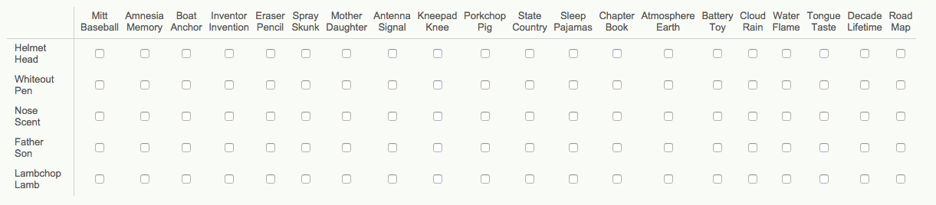
Matrix 1 (Helmet-Head)

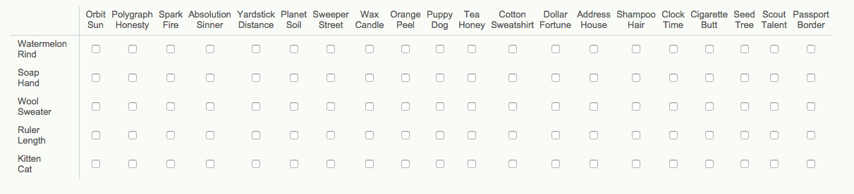
Matrix 2 (Watermelon-Rind)
Scoring Information:

For all of the below, the first correct response listed is “within domain.” All other analogies are “cross-domain.”

Word Pair | Correct Response | Semantic Distances of Correct Response
Watermelon: Rind | J, R, Q | Sem Distance: 75 (J), 95 (R), 99 (Q) = 269; Cross-Domain = 194 (R + Q)
Soap: Hand | K, B, L | Sem Distance: 71 (K), 79 (B), 89 (L) = 239; Cross-Domain = 168 (B+L)
Wool: Sweater | S, F, C | Sem Distance: 38 (S), 75 (F), 90 (C) = 203; Cross-Domain = 165 (F+C)
Ruler: Length | O, E, N, D | Sem Distance: 41 (O), 88 (E), 81 (N), 89 (D) = 299; Cross-Domain = 258 (E+N+D)
Kitten: Cat | M, T, I, C | Sem Distance: 61 (M), 79 (T), 93 (I), 95 (C) = 300; Cross-Domain = 267 (T+I+C)

A. | Orbit  Sun | E. | Polygraph  Honesty | I. | Spark  Fire | L. | Absolution  Sinner | O. | Yardstick  Distance | R. | Planet  Soil
B. | Sweeper  Street | F. | Wax  Candle | J. | Orange  Peel | M. | Puppy  Dog | P. | Tea  Honey | S. | Cotton  Sweatshirt
C. | Dollar  Fortune | G. | Address  House | K. | Shampoo  Hair | N. | Clock  Time | Q. | Cigarette  Butt | T. | Seed  Tree
D. | Scout  Talent | H. | Passport  Border

For all of the below, the first correct response listed is “within domain.” All other analogies are “cross-domain.”

Word Pair | Correct Response | Semantic Distances of Correct Response
Helmet: Head | J, G, R, A | Sem Distance: 52 (J), 92 (G), 74 (R), 88 (A) = 305; Cross-Domain = 254 (G+R+A)
Whiteout: Pen | O, Q, E | Sem Distance: 61 (O), 94 (Q), 85 (E) = 240; Cross-Domain = 179 (Q+E)
Nose: Scent | T, F, A | Sem Distance: 41 (T), 93 (F), 92 (A) = 226; Cross-Domain = 185 (F+A)
Father : Son | B, L, N | Sem Distance: 41 (B), 91 (L), 92 (N) = 224; Cross-Domain = 183 (L+N)
Lambchop: Lamb | M, C, P, D | Sem Distance: 35 (M), 95 (C), 88 (P); 85 (D) = 303; Cross-Domain = 268 (C+P+D)

A. | Mitt  Baseball | E. | Amnesia  Memory | I. | Boat  Anchor | L. | Inventor  Invention | O. | Eraser  Pencil | R. | Spray  Skunk
B. | Mother  Daughter | F. | Antenna  Signal | J. | Kneepad  Knee | M. | Porkchop  Pig | P. | State  Country | S. | Sleep  Pajamas
C. | Chapter  Book | G. | Atmosphere  Earth | K. | Battery  Toy | N. | Cloud  Rain | Q. | Water  Flame | T. | Tongue  Taste
D. | Decade  Lifetime | H. | Road  Map

