**# TASK 1 System Monitoring Documentation**

**Tools Installed**

**htop**

* **Command to Install:** sudo apt update && sudo apt install htop -y
* **Status:** SUCCESS
* **Purpose:** Monitor CPU, memory, and processes interactively in real-time.
* **Command to Launch:** htop
* **Customization:** Added CPU, memory, and process columns for detailed insights.
* **Logging:** htop -d 10

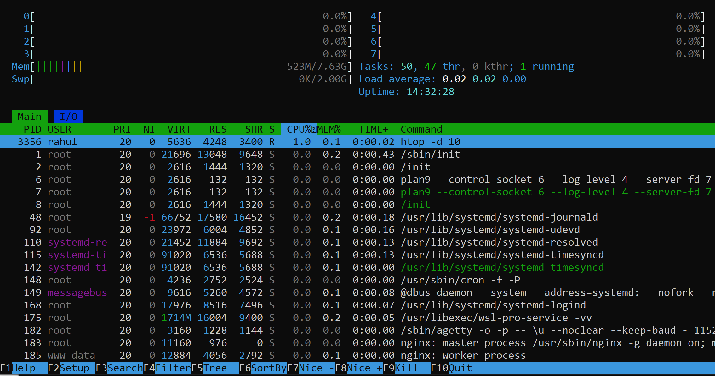

**nmon**

* **Command to Install:** sudo apt update && sudo apt install nmon -y
* **Status:** SUCCESS
* **Purpose:** Advanced monitoring of CPU, memory, and system performance metrics.

**Monitoring Disk Usage**

**Check Disk Space**

* Use the df command to log disk usage: df -h > /var/log/system_metrics.log

**Identify Large Files or Directories**

* Display disk space used by each directory in the current directory: du -sh *
* Display disk space used by the top-level directories in the current directory: du -h --max-depth=1

**Monitoring CPU and Memory Usage**

**Identify CPU-Intensive Processes**

* Use the following command to log processes consuming the most CPU: ps -eo pid,ppid,cmd,%mem,%cpu --sort=-%cpu | head > /var/log/cpu_intensive.log

**Identify Memory-Intensive Processes**

* Use the following command to log processes consuming the most memory: ps -eo pid,ppid,cmd,%mem,%cpu --sort=-%mem | head > /var/log/memory_intensive.log

**Dynamic Process Monitoring**

**Using top**

* Display a dynamic view of system processes sorted by CPU usage: top
* Press P to sort by CPU percentage.

**Automating Monitoring Tasks**

**Cron Jobs**

**Log Disk Space Usage Every Hour**

* **Cron Job Command:** 0 * * * * df -h > /var/log/system_metrics.log

**Log CPU-Intensive Processes Every 15 Minutes**

* **Cron Job Command:** */15 * * * * ps -eo pid,ppid,cmd,%mem,%cpu --sort=-%cpu | head > /var/log/cpu_intensive.log

**Log Memory-Intensive Processes Every 15 Minutes**

* **Cron Job Command:** */15 * * * * ps -eo pid,ppid,cmd,%mem,%cpu --sort=-%mem | head > /var/log/memory_intensive.log

**Log Large Files and Directories Every Day**

* **Cron Job Command:** 0 0 * * * du -h --max-depth=1 > /var/log/large_files.log