SolverWaveFunction(QM)

deltaX=.1nm

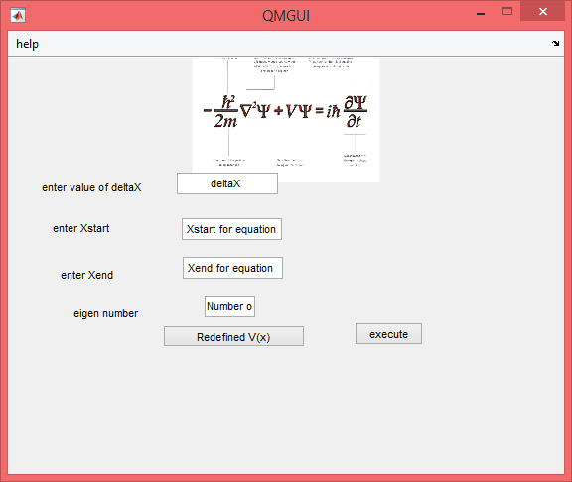

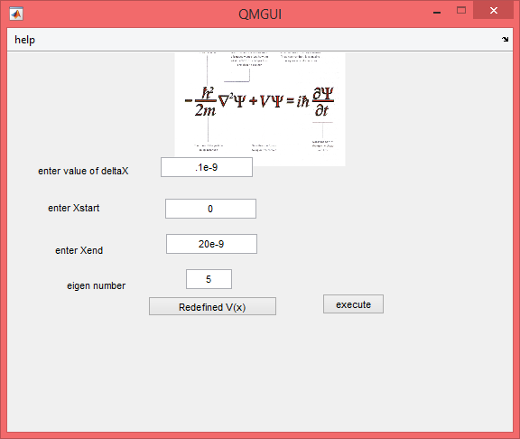





N=5



N=195



deltaX=.2nm

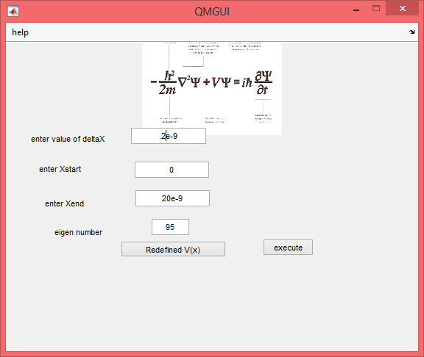





****

N=5



N=95



The End