Ansible-Assessment

* Yaswanth Mahesh Samudrala

**Question4: Installing Mariadb using handlers.**

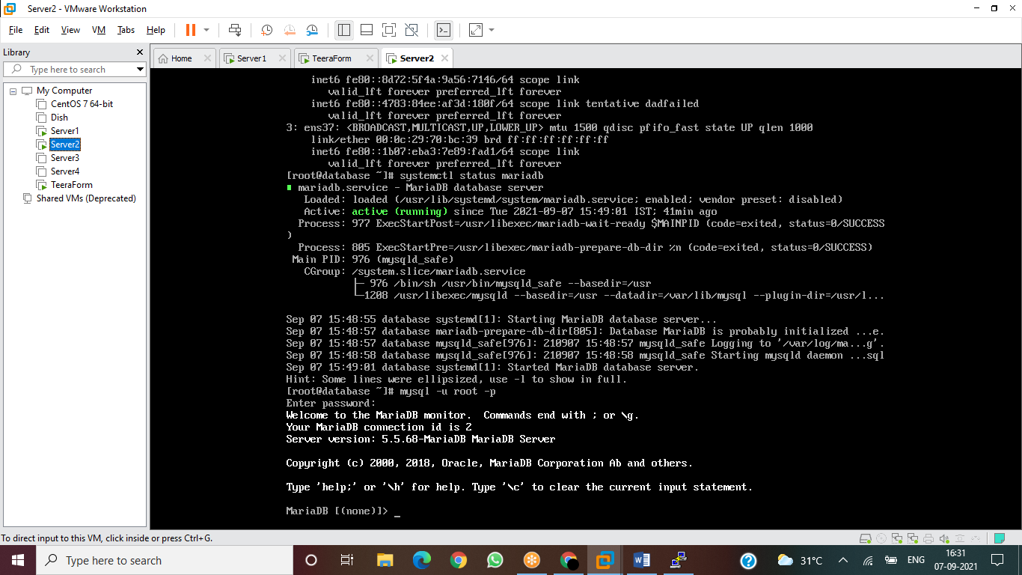

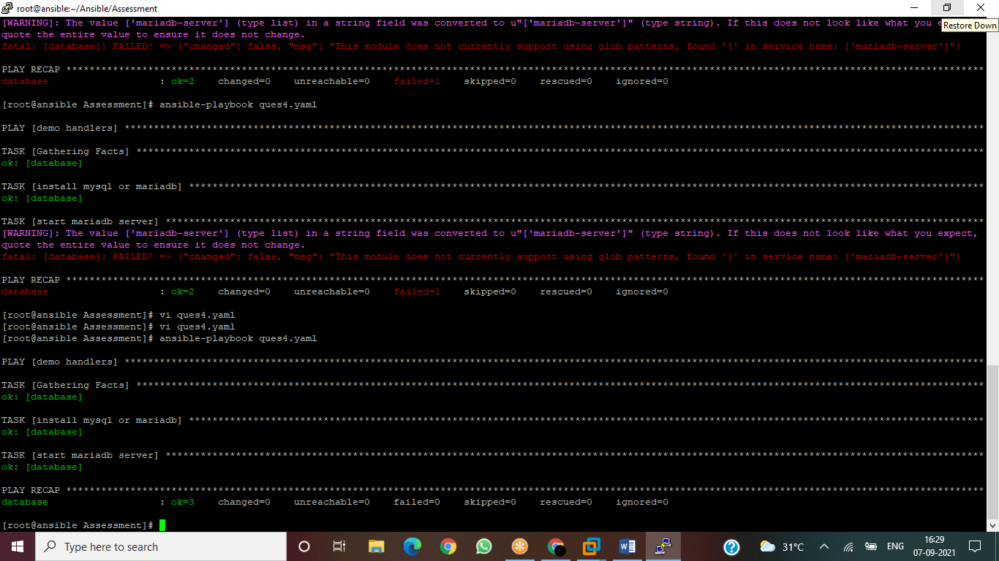

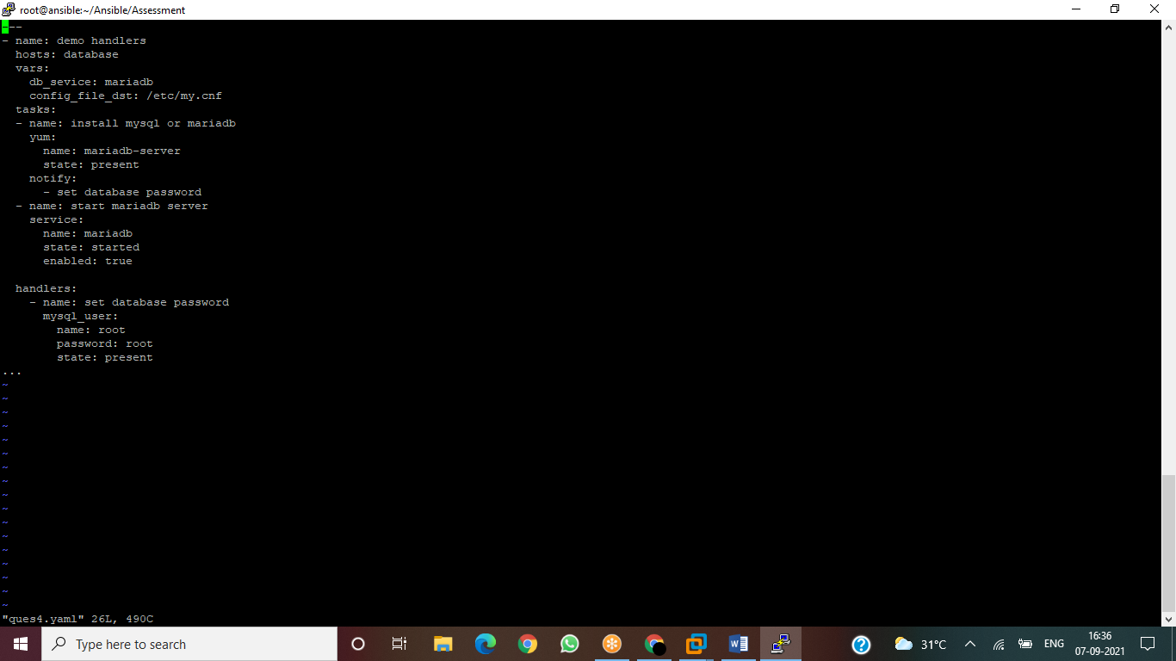

**Question3: AWS Instance creation and stopping**

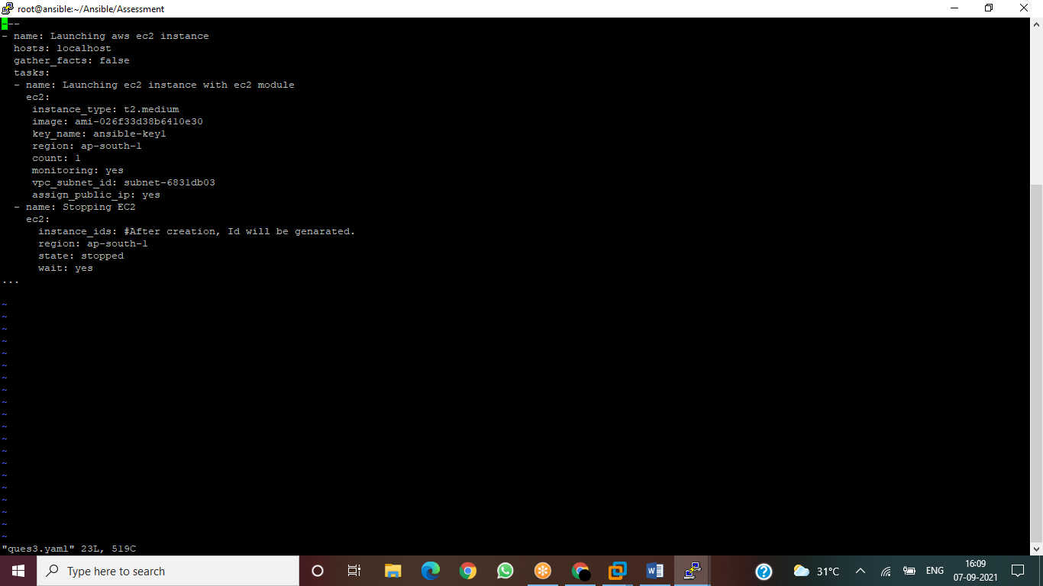

**Question6: Install Docker and enable**

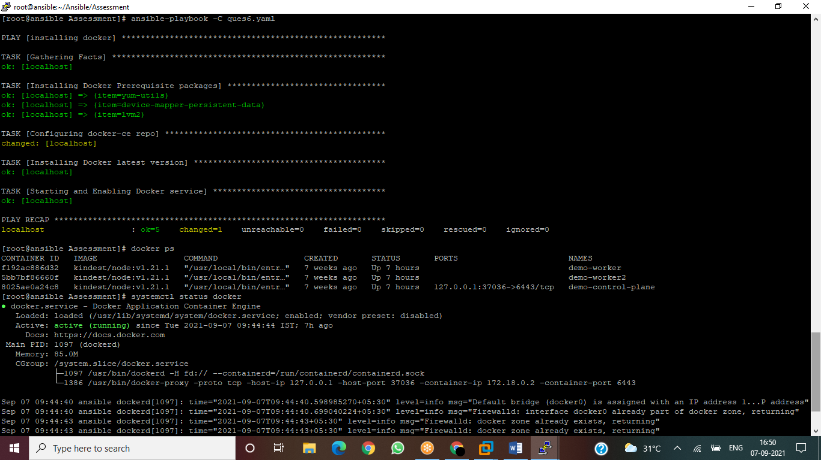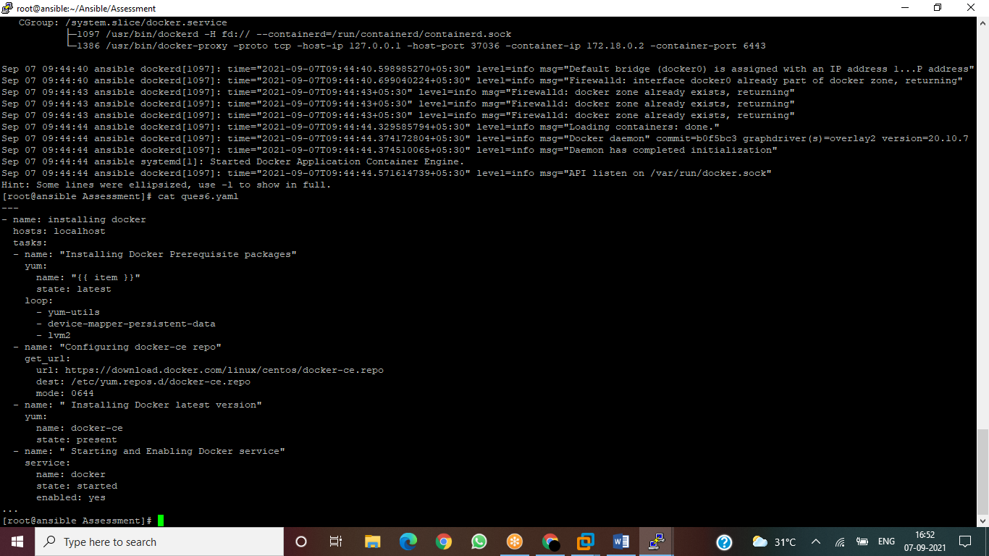

**Question5: Installing httpd when OS ==CentOS**

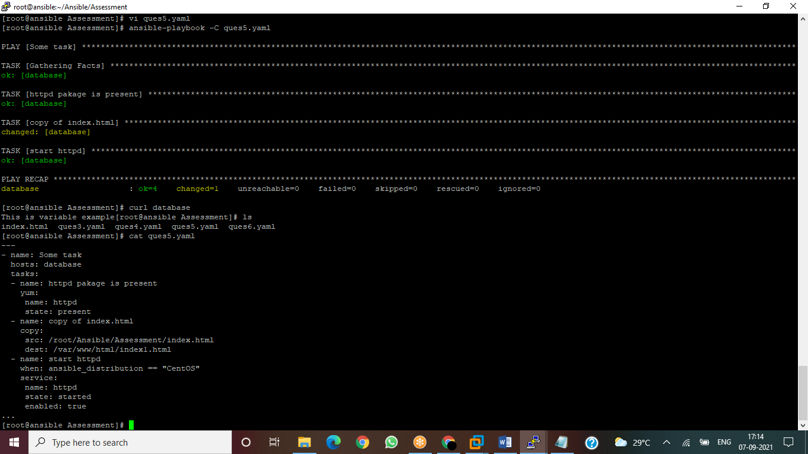

**Question2: Adding Multiple Users:**

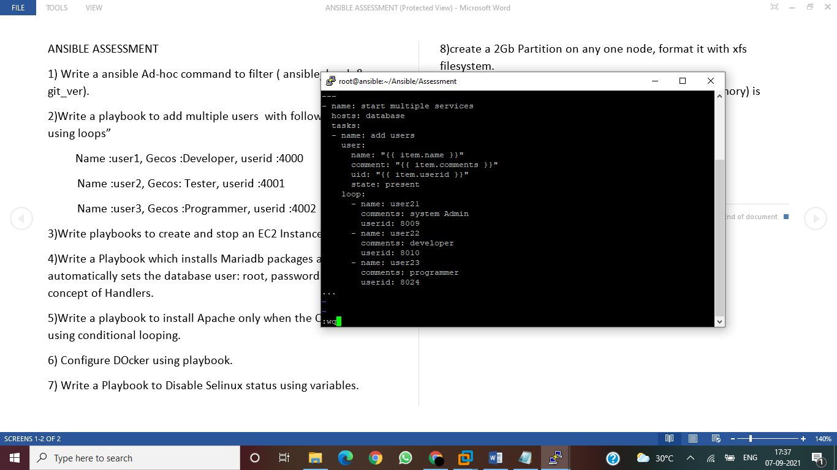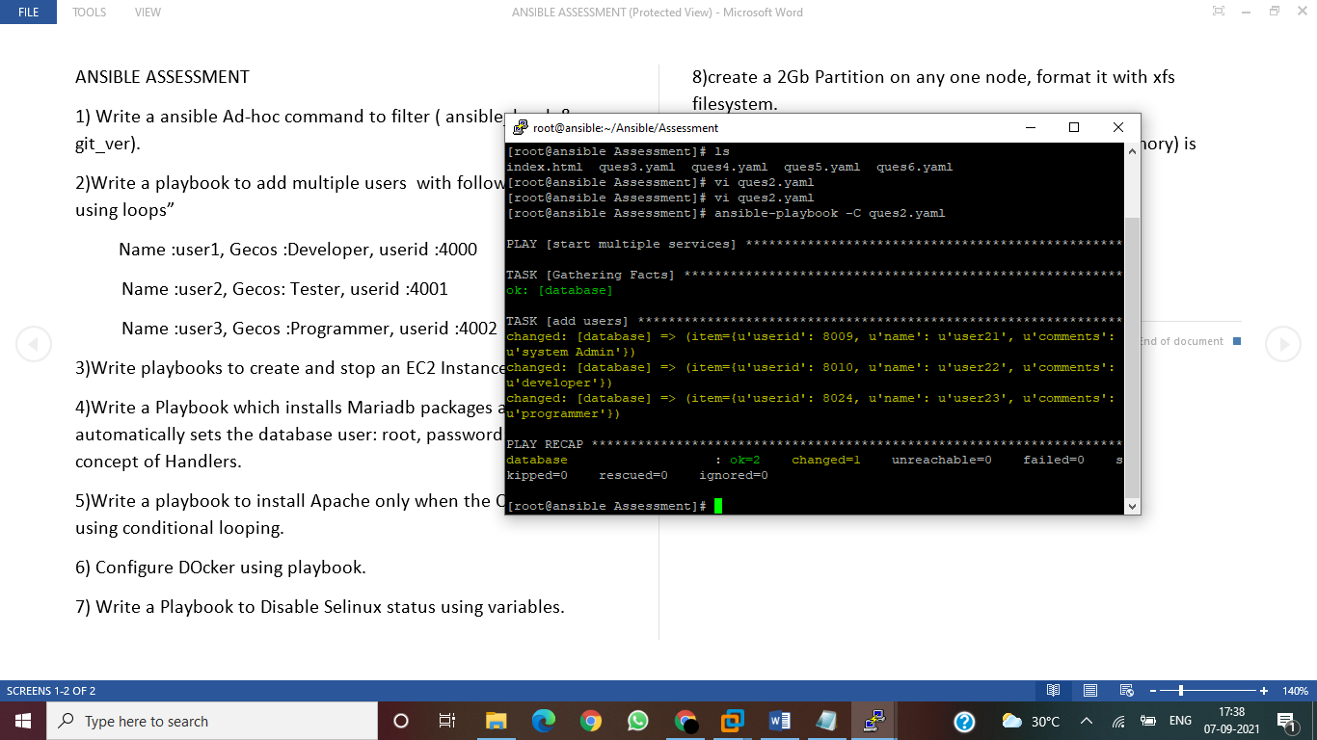

**Question7: Disabling SELINUX**

**To Check: Cat etc/selinix/config**

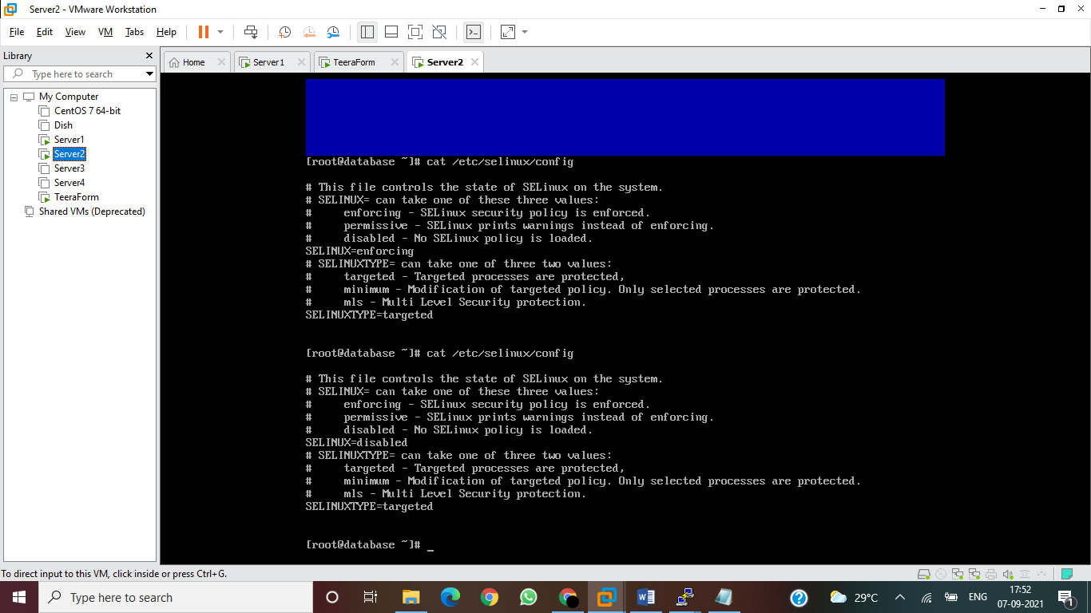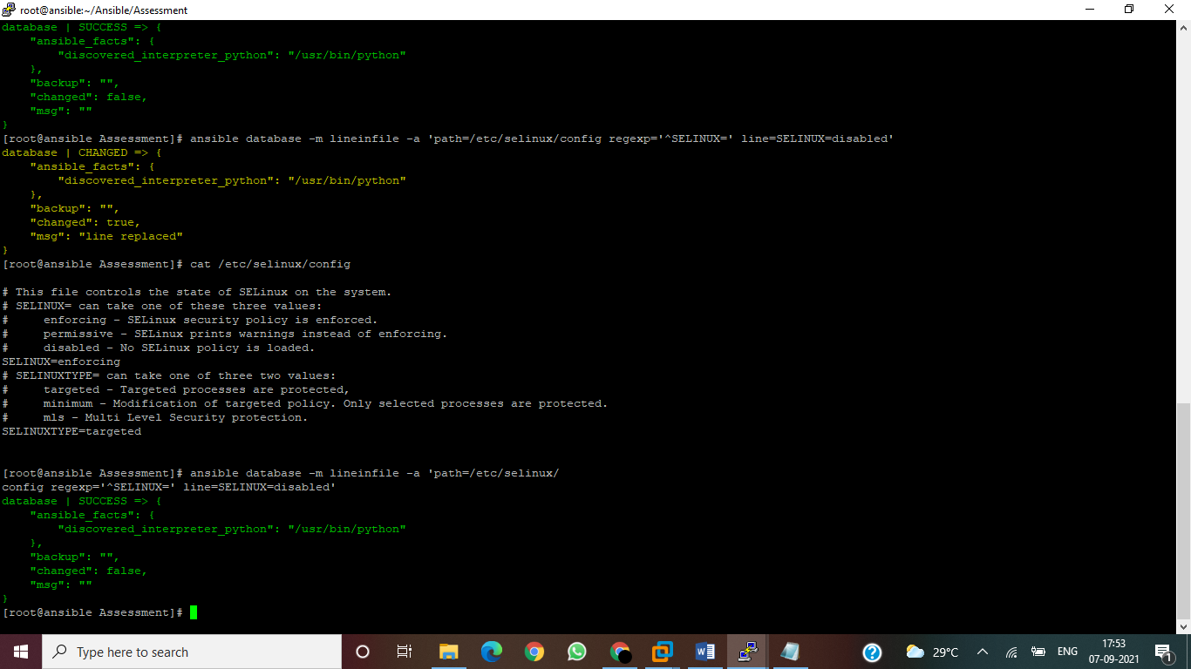

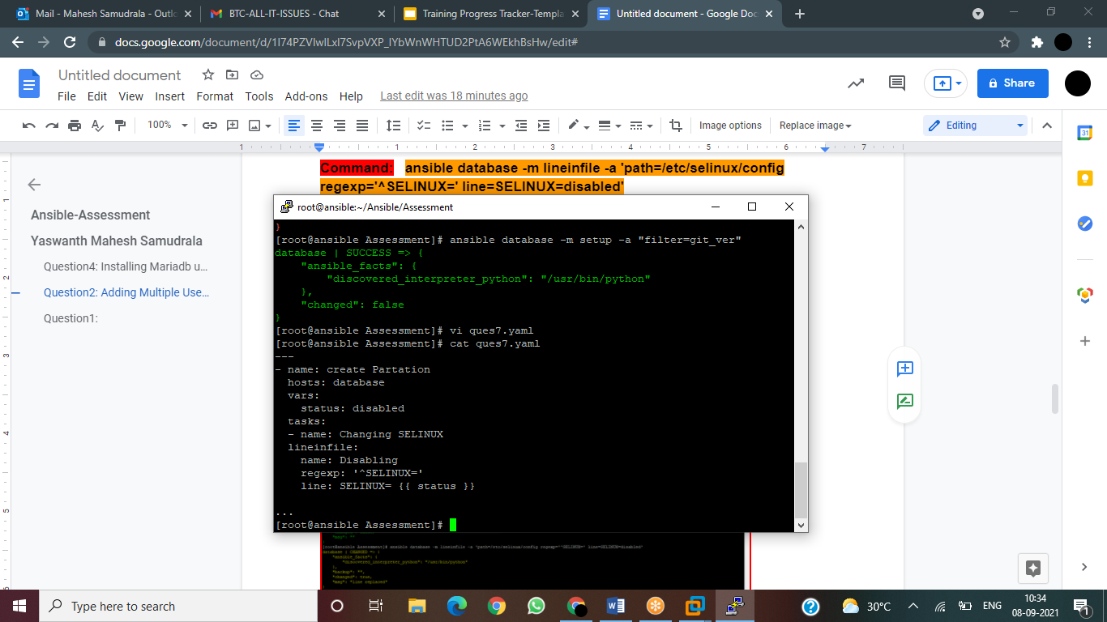

**Question9: Create user harry if size > 10MB**

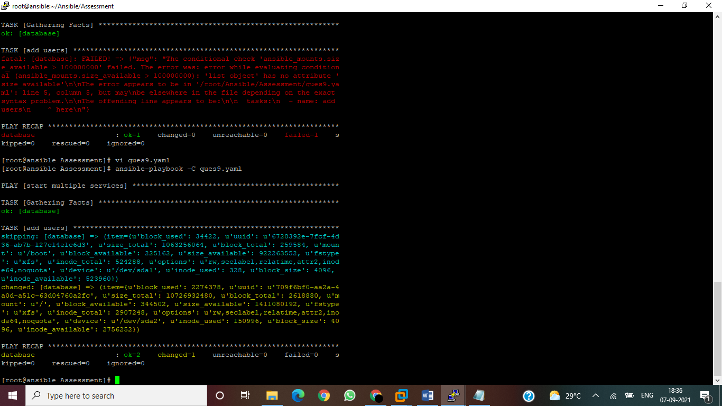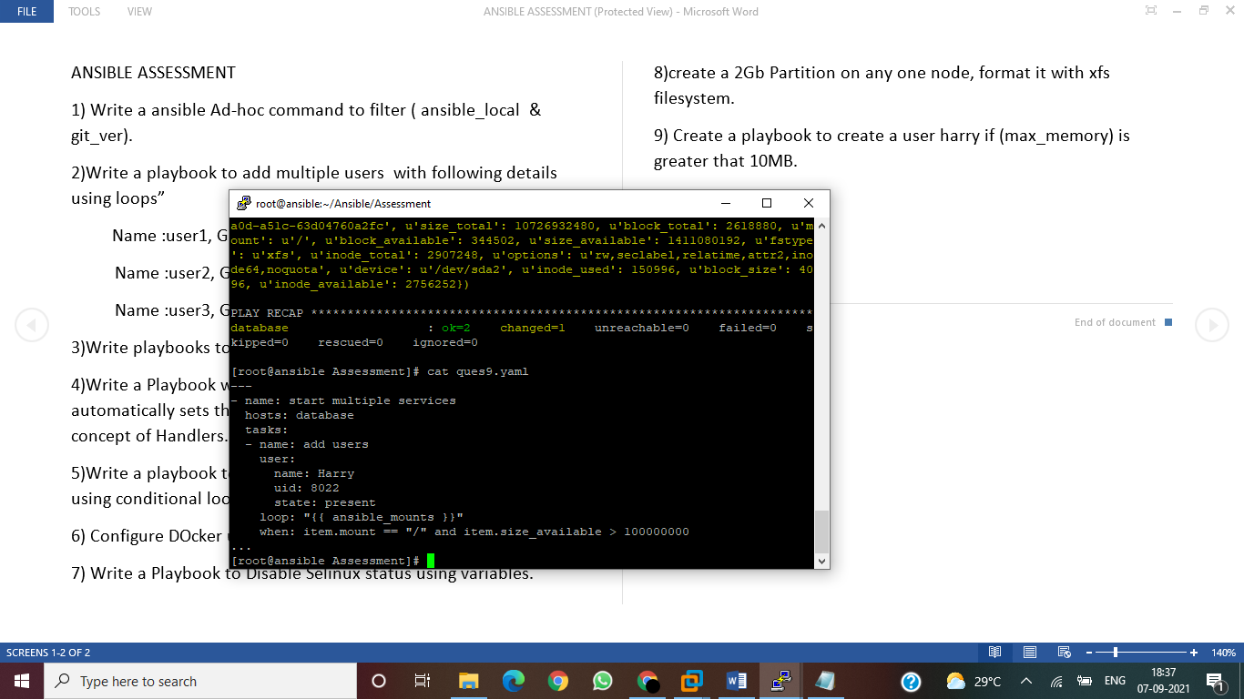

**Question1:**

**Ansible database -m setup -a ‘filter=git_ver’**

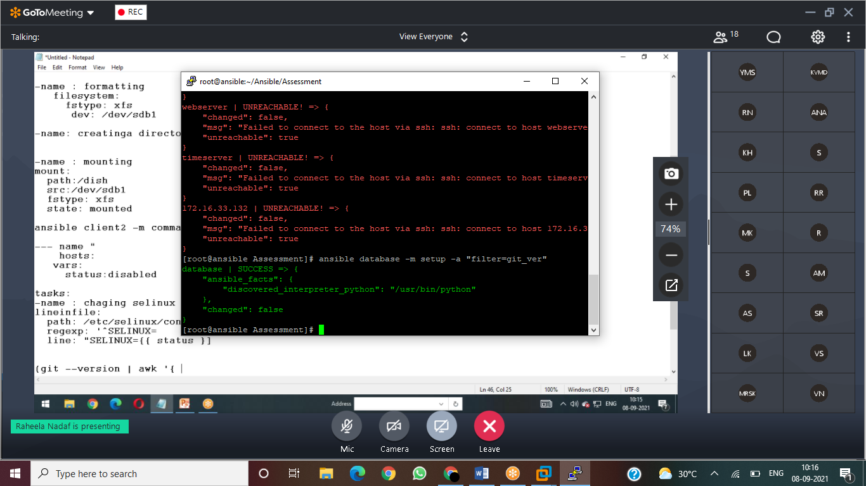

**Question8: 2Gb partition using xfs filesystem:**

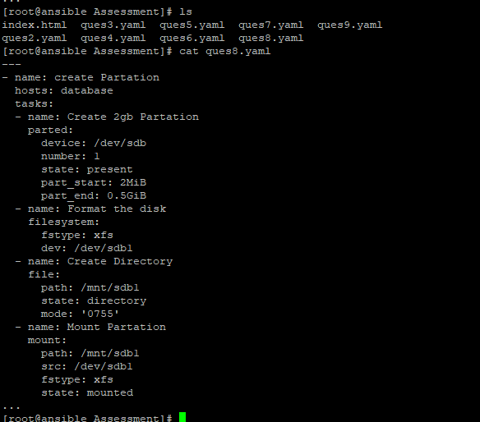

**To check the partition mounted→ ansible localhost -m command -a 'lsblk'**