Gabriel Garcia
CMSI-4072
13 February 2025

Problem 1.1

All software engineering projects must handle general documentation and history management. Everything such as software requirements, changes to code, and even legacy code need to be accessible throughout the project’s lifespan. Code should be documented precisely, and code comments should describe the code so that other programmers can understand

Problem 1.2

- Changes to code should be in the commit history or on some other document
- Requirements should have their own SRS
- Code should be written with clear comments describing functions

Problem 2.4

In GitHub, you can access previous version of code through the commit history. When using it in the terminal, you can use git diff to see the revisions of the current version against the last commit. To see past versions like Google Docs, you can also look at the commit history in github.

Problem 2.5

JBGE stand for “just barely good enough”. It is a philosophy that means that you should only leave comments on your code that just barely explains everything because over documentation can end up wasting time when you try to update other pieces of code.

Problem 4.2

- A=5, B=9, C=4, D=12, E=19, F=7, G=6, H=3, I=6, J=6, K=17, L=12, M=28, N=26, O=11, P=17, Q=32, R=30
- G → D → E → M → Q
- 32 working days

Problem 4.4

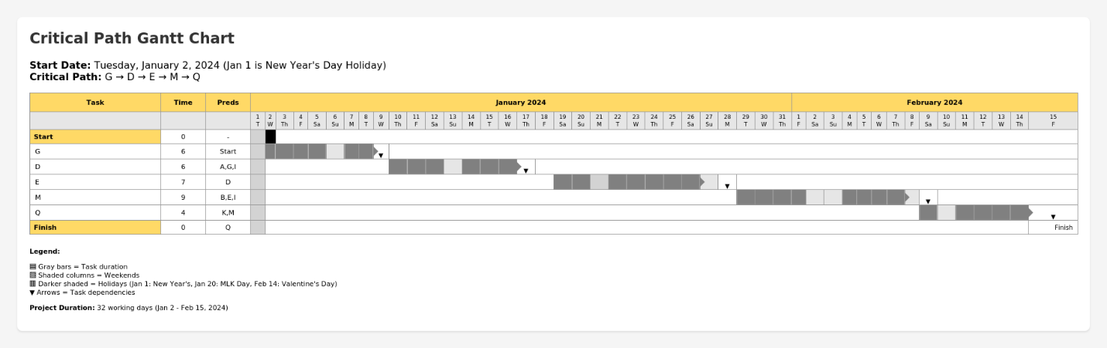

Problem 4.6

Development should cater to the current situation. If someone moves to Iceland, then they can work remote. Software does not necessarily have to be built in person. If there are people sick, then delaying the project may be necessary.

Problem 4.8

Not allotting time for delays and not calculating risk management

Problem 5.1

- Clear
- Consistent
- Grouped in categories (e.g. FURPS/FURPS+)
- Cater to audience
- Recorded consistently

Problem 5.3

- Functionality
- Usability
- Usability
- Usability
- Reliability
- Reliability
- Performance
- Functionality
- Functionality
- Reliability
- Supportability
- Usability
- Functionality
- Usability
- Supportability
- Supportability

Problem 5.9

M

- Win Screen
- Lose Screen
- New Game button that resets to a new game
- Word generator
- Some assets for the hanged man
- A UI

S

- Green button assets for correct guesses
- Greyed button assets for incorrect guesses
- Mr. Bones’ finished assets
- A clean UI

C

- Pretty animations for Mr. Bones
- Pretty animations for the keyboard
- An animated win/loss screen

W

- AI integration
- A versus mode against other users

