Gabriel Garcia
CMSI-4072
Professor Johnson
17 February 2026

homework02

Problem 5.1

In component-based software engineering (CBSE), you regard the system as a collection of loosely coupled components that provide services for each other.
A service-oriented architecture (SOA) is similar to a component-based architecture except the pieces are implemented as services.

Problem 5.2

I believe a service-oriented architecture would be a good approach to this system. The services would be split between the high score internal database, the computer opponent, and the tic-tac-toe game. I believe the best architecture for this could be component based. The high score internal database requires input from the tic-tac-toe game and the-tic-tac toe game requires input from both the player and the computer opponent. They all are connected.

Problem 5.4

A service-oriented architecture would work great on this chess program. The service would be the chess website/app and then it would connect the two players.

Problem 5.6

ClassyDraw could use a simple database that stores the user’s created image. It could be a key-value database where you search the (unique) name of the image. The maintenance would be to make sure that no image has the same name as another image. There would also be the regular work done of deleting old images not needed. I would think this would be user dependent.

Problem 5.8

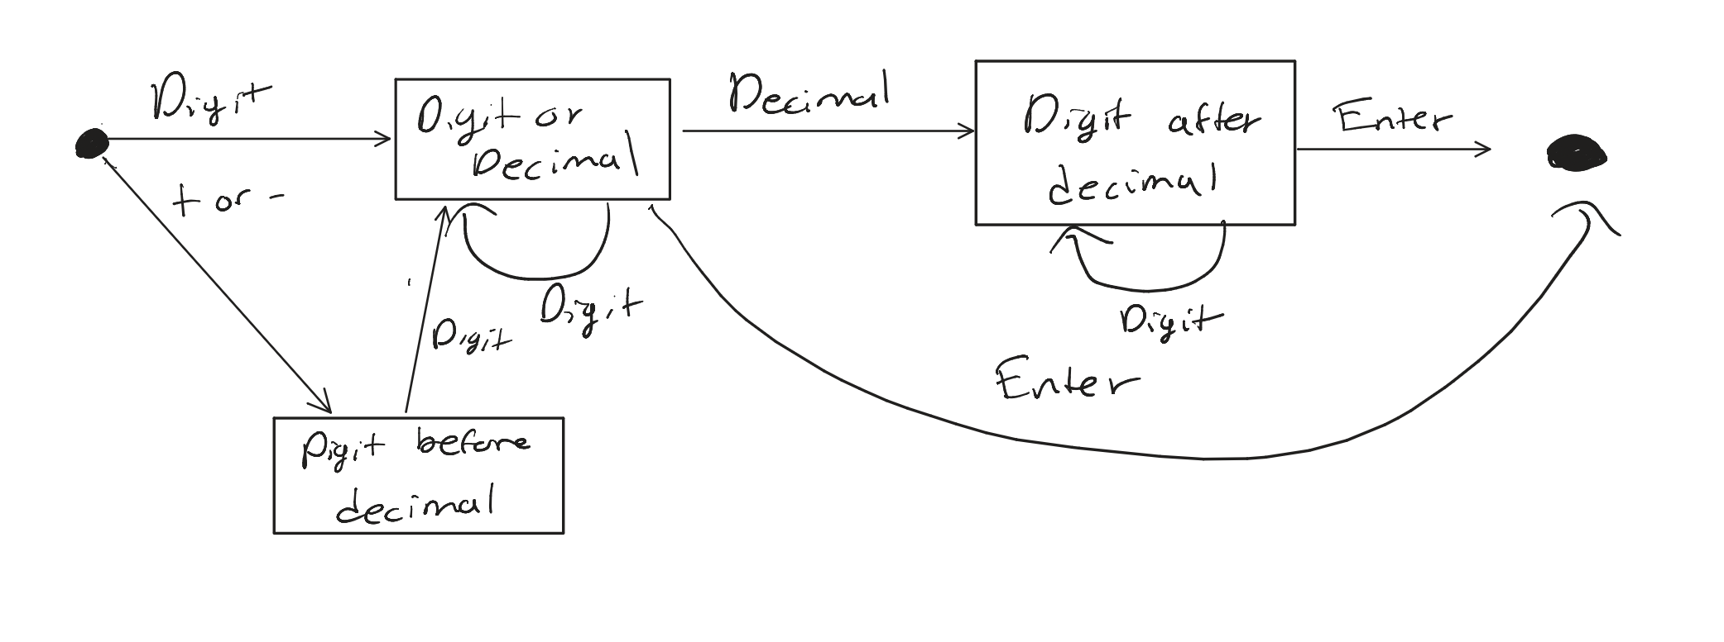

Problem 6.1

- All these classes share these properties: drawing tool, shapes (general umbrella term)
- All these classes do NOT share these properties: different shapes
- Yes, a rectangle could be considered to be a child class to the line class since rectangles are made of 4 lines. Similarly with the star class, since a star would be made up of 10 lines. Text class seems to be the most unique since it would be where the user would type text, so I believe it does not have any properties that it would share with other classes.
- The shared properties would be shared between the rectangle, star, and line classes.

Problem 6.2

