Bhuvi Sudheendra Katti
PES1UG24AM418
SE lab 6
55:
Code coverage:
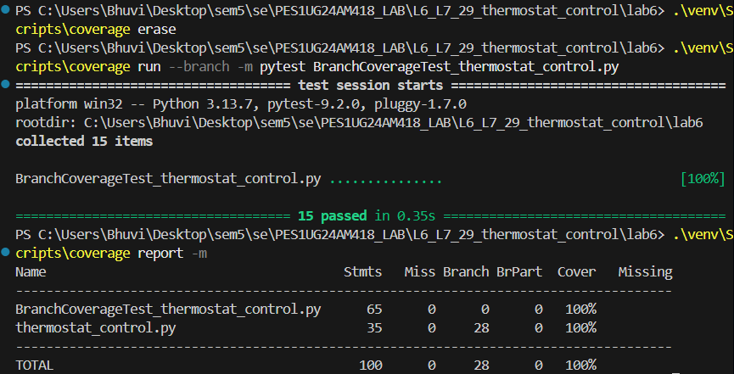
Branch coverage:


