JIRA LAB SUBMISSION
ScrumBoard ,Sprints & Burndown Analysis

Name Bhuvi Sudheendra Katti
SRN PES1UG24AM418
Project Vaccination Cohort and Dose Scheduling System
Sprints Sprint 1 & Sprint 2

Submission Contents
1. Backlog / Stories / Priorities / Story Points
2. Sprint 1 Board
3. Sprint 2 Board
4. Sprint 1 Burndown Chart
5. Sprint 2 Burndown Chart
6. Reflection Questions

1. Backlog / Stories / Priorities / Story Points

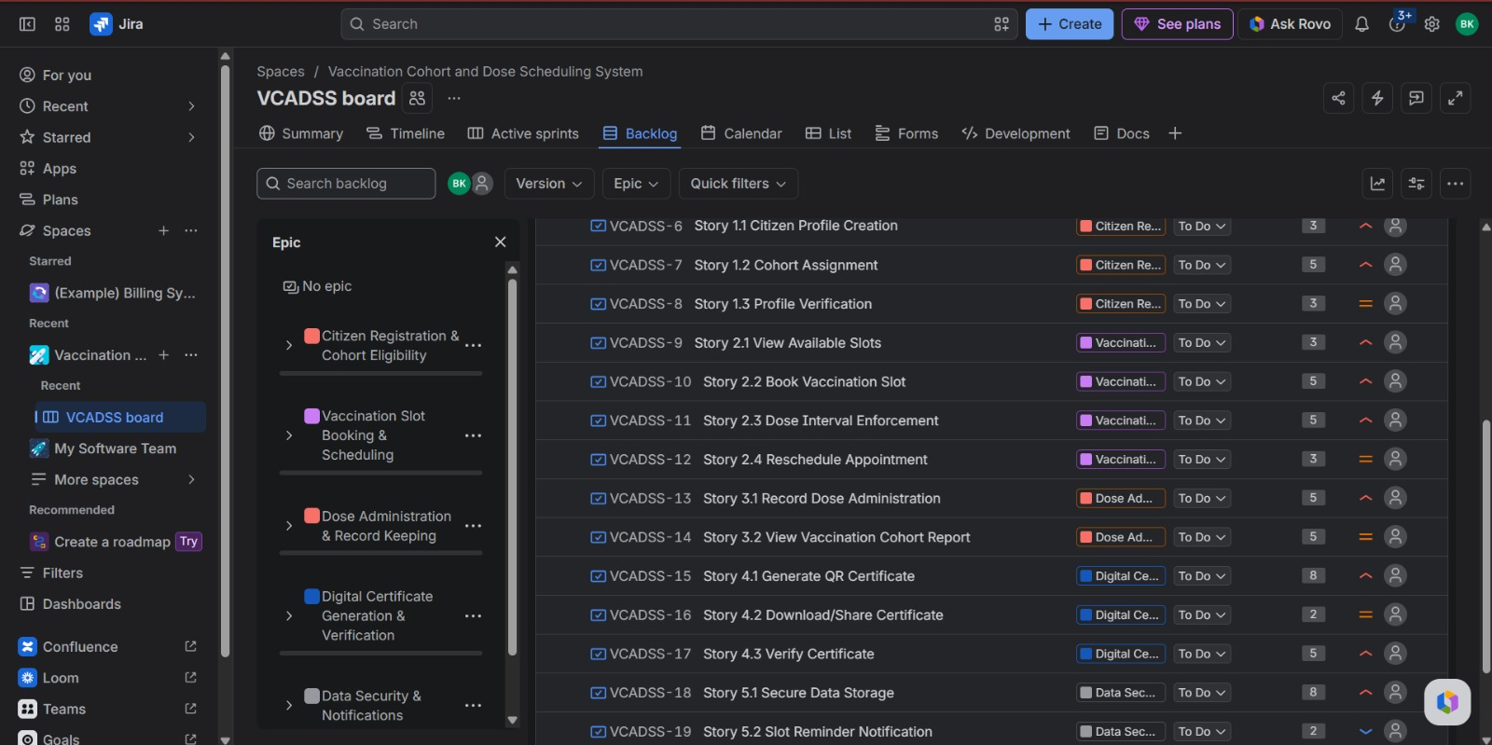
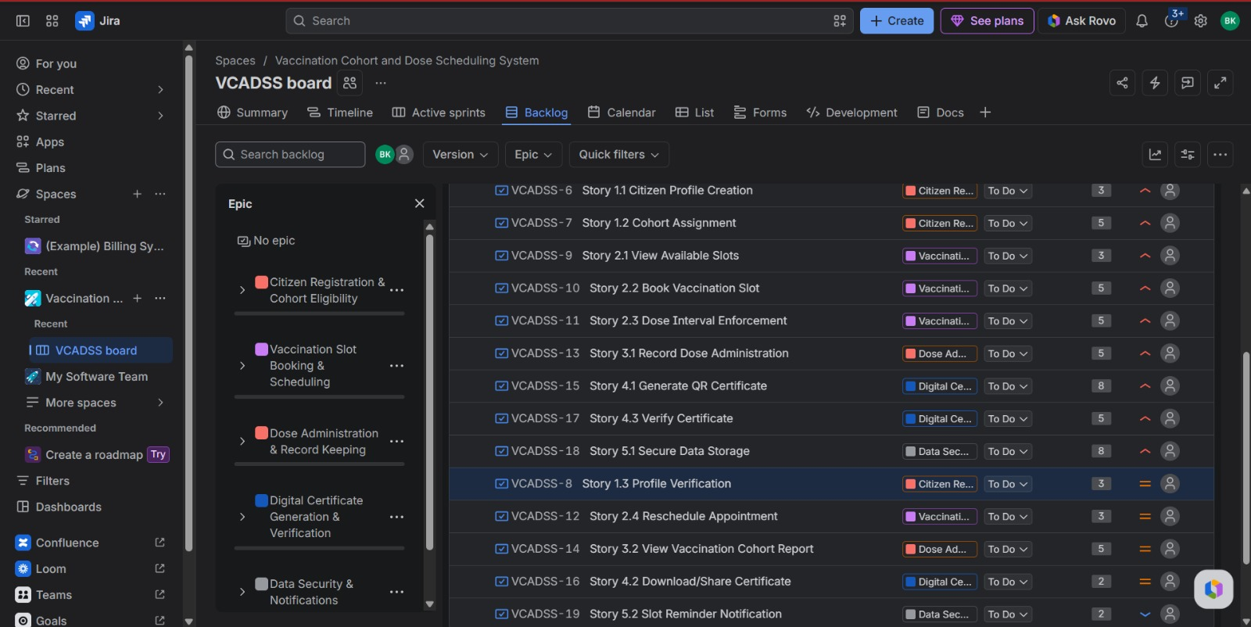

2. Sprint 1 Board
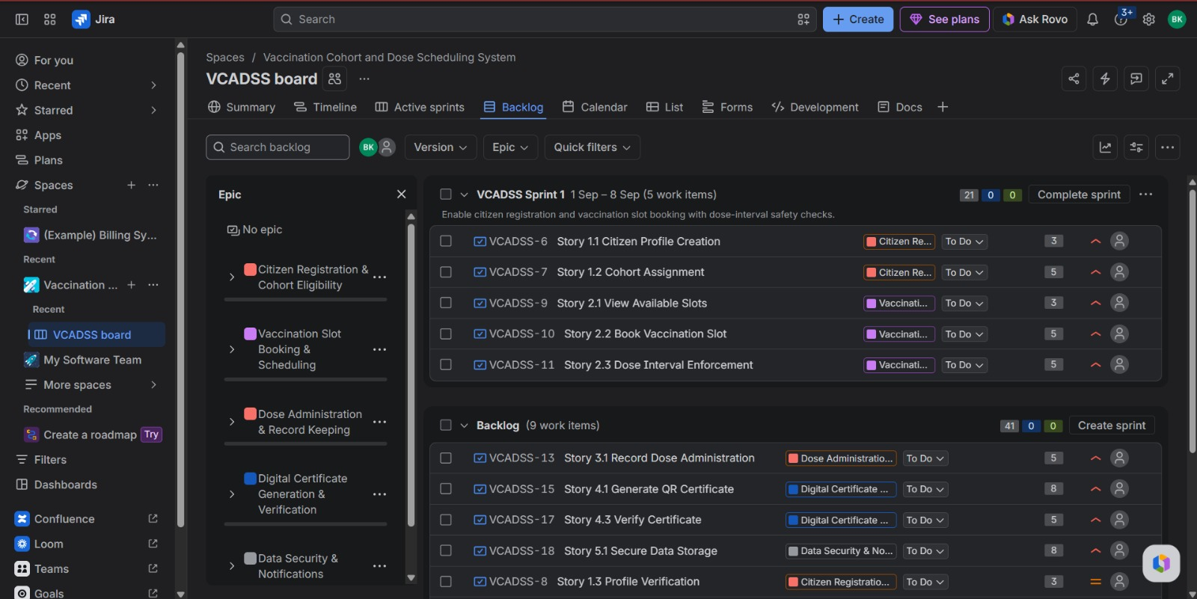

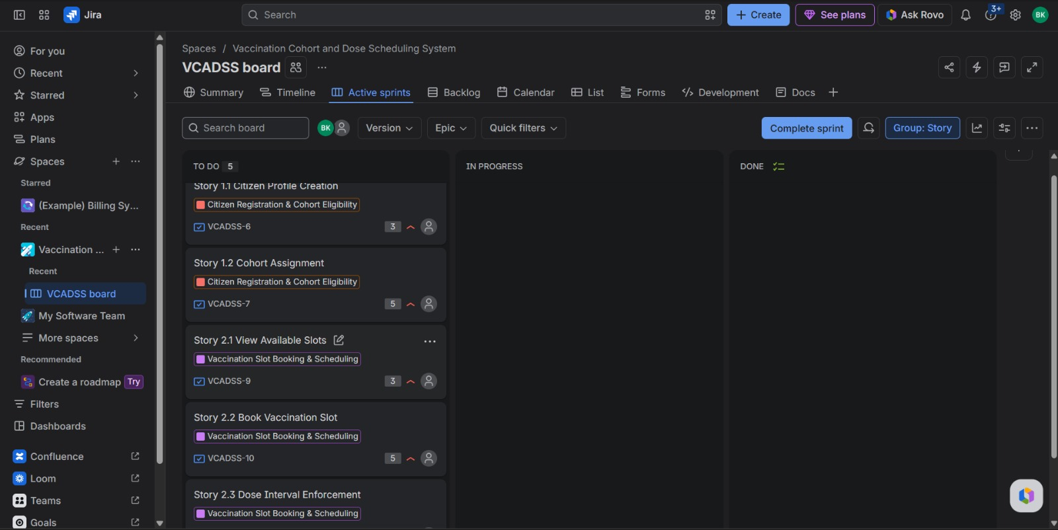
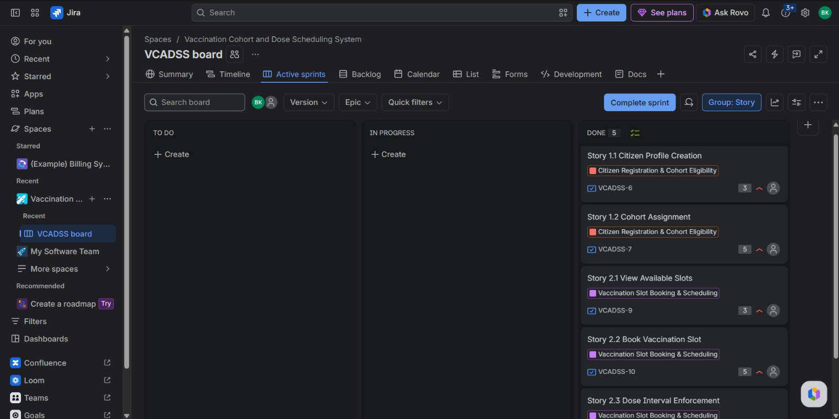

3. Sprint 2 Board
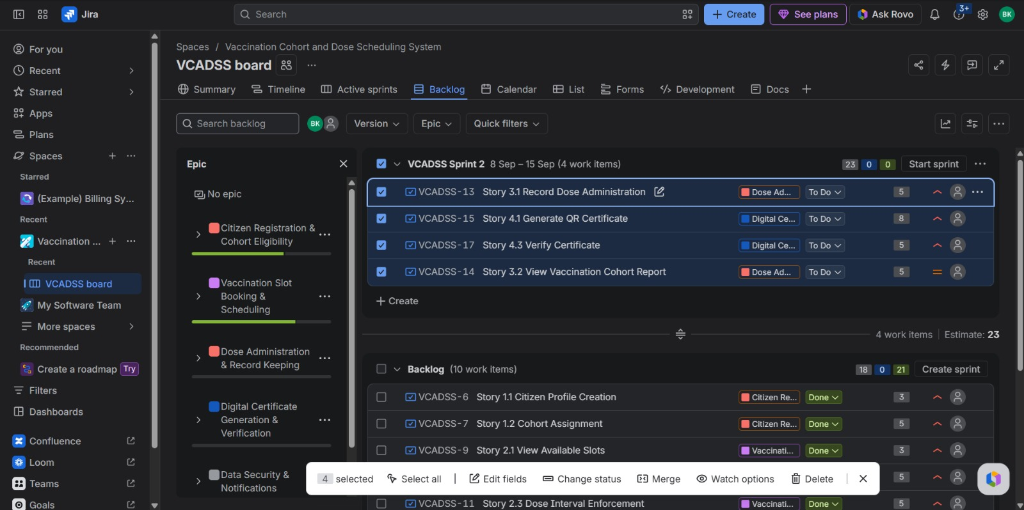
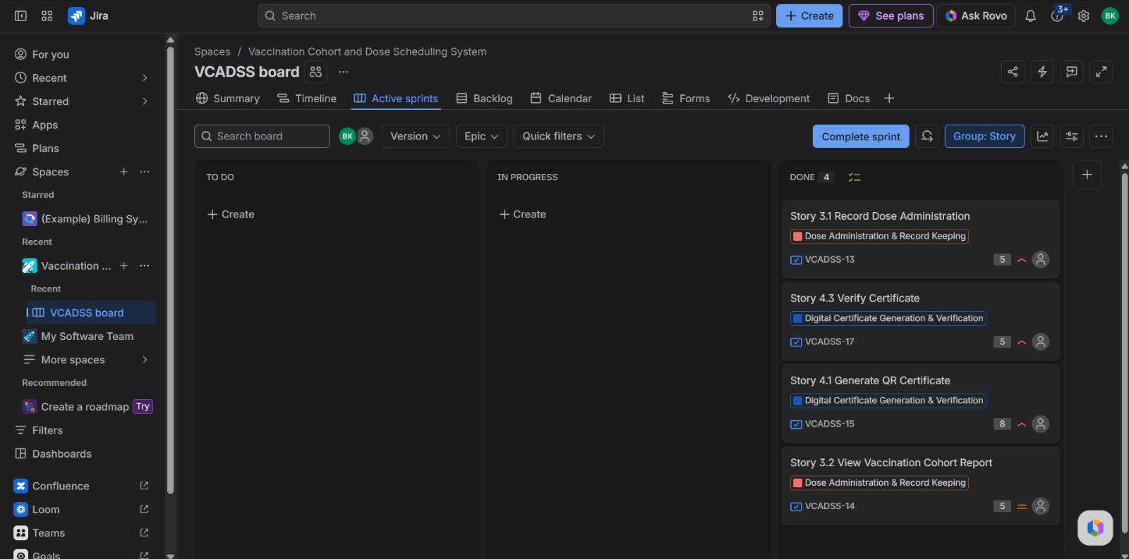

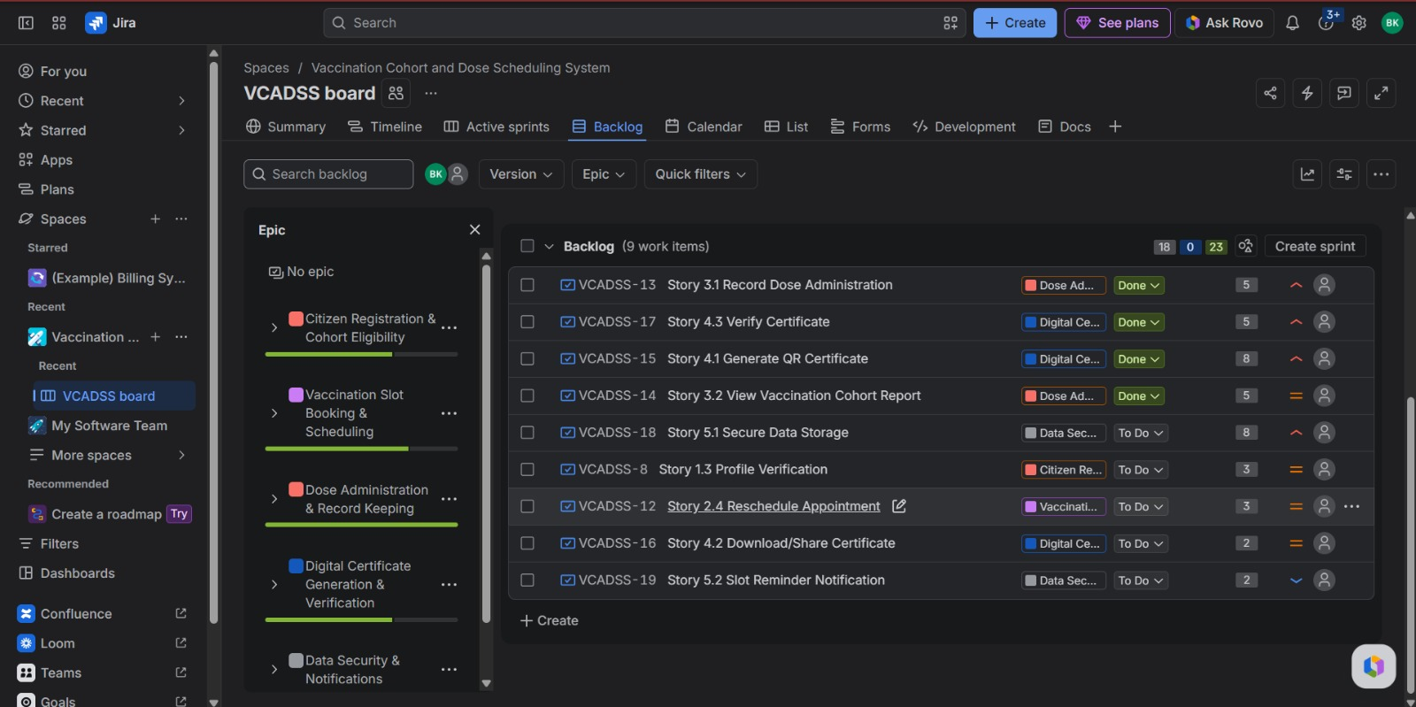

4. Sprint 1 Burndown Chart
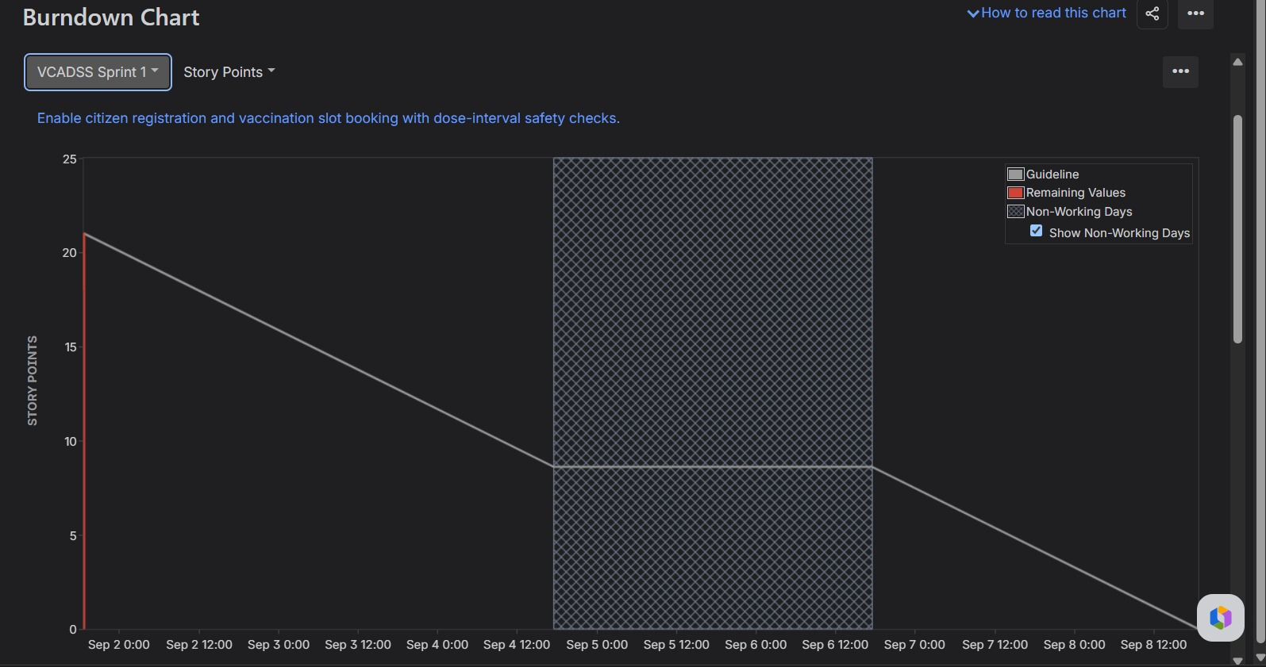

5. Sprint 2 Burndown Chart

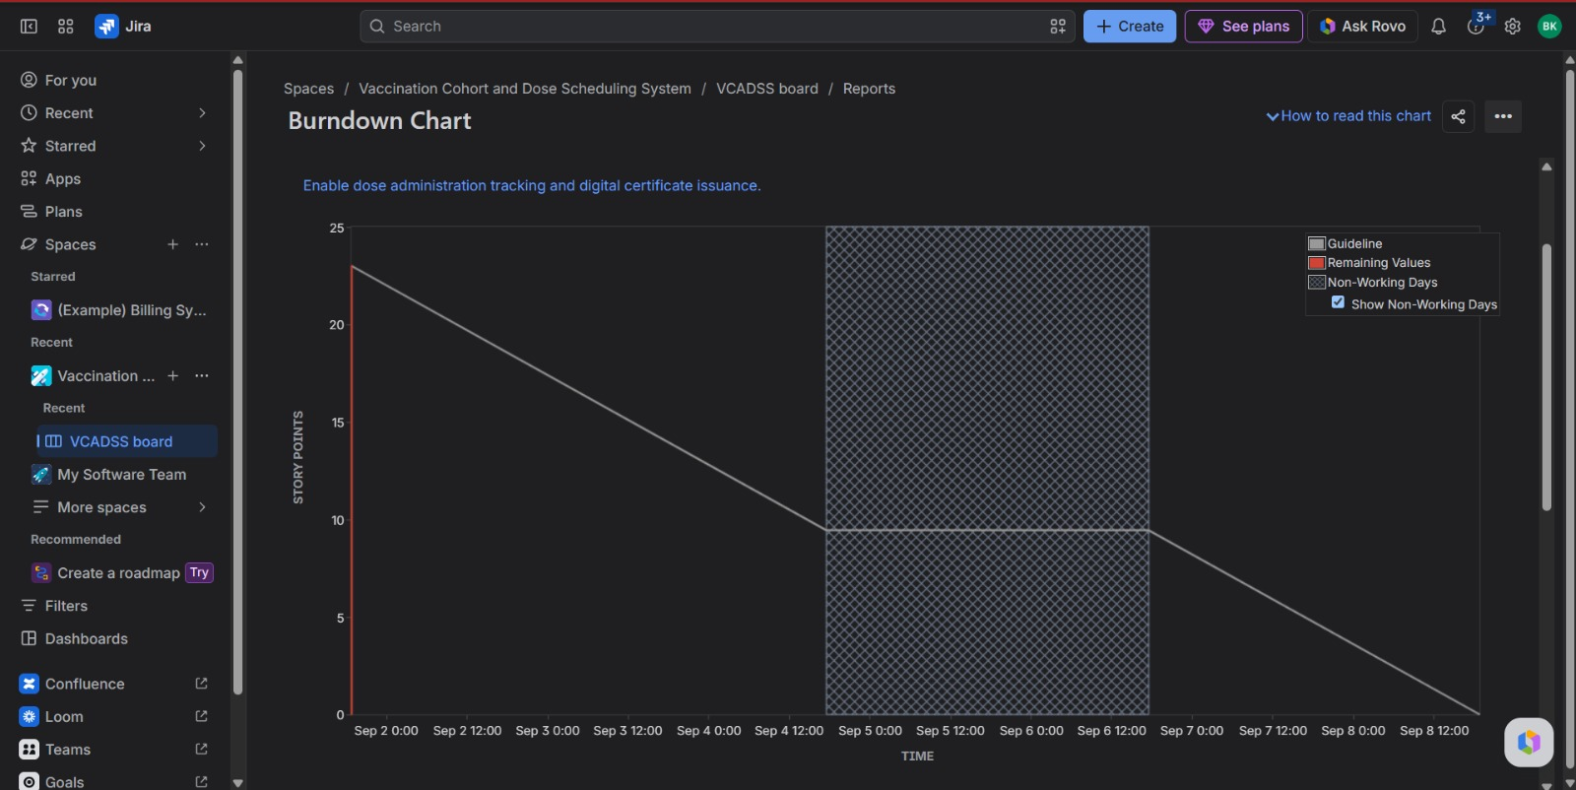

6. Reflection Questions

1. Did your estimations reflect the actual effort?
The story point estimates provided a reasonable representation of the relative effort and complexity of the user stories. Simpler stories such as Citizen Profile Creation were assigned 3 points, while more complex stories such as Generate QR Certificate and Secure Data Storage were assigned 8 points due to their higher complexity and uncertainty. Since the sprint was simulated, the estimates could not be directly compared with actual development hours.

2. Was your backlog well-prioritized?
Yes. The backlog was prioritized according to user impact and the importance of each feature to the vaccination workflow. Core registration, eligibility, appointment booking, dose administration, certificate generation, verification, and security features were given high priority, while supporting features such as profile verification, rescheduling, certificate sharing, and reminders were assigned medium or low priority.

3. How did your simulated sprint align with your plan?
The simulated sprints followed the planned priorities and dependencies. Sprint 1 focused on citizen registration, cohort assignment, slot availability, appointment booking, and dose interval enforcement. Sprint 2 focused on dose administration records, cohort reporting, digital certificate generation, and certificate verification. The stories were moved through To Do, In Progress, and Done to simulate the team's development progress.

4. What insights did the Burndown Chart give about your team's capacity?
The Burndown Chart provided a visual representation of how quickly the planned story points were being completed during each sprint. It helped compare actual progress with the expected sprint trajectory and showed whether the team was progressing at an appropriate pace. Since the activity was simulated, the chart primarily demonstrated how Jira can be used to monitor sprint progress and remaining work rather than measuring actual development capacity.

