Name: Bhuvi Sudheendra Katti
SRN: PES1UG24AM418

Architectural Justification
Problem Statement #17 — Vaccination Cohort & Dose Scheduling System
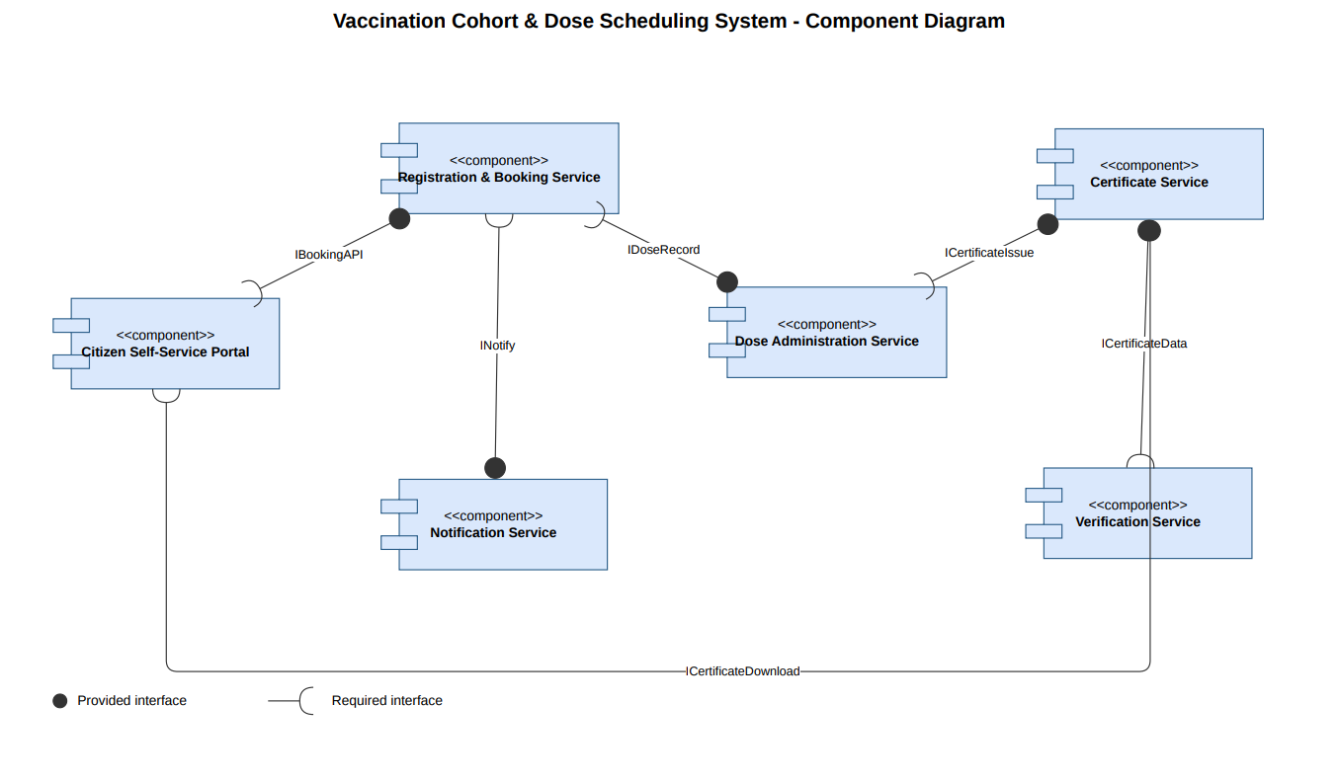
Architecture Selection
We chose Microservices Architecture for the Vaccination Cohort & Dose Scheduling System.
Reason 1: Independent Scaling for Divergent Load Patterns
The system's components face very different, and largely uncorrelated, load patterns. The Registration & Booking Service experiences sharp spikes when a new cohort opens for booking, while the Verification Service faces its own independent spikes at high-traffic checkpoints such as airports and workplaces. A microservices architecture allows each service to be scaled independently — for example, adding Booking Service replicas during a rollout window without over-provisioning the Verification or Notification services — which would not be possible if these functions were bundled into a single deployable unit.
Reason 2: Fault Isolation Across Independent Citizen-Facing Functions
Booking a slot, recording a dose, and verifying a certificate are largely independent citizen and officer workflows that should not fail together. With microservices, if the Notification Service (which depends on an external SMS/email provider) becomes temporarily unavailable, citizens can still register and book slots, and Vaccination Officers can still record dose administration — the failure stays contained to reminders and confirmations rather than cascading into the booking or dose-recording workflows, as it could in a tightly coupled architecture.
Security Advantage
Isolating the Certificate Service as its own microservice, with a narrow and tightly scoped API, limits the blast radius of a security breach elsewhere in the system. The digital signing keys used to issue QR vaccination certificates never need to be exposed to the Registration & Booking Service, the Notification Service, or any citizen-facing component — only the Certificate Service's own process holds them. If an attacker compromises the Booking Service, they cannot directly reach the signing keys, since inter-service communication only exposes the specific ICertificateIssue and ICertificateData interfaces, not the underlying key material.
Performance Benefit
The Verification Service can be deployed with its own dedicated, geographically distributed replicas that do nothing but authenticate QR codes, independent of the resource demands of heavier services like Booking or Dose Administration. This directly supports the non-functional requirement that certificate verification complete in under 150 ms, even under peak checkpoint load — a target that would be far harder to guarantee if verification requests had to compete for the same resources as booking and registration traffic in a single monolithic or layered deployment.

