Reproducibility Package for “Missing SDG Gender Indicators”

Kathleen Beegle, Umar Serajuddin, Brian Stacy, Divyanshi Wadhwa

2024-08-16

Table of Contents

# 1 Main Tables and Figures

## 1.1 Figure 1: Sources of gender data gaps

Figure produced using Microsoft Powerpoint.

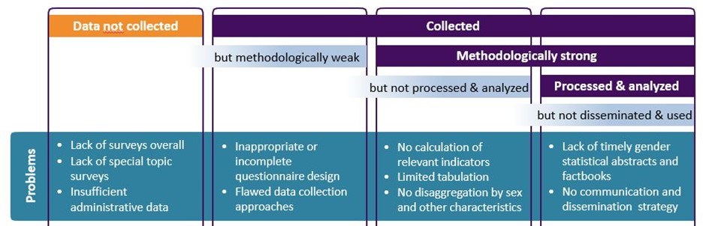

Source: Bonfert et al. 2022

## 1.2 Figure 2. Availability of SDG5 gender-related indicators (N=181 countries)

Published figure produced using Microsoft Excel. See the file Fig2 SDG5 coverage.xlsx.

Data for excel figure produced below.

## # A tibble: 11 × 3  
## count n share  
## <dbl> <int> <dbl>  
## 1 0 3 0.0166   
## 2 1 3 0.0166   
## 3 2 14 0.0773   
## 4 3 21 0.116   
## 5 4 40 0.221   
## 6 5 44 0.243   
## 7 6 24 0.133   
## 8 7 21 0.116   
## 9 8 9 0.0497   
## 10 9 1 0.00552  
## 11 10 1 0.00552

## 1.3 Figure 3. Availability of SDG gender indicators by region (N=181 countries)

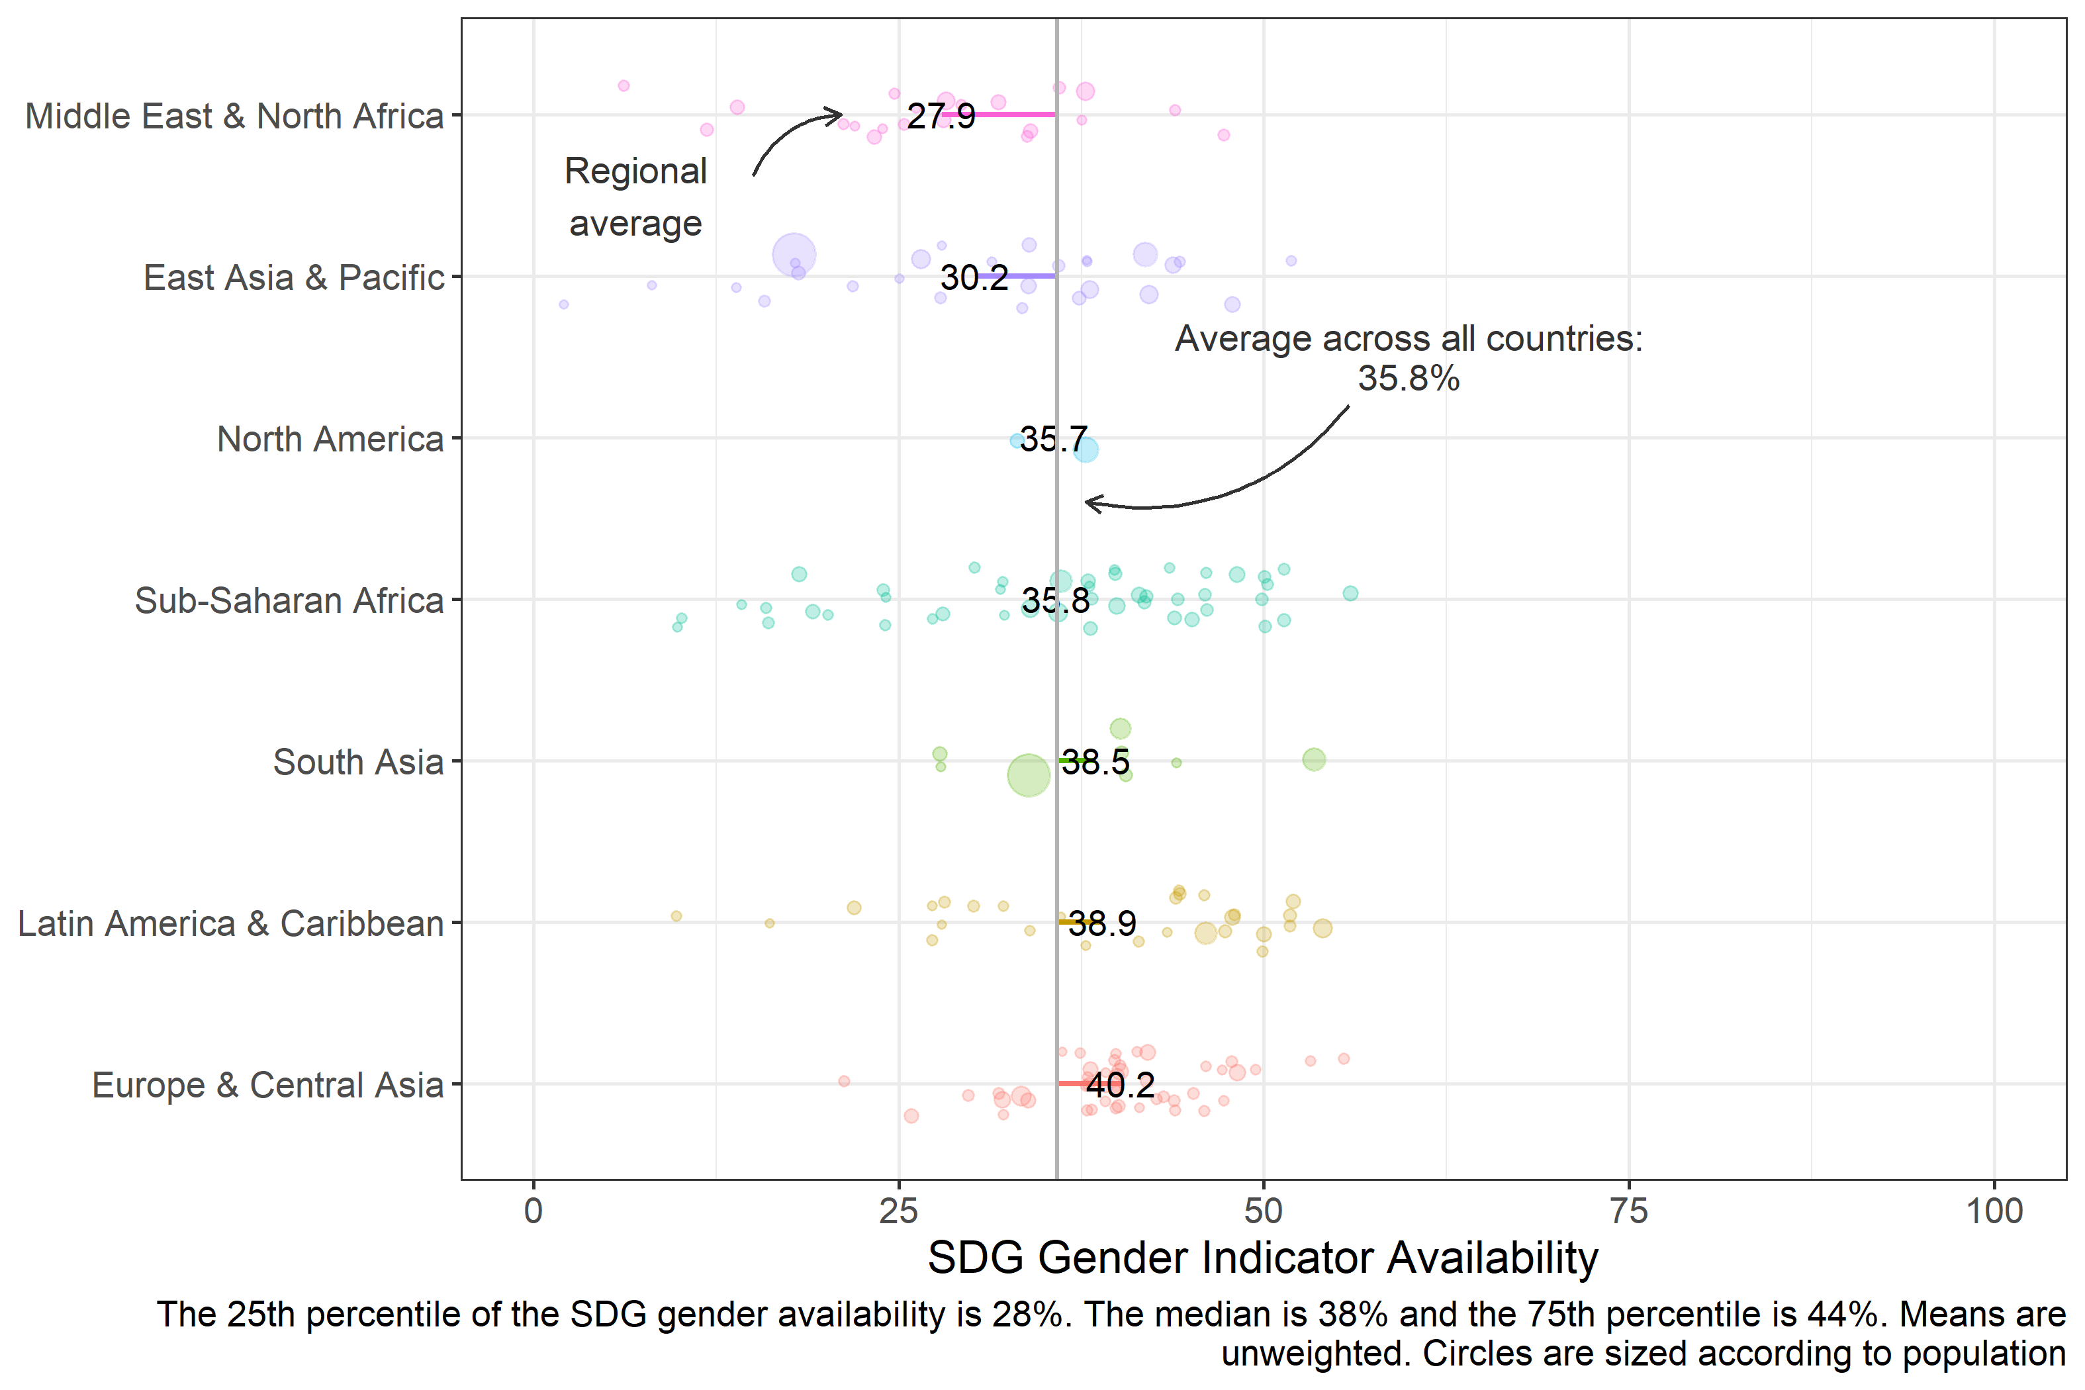

## 1.4 Figure 4. Availability of SDG gender indicators by income group (N=181 countries)

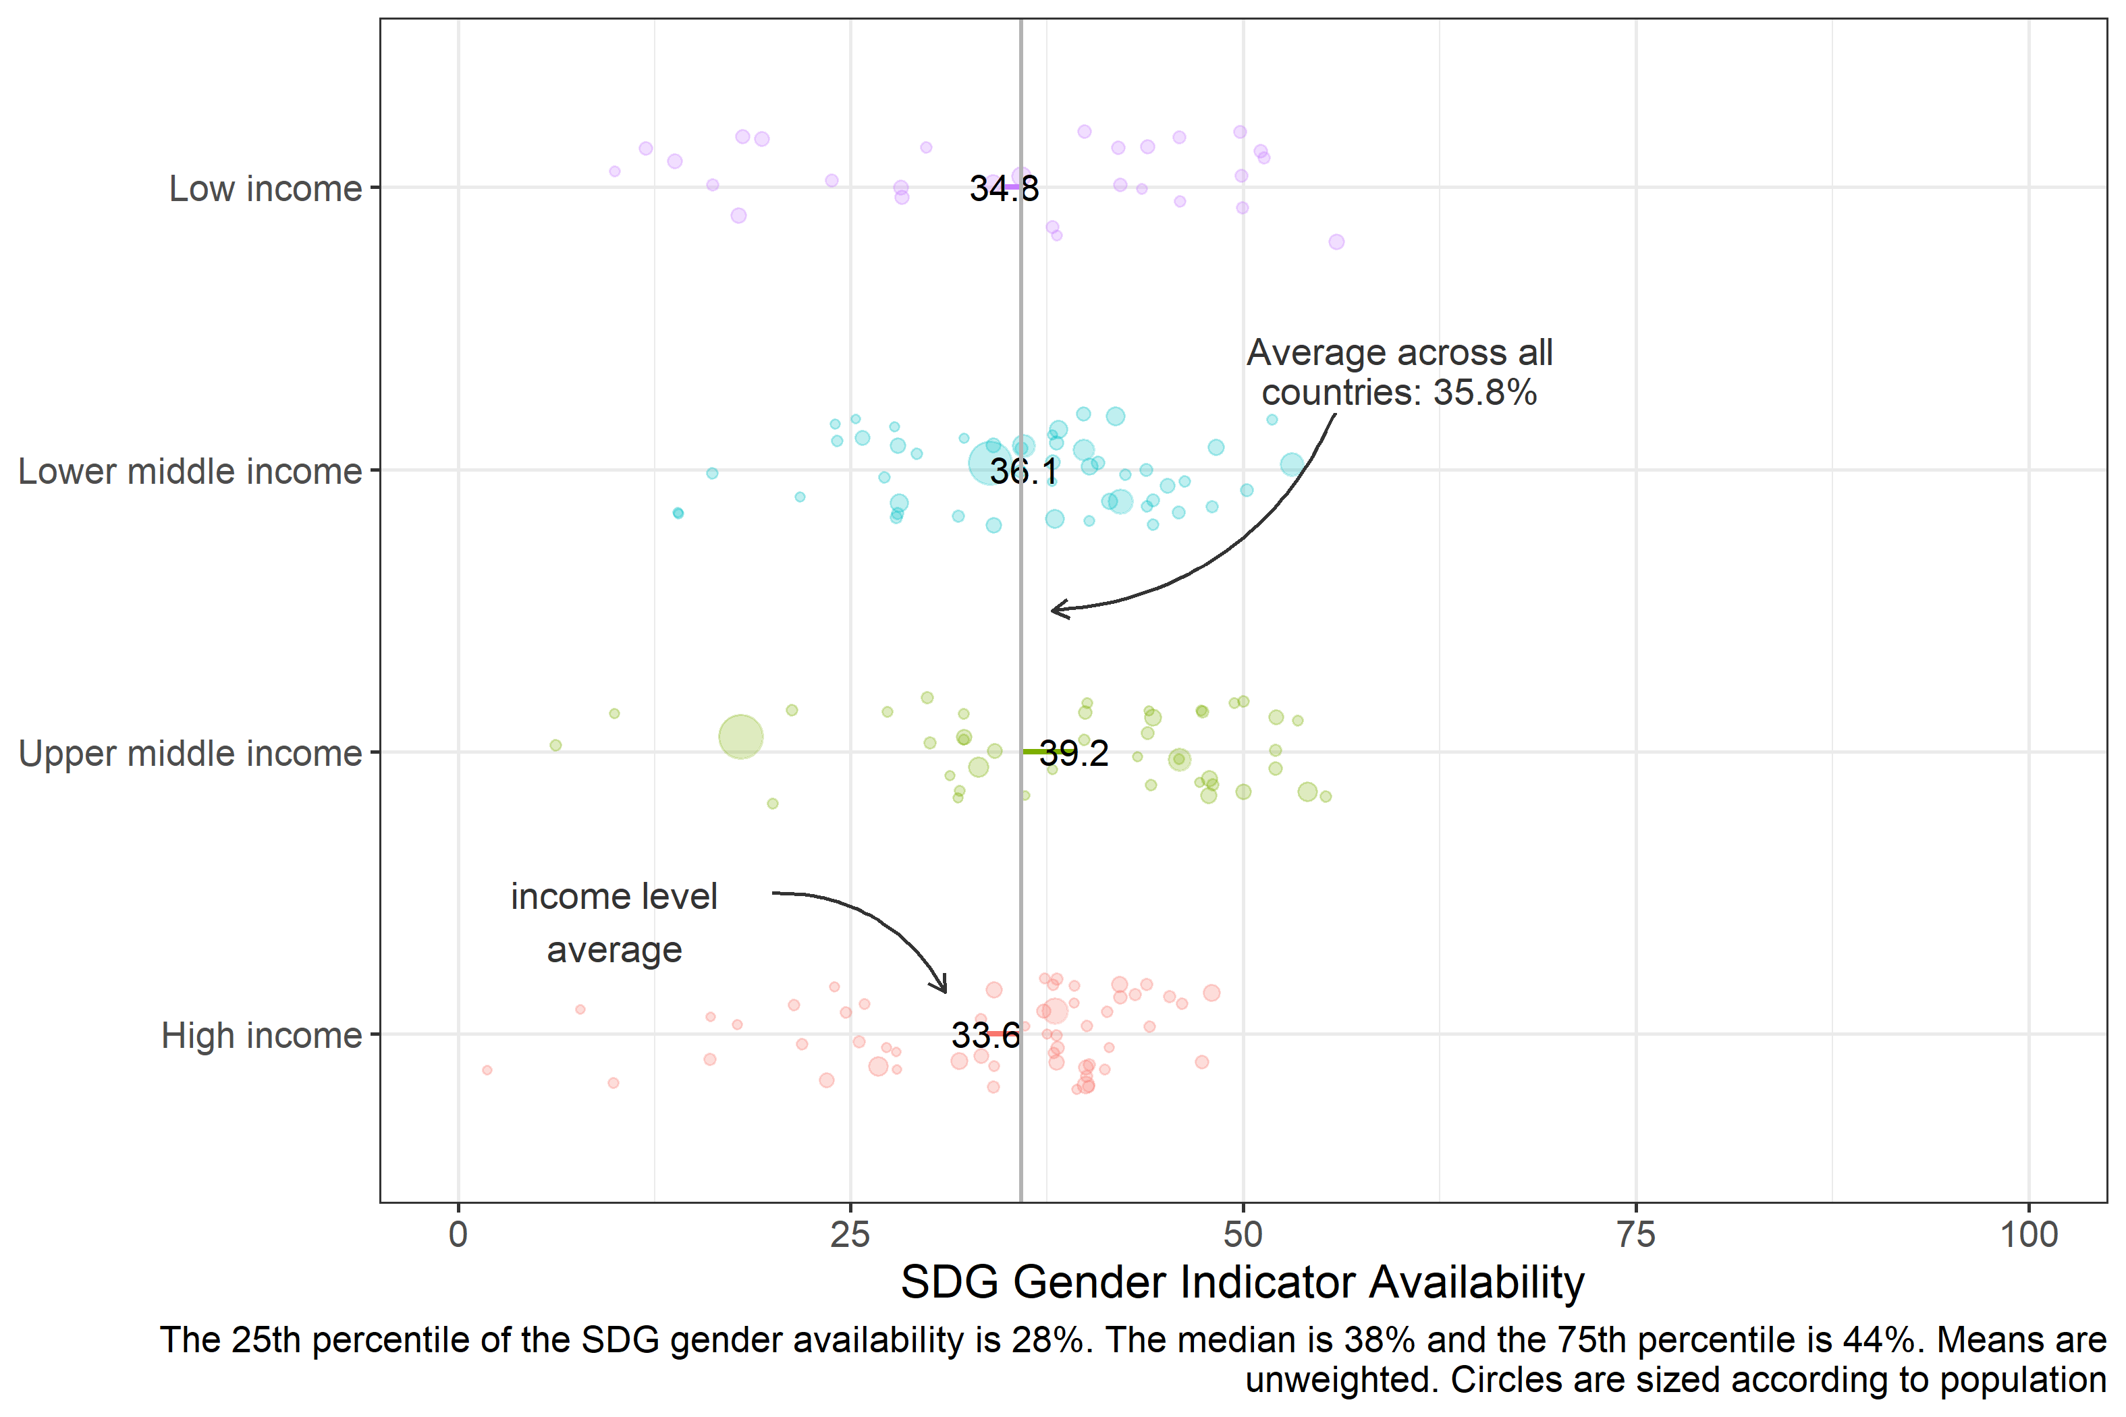

## 1.5 Figure 5. GDP per capita and SDG gender indicators (n=181 economies)

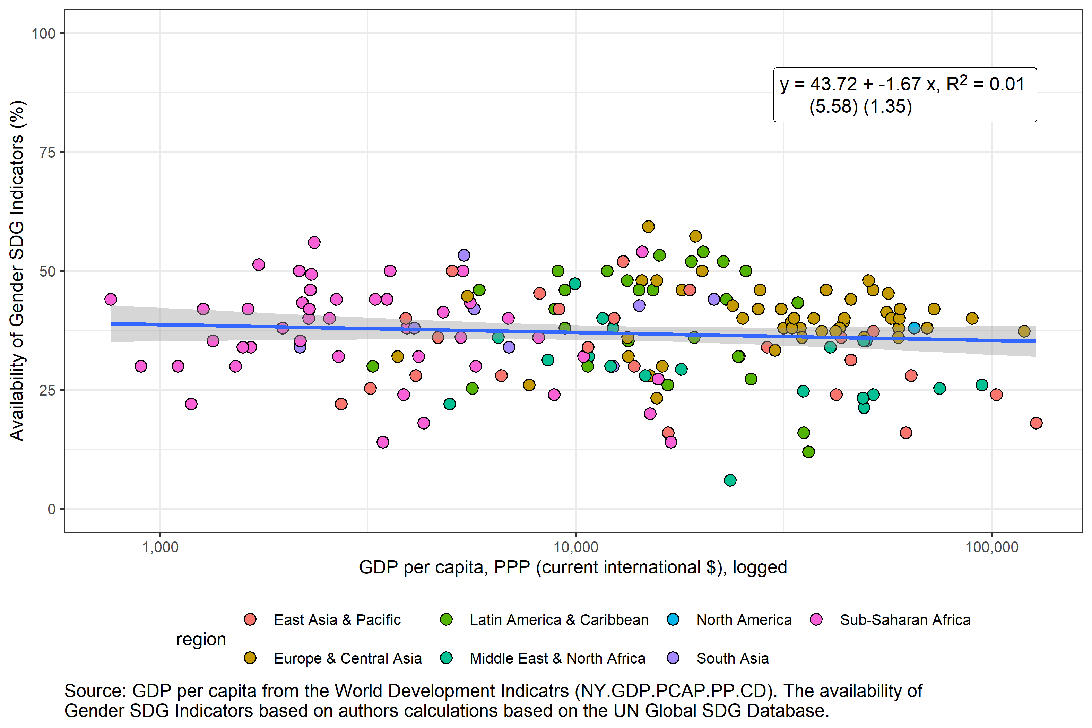

## 1.6 Table 1. SDG indicators related to gender (N=181 countries)

| **Table 1. SDG Indicators related to Gender** | | | | | | |
| --- | --- | --- | --- | --- | --- | --- |
| **Goal** | **Indicator** | **Tier** | **Description** | **Sub-Indicators** | **Sex Disaggregation Available** | **Any Data Available** |
| 1 | 1.1.1 | 1 | Proportion of the population living below the international poverty line by sex, age, employment status and geographic location (urban/rural) | Proportion of population below international poverty line (%) | 59.1% | 69.6% |
| 1.1.1 | 1 | Proportion of the population living below the international poverty line by sex, age, employment status and geographic location (urban/rural) | Employed population below international poverty line, by sex and age (%) | 2.8% | 17.7% |
| 1.2.1 | 1 | Proportion of population living below the national poverty line, by sex and age | Proportion of population living below the national poverty line (%) | 0.0% | 65.2% |
| 1.2.2 | 2 | Proportion of men, women and children of all ages living in poverty in all its dimensions according to national definitions | Proportion of population living in multidimensional poverty (%) | 24.3% | 34.8% |
| 1.3.1 | 1 | Proportion of population covered by social protection floors/systems, by sex, distinguishing children, unemployed persons, older persons, persons with disabilities, pregnant women, newborns, work-injury victims and the poor and the vulnerable | [ILO] Proportion of population covered by at least one social protection benefit, by sex (%) | 14.9% | 87.3% |
| 1.4.2 | 2 | Proportion of total adult population with secure tenure rights to land, (a) with legally recognized documentation, and (b) who perceive their rights to land as secure, by sex and type of tenure | Proportion of people with legally recognized documentation of their rights to land out of total adult population, by sex (%); /n Proportion of people who perceive their rights to land as secure out of total adult population, by sex (%); /n Proportion of people with secure tenure rights to land out of total adult population, by sex (%) | 12.7% | 13.3% |
| 2 | 2.2.3 | 1 | Prevalence of anaemia in women aged 15 to 49 years, by pregnancy status (percentage) | Proportion of women aged 15-49 years with anaemia, pregnant (%) | NA% | 65.2% |
| 2.3.2 | 2 | Average income of small-scale food producers, by sex and indigenous status | Average income of small-scale food producers, PPP (constant 2011 international $) | 11.6% | 12.7% |
| 3 | 3.1.1 | 1 | Maternal mortality ratio | Maternal mortality ratio | NA% | 97.8% |
| 3.1.2 | 1 | Proportion of births attended by skilled health personnel | Proportion of births attended by skilled health personnel (%) | NA% | 82.9% |
| 3.3.1 | 1 | Number of new HIV infections per 1,000 uninfected population, by sex, age and key populations | Number of new HIV infections per 1,000 uninfected population, by sex and age (per 1,000 uninfected population) | 72.4% | 80.7% |
| 3.7.1 | 1 | Proportion of women of reproductive age (aged 15-49 years) who have their need for family planning satisfied with modern methods | Proportion of women of reproductive age (aged 15-49 years) who have their need for family planning satisfied with modern methods (% of women aged 15-49 years) | NA% | 49.7% |
| 3.7.2 | 1 | Adolescent birth rate (aged 10-14 years; aged 15-19 years) per 1,000 women in that age group | Adolescent birth rate (per 1,000 women aged 15-19 and 10-14 years) | NA% | 89.0% |
| 4 | 4.1.1 | 1 | Proportion of children and young people (a) in grades 2/3; (b) at the end of primary; and (c) at the end of lower secondary achieving at least a minimum proficiency level in (i) reading and (ii) mathematics, by sex | Proportion of children and young people achieving a minimum proficiency level in reading and mathematics (%) | 62.4% | 63.0% |
| 4.2.1 | 2 | Proportion of children aged 24-59 months who are developmentally on track in health, learning and psychosocial well-being, by sex | Proportion of children aged 36−59 months who are developmentally on track in at least three of the following domains: literacy-numeracy, physical development, social-emotional development, and learning (% of children aged 36-59 months) | 30.4% | 30.9% |
| 4.2.2 | 1 | Participation rate in organized learning (one year before the official primary entry age), by sex | Participation rate in organized learning (one year before the official primary entry age), by sex (%) | 81.8% | 85.1% |
| 4.3.1 | 2 | Participation rate of youth and adults in formal and non-formal education and training in the previous 12 months, by sex | Participation rate in formal and non-formal education and training, by sex (%) | 73.5% | 74.0% |
| 4.5.1 | 2 | Parity indices (female/male, rural/urban, bottom/top wealth quintile and others such as disability status, indigenous peoples and conflict-affected, as data become available) for all education indicators on this list that can be disaggregated | Adjusted gender parity index for participation rate in organized learning (one year before the official primary entry age), (ratio); /n Adjusted gender parity index for the proportion of teachers with the minimum required qualifications, by education level (ratio); /n Adjusted gender parity index for participation rate in formal and non-formal education and training (ratio); /n Gender parity index for youth/adults with information and communications technology (ICT) skills, by type of skill (ratio); /n Adjusted gender parity index for achieving a minimum proficiency level in reading and mathematics (ratio); /n Adjusted gender parity index for completion rate, by location, wealth quintile and education level; /n Adjusted gender parity index for achieving at least a fixed level of proficiency in functional skills, by numeracy/literacy skills (ratio) | NA% | 98.3% |
| 4.6.1 | 2 | Proportion of population in a given age group achieving at least a fixed level of proficiency in functional (a) literacy and (b) numeracy skills, by sex | Proportion of population achieving at least a fixed level of proficiency in functional skills, by sex, age and type of skill (%) | 7.2% | 7.7% |
| 5 | 5.1.1 | 2 | Whether or not legal frameworks are in place to promote, enforce and monitor equality and non‑discrimination on the basis of sex | Legal frameworks that promote, enforce and monitor gender equality (percentage of achievement, 0 - 100) -- Area 4: marriage and family; /n Legal frameworks that promote, enforce and monitor gender equality (percentage of achievement, 0 - 100) -- Area 3: employment and economic benefits; /n Legal frameworks that promote, enforce and monitor gender equality (percentage of achievement, 0 - 100) -- Area 1: overarching legal frameworks and public life; /n Legal frameworks that promote, enforce and monitor gender equality (percentage of achievement, 0 - 100) -- Area 2: violence against women | NA% | 52.5% |
| 5.2.1 | 1 | Proportion of ever-partnered women and girls aged 15 years and older subjected to physical, sexual or psychological violence by a current or former intimate partner in the previous 12 months, by form of violence and by age | Proportion of ever-partnered women and girls subjected to physical and/or sexual violence by a current or former intimate partner in the previous 12 months, by age (%) | NA% | 81.8% |
| 5.2.2 | 2 | Proportion of women and girls aged 15 years and older subjected to sexual violence by persons other than an intimate partner in the previous 12 months, by age and place of occurrence | NA | NA% | 0.0% |
| 5.3.1 | 1 | Proportion of women aged 20-24 years who were married or in a union before age 15 and before age 18 | Proportion of women aged 20-24 years who were married or in a union before age 18 (%); /n Proportion of women aged 20-24 years who were married or in a union before age 15 (%) | NA% | 44.2% |
| 5.3.2 | 1 | Proportion of girls and women aged 15-49 years who have undergone female genital mutilation/cutting, by age | Proportion of girls and women aged 15-49 years who have undergone female genital mutilation/cutting, by age (%) | NA% | 10.5% |
| 5.4.1 | 2 | Proportion of time spent on unpaid domestic and care work, by sex, age and location | Proportion of time spent on unpaid domestic chores and care work, by sex, age and location (%) | 18.2% | 18.8% |
| 5.5.1 | 1 | Proportion of seats held by women in (a) national parliaments and (b) local governments | Proportion of seats held by women in national parliaments (% of total number of seats); /n Proportion of elected seats held by women in deliberative bodies of local government (%) | NA% | 98.3% |
| 5.5.2 | 1 | Proportion of women in managerial positions | Proportion of women in senior and middle management positions (%) | NA% | 65.2% |
| 5.6.1 | 2 | Proportion of women aged 15-49 years who make their own informed decisions regarding sexual relations, contraceptive use and reproductive health care | Proportion of women who make their own informed decisions regarding sexual relations, contraceptive use and reproductive health care (% of women aged 15-49 years) | NA% | 22.7% |
| 5.6.2 | 2 | Number of countries with laws and regulations that guarantee full and equal access to women and men aged 15 years and older to sexual and reproductive health care, information and education | Extent to which countries have laws and regulations that guarantee full and equal access to women and men aged 15 years and older to sexual and reproductive health care, information and education (%) | NA% | 17.1% |
| 5.a.1 | 2 | (a) Proportion of total agricultural population with ownership or secure rights over agricultural land, by sex; and (b) share of women among owners or rights-bearers of agricultural land, by type of tenure | Share of women among owners or rights-bearers of agricultural land, by type of tenure (%); /n Proportion of people with ownership or secure rights over agricultural land (out of total agricultural population), by sex (%) | 18.2% | 18.2% |
| 5.a.2 | 2 | Proportion of countries where the legal framework (including customary law) guarantees women’s equal rights to land ownership and/or control | Degree to which the legal framework (including customary law) guarantees women’s equal rights to land ownership and/or control (1=No evidence to 6=Highest levels of guarantees) | NA% | 18.8% |
| 5.b.1 | 2 | Proportion of individuals who own a mobile telephone, by sex | Proportion of individuals who own a mobile telephone, by sex (%) | 44.2% | 56.4% |
| 5.c.1 | 2 | Proportion of countries with systems to track and make public allocations for gender equality and women’s empowerment | Proportion of countries with systems to track and make public allocations for gender equality and women's empowerment (%) | NA% | 0.0% |
| 8 | 8.3.1 | 2 | Proportion of informal employment in total employment, by sector and sex | Proportion of informal employment, by sector and sex (ILO harmonized estimates) (%) | 64.1% | 64.1% |
| 8.5.1 | 2 | Average hourly earnings of employees, by sex, age, occupation and persons with disabilities | Average hourly earnings of employees by sex and occupation (local currency) | 56.4% | 56.4% |
| 8.5.2 | 1 | Unemployment rate, by sex, age and persons with disabilities | Unemployment rate, by sex and age (%) | 88.4% | 89.0% |
| 8.7.1 | 2 | Proportion and number of children aged 5-17 years engaged in child labour, by sex and age | Proportion of children engaged in economic activity, by sex and age (%) | 35.4% | 35.4% |
| 8.8.1 | 2 | Fatal and non-fatal occupational injuries per 100,000 workers, by sex and migrant status | Non-fatal occupational injuries among employees, by sex and migrant status (per 100,000 employees); /n Fatal occupational injuries among employees, by sex and migrant status (per 100,000 employees) | 32.6% | 42.0% |
| 8.8.2 | 2 | Level of national compliance with labour rights (freedom of association and collective bargaining) based on International Labour Organization (ILO) textual sources and national legislation, by sex and migrant status | Level of national compliance with labour rights (freedom of association and collective bargaining) based on International Labour Organization (ILO) textual sources and national legislation | 0.0% | 95.6% |
| 10 | 10.2.1 | 2 | Proportion of people living below 50 per cent of median income, by sex, age and persons with disabilities | Proportion of people living below 50 percent of median income (%) | 0.0% | 69.1% |
| 11 | 11.7.2 | 2 | Proportion of persons victim of physical or sexual harassment, by sex, age, disability status and place of occurrence, in the previous 12 months | NA | 0.0% | 0.0% |
| 16 | 16.1.1 | 2 | Number of victims of intentional homicide per 100,000 population, by sex and age | Number of victims of intentional homicide per 100,000 population, by sex (victims per 100,000 population) | 65.7% | 75.1% |
| 16.1.3 | 2 | Proportion of population subjected to (a) physical violence, (b) psychological violence and (c) sexual violence in the previous 12 months | Proportion of population subjected to physical violence in the previous 12 months, by sex (%); /n Proportion of population subjected to robbery in the previous 12 months, by sex (%); /n Proportion of population subjected to sexual violence in the previous 12 months, by sex (%) | 19.3% | 24.3% |
| 16.2.2 | 2 | Number of victims of human trafficking per 100,000 population, by sex, age and form of exploitation | Detected victims of human trafficking, by age and sex (number) | 56.7% | 68.7% |
| 16.2.3 | 2 | Proportion of young women and men aged 18-29 years who experienced sexual violence by age 18 | Proportion of population aged 18-29 years who experienced sexual violence by age 18, by sex (% of population aged 18-29) | 21.5% | 21.5% |
| 16.7.1 | 2 | Proportions of positions in national and local institutions, including (a) the legislatures; (b) the public service; and (c) the judiciary, compared to national distributions, by sex, age, persons with disabilities and population groups | Ratio for female members of parliaments (Ratio of the proportion of women in parliament in the proportion of women in the national population with the age of eligibility as a lower bound boundary), Upper Chamber; /n Ratio for female members of parliaments (Ratio of the proportion of women in parliament in the proportion of women in the national population with the age of eligibility as a lower bound boundary), Lower Chamber or Unicameral | NA% | 0.0% |
|  | 11.2.1 |  |  | NA | 0.0% | 0.0% |
| 11.7.1 |  |  | NA | 0.0% | 0.0% |
| 16.1.2 |  |  | NA | 0.0% | 0.0% |
| 16.7.2 |  |  | NA | 0.0% | 0.0% |
| Source: UN. | | | | | | |

## 1.7 Figure 6. SDG gender indicators and SPI score (n=161 economies)

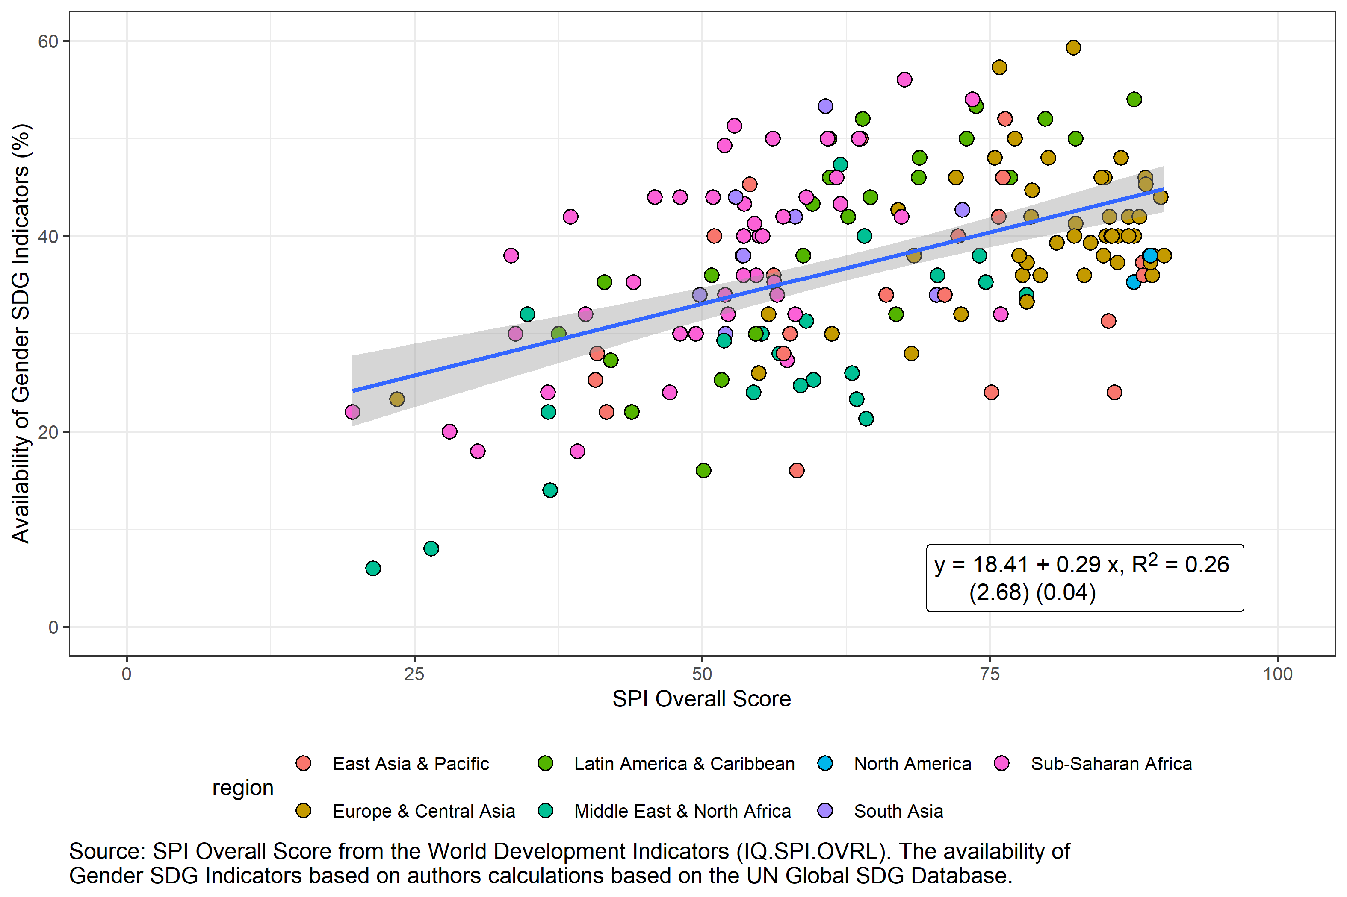

## 1.8 Figure 7. SDG gender indicators and all SDG indicators (n=161 economies)

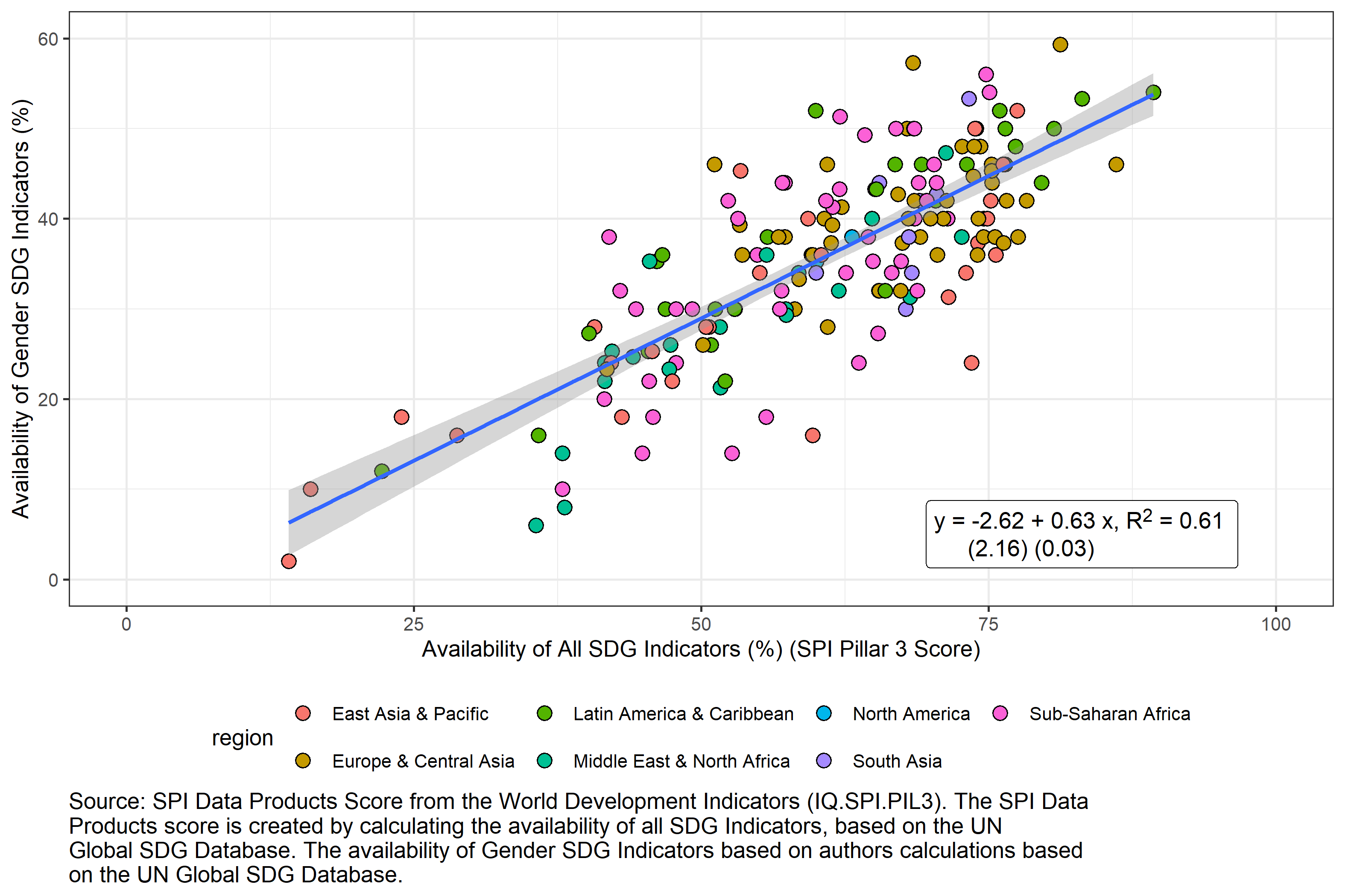

## 1.9 Figure 8: Top 15 Over/Under-Performers on Availability of Gender SDG Indicators as predicted by SPI in terms of number of additional SDG gender indicators

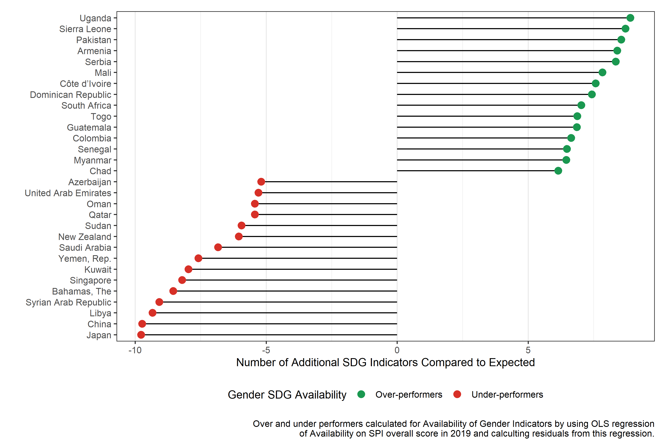

## 1.10 Figure 9: Top 15 Over/Under-Performers on Availability of Gender SDG Indicators as predicted by SPI in terms of percentage change in SDG gender indicators

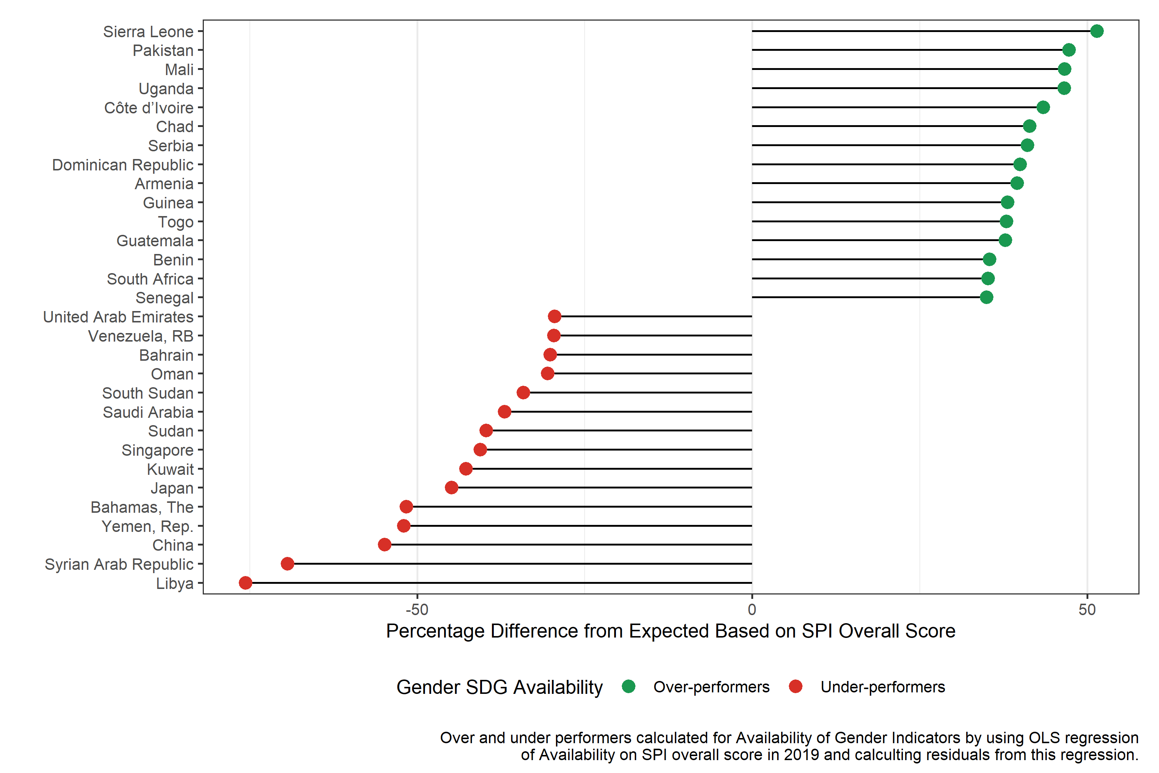

## 1.11 Table 2. Regression of availability of SDG gender indicators on country traits

|  | SPI Only | Region Only | Region Excluded | All Explanatory Variables Included | All Explanatory Variables Included + GII | All Explanatory Variables Included + SIGI |
| --- | --- | --- | --- | --- | --- | --- |
| (Intercept) | 21.37*** | 34.34*** | 61.55*** | 54.84*** | 31.51* | 47.79** |
|  | (2.76) | (2.09) | (10.79) | (11.44) | (15.48) | (17.91) |
| SPI Overall Score | 0.25*** |  | 0.46*** | 0.53*** | 0.62*** | 0.64*** |
|  | (0.04) |  | (0.06) | (0.06) | (0.06) | (0.08) |
| regionEurope & Central Asia |  | 6.18** |  | 1.46 | 4.36* | 1.44 |
|  |  | (2.30) |  | (2.23) | (2.20) | (2.87) |
| regionLatin America & Caribbean |  | 7.01* |  | 8.48*** | 7.99*** | 8.41** |
|  |  | (2.96) |  | (2.20) | (2.13) | (2.71) |
| regionMiddle East & North Africa |  | -5.20+ |  | 2.16 | 2.89 | 1.23 |
|  |  | (2.90) |  | (2.23) | (2.38) | (3.18) |
| regionNorth America |  | 2.31 |  | -2.27 | -0.34 | -3.11 |
|  |  | (2.31) |  | (3.00) | (2.37) | (3.11) |
| regionSouth Asia |  | 5.41+ |  | 7.31* | 4.97 | 0.97 |
|  |  | (3.25) |  | (3.34) | (3.41) | (3.42) |
| regionSub-Saharan Africa |  | 3.67 |  | 3.98+ | 2.14 | 5.10+ |
|  |  | (2.54) |  | (2.19) | (2.50) | (2.88) |
| Log GDP per capita |  |  | -5.23*** | -5.06*** | -3.56*** | -4.05** |
|  |  |  | (0.69) | (0.77) | (1.03) | (1.23) |
| Log Population |  |  | -0.59 | -0.62 | -0.90+ | -0.55 |
|  |  |  | (0.51) | (0.49) | (0.50) | (0.60) |
| Population under 1.5 million |  |  | -3.29 | -2.95 | -1.20 | -2.63 |
|  |  |  | (2.00) | (1.97) | (2.04) | (2.30) |
| Women Business and the Law Index Score (scale 1-100) |  |  | 0.07+ | 0.05 | 0.04 | -0.12 |
|  |  |  | (0.04) | (0.05) | (0.06) | (0.09) |
| Gender Inequality Index |  |  |  |  | 25.00** |  |
|  |  |  |  |  | (7.59) |  |
| Social Institutions and Gender Index |  |  |  |  |  | 0.12 |
|  |  |  |  |  |  | (0.10) |
| N | 163 | 163 | 163 | 163 | 140 | 101 |
| R Sq. | 0.20 | 0.17 | 0.46 | 0.54 | 0.56 | 0.43 |
|  | | | | | | |

# 2 Annex

## 2.1 Figure A1.1. Availability of Tier 1 SDG gender indicators by region (N=181 countries)

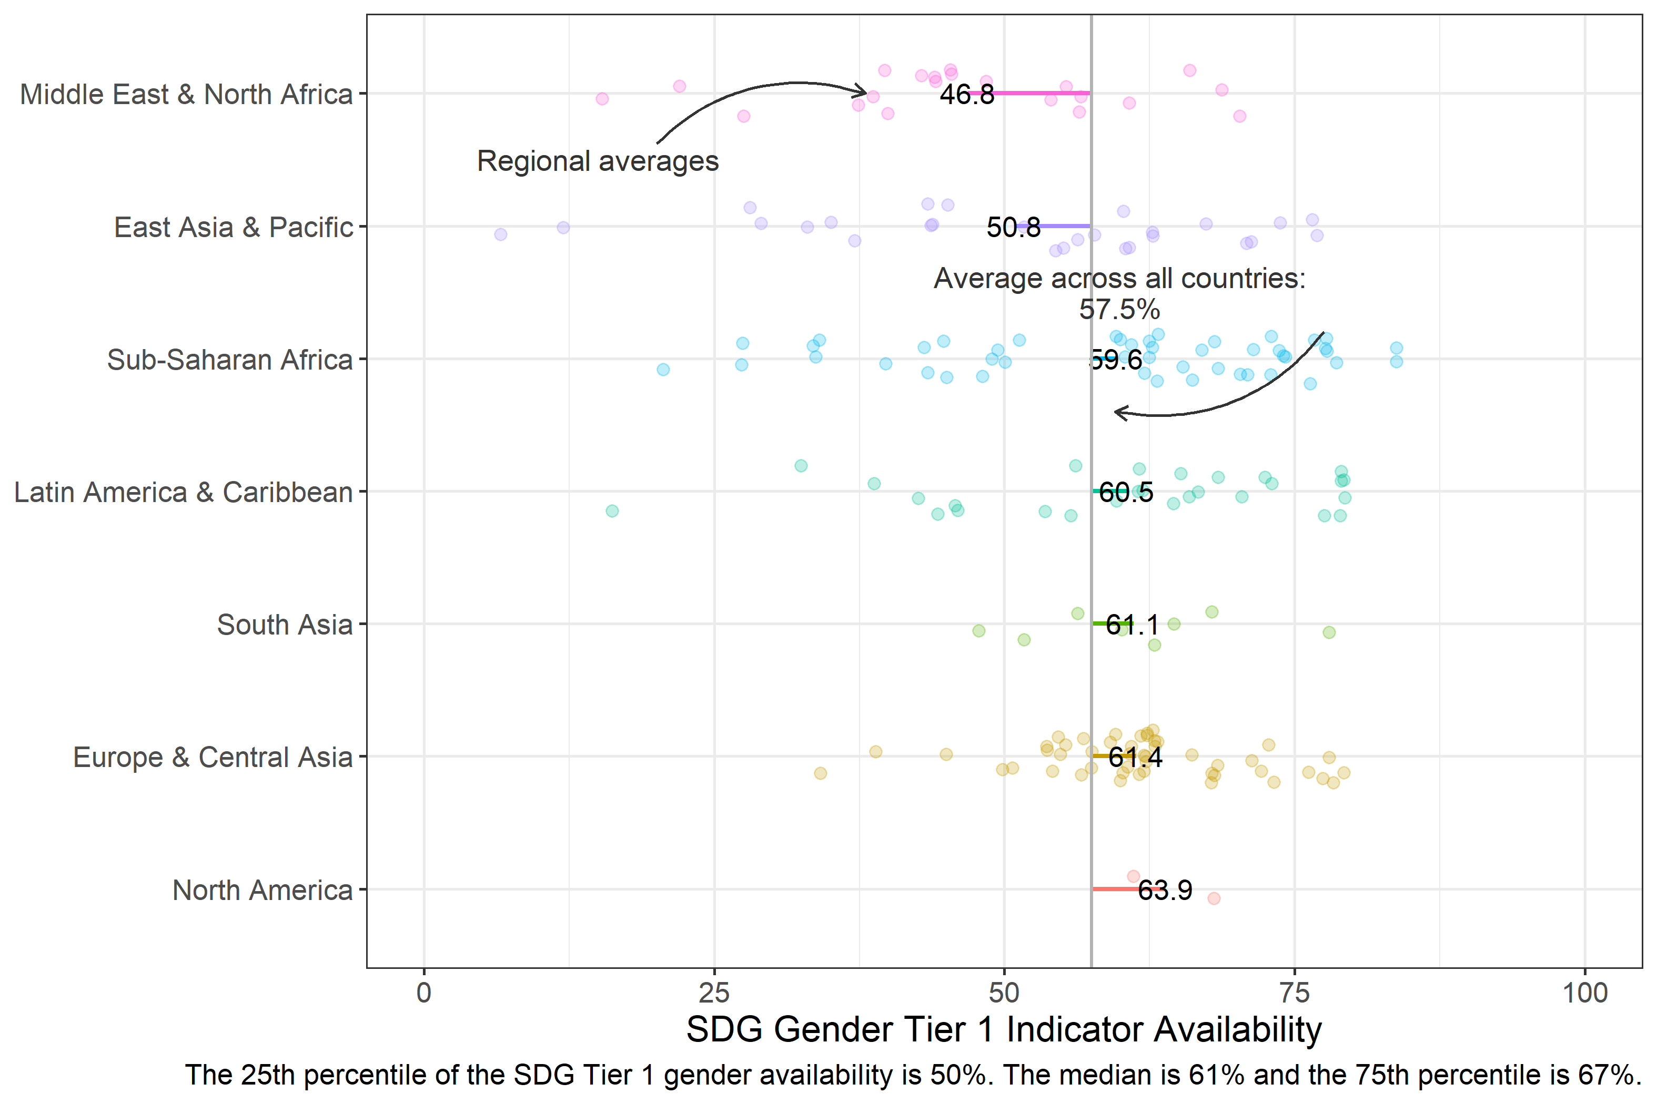

## 2.2 Figure A1.2. Availability of Tier 1 SDG gender indicators by income group (N=181 countries)

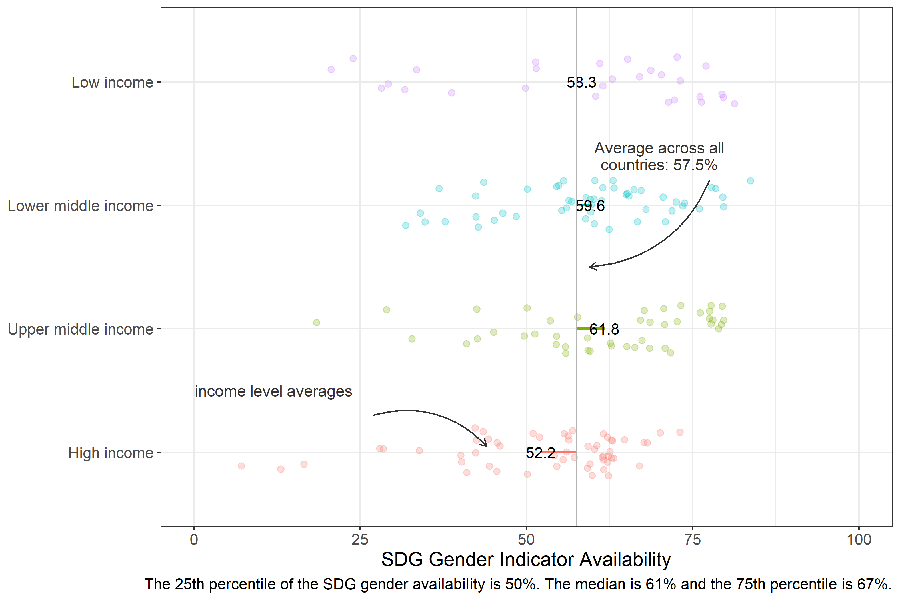

## 2.3 Figure A1.3. Availability of Tier 2 SDG gender indicators by region (N=181 countries)

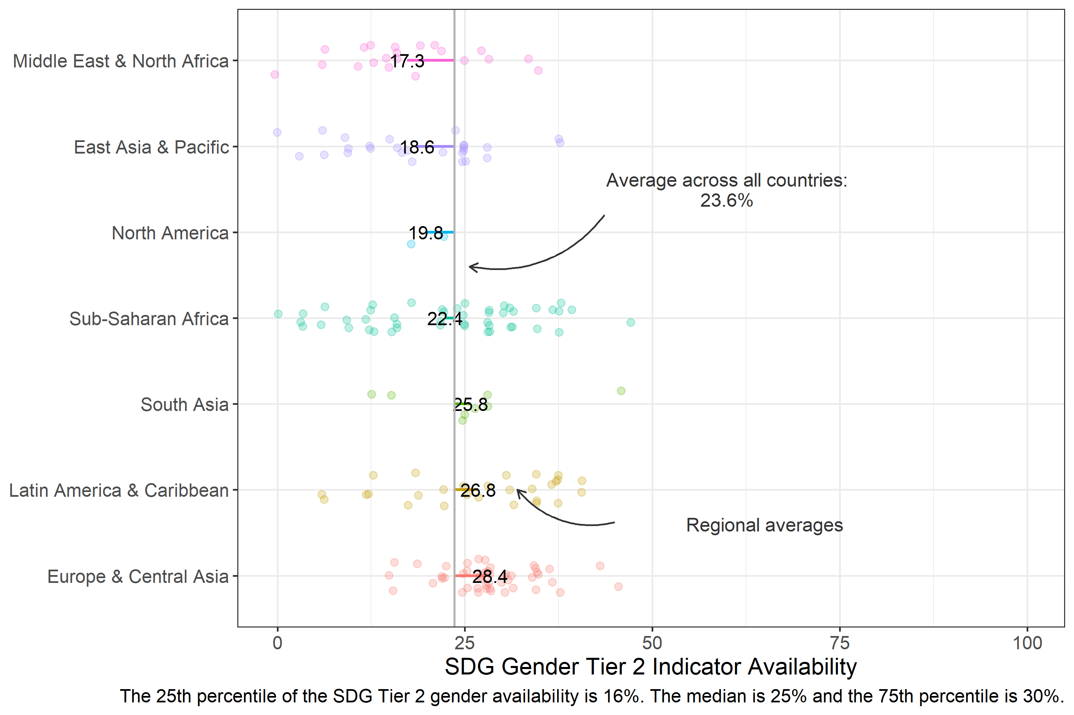

## 2.4 Figure A1.4. Availability of Tier 2 SDG gender indicators by income (N=181 countries)

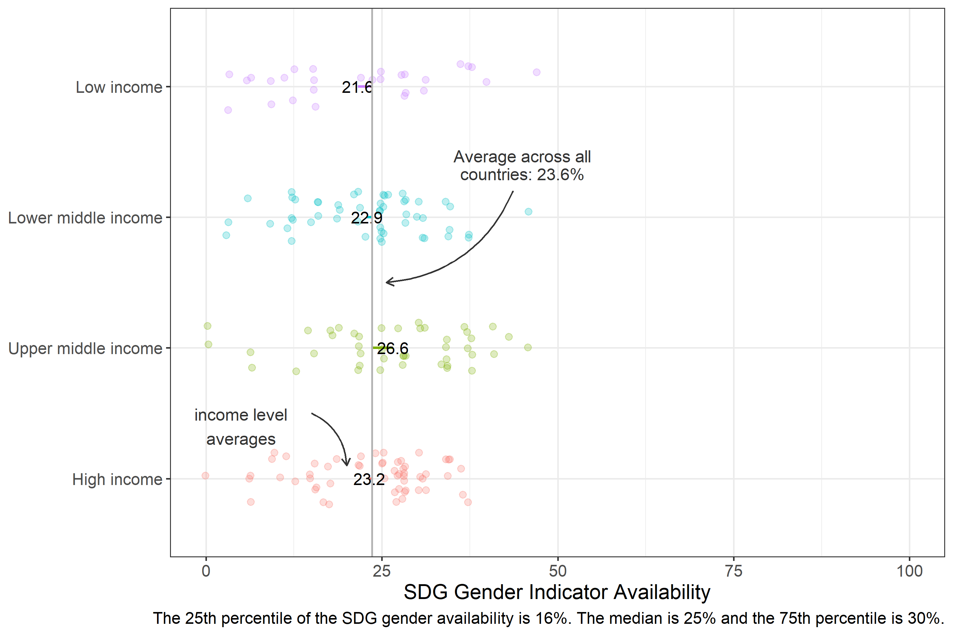

## 2.5 Figure A1.5. Availability of SDG5 gender indicators by region (N=181 countries)

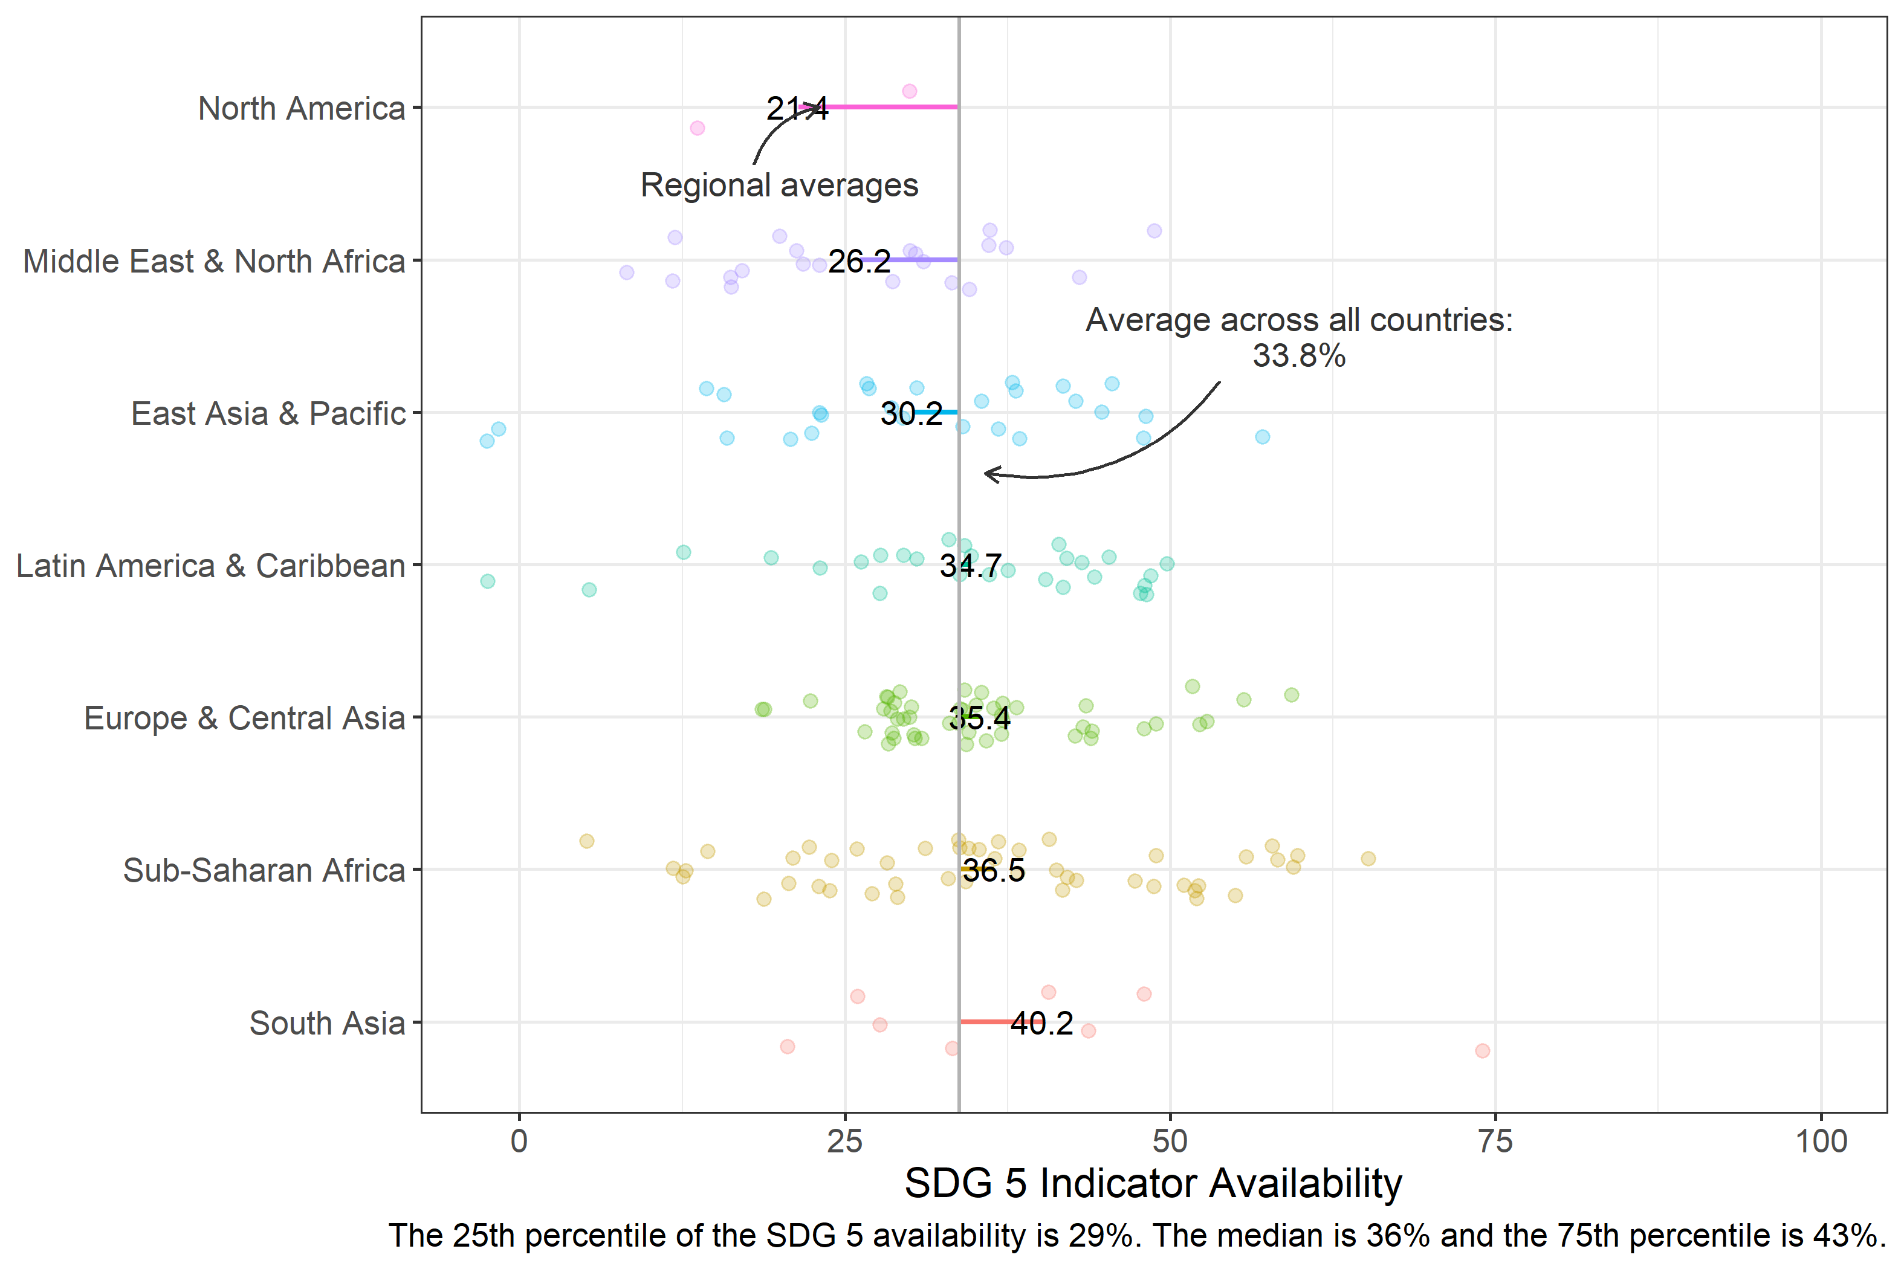

## 2.6 Figure A1.6. Availability of SDG5 gender indicators by income (N=181 countries)

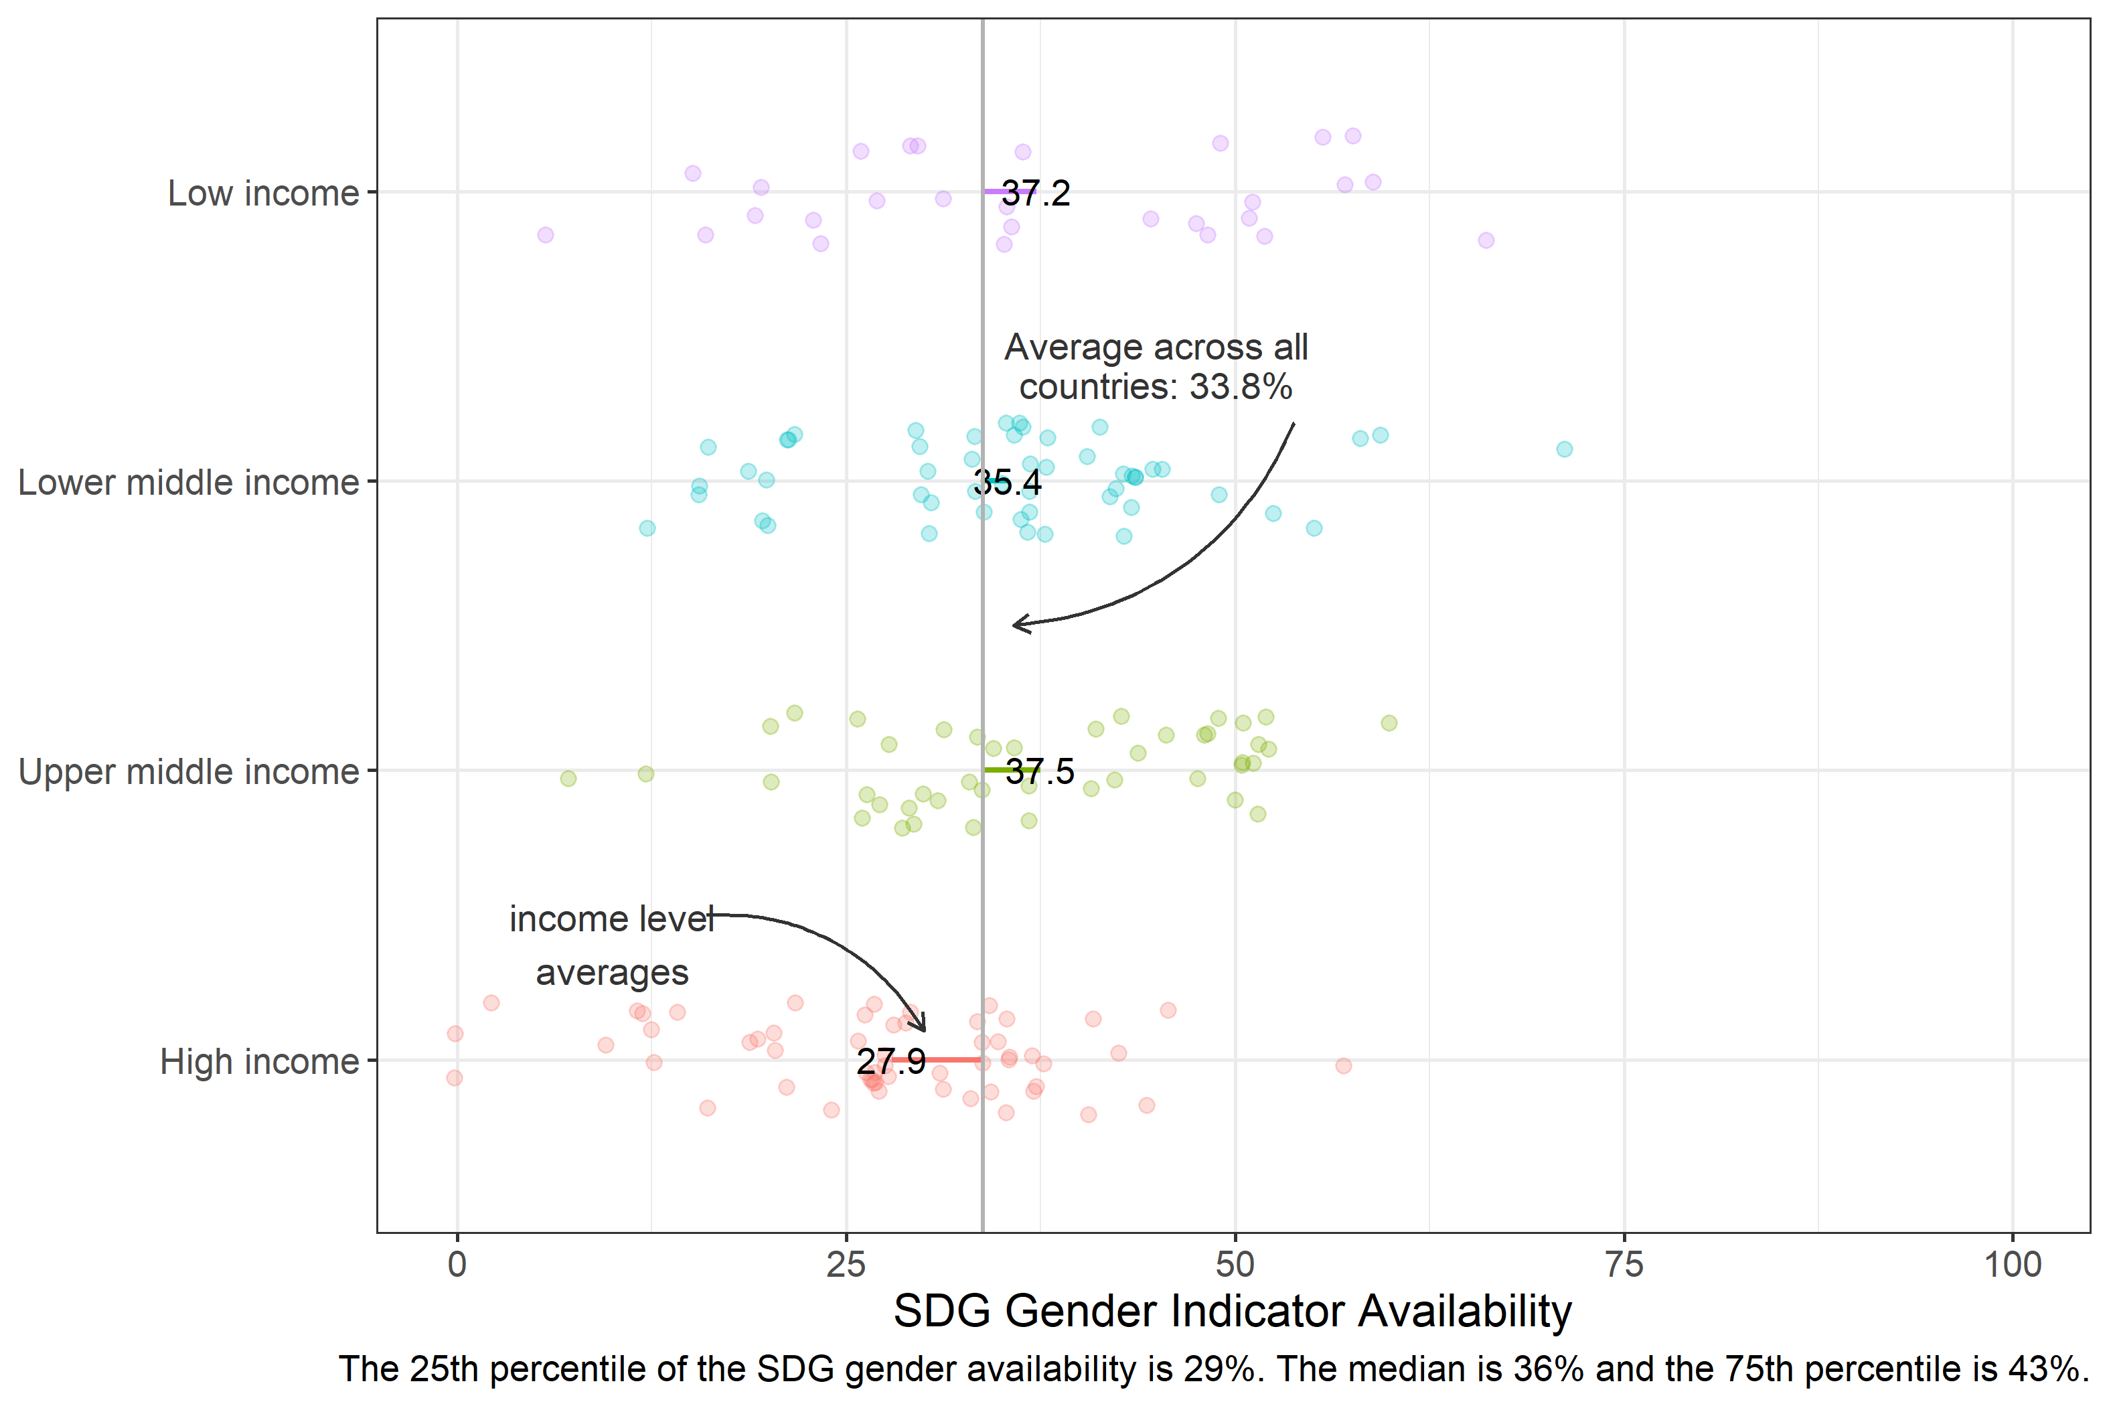

## 2.7 Annex 3

## [1] "GDP per capita Correlations"

## [1] "Log GDP per capita & Gender SDG Availability: -0.09"

## [1] "Log GDP per capita & SPI Overall Score: `0.67***"

## [1] "Log GDP per capita & SPI Pillar 1 (Data use) Score: `0.42***"

## [1] "Log GDP per capita & SPI Pillar 2 (Data services) Score: 0.53***"

## [1] "Log GDP per capita & SPI Pillar 3 (Data products) Score: 0.05"

## [1] "Log GDP per capita & SPI Pillar 4 (Data sources) Score: 0.74***"

## [1] "Log GDP per capita & SPI Pillar 5 (Data infrastructure) Score: 0.7***"

## [1] "SPI Correlations"

## [1] "Gender SDG Availability & SPI Overall Score: 0.54***"

## [1] "Gender SDG Availability & SPI Pillar 1 (Data use) Score: 0.54***"

## [1] "Gender SDG Availability & SPI Pillar 2 (Data services) Score: 0.51***"

## [1] "Gender SDG Availability & SPI Pillar 3 (Data products [Overall SDG Indicator availability]) Score: 0.7***"

## [1] "Gender SDG Availability & SPI Pillar 4 (Data sources) Score: 0.38***"

## [1] "Gender SDG Availability & SPI Pillar 5 (Data infrastructure) Score: 0.3***"