Reproducibility Package for “Missing SDG Gender Indicators: 2016-2023”
Kathleen Beegle, Umar Serajuddin, Brian Stacy, Divyanshi Wadhwa
2024-10-23
Abstract
Table of Contents

1 Main Tables and Figures

1.1 Figure 1: Sources of gender data gaps
Figure produced using Microsoft Powerpoint.
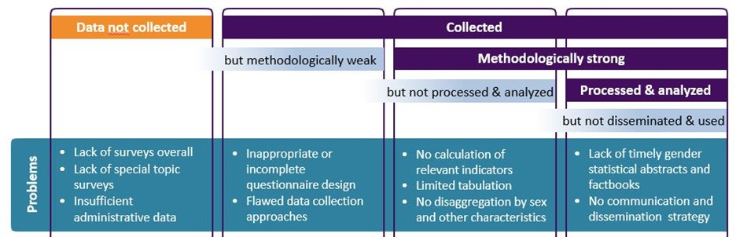
Source: Bonfert et al. 2022

1.2 Figure 2. Availability of SDG5 gender-related indicators (N=181 countries)
Published figure produced using Microsoft Excel. See the file Fig2 SDG5 coverage.xlsx.
Data for excel figure produced below.
## # A tibble: 14 × 3
## count n share
## <dbl> <int> <dbl>
## 1 0 2 0.0110
## 2 1 3 0.0166
## 3 2 2 0.0110
## 4 3 6 0.0331
## 5 4 15 0.0829
## 6 5 19 0.105
## 7 6 33 0.182
## 8 7 34 0.188
## 9 8 19 0.105
## 10 9 24 0.133
## 11 10 14 0.0773
## 12 11 8 0.0442
## 13 12 1 0.00552
## 14 13 1 0.00552

1.3 Figure 3. Availability of SDG gender indicators by region (N=181 countries)
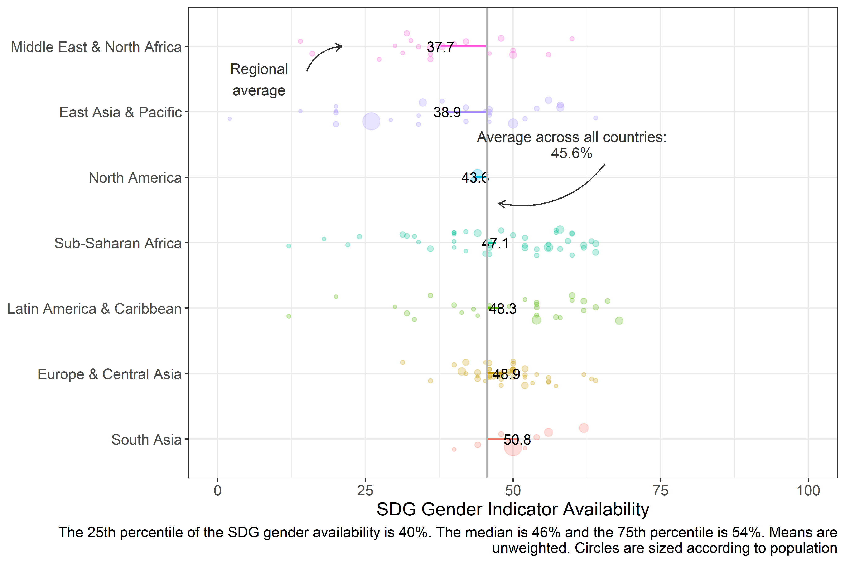
For example, of the 32 gender-related indicators which are sex disaggregated, if countries which had a population estimate also had a sex-disaggregated estimate (almost always, if not always, feasible), the SDG gender coverage rate would be 5583.6% instead of 4556.8%.

1.4 Figure 4. Availability of SDG gender indicators by income group (N=181 countries)
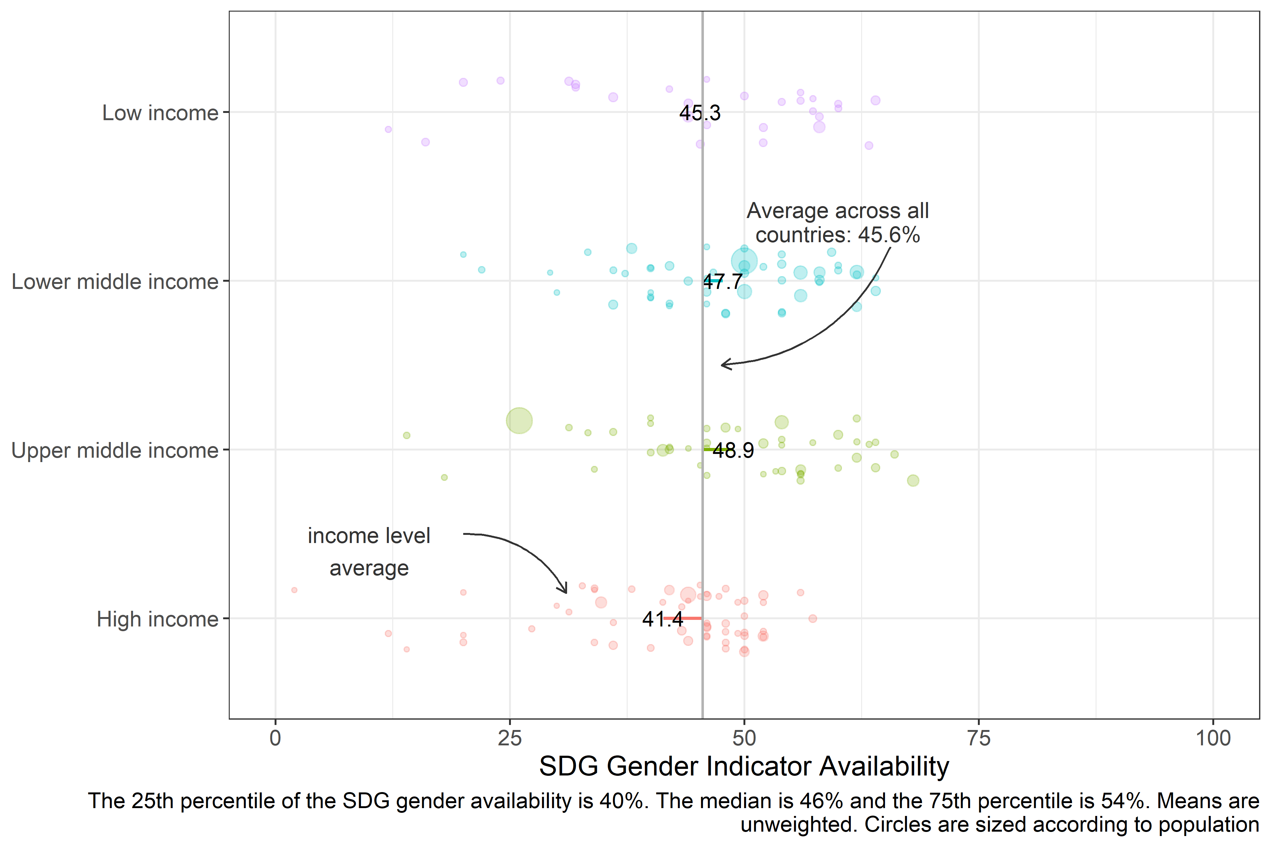

1.5 Figure 5. GDP per capita and SDG gender indicators (n=181 economies)
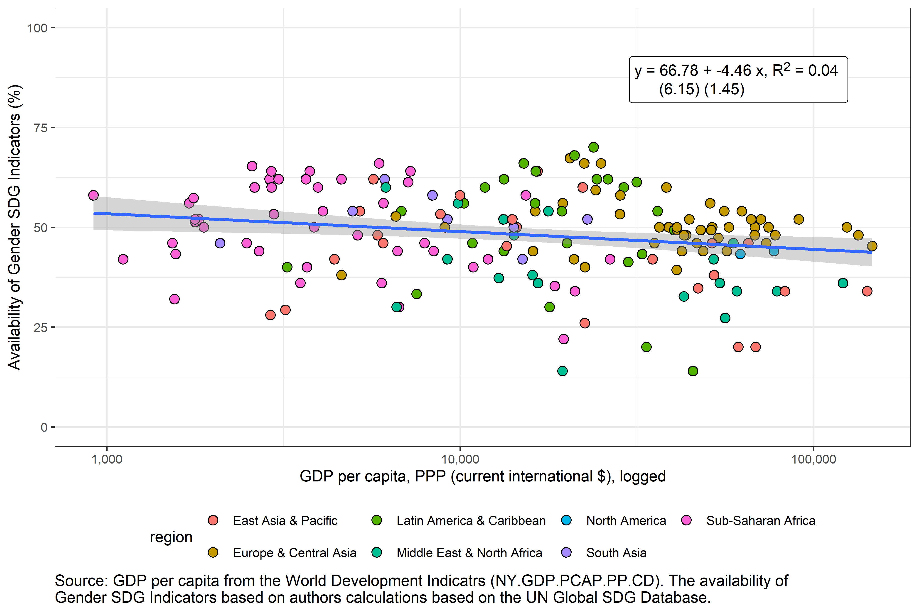

1.6 Table 1. SDG indicators related to gender (N=181 countries)
Table 1. SDG Indicators related to Gender
Goal | Indicator | Tier | Description | Sex Disaggregation Available | Any Data Available
1 | 1.1.1 | 1 | Proportion of population below international poverty line (%) | 59.7% | 69.6%
 | 1.1.1 | 1 | Employed population below international poverty line, by sex and age (%) | 2.8% | 3.9%
 | 1.2.1 | 1 | Proportion of population living below the national poverty line, by sex and age | 0.0% | 64.6%
 | 1.2.2 | 2 | Proportion of men, women and children of all ages living in poverty in all its dimensions according to national definitions | 24.9% | 34.8%
 | 1.3.1 | 1 | Proportion of population covered by social protection floors/systems, by sex, distinguishing children, unemployed persons, older persons, persons with disabilities, pregnant women, newborns, work-injury victims and the poor and the vulnerable | 97.2% | 98.9%
 | 1.4.2 | 2 | Proportion of total adult population with secure tenure rights to land, (a) with legally recognized documentation, and (b) who perceive their rights to land as secure, by sex and type of tenure | 10.5% | 11.0%
2 | 2.2.3 | 1 | Prevalence of anaemia in women aged 15 to 49 years, by pregnancy status (percentage) | NA% | 65.2%
 | 2.3.2 | 2 | Average income of small-scale food producers, by sex and indigenous status | 11.0% | 13.3%
3 | 3.1.1 | 1 | Maternal mortality ratio | NA% | 97.8%
 | 3.1.2 | 1 | Proportion of births attended by skilled health personnel | NA% | 86.2%
 | 3.3.1 | 1 | Number of new HIV infections per 1,000 uninfected population, by sex, age and key populations | 72.9% | 81.2%
 | 3.7.1 | 1 | Proportion of women of reproductive age (aged 15-49 years) who have their need for family planning satisfied with modern methods | NA% | 43.6%
 | 3.7.2 | 1 | Adolescent birth rate (aged 10-14 years; aged 15-19 years) per 1,000 women in that age group | NA% | 86.2%
4 | 4.1.1 | 1 | Proportion of children and young people (a) in grades 2/3; (b) at the end of primary; and (c) at the end of lower secondary achieving at least a minimum proficiency level in (i) reading and (ii) mathematics, by sex | 65.2% | 65.2%
 | 4.2.1 | 2 | Proportion of children aged 24-59 months who are developmentally on track in health, learning and psychosocial well-being, by sex | 37.0% | 37.6%
 | 4.2.2 | 1 | Participation rate in organized learning (one year before the official primary entry age), by sex | 81.8% | 85.1%
 | 4.3.1 | 1 | Participation rate of youth and adults in formal and non-formal education and training in the previous 12 months, by sex | 77.3% | 77.3%
 | 4.5.1 | 2 | Parity indices (female/male, rural/urban, bottom/top wealth quintile and others such as disability status, indigenous peoples and conflict-affected, as data become available) for all education indicators on this list that can be disaggregated | NA% | 97.8%
 | 4.6.1 | 2 | Proportion of population in a given age group achieving at least a fixed level of proficiency in functional (a) literacy and (b) numeracy skills, by sex | 3.3% | 3.3%
5 | 5.1.1 | 1 | Whether or not legal frameworks are in place to promote, enforce and monitor equality and non‑discrimination on the basis of sex | NA% | 64.6%
 | 5.2.1 | 1 | Proportion of ever-partnered women and girls aged 15 years and older subjected to physical, sexual or psychological violence by a current or former intimate partner in the previous 12 months, by form of violence and by age | NA% | 81.8%
 | 5.2.2 | 2 | Proportion of women and girls aged 15 years and older subjected to sexual violence by persons other than an intimate partner in the previous 12 months, by age and place of occurrence | NA% | 0.0%
 | 5.3.1 | 1 | Proportion of women aged 20-24 years who were married or in a union before age 15 and before age 18 | NA% | 56.9%
 | 5.3.2 | 1 | Proportion of girls and women aged 15-49 years who have undergone female genital mutilation, by age | NA% | 12.7%
 | 5.4.1 | 2 | Proportion of time spent on unpaid domestic and care work, by sex, age and location | 18.2% | 18.8%
 | 5.5.1 | 1 | Proportion of seats held by women in (a) national parliaments and (b) local governments | NA% | 98.3%
 | 5.5.2 | 1 | Proportion of women in managerial positions | NA% | 82.3%
 | 5.6.1 | 2 | Proportion of women aged 15-49 years who make their own informed decisions regarding sexual relations, contraceptive use and reproductive health care | NA% | 25.4%
 | 5.6.2 | 1 | Number of countries with laws and regulations that guarantee full and equal access to women and men aged 15 years and older to sexual and reproductive health care, information and education | NA% | 82.9%
 | 5.a.1 | 2 | (a) Proportion of total agricultural population with ownership or secure rights over agricultural land, by sex; and (b) share of women among owners or rights-bearers of agricultural land, by type of tenure | 21.0% | 21.0%
 | 5.a.2 | 2 | Proportion of countries where the legal framework (including customary law) guarantees women’s equal rights to land ownership and/or control | NA% | 41.4%
 | 5.b.1 | 2 | Proportion of individuals who own a mobile telephone, by sex | 45.3% | 56.4%
 | 5.c.1 | 2 | Proportion of countries with systems to track and make public allocations for gender equality and women’s empowerment | NA% | 52.5%
8 | 8.3.1 | 1 | Proportion of informal employment in total employment, by sector and sex | 65.7% | 65.7%
 | 8.5.1 | 1 | Average hourly earnings of employees, by sex, age, occupation and persons with disabilities | 59.7% | 59.7%
 | 8.5.2 | 1 | Unemployment rate, by sex, age and persons with disabilities | 90.6% | 91.7%
 | 8.7.1 | 1 | Proportion and number of children aged 5-17 years engaged in child labour, by sex and age | 41.4% | 42.0%
 | 8.8.1 | 2 | Fatal and non-fatal occupational injuries per 100,000 workers, by sex and migrant status | 28.2% | 41.4%
 | 8.8.2 | 1 | Level of national compliance with labour rights (freedom of association and collective bargaining) based on International Labour Organization (ILO) textual sources and national legislation, by sex and migrant status | 0.0% | 95.6%
10 | 10.2.1 | 1 | Proportion of people living below 50 per cent of median income, by sex, age and persons with disabilities | 0.0% | 69.1%
11 | 11.2.1 | 1 | Proportion of population that has convenient access to public transport, by sex, age and persons with disabilities | 0.0% | 97.2%
 | 11.7.1 | 1 | Average share of the built-up area of cities that is open space for public use for all, by sex, age and persons with disabilities | 0.0% | 95.6%
 | 11.7.2 | 2 | Proportion of persons victim of non-sexual or sexual harassment, by sex, age, disability status and place of occurrence, in the previous 12 months | 3.3% | 3.9%
16 | 16.1.1 | 1 | Number of victims of intentional homicide per 100,000 population, by sex and age | 65.2% | 73.5%
 | 16.1.2 | 2 | Conflict-related deaths per 100,000 population, by sex, age and cause | 7.7% | 7.7%
 | 16.1.3 | 2 | Proportion of population subjected to (a) physical violence, (b) psychological violence and/or (c) sexual violence in the previous 12 months | 23.2% | 27.1%
 | 16.2.2 | 1 | Number of victims of human trafficking per 100,000 population, by sex, age and form of exploitation | 61.0% | 74.6%
 | 16.2.3 | 2 | Proportion of young women and men aged 18-29 years who experienced sexual violence by age 18 | 25.4% | 25.4%
 | 16.7.1 | 2 | Proportions of positions in national and local institutions, including (a) the legislatures; (b) the public service; and (c) the judiciary, compared to national distributions, by sex, age, persons with disabilities and population groups | NA% | 98.3%
 | 16.7.2 | 2 | Proportion of population who believe decision-making is inclusive and responsive, by sex, age, disability and population group | 5.0% | 5.5%
Source: UN.

1.7 Figure 6. SDG gender indicators and SPI score (n=161 economies)
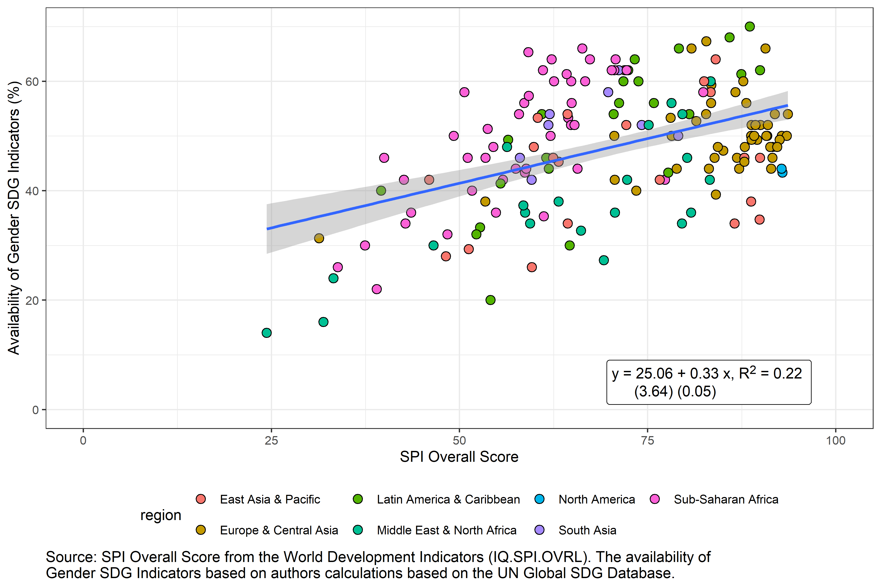

1.8 Figure 7. SDG gender indicators and all SDG indicators (n=161 economies)
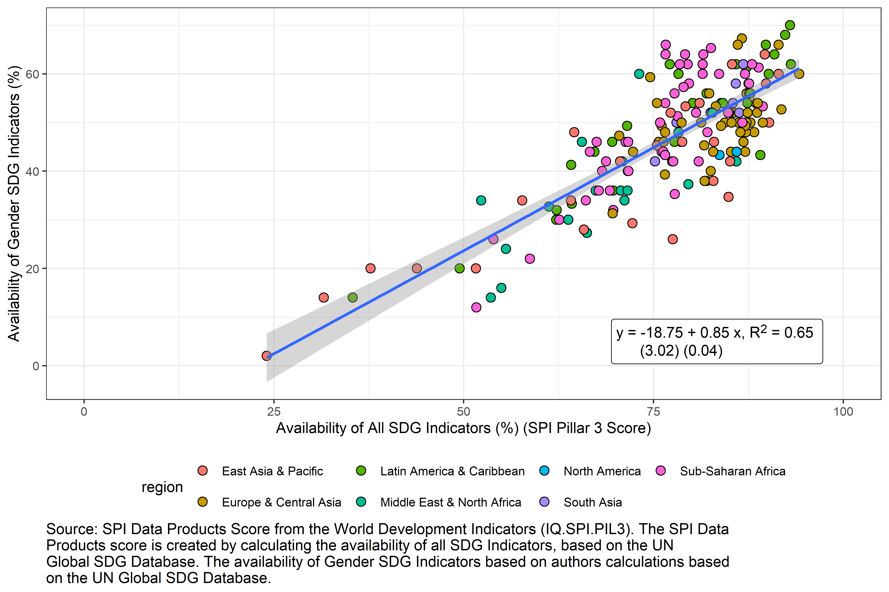

1.9 Figure 8: Top 15 Over/Under-Performers on Availability of Gender SDG Indicators as predicted by SPI in terms of number of additional SDG gender indicators
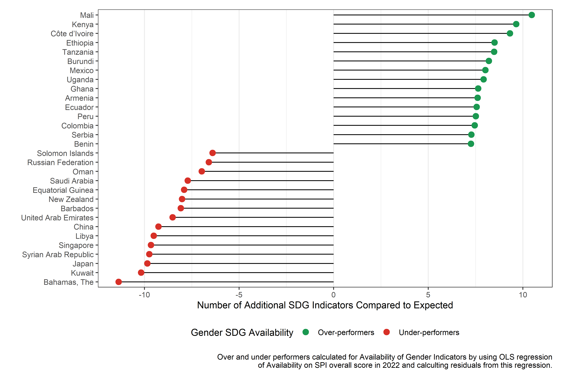

1.10 Figure 9: Top 15 Over/Under-Performers on Availability of Gender SDG Indicators as predicted by SPI in terms of percentage change in SDG gender indicators
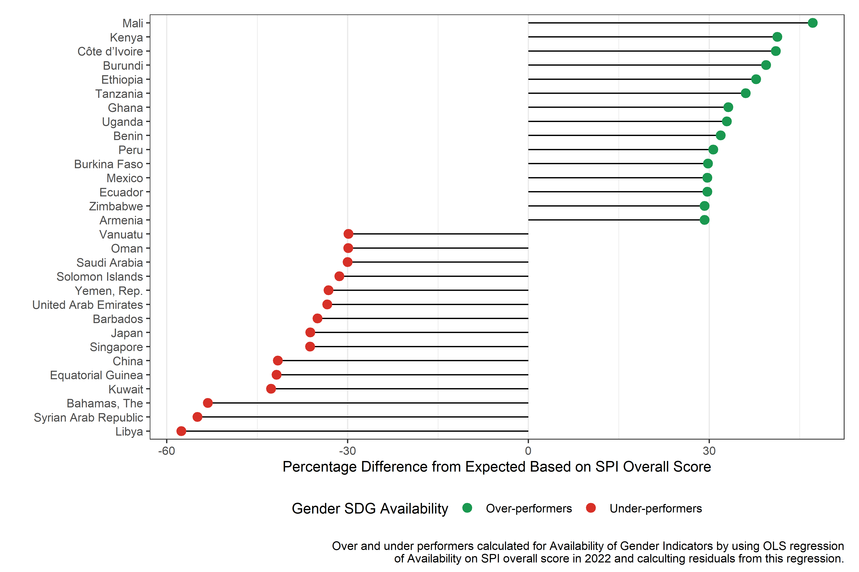

1.11 Table 2. Regression of availability of SDG gender indicators on country traits
 | SPI Only | Region Only | Region Excluded | All Explanatory Variables Included | All Explanatory Variables Included + GII | All Explanatory Variables Included + SIGI
(Intercept) | 29.13*** | 45.12*** | 65.54*** | 51.67*** | 19.29 | 61.28***
 | (3.97) | (2.36) | (10.53) | (11.22) | (14.10) | (15.35)
SPI Overall Score | 0.27*** |  | 0.58*** | 0.66*** | 0.69*** | 0.68***
 | (0.05) |  | (0.06) | (0.06) | (0.06) | (0.08)
regionEurope & Central Asia |  | 5.27* |  | 0.55 | 2.03 | 0.68
 |  | (2.54) |  | (2.36) | (2.02) | (2.79)
regionLatin America & Caribbean |  | 6.98* |  | 8.54*** | 4.83* | 9.27**
 |  | (3.46) |  | (2.45) | (2.08) | (2.93)
regionMiddle East & North Africa |  | -5.37 |  | 0.64 | 0.19 | 1.97
 |  | (3.47) |  | (2.44) | (2.26) | (3.13)
regionNorth America |  | -1.47 |  | -8.39** | -7.36*** | -7.68**
 |  | (2.38) |  | (2.60) | (2.03) | (2.71)
regionSouth Asia |  | 6.88* |  | 6.20* | 3.29 | 5.89+
 |  | (3.19) |  | (3.01) | (2.62) | (3.04)
regionSub-Saharan Africa |  | 5.18+ |  | 4.87* | 0.43 | 5.89+
 |  | (2.90) |  | (2.24) | (1.86) | (2.98)
Log GDP per capita |  |  | -6.99*** | -6.29*** | -3.89*** | -6.57***
 |  |  | (0.68) | (0.73) | (1.00) | (0.86)
Log Population |  |  | 0.13 | 0.22 | -0.22 | 0.24
 |  |  | (0.49) | (0.49) | (0.44) | (0.53)
Population under 1.5 million |  |  | -2.25 | -1.80 | -1.63 | -0.18
 |  |  | (2.08) | (2.17) | (2.10) | (2.68)
Women Business and the Law Index Score (scale 1-100) |  |  | 0.09* | 0.05 | 0.11* | -0.03
 |  |  | (0.04) | (0.05) | (0.05) | (0.08)
Gender Inequality Index |  |  |  |  | 33.42***
 |  |  |  |  | (7.64)
Social Institutions and Gender Index |  |  |  |  |  | -0.09
 |  |  |  |  |  | (0.09)
N | 167 | 167 | 167 | 167 | 160 | 134
R Sq. | 0.15 | 0.13 | 0.54 | 0.61 | 0.63 | 0.52

2 Annex

2.1 Figure A1.1. Availability of Tier 1 SDG gender indicators by region (N=181 countries)
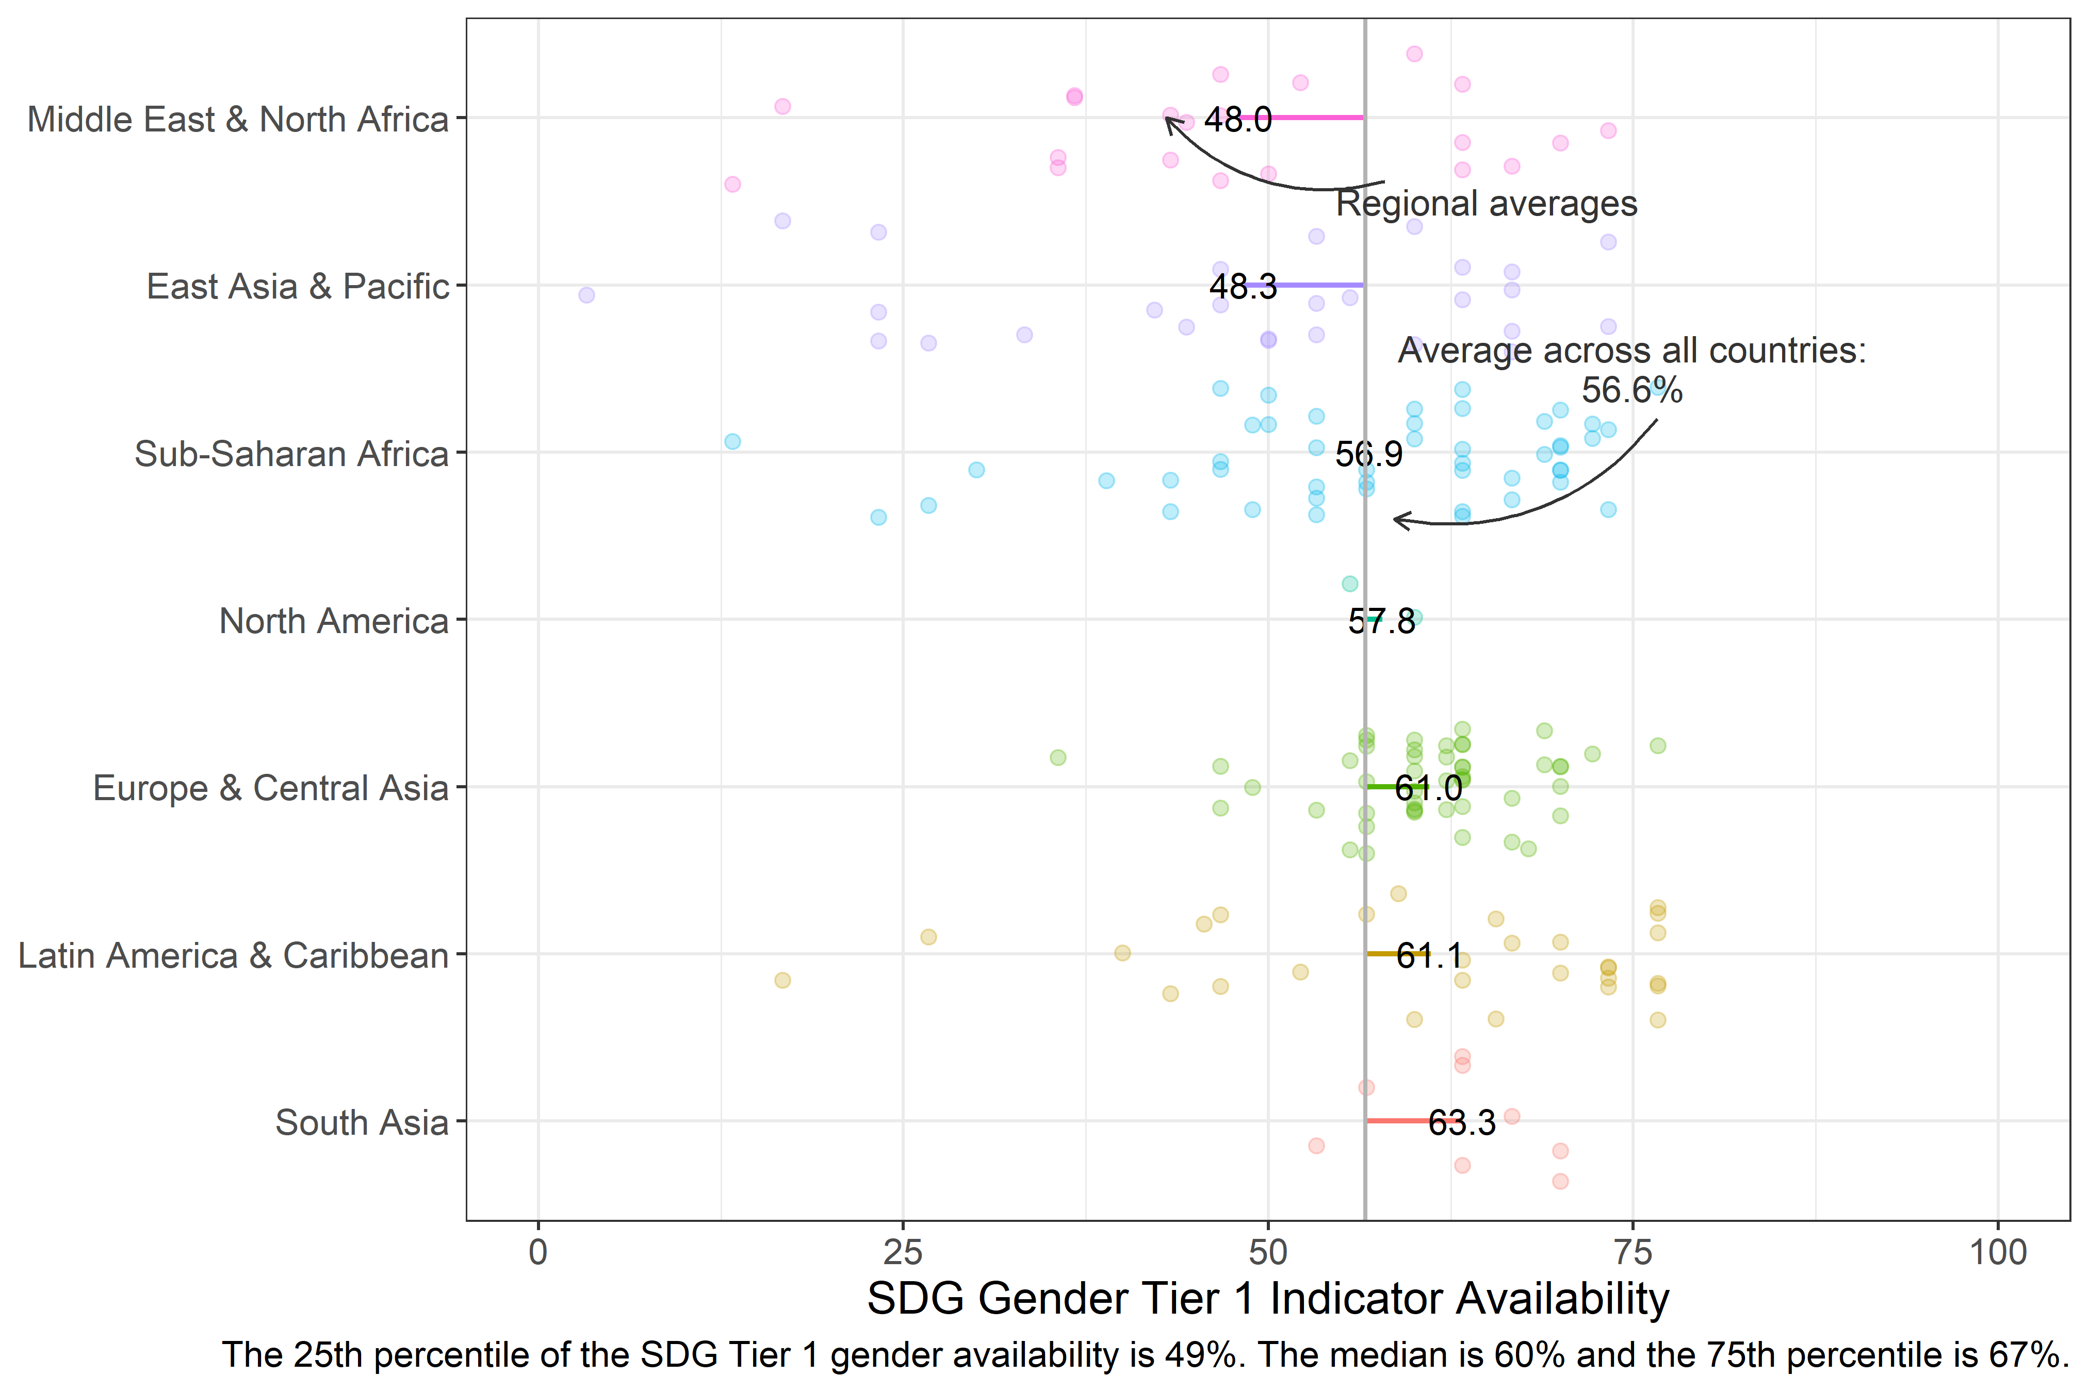

2.2 Figure A1.2. Availability of Tier 1 SDG gender indicators by income group (N=181 countries)
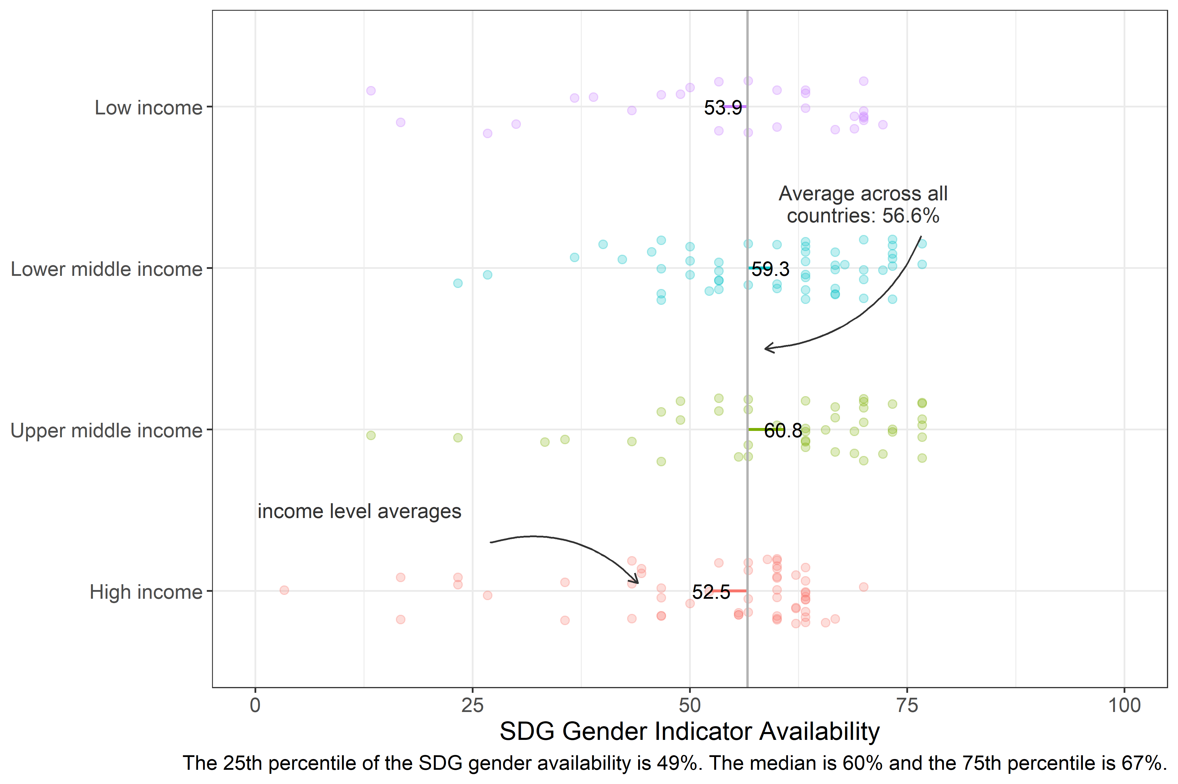

2.3 Figure A1.3. Availability of Tier 2 SDG gender indicators by region (N=181 countries)
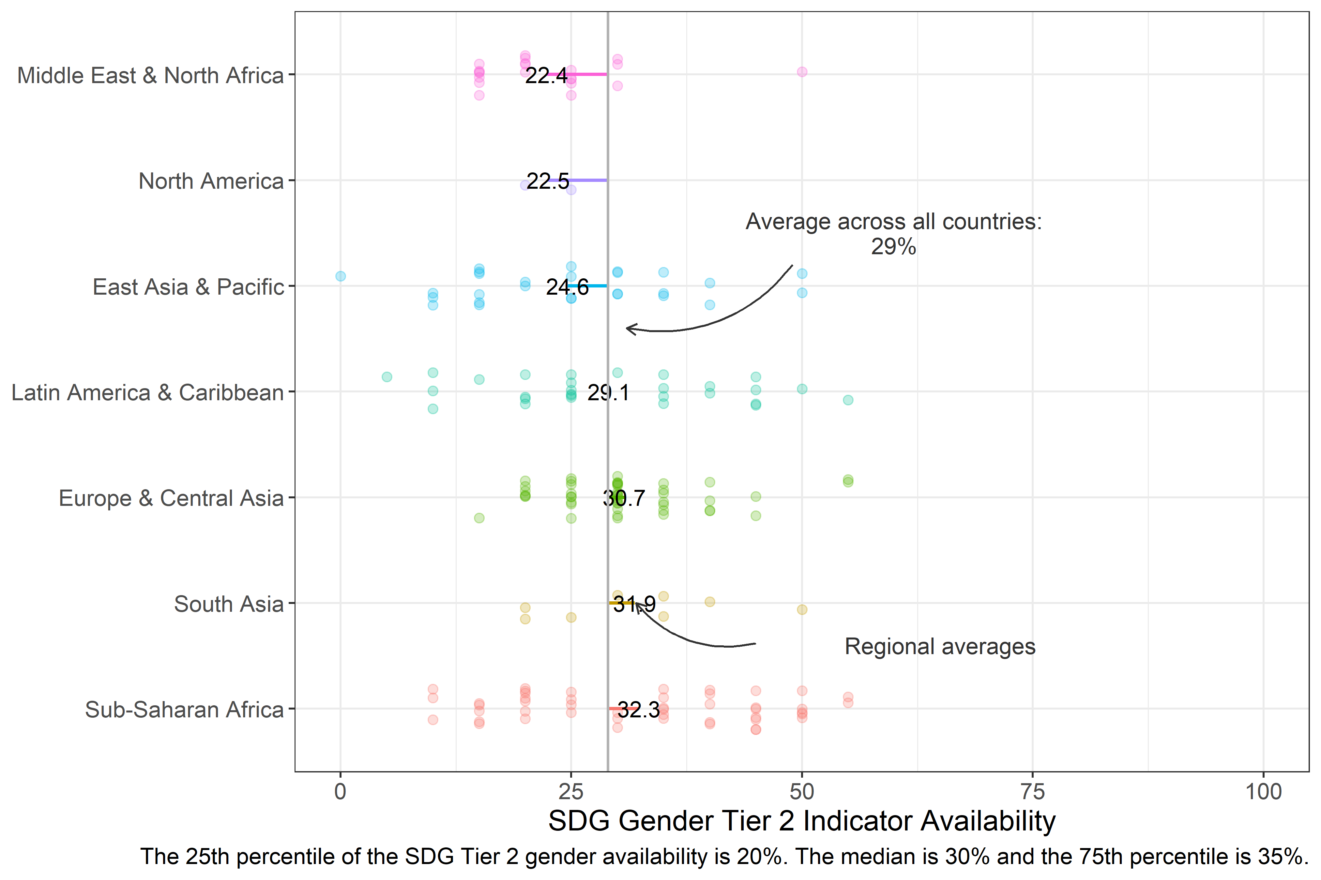

2.4 Figure A1.4. Availability of Tier 2 SDG gender indicators by income (N=181 countries)
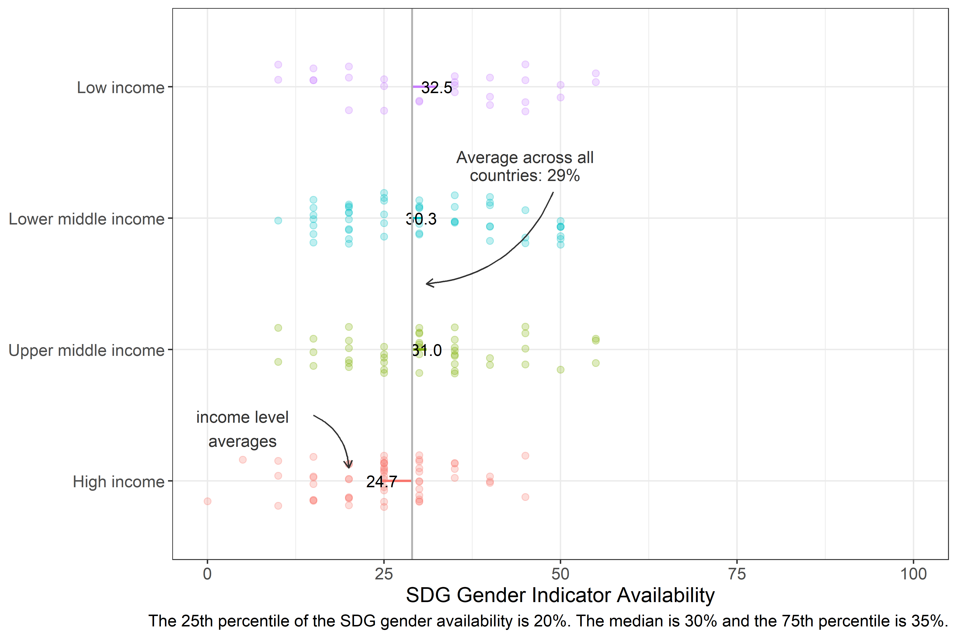

2.5 Figure A1.5. Availability of SDG5 gender indicators by region (N=181 countries)
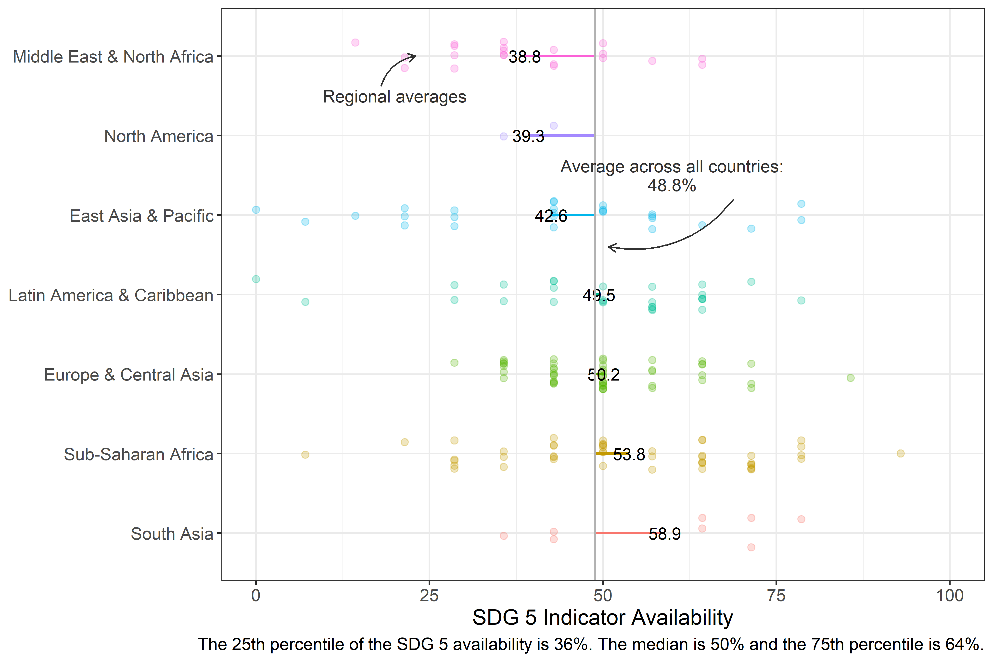

2.6 Figure A1.6. Availability of SDG5 gender indicators by income (N=181 countries)
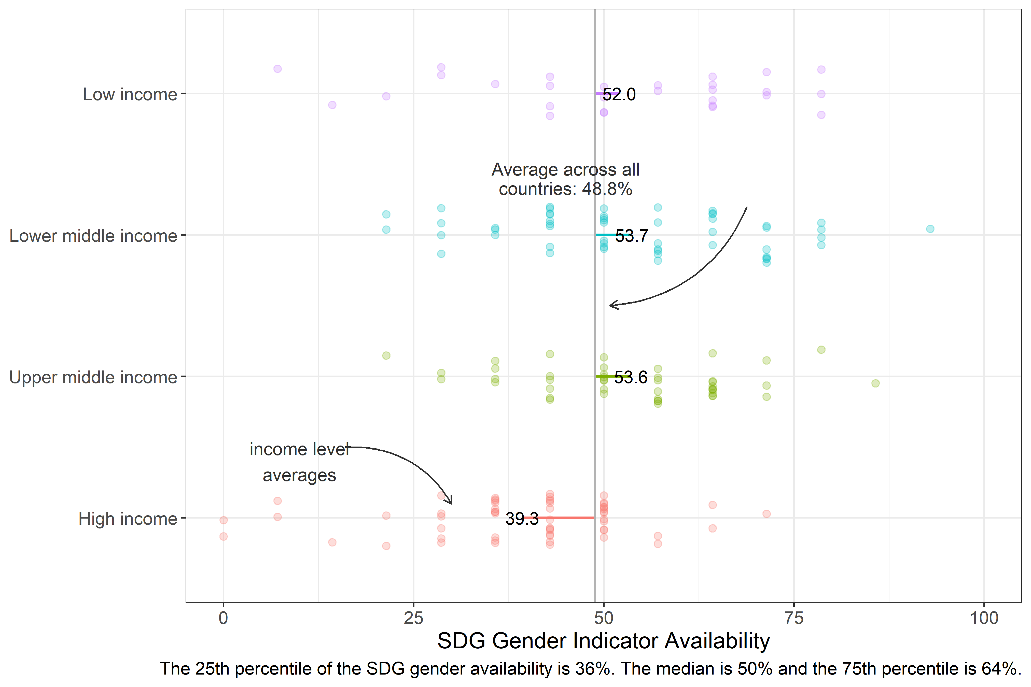

2.7 Annex 3
## [1] "GDP per capita Correlations"
## [1] "Log GDP per capita & Gender SDG Availability: -0.21**"
## [1] "Log GDP per capita & SPI Overall Score: `0.68***"
## [1] "Log GDP per capita & SPI Pillar 1 (Data use) Score: `0.46***"
## [1] "Log GDP per capita & SPI Pillar 2 (Data services) Score: 0.58***"
## [1] "Log GDP per capita & SPI Pillar 3 (Data products) Score: 0.01"
## [1] "Log GDP per capita & SPI Pillar 4 (Data sources) Score: 0.78***"
## [1] "Log GDP per capita & SPI Pillar 5 (Data infrastructure) Score: 0.67***"
## [1] "SPI Correlations"
## [1] "Gender SDG Availability & SPI Overall Score: 0.51***"
## [1] "Gender SDG Availability & SPI Pillar 1 (Data use) Score: 0.53***"
## [1] "Gender SDG Availability & SPI Pillar 2 (Data services) Score: 0.48***"
## [1] "Gender SDG Availability & SPI Pillar 3 (Data products [Overall SDG Indicator availability]) Score: 0.75***"
## [1] "Gender SDG Availability & SPI Pillar 4 (Data sources) Score: 0.3***"
## [1] "Gender SDG Availability & SPI Pillar 5 (Data infrastructure) Score: 0.36***"

