Replication package for: Reviewing Assessment Tools for Measuring Country Statistical Capacity

Brian Stacy

8/16/23

## Figure M.1. The Pillars and Dimensions that Construct the New SPI

Figure produced using Microsoft Powerpoint. Figure reproduced below.

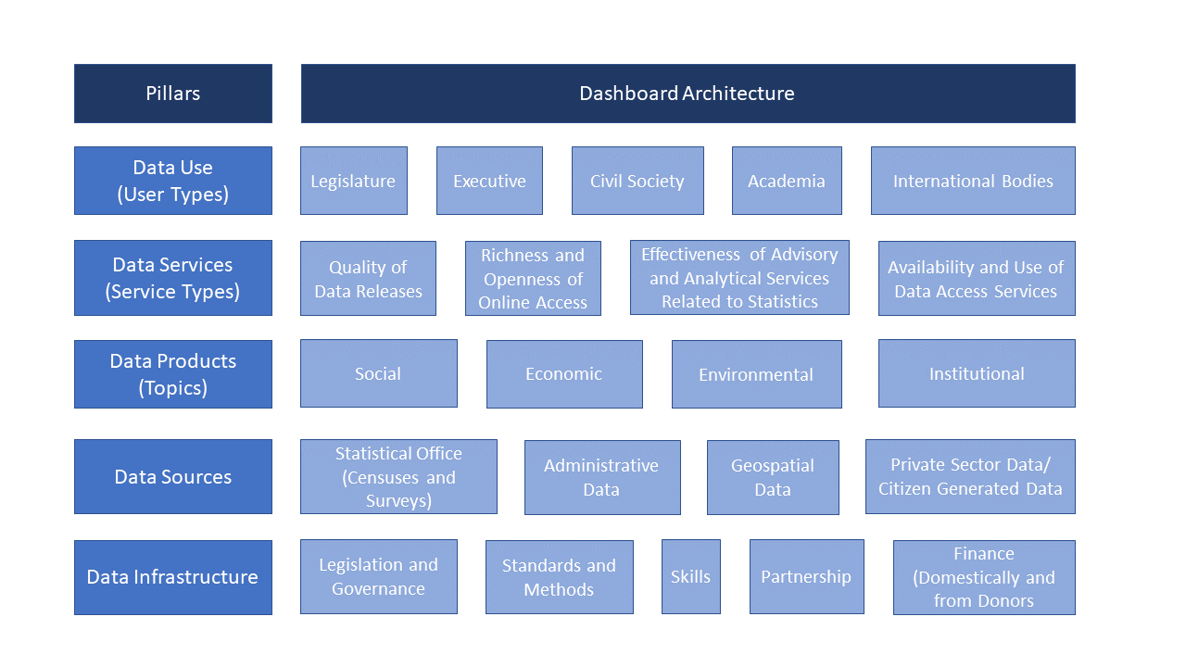

## Figure M.2. Correlation between the SPI Pillars

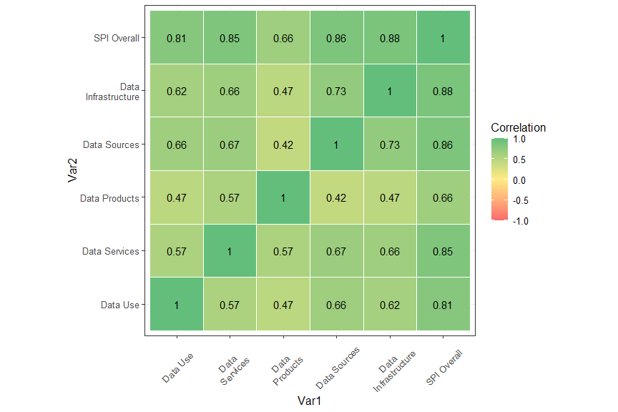

## Figure M.3. Contribution of Each Pillar to SPI Score, by Country Income Level

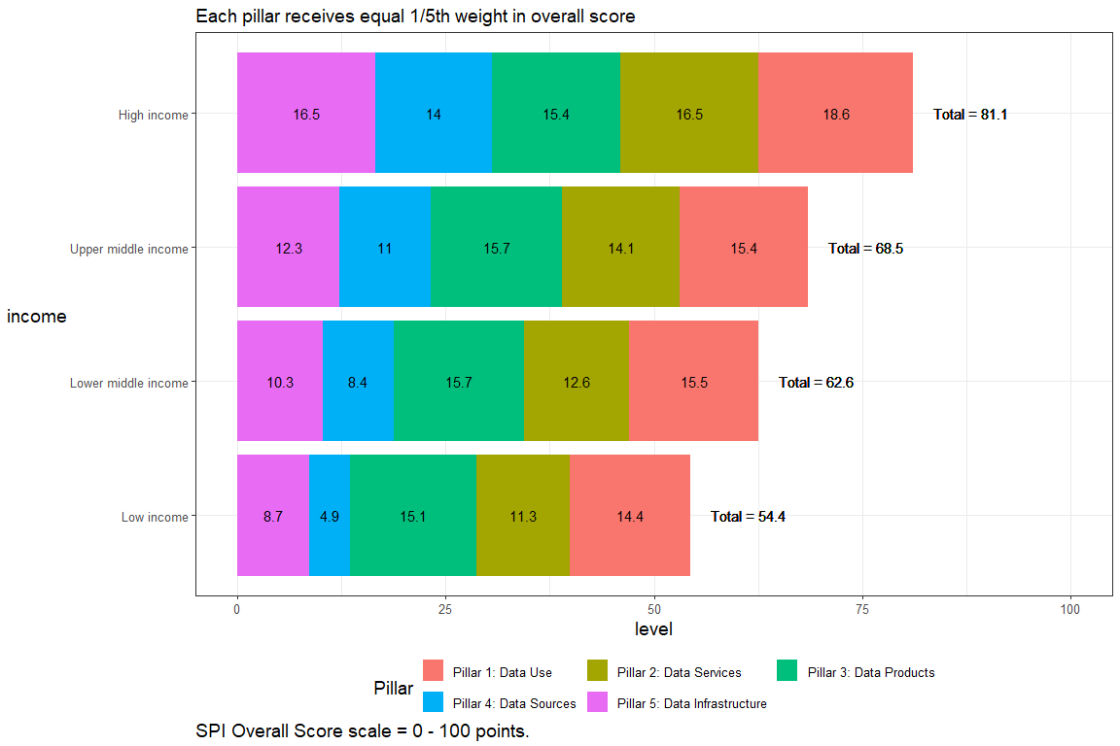

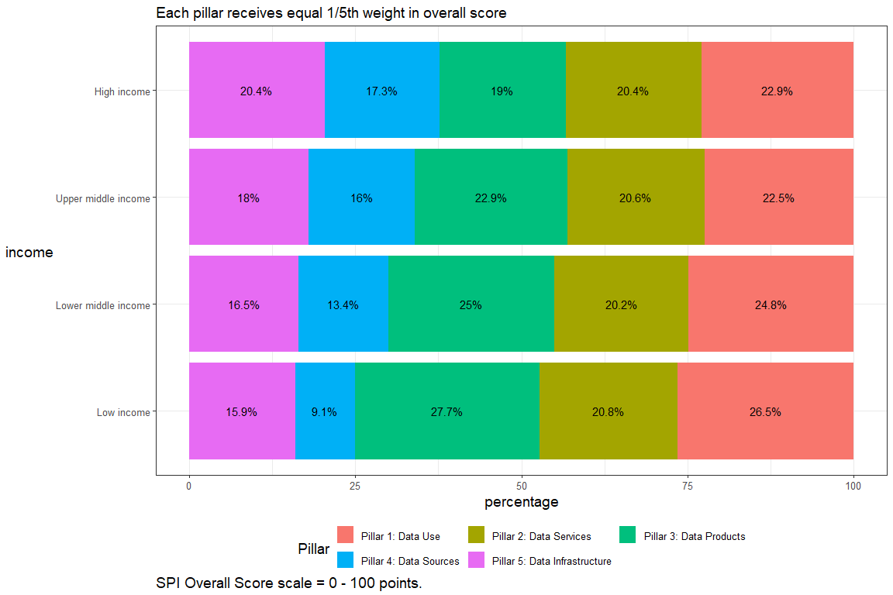

## Table 1. Comparing the SPI and Other Data and Statistics Indexes

Table produced using Microsoft Word. Numbers come from research on each index.

## Figure 1. Number of Household Surveys vs. Country Income, 1982- 2022

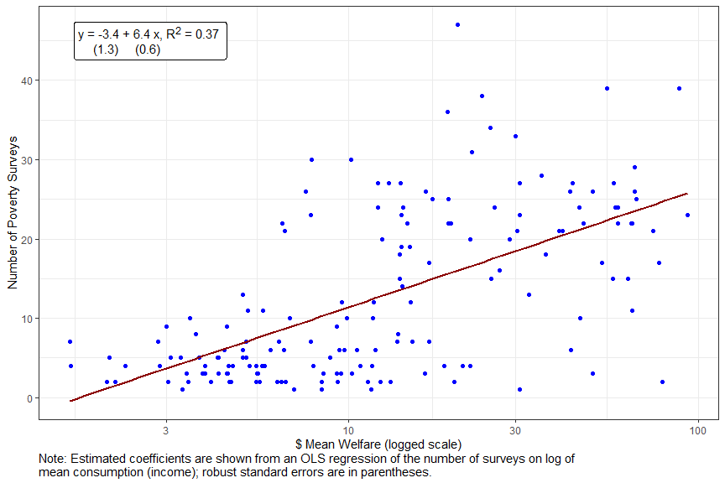

**Note**: This figure employs data from the World Bank’s PIP database.

## Figure 2. Mapping Other Data Tools to SPI Framework

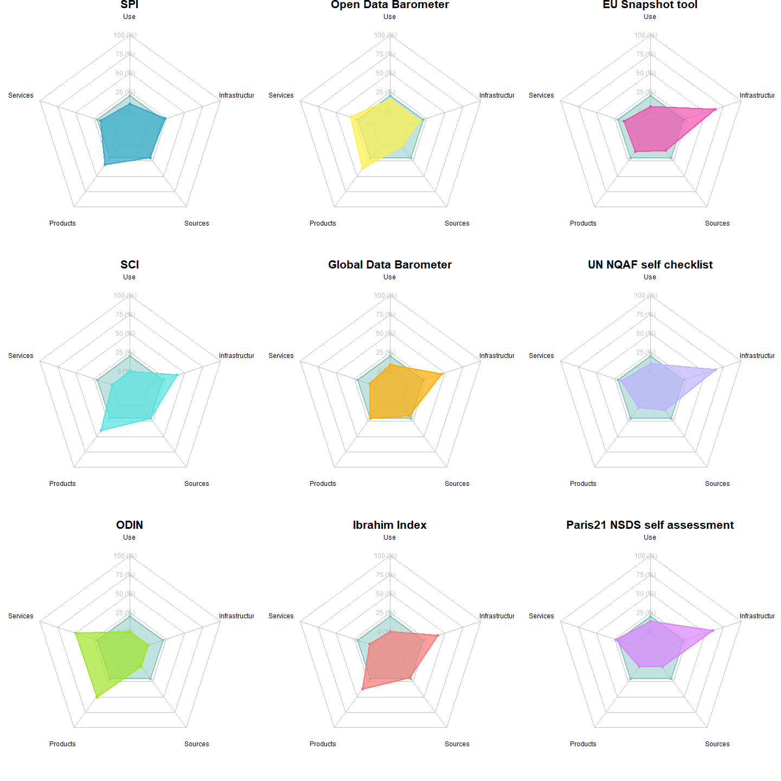

[[1]]  
NULL  
  
[[2]]  
NULL  
  
[[3]]  
NULL  
  
[[4]]  
NULL  
  
[[5]]  
NULL  
  
[[6]]  
NULL  
  
[[7]]  
NULL  
  
[[8]]  
NULL  
  
[[9]]  
NULL

## Measuring Country Progress over time

This analysis explores countries that experienced large deviations from their country specific time trends in the year 2022 for both the SPI and ODIN indices.

For each country, a country specific time trend was calculated using data for that country from 2016 to 2020. This time trend was calculated using OLS regression of the index (SPI or ODIN as the case may be) on the year. Each regression is calculated separately by country. A predicted value based on these regressions is then calculated for the year 2022.

A set of 15 countries that are the largest over-performers and 15 of the largest underperformers are shown below for each index.

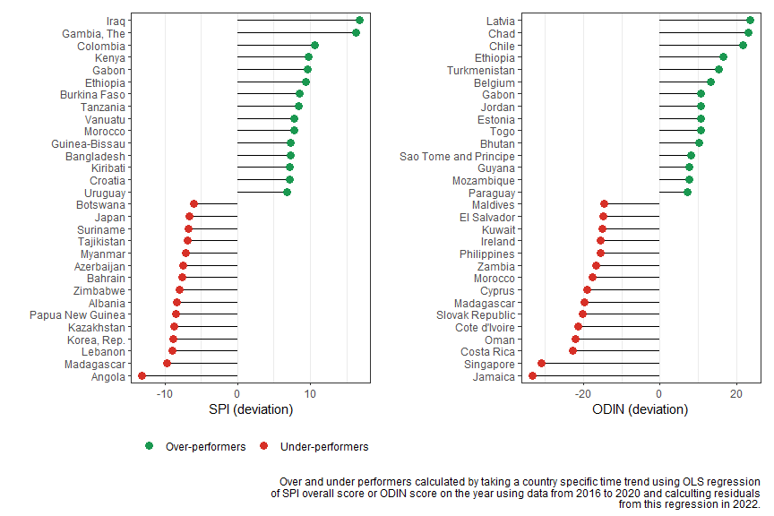

| SPI and ODIN Over/Under-performers in 2022 compared to country time trend from 2016 to 2020. | | | |
| --- | --- | --- | --- |
| SPI Country | SPI Difference | ODIN Country | ODIN Difference |
| Iraq | 16.8 | Latvia | 23.6 |
| Gambia, The | 16.3 | Chad | 23.1 |
| Colombia | 10.6 | Chile | 21.8 |
| Kenya | 9.8 | Ethiopia | 16.6 |
| Gabon | 9.6 | Turkmenistan | 15.5 |
| Ethiopia | 9.3 | Belgium | 13.2 |
| Burkina Faso | 8.5 | Gabon | 10.8 |
| Tanzania | 8.4 | Jordan | 10.8 |
| Vanuatu | 7.7 | Estonia | 10.7 |
| Morocco | 7.7 | Togo | 10.7 |
| Guinea-Bissau | 7.3 | Bhutan | 10.3 |
| Bangladesh | 7.2 | Sao Tome and Principe | 8.1 |
| Kiribati | 7.2 | Guyana | 7.8 |
| Croatia | 7.2 | Mozambique | 7.7 |
| Uruguay | 6.8 | Paraguay | 7.2 |
| Botswana | -6.1 | Maldives | -14.5 |
| Japan | -6.7 | El Salvador | -14.8 |
| Suriname | -6.8 | Kuwait | -15.1 |
| Tajikistan | -6.9 | Philippines | -15.5 |
| Myanmar | -7.1 | Ireland | -15.5 |
| Azerbaijan | -7.5 | Zambia | -16.8 |
| Bahrain | -7.7 | Morocco | -17.6 |
| Zimbabwe | -8.0 | Cyprus | -19.0 |
| Albania | -8.4 | Madagascar | -19.8 |
| Papua New Guinea | -8.5 | Slovak Republic | -20.2 |
| Kazakhstan | -8.7 | Cote d'Ivoire | -21.4 |
| Korea, Rep. | -8.9 | Oman | -22.1 |
| Lebanon | -9.0 | Costa Rica | -22.7 |
| Madagascar | -9.7 | Singapore | -31.0 |
| Angola | -13.1 | Jamaica | -33.3 |

[1] 3.949142

[1] 6.927273

[1] 0.1731068

## Figure 3. Trends in Overall ODIN and SPI Scores, 2016-2022

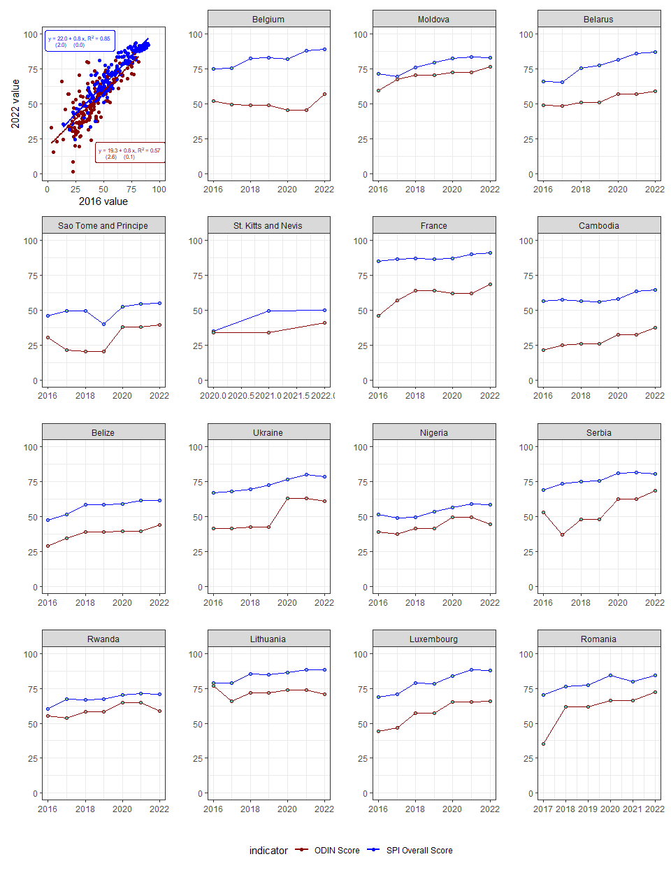

[1] -5.012917

## Figure 4. Absolute Value of Correlation between Key SDGs and Indexes

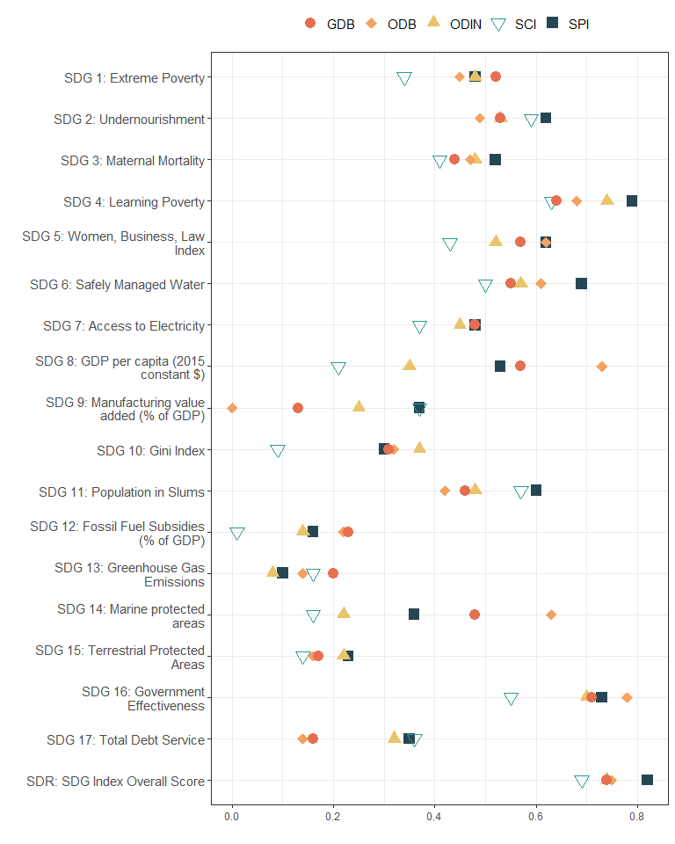

Figure 5. Theory of Change

Figure created using Microsoft Powerpoint. Image shown below for completeness.

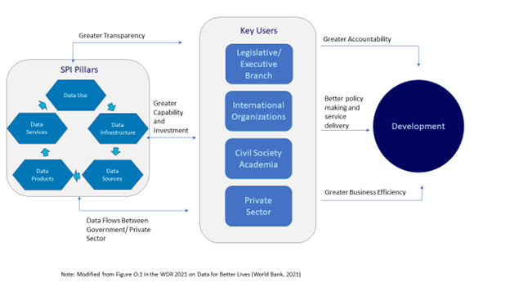

Note: the indexes with a correlation with the shown SDG outcome that is statistically not different from each other are shown in adjacent row.

## Figure 5. Theory of Change

Figure produced using Microsoft Powerpoint.



## Table A.1. An Overview of the World Bank’s Statistical Capacity Index (SCI) in Selected Recent Studies

Table produced using Microsoft Word. Articles gathered through a literature review.

## Table A.2. Description of SPI Dimensions

Table produced using Microsoft Word, based on SPI metadata.

## Table A.3. Mapping of SPI Indicators to SDG Indicators

Table produced using Microsoft Word, based on SPI metadata and UN SDG Indicator metadata.

## Table A.4. SPI overall score and Pillar Scores in 2022

Below, the full list of countries by their SPI overall score in 2022 is presented. The first column is the country name and the following columns are the overall SPI overall score, and then the sub-scores for pillars 1, 2, 3, 4, and 5. The purpose of the SPI is to help countries assess and improve the performance of their statistical systems. The presentation of SPI overall scores is designed to reflect that aim. Small differences between countries should not be stressed since they can reflect imprecision arising from the currently available indicators rather than meaningful differences in performance. Instead, the presentation of overall SPI scores focuses on larger groupings of countries reflecting broad categories of performance as measured by the indicator framework. In total there are 186 countries with sufficient data to compute an index value. This set of countries covers 99.3 percent of the world population. Countries shaded in dark orange are the lowest performing, countries in dark green are the highest performing. Countries are grouped into five groups:

* **Top Quintile**: Countries in the Top quintile are classified in this group. Shading in dark green.
* **4th Quintile**: Countries in the 4th quintile, or those above the 60th percentile but below the 80th percentile are in this group. Shading in light green.
* **3rd Quintile**: Countries in the 3rd quintile, or those between the 40th and 60th percentile, are classified in this group. Shading in yellow.
* **2nd Quintile**: Countries in the 2nd quintile, or those above the 20th percentile but below the 40th percentile, are in this group. Shading in light orange.
* **Bottom 20%**: Countries in the bottom 20% are classified in this group. Shading in dark orange .

| Country | SPI overall score | Pillar 1: Data Use | Pillar 2: Data Services | Pillar 3: Data Products | Pillar 4: Data Sources | Pillar 5: Data Infrastructure |
| --- | --- | --- | --- | --- | --- | --- |
| Finland | 93.6 | 100.0 | 96.4 | 88.5 | 83.3 | 100 |
| Norway | 93.5 | 100.0 | 97.1 | 87.2 | 83.1 | 100 |
| Canada | 92.9 | 100.0 | 92.6 | 83.7 | 88.3 | 100 |
| Netherlands | 92.8 | 100.0 | 96.9 | 87.8 | 79.5 | 100 |
| United States | 92.8 | 100.0 | 93.6 | 86.0 | 84.4 | 100 |
| Slovenia | 92.5 | 100.0 | 97.5 | 87.1 | 78.1 | 100 |
| Sweden | 92.2 | 100.0 | 96.0 | 86.4 | 78.7 | 100 |
| Italy | 91.9 | 100.0 | 93.0 | 88.7 | 77.8 | 100 |
| Denmark | 91.6 | 90.0 | 98.7 | 86.5 | 82.9 | 100 |
| Poland | 91.6 | 90.0 | 97.1 | 86.8 | 84.0 | 100 |
| Spain | 91.4 | 100.0 | 91.1 | 82.9 | 83.1 | 100 |
| Ireland | 91.3 | 100.0 | 96.4 | 87.2 | 72.9 | 100 |
| Germany | 91.0 | 100.0 | 94.9 | 85.0 | 80.1 | 95 |
| Czechia | 90.9 | 100.0 | 88.8 | 84.4 | 81.2 | 100 |
| France | 90.8 | 100.0 | 92.1 | 86.2 | 75.6 | 100 |
| Georgia | 90.7 | 100.0 | 92.0 | 91.5 | 79.9 | 90 |
| Austria | 90.0 | 100.0 | 89.5 | 88.6 | 76.8 | 95 |
| Australia | 89.9 | 90.0 | 92.9 | 83.0 | 83.9 | 100 |
| Costa Rica | 89.9 | 100.0 | 86.3 | 93.1 | 80.2 | 90 |
| Japan | 89.9 | 100.0 | 90.3 | 84.9 | 79.2 | 95 |
| Estonia | 89.6 | 90.0 | 96.9 | 83.9 | 77.0 | 100 |
| Portugal | 89.3 | 90.0 | 93.1 | 87.4 | 76.1 | 100 |
| Slovak Republic | 89.1 | 90.0 | 94.5 | 85.3 | 76.0 | 100 |
| Belgium | 88.9 | 100.0 | 86.9 | 81.3 | 76.4 | 100 |
| Latvia | 88.8 | 100.0 | 97.1 | 76.1 | 70.9 | 100 |
| Switzerland | 88.8 | 100.0 | 88.4 | 85.6 | 80.0 | 90 |
| Greece | 88.7 | 100.0 | 88.1 | 78.6 | 77.0 | 100 |
| New Zealand | 88.7 | 100.0 | 92.4 | 82.9 | 78.4 | 90 |
| Mexico | 88.6 | 100.0 | 93.4 | 93.0 | 81.5 | 75 |
| Lithuania | 88.1 | 90.0 | 91.1 | 82.3 | 77.2 | 100 |
| Hungary | 87.9 | 100.0 | 89.0 | 88.2 | 72.3 | 90 |
| Korea, Rep. | 87.8 | 100.0 | 92.1 | 83.0 | 79.2 | 85 |
| Luxembourg | 87.8 | 100.0 | 93.4 | 81.7 | 64.1 | 100 |
| Turkiye | 87.7 | 100.0 | 86.8 | 94.2 | 57.6 | 100 |
| Chile | 87.4 | 100.0 | 85.6 | 87.2 | 69.4 | 95 |
| United Kingdom | 87.1 | 100.0 | 88.0 | 85.2 | 72.6 | 90 |
| Iceland | 86.9 | 100.0 | 86.3 | 76.3 | 71.8 | 100 |
| Belarus | 86.7 | 100.0 | 85.4 | 87.5 | 65.4 | 95 |
| Singapore | 86.6 | 100.0 | 99.7 | 64.1 | 88.9 | 80 |
| Colombia | 85.9 | 100.0 | 82.9 | 92.3 | 74.2 | 80 |
| Cyprus | 85.1 | 100.0 | 88.8 | 70.5 | 71.0 | 95 |
| Romania | 84.3 | 90.0 | 94.2 | 76.5 | 75.9 | 85 |
| Russian Federation | 84.1 | 93.4 | 87.6 | 76.5 | 72.8 | 90 |
| Mongolia | 84.0 | 100.0 | 97.2 | 89.7 | 73.4 | 60 |
| Bulgaria | 83.9 | 90.0 | 91.3 | 75.7 | 72.4 | 90 |
| North Macedonia | 83.5 | 100.0 | 87.5 | 74.6 | 75.3 | 80 |
| Albania | 83.4 | 90.0 | 69.8 | 87.2 | 70.1 | 100 |
| Philippines | 83.4 | 100.0 | 90.6 | 89.8 | 81.4 | 55 |
| West Bank and Gaza | 83.4 | 100.0 | 92.1 | 73.1 | 66.7 | 85 |
| Israel | 83.3 | 100.0 | 91.1 | 70.9 | 59.3 | 95 |
| Croatia | 83.1 | 90.0 | 87.5 | 72.3 | 71.0 | 95 |
| Armenia | 82.8 | 90.0 | 85.4 | 86.6 | 61.9 | 90 |
| Moldova | 82.8 | 90.0 | 95.4 | 75.5 | 68.0 | 85 |
| Thailand | 82.5 | 100.0 | 81.3 | 91.5 | 54.8 | 85 |
| South Africa | 82.4 | 80.0 | 86.0 | 87.6 | 73.4 | 85 |
| Kyrgyz Republic | 81.5 | 100.0 | 81.0 | 91.8 | 54.4 | 80 |
| Serbia | 80.8 | 100.0 | 74.5 | 86.1 | 73.6 | 70 |
| Saudi Arabia | 80.8 | 100.0 | 88.2 | 71.6 | 79.1 | 65 |
| Brazil | 80.5 | 90.0 | 87.2 | 80.2 | 75.3 | 70 |
| Malta | 80.3 | 100.0 | 86.1 | 65.6 | 74.6 | 75 |
| Egypt, Arab Rep. | 79.6 | 100.0 | 77.1 | 83.9 | 67.0 | 70 |
| Ecuador | 79.2 | 100.0 | 89.1 | 89.8 | 56.9 | 60 |
| Sri Lanka | 79.1 | 100.0 | 81.8 | 78.0 | 80.4 | 55 |
| Indonesia | 79.0 | 100.0 | 91.1 | 90.2 | 53.5 | 60 |
| Ukraine | 78.9 | 100.0 | 53.8 | 87.1 | 58.5 | 95 |
| India | 78.2 | 100.0 | 87.7 | 86.3 | 62.0 | 55 |
| Kazakhstan | 78.2 | 90.0 | 89.3 | 89.4 | 62.3 | 60 |
| Jordan | 78.2 | 80.0 | 90.4 | 87.6 | 62.9 | 70 |
| Montenegro | 78.1 | 100.0 | 69.9 | 83.2 | 57.2 | 80 |
| Uruguay | 77.7 | 100.0 | 87.9 | 89.1 | 56.7 | 55 |
| United Arab Emirates | 77.5 | 100.0 | 79.6 | 71.2 | 67.0 | 70 |
| Mauritius | 77.3 | 90.0 | 85.5 | 80.9 | 60.1 | 70 |
| Malaysia | 76.6 | 80.0 | 87.6 | 85.1 | 75.4 | 55 |
| Paraguay | 75.8 | 90.0 | 69.4 | 87.7 | 57.1 | 75 |
| Tunisia | 75.1 | 90.0 | 89.5 | 82.8 | 58.4 | 55 |
| El Salvador | 73.8 | 90.0 | 78.8 | 78.3 | 51.7 | 70 |
| Azerbaijan | 73.5 | 80.0 | 68.8 | 82.5 | 66.1 | 70 |
| Peru | 73.3 | 90.0 | 87.3 | 90.9 | 53.1 | 45 |
| Vietnam | 73.2 | 100.0 | 69.3 | 77.2 | 79.2 | 40 |
| Dominican Republic | 72.4 | 100.0 | 68.0 | 77.1 | 42.0 | 75 |
| Morocco | 72.3 | 80.0 | 89.6 | 85.9 | 60.8 | 45 |
| Senegal | 72.2 | 80.0 | 82.0 | 78.5 | 45.6 | 75 |
| Guatemala | 72.0 | 80.0 | 62.0 | 85.9 | 62.1 | 70 |
| Myanmar | 72.0 | 100.0 | 67.4 | 85.3 | 42.1 | 65 |
| Argentina | 71.8 | 70.0 | 78.9 | 90.2 | 59.8 | 60 |
| Bolivia | 71.2 | 100.0 | 66.9 | 82.0 | 62.0 | 45 |
| Pakistan | 71.1 | 100.0 | 61.9 | 86.8 | 46.9 | 60 |
| Uganda | 70.7 | 100.0 | 65.4 | 81.6 | 36.8 | 70 |
| Qatar | 70.6 | 100.0 | 62.1 | 67.4 | 58.8 | 65 |
| Bosnia and Herzegovina | 70.6 | 70.0 | 63.8 | 77.5 | 61.8 | 80 |
| Rwanda | 70.6 | 90.0 | 70.6 | 79.5 | 52.8 | 60 |
| Uzbekistan | 70.6 | 80.0 | 74.7 | 78.7 | 44.4 | 75 |
| Panama | 70.5 | 80.0 | 66.0 | 87.4 | 64.1 | 55 |
| Zimbabwe | 70.2 | 100.0 | 67.0 | 88.0 | 36.1 | 60 |
| Bangladesh | 69.7 | 90.0 | 61.9 | 85.8 | 51.0 | 60 |
| Kuwait | 69.2 | 100.0 | 63.2 | 66.2 | 61.5 | 55 |
| Tanzania | 67.3 | 90.0 | 70.7 | 76.6 | 44.4 | 55 |
| Togo | 66.7 | 90.0 | 63.7 | 87.0 | 32.7 | 60 |
| Oman | 66.1 | 100.0 | 46.6 | 61.2 | 67.8 | 55 |
| St. Lucia | 66.0 | 70.0 | 69.6 | 68.6 | 66.8 | 55 |
| Seychelles | 66.0 | 90.0 | 44.2 | 68.4 | 57.3 | 70 |
| Cabo Verde | 65.7 | 80.0 | 64.4 | 76.1 | 63.0 | 45 |
| Niger | 65.3 | 90.0 | 60.8 | 84.8 | 30.8 | 60 |
| Liberia | 64.9 | 90.0 | 65.7 | 82.3 | 26.5 | 60 |
| Burkina Faso | 64.8 | 80.0 | 68.9 | 81.5 | 33.8 | 60 |
| Malawi | 64.8 | 90.0 | 62.0 | 80.6 | 46.5 | 45 |
| Barbados | 64.6 | 100.0 | 57.6 | 62.2 | 48.3 | 55 |
| Gambia, The | 64.4 | 80.0 | 65.5 | 89.4 | 32.3 | 55 |
| Brunei Darussalam | 64.4 | 90.0 | 71.0 | 57.7 | 53.2 | 50 |
| Cambodia | 64.3 | 80.0 | 63.6 | 81.0 | 42.0 | 55 |
| Ghana | 64.2 | 66.6 | 61.8 | 88.8 | 44.0 | 60 |
| Fiji | 63.2 | 80.0 | 63.1 | 75.4 | 37.3 | 60 |
| Algeria | 63.2 | 80.0 | 57.8 | 82.0 | 46.0 | 50 |
| Benin | 62.6 | 80.0 | 69.7 | 83.6 | 29.5 | 50 |
| Samoa | 62.4 | 70.0 | 63.0 | 78.8 | 40.5 | 60 |
| Kenya | 62.3 | 70.0 | 60.1 | 76.6 | 34.9 | 70 |
| Cote d'Ivoire | 62.2 | 80.0 | 57.7 | 79.1 | 29.4 | 65 |
| Nepal | 62.0 | 80.0 | 62.8 | 85.5 | 36.6 | 45 |
| Belize | 61.9 | 70.0 | 64.6 | 67.2 | 62.5 | 45 |
| Maldives | 61.8 | 70.0 | 63.9 | 82.5 | 57.7 | 35 |
| Jamaica | 61.6 | 60.0 | 72.6 | 77.8 | 57.9 | 40 |
| Suriname | 61.5 | 50.0 | 69.2 | 69.6 | 58.9 | 60 |
| Botswana | 61.2 | 50.0 | 68.8 | 77.8 | 64.4 | 45 |
| Ethiopia | 61.1 | 90.0 | 64.5 | 81.5 | 29.5 | 40 |
| Honduras | 61.0 | 90.0 | 62.1 | 84.1 | 38.5 | 30 |
| Lao PDR | 60.4 | 76.6 | 65.5 | 79.2 | 40.7 | 40 |
| Zambia | 60.1 | 80.0 | 60.4 | 86.7 | 28.5 | 45 |
| Tonga | 59.9 | 70.0 | 63.2 | 75.9 | 45.4 | 45 |
| Timor-Leste | 59.9 | 80.0 | 61.0 | 64.5 | 28.8 | 65 |
| China | 59.6 | 83.4 | 43.8 | 77.5 | 43.3 | 50 |
| Bhutan | 59.6 | 80.0 | 63.9 | 75.2 | 38.8 | 40 |
| Bahrain | 59.4 | 80.0 | 72.8 | 52.3 | 61.7 | 30 |
| Sierra Leone | 59.2 | 80.0 | 65.3 | 79.0 | 31.7 | 40 |
| Mali | 59.1 | 80.0 | 60.7 | 82.6 | 27.4 | 45 |
| Mauritania | 58.9 | 80.0 | 63.2 | 66.6 | 24.5 | 60 |
| Iran, Islamic Rep. | 58.7 | 80.0 | 29.3 | 70.7 | 68.6 | 45 |
| Nigeria | 58.6 | 80.0 | 63.8 | 77.8 | 31.5 | 40 |
| Lebanon | 58.5 | 60.0 | 61.6 | 79.6 | 51.3 | 40 |
| Afghanistan | 58.0 | 80.0 | 59.4 | 78.6 | 17.0 | 55 |
| Guinea | 57.9 | 80.0 | 62.8 | 76.6 | 20.2 | 50 |
| Lesotho | 57.5 | 80.0 | 29.4 | 76.3 | 41.7 | 60 |
| Mozambique | 56.7 | 60.0 | 59.7 | 76.5 | 32.2 | 55 |
| Guyana | 56.5 | 70.0 | 62.7 | 71.5 | 33.0 | 45 |
| Iraq | 56.3 | 60.0 | 64.5 | 78.3 | 33.8 | 45 |
| Namibia | 55.8 | 60.0 | 62.7 | 77.6 | 23.6 | 55 |
| Trinidad and Tobago | 55.4 | 60.0 | 61.2 | 64.2 | 36.9 | 55 |
| St. Vincent and the Grenadines | 55.3 | 60.0 | 67.4 | 60.9 | 48.1 | 40 |
| Sao Tome and Principe | 54.8 | 60.0 | 60.9 | 69.2 | 49.0 | 35 |
| Cameroon | 54.5 | 60.0 | 64.2 | 82.1 | 21.2 | 45 |
| Bahamas, The | 54.1 | 80.0 | 27.7 | 49.5 | 38.5 | 75 |
| Madagascar | 53.7 | 60.0 | 60.6 | 78.2 | 25.0 | 45 |
| Angola | 53.5 | 60.0 | 60.8 | 71.3 | 35.2 | 40 |
| Tajikistan | 53.4 | 80.0 | 29.2 | 81.7 | 46.2 | 30 |
| Nicaragua | 52.7 | 60.0 | 61.1 | 64.2 | 23.3 | 55 |
| Venezuela, RB | 52.3 | 80.0 | 59.9 | 62.2 | 34.1 | 25 |
| Eswatini | 51.7 | 80.0 | 22.3 | 71.7 | 24.3 | 60 |
| Vanuatu | 51.2 | 56.6 | 59.1 | 72.2 | 33.2 | 35 |
| Congo, Dem. Rep. | 51.1 | 70.0 | 62.4 | 67.5 | 15.5 | 40 |
| Burundi | 50.7 | 60.0 | 62.9 | 79.7 | 15.8 | 35 |
| St. Kitts and Nevis | 50.0 | 60.0 | 66.7 | 44.8 | 43.6 | 35 |
| Chad | 49.2 | 63.4 | 59.2 | 75.8 | 17.8 | 30 |
| Somalia | 48.4 | 80.0 | 47.9 | 69.7 | 4.4 | 40 |
| Palau | 48.3 | 40.0 | 59.6 | 56.4 | 45.7 | 40 |
| Solomon Islands | 48.2 | 50.0 | 59.3 | 65.8 | 15.9 | 50 |
| Antigua and Barbuda | 48.2 | 60.0 | 26.9 | 64.6 | 49.3 | 40 |
| Djibouti | 46.6 | 50.0 | 59.5 | 63.8 | 14.5 | 45 |
| Papua New Guinea | 46.0 | 60.0 | 59.2 | 70.6 | 10.1 | 30 |
| Dominica | 44.2 | 60.0 | 28.3 | 59.3 | 43.4 | 30 |
| Kiribati | 43.8 | 40.0 | 59.5 | 75.4 | 18.9 | 25 |
| Sudan | 43.6 | 53.4 | 57.9 | 67.8 | 18.8 | 20 |
| Gabon | 42.8 | 60.0 | 29.8 | 66.1 | 13.2 | 45 |
| Central African Republic | 42.6 | 50.0 | 58.6 | 68.8 | 10.7 | 25 |
| Grenada | 41.1 | 40.0 | 22.1 | 68.7 | 45.0 | 30 |
| Guinea-Bissau | 40.0 | 70.0 | 23.7 | 71.7 | 14.6 | 20 |
| Haiti | 39.6 | 50.0 | 18.0 | 71.6 | 13.3 | 45 |
| Equatorial Guinea | 39.0 | 30.0 | 59.6 | 58.7 | 21.8 | 25 |
| Tuvalu | 38.1 | 40.0 | 59.4 | 60.8 | 15.5 | 15 |
| Congo, Rep. | 37.5 | 50.0 | 29.4 | 62.6 | 20.2 | 25 |
| Marshall Islands | 35.5 | 10.0 | 58.3 | 64.0 | 25.3 | 20 |
| Micronesia, Fed. Sts. | 35.3 | 20.0 | 59.1 | 58.6 | 13.7 | 25 |
| South Sudan | 33.8 | 40.0 | 37.8 | 53.9 | 7.5 | 30 |
| Yemen, Rep. | 33.2 | 46.6 | 28.0 | 55.6 | 16.0 | 20 |
| Nauru | 32.6 | 30.0 | 37.6 | 55.4 | 35.0 | 5 |
| Syrian Arab Republic | 31.9 | 36.6 | 23.1 | 55.0 | 15.0 | 30 |
| Turkmenistan | 31.4 | 60.0 | 0.5 | 69.6 | 11.7 | 15 |
| Libya | 24.4 | 20.0 | 25.6 | 53.6 | 7.6 | 15 |
| American Samoa |  | 40.0 |  | 22.6 |  |  |
| Andorra |  | 80.0 |  | 38.6 |  | 15 |
| Aruba |  | 60.0 |  | 28.5 |  |  |
| Bermuda |  | 60.0 |  | 27.1 |  |  |
| British Virgin Islands |  | 60.0 |  | 27.2 |  |  |
| Cayman Islands |  | 50.0 |  | 28.6 |  |  |
| Channel Islands |  | 60.0 |  |  |  |  |
| Comoros |  | 50.0 |  | 68.2 |  | 40 |
| Cuba |  | 60.0 |  | 69.7 |  |  |
| Curacao |  | 80.0 |  | 28.5 |  |  |
| Eritrea |  | 36.6 |  | 51.7 |  | 10 |
| Faroe Islands |  | 60.0 |  | 14.7 |  |  |
| French Polynesia |  | 60.0 |  | 24.0 |  |  |
| Gibraltar |  | 60.0 |  | 18.1 |  |  |
| Greenland |  | 50.0 |  | 21.0 |  |  |
| Guam |  | 60.0 |  | 22.1 |  |  |
| Hong Kong SAR, China |  | 80.0 |  | 43.8 |  |  |
| Isle of Man |  | 70.0 |  | 12.3 |  |  |
| Korea, Dem. People's Rep. |  | 30.0 |  | 51.6 |  |  |
| Kosovo |  | 40.0 | 66.5 |  | 50.3 | 80 |
| Liechtenstein |  | 70.0 |  | 38.3 |  |  |
| Macao SAR, China |  | 80.0 |  | 37.7 |  |  |
| Monaco |  | 90.0 |  | 41.6 |  |  |
| New Caledonia |  | 80.0 |  | 31.6 |  |  |
| Northern Mariana Islands |  | 60.0 |  | 16.0 |  |  |
| Puerto Rico |  | 60.0 |  | 35.4 |  |  |
| San Marino |  | 90.0 | 60.7 | 38.1 |  | 55 |
| Sint Maarten (Dutch part) |  | 50.0 |  | 19.7 |  |  |
| St. Martin (French part) |  | 40.0 |  | 13.6 |  |  |
| Taiwan, China |  | 40.0 |  |  |  |  |
| Turks and Caicos Islands |  | 60.0 |  | 31.5 |  |  |
| Virgin Islands (U.S.) |  | 60.0 |  | 19.0 |  |  |

## Table A.5. Comparison of SPI to Other Statistical and Development Indices

Table produced using Microsoft Word and a review of other indices.

## Table A.6. Bivariate Correlation between Statistical Indexes and Key Development Outcomes

| Table. Correlation between Development Outcomes | | | | | |
| --- | --- | --- | --- | --- | --- |
| var | GDB | ODB | ODIN | SCI | SPI |
| SDG 1: Extreme Poverty | -0.52*** | -0.45*** | -0.48*** | -0.34*** | -0.48*** |
| SDG 2: Undernourishment | -0.53*** | -0.49*** | -0.53*** | -0.59*** | -0.62*** |
| SDG 3: Maternal Mortality | -0.44*** | -0.47*** | -0.48*** | -0.41*** | -0.52*** |
| SDG 4: Learning Poverty | -0.64*** | -0.68*** | -0.74*** | -0.63*** | -0.79*** |
| SDG 5: Women, Business, Law Index | 0.57*** | 0.62*** | 0.52*** | 0.43*** | 0.62*** |
| SDG 6: Safely Managed Water | 0.55*** | 0.61*** | 0.57*** | 0.5*** | 0.69*** |
| SDG 7: Access to Electricity | 0.48*** | 0.48*** | 0.45*** | 0.37*** | 0.48*** |
| SDG 8: GDP per capita (2015 constant $) | 0.57*** | 0.73*** | 0.35*** | 0.21** | 0.53*** |
| SDG 9: Manufacturing value added (% of GDP) | 0.13** | 0 | 0.25*** | 0.37*** | 0.37*** |
| SDG 10: Gini Index | -0.31*** | -0.32*** | -0.37*** | -0.09** | -0.3*** |
| SDG 11: Population in Slums | -0.46*** | -0.42*** | -0.48*** | -0.57*** | -0.6*** |
| SDG 12: Fossil Fuel Subsidies (% of GDP) | -0.23** | -0.22** | -0.14** | -0.01 | -0.16** |
| SDG 13: Greenhouse Gas Emissions | 0.2** | 0.14** | 0.08** | 0.16* | 0.1** |
| SDG 14: Marine protected areas | 0.48*** | 0.63*** | 0.22*** | 0.16* | 0.36*** |
| SDG 15: Terrestrial Protected Areas | 0.17* | 0.16* | 0.22*** | 0.14* | 0.23*** |
| SDG 16: Government Effectiveness | 0.71*** | 0.78*** | 0.7*** | 0.55*** | 0.73*** |
| SDG 17: Total Debt Service | 0.16** | 0.14** | 0.32*** | 0.36*** | 0.35*** |
| SDR: SDG Index Overall Score | 0.74*** | 0.75*** | 0.74*** | 0.69*** | 0.82*** |
| Note: * p<0.1,** p<0.05,*** p<0.01 | | | | | |

## Table A.7. Testing for Bivaration Correlation between Statistical Indexes and Key Development Outcomes

| SDG | GDB | | | | ODB | | | | ODIN | | | | SCI | | | | SPI | | | |
| --- | --- | --- | --- | --- | --- | --- | --- | --- | --- | --- | --- | --- | --- | --- | --- | --- | --- | --- | --- | --- |
| SDG 1: Extreme Poverty | ODB | ODIN | SCI | SPI | GDB | ODIN | SCI | SPI | GDB | ODB | SCI | SPI | GDB | ODB | ODIN | SPI | GDB | ODB | ODIN | SCI |
| SDG 2: Undernourishment | ODB | ODIN | SCI | SPI | GDB | ODIN | SCI | SPI | GDB | ODB | SCI | SPI | GDB | ODB | ODIN | SPI | GDB | ODB | ODIN | SCI |
| SDG 3: Maternal Mortality | ODB | ODIN | SCI | SPI | GDB | ODIN | SCI | SPI | GDB | ODB | SCI | SPI | GDB | ODB | ODIN | SPI | GDB | ODB | ODIN | SCI |
| SDG 4: Learning Poverty | ODB | ODIN | SCI |  | GDB | ODIN | SCI | SPI | GDB | ODB | SCI | SPI | GDB | ODB | ODIN |  |  | ODB | ODIN |  |
| SDG 5: Women, Business, Law Index | ODB | ODIN | SCI | SPI | GDB | ODIN |  | SPI | GDB | ODB | SCI | SPI | GDB |  | ODIN |  | GDB | ODB | ODIN |  |
| SDG 6: Safely Managed Water | ODB | ODIN | SCI | SPI | GDB | ODIN | SCI | SPI | GDB | ODB | SCI | SPI | GDB | ODB | ODIN | SPI | GDB | ODB | ODIN | SCI |
| SDG 7: Access to Electricity | ODB | ODIN | SCI | SPI | GDB | ODIN | SCI | SPI | GDB | ODB | SCI | SPI | GDB | ODB | ODIN | SPI | GDB | ODB | ODIN | SCI |
| SDG 8: GDP per capita (2015 constant $) |  |  |  | SPI |  |  |  |  |  |  | SCI |  |  |  | ODIN |  | GDB |  |  |  |
| SDG 9: Manufacturing value added (% of GDP) | ODB | ODIN | SCI |  | GDB |  |  |  | GDB |  | SCI | SPI | GDB |  | ODIN | SPI |  |  | ODIN | SCI |
| SDG 10: Gini Index | ODB | ODIN | SCI | SPI | GDB | ODIN | SCI | SPI | GDB | ODB |  | SPI | GDB | ODB |  | SPI | GDB | ODB | ODIN | SCI |
| SDG 11: Population in Slums | ODB | ODIN | SCI | SPI | GDB | ODIN | SCI | SPI | GDB | ODB | SCI | SPI | GDB | ODB | ODIN | SPI | GDB | ODB | ODIN | SCI |
| SDG 12: Fossil Fuel Subsidies (% of GDP) | ODB | ODIN | SCI | SPI | GDB | ODIN | SCI | SPI | GDB | ODB | SCI | SPI | GDB | ODB | ODIN | SPI | GDB | ODB | ODIN | SCI |
| SDG 13: Greenhouse Gas Emissions | ODB | ODIN | SCI | SPI | GDB | ODIN | SCI | SPI | GDB | ODB | SCI | SPI | GDB | ODB | ODIN | SPI | GDB | ODB | ODIN | SCI |
| SDG 14: Marine protected areas | ODB |  |  | SPI | GDB |  |  |  |  |  | SCI | SPI |  |  | ODIN | SPI | GDB |  | ODIN | SCI |
| SDG 15: Terrestrial Protected Areas | ODB | ODIN | SCI | SPI | GDB | ODIN | SCI | SPI | GDB | ODB | SCI | SPI | GDB | ODB | ODIN | SPI | GDB | ODB | ODIN | SCI |
| SDG 16: Government Effectiveness | ODB | ODIN |  | SPI | GDB | ODIN |  | SPI | GDB | ODB |  | SPI |  |  |  |  | GDB | ODB | ODIN |  |
| SDG 17: Total Debt Service | ODB | ODIN | SCI | SPI | GDB | ODIN | SCI | SPI | GDB | ODB | SCI | SPI | GDB | ODB | ODIN | SPI | GDB | ODB | ODIN | SCI |
| SDR: SDG Index Overall Score | ODB | ODIN | SCI | SPI | GDB | ODIN | SCI | SPI | GDB | ODB | SCI | SPI | GDB | ODB | ODIN |  | GDB | ODB | ODIN |  |

## Table A.8 Relationship between Log GDP per capita and SPI scores, 2016-2022

|  | Model 1 | Model 2 | Model 3 | Model 4 | Model 5 | Model 6 |
| --- | --- | --- | --- | --- | --- | --- |
| Overall SPI Score | 0.053*** | 0.001 | 0.001 |  |  |  |
|  | (0.00) | (0.00) | (0.00) |  |  |  |
| SPI Pillar 1 Score (Data use) |  |  |  | -0.007* | 0.000 | 0.000 |
|  |  |  |  | (0.00) | (0.00) | (0.00) |
| SPI Pillar 2 Score (Data services) |  |  |  | 0.001 | 0.000 | 0.000 |
|  |  |  |  | (0.00) | (0.00) | (0.00) |
| SPI Pillar 3 Score (Data products) |  |  |  | -0.035*** | 0.000 | 0.000 |
|  |  |  |  | (0.00) | (0.00) | (0.00) |
| SPI Pillar 4 Score (Data sources) |  |  |  | 0.044*** | 0.002*** | 0.002*** |
|  |  |  |  | (0.00) | (0.00) | (0.00) |
| SPI Pillar 5 Score (Data infrastructure) |  |  |  | 0.020*** | 0.000 | 0.000 |
|  |  |  |  | (0.00) | (0.00) | (0.00) |
| Trade (% of GDP) |  |  | 0.001*** |  |  | 0.001*** |
|  |  |  | (0.00) |  |  | (0.00) |
| Agriculture, forestry, fishing value added (% of GDP) |  |  | -0.002 |  |  | -0.003 |
|  |  |  | (0.00) |  |  | (0.00) |
| Manufacturing value added (% of GDP) |  |  | -0.004 |  |  | -0.004 |
|  |  |  | (0.00) |  |  | (0.00) |
| School Enrollment, Primary (% gross) |  |  | 0.001 |  |  | 0.001 |
|  |  |  | (0.00) |  |  | (0.00) |
| WGI Index |  |  | 0.108*** |  |  | 0.111*** |
|  |  |  | (0.04) |  |  | (0.04) |
| Year 2017 |  | 0.017*** | 0.014*** |  | 0.023*** | 0.020*** |
|  |  | (0.00) | (0.00) |  | (0.00) | (0.00) |
| Year 2018 |  | 0.036*** | 0.030*** |  | 0.043*** | 0.038*** |
|  |  | (0.01) | (0.01) |  | (0.01) | (0.01) |
| Year 2019 |  | 0.054*** | 0.048*** |  | 0.062*** | 0.055*** |
|  |  | (0.01) | (0.01) |  | (0.01) | (0.01) |
| Year 2020 |  | -0.002 | 0.004 |  | 0.003 | 0.008 |
|  |  | (0.01) | (0.01) |  | (0.01) | (0.01) |
| Year 2021 |  | 0.034** | 0.033** |  | 0.038* | 0.034* |
|  |  | (0.02) | (0.02) |  | (0.02) | (0.02) |
| Year 2022 |  | 0.061*** | 0.050*** |  | 0.066*** | 0.052** |
|  |  | (0.02) | (0.02) |  | (0.02) | (0.02) |
| Constant | 5.158*** |  |  | 8.145*** |  |  |
|  | (0.35) |  |  | (0.33) |  |  |
| Num.Obs. | 1113 | 1113 | 1113 | 1113 | 1113 | 1113 |
| R2 | 0.396 | 0.999 | 0.999 | 0.670 | 0.999 | 0.999 |
| R2 Adj. | 0.396 | 0.998 | 0.999 | 0.669 | 0.998 | 0.999 |
| R2 Within |  | 0.194 | 0.256 |  | 0.210 | 0.271 |
| R2 Within Adj. |  | 0.188 | 0.247 |  | 0.200 | 0.259 |
| AIC | 3350.6 | -3142.0 | -3220.7 | 2686.1 | -3155.3 | -3235.6 |
| BIC | 3360.6 | -2299.5 | -2353.1 | 2716.2 | -2292.7 | -2348.0 |
| RMSE | 1.09 | 0.05 | 0.05 | 0.80 | 0.05 | 0.05 |
| Std.Errors | by: country | by: country | by: country | by: country | by: country | by: country |
| FE: country |  | X | X |  | X | X |
| Note: * p<0.10, ** p<0.05, *** p<0.01. Standard errors are clustered at the country level. Data are from the World Bank's World Development Indicators (WDI) and SPI. In cases where data are missing for a particular covariate, the data are imputed forward using the nearest available value. | | | | | | |

[1] "Model 2: sigma_e=0.06. sigma_u=1.06"

[1] "Model 3: sigma_e=0.06. sigma_u=0.54"

[1] "Model 5: sigma_e=0.06. sigma_u=0.77"

[1] "Model 6: sigma_e=0.06. sigma_u=0.49"

## Table A.9. Relationship between Government Effectiveness from Worldwide Governance Indicators and SPI scores, 2016-2022

|  | Model 1 | Model 2 | Model 3 | Model 4 | Model 5 | Model 6 |
| --- | --- | --- | --- | --- | --- | --- |
| Overall SPI Score | 0.033*** | 0.002* | 0.002 |  |  |  |
|  | (0.00) | (0.00) | (0.00) |  |  |  |
| SPI Pillar 1 Score (Data use) |  |  |  | -0.004 | 0.001 | 0.001 |
|  |  |  |  | (0.00) | (0.00) | (0.00) |
| SPI Pillar 2 Score (Data services) |  |  |  | 0.006*** | 0.001 | 0.001 |
|  |  |  |  | (0.00) | (0.00) | (0.00) |
| SPI Pillar 3 Score (Data products) |  |  |  | -0.017*** | 0.003** | 0.003*** |
|  |  |  |  | (0.00) | (0.00) | (0.00) |
| SPI Pillar 4 Score (Data sources) |  |  |  | 0.019*** | 0.000 | 0.000 |
|  |  |  |  | (0.00) | (0.00) | (0.00) |
| SPI Pillar 5 Score (Data infrastructure) |  |  |  | 0.012*** | -0.001 | -0.001 |
|  |  |  |  | (0.00) | (0.00) | (0.00) |
| Log GDP per capita (constant 2015 US$) |  |  | 0.189*** |  |  | 0.192*** |
|  |  |  | (0.07) |  |  | (0.06) |
| Trade (% of GDP) |  |  | 0.000 |  |  | 0.000 |
|  |  |  | (0.00) |  |  | (0.00) |
| Agriculture, forestry, fishing value added (% of GDP) |  |  | -0.005* |  |  | -0.005 |
|  |  |  | (0.00) |  |  | (0.00) |
| Manufacturing value added (% of GDP) |  |  | -0.001 |  |  | -0.002 |
|  |  |  | (0.01) |  |  | (0.01) |
| School Enrollment, Primary (% gross) |  |  | -0.001 |  |  | -0.001 |
|  |  |  | (0.00) |  |  | (0.00) |
| Year 2017 |  | -0.007 | -0.010* |  | -0.013* | -0.016** |
|  |  | (0.01) | (0.01) |  | (0.01) | (0.01) |
| Year 2018 |  | -0.015 | -0.024** |  | -0.021** | -0.031*** |
|  |  | (0.01) | (0.01) |  | (0.01) | (0.01) |
| Year 2019 |  | -0.012 | -0.025** |  | -0.012 | -0.027** |
|  |  | (0.01) | (0.01) |  | (0.01) | (0.01) |
| Year 2020 |  | -0.017 | -0.018 |  | -0.032** | -0.034** |
|  |  | (0.01) | (0.01) |  | (0.01) | (0.01) |
| Year 2021 |  | -0.025 | -0.033** |  | -0.052** | -0.061*** |
|  |  | (0.02) | (0.02) |  | (0.02) | (0.02) |
| Year 2022 |  | -0.026 | -0.038** |  | -0.052** | -0.067*** |
|  |  | (0.02) | (0.02) |  | (0.02) | (0.02) |
| Constant | -2.152*** |  |  | -0.615** |  |  |
|  | (0.24) |  |  | (0.31) |  |  |
| Num.Obs. | 1113 | 1113 | 1113 | 1113 | 1113 | 1113 |
| R2 | 0.395 | 0.994 | 0.994 | 0.548 | 0.994 | 0.995 |
| R2 Adj. | 0.394 | 0.993 | 0.993 | 0.546 | 0.993 | 0.994 |
| R2 Within |  | 0.012 | 0.044 |  | 0.038 | 0.071 |
| R2 Within Adj. |  | 0.004 | 0.031 |  | 0.027 | 0.055 |
| AIC | 2271.0 | -2571.5 | -2598.0 | 1954.7 | -2593.8 | -2622.3 |
| BIC | 2281.1 | -1729.0 | -1730.4 | 1984.8 | -1731.2 | -1734.6 |
| RMSE | 0.67 | 0.07 | 0.06 | 0.58 | 0.06 | 0.06 |
| Std.Errors | by: country | by: country | by: country | by: country | by: country | by: country |
| FE: country |  | X | X |  | X | X |
| Note: * p<0.10, ** p<0.05, *** p<0.01. Standard errors are clustered at the country level. Data are from the World Bank's World Development Indicators (WDI) and SPI. In cases where data are missing for a particular covariate, the data are imputed forward using the nearest available value. | | | | | | |

[1] "Model 2: sigma_e=0.07. sigma_u=0.65"

[1] "Model 3: sigma_e=0.07. sigma_u=0.39"

[1] "Model 5: sigma_e=0.07. sigma_u=0.56"

[1] "Model 6: sigma_e=0.07. sigma_u=0.38"

## Table A.10. Relationship between the SDG Index Overall Score from the 2023 Sustainable Development Report and SPI scores, 2016-2022

|  | Model 1 | Model 2 | Model 3 | Model 4 | Model 5 | Model 6 |
| --- | --- | --- | --- | --- | --- | --- |
| Overall SPI Score | 0.530*** | 0.000 | 0.000 |  |  |  |
|  | (0.03) | (0.00) | (0.00) |  |  |  |
| SPI Pillar 1 Score (Data use) |  |  |  | 0.075* | 0.000 | 0.000 |
|  |  |  |  | (0.04) | (0.00) | (0.00) |
| SPI Pillar 2 Score (Data services) |  |  |  | 0.006 | 0.000 | 0.000 |
|  |  |  |  | (0.02) | (0.00) | (0.00) |
| SPI Pillar 3 Score (Data products) |  |  |  | -0.069** | 0.000 | 0.000 |
|  |  |  |  | (0.03) | (0.00) | (0.00) |
| SPI Pillar 4 Score (Data sources) |  |  |  | 0.269*** | 0.000 | 0.000 |
|  |  |  |  | (0.03) | (0.00) | (0.00) |
| SPI Pillar 5 Score (Data infrastructure) |  |  |  | 0.135*** | 0.000 | 0.000 |
|  |  |  |  | (0.02) | (0.00) | (0.00) |
| Log GDP per capita (constant 2015 US$) |  |  | 0.000* |  |  | 0.000* |
|  |  |  | (0.00) |  |  | (0.00) |
| Trade (% of GDP) |  |  | 0.000 |  |  | 0.000 |
|  |  |  | (0.00) |  |  | (0.00) |
| Agriculture, forestry, fishing value added (% of GDP) |  |  | 0.000 |  |  | 0.000 |
|  |  |  | (0.00) |  |  | (0.00) |
| Manufacturing value added (% of GDP) |  |  | 0.000 |  |  | 0.000 |
|  |  |  | (0.00) |  |  | (0.00) |
| School Enrollment, Primary (% gross) |  |  | 0.000 |  |  | 0.000 |
|  |  |  | (0.00) |  |  | (0.00) |
| Year 2017 |  | 0.000 | 0.000 |  | 0.000 | 0.000 |
|  |  | (0.00) | (0.00) |  | (0.00) | (0.00) |
| Year 2018 |  | 0.000 | 0.000 |  | 0.000 | 0.000 |
|  |  | (0.00) | (0.00) |  | (0.00) | (0.00) |
| Year 2019 |  | 0.000 | 0.000 |  | 0.000 | 0.000 |
|  |  | (0.00) | (0.00) |  | (0.00) | (0.00) |
| Year 2020 |  | 0.000 | 0.000 |  | 0.000 | 0.000 |
|  |  | (0.00) | (0.00) |  | (0.00) | (0.00) |
| Year 2021 |  | 0.000 | 0.000 |  | 0.000 | 0.000 |
|  |  | (0.00) | (0.00) |  | (0.00) | (0.00) |
| Year 2022 |  | 0.000 | 0.000 |  | 0.000 | 0.000 |
|  |  | (0.00) | (0.00) |  | (0.00) | (0.00) |
| Constant | 31.908*** |  |  | 43.236*** |  |  |
|  | (2.53) |  |  | (3.90) |  |  |
| Num.Obs. | 1015 | 1015 | 1015 | 1015 | 1015 | 1015 |
| R2 | 0.630 | 1.000 | 1.000 | 0.735 | 1.000 | 1.000 |
| R2 Adj. | 0.630 | 1.000 | 1.000 | 0.734 | 1.000 | 1.000 |
| R2 Within |  | 0.000 | 0.000 |  | 0.000 | 0.000 |
| R2 Within Adj. |  | -0.008 | -0.014 |  | -0.013 | -0.019 |
| AIC | 6601.9 | -62917.1 | -62907.1 | 6269.6 | -62909.1 | -62899.1 |
| BIC | 6611.7 | -62159.0 | -62124.4 | 6299.1 | -62131.3 | -62096.7 |
| RMSE | 6.24 | 0.00 | 0.00 | 5.28 | 0.00 | 0.00 |
| Std.Errors | by: country | by: country | by: country | by: country | by: country | by: country |
| FE: country |  | X | X |  | X | X |
| Note: * p<0.10, ** p<0.05, *** p<0.01. Standard errors are clustered at the country level. Data are from the World Bank's World Development Indicators (WDI) and SPI. In cases where data are missing for a particular covariate, the data are imputed forward using the nearest available value. | | | | | | |

[1] "Model 2: sigma_e=0. sigma_u=5.6"

[1] "Model 3: sigma_e=0. sigma_u=4.71"

[1] "Model 5: sigma_e=0. sigma_u=5.06"

[1] "Model 6: sigma_e=0. sigma_u=4.61"

## Table A.11. Relationship between Log GDP per capita and ODIN, Open Data Barometer, and Global Data Barometer scores, 2016-2022

|  | ODIN - Model 1 | ODIN - Model 2 | ODIN - Model 3 | ODB - Model 1 | ODB - Model 2 | ODB - Model 3 | GDB - Model 1 |
| --- | --- | --- | --- | --- | --- | --- | --- |
| ODIN Score | 0.052*** | 0.000 | 0.000 |  |  |  |  |
|  | (0.00) | (0.00) | (0.00) |  |  |  |  |
| Open Data Barometer Score |  |  |  | 0.049*** | 0.000 | 0.000 |  |
|  |  |  |  | (0.00) | (0.00) | (0.00) |  |
| Global Data Barometer Score |  |  |  |  |  |  | 0.057*** |
|  |  |  |  |  |  |  | (0.01) |
| Trade (% of GDP) |  |  | 0.001*** |  |  | 0.001 |  |
|  |  |  | (0.00) |  |  | (0.00) |  |
| Agriculture, forestry, fishing value added (% of GDP) |  |  | -0.001 |  |  | -0.027*** |  |
|  |  |  | (0.00) |  |  | (0.00) |  |
| Manufacturing value added (% of GDP) |  |  | -0.001 |  |  | 0.009*** |  |
|  |  |  | (0.00) |  |  | (0.00) |  |
| School Enrollment, Primary (% gross) |  |  | 0.001 |  |  | 0.001 |  |
|  |  |  | (0.00) |  |  | (0.00) |  |
| WGI Index |  |  | 0.132*** |  |  | 0.162* |  |
|  |  |  | (0.04) |  |  | (0.10) |  |
| Year 2014 |  |  |  |  | 0.020*** | 0.014*** |  |
|  |  |  |  |  | (0.00) | (0.00) |  |
| Year 2015 |  |  |  |  | 0.029*** | 0.023** |  |
|  |  |  |  |  | (0.01) | (0.01) |  |
| Year 2016 |  |  |  |  | 0.045*** | 0.043*** |  |
|  |  |  |  |  | (0.01) | (0.01) |  |
| Year 2017 |  | 0.021*** | 0.018*** |  | 0.064*** | 0.063*** |  |
|  |  | (0.00) | (0.00) |  | (0.01) | (0.01) |  |
| Year 2018 |  | 0.043*** | 0.039*** |  |  |  |  |
|  |  | (0.01) | (0.01) |  |  |  |  |
| Year 2019 |  | 0.062*** | 0.057*** |  |  |  |  |
|  |  | (0.01) | (0.01) |  |  |  |  |
| Year 2020 |  | 0.010 | 0.017* |  |  |  |  |
|  |  | (0.01) | (0.01) |  |  |  |  |
| Year 2021 |  | 0.052*** | 0.050*** |  |  |  |  |
|  |  | (0.01) | (0.01) |  |  |  |  |
| Year 2022 |  | 0.078*** | 0.068*** |  |  |  |  |
|  |  | (0.01) | (0.01) |  |  |  |  |
| Constant | 6.157*** |  |  | 7.273*** |  |  | 6.856*** |
|  | (0.21) |  |  | (0.18) |  |  | (0.23) |
| Num.Obs. | 1095 | 1095 | 1095 | 376 | 376 | 376 | 96 |
| R2 | 0.401 | 0.999 | 0.999 | 0.558 | 0.999 | 1.000 | 0.490 |
| R2 Adj. | 0.401 | 0.999 | 0.999 | 0.557 | 0.999 | 0.999 | 0.485 |
| R2 Within |  | 0.218 | 0.277 |  | 0.177 | 0.487 |  |
| R2 Within Adj. |  | 0.212 | 0.268 |  | 0.161 | 0.468 |  |
| AIC | 3286.9 | -3150.9 | -3226.8 | 1040.9 | -1161.4 | -1329.4 | 261.9 |
| BIC | 3296.9 | -2306.1 | -2357.1 | 1048.8 | -733.1 | -881.4 | 267.0 |
| RMSE | 1.08 | 0.05 | 0.05 | 0.96 | 0.04 | 0.03 | 0.93 |
| Std.Errors | by: country | by: country | by: country | by: country | by: country | by: country | by: country |
| FE: country |  | X | X |  | X | X |  |
| Note: * p<0.10, ** p<0.05, *** p<0.01. Standard errors are clustered at the country level. Data from the World Bank's World Development Indicators (WDI), Open Data Watch (ODIN), Global Data Barometer (GDB), and Open Data Barometer (ODB). In cases where data are missing for a particular covariate, the data are imputed forward using the nearest available value. Estimates with country fixed effects not available for the Global Data Barometer, because the indicator contains on ly one time period. | | | | | | | |

[1] "ODIN Model 2: sigma_e=0.06. sigma_u=1.02"

[1] "ODIN Model 3: sigma_e=0.06. sigma_u=0.54"

[1] "ODB Model 2: sigma_e=0.05. sigma_u=0.92"

[1] "ODB Model 3: sigma_e=0.04. sigma_u=0.54"

## Table A.12. Relationship between Government Effectiveness from Worldwide Governance Indicators and ODIN, Open Data Barometer, and Global Data Barometer scores, 2013-2022

|  | ODIN - Model 1 | ODIN - Model 2 | ODIN - Model 3 | ODB - Model 1 | ODB - Model 2 | ODB - Model 3 | GDB - Model 1 |
| --- | --- | --- | --- | --- | --- | --- | --- |
| ODIN Score | 0.032*** | 0.000 | 0.000 |  |  |  |  |
|  | (0.00) | (0.00) | (0.00) |  |  |  |  |
| Open Data Barometer Score |  |  |  | 0.032*** | 0.001* | 0.001* |  |
|  |  |  |  | (0.00) | (0.00) | (0.00) |  |
| Global Data Barometer Score |  |  |  |  |  |  | 0.034*** |
|  |  |  |  |  |  |  | (0.00) |
| Trade (% of GDP) |  |  | -0.001 |  |  | -0.001 |  |
|  |  |  | (0.00) |  |  | (0.00) |  |
| Agriculture, forestry, fishing value added (% of GDP) |  |  | -0.006** |  |  | 0.005 |  |
|  |  |  | (0.00) |  |  | (0.01) |  |
| Manufacturing value added (% of GDP) |  |  | -0.002 |  |  | -0.009** |  |
|  |  |  | (0.01) |  |  | (0.00) |  |
| School Enrollment, Primary (% gross) |  |  | 0.000 |  |  | 0.002 |  |
|  |  |  | (0.00) |  |  | (0.00) |  |
| Year 2014 |  |  |  |  | 0.004 | -0.006 |  |
|  |  |  |  |  | (0.01) | (0.01) |  |
| Year 2015 |  |  |  |  | 0.000 | -0.015 |  |
|  |  |  |  |  | (0.01) | (0.01) |  |
| Year 2016 |  |  |  |  | -0.001 | -0.028 |  |
|  |  |  |  |  | (0.01) | (0.02) |  |
| Year 2017 |  | 0.000 | -0.004 |  | -0.005 | -0.040* |  |
|  |  | (0.01) | (0.01) |  | (0.02) | (0.02) |  |
| Year 2018 |  | -0.005 | -0.016* |  |  |  |  |
|  |  | (0.01) | (0.01) |  |  |  |  |
| Year 2019 |  | -0.003 | -0.021* |  |  |  |  |
|  |  | (0.01) | (0.01) |  |  |  |  |
| Year 2020 |  | -0.006 | -0.012 |  |  |  |  |
|  |  | (0.01) | (0.01) |  |  |  |  |
| Year 2021 |  | -0.007 | -0.019 |  |  |  |  |
|  |  | (0.01) | (0.01) |  |  |  |  |
| Year 2022 |  | -0.007 | -0.023 |  |  |  |  |
|  |  | (0.01) | (0.02) |  |  |  |  |
| Constant | -1.544*** |  |  | -0.861*** |  |  | -1.107*** |
|  | (0.14) |  |  | (0.09) |  |  | (0.11) |
| Num.Obs. | 1095 | 1095 | 1095 | 376 | 376 | 376 | 96 |
| R2 | 0.402 | 0.994 | 0.994 | 0.588 | 0.996 | 0.996 | 0.499 |
| R2 Adj. | 0.401 | 0.993 | 0.993 | 0.587 | 0.994 | 0.995 | 0.493 |
| R2 Within |  | 0.001 | 0.048 |  | 0.016 | 0.129 |  |
| R2 Within Adj. |  | -0.006 | 0.035 |  | -0.002 | 0.095 |  |
| AIC | 2217.9 | -2498.0 | -2540.5 | 660.2 | -858.5 | -894.2 | 159.1 |
| BIC | 2227.9 | -1653.3 | -1670.8 | 668.1 | -430.2 | -446.2 | 164.2 |
| RMSE | 0.66 | 0.07 | 0.06 | 0.58 | 0.06 | 0.05 | 0.54 |
| Std.Errors | by: country | by: country | by: country | by: country | by: country | by: country | by: country |
| FE: country |  | X | X |  | X | X |  |
| Note: * p<0.10, ** p<0.05, *** p<0.01. Standard errors are clustered at the country level. Data from the World Bank's World Development Indicators (WDI), Open Data Watch (ODIN), Global Data Barometer (GDB), and Open Data Barometer (ODB). In cases where data are missing for a particular covariate, the data are imputed forward using the nearest available value. Estimates with country fixed effects not available for the Global Data Barometer, because the indicator contains on ly one time period. | | | | | | | |

[1] "ODIN Model 2: sigma_e=0.07. sigma_u=0.62"

[1] "ODIN Model 3: sigma_e=0.07. sigma_u=0.41"

[1] "ODB Model 2: sigma_e=0.07. sigma_u=0.55"

[1] "ODB Model 3: sigma_e=0.07. sigma_u=0.4"

## Table A.13. Relationship between the SDG Index Overall Score from the 2023 Sustainable Development Report and ODIN, Open Data Barometer, and Global Data Barometer scores, 2013-2022

|  | ODIN - Model 1 | ODIN - Model 2 | ODIN - Model 3 | ODB - Model 1 | ODB - Model 2 | ODB - Model 3 | GDB - Model 1 |
| --- | --- | --- | --- | --- | --- | --- | --- |
| ODIN Score | 0.418*** | 0.000 | 0.000 |  |  |  |  |
|  | (0.03) | (0.00) | (0.00) |  |  |  |  |
| Open Data Barometer Score |  |  |  | 0.326*** | 0.000 | 0.000 |  |
|  |  |  |  | (0.03) | (0.00) | (0.00) |  |
| Global Data Barometer Score |  |  |  |  |  |  | 0.387*** |
|  |  |  |  |  |  |  | (0.04) |
| Trade (% of GDP) |  |  | 0.000 |  |  | 0.000 |  |
|  |  |  | (0.00) |  |  | (0.00) |  |
| Agriculture, forestry, fishing value added (% of GDP) |  |  | 0.000 |  |  | 0.000 |  |
|  |  |  | (0.00) |  |  | (0.00) |  |
| Manufacturing value added (% of GDP) |  |  | 0.000 |  |  | 0.000 |  |
|  |  |  | (0.00) |  |  | (0.00) |  |
| School Enrollment, Primary (% gross) |  |  | 0.000 |  |  | 0.000 |  |
|  |  |  | (0.00) |  |  | (0.00) |  |
| Year 2014 |  |  |  |  | 0.000 | 0.000 |  |
|  |  |  |  |  | (0.00) | (0.00) |  |
| Year 2015 |  |  |  |  | 0.000 | 0.000 |  |
|  |  |  |  |  | (0.00) | (0.00) |  |
| Year 2016 |  |  |  |  | 0.000 | 0.000 |  |
|  |  |  |  |  | (0.00) | (0.00) |  |
| Year 2017 |  | 0.000 | 0.000 |  | 0.000 | 0.000 |  |
|  |  | (0.00) | (0.00) |  | (0.00) | (0.00) |  |
| Year 2018 |  | 0.000 | 0.000 |  |  |  |  |
|  |  | (0.00) | (0.00) |  |  |  |  |
| Year 2019 |  | 0.000 | 0.000 |  |  |  |  |
|  |  | (0.00) | (0.00) |  |  |  |  |
| Year 2020 |  | 0.000 | 0.000 |  |  |  |  |
|  |  | (0.00) | (0.00) |  |  |  |  |
| Year 2021 |  | 0.000 | 0.000 |  |  |  |  |
|  |  | (0.00) | (0.00) |  |  |  |  |
| Year 2022 |  | 0.000 | 0.000 |  |  |  |  |
|  |  | (0.00) | (0.00) |  |  |  |  |
| Constant | 47.677*** |  |  | 58.909*** |  |  | 56.367*** |
|  | (1.87) |  |  | (1.23) |  |  | (1.65) |
| Num.Obs. | 1006 | 1006 | 1006 | 375 | 375 | 375 | 94 |
| R2 | 0.481 | 1.000 | 1.000 | 0.570 | 1.000 | 1.000 | 0.532 |
| R2 Adj. | 0.480 | 1.000 | 1.000 | 0.569 | 1.000 | 1.000 | 0.527 |
| R2 Within |  | 0.000 | 0.000 |  | 0.000 | 0.000 |  |
| R2 Within Adj. |  | -0.008 | -0.014 |  | -0.019 | -0.038 |  |
| AIC | 6846.3 | -62349.5 | -62339.5 | 2433.1 | -24772.3 | -24762.3 | 600.4 |
| BIC | 6856.2 | -61597.7 | -61563.2 | 2441.0 | -24348.2 | -24318.5 | 605.5 |
| RMSE | 7.26 | 0.00 | 0.00 | 6.17 | 0.00 | 0.00 | 5.77 |
| Std.Errors | by: country | by: country | by: country | by: country | by: country | by: country | by: country |
| FE: country |  | X | X |  | X | X |  |
| Note: * p<0.10, ** p<0.05, *** p<0.01. Standard errors are clustered at the country level. Data from the World Bank's World Development Indicators (WDI), Open Data Watch (ODIN), Global Data Barometer (GDB), and Open Data Barometer (ODB). In cases where data are missing for a particular covariate, the data are imputed forward using the nearest available value. Estimates with country fixed effects not available for the Global Data Barometer, because the indicator contains on ly one time period. | | | | | | | |

[1] "ODIN Model 2: sigma_e=0. sigma_u=6.59"

[1] "ODIN Model 3: sigma_e=0. sigma_u=5.25"

[1] "ODB Model 2: sigma_e=0. sigma_u=5.9"

[1] "ODB Model 3: sigma_e=0. sigma_u=4.85"

## Figure A.1. SPI Score, by Region and Income

Panel A. SPI Overall Score

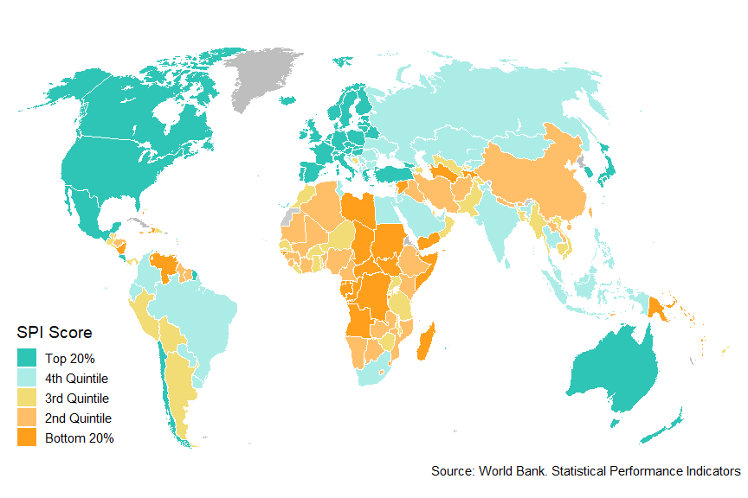

Panel B. SPI Overall Score by Region

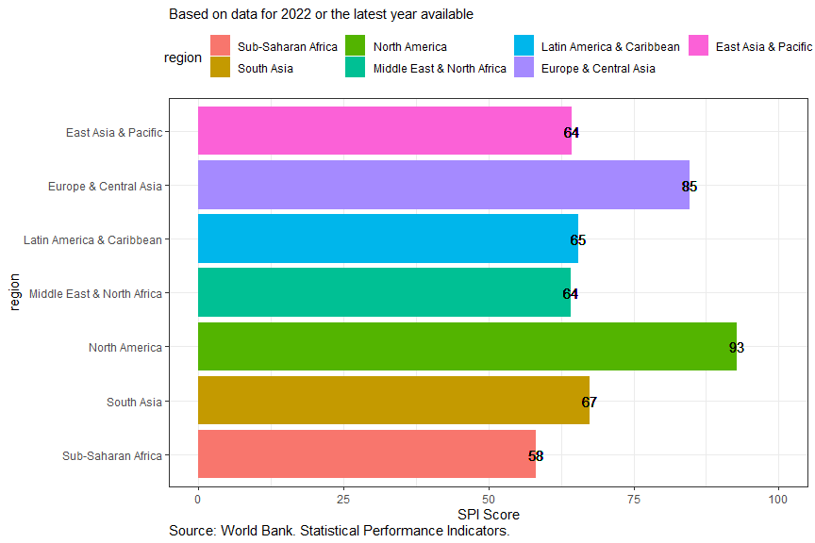

Panel C. SPI Overall Score by Income Levels

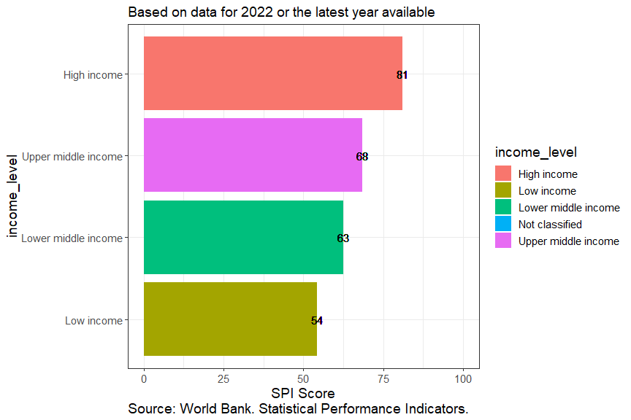

## Figure A.2. SPI Overall Score by Country within Each Region

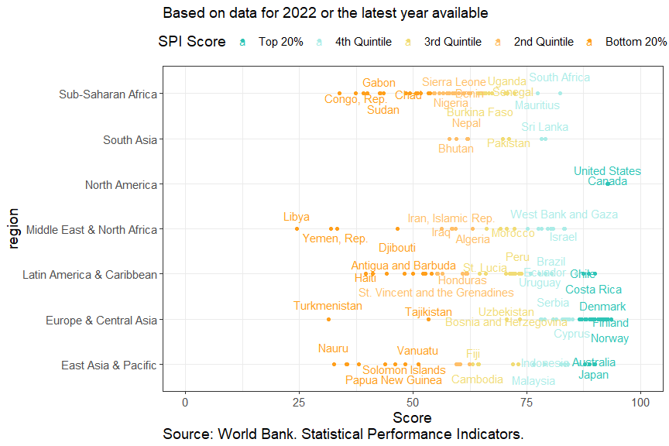

## Figure A.3. Changes with the SPI Overall Score between 2016 and 2022

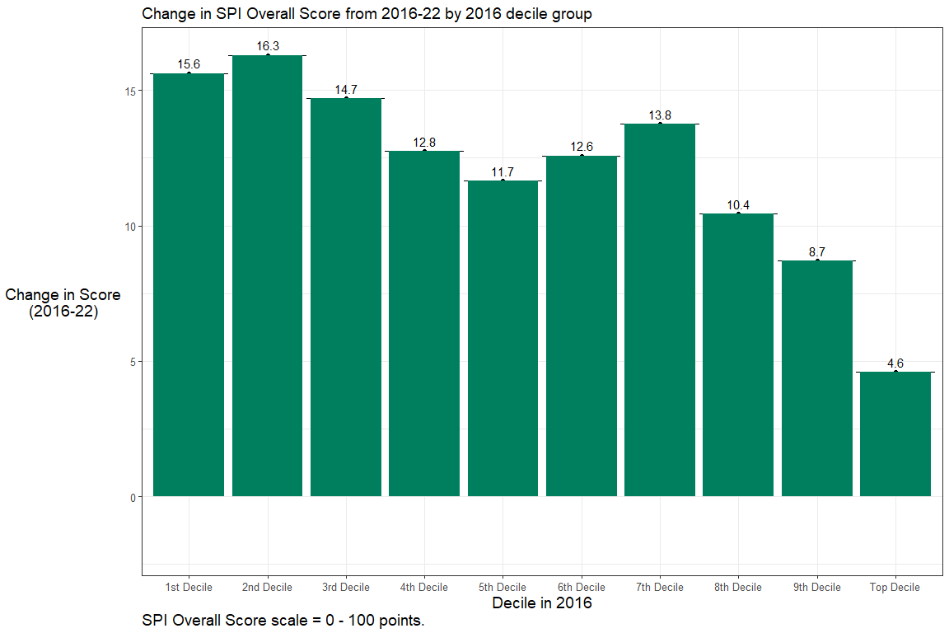

## Table B.1: Comparing the SPIs and the SCI

Table produced using Microsoft Word.

## Figure B.1: Volatility of SPI and SCI Scores between 2016 and 2020

