Graphs and Tables for Ziphius HHMM Paper
Note: see code for details on how to produce optional interactive graphs and tables. They are not included in the rendered version in the repository because they result in an html file that exceeds GitHub’s file size rules.

Tag Deployment Summary
Table 1: Metadata for all analyzed tag deployments. Full record duration is usually longer than analyzed record duration because modeling included only time-periods where acoustic data were recorded (and many tags recorded high-resolution movement data for an additional period at the end of the deployment). In addition, only complete dives were included in analysis. All other columns in the table are computed for analyzed data only. The number of Typical and Variant dive cycles is based on the fitted HHMM, using the Viterbi algorithm to estimate the most likely state sequence for each whale. In addition to the number of dive cycles including MFAS sounds, we note the number of dive cycles for which review of the acoustic data indicated confirmed presence of echosounder, impulsive, or orca sounds.
Deployment Number | Whale ID | Record Start (UTC) | Tag-on Location | Record Duration (h) | Analyzed Record Duration (h) | Dive Cycles | Typical Dive Cycles | Variant Dive Cycles | MFAS Dive Cycles | Echosounder Dive Cycles | Impulsives Dive Cycles | Orca Dive Cycles | Median N Non-Foraging Dives
1 | Zica-20191012-144029 | 12-Oct-2019 16:43:59 | 32.7592, -118.9226 | 141.6 | 123.6 | 37 | 13 | 24 | 2 | 1 | 0 | 0 | 4.5
2 | Zica-20191012-145101 | 12-Oct-2019 20:38:04 | 32.7096, -118.7881 | 167.2 | 122.0 | 42 | 25 | 17 | 5 | 2 | 18 | 0 | 4.0
3 | Zica-20191111-94810 | 11-Nov-2019 22:45:03 | 32.7096, -118.7881 | 289.2 | 118.6 | 39 | 30 | 9 | 4 | 3 | 4 | 0 | 4.0
4 | Zica-20191117-195993 | 17-Nov-2019 18:00:06 | 32.6745, -118.8221 | 8.1 | 2.7 | 2 | 1 | 1 | 0 | 0 | 0 | 0 | 4.0
5 | Zica-20211112-94819 | 12-Nov-2021 22:02:43 | 32.9163, -118.987167 | 274.4 | 166.2 | 52 | 43 | 9 | 8 | 0 | 0 | 0 | 5.0
6 | Zica-20211113-195993 | 13-Nov-2021 18:24:30 | 32.868333, -119.102167 | 99.6 | 96.7 | 50 | 3 | 47 | 2 | 0 | 0 | 0 | 3.0
7 | Zica-20220112-195994 | 12-Jan-2022 18:22:20 | 32.771, -118.9546 | 161.9 | 159.7 | 51 | 49 | 2 | 5 | 0 | 0 | 1 | 3.0
8 | Zica-20230518-233391 | 18-May-2023 19:06:26 | 32.8808, -119.0669 | 259.0 | 252.2 | 84 | 39 | 45 | 3 | 0 | 20 | 0 | 3.0
9 | Zica-20230519-232950 | 19-May-2023 23:07:08 | 32.845, -118.9746 | 245.5 | 240.5 | 80 | 60 | 20 | 2 | 5 | 17 | 0 | 4.0
10 | Zica-20230723-233394 | 23-Jul-2023 18:48:26 | 32.828, -119.0363 | 63.5 | 59.5 | 20 | 15 | 5 | 7 | 0 | 8 | 0 | 5.0
11 | Zica-20230723-233395 | 23-Jul-2023 20:45:37 | 32.8752, -119.0218 | 48.1 | 47.1 | 18 | 14 | 4 | 6 | 1 | 10 | 0 | 3.0
12 | Zica-20240227-233396 | 27-Feb-2024 22:11:43 | 32.8801, -118.9486 | 241.8 | 217.7 | 66 | 43 | 23 | 7 | 2 | 7 | 0 | 5.0
13 | Zica-20240227-240128 | 27-Feb-2024 20:00:10 | 32.8713, -118.958 | 97.0 | 91.1 | 28 | 26 | 2 | 1 | 0 | 0 | 0 | 5.0
NA | Total | NA | NA | 2096.9 | 1697.6 | 569 | 361 | 208 | 52 | 14 | 84 | NA | NA

Comparison of fitted models
These models were fitted including all dive cycles with acoustic data.
Table 2: Model comparison results for HHMMs.
Model | Intensity Metric | MFAS Effect at Dive-Cycle Scale | MFAS Effect at 5-Minute Scale | MFAS-before-EOE Effect | AIC | AIC Difference
1 | cSEL | Yes | Yes | None | 20417.9 | 0.0
2 | cSEL | Yes | Yes | Additive | 20420.9 | 3.0
3 | cSEL | Yes | Yes | Interactive | 20423.3 | 5.4
4 | cSEL | Yes | No | None | 20454.1 | 36.2
5 | RMS | Yes | No | None | 20454.9 | 37.0
6 | RMS | Yes | No | Additive | 20458.0 | 40.1
7 | None | Yes | No | None | 20459.4 | 41.5
8 | RMS | Yes | No | Interactive | 20461.2 | 43.3
9 | None | No | No | None | 20461.4 | 43.5
10 | RMS, cSEL | Yes | Yes | None | 20465.7 | 47.9
11 | RMS | Yes | Yes | None | 20466.7 | 48.8
12 | RMS | Yes | Yes | Additive | 20469.7 | 51.8
13 | RMS, cSEL | Yes | Yes | Interactive | 20471.7 | 53.8
14 | RMS | Yes | Yes | Interactive | 20473.3 | 55.4
15 | cSEL | Yes | No | None | 21663.1 | 1245.2

Rates of Transition Between States

Dive-cycle Scale
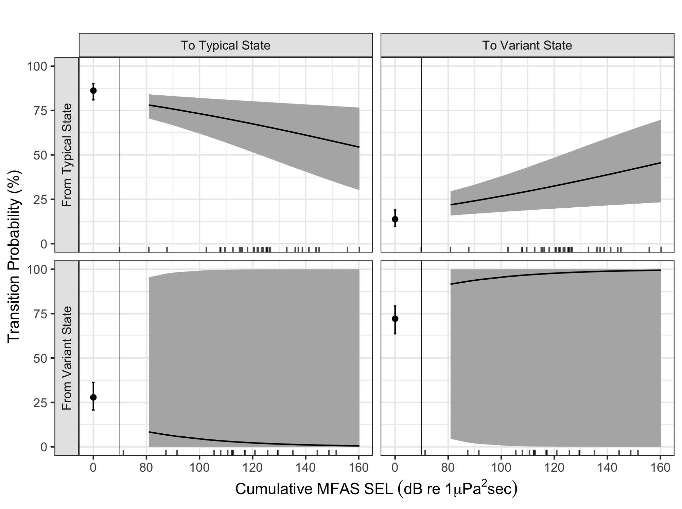
Figure 1: Rates of transition between states at the dive cycle scale. Rug plot on the x-axis indicates observed MFAS cSEL values, allocated to panels according to the most-likely decoded state sequence.

5-minute Scale
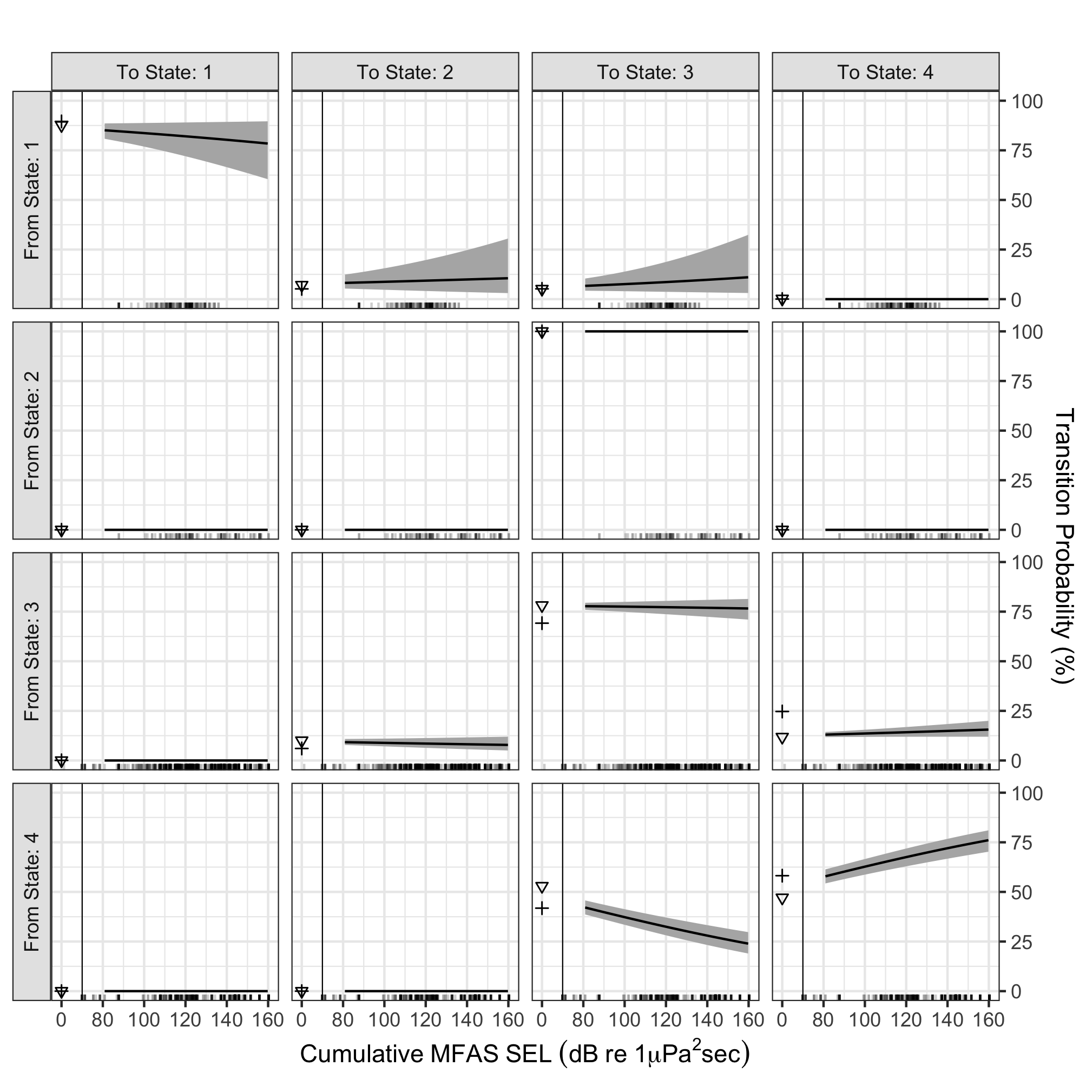
Figure 2: Rates of transition between states at the 5-minute scale.

State-dependent distributions with data

Dive-cycle Scale
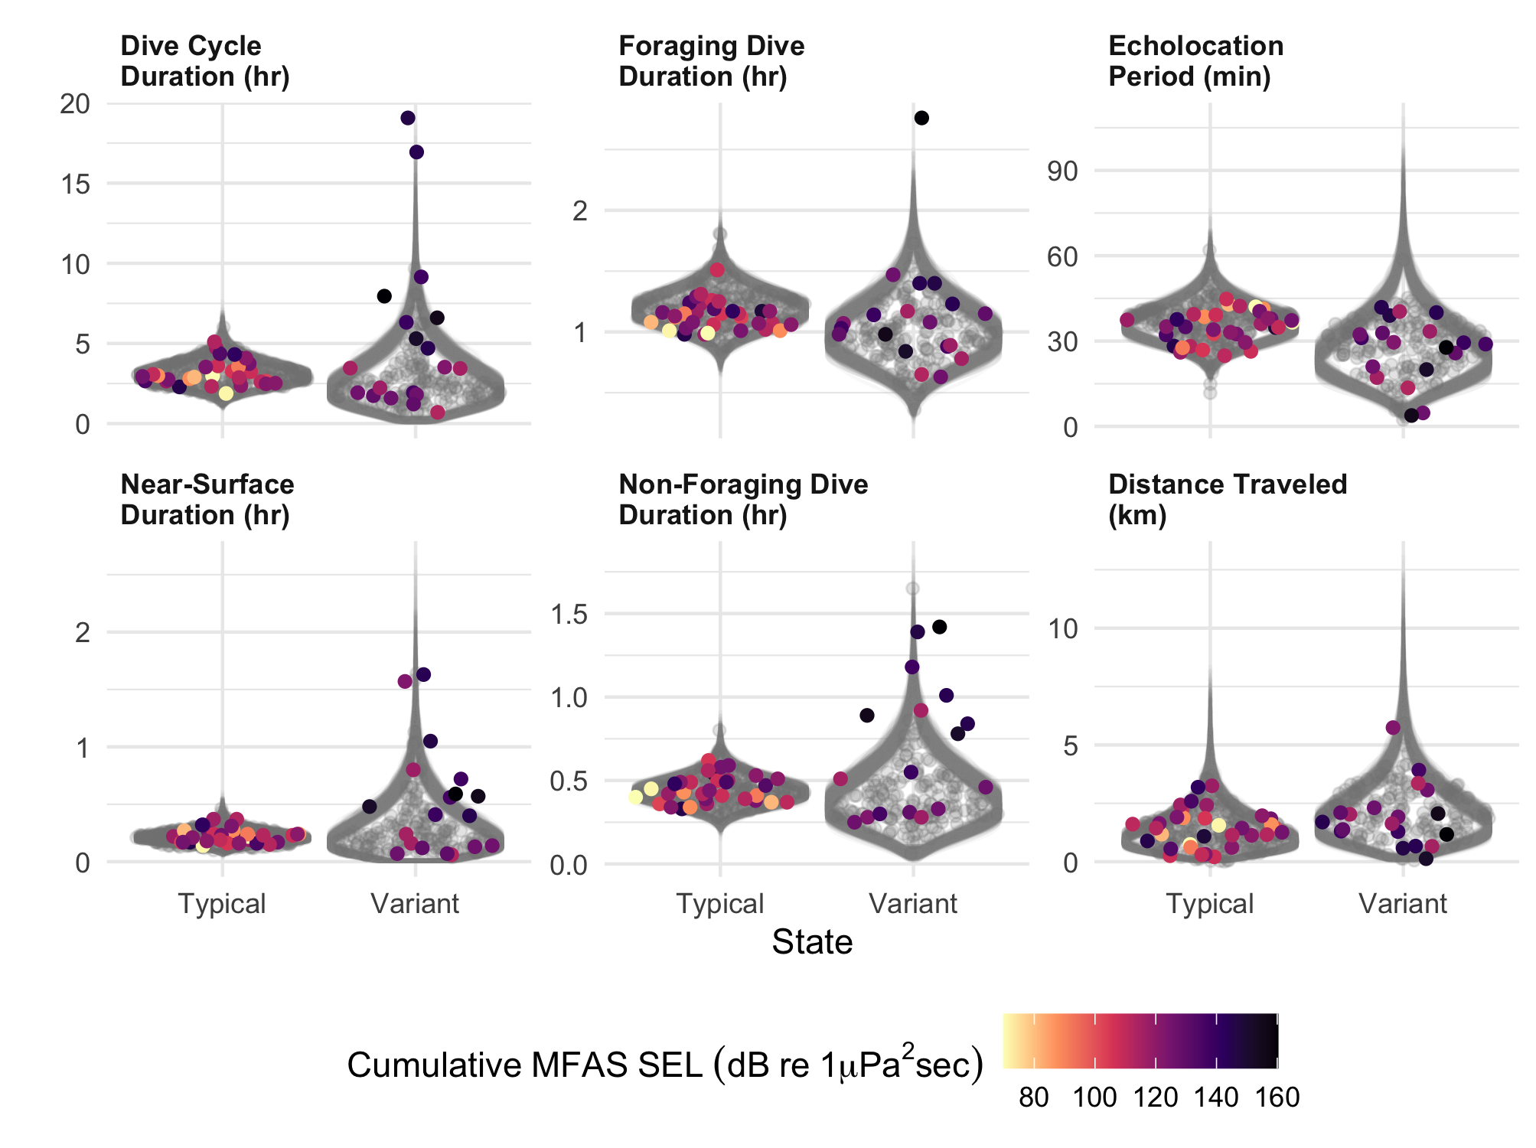
Figure 3: Characteristics of state-dependent distributions at the dive cycle scale.

5-minute Scale
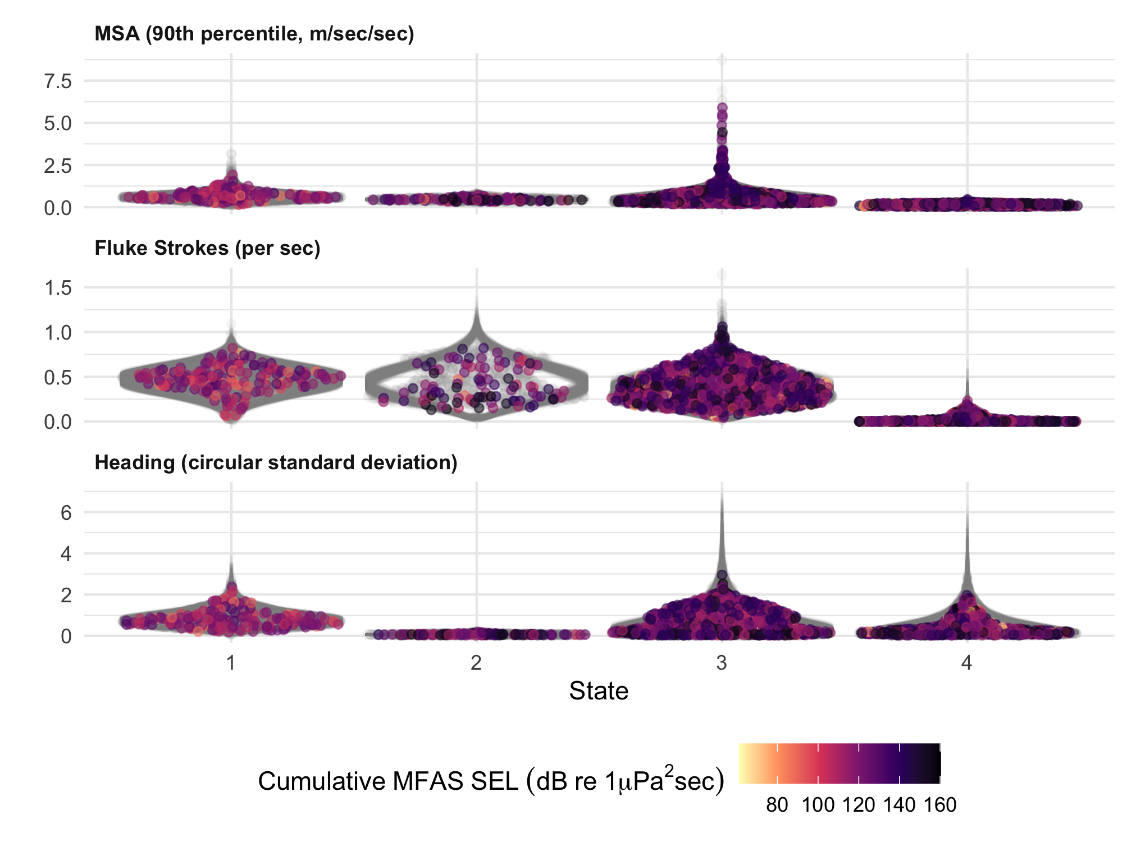
Figure 4: Characteristics of state-dependent distributions at the 5-minute scale.

Variant-state duration
How long do whales spend in the Variant state, according to the Viterbi decoded state sequences?
Also: based on the fitted model, what would the expected duration of a response be, if a whale responded to an MFAS exposure by switching to Variant state and then there was no further MFAS exposure subsequently?
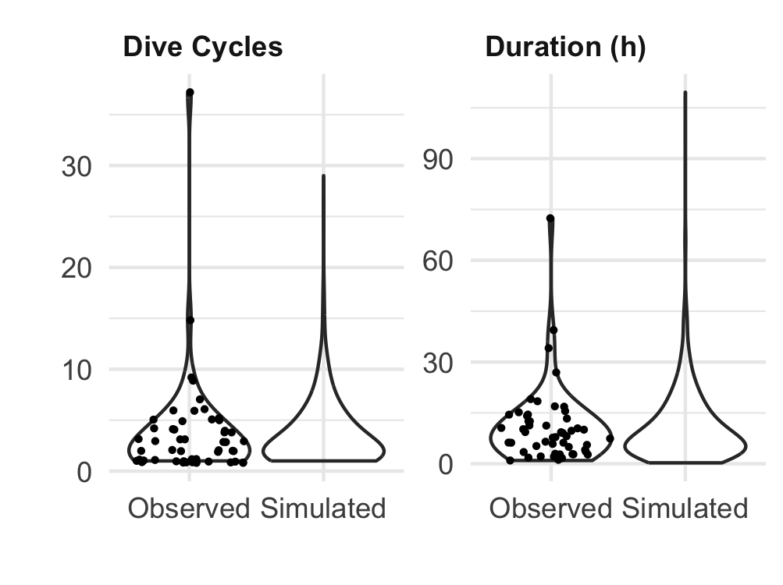
Figure 5: Duration of observed and simulated Variant state bouts.

