Viktor 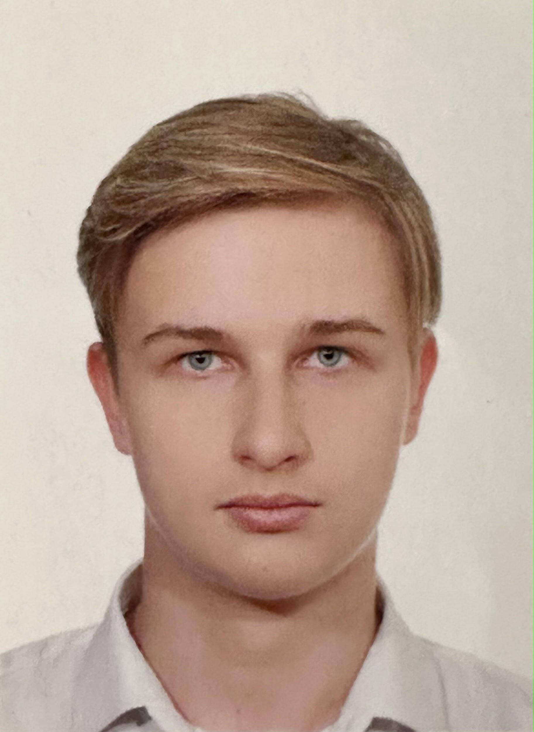KOROTKOV

17 years old (born 02/03/2007)

Phone number: +33 7 82 28 28 63

Email: [korotkov.viktor07@gmail.com](mailto:korotkov.viktor07@gmail.com)

Address: 79 Cr de la Liberte  
69003, Lyon, France

**Education**

2024-2028 **Bachelor of Science in Data Science for Responsible Business**

Lyon, emlyon business school

2023-2024 **High School Diploma** (grades 10 and 11th in one year), with honours  
Moscow, Moscow Lyceum “Stupeni” (10-11th grade)

2022-2023 **Diploma of completion of the “Python Junior Developer” course**  
Online, Tomsk State University

2014-2023 **Basic Secondary Education** (grade 1 to 9th, out of 11), with honours   
Kaluga, Gymnasia 24

**Working experience**

01/09/2020 — 06/10/2023 **Technical assistant for working with advertising**  
Kaluga, LLC «Prazdnichnyy Stol»

* Compilation of playlists with advertisement
* Sound correction in advertising (through Total Commander)

01/06/2023 — 31/08/2023 **System administrator**  
Kaluga, LLC «IT Perspectiva»

* Networks, domains, and operating systems configuring
* CCTV cameras installing
* Office equipment testing and maintenance

I also tried myself in various fields as a freelancer, from English tutor to mystery shopper through stock exchange trader/crypto trader, interpreter (in ordinary life, non-official conversations), reviewer (of applications and videos) and reseller on marketplace (resold clothes, technics). I found a mobile game competitive community (managed tournaments), a blog «Investments and Money» (publications on economy and investing strategies) and the blog «Russian Fishers» (for reselling fishing rods).

**My skills**

Hard skills: Maths, Research skills, Economy and business, Computer Science, Excel, Word, PowerPoint, Python, Go (basics), HTML, CSS, JavaScript (basics), Technological literacy, Git.  
Soft skills: Analytical thinking, Curiosity, Flexibility, Self-awareness, Responsibility, Friendliness, Stress resistance

**Languages**

- English B2

- German A2

- Polish A1

- French A1

- Russian (native)

**Hobbies / Personal Life**

- Sports: martial arts, football, basketball.

- Photography

- Writing (verses and articles, notably for personal blog channel)

- Reading publications and watching lectures on different scientific topics (Physics, Biology, Computer Science, Maths)  
- Various hobby projects, some of them you can find on my GitHub: [stacyshki (Vitya)](https://github.com/stacyshki)

**Questions and answers about me**

1. Are you part of any organization or association? Which one and why?

I currently don’t have time for any organization or association but until last year I used to be a part of Leukemia Foundation. I notably played the role of a sponsor and donated money that I earned from my job, because I think that we must help people that are in need. People with leukemia require an expensive treatment that not all the patients can afford. I also was a part of Ninja Association, where I assisted in developing my martial art, ninjutsu, in Russia. I participated in plenty of seminars to promote this art which is undervalued in my country. It teaches you not only self-defense, but also to appreciate and respect people, their individuality and freedom. Last but not least, my classmates and I regularly gathered in summer and autumn to clean the streets of our city, in order to contribute to our community.

2. Have you ever worked in a team? What was the context?

I had many opportunities to work in a team and to boost my team spirit in different fields and situations. In the IT field, the most significant happened during my summer 2023 job, which involved a lot of teamwork. We were building computers, setting the network and so on, supplying about 150-200 workplaces. In addition to that, a friend and I organized championships in mobile games, where we tried to create a concept of paid mini-tournament (the entrance was fee-paying) with a system of awarding players who took the first five places out of ten.   
As I have already mentioned, I used to do martial arts, but also other sports like football. In football you always have to work as a team, otherwise you lose the game. This sport taught me how important it is to work harmoniously. Then I had some experience of working in a team when we prepared for our school Stand-up. 3 or 4 times we worked in various teams, I usually prepared the plot and chose jokes we should use according to the concept of our Stand-up, once I even voiced the video we made.

And, of course, now I frequently work on different projects in a team with my classmates at university. For example, the last project task was to create a website of a sustainable business. There I was working on HTML and JS a bit, but mainly on CSS.

3. Describe a particular event or experience that left such an impression on you.

I would like to mention not only one, but three events that left a huge impression on me, and even changed my mindset. All of them happened a few years ago. The first was my first attempt at trading on our national stock exchange, and then I even had a chance to trade depository receipts of USA and some European companies. It taught me to save and make money on stock exchanges. We all know that on the Internet there are a lot of people who say that making money is very simple and you are able to do it fast. Now I can disprove this opinion. Since that time I have read a lot of scientific papers and have obtained experience that shows how strategy and tactics are important. We are unable to predict everything, but we can make us ready for the hardest times.

The second important experience was when my friends and I tried to create a few start-up projects. Unfortunately, none of them succeeded, but we learn from our failures and I have gained some experience in accounting, making SWOT-analysis, advertising, communication with customers.

As of the third event, I would like to write about my experience as a publisher. My first publications were on the platform of Yandex (the Russian equivalent of Google), they were about Physics (the principle of superposition) and English. Now I have a Telegram channel where I make publications on Economics, sometimes on investing. There I also observe different events, indicators and other things connected with real life. For example, the latest three publications were on HDI, top economies in the nearest future (100 years), integration of AI into economy and people’s lives. So, this experience showed me that I am able to express my opinion in public and do some research, present it for people.  
Ultimately, my application to your program is largely explained by these life-changing experiences, which led me to want to study data and tech management.

**My achievements (range from more to less important)** (I can supply and translate the relevant certificates on request)

2024 – High School Diploma by Moscow Lyceum “Stupeni”

2024 – A diploma from Moscow authorities for excellence in studying

2023 – Diploma, graduated from the course “Python-developer: from zero to junior-level” by Tomsk State University  
2023 – Participant in debates in English on the theme: “New technologies and their impact on our lives”  
2023 – Prize-winner of All-Russia Olympiad in English, regional stage  
2023 – Prize-winner of All-Russia Olympiad in Economics, regional stage  
2023 – Prize-winner of All-Russia Olympiad in English, city stage  
2023 – Winner of All-Russia Olympiad in Economics, city stage  
2022 – Certificate for graduating from a free mini-course “Profession: SMM-manager"

2022 – Participant of All-Russia space dictation

2022 – Prize-winner of All-Russia Olympiad in English, city stage

2022 – Prize-winner of All-Russia Olympiad in Physics, city stage

2019 – Diploma of the second degree in Maths, All-Russia Olympiad

2019 – Grand Prix of the school DIY contest

2017 – Commendation sheet for second place in city Olympiad, Russian language

2017 – Commendation sheet for excellent progress in studying

2016 – Martial arts, first place, traditional tournament “Russian shield”

2016 – Martial arts, second place, open tournament by martial arts federation “OSE” (“Nation`s Pride-2")

2016 – Martial arts, first place on an open regional tournament “Nation`s Pride”

2015 – Ninjutsu, diploma from the Department of Physical Culture, Sports and Youth Policy of the city Kaluga for a great contribution to the development of physical culture and sports in the city of Kaluga

2016 – Wushu regional championship “Gold Gragon” (third place)

05/07/2015 – Ninjutsu, participant of international Taikai festival (certificate)

13/12/2014 – Ninjutsu, green belt, 8th kyu (passed an exam)

26/05/2014 – Ninjutsu, white belt, 10th kyu (passed an exam on a seminar)