1. Introduction

1.1 Background: AI and Big Data in the life of ordinary people, professionals, scientists
In today's digital era, Artificial Intelligence and Big Data are integrated in almost every part of our society. They are mutually reinforcing each other: Big Data provides the resources for AI to learn, at the same time AI helps us to extract valuable information from massive amounts of data.
- For ordinary people, AI and Big Data are everywhere in their life . From personalized recommendations on streaming platforms to the helps of different Large Language Models like ChatGPT, these technologies are making our lives easier and changing the way we access information.
- For professionals, these technologies are changing their daily workflows nowadays. For example, doctors can use computer vision to help themselves in analyzing medical images, financial analysts rely on AI models to predict market changes and risks, which significantly improves the working efficiency in a lot of industries.
- For scientists, AI and Big Data have brought them a new era of "data-driven research." When facing massive experimental data that humans cannot process manually, scientists can use machine learning algorithms to discover patterns such as analyzing gene sequences or predicting weather changes which greatly accelerates the speed of scientific discovery.
  - Project Motivation
Although the rapid boom of AI is a hot topic nowadays, many discussions tend to be subjective. As the researchers of this project, our primary motivation is to jump out of the narrative of news reports and use objective, real-world data to see how the AI field has actually evolved. We hope to explore several specific phenomena through data analysis: How have AI research hotspots shifted over the past decade? What roles have universities (academia) and tech companies (industry) played in this process? By mining a massive amount of published scientific paper data, we aim to map out a clear trajectory of AI's development.

1.3 Questions we tried to answer
To completely understand the trajectory of AI research, our analysis is driven by eight core dimensions. Specifically, we aimed to answer the following grouped questions:
- Overall Publication Trends: What is the volume and growth trajectory of AI publications since 2010, and do specific publication peaks align with major technological breakthroughs (e.g., the deep learning boom)?
- Thematic Structure of AI: Which core subtopics (e.g., Machine Learning, NLP, Computer Vision) dominate the literature, and how do their growth rates and popularity changes compare over time?
- Geography of Research: Which countries lead the world in AI research output, and how is the global balance of scientific power changing?
- Authors & Scientific Community: How is researcher productivity distributed? Furthermore, is there a measurable increase in the average number of authors per paper and international collaborations?
- Institutions & Universities: Which specific academic universities and industrial research centers publish the most, and do they exhibit specialization in certain AI subtopics?
- Research Quality and Impact: Which journals and conferences publish the highest-impact work, and how do citation rates vary across different AI subtopics or institutions?
- Evolution of Science & Trends: Which AI areas emerged only post-2010? How can we distinguish between "mature" and "emerging" technologies, and how quickly do new subtopics enter the mainstream?
- Data Limitations & Quality: How complete is the underlying bibliographic metadata, which entities are worst represented, and how do these missing values affect our final interpretations?

1.4 DBLP for data analysis
To answer these questions, we needed a massive and accurate bibliographic database. Initially, we tried using Wikidata as our data source. However, after our first exploration, we found that while Wikidata has a broad knowledge coverage, it suffers from severe missing data issues in the specific field of computer science publications (for example, it is often difficult to find an author's specific affiliation or detailed conference information).
Therefore, we ultimately decided to use the DBLP Computer Science Bibliography. DBLP is a knowledge graph specifically dedicated to computer science, and its main advantage lies in its highly structured data. It details and accurately records the publication year, author information, affiliations, and publication venues of the papers. This high-quality data allows us to precisely track the evolution of specific AI fields, making it highly suitable for rigorous quantitative analysis.

1.5 Analytical Framework
In this project, we built a complete data analysis pipeline, which is mainly divided into three steps:
- Data Extraction: We wrote SPARQL queries to filter and extract the target data directly from the DBLP database.
- Data Processing: The extracted raw data was saved in CSV format. Subsequently, we used Python to clean, merge, and engineer features from the data.
- Data Visualization: To make our analysis results intuitive and easy to understand, we used Plotly, Seaborn, and Matplotlib. Through visualizations such as bar charts and line graphs, we clearly presented publication trends, institutional distributions, and collaboration networks.

2. Data Collection
2.1 SPARQL Query Architecture
Data extraction leveraged the DBLP Query Service, which provides a SPARQL endpoint for querying DBLP RDF (Resource Description Framework) knowledge graph. SPARQL enables precise, structured queries against linked data, making it ideal for extracting entities meeting specific criteria across multiple dimensions.
DBLP is a computer science bibliography website. Starting in 1993 at Universität Trier in Germany, it grew from a small collection of HTML files and became an organization hosting a database and logic programming bibliography site.

2.2 Queries and Components
The extraction process consisted of 13 different queries to retrieve different kind of data on the bibliography:
Query 1
PREFIX dblp: <https://dblp.org/rdf/schema#>
SELECT ?year (COUNT(?pub) AS ?count) WHERE {
VALUES ?venue {
<https://dblp.org/streams/conf/nips>
<https://dblp.org/streams/conf/icml>
<https://dblp.org/streams/conf/cvpr>
<https://dblp.org/streams/conf/icc>
<https://dblp.org/streams/conf/aaai>
<https://dblp.org/streams/conf/ijcai>
<https://dblp.org/streams/conf/acl>
}
?pub dblp:publishedInStream ?venue .
?pub dblp:yearOfPublication ?year .
}
GROUP BY ?year
ORDER BY ?year
This SPARQL query counts the total number of publications per year across 7 major AI/ML conferences (NeurIPS, ICML, CVPR, ICC, AAAI, IJCAI, ACL), grouped and ordered chronologically.

Query 2
PREFIX dblp: <https://dblp.org/rdf/schema#>
SELECT ?topic (COUNT(?pub) AS ?count) WHERE {
VALUES (?venue ?topic) {
(<https://dblp.org/streams/conf/nips> "1. Machine Learning (NeurIPS)")
(<https://dblp.org/streams/conf/icml> "1. Machine Learning (ICML)")
(<https://dblp.org/streams/conf/iclr> "1. Machine Learning (ICLR)")
(<https://dblp.org/streams/conf/cvpr> "2. Computer Vision (CVPR)")
(<https://dblp.org/streams/conf/iccv> "2. Computer Vision (ICCV)")
(<https://dblp.org/streams/conf/eccv> "2. Computer Vision (ECCV)")
(<https://dblp.org/streams/conf/acl> "3. NLP & GenAI (ACL)")
(<https://dblp.org/streams/conf/emnlp> "3. NLP & GenAI (EMNLP)")
(<https://dblp.org/streams/conf/naacl> "3. NLP & GenAI (NAACL)")
(<https://dblp.org/streams/conf/aaai> "4. General AI (AAAI)")
(<https://dblp.org/streams/conf/ijcai> "4. General AI (IJCAI)")
(<https://dblp.org/streams/conf/kr> "4. Knowledge Rep (KR)")
(<https://dblp.org/streams/conf/iswc> "4. Semantic Web (ISWC)")
}
?pub dblp:publishedInStream ?venue .
?pub dblp:yearOfPublication ?year .
}
GROUP BY ?topic
ORDER BY DESC(?count)
This query counts total publications per conference across 13 AI venues, grouped into topic categories (ML, Computer Vision, NLP/GenAI, General AI). Each venue is labeled with a topic string, and results are sorted by publication count descending

Query 3
PREFIX dblp: <https://dblp.org/rdf/schema#>
SELECT ?year ?topic (COUNT(?pub) AS ?count) WHERE {
VALUES (?venue ?topic) {
(<https://dblp.org/streams/conf/nips> "1. Machine Learning")
(<https://dblp.org/streams/conf/icml> "1. Machine Learning")
(<https://dblp.org/streams/conf/cvpr> "2. Computer Vision")
(<https://dblp.org/streams/conf/iccv> "2. Computer Vision")
(<https://dblp.org/streams/conf/acl> "3. NLP")
(<https://dblp.org/streams/conf/emnlp> "3. NLP")
(<https://dblp.org/streams/conf/kr> "4. Knowledge Rep")
(<https://dblp.org/streams/conf/ijcai> "4. Knowledge Rep")
}
?pub dblp:publishedInStream ?venue .
?pub dblp:yearOfPublication ?year .
FILTER (?year >= "2010"^^<http://www.w3.org/2001/XMLSchema#gYear>)
}
GROUP BY ?year ?topic
ORDER BY ?year ?topic.
Similar query as the one above, but now grouping by both year and topic to get a time series per research area (ML, CV, NLP, Knowledge Rep) from 2010 onward.

Query 4
PREFIX dblp: <https://dblp.org/rdf/schema#>
SELECT ?pub ?year ?affiliationName
WHERE {
?pub a dblp:Inproceedings ;
dblp:yearOfPublication ?year ;
dblp:authoredBy ?author .
FILTER (
STRSTARTS(STR(?pub), "https://dblp.org/rec/conf/aaai/") ||
STRSTARTS(STR(?pub), "https://dblp.org/rec/conf/ijcai/") ||
STRSTARTS(STR(?pub), "https://dblp.org/rec/conf/nips/") ||
STRSTARTS(STR(?pub), "https://dblp.org/rec/conf/icml/") ||
STRSTARTS(STR(?pub), "https://dblp.org/rec/conf/cvpr/")
)
?author dblp:primaryAffiliation ?affiliationName .
}
This query retrieves individual papers (with year and author affiliation) from 5 major AI conferences, by joining publications to their authors and then to each author's primary institution.

Query 5
PREFIX dblp: <https://dblp.org/rdf/schema#>
PREFIX rdfs: <http://www.w3.org/2000/01/rdf-schema#>
SELECT ?pub ?year ?authorName
WHERE {
?pub a dblp:Inproceedings ;
dblp:yearOfPublication ?year ;
dblp:authoredBy ?author .
FILTER (
STRSTARTS(STR(?pub), "https://dblp.org/rec/conf/aaai/") ||
STRSTARTS(STR(?pub), "https://dblp.org/rec/conf/ijcai/") ||
STRSTARTS(STR(?pub), "https://dblp.org/rec/conf/nips/") ||
STRSTARTS(STR(?pub), "https://dblp.org/rec/conf/icml/") ||
STRSTARTS(STR(?pub), "https://dblp.org/rec/conf/cvpr/")
)
?author rdfs:label ?authorName .
}
Same as the previous query but swaps affiliation for author name (rdfs:label), enabling analysis of the most prolific individual researchers across those 5 conferences.

Query 6
PREFIX dblp: <https://dblp.org/rdf/schema#>
SELECT ?pub ?year ?venue ?affiliationName
WHERE {
?pub a dblp:Inproceedings ;
dblp:yearOfPublication ?year ;
dblp:publishedIn ?venue ;
dblp:authoredBy ?author .
FILTER (
STRSTARTS(STR(?pub), "https://dblp.org/rec/conf/aaai/") ||
STRSTARTS(STR(?pub), "https://dblp.org/rec/conf/ijcai/") ||
STRSTARTS(STR(?pub), "https://dblp.org/rec/conf/nips/") ||
STRSTARTS(STR(?pub), "https://dblp.org/rec/conf/icml/") ||
STRSTARTS(STR(?pub), "https://dblp.org/rec/conf/cvpr/")
)
?author dblp:primaryAffiliation ?affiliationName .
}
Same as the affiliation query before, but now also fetches the venue name (dblp:publishedIn) — allowing breakdowns by both institution and specific conference/proceedings volume.
Query 7
PREFIX dblp: <https://dblp.org/rdf/schema#>
PREFIX rdf: <http://www.w3.org/1999/02/22-rdf-syntax-ns#>
SELECT ?venue (COUNT(?pub) AS ?papers)
WHERE {
?pub rdf:type dblp:Article ;
dblp:title ?title ;
dblp:publishedIn ?venue .
FILTER(REGEX(?title,
"artificial intelligence|machine learning|deep learning|neural network|big data|data mining",
"i"))
}
GROUP BY ?venue
ORDER BY DESC(?papers)
Counts journal articles containing AI/ML buzzwords in their title, grouped by publication venue and ranked by volume — useful for identifying which journals publish the most AI-related work.

Query 8
PREFIX dblp: <https://dblp.org/rdf/schema#>
PREFIX rdf: <http://www.w3.org/1999/02/22-rdf-syntax-ns#>
SELECT ?venue (COUNT(?pub) AS ?papers)
WHERE {
?pub rdf:type dblp:Inproceedings ;
dblp:title ?title ;
dblp:publishedIn ?venue .
FILTER(REGEX(?title,
"artificial intelligence|machine learning|deep learning|neural network|big data|data mining",
"i"))
}
GROUP BY ?venue
ORDER BY DESC(?papers)
Identical to the previous query but targets conference papers (Inproceedings) instead of journal articles — ranking which proceedings volumes contain the most AI/ML-titled work.

Query 9
PREFIX dblp: <https://dblp.org/rdf/schema#>
PREFIX cito: <http://purl.org/spar/cito/>
PREFIX xsd: <http://www.w3.org/2001/XMLSchema#>
SELECT ?subtopic (COUNT(?paper) AS ?paperCount) (SUM(?cites) AS ?totalCitations)
WHERE {
{
SELECT ?paper (COUNT(?citation) AS ?cites) WHERE {
?citation cito:hasCitedEntity ?omid .
?paper dblp:omid ?omid .
} GROUP BY ?paper
}
?paper dblp:title ?title .
BIND(
IF(REGEX(?title, "Transformer|LLM|Large Language Model|GPT|Attention Mechanism", "i"), "Generative AI & LLMs",
IF(REGEX(?title, "Diffusion Model|Stable Diffusion|GAN|Generative Adversarial", "i"), "Image & Media Synthesis",
IF(REGEX(?title, "Reinforcement Learning|RLHF|Policy Gradient", "i"), "Reinforcement Learning",
IF(REGEX(?title, "Computer Vision|Object Detection|Segmentation|Image Recognition", "i"), "Computer Vision",
IF(REGEX(?title, "Natural Language|NLP|Sentiment Analysis|Text Mining", "i"), "Classical NLP",
IF(REGEX(?title, "Explainable AI|XAI|Interpretability|Fairness|Ethics|Bias", "i"), "AI Ethics & Interpretability",
IF(REGEX(?title, "Federated Learning|Privacy-Preserving|Differential Privacy", "i"), "Privacy & Distributed AI",
IF(REGEX(?title, "Graph Neural Network|GNN|Relational Learning", "i"), "Graph Learning",
IF(REGEX(?title, "Edge AI|TinyML|Hardware Acceleration|Neuromorphic", "i"), "AI Hardware & Edge",
"General AI/Other"))))))))) AS ?subtopic
)
FILTER(?subtopic != "General AI/Other")
}
GROUP BY ?subtopic
ORDER BY DESC(?totalCitations)
A two-level query that first counts citations per paper (via the CiTO ontology linking DBLP's OMID identifiers to citation records), then classifies each paper into an AI subtopic using regex on the title, and finally aggregates both paper count and total citations per subtopic.

Query 10
PREFIX dblp: <https://dblp.org/rdf/schema#>
PREFIX xsd: <http://www.w3.org/2001/XMLSchema#>
SELECT ?subtopic
(MIN(xsd:integer(STR(?year))) AS ?birthYear)
(AVG(xsd:decimal(STR(?year))) AS ?avgYear)
(COUNT(?paper) AS ?totalVolume)
WHERE {
?paper a dblp:Publication ;
dblp:title ?title ;
dblp:yearOfPublication ?year .
# Optimization: I filter was changed by hand multiple times to get results
FILTER(xsd:integer(STR(?year)) > 2010 && xsd:integer(STR(?year)) <= 2020)
BIND(
IF(REGEX(?title, "Transformer|Large Language Model|LLM|GPT-[34]|Attention Mechanism", "i"), "LLMs & Attention",
IF(REGEX(?title, "Diffusion Model|Stable Diffusion|DALL-E|Generative Adversarial", "i"), "Generative Media",
IF(REGEX(?title, "Graph Neural|GNN|Graph Convolutional", "i"), "Graph Learning",
IF(REGEX(?title, "Neural Radiance Field|NeRF|3D Reconstruction", "i"), "Neural Rendering (NeRF)",
IF(REGEX(?title, "Reinforcement Learning|Proximal Policy|Deep Q-Network", "i"), "Deep RL",
IF(REGEX(?title, "AI for Science|Protein Folding|AlphaFold|Scientific Machine Learning", "i"), "AI for Science",
IF(REGEX(?title, "Federated Learning|Differential Privacy|Private ML", "i"), "Privacy-Preserving AI",
IF(REGEX(?title, "Explainable AI|XAI|Model Interpretability|Fairness in AI", "i"), "Ethics & Interpretability",
"Other")))))))) AS ?subtopic
)
FILTER(?subtopic != "Other")
}
GROUP BY ?subtopic
ORDER BY ?birthYear
Tracks the emergence timeline of AI subtopics by finding each topic's earliest publication year (birthYear), average publication year (avgYear as a center-of-gravity metric), and total volume. All filtered to 2011–2020, ordered chronologically to show when each research trend first appeared and matured. Following the comment in the query we would like to highlight that different filters were applied in this query to gather information from 1949 to 2026, as we encountered runtime timeout error trying to perform one big query without this filter.

Query 11
PREFIX dblp: <https://dblp.org/rdf/schema#>
PREFIX xsd: <http://www.w3.org/2001/XMLSchema#>
SELECT ?type (AVG(xsd:decimal(STR(?year))) AS ?avgYear) (COUNT(?paper) AS ?count)
WHERE {
?paper a dblp:Publication ;
dblp:title ?title ;
dblp:yearOfPublication ?year .
BIND(IF(REGEX(?title, "Theory|Foundations|Fundamental", "i"), "Fundamental",
IF(REGEX(?title, "Applications|Applied|Systems|Implementation", "i"), "Applied", "Unknown")) AS ?type)
FILTER(?type != "Unknown")
}
GROUP BY ?type
Classifies all publications as either Fundamental or Applied based on title keywords, then compares the two groups by average publication year and total count.

Query 12
PREFIX dblp: <https://dblp.org/rdf/schema#>
PREFIX xsd: <http://www.w3.org/2001/XMLSchema#>
SELECT ?subtopic ?hasAffiliation (COUNT(?paper) AS ?count)
WHERE {
?paper a dblp:Publication ;
dblp:title ?title ;
dblp:yearOfPublication ?year .
BIND(
IF(REGEX(?title, "Large Language Model|LLM|Transformer", "i"), "Generative AI",
IF(REGEX(?title, "Reinforcement Learning", "i"), "RL",
IF(REGEX(?title, "Computer Vision", "i"), "Vision",
"Other"))) AS ?subtopic
)
FILTER(?subtopic != "Other")
OPTIONAL {
?paper dblp:author ?author .
?author dblp:note ?note .
FILTER(CONTAINS(LCASE(STR(?note)), "affiliation"))
}
BIND(IF(BOUND(?note), "With Affiliation", "Missing Affiliation") AS ?hasAffiliation)
}
GROUP BY ?subtopic ?hasAffiliation
ORDER BY ?subtopic
For each AI subtopic, counts papers split by whether their authors have affiliation metadata present. It is a data completeness audit showing how reliably DBLP's affiliation data covers each research area.

Query 13
PREFIX dblp: <https://dblp.org/rdf/schema#>
PREFIX xsd: <http://www.w3.org/2001/XMLSchema#>
SELECT ?subtopic ?citationStatus (COUNT(?paper) AS ?count)
WHERE {
?paper a dblp:Publication ;
dblp:title ?title ;
dblp:yearOfPublication ?year .
BIND(
IF(REGEX(?title, "Large Language Model|LLM|Transformer", "i"), "Generative AI",
IF(REGEX(?title, "Reinforcement Learning", "i"), "RL",
IF(REGEX(?title, "Computer Vision", "i"), "Vision",
"Other"))) AS ?subtopic
)
FILTER(?subtopic != "Other")
OPTIONAL { ?paper dblp:omid ?omid . }
BIND(IF(BOUND(?omid), "Citations Tracked", "No Citation Data") AS ?citationStatus)
}
GROUP BY ?subtopic ?citationStatus
ORDER BY ?subtopic
Same structure as the affiliation audit, but checking for citation data coverage. It splits each subtopic's papers by whether they have an OMID identifier (and thus trackable citations), revealing how much of each area's output is actually covered by DBLP's citation metadata.

2.3 Entity Selection Criteria
Query 1 — Publications per Year (7 venues)
Papers published in any of 7 manually curated AI conference streams (NeurIPS, ICML, CVPR, ICC, AAAI, IJCAI, ACL), with no year filter — full historical coverage.
Query 2 — Publications per Topic (13 venues)
Papers from 13 conferences grouped into 4 topic buckets via hard-coded venue-to-label mappings. All years included, ranked by volume.
Query 3 — Time Series by Topic (2010+)
Papers from 8 conferences across 4 topics, restricted to yearOfPublication >= 2010 via an XSD gYear filter to focus on the modern deep learning era.
Query 4 — Affiliation per Paper (5 venues, URI filter)
Inproceedings entities whose URI starts with one of 5 conference path prefixes (/conf/aaai/, /conf/ijcai/, /conf/nips/, /conf/icml/, /conf/cvpr/), joined to authors that have a primaryAffiliation value present.
Query 5 — Author Names per Paper (5 venues, URI filter)
Same URI-based venue filter as Query 4, but selecting only authors that have an rdfs:label (i.e. named entities). Anonymous or unlabeled authors are implicitly excluded.
Query 6 — Affiliation + Venue Name (5 venues)
Same URI filter as Query 4, additionally requiring dblp:publishedIn to be bound, so papers missing a venue string are excluded.
Query 7 — AI/ML Journals by Title Keyword
All dblp:Article entities (journal papers) whose title matches a 6-term regex (artificial intelligence, machine learning, deep learning, neural network, big data, data mining). No venue or year pre-filter.
Query 8 — AI/ML Conference Papers by Title Keyword
Same keyword regex as Query 7, applied to dblp:Inproceedings only. No venue or year pre-filter.
Query 9 — Citations by AI Subtopic
All dblp:Publication entities that
- have at least one CiTO citation record linked via OMID;
- match at least one of 9 subtopic regexes; papers matching none are excluded via FILTER(?subtopic != "General AI/Other").
Query 10 — Subtopic Emergence Timeline
All dblp:Publication entities published between 1949 and 2026 whose title matches one of 8 subtopic patterns. Unclassified papers filtered out.
Query 11 — Fundamental vs. Applied Split
All dblp:Publication entities whose title contains either theory/foundations keywords or applications/systems keywords. Papers matching neither label are excluded via FILTER(?type != "Unknown").
Query 12 — Affiliation Coverage Audit
All dblp:Publication entities matching 3 subtopic regexes (Generative AI, RL, Vision); affiliation presence tested via OPTIONAL on dblp:note containing the string "affiliation", no year or venue restriction.
Query 13 — Citation Coverage Audit
Same 3-subtopic publication set as Query 12. OMID presence tested via OPTIONAL { ?paper dblp:omid ?omid }, papers without OMID are retained but flagged, giving full coverage of both tracked and untracked entities.
Disclaimer: subtopic classification based on title keywords; definitions vary by query due to questions’ split in the team. The inconsistency is mostly cosmetic (naming) rather than structural. The populations captured by the regex’es are substantially the same.

2.4 Extracted Data Fields and Analytical Significance
Query 1 — Publications per Year
The query returns two fields: year (integer) serving as the temporal grouping key, and count (integer) representing the total publication volume used for trend analysis.
Query 2 — Publications per Topic
The query returns two fields: topic (string) encoding both the thematic category and source venue as a combined label, and count (integer) used for cross-venue volume comparison.
Query 3 — Time Series by Topic
The query returns three fields: year (integer) and topic (string) jointly forming the grouping key for the time series, and count (integer) providing the per-topic annual publication volume used for trend visualization.
Query 4 — Affiliation per Paper
The query returns three fields: pub (string, URI) as the unique paper identifier, year (integer) for temporal filtering, and affiliationName (string) used for institutional productivity analysis.
Query 5 — Author Names per Paper
The query returns three fields: pub (string, URI) as the paper identifier, year (integer) for temporal context, and authorName (string) used for individual researcher productivity ranking.
Query 6 — Affiliation + Venue Name
The query returns four fields: pub (string, URI) as the paper identifier, year (integer) for temporal context, venue (string) identifying the specific proceedings volume, and affiliationName (string) enabling joint institution-venue analysis.
Query 7 — AI/ML Journals by Keyword
The query returns two fields: venue (string) identifying the journal, and papers (integer) counting keyword-matching articles used to rank journals by AI/ML output.
Query 8 — AI/ML Conference Papers by Keyword
The query returns two fields: venue (string) identifying the proceedings volume, and papers (integer) counting keyword-matching conference papers used to rank venues by AI/ML output.
Query 9 — Citations by AI Subtopic
The query returns three fields: subtopic (string) as the thematic classification label, paperCount (integer) representing publication volume, and totalCitations (integer) aggregating citation impact, jointly used for impact-vs-volume analysis per research area.
Query 10 — Subtopic Emergence Timeline
The query returns four fields: subtopic (string) as the thematic label, birthYear (integer) marking the earliest recorded publication used to date a trend's emergence, avgYear (float) as a center-of-gravity metric indicating maturity, and totalVolume (integer) quantifying research momentum.
Query 11 — Fundamental vs. Applied Split
The query returns three fields: type (string) as the binary classification label, avgYear (float) used to assess temporal drift between research orientations, and count (integer) providing volume for proportional comparison.
Query 12 — Affiliation Coverage Audit
The query returns three fields: subtopic (string) as the thematic category, hasAffiliation (string, unique) as a unique data quality flag, and count (integer) quantifying the coverage rate of affiliation metadata per research area.
Query 13 — Citation Coverage Audit
The query returns three fields: subtopic (string) as the thematic category, citationStatus (string) as a binary flag indicating OMID presence, and count (integer) quantifying citation metadata coverage per research area.
There are no missing values in the csv file.

2.5 Data Extraction Results
The queries retrieved 15 csv files of shapes:
- (52, 2)
- (13, 2)
- (64, 3)
- (175346, 3)
- (483361, 3)
- (175346, 4)
- (1730, 2)
- (7442, 2)
- (9, 3)
- (8, 4), three csv’s on the same question
- (2, 3)
- (3, 3)
- (6, 3)
3. Data Analysis
3.1 Analytical Framework and Tools
The extracted DBLP datasets were processed using Python’s scientific computing ecosystem. The pipeline integrated data cleaning, feature engineering, and data analysis (descriptive statistics and plotting). The core stack included:
- pandas and numpy for data manipulation;
- plotly, matplotlib, seaborn for plotting;
- prettytable for output visualization;
- re, pathlib, warnings for other manipulations.

3.2 Data Cleaning and Preprocessing
Sections 3 & 5 (Geography & Institutions): The names of institution are inconsistent, to solve it, we convert text to lowercase, stripping whitespaces, and removing redundant punctuation to set a baseline for later feature engineering (pattern matching) .
Section 4 (Authors): We parsed concatenated co-author strings into iterable Python lists. Additionally, we strictly cast the year of publication column to integers, preparing for next time-series aggregation.
Due to the nature of the data (coming from queries) and specifics of the data collection techniques we managed to avoid most of the cleaning/preprocessing part. The were no missing values left as well. The only preprocessing that was essential was merging csv files for Query 10, where there was a timeout problem described above. Little manipulations were made during the analysis, like transferring integer year to datetime format to obtain desired results.

3.3 Feature Engineering
Geographic Mapping (Section 3 & Section 5): We extracted countries using a predefined global list. To minimize missing data, we tried our best to do a Fallback Mapping through Regex to infer some important countries directly from prominent institution names (e.g., matching r'\b(stanford|google)\b' to "USA").
Collaboration Metrics (Section 4): We calculated an Author Count for each paper. Additionally, if a paper's co-authors spanned more than one unique country, we recognize the boolean feature ‘Is International Collab’ as True.
Sector Categorization (Section 5): We created a binary SectorType feature. Affiliations matching industry keywords (e.g., r'\binc\b', r'\bcorp\b') were labeled "Industry"; all others defaulted to "Academic".

3.4 Answers to questions and analysis upon what we did in Python notebook
Section 3:
1. Absolute Output US and China almost dominate AI research output, acting as a global leadership. The US leads overall (36,232 publications), followed closely by China (25,219), with a steep drop-off to the UK (6,413) and Germany (5,318).
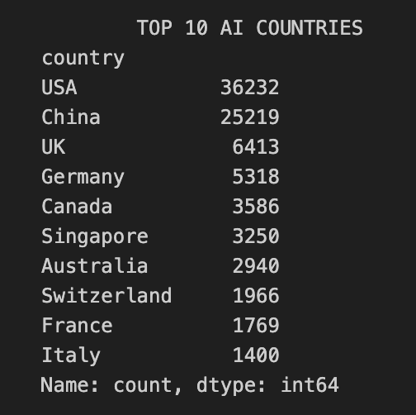
2. Growth & Temporal Trends While the US maintained steady historical growth, China's publication volume grew exponentially, ultimately getting over the US in recent years (post-2023). Furthermore, the 2018–2023 Compound Annual Growth Rate (CAGR) highlights rapid acceleration across Asia, led decisively by South Korea (40.96%), China (22.55%), and Singapore (20.56%)
.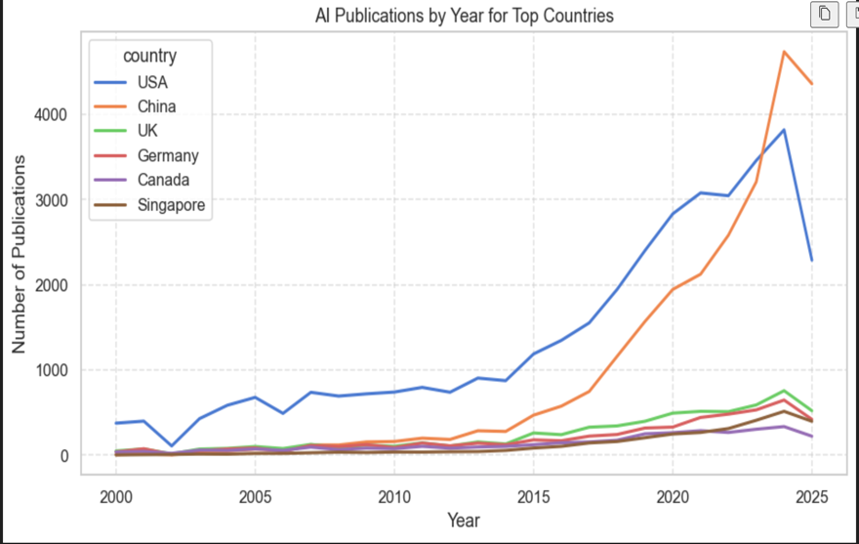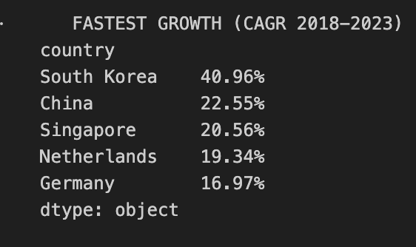
3. Shifting Global Balance The global distribution of AI research is shifting from US-centric to heavily multipolar. In 2000, the US accounted for roughly 50% of the top-tier research share. By 2025, this share contracted to approximately 20%, displaced largely by China's aggressive expansion. Meanwhile, traditional hubs like the UK and Germany maintained stable but compressed shares.
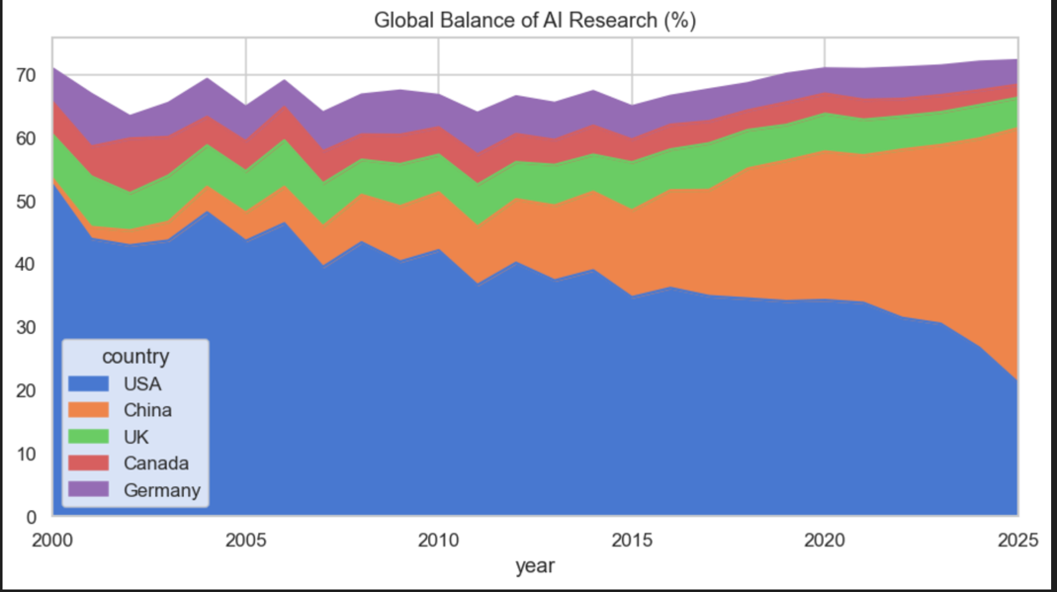
Section 4
1.The Author Landscape and Productivity Skew. The AI research ecosystem is vast, comprising 138,398 unique authors in our dataset. However, author productivity is highly asymmetric, exhibiting a pronounced heavy-tailed distribution (Lotka's Law). The vast majority of researchers contribute to only one or two publications. Conversely, a micro-fraction of "super-productive" researchers drives a disproportionate volume of output, led by individuals such as Dacheng Tao (286 publications) and Luc Van Gool (279).
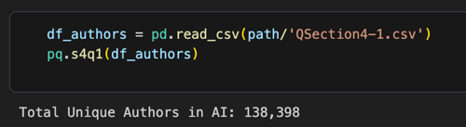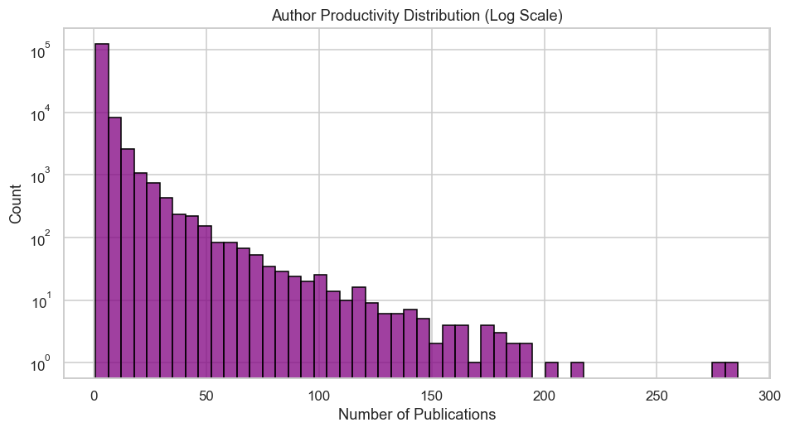
2.Expanding Team Sizes. AI scientific inquiry is systematically transitioning from isolated efforts to large-scale team science. The longitudinal data demonstrates a sustained, near-linear increase in the average number of authors per publication. Team sizes have more than doubled over the observed period, rising from an average of ~2.4 authors per paper in 2000 to over 5.5 by 2025
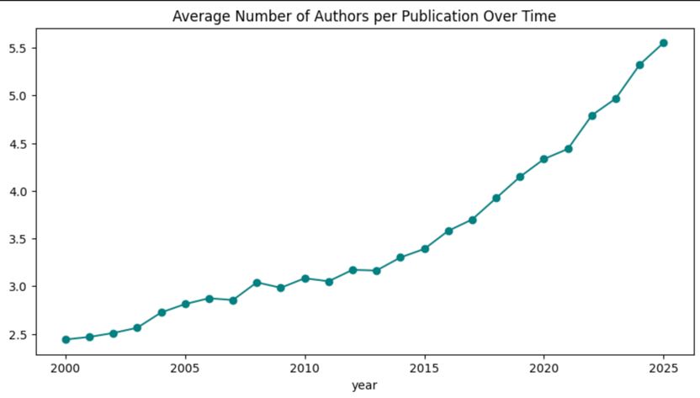
3. The International Collaboration Paradox. While the absolute number of internationally collaborative papers has surged (particularly between 2015 and 2024), their proportion of total AI output has steadily declined. After peaking at approximately 24% in 2015, the share of international collaborations dropped to roughly 16.5% by 2025. This indicates that while cross-border partnerships are growing in raw volume, domestic research output is accelerating at a much faster rate
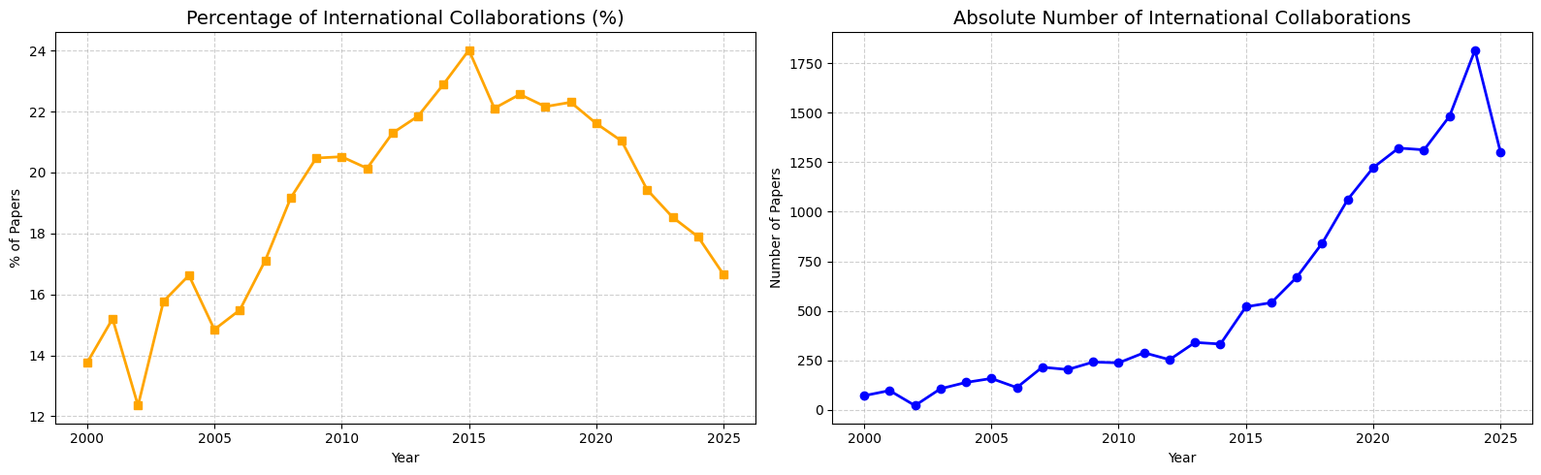
Section 5
1. Leading Institutions Top-tier AI research is leading by a global set of elite universities. Carnegie Mellon University (USA, 950 publications) and Nanyang Technological University (Singapore, 941) lead historical output, followed by the University of Oxford (UK, 806). Notably, Microsoft Research Asia is the only corporate laboratory to break into the top 10 institutions, showing the important role of those academic institutions. 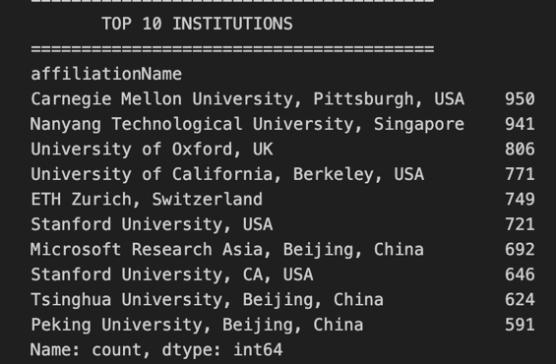
2. Temporal Dynamics While CMU maintained a steady historical advantage in the early 2000s, longitudinal tracking reveals a paradigm changet. NTU (Singapore) exhibited explosive, exponential growth post-2010, decisively overtaking its Western counterparts to become the undisputed volume leader in recent years. Other elite universities display parallel, though more moderate, upward trajectories.
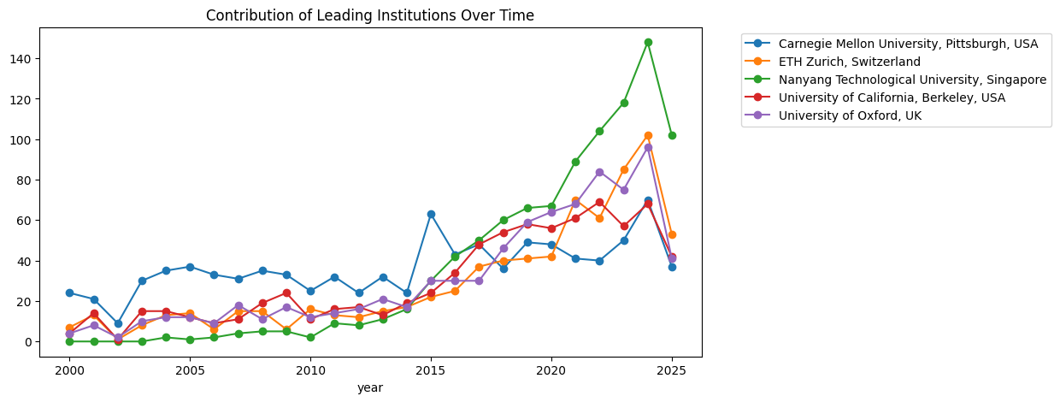
3. Subtopic Specialization The heatmap analysis reveals that top institutions possess distinct strategic concentrations rather than uniform outputs. ETH Zurich and UC Berkeley are highly specialized, directing the vast majority of their output toward computer vision (CVPR) and neural information processing (NIPS). Conversely, CMU and NTU maintain broader, more balanced research portfolios that heavily include general AI conferences (AAAI, IJCAI).
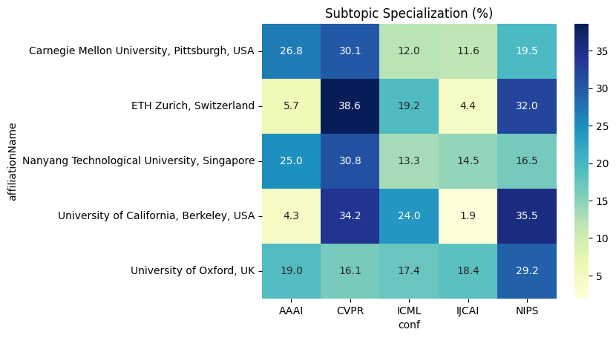
4.Academic vs. Industrial Dominance Despite the high public visibility of tech giants in AI discourse, academic institutions overwhelmingly dominate raw scientific publication volume. The temporal data clearly illustrates academia driving the exponential growth curve of the field, while industrial research centers maintain a stable, but ultimately fractional, footprint by comparison.
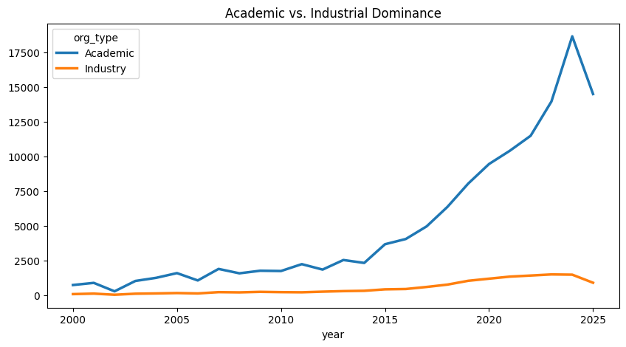

4. Key Findings
3. Geographic Shifts
The AI research landscape is slowly changing from US dominance to a US-China duopoly. While the US holds the historical volume advantage, China now leads in annual output. Rapid growth in hubs like South Korea and Singapore confirms a decisive eastward migration of global AI research power.
4.Collaboration Trends
AI is increasingly a team-science discipline; the average number of authors per paper has doubled since 2000. However, while the absolute number of international collaborations is rising, their percentage share has declined since 2015, indicating a strong pivot toward localized, domestic research.
- Institutional Leadership
Academia heavily outpaces industry in raw publication volume. The ecosystem is highly concentrated (Lotka's Law), relying on a small vanguard of super-productive researchers and elite universities (e.g., CMU, NTU) that exhibit distinct specializations across AI subfields.

