Control Optimizer Report
Plant
$$G\left(s\right)=\frac{b_{q}s^{q}+b_{q-1}s^{q-1}+…+b_{1}s+b_{0}}{a_{n}s^{n}+a_{n-1}s^{n-1}+…+a_{1}s+a_{0}}$$
Excitation Function
$$u\left(t\right)=λ⋅σ\left(t-t_{0}\right)$$
Parameter | Value
$$λ$$ | 1
$$t_{0}$$ | 0

Controller
- Controller Type: PID
- Constraint
  - Min: -5
  - Max: 5
- Anti Windup Method: Clamping
  - (Ka: 1)
- Filter Time Constant Tf
  - Factor N: 5
  - Sampling Rate: Sampling rate unknown
PSO Parameter
- Excitation Target: Reference
- Simulation Time
  - Start time: 0s
  - End time: 10s
- Performance Index
  - Time Domain
    - Error Criterion: ITAE
    - Max Overshoot: disabled
    - Slew Rate: disabled
  - Frequency Domain
    - Gain Margin: 16dB
    - Phase Margin: disabled
    - Sensitivity: disabled
- PSO Bounds
  - Kp
    - Min: 0
    - Max: 10
  - Ti
    - Min: 0
    - Max: 10
  - Td
    - Min: 0
    - Max: 10
PSO Results
PSO simulation finished after 10 seconds.
Controller Parameter:
Parameter | Value
Kp | 10
Ti | 5
Td | 1
Tf | 0.01
Min sampling rate | 100Hz

Time Domain
Parameter | Value
ITAE | 0.1
Overshoot | 10%
Slew rate | 0.2

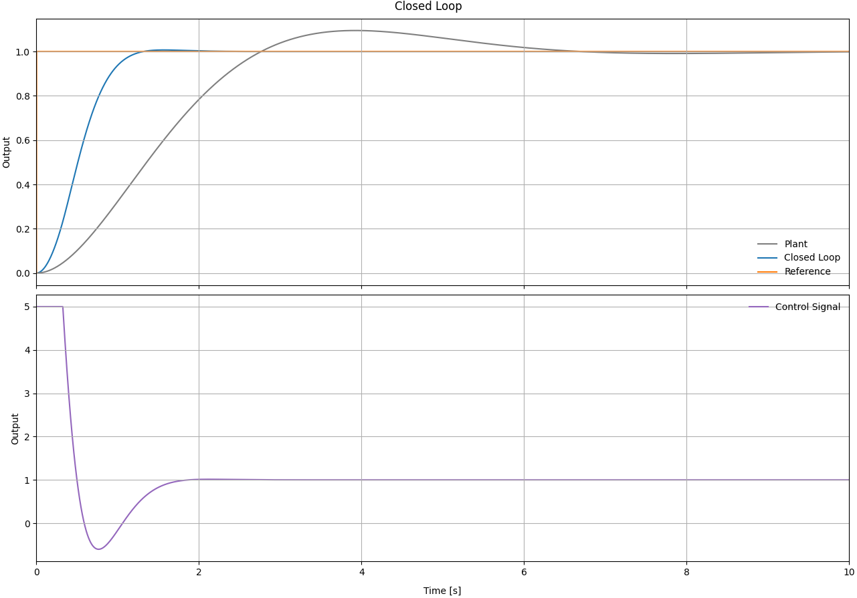
Frequency Domain
Parameter | Value
Gain margin | 8 dB @ 100 rad/s
Phase margin | 59° @ 4 rad/s
Stability margin | 2dB
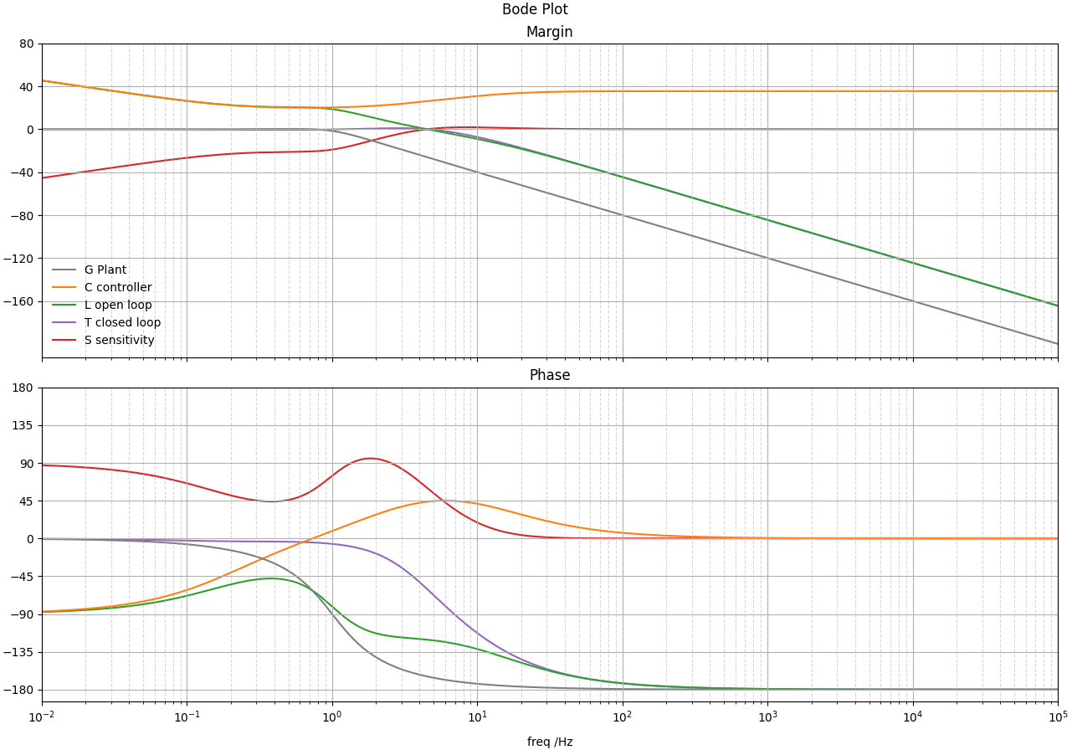

Block diagram
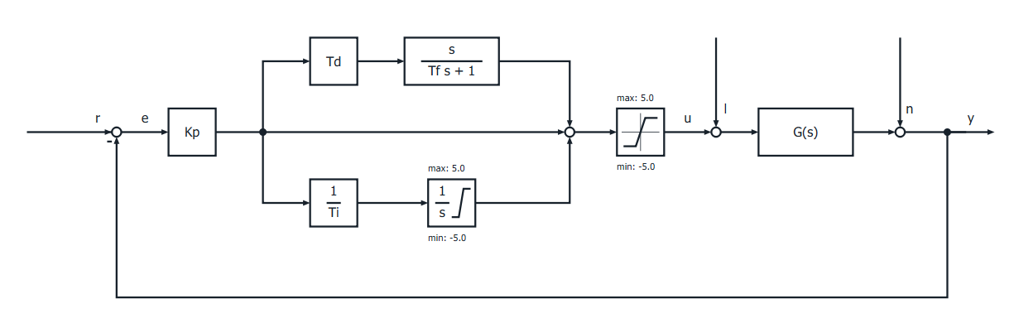
Transfer functions
Plant | $$G\left(s\right)=\frac{b_{q}s^{q}+b_{q-1}s^{q-1}+…+b_{1}s+b_{0}}{a_{n}s^{n}+a_{n-1}s^{n-1}+…+a_{1}s+a_{0}}$$
Controller | $$C\left(s\right)=K_{P}\frac{\left(T_{i}s+1\right)\left(T_{d}s+1\right)}{T_{i}s\left(T_{f}s+1\right)}$$
Opne loop | $$L\left(s\right)=G\left(s\right)C\left(s\right)$$
Closed Loop | $$T\left(s\right)=\frac{C\left(s\right)G\left(s\right)}{1+ C\left(s\right)G\left(s\right)}$$
Sensitivity | $$S\left(s\right)=\frac{1}{1+C\left(s\right)G\left(s\right)}$$

