plant_num = [1]
plant_den = [1, 0.1, 1]
use_freq_metrics = False
pm_min_deg = 100
gm_min_db = 10
ms_max = 20
big_m = 10e9
use_tracking_tolerance_constraint = False
tracking_tolerance_pct = 0.1
sim_mode = "fixed"
start_time = 0
end_time = 10
time_step = 1e-4
anti_windup = AntiWindup.CLAMPING
excitation_target = "reference"
constraint_min = -100
constraint_max = 100
performance_index = PerformanceIndex.ITAE
32s
{'best_Kp': np.float64(2.3003129482827966), 'best_Ti': np.float64(0.1), 'best_Td': np.float64(9.865698562641423), 'performance_index': <PerformanceIndex.ITAE: 3>, 'best_performance_index': np.float64(0.11339047415375224), 'plant':
PM [deg]: 24.997 (has_wc=True)
GM [dB ]: inf (has_w180=False)
Ms [lin]: 2.503672 (= 7.972 dB)
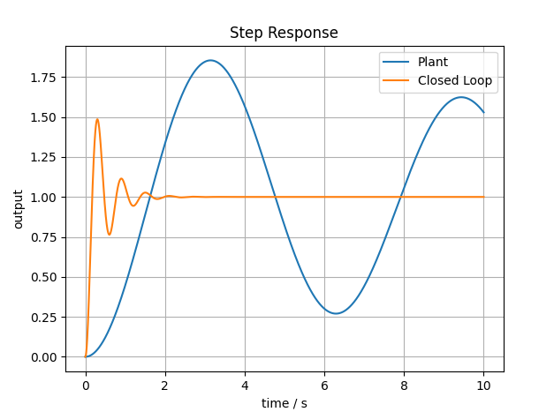
use_tracking_tolerance_constraint = True
tracking_tolerance_pct = 5
26s
{'best_Kp': np.float64(0.4992855331564965), 'best_Ti': np.float64(0.6201098857674034), 'best_Td': np.float64(2.7194087339679105), 'performance_index': <PerformanceIndex.ITAE: 3>, 'best_performance_index': np.float64(3.14014063192921), 'plant':
PM [deg]: 58.031 (has_wc=True)
GM [dB ]: inf (has_w180=False)
Ms [lin]: 1.239820 (= 1.867 dB)
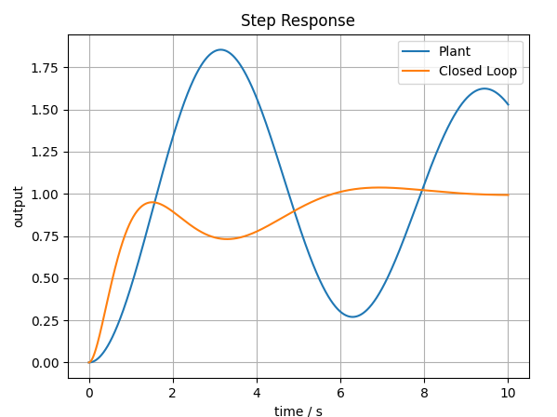

use_freq_metrics = True
pm_min_deg = 90
gm_min_db = 10
ms_max = 2
big_m = 10e9
use_tracking_tolerance_constraint = True
tracking_tolerance_pct = 5
6s
{'best_Kp': np.float64(0.03690429323121039), 'best_Ti': np.float64(0.1), 'best_Td': np.float64(10.0), 'performance_index': <PerformanceIndex.ITAE: 3>, 'best_performance_index': np.float64(6.141890877244843)
PM [deg]: 67.968 (has_wc=True)
GM [dB ]: inf (has_w180=False)
Ms [lin]: 1.287528 (= 2.195 dB)
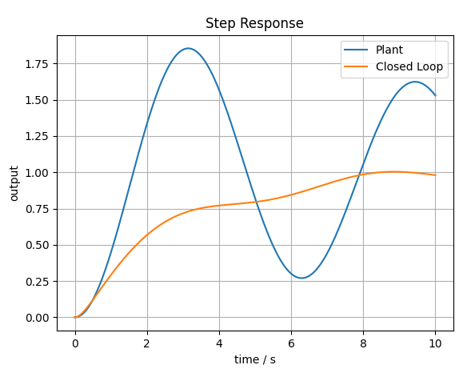
??? warum wird PM nicht aussortiert

