Dependency conflicts when installing @agm/core1.0.0
Cannot find namespace Google
map: google.maps.Map
- Needed to restart the server/ vscode, not sure which did the trick

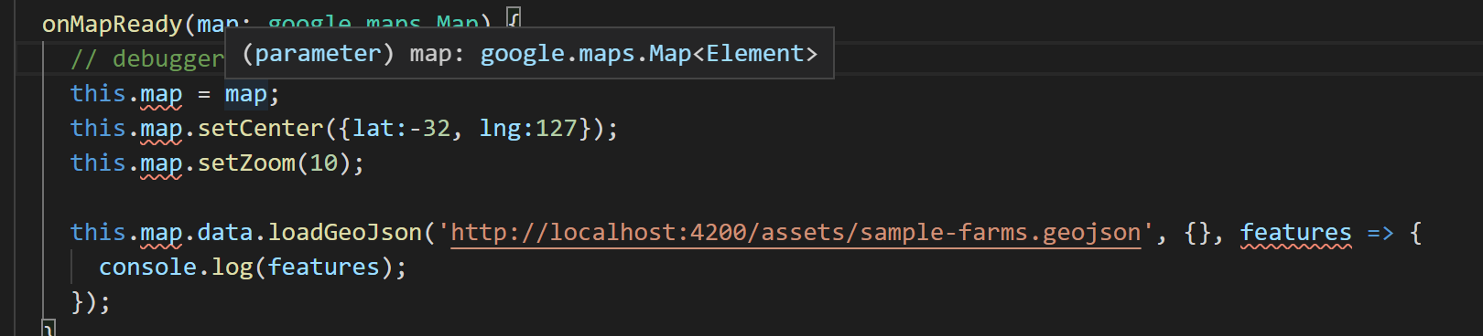
Property 'map' does not exist on type 'AppComponent'.
- Fixed, had to declare the map variable type
- map: any;
- put this just after the class heading for class AppComponent
- then it is accessible as an attribute of the AppComponent class using this.map
- similar to self.map in Python

Geojson copied from popwerpoint…
- Had to remove the \u200b characters (zero width space, at the end of each line)
- Geojson.io helped to spot this error

Could not access assets/sample-farms.geojson
- May be the – special character?
- Renamed to farms.geojson works? NO
- The system CAN access files in the assets folder though… I put something else in there and it was accessible… Perhaps it get renamed or something when it builds? Any files included in the code just show the whole application screen when you go the the json URL… But a json file not used in the program shows json in the browser… whats happening there?
- Maybe rewrite that loadGeoJson method call again to use the thick arrow syntax…

