5.1 – 2.3.5_01: Requirements Tracing

## Admin

Default admin username: admin

Default admin password: admin

* To log in as admin, enter 1 from main menu, this will take you to username and password input screens.

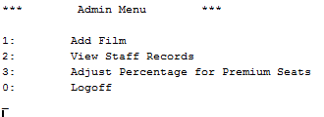

* To add a film select option one to bring you to the next menu, this will ask you to enter a film name and age rating.



* To look at staff records enter option 2 at the admin menu and will display the details of staff.

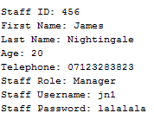

* As the admin it is also possible to change the percentage of the price increase from standard seats to premium seats. It will display the current percentage and then ask if you would like to change it, if you select yes it will ask you for the new percentage.

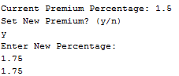

* To log out of the admin account press 0 at the main menu.

## User

Default user username: user

Default user password: user

* To log in as user, enter 2 from main menu, this will take you to username and password input screens.

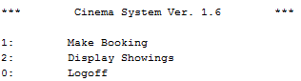

* To make a new booking select option 1 to go to the booking menu.

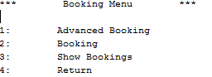

* To make an advanced booking select option 1, this will take you to another screen which will require you to input your name, age and telephone number.

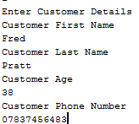

* After you have entered your details a list of film showings will appear and you will be asked to enter the ID of the showing you wish to book.

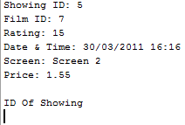

* You will then be asked to enter the number of seats you wish to book and select which row and column you wish to have the seats in. It will then display the total price of the booking and then a visual display of the seats being booked with date and time of when the booking was made with the screen number.

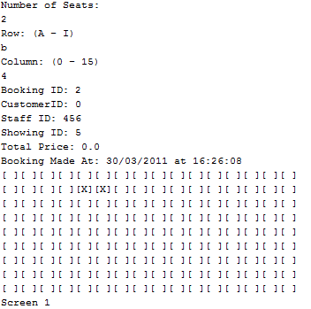

* To complete a normal booking you must select booking from the main menu by entering 2, the process is the same as advanced booking however you will not be required to enter the customer details.
* In order to see the bookings that have already been made it is possible to select the show bookings option from the main menu, this will display the seats that have been booked for each screen of the cinema.

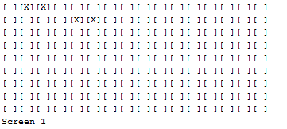

* It is then possible to logoff the system by entering 0 at the main menu, from here you can select to log back in as admin or user.