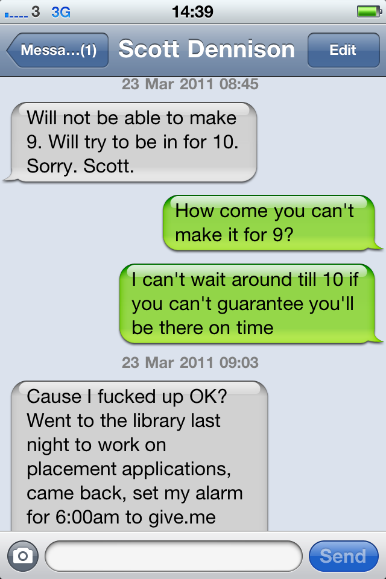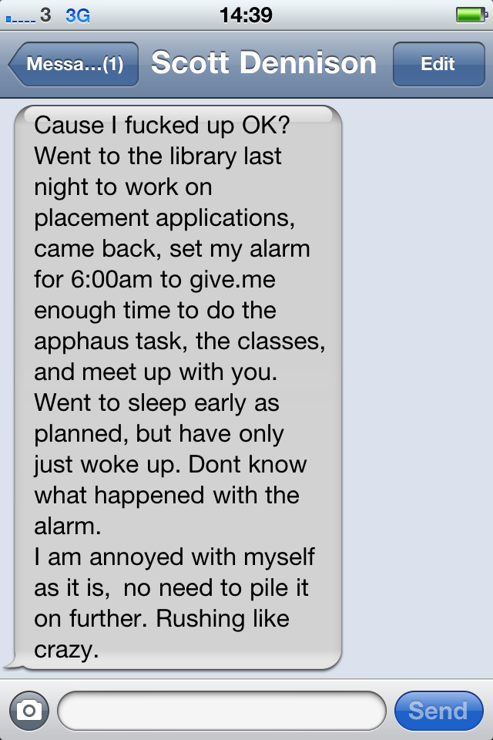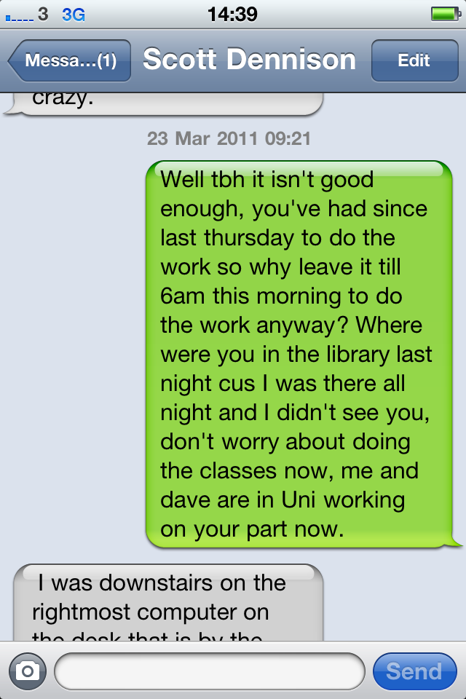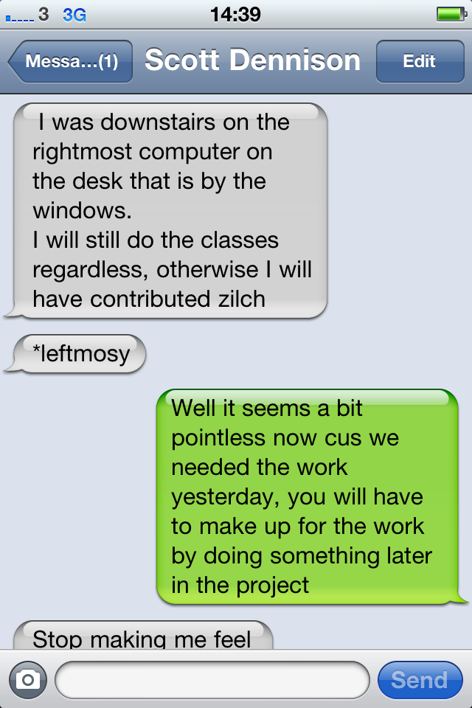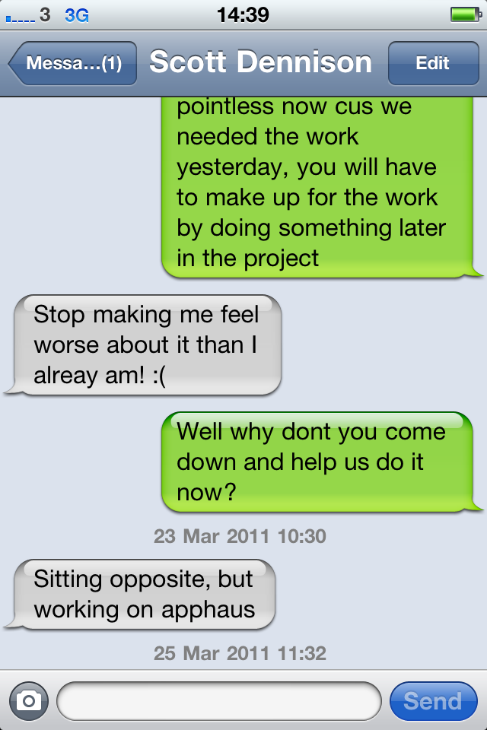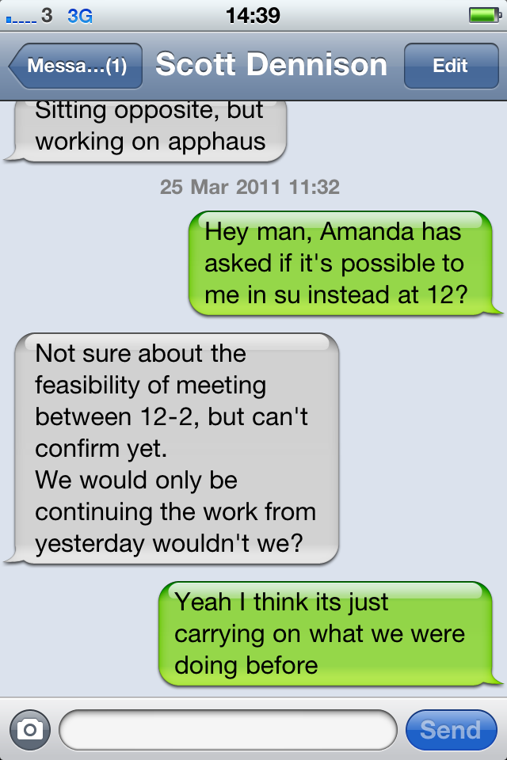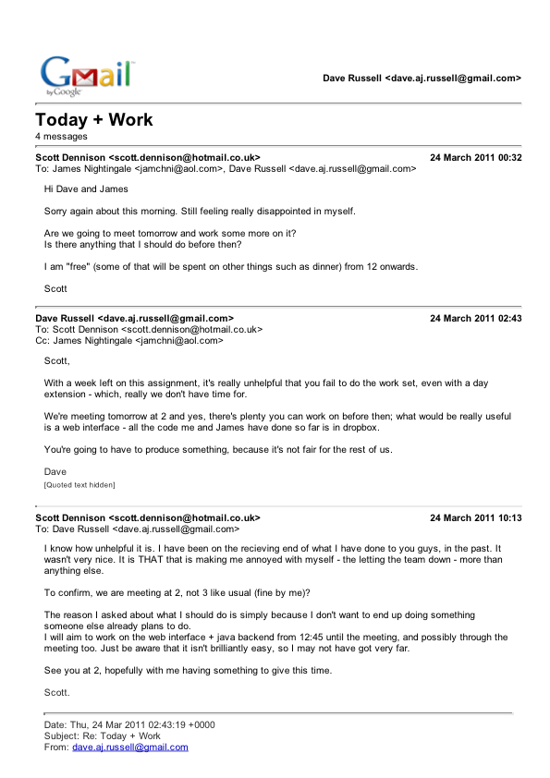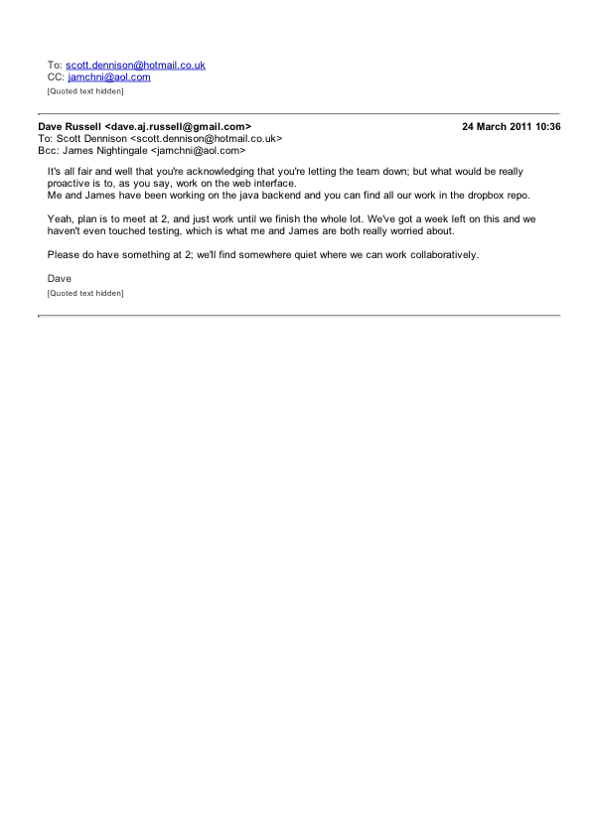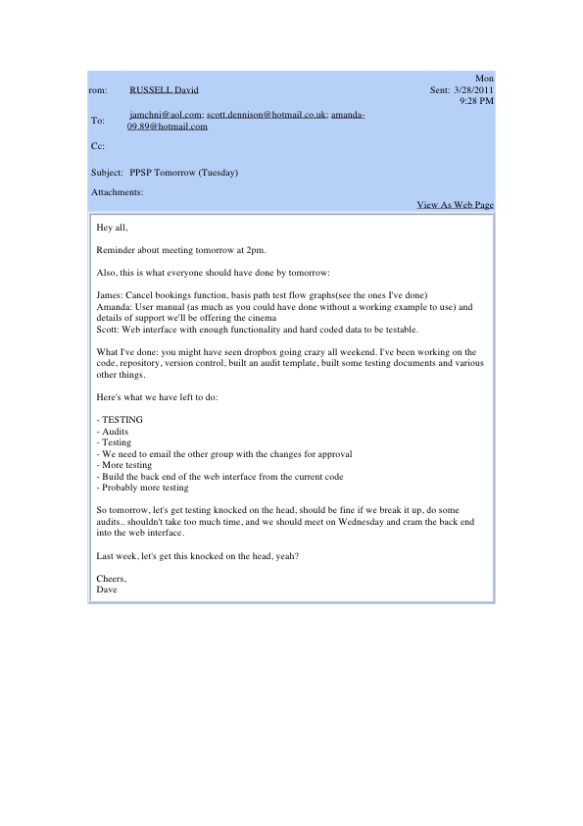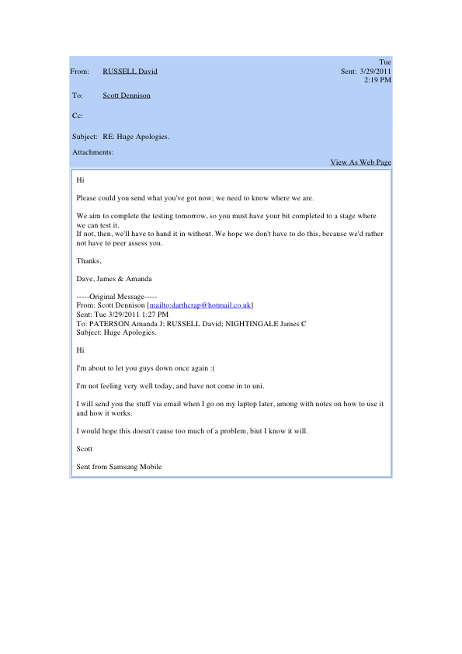

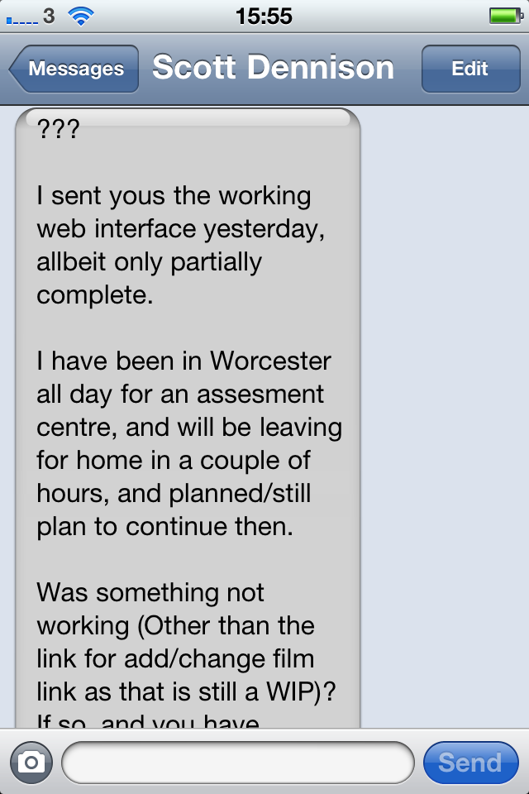

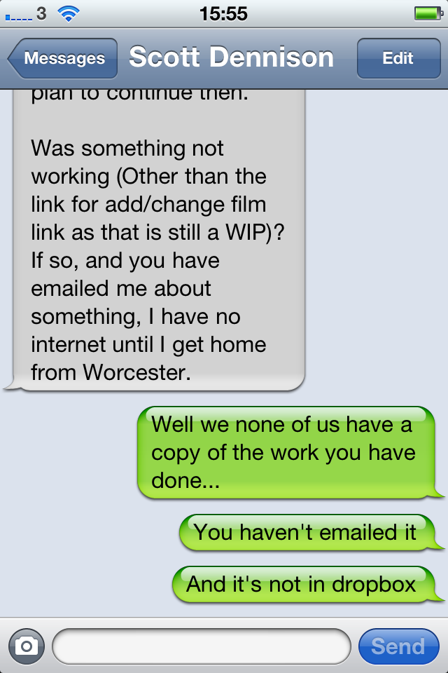

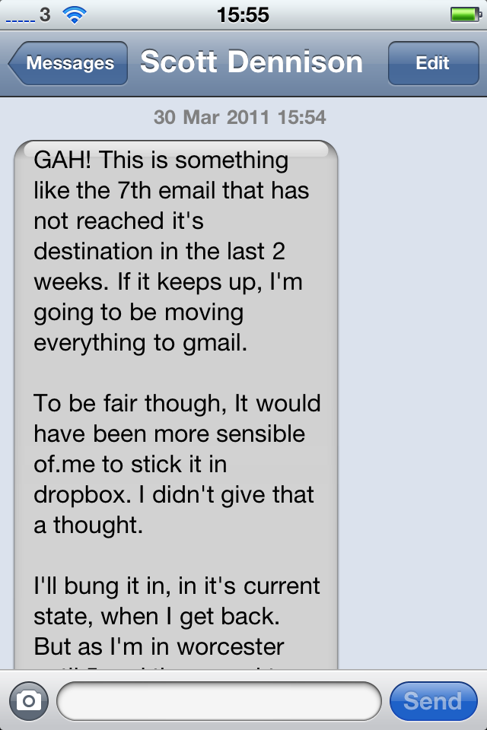

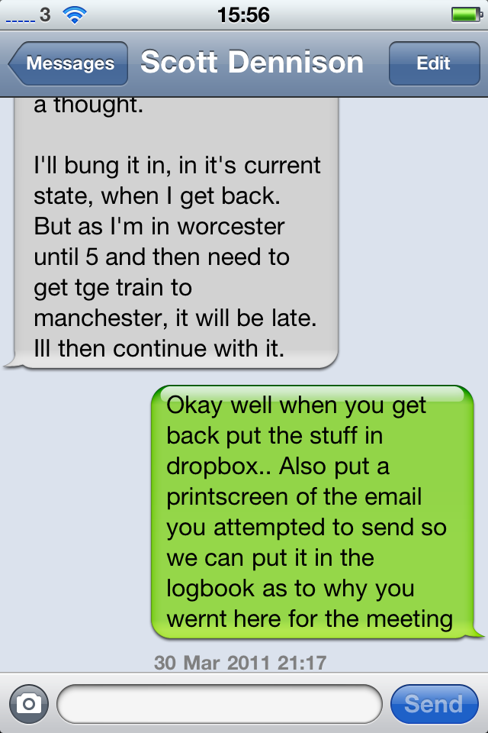

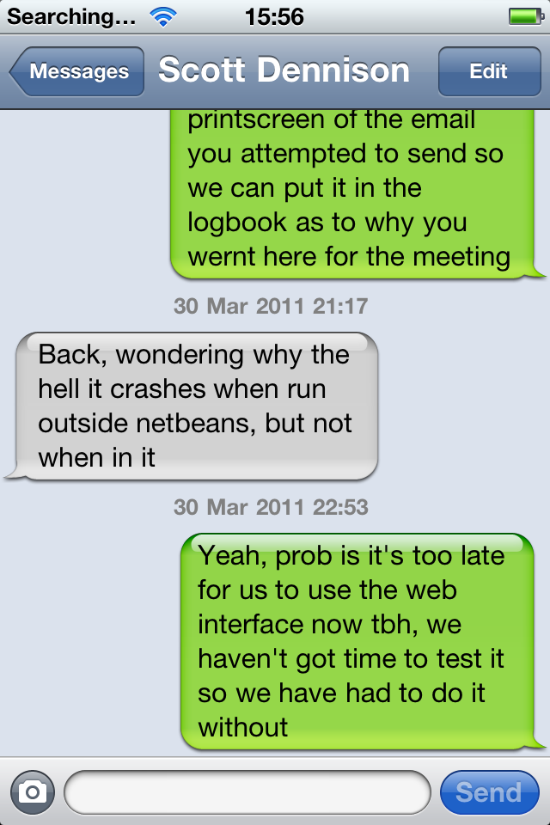

In addition, At 2pm I will be on a train that is somewhere between Nuneaton and Leicester, so that will not be possible.  
I will be in the uni from 9 until shortly after 11. This is going to cause problems signing the peer assessment isn't it.  
  
Well today has gone from a brilliant day (Proceeded to the second stage of the assessment centre. Was nervous going in, but I feel like I did well in the interview. ), to the complete opposite (Knowing I've failed PPSP).  
  
Scott

From: scott.dennison@hotmail.co.uk  
To: rw002084@student.staffs.ac.uk  
Subject: RE: PPSP tomorrow  
Date: Thu, 31 Mar 2011 01:03:20 +0100  
  
I can understand. Doesn't mean I like it, but it is perfectly fair.  
It will be annoying to see the work on the WI go to waste though.  
  
I shouldn't have suggested doing a WI using Java itself for all the processing. It's turned out to be a FAR FAR to bigger task than anticipated. I had expected it to be quite easy, but it's turned out to be nothing but a nightmare.  
  
As I've said to James, I sent you a partial (working?!? - see next sentence) copy of the interface on Tuesday night. However, for some reason, it runs when inside netbeans, but gives errors and crashes at random intervals for absolutely no apparent reason when running outside. That's no use to you is it! I still haven't found out what is causing it, and am almost at my damn limit with the thing.  
  
Do note though, it may still be possible for me to get a small extension, but with only less than two days to go, it would be more difficult than when I suggested it at the end of last week. Even if it was just for the weekend, wouldn't that be enough?  
  
Will you be peer assessing me down to a 0? I know I deserve it TBH.  
  
Scott

Subject: PPSP tomorrow  
Date: Wed, 30 Mar 2011 23:04:41 +0100  
From: rw002084@student.staffs.ac.uk  
To: jamchni@aol.com; scott.dennison@hotmail.co.uk; amanda-09.89@hotmail.com  
  
Hi all,  
  
Just to remind you; meeting tomorrow at 2 for a final polish and collaboration of everything we have for hand-in.  
  
Scott, due to your consistent failure to submit any of your delegated group work despite several promises of submissions, reminders and extensions..  
we've made the decision to peer assess you. I'm sorry it has come to this, but you've given us no choice.  
  
We took it on the chin for the first task, because we knew that you weren't so keen on the documentation and planning, as we knew that your strengths as a programmer would more than make up for it on the second task.  
However, you've not delivered anything by the deadlines we've given (and even extended) so I'm sorry, but it would just be unfair on the rest of us.  
  
So,  
Please, everyone, be there at 2pm, everyone needs to stick about for the hand in and the business of the peer assessment.  
  
Cheers all,  
Dave

|  |  |  |  |  |  |  |  |  |  |  |  |  |  |  |  |  |  |  |  |  |
| --- | --- | --- | --- | --- | --- | --- | --- | --- | --- | --- | --- | --- | --- | --- | --- | --- | --- | --- | --- | --- |
| |  |  |  |  | | --- | --- | --- | --- | | From: | [RUSSELL David](https://weboutlook.staffs.ac.uk/exchange/rw002084@student.staffs.ac.uk/Sent%20Items/RE:%20RE%20(Edit):%20PPSP%20tomorrow.EML/?cmd=editrecipient&Index=-1) | Sent: | Thu 3/31/2011 4:37 PM | | To: | [Scott Dennison](https://weboutlook.staffs.ac.uk/exchange/rw002084@student.staffs.ac.uk/Sent%20Items/RE:%20RE%20(Edit):%20PPSP%20tomorrow.EML/?cmd=editrecipient&Index=0) |  |  | | Cc: |  |  |  | | Subject: | RE: RE (Edit): PPSP tomorrow |  |  |  |  |  | | --- | --- | | Attachments: |  | | [View As Web Page](https://weboutlook.staffs.ac.uk/exchange/rw002084@student.staffs.ac.uk/Sent%20Items/RE:%20RE%20(Edit):%20PPSP%20tomorrow.EML/) | | |
| |  | | --- | | Hi Scott,  Because you're at your interview, we're going to aim to do the final collaboration and hand in on Friday instead. Please could you meet us at 11.30am in the octagon?  Regarding your web ui..  We've decided that it's just too late to do anything about it now.  You said that you sent us a partially working one on tuesday evening which we'd have been able to include in the testing document. But none of us ever got this email, and you ignored James's request to see a screen shot of that email as proof of you sending it.  Sorry, but a submission at 6am, 2 days after the deadline (and an extension) and the day after we scheduled to test the software (we know you had an interview, but you knew that we hadn't got anything from you on Tuesday, the day before we scheduled to test) is just too late.  We've all got assignments that we've put on the back burner for this project and we can't afford to spend more time than we already have done compensating for your non/late submissions.  Dave, James & Amanda | |