The Muressons Stakeholder Module
Comprehensive Reference — architecture, archetypes, and decision flow
Business & Sustainability simulation · stakeholder ↔ Social-License-to-Operate (SLO) system

Contents
Open in Word and right-click → Update Field to populate the table of contents.

Part I — Conceptual Overview
This part is written for facilitators and designers: what the stakeholder module represents, who the stakeholders are, and how the system behaves. Part II goes to code level for engineers.

1. Purpose: why the module exists
Muressons is a conglomerate-management simulation in which players run four business units across ten six-month rounds. Financial success alone is not the point — the pedagogical goal is that players learn to manage a company's Social Licence to Operate (SLO): the ongoing acceptance a business earns from the communities, regulators, investors and media around it. The stakeholder module is the engine that makes that licence feel earned rather than scored.
It turns a set of numbers into relationships with history and stakes. Stakeholders remember how they were treated, escalate when neglected, form coalitions, hold the company to its promises, and — when pushed far enough — strike, sue, divest, or expose. SLO sits at the centre as the hinge between what players decide and how the world reacts.

2. The core idea in one loop
Everything in the module is one reinforcing loop. Player decisions move SLO; SLO decides how each stakeholder feels; feeling becomes escalation and action; those actions hit revenue, reputation, treasury and SLO itself — which constrains the next round of decisions. Neglect compounds, and 'stakeholder fatigue' makes each recovery harder than the last.
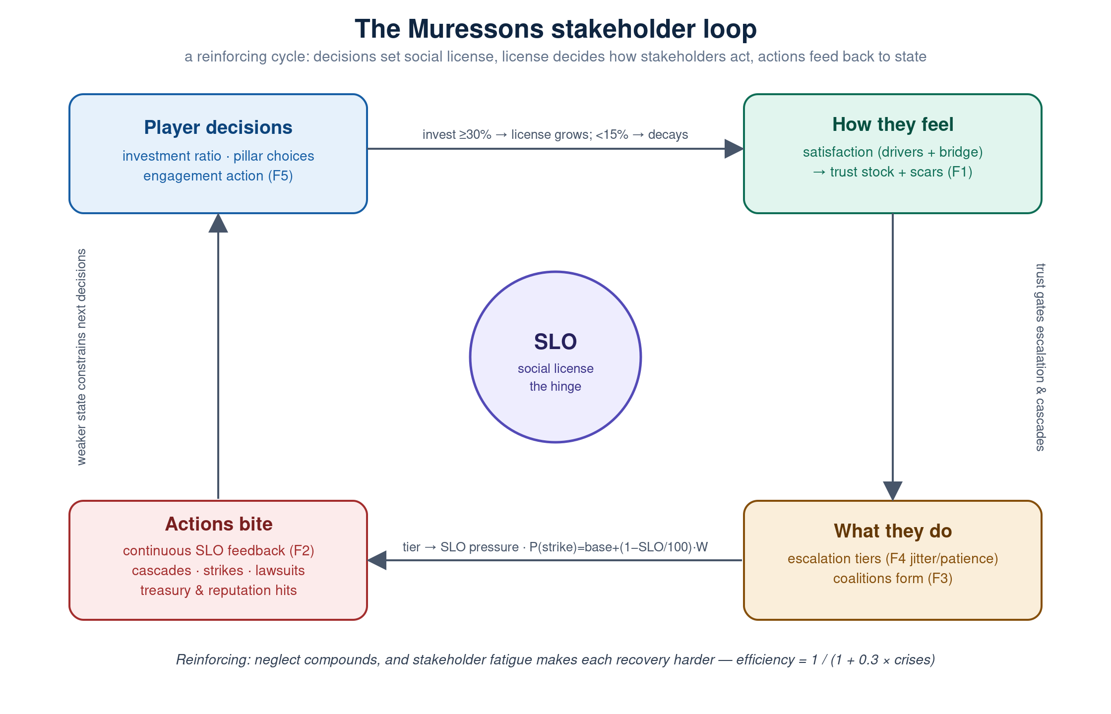
Figure 1 — The stakeholder feedback loop. SLO is the hinge; F1–F6 label the behaviour waves.

3. The four stakeholder archetypes
Four named non-player characters (NPCs) personify the stakeholder landscape. Each is modelled on the Mitchell, Agle & Wood (1997) salience framework — the mix of power (can they hurt you?), legitimacy (is their claim seen as valid?) and urgency (how fast do they demand a response?). Each cares about different things, escalates through its own four-rung ladder, and has a distinct breaking-point action.

3.1 The Activist Investor — Elise Thornton
FutureFirst Activist Fund · assertive · 🦅
- Leverage (salience): high power, high urgency, moderate legitimacy
- What moves them: Climate disclosure, board diversity, stranded assets. Rewards rising reputation, ESG-linked pay and low carbon; punished by governance risk.
- Escalation ladder: Supportive → Concerned letter to the board → Public campaign → Proxy fight / AGM challenge.
- At breaking point: At breaking point launches a divestment campaign (share price −5%, reputation −8, drags the media in) or a proxy fight (−$2M AGM cost, but governance actually improves and the regulator starts watching).
“We’ve been patient, but your governance shortfall is becoming a liability.”

3.2 The Regulator — Commissioner Sofia Petrova
EU DG FISMA, Corporate Sustainability Division · methodical · 🏛️
- Leverage (salience): very high power and legitimacy, lower urgency (slow but decisive)
- What moves them: CSRD compliance, taxonomy alignment, audit quality. Rewards low governance risk and strong disclosure.
- Escalation ladder: Compliant (no action) → Enhanced monitoring → Formal investigation → Enforcement action / fine.
- At breaking point: At breaking point issues an enforcement action: a fine worth ~4% of revenue plus mandatory enhanced disclosure, and pulls both the media and activist investor in behind it.
“Persistent non-compliance is not acceptable.”

3.3 The Community Leader — Rajesh Patil
Head Panchayat, Deccan Plateau District Council · passionate · 🏘️
- Leverage (salience): high legitimacy, low power — pressure builds slowly but is morally weighty
- What moves them: Water rights, employment, environmental justice. Rewards social licence, water stewardship and a funded just-transition; punished by water stress.
- Escalation ladder: Community partnership → Community monitoring → Community protest → Legal action / injunction.
- At breaking point: At breaking point files a court injunction against facility operations (SLO −10, reputation −5) and the story goes to the press.
“Our water, our land, our lives! Muressons takes everything and gives nothing.”

3.4 The Journalist — Jaya Mehta
Senior Investigative Reporter, Deccan Herald Business · curious · 📰
- Leverage (salience): moderate across the board — the amplifier rather than the initiator
- What moves them: Transparency, greenwashing, worker conditions. Rewards openness and reputation; punished by governance risk.
- Escalation ladder: Positive feature story → Balanced coverage → Critical investigation → Viral exposé.
- At breaking point: Has no cascade of its own, but is the amplification target other stakeholders’ cascades reach for — a hostile journalist multiplies every other reputational hit and can help tip a coalition into a viral story.
“Documents reveal systematic failures. Investors are demanding answers.”
A fifth archetype, the Gen-Z Employee, exists in the reaction catalogue (a coordinated mass resignation that spikes burnout +15, OPEX +8% and reputation −5) but does not yet carry a full satisfaction/escalation profile — it is a defined extension point rather than an active named NPC.

4. The six behaviour waves at a glance
On top of the base archetypes, six optional 'waves' deepen the realism. Each is independently switchable per cohort and ships off by default, so a facilitator can dial the richness up as a class matures.
Wave | What it adds
F1 — Memory | A persistent trust stock that rises slowly, falls fast, and scars on betrayal; a sentiment bridge keeps named NPCs consistent with the portfolio view.
F2 — SLO feedback | Each stakeholder's escalation tier continuously nudges the social licence of the units it is attached to — the loop's 'slope' between the discrete 'cliffs'.
F3 — Coalitions | Two or more hostile stakeholders combine into a coalition that amplifies SLO pressure and strike risk; fired reactions nudge their named targets.
F4 — Uncertainty | Escalation thresholds are jittered per cohort (fair but unknown) and a patience clock forces escalation on stakeholders kept waiting.
F5 — Promises | A dialogic verb: town halls, public pledges and private commitments, tracked in a ledger — kept promises pay off, broken ones scar.
F6 — Intel | An intent-forward UI that surfaces what each stakeholder wants, how much leverage they hold, and their trend — numbers move to the facilitator view.

Part II — Technical Deep-Dive
This part is written for engineers and system designers: modules, state, the round pipeline, the governing formulas, configuration and safety.

5. Architecture & modules
Module | Responsibility
npc_stakeholders.py | The four named NPCs: satisfaction, the trust integrator (F1), escalation with jitter/patience (F4), continuous SLO feedback (F2), and the intent intel emitter (F6).
stakeholder_sentiment.py | Portfolio-level sentiment: per-stakeholder attitude_score, flag-driven deltas, black-swan shocks, and salience-weighted scoring.
systemic_risk_engine.py | Discrete reaction cascades (STAKEHOLDER_REACTION_GATES), coalitions & contagion (F3), materiality shocks, and systemic tipping points.
stakeholder_engagement.py | Engagement actions and the promise ledger (F5): apply an action, resolve due promises.
round_logic.py :: run_new_engines | Orchestration and gating — runs each engine in toggle-guarded try/except so no stakeholder engine can ever block a tick.
engine.py :: process_tick | Earlier in the tick: SLO natural decay, pillar deltas, strike probability, sentiment update, and the whitelisted next-round state assembly.
config.py | All tunables (trust rates, SLO coupling, coalition gains, jitter, patience, engagement costs), resolved from the config-Excel pipeline.

6. State model & persistence
All named-NPC state lives in one sub-dict, global_state["npc_stakeholders"], holding each NPC's profile, satisfaction, trust, escalation level, interaction history, scar window, threshold offsets, and the promise ledger. A key correctness fix underpins the whole module: process_tick rebuilds the next-round state from an explicit whitelist, which historically dropped this sub-dict and re-initialised the NPCs every round. It is now carried forward via a named ENGINE_STATE_KEYS passthrough, so trust, promises and patience actually persist. The sub-dict never surfaces through the typed GlobalStateOut response; per-round UI data flows through the diagnostics channel instead.

7. Decision flow — order of operations
A single player commit produces a single tick. The stakeholder work happens in a fixed order, chosen so that SLO is finalised for the round's economics before the stakeholder engines read it, and so cascades, coalitions and continuous feedback compose without double-counting.
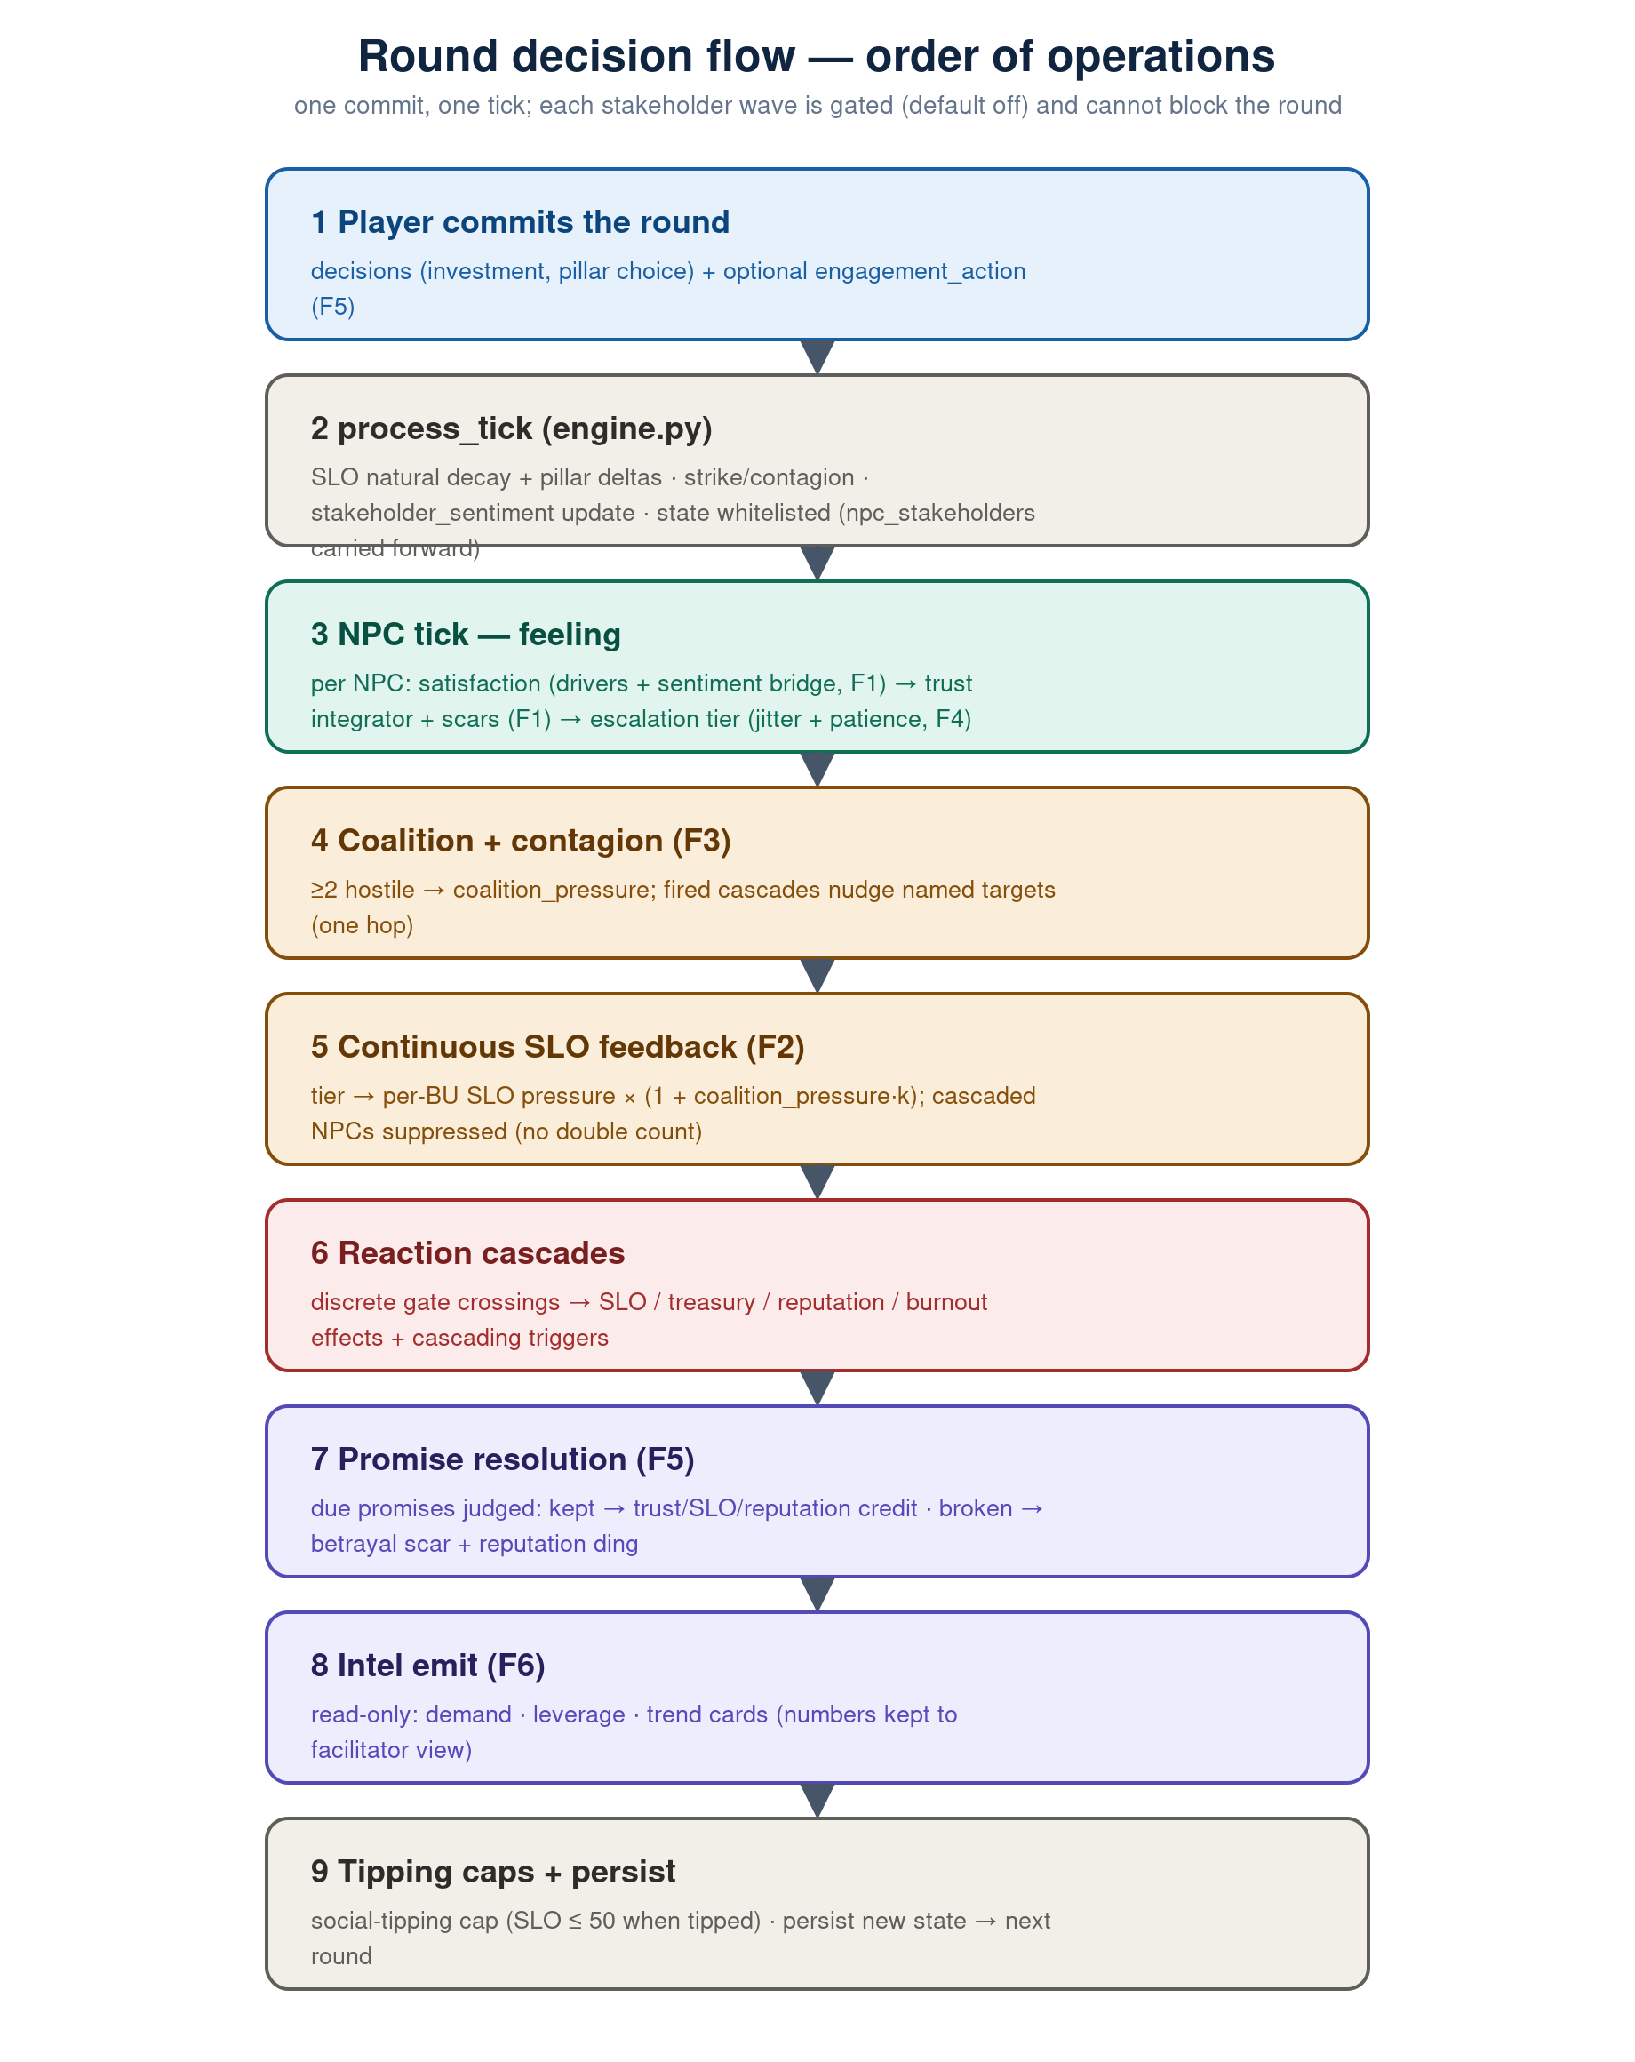
Figure 2 — The round pipeline. Steps 3–8 are the stakeholder engines, each gated and non-fatal.
The double-count guard is the subtle part: continuous SLO feedback (step 5) runs after cascade detection but before cascade effects, and suppresses any NPC that cascades this round — the discrete social-licence delta supersedes the continuous term. The later social-tipping cap still clamps SLO, and is not duplicated.

8. The governing mechanics

8.1 Natural decay & satisfaction
Each round, an unattended SLO drifts: investment ratio ≥ 0.30 grows it (+3 to +10), ≥ 0.15 holds it, and below 0.15 it decays by ~4% (×0.96). Satisfaction for each NPC is a weighted sum of its drivers:
satisfaction = clamp(50 + Σ weight·(value − baseline), 0, 100)
With F1 memory on, satisfaction is blended toward the matching sentiment cohort's attitude_score at bridge_weight 0.30, so the named NPC and the portfolio view cannot drift apart.

8.2 Trust integrator & scars (F1)
Trust is a stock that integrates satisfaction asymmetrically — slow to earn, fast to lose — and scars on betrayal (a deny-and-deflect or greenwash choice, or a broken promise):
gap = satisfaction − trust_prev
rate = 0.25 if gap ≥ 0 else 0.55
trust = trust_prev + rate·gap
# betrayal: trust −= 12 ; recovery capped at 60 for 3 rounds

8.3 Escalation tiers & uncertainty (F4)
Escalation selects the worst tier whose threshold the gating metric clears — trust when memory is on, else satisfaction. With F4, each NPC's four thresholds are jittered ±4, drawn once per cohort from the GAME-4 seed (identical for every team, unknown to all). A patience clock escalates any NPC held at a wary tier for three rounds, regardless of the metric; recovering to the cooperative tier resets it.

8.4 Continuous SLO feedback (F2)
Each round every non-cascading NPC applies a per-tier nudge to the SLO of the units it is attached to (the community leader → water/agri units; regulator, investor and journalist → all units):
pressure = [+1.0, 0.0, −2.0, −3.5][tier] × coupling × (1 + coalition_pressure·0.5)
It clamps to [0, 100] (not the tipping cap), is idempotent within a round, and skips cascaded NPCs.

8.5 Reaction cascades
At much lower thresholds, stakeholders cross discrete gates with hard effects — divestment, enforcement, injunction, mass resignation — each carrying treasury, reputation, SLO or burnout deltas and a list of cascading_triggers naming the stakeholders it drags along. See Appendix A for the full gate table.

8.6 Coalitions & contagion (F3)
When two or more stakeholders sit at a hostile tier a coalition forms; its pressure grows with the number of members beyond the first and their mean salience:
coalition_pressure = min(1.0, mean_salience · (member_count − 1))
The pressure amplifies F2 feedback and next round's strike risk; separately, each fired cascade nudges the satisfaction/trust of its named targets by −5, one hop only, so a chain can never run away.

8.7 Strike probability
Low social licence raises the odds of a revenue-zeroing strike, amplified by any coalition:
P(strike) = base_risk + (1 − SLO/100)·0.4·(1 + coalition_pressure·0.5) # clamped [0,1]
# base_risk = governance_risk / 100
Stakeholder fatigue makes recovery progressively harder: recovery_efficiency = 1 / (1 + 0.3 · crises).

8.8 Promises & engagement (F5)
Players may spend a round targeting one stakeholder: a town hall (+3 trust, no promise), a public pledge (+6 trust, registers a promise) or a private commitment (+4 trust, registers a promise), each with a treasury cost. At the due round a promise is judged: kept pays +8 trust, +4 SLO and +3 reputation; broken fires the F1 betrayal scar (−12 trust, capped recovery) and a −6 reputation ding. The ledger lives inside the carried-forward npc_stakeholders sub-dict.

8.9 Intent intel (F6)
A read-only emitter turns each NPC into a card: its top unmet demand in plain language, its leverage (salience in words, e.g. 'high legitimacy, low power'), and its trend. Raw satisfaction and trust numbers are kept to a facilitator sub-dict. The demand phrasing is authored on the backend as the single source of truth, so the front-end rail can never drift from it.

9. Configuration & toggles
Every wave is gated on a pedagogical toggle, all default off, flippable per cohort in the setup modal (no code). With all off, behaviour is identical to the pre-module baseline and the regression 'golden trace' is byte-identical.
Toggle (default off) | Wave / effect
stakeholder_memory_enabled | F1 — trust stock, scars, sentiment bridge
stakeholder_slo_feedback_enabled | F2 — continuous tier → SLO feedback
stakeholder_engagement_enabled | F5 — engagement actions + promise ledger
stakeholder_coalitions_enabled | F3 — coalitions & salience contagion
stakeholder_uncertainty_enabled | F4 — seeded thresholds + patience
stakeholder_intel_ui_enabled | F6 — intent-forward intel rail

Recommended enablement order mirrors the dependencies: Memory → SLO feedback → Promises, then Coalitions, Uncertainty and Intel in any order. Enabling F1–F5 changes the golden trace (trust and SLO now evolve) — that diff is the signal the wave works; re-baseline deliberately. All numeric tunables resolve through config.py's config-Excel pipeline, so they are adjustable without a code change.

10. Testing & safety
- Golden oracle: A seeded golden round-trace oracle pins SLO, reputation, governance risk and NPC state across a fixed 10-round run; with every wave off it must stay byte-identical to the prior baseline.
- Per-wave tests: Each wave ships with focused unit tests — trust asymmetry and scars, the sentiment bridge, the F2 double-count/idempotency guards, coalition pressure and strike coupling, jitter reproducibility and patience, promise kept/broken, and the intel drift tripwire.
- Determinism: All randomness flows through the seeded GAME-4 stream, so every team in a cohort faces the same rolls; the last bare-random draws in the stakeholder path were moved onto it.
- Non-fatal: Every stakeholder engine runs inside a toggle-guarded try/except that logs and continues, so a fault in any wave can never block a round.

Appendix A — Archetype specification tables

Salience (Mitchell–Agle–Wood)
Stakeholder | Power | Legitimacy | Urgency
Activist investor | 0.85 | 0.70 | 0.90
Regulator | 0.95 | 0.95 | 0.60
Community leader | 0.30 | 0.90 | 0.75
Journalist | 0.50 | 0.60 | 0.40

Satisfaction drivers (weight, baseline)
Stakeholder | Drivers
Activist investor | reputation (+0.3/50), carbon intensity (−0.3/50), ESG-linked pay (+0.2/20), governance risk (−0.2/30)
Regulator | governance risk (−0.4/30), reputation (+0.2/50), TNFD disclosure (+0.2/0)
Community leader | social licence (+0.4/50), water stress (−0.3/40), just-transition fund (+0.2/0)
Journalist | transparency (+0.3/50), reputation (+0.2/50), governance risk (−0.3/30)

Reaction-cascade gates
Stakeholder → action | Trigger | Effects
Activist → divestment campaign | trust < 25 | treasury −5%, reputation −8, drags in journalist (persists 2 rounds)
Activist → proxy fight | trust < 15 | −$2M, governance risk −10 (improves), board change, regulator watches
Regulator → enforcement action | trust < 20 | treasury −4% fine, mandatory disclosure, drags in journalist + activist
Community → court injunction | trust < 20 | SLO −10, reputation −5, drags in journalist
Gen-Z employee → mass resignation | trust < 20 | burnout +15, OPEX +8%, reputation −5, drags in journalist

Appendix B — Key configuration constants
Constant | Default | Meaning
TRUST_GAIN_RATE / LOSS_RATE | 0.25 / 0.55 | Asymmetric trust integration (rise / fall)
TRUST_SCAR_IMMEDIATE / DURATION / CEILING | 12 / 3 / 60 | Betrayal hit, scar window, capped recovery
NPC_SENTIMENT_BRIDGE_WEIGHT | 0.30 | Pull of the portfolio cohort on named-NPC satisfaction
STAKEHOLDER_SLO_COUPLING | 1.0 | Scales the F2 per-tier SLO pressure
COALITION_TIER_MIN / F2_GAIN / STRIKE_GAIN | 2 / 0.5 / 0.5 | Hostile-tier threshold; coalition amplification of F2 and strike
CONTAGION_SAT_NUDGE | 5.0 | One-hop satisfaction/trust nudge to a cascade's named targets
THRESHOLD_JITTER / PATIENCE_LIMIT | 4.0 / 3 | Escalation-threshold band; rounds-at-tier before forced escalation

Muressons stakeholder module — reference v1. Mechanics gated behind per-cohort toggles; all tunables config-Excel adjustable.

