Muressons Global Corporation

Student Manual

Version 3.0 | May 2026

Table of Contents 4
PART I: GETTING STARTED 6
1. Welcome & Simulation Overview 7
1.1 The Simulation Premise 7
1.2 The Four Business Units 7
1.3 Difficulty Tiers 7
2. Joining a Session & Onboarding 8
2.1 Accessing the Simulation 8
2.2 Starting a Solo Session 8
2.3 The Onboarding Tour 8
3. The Executive Cockpit 9
3.1 Header Bar 9
3.2 KPI Gauges Panel (Left Sidebar) 9
3.3 Investment Matrix 10
3.4 Strategic Options Panel 10
3.5 Bottom Navigation Bar 10
3.6 Market Ticker 10
PART II: THE GAME LOOP 11
4. Decision-Making Framework 12
4.1 The Three-Step Decision Cycle 12
4.2 Understanding the Investment Matrix 12
5. Round-by-Round Walkthrough 13
Round 1: 📋 Foundations — ESG Baseline Assessment 13
Round 2: 📊 Double Materiality — Materiality-Based Budget Allocation 13
Round 3: 🌍 Scope 3 Emissions — Supply Chain Decarbonisation 14
Round 4: 🔥 Contagion — Reputation Crisis Cascade 15
Round 5: 🌪️ Climate — Physical Climate Risk Event 16
Round 6: 🤖 AI Bias — Algorithmic Ethics & Brand Risk 16
Round 7: ♻️ Circularity — Circular Economy Transition 17
Round 8: 💧 Blue Stress — Water Scarcity Emergency 18
Round 9: ⚖️ Just Transition — Workforce & Community Justice 19
Round 10: 🏛️ Grand Finale — Year 5 Activist Ultimatum & Terminal Valuation 19
6. Strategic Pillars Paradigm 21
Round 1: ESG Foundation Strategy 21
Round 2: Double Materiality Investment 21
Round 3: Scope 3 Decarbonisation 22
Round 4: Reputation Crisis Response 23
Round 5: Climate Resilience 24
7. Round 10: Grand Finale & Ending Pathways 26
7.1 The Five Ending Pathways 26
🎯 Activist Ultimatum 26
🎯 Climate Black Swan 26
🎯 Stakeholder Revolt 26
🎯 Hostile Takeover 27
🎯 Regulatory Shutdown 28
7.2 Corporate Archetypes 28
7.3 Game Over Summary 29
PART III: UNDER THE HOOD 31
8. Mathematical Engines Explained 32
8.1 Core Engines 32
8.1.1 Corporate Strategic Fund (CSF) 32
8.1.2 Contagion Engine (Sigmoid Model) 32
8.1.3 Synergy Engine (Diminishing Returns) 32
8.1.4 Natural Capital Cost of Debt 33
8.1.5 VRIO Decay 33
8.1.6 Talent Brain-Drain 33
8.1.7 Strike Probability (R9) 33
8.1.8 Natural Decay (Entropy) 34
8.2 Advanced Engines (Available in Advanced/Expert Tiers) 34
9. KPI Deep Dive 35
10. Scoring & Terminal Valuation 36
10.1 Terminal EBITDA Calculation 36
10.2 Regenerative Multiple (M_R) 36
10.3 Terminal Value Formula 36
10.4 What-If Scenario Comparison 37
11. Flag Dependencies & Cascades 38
PART IV: REFERENCE 39
12. Real-World Case Studies 40
Case 1: 🚗 Volkswagen Dieselgate (2015) 40
Case 2: 🥛 Danone's Double Materiality Journey (2020-2023) 40
Case 3: 🌊 Ørsted's Green Transformation (2017-2023) 41
Case 4: 👟 Nike's Supply Chain Scandal (1990s) 42
Case 5: 🌿 Unilever's Climate Adaptation (2010-2020) 42
Case 6: 🤖 Amazon's AI Recruitment Tool Bias (2018) 43
Case 7: ♻️ Interface Carpets' Circular Transformation (1994-2020) 44
Case 8: 💧 Coca-Cola's Water Crisis in India (2003-2007) 44
Case 9: ⚡ Enel's Just Transition (2019-2025) 45
Case 10: 🦈 Danone's Activist Investor Battle (2021) 45
13. Strategic Tips & Common Mistakes 47
13.1 Top 5 Strategic Tips 47
13.2 Common Mistakes 47
14. Glossary of Key Terms 48
15. Quick Reference Card 53
APPENDICES 55
Appendix A: Decision Paradigm Comparison 55
Appendix B: Industry Vertical Alternatives 55
Appendix C: Minigames & Side Activities 55
Appendix D: Further Reading & Academic References 55

PART I: GETTING STARTED

1. Welcome & Simulation Overview
Welcome to Muressons Global Corporation — a multi-round ESG strategy simulation where you step into the role of Chief Sustainability Officer of a diversified multinational conglomerate.
Your mission is to navigate 10 rounds (representing 5 years of corporate strategy) of escalating environmental, social, and governance crises while maximising the long-term Terminal Value of the corporation.

1.1 The Simulation Premise
Muressons Global Corporation is a diversified conglomerate with four business units, each facing unique ESG challenges. Every round presents a crisis scenario requiring strategic decisions that have cascading consequences across future rounds.
- Each round represents a 6-month semester of corporate strategy
- 10 rounds = 5 years of strategic decision-making
- Your objective: maximise Terminal Value (TV) = EBITDA × Exit Multiple × Regenerative Multiple
- Decisions are irreversible — once committed, your choices are permanently recorded

1.2 The Four Business Units
Your conglomerate comprises four distinct business units, each with different financial profiles and ESG exposures:
Business Unit | Revenue | OPEX | Key ESG Exposure
💊 Muressons Pharma | $18.0M | $12.0M | High water dependency, clinical compliance
⚡ Muressons Electronics | $16.5M | $11.5M | Highest carbon intensity (72), supply chain risk
🛒 Muressons Consumer Goods | $10.5M | $7.5M | Packaging waste, consumer scrutiny
💻 Muressons Software | $8.5M | $5.5M | Talent retention, AI ethics, lowest footprint

Starting Financial Position: Corporate Treasury = $50.0M | Group Reputation = 50/100 | Synergy Multiplier = 1.00

1.3 Difficulty Tiers
Tier | Advanced Engines | Best For
Standard | 8 core engines only | First-time players, introductory workshops
Advanced | 8 core + 14 advanced engines | MBA students, experienced participants
Expert | All engines + Regulatory Sandbox | Executive education, research sessions

2. Joining a Session & Onboarding

2.1 Accessing the Simulation
Your facilitator will provide you with:
- A URL to access the simulation (e.g., https://muressons.example.com)
- An Executive Identifier (e.g., MUR-001) — your unique player ID
- A Clearance Cipher (password) — provided by the facilitator
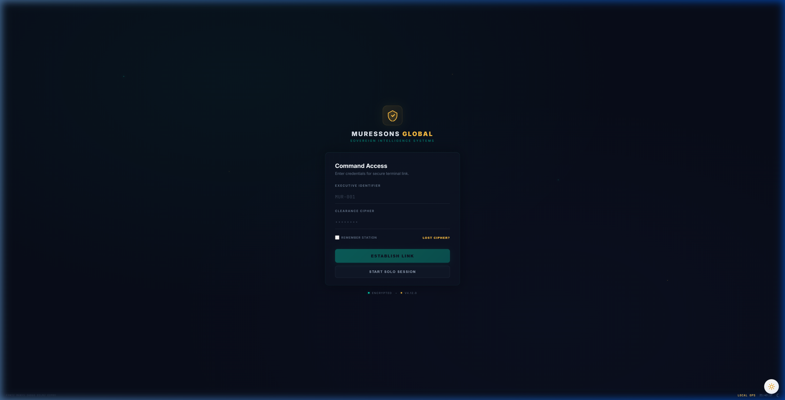
Figure 2.1 — Command Access Login Screen

2.2 Starting a Solo Session
If you are practising individually, click "START SOLO SESSION" on the login screen. This creates a private session where you can explore the simulation at your own pace without needing facilitator credentials.

2.3 The Onboarding Tour
On your first login, an interactive 7-step tour guides you through the Executive Cockpit interface. Key stops include:
- Step 1: Welcome — Your role as Chief Sustainability Officer
- Step 2: KPI Dashboard — Understanding your key performance indicators
- Step 3: Investment Matrix — How to allocate capital across business units
- Step 4: Strategic Options — Navigating A/B/C crisis decisions
- Step 5: Market Ticker — Reading real-time market intelligence
- Step 6: Executive Mailbox — Crisis alerts and foreshadowing events
- Step 7: Commit Button — Submitting your final decisions

3. The Executive Cockpit
The Executive Cockpit is your primary command interface throughout the simulation. Understanding its layout is essential for effective decision-making.
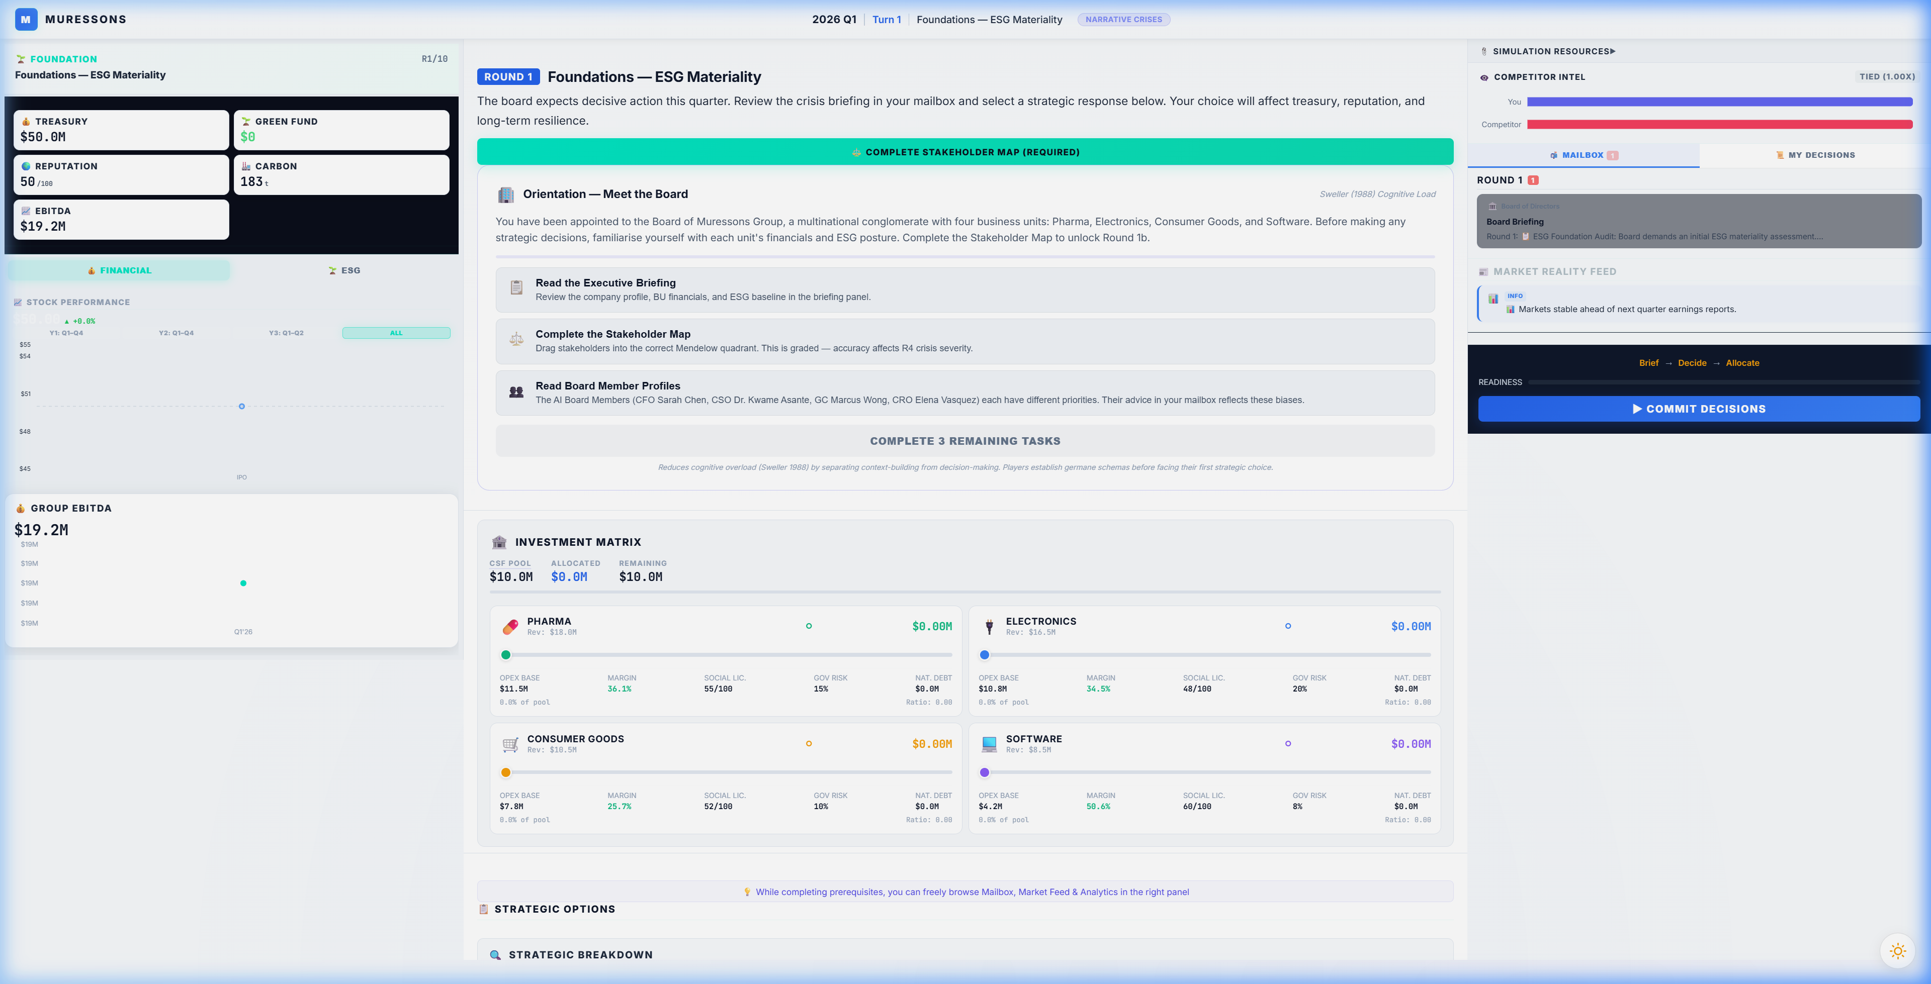
Figure 3.1 — The Executive Cockpit (Full View)

3.1 Header Bar
The top bar displays critical status information:
- Round Indicator — Current round number (R1/10 to R10/10)
- Session Status — "LIVE" indicator with connection status
- Decision Paradigm Badge — Shows active paradigm (NARRATIVE, PILLARS, etc.)
- Logout Button — Exit the simulation (progress is saved)

3.2 KPI Gauges Panel (Left Sidebar)
The left panel shows your critical KPIs with tabs for KPIs, Charts, and Metrics:
KPI | Starting Value | What It Means
💰 Treasury | $50.0M | Your available cash for investments and operations
🌿 Green Fund | $0 | Dedicated environmental investment fund
🌟 Reputation | 50/100 | Corporate reputation across all stakeholders
🏭 Carbon | 2,635t | Total CO₂ emissions in tonnes
📊 EBITDA | $19.2M | Earnings before interest, taxes, depreciation & amortisation

3.3 Investment Matrix
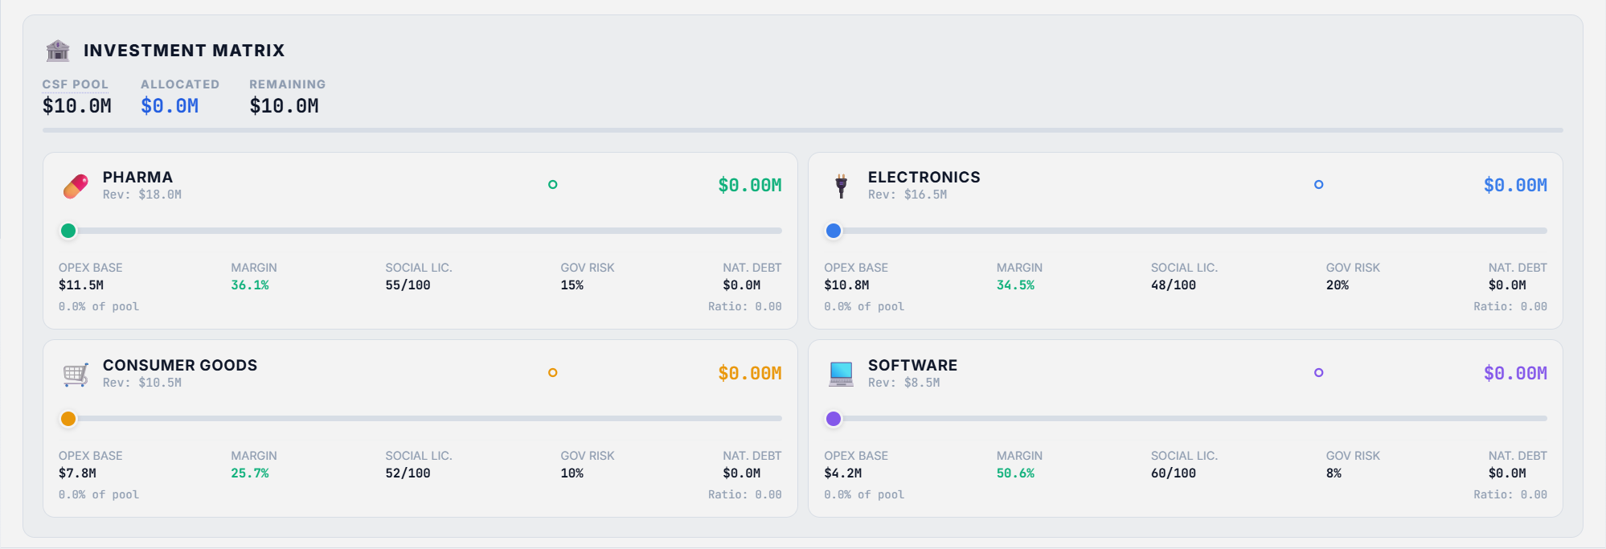
Figure 3.2 — Investment Matrix with BU Sliders
The Investment Matrix is where you allocate capital to each business unit:
- CSF Pool — Total available capital (Corporate Strategic Fund)
- Allocated — Amount currently distributed across BUs
- Remaining — Unallocated funds
- Per-BU Slider — Drag to set investment ratio (0% to 100%)
- BU Metrics — OPEX Base, Margin, Social License, Governance Risk per BU

3.4 Strategic Options Panel
Below the Investment Matrix, the Strategic Options panel presents the A/B/C crisis decision:
- Each option shows its title, description, and cost
- The Comparison Matrix below compares Treasury, Revenue, and Reputation impacts
- Select one option before committing — this choice is final

3.5 Bottom Navigation Bar
The bottom bar provides access to supplementary features:
Button | Function
🎙️ Podcast | Listen to AI-generated round briefing audio
📊 Leaderboard | View peer cohort performance rankings
🏆 Badges | Track achievement badges earned
🤖 Advisor | Consult the AI strategic advisor
📈 Analytics | View detailed analytical dashboards
📖 Glossary | Access the in-game glossary of terms
🔊 Sound | Toggle sound effects and ambient audio
🚪 Log Out | Exit the simulation

3.6 Market Ticker
The scrolling ticker at the bottom displays real-time market data including ESG Index values, Carbon Credit prices, EU Taxonomy compliance percentages, Water Futures, Green Bond yields, and S&P Clean Energy metrics. These provide contextual market intelligence but do not directly affect gameplay.

PART II: THE GAME LOOP

4. Decision-Making Framework

4.1 The Three-Step Decision Cycle
Every round follows a structured decision cycle:
Step 1: REVIEW
- Read the Intelligence Briefing — understand the crisis scenario and context
- Check the Executive Mailbox for market intelligence and foreshadowing events
- Review your current KPIs, treasury balance, and BU health metrics
- Complete any Pre-Requisite Gates (e.g., Stakeholder Map in R1)
Step 2: DECIDE
- Select one Strategic Option (A, B, or C) — read descriptions carefully
- Set Investment Matrix sliders for each BU — allocate your CSF pool
- Consider the Comparison Matrix to understand trade-offs between options
- Use the Confidence Nudge prompt to reflect before committing
Step 3: COMMIT
- Click the Commit button to submit your decisions
- Decisions are IRREVERSIBLE — the simulation uses immutable state recording
- After commit, review the Results Overlay showing KPI deltas and "What Changed"
- Check the Peer Leaderboard to see how you compare to other teams

4.2 Understanding the Investment Matrix
The CSF (Corporate Strategic Fund) is your total available CAPEX each round:
- CSF = Σ(Revenue - OPEX) - Dividends_Paid
- Each BU slider sets its Investment Ratio (0.0 to 1.0)
- CAPEX per BU = Investment Ratio × BU Revenue
- Total allocation cap: 120% of CSF (above 100% triggers a loan at 12% interest)
- Investment affects OPEX reduction via the Synergy Engine (see Section 8)
Key Insight: Investments ≤ 10% apply immediately. Investments > 10% are DEFERRED one round (implementation lag). You pay now but benefit next round.

5. Round-by-Round Walkthrough
This section provides a detailed narrative walkthrough of all 10 rounds in the standard (Narrative Crisis) paradigm. Each round includes the crisis scenario, decision options, strategic considerations, and flag dependencies.

Round 1: 📋 Foundations — ESG Baseline Assessment
Crisis Scenario: 📋 ESG Audit Decision
The board has mandated an initial ESG assessment across all business units. You must decide the depth and scope of the audit.
Decision Options:
Option | Title | Description | Key Impacts
A | Surface-Level Scan | Run a quick compliance check. Fast and cheap, but Electronics BU blind spots will be missed. | treasury: 0  reputation: -2  carbon_intensity_delta: +2  revenue_delta: +500000  social_license_delta: -3  governance_risk_delta: +5  natural_capital_debt_delta: 0
B | Deep Forensic Audit | Commission a full forensic audit across all units. Costly but uncovers hidden risks. | treasury: $-3M  reputation: +5  carbon_intensity_delta: -5  revenue_delta: -200000  social_license_delta: +5  governance_risk_delta: -5  natural_capital_debt_delta: 0
C | Phased Audit Rollout | Audit Pharma and Consumer Goods now; defer Electronics and Software to next period. Balanced cost, but partial blind spots remain. | treasury: $-2M  reputation: +2  carbon_intensity_delta: -2  revenue_delta: 0  social_license_delta: +2  governance_risk_delta: 0  natural_capital_debt_delta: 0
- Option A: Flags: electronics_blindspot
- Option B: Flags: deep_audit_completed
- Option C: Flags: deferred_audit
📚 Teaching Point:
Your R1 audit choice sets the "butterfly effect" — choosing a Surface Scan (Option A) sets the electronics_blindspot flag that DOUBLES crisis severity in Round 4.

Round 2: 📊 Double Materiality — Materiality-Based Budget Allocation
Crisis Scenario: 📊 Double Materiality Matrix
The CFO requires all investment proposals to demonstrate alignment with the High Financial Impact / High ESG Impact quadrant per the Double Materiality framework.
Decision Options:
Option | Title | Description | Key Impacts
A | Full Materiality Alignment | Allocate exclusively to high-impact nodes. Genuine CSRD compliance: assurance-ready report, stakeholder panel, full ESRS disclosure. In Advanced Climate mode: unlocks CSRD/ESRS climate materiality bonus (NCD forgiveness +25%). Compliance cost is real. | treasury: $-2M  reputation: +5  governance_risk_delta: -5  carbon_intensity_delta: -3  revenue_delta: $-2M  social_license_delta: +5  natural_capital_debt_delta: -3
B | Strategic Exceptions | Allow limited off-quadrant spending with CFO approval. Partial compliance. | treasury: 0  reputation: +2  governance_risk_delta: -2  carbon_intensity_delta: -1  revenue_delta: 0  social_license_delta: +2  natural_capital_debt_delta: 0
C | CEO-Only Sign-Off (No Board Committee Oversight) | CEO approves capital allocation without board committee review or endorsement. ⚠️ ESRS 1 §1.51 Violation: The standard requires the management body (board level) to oversee and endorse the materiality assessment process. CEO-only sign-off breaches this requirement. Institutional investors apply a risk premium to your Green Bond — 40% of your materiality budget will be clawed back. Governance posture must match investment rationale under ESRS 2 GOV-1. | treasury: 0  reputation: -5  governance_risk_delta: +10  carbon_intensity_delta: +3  revenue_delta: +400000  social_license_delta: -5  natural_capital_debt_delta: +3
- Option A: Flags: materiality_aligned
- Option B: Flags: materiality_exceptions
- Option C: Flags: materiality_ignored
📚 Teaching Point:
Option A (Materiality-Aligned Budget) sets the materiality_aligned flag worth +0.10 M_R at terminal valuation. This is the governance foundation.

Round 3: 🌍 Scope 3 Emissions — Supply Chain Decarbonisation
Crisis Scenario: 🏭 Scope 3 Supply Chain Crisis
Regulators have signalled mandatory Scope 3 disclosures. Your supply chain carbon footprint is 4x your direct emissions.
Decision Options:
Option | Title | Description | Key Impacts
A | Rapid Supplier Switch | Immediately switch to low-carbon suppliers. Fast reduction but high disruption risk. Early movers gain a strategic advantage in circular economy. | treasury: $-4M  carbon_intensity_delta: -15  supply_chain_disruption: Yes  revenue_delta: -800000  reputation: +3  social_license_delta: +4  governance_risk_delta: -3  natural_capital_debt_delta: -10
B | Green Bond Investment | Issue a green bond to fund supplier transition. Lowers Natural Capital Debt over 3 rounds. | treasury: $-2M  natural_capital_debt_delta: -15  carbon_intensity_delta: -8  revenue_delta: +300000  reputation: +4  social_license_delta: +3  governance_risk_delta: -2
C | Offset & Defer | Buy carbon offsets and wait for regulation clarity. | treasury: $-1M  natural_capital_debt_delta: +5  reputation: -3  carbon_intensity_delta: -1  revenue_delta: +100000  social_license_delta: -4  governance_risk_delta: +3
- Option A: Flags: supply_chain_disruption_risk, early_decarboniser
- Option B: Flags: green_bond_active
- Option C: Flags: carbon_deferred
📚 Teaching Point:
Beware the Marketing-Only Pledge (Option C) — it activates the Greenwashing Engine. If your average investment ratio drops below 15%, ALL BUs lose 8 Social Licence points.

Round 4: 🔥 Contagion — Reputation Crisis Cascade
Crisis Scenario: 🔥 Electronics Supply Chain Scandal
A labour-rights exposé in your Electronics supply chain has gone viral. The contagion engine will propagate reputational damage across all BUs.
Decision Options:
Option | Title | Description | Key Impacts
A | Full Transparency & Remediation | Public disclosure, factory audits, worker compensation. | treasury: $-6M  reputation: +10  social_license: +8  carbon_intensity_delta: -4  revenue_delta: -500000  governance_risk_delta: -5  natural_capital_debt_delta: 0
B | Damage Control PR | Hire crisis PR firm. Contains narrative but doesn't fix root cause. | treasury: $-2M  reputation: +2  social_license: -3  carbon_intensity_delta: -1  revenue_delta: 0  governance_risk_delta: +3  natural_capital_debt_delta: 0
C | Deny & Deflect | Issue a denial. Cheapest option but highest contagion risk. | treasury: 0  reputation: -15  social_license: -10  carbon_intensity_delta: +4  revenue_delta: $-1M  governance_risk_delta: +8  natural_capital_debt_delta: +5
- Option A: Flags: remediation_active
- Option B: Flags: pr_containment
- Option C: Flags: deny_and_deflect
📚 Teaching Point:
This is where R1 decisions cascade. If electronics_blindspot is active, crisis severity DOUBLES from 40 to 80. The Contagion Engine uses a sigmoid function to propagate damage.

Round 5: 🌪️ Climate — Physical Climate Risk Event
Crisis Scenario: 🌪️ Extreme Weather Event
A Category 4 cyclone is projected to hit your primary manufacturing corridor. Base damage: $12M. A stochastic roll determines actual impact.
Decision Options:
Option | Title | Description | Key Impacts
A | Hard Engineering Defence | Build flood walls and reinforced infrastructure. Resilience Factor 0.85 — but construction takes 2 rounds. ⚠️ NO PROTECTION THIS ROUND. Infrastructure completes in Round 7. Adds 10 Natural Capital Debt (concrete/steel environmental cost). 🌡️ CLIMATE WARNING: +3 Carbon Intensity contributes to the Climate Tipping Point (avg CI > 70). In Advanced Climate mode, crossing this threshold doubles NCD costs permanently. | resilience_factor: +0.85  natural_capital_debt_delta: +10  treasury: $-8M  carbon_intensity_delta: +3  revenue_delta: -600000  reputation: +3
B | Nature-Based Solutions | Invest in mangrove restoration and natural buffers. Resilience Factor 0.60 — but ecosystem establishment takes 2 rounds. ⚠️ NO PROTECTION THIS ROUND. Buffers mature by Round 7. Reduces Natural Capital Debt (nature-positive infrastructure). | resilience_factor: +0.6  natural_capital_debt_delta: -8  treasury: $-5M  carbon_intensity_delta: -6  revenue_delta: +500000  reputation: +6
C | Insurance Only | Buy comprehensive insurance. No physical resilience built — full damage if cyclone strikes this round or any future round. ⚠️ Blocks the Resilience Bonus at terminal valuation (−0.20 M_R). | resilience_factor: 0.0  treasury: $-2M  carbon_intensity_delta: +1  revenue_delta: 0  reputation: -5
- Option A: Flags: hard_engineering
- Option B: Flags: nature_based_resilience
- Option C: Flags: insurance_only
📚 Teaching Point:
The stochastic dice roll (75% chance of cyclone) makes this the first round where luck matters. But resilience investments from your choice determine damage absorption.

Round 6: 🤖 AI Bias — Algorithmic Ethics & Brand Risk
Crisis Scenario: 🤖 AI Hiring Bias Scandal
Your Software BU's AI recruitment tool has been found to systematically discriminate against minority applicants. The story has reached mainstream media.
Decision Options:
Option | Title | Description | Key Impacts
A | Monetise the Algorithm | Pivot the AI tool into a commercial product. High revenue but massive reputational risk, spiking the contagion factor. | software_revenue_delta: +$10M  reputation_delta: -20  contagion_spike: Yes  carbon_intensity_delta: +2  social_license_delta: -15  governance_risk_delta: +8  natural_capital_debt_delta: 0
B | Ethical AI Overhaul | Shut down the tool, hire an ethics board, retrain models. Costly but builds social capital. | treasury: $-8M  social_license_delta: +15  reputation_delta: +5  carbon_intensity_delta: -4  revenue_delta: +800000  governance_risk_delta: -5  natural_capital_debt_delta: 0
C | Quiet Patch | Silently fix the algorithm. Low cost but if leaked, devastating. | treasury: $-1M  reputation_delta: -5  governance_risk_delta: +10  carbon_intensity_delta: 0  revenue_delta: -200000  social_license_delta: -3  natural_capital_debt_delta: 0
- Option A: Flags: ai_monetised
- Option B: Flags: ethical_ai_overhaul
- Option C: Flags: quiet_patch
📚 Teaching Point:
Option B (Ethical AI Overhaul at -$8M) earns the Truth Premium (+0.15 M_R). Option C (Monetise the Algorithm) triggers EU AI Act costs from R7 onward.

Round 7: ♻️ Circularity — Circular Economy Transition
Crisis Scenario: ♻️ Waste Regulation Tightening
New EU circular economy regulations mandate 60% waste diversion by next year. Non-compliance fines: $15M.
Decision Options:
Option | Title | Description | Key Impacts
A | Full Circular Redesign | Redesign products for full disassembly and reuse. | treasury: $-10M  natural_capital_debt_delta: -12  reputation: +8  carbon_intensity_delta: -8  revenue_delta: +$1M  social_license_delta: +6  governance_risk_delta: -3
B | Extended Producer Responsibility | Fund take-back programs and recycling partnerships. | treasury: $-5M  natural_capital_debt_delta: -6  reputation: +4  carbon_intensity_delta: -5  revenue_delta: +600000  social_license_delta: +3  governance_risk_delta: -2
C | Waste-to-Energy Partnership | Build waste-to-energy facility. Unlocks high synergy multiplier across BUs. | treasury: $-7M  synergy_multiplier_boost: +0.3  natural_capital_debt_delta: -4  carbon_intensity_delta: -6  revenue_delta: +400000
- Option A: Flags: circular_redesign
- Option B: Flags: epr_program
- Option C: Flags: waste_to_energy, synergy_unlock
📚 Teaching Point:
The Synergy Unlock (Option C) is the single highest M_R bonus available (+0.30). If synergy_multiplier ≥ 0.80, this is the most valuable single decision in the game.

Round 8: 💧 Blue Stress — Water Scarcity Emergency
Crisis Scenario: 🌊 Critical Water Shortage
A multi-year drought has depleted the watershed serving Pharma and Electronics. Government water rationing is imminent.
Decision Options:
Option | Title | Description | Key Impacts
A | Water Efficiency for All BUs | Equitable water-saving upgrades across all units. | treasury: $-12M  water_dependency_delta: -20  social_license_delta: +5  carbon_intensity_delta: -3  revenue_delta: +700000  reputation: +5
B | Prioritise Electronics | Divert water allocation to Electronics (highest margin). Pharma and Consumer Goods take severe social licence hit. | treasury: $-4M  social_license_severe_drop: Yes  social_license_drop_amount: -25  carbon_intensity_delta: +2  revenue_delta: -400000  reputation: -8
C | Desalination Mega-Project | Build a desalination plant. Massive cost ($30M) with a 2-round construction delay before benefits arrive. Reduces Natural Capital Debt by 30 points and water dependency by 40. Generates $5M/round revenue from Round 10 onward (Rounds 8+2) for 3 rounds. | treasury: $-30M  natural_capital_debt_delta: -30  water_dependency_delta: -40  carbon_intensity_delta: +5  revenue_delta: +300000  generates_revenue: +$5M  payback_rounds: +3  reputation: +3
- Option A: Flags: water_efficiency_all
- Option B: Flags: electronics_water_priority
- Option C: Flags: desalination_built
📚 Teaching Point:
Water-dependent BUs (Pharma at 85%) face severe revenue cuts. Choosing to prioritise Electronics water (Option B) BLOCKS the +0.20 Resilience M_R bonus.

Round 9: ⚖️ Just Transition — Workforce & Community Justice
Crisis Scenario: ✊ Factory Closure & Workforce Crisis
Decarbonisation commitments require closing 3 legacy factories. 2,000 jobs are at risk. Community protests are escalating.
Decision Options:
Option | Title | Description | Key Impacts
A | Immediate Closure | Close factories now for maximum cost savings. If Social License is low, 75% chance of a strike that zeros revenue. | treasury: +$5M  social_license_delta: -20  reputation_delta: -15  strike_risk: Yes  carbon_intensity_delta: +3  revenue_delta: $-1M
B | Managed Transition | 2-year phase-out with retraining and severance packages. | treasury: $-12M  social_license_delta: +10  reputation_delta: +8  carbon_intensity_delta: -4  revenue_delta: +600000
C | Community Investment Fund | Create a $20M fund for community economic development and green job training. | treasury: $-20M  social_license_delta: +18  reputation_delta: +12  governance_risk_delta: -5  carbon_intensity_delta: -3  revenue_delta: +400000
- Option A: Flags: immediate_closure
- Option B: Flags: managed_transition
- Option C: Flags: community_fund
📚 Teaching Point:
Option C (Community Fund) earns +0.18 M_R with Just Transition scaling. Option A (Immediate Closure) triggers the Strike Probability Engine — a stochastic revenue-zeroing event.

Round 10: 🏛️ Grand Finale — Year 5 Activist Ultimatum & Terminal Valuation
Crisis Scenario: 🏛️ Activist Ultimatum
An activist investor consortium has acquired a blocking stake. They are demanding a strategic restructuring. The board must decide the company's Year 5 trajectory.
Decision Options:
Option | Title | Description | Key Impacts
A | Resist & Integrate | Fight the activist. Keep all BUs integrated and leverage synergy. DISABLED if Synergy Score ≤ 80. | synergy_bonus: Yes  treasury: $-5M  carbon_intensity_delta: -3  revenue_delta: +$1M  reputation: +5  social_license_delta: +3  governance_risk_delta: -3  natural_capital_debt_delta: 0
B | Spin-off | Spin off the weakest-performing BU as a separate entity. Moderate risk, unlocks partial value. | spinoff_weakest_bu: Yes  treasury: +$10M  carbon_intensity_delta: -1  revenue_delta: -500000  reputation: +2  social_license_delta: -5  governance_risk_delta: +3  natural_capital_debt_delta: 0
C | Divest | Full divestiture of non-core assets. Maximum short-term cash extraction at the cost of long-term value. | divest_all: Yes  treasury: +$25M  synergy_wipe: Yes  carbon_intensity_delta: +2  revenue_delta: $-2M  reputation: -10  social_license_delta: -12  governance_risk_delta: +5  natural_capital_debt_delta: +8
- Option A: Flags: resist_integrate
- Option B: Flags: spinoff
- Option C: Flags: divest
📚 Teaching Point:
All accumulated flags are evaluated. The Regenerative Multiple (M_R) is calculated, Terminal Value is computed, and your Corporate Archetype is revealed.

6. Strategic Pillars Paradigm
In the Strategic Pillars paradigm (multi_toggles), instead of choosing a single A/B/C option, you make decisions across five strategic areas simultaneously: Energy, Operations, Supply Chain, Offsetting, and Human Resources. Each area offers three options with different costs and impacts.

Round 1: ESG Foundation Strategy
Set your initial ESG investment strategy across four key areas.
⚡ Energy Strategy
Option | Cost | Key Impacts
Renewable PPA | -$2.0M | carbon_intensity_delta: -8, reputation: +3
Fossil Fuel Status Quo | Free | carbon_intensity_delta: +2, reputation: -1
Solar CapEx | -$4.0M | carbon_intensity_delta: -12, reputation: +5

🏭 Operational Efficiency
Option | Cost | Key Impacts
Lean Process Optimization | -$1.5M | reputation: +2
Digital Twin Deployment | -$3.0M | reputation: +4, governance_risk_delta: -3
No Operational Change | Free | None

🔗 Supply Chain
Option | Cost | Key Impacts
Full Supplier Audit | -$2.5M | reputation: +4, social_license_delta: +3
Tier-1 Screening Only | -$-500,000 | reputation: +1
Defer Supply Chain Review | Free | reputation: -2, governance_risk_delta: +5

🌱 Carbon Offsetting
Option | Cost | Key Impacts
Nature-Based Offsets | -$2.0M | natural_capital_debt_delta: -5, reputation: +3
Carbon Credit Purchase | -$1.0M | natural_capital_debt_delta: -2, reputation: +1
No Offsetting | Free | natural_capital_debt_delta: +3

👥 Talent & Culture
Option | Cost | Key Impacts
DEI & Inclusion Program | -$2.0M | social_license_delta: +4, reputation: +3, burnout_delta: -8
Leadership Development | -$1.5M | reputation: +2, governance_risk_delta: -2
No HR Investment | Free | social_license_delta: -1

Round 2: Double Materiality Investment
Align capital allocation with double materiality principles.
⚡ Energy Transition
Option | Cost | Key Impacts
Green Energy Tariff | -$1.5M | carbon_intensity_delta: -6, reputation: +2
Energy Efficiency Upgrades | -$2.5M | carbon_intensity_delta: -4, reputation: +3
Maintain Baseline | Free | None

🏛️ Governance & Compliance
Option | Cost | Key Impacts
Materiality Advisory Board | -$2.0M | governance_risk_delta: -8, reputation: +5
Minimum Compliance | -$-500,000 | governance_risk_delta: -2, reputation: +1
Ignore Materiality | Free | governance_risk_delta: +10, reputation: -5

🔗 Supply Chain Transparency
Option | Cost | Key Impacts
Blockchain Traceability | -$3.5M | social_license_delta: +5, reputation: +4, burnout_delta: -10
Annual ESG Report | -$-800,000 | reputation: +2
No Additional Transparency | Free | reputation: -1

🌱 Impact Mitigation
Option | Cost | Key Impacts
Community Impact Fund | -$3.0M | social_license_delta: +8, reputation: +4
Employee Wellbeing Program | -$1.5M | social_license_delta: +3, reputation: +2
No Mitigation | Free | social_license_delta: -2

👥 Workforce Analytics
Option | Cost | Key Impacts
People Analytics Platform | -$2.5M | governance_risk_delta: -4, reputation: +3
Annual Engagement Survey | -$-500,000 | social_license_delta: +2, reputation: +1
No Workforce Analytics | Free | None

Round 3: Scope 3 Decarbonisation
Address Scope 3 supply chain emissions across all areas.
⚡ Energy Decarbonisation
Option | Cost | Key Impacts
Fleet Electrification | -$5.0M | carbon_intensity_delta: -15, reputation: +4
Hybrid Transition | -$2.0M | carbon_intensity_delta: -6, reputation: +2
Keep Diesel Fleet | Free | carbon_intensity_delta: +3, reputation: -2

🏭 Process Redesign
Option | Cost | Key Impacts
Closed-Loop Manufacturing | -$4.0M | natural_capital_debt_delta: -8, reputation: +5
Waste Reduction Program | -$1.5M | natural_capital_debt_delta: -3, reputation: +2
No Process Change | Free | natural_capital_debt_delta: +5

🔗 Supplier Decarbonisation
Option | Cost | Key Impacts
Rapid Supplier Switch | -$4.0M | carbon_intensity_delta: -12, governance_risk_delta: +10
Green Bond Supplier Fund | -$2.0M | natural_capital_debt_delta: -10, carbon_intensity_delta: -6
Offset & Defer | -$1.0M | natural_capital_debt_delta: +5, reputation: -3

🌱 Carbon Neutrality
Option | Cost | Key Impacts
Science-Based Targets | -$3.0M | carbon_intensity_delta: -8, reputation: +6
Voluntary Offset Purchase | -$1.5M | natural_capital_debt_delta: -4, reputation: +2
Marketing-Only Pledge | -$-200,000 | reputation: -3, governance_risk_delta: +5

👥 Green Skills Pipeline
Option | Cost | Key Impacts
Internal Green Skills Academy | -$3.0M | social_license_delta: +5, reputation: +4
Basic OHS Compliance | -$-500,000 | reputation: +1
No Workforce Change | Free | social_license_delta: -2

Round 4: Reputation Crisis Response
A supply chain scandal has gone viral. Manage damage across all fronts.
⚡ Energy Crisis Response
Option | Cost | Key Impacts
Green Energy Pivot | -$3.0M | carbon_intensity_delta: -10, reputation: +5
Maintain Course | Free | None
Cut Energy Spending | +$1.5M | carbon_intensity_delta: +5, reputation: -3

🏭 Operational Response
Option | Cost | Key Impacts
Full Factory Transparency | -$2.0M | reputation: +8, social_license_delta: +5
PR Crisis Management | -$1.5M | reputation: +2, social_license_delta: -2
Deny Allegations | Free | reputation: -15, social_license_delta: -10

🔗 Supplier Remediation
Option | Cost | Key Impacts
Full Supply Chain Remediation | -$5.0M | social_license_delta: +10, reputation: +6
Targeted Fix | -$1.5M | social_license_delta: +3, reputation: +2
Ignore Supply Chain | Free | social_license_delta: -5, governance_risk_delta: +8

🌱 Stakeholder Repair
Option | Cost | Key Impacts
Stakeholder Compensation Fund | -$4.0M | social_license_delta: +8, reputation: +5
NGO Partnership | -$1.0M | social_license_delta: +3, reputation: +3
No Stakeholder Action | Free | reputation: -5

👥 Crisis Workforce Support
Option | Cost | Key Impacts
Employee Crisis Support | -$1.5M | social_license_delta: +4, reputation: +3
Overtime & Crisis Push | +$500,000 | social_license_delta: -4, reputation: -2, burnout_delta: +12
No Employee Support | Free | social_license_delta: -2, reputation: -1

Round 5: Climate Resilience
A severe weather event threatens operations. Build resilience.
⚡ Energy Resilience
Option | Cost | Key Impacts
Distributed Microgrids | -$4.0M | reputation: +3
Diesel Generator Backup | -$1.0M | carbon_intensity_delta: +3
No Energy Backup | Free | None

🏭 Physical Defence
Option | Cost | Key Impacts
Hard Engineering Defence | -$8.0M | natural_capital_debt_delta: +10, resilience_factor: +0.85
Nature-Based Solutions | -$5.0M | natural_capital_debt_delta: -8, reputation: +4, resilience_factor: +0.6
Insurance Only | -$2.0M | resilience_factor: 0.0

🔗 Supply Chain Resilience
Option | Cost | Key Impacts
Geographic Diversification | -$3.0M | governance_risk_delta: -5, reputation: +3
Nearshoring | -$2.0M | carbon_intensity_delta: -3, reputation: +2
Accept Supply Risk | Free | governance_risk_delta: +5

🌱 Adaptation Finance
Option | Cost | Key Impacts
Climate Adaptation Fund | -$3.0M | social_license_delta: +6, reputation: +4, burnout_delta: -10
Parametric Insurance | -$1.5M | reputation: +1
No Adaptation Spending | Free | reputation: -2

👥 Worker Safety & Resilience
Option | Cost | Key Impacts
Emergency Response Training | -$2.0M | social_license_delta: +5, reputation: +3, governance_risk_delta: -3
Basic Safety Gear Upgrade | -$-500,000 | social_license_delta: +1, reputation: +1
No Workforce Safety Investment | Free | social_license_delta: -3

7. Round 10: Grand Finale & Ending Pathways

7.1 The Five Ending Pathways
The simulation features five dynamic R10 crisis scenarios. The facilitator selects the ending pathway at session creation. Players receive subtle foreshadowing hints during Rounds 5-8 but never see the pathway name directly.

🎯 Activist Ultimatum
An activist consortium acquires a blocking stake and forces a strategic review. The board must choose between integration, spin-off, or full divestiture.
Foreshadowing Events:
- R6: Activist Fund Files 13D — 4.9% Stake Acquired
- R7: Analyst Note: 'Muressons Ripe for Restructuring'
- R8: Blocking Stake Reached — Board Engagement Imminent

🎯 Climate Black Swan
A cascading climate event triggers stranded asset write-downs and investor flight. The company faces an existential question: can it decarbonise fast enough to survive?
Foreshadowing Events:
- R5: IPCC Special Report: 1.5°C Overshoot Now 'Likely'
- R6: Carbon Futures Surge 40% — EU ETS Hits Record
- R7: Insurance Consortium Warns: 'Uninsurable Assets by 2035'
- R8: ALERT: 1.5°C Threshold Breached — Carbon Markets in Turmoil
R10 Decision Options:
Option | Title | Description | Key Impacts
A | Emergency Decarbonisation | Accelerated transition to net-zero operations. All BU carbon intensities halved. NCD reduced by 50%. Early movers (avg CI < 25) earn the Climate Leader bonus (+0.30 M_R). | treasury: $-20M  carbon_intensity_halve: Yes  ncd_halve: Yes
B | Climate Adaptation Portfolio | Restructure around climate-resilient BUs only. BUs with CI > 40 are divested at fire-sale prices (50% book value). Remaining BUs receive reallocation capital. | divest_high_ci: Yes  ci_divest_threshold: +40  reallocation_per_bu: +$3M
C | Deny & Delay | Lobby against carbon regulation. Avoid transition costs but carbon tax triples, NCD doubles, and exit multiple drops to 6×. A bet against the climate consensus. | treasury: +$5M  carbon_tax_triple: Yes  ncd_double: Yes  exit_multiple_override: +6.0  mr_penalty: -0.4

🎯 Stakeholder Revolt
Community protests, employee strikes, and supplier boycotts converge. Social capital has eroded to the point where the company's social licence to operate is revoked.
Foreshadowing Events:
- R5: Glassdoor Review: 'Muressons Culture is Toxic'
- R6: Community Coalition Forms Against Industrial Operations
- R7: Consumer Boycott Hashtag Gains 2M Impressions
- R8: #MuressonsExposed — Triple Stakeholder Ultimatum
R10 Decision Options:
Option | Title | Description | Key Impacts
A | Total Stakeholder Compact | Sign a legally binding stakeholder charter: guaranteed living wages, community benefit agreements, and product quality standards. If avg SLO ≥ 70 AND avg burnout < 30: +0.35 M_R Social Regeneration bonus. Revenue +15% (brand loyalty). | treasury: $-18M  revenue_boost_pct: +0.15  social_regeneration_gate: Yes
B | Selective Appeasement | Address the loudest stakeholder group only (auto-selects based on worst metric). Fixes one dimension but remaining groups escalate (−10 SLO for unaddressed). | treasury: $-8M  selective_fix: Yes  unaddressed_slo_penalty: -10
C | Corporate Hardball | Threaten to relocate operations overseas. All BU SLO: −25. All BU burnout: +20. If any BU SLO hits 0, that BU is shuttered. Short-term treasury gain but devastating social cost. | treasury: +$10M  slo_all_penalty: -25  burnout_all_increase: +20  shutter_zero_slo: Yes  mr_penalty: -0.3

🎯 Hostile Takeover
A competitor launches an unsolicited bid, exploiting weak governance and low market capitalisation. The board must defend or negotiate.
Foreshadowing Events:
- R6: Unusual Share Volume Detected in Muressons Stock
- R7: PE Firm 'Cerberus Capital' Denies Acquisition Interest
- R8: Cerberus Files Preliminary Offer with Regulator
R10 Decision Options:
Option | Title | Description | Key Impacts
A | White Knight Defence | Seek a friendly acquirer (strategic partner) who will preserve the integrated strategy. If synergy_multiplier ≥ 1.3 AND treasury > $30M: +0.25 M_R Strategic Integration bonus. Revenue −5% (integration friction). | treasury: $-15M  revenue_drag_pct: -0.05  white_knight: Yes
B | Poison Pill + Crown Jewel Lock-Up | Deploy anti-takeover defences: dilutive share issuance and lock-up agreements on top-performing BUs. Preserves independence but increases debt. Treasury −$25M, exit multiple reduced to 10× (debt overhang). | treasury: $-25M  exit_multiple_override: +10.0  poison_pill: Yes
C | Accept the Bid | Accept Cerberus's offer. Shareholders get the premium, but the conglomerate will be broken up. Exit multiple locked at 8× (breakup discount). M_R capped at 1.0 (no regenerative value recognised). | treasury: +$20M  exit_multiple_override: +8.0  mr_cap: +1.0  mr_penalty: -0.5

🎯 Regulatory Shutdown
A major regulatory authority issues a compliance notice threatening operational shutdown. Years of deferred governance catch up in a single enforcement action.
Foreshadowing Events:
- R5: EU Adopts Corporate Sustainability Due Diligence Directive
- R6: Sector Peers Face €50M+ CSDDD Compliance Costs
- R7: Whistleblower Contacts Environmental Regulator
- R8: Regulator Issues Show Cause Notice to Muressons
R10 Decision Options:
Option | Title | Description | Key Impacts
A | Full Remediation Programme | Voluntarily exceed CSDDD requirements: implement full supply chain traceability, publish impact assessments, and establish a community remediation fund. If ethical score > 7 AND no scandal flags: +0.30 M_R Regulatory Exemplar bonus. Heavy upfront cost ($4M per BU). | compliance_cost_all_bus: Yes  regulatory_exemplar_gate: Yes
B | Negotiate Consent Decree | Negotiate a settlement with the regulator: accept a $30M fine and third-party monitoring for 3 years. Operations continue but exit multiple reduced to 10× (governance discount). Carbon tax increases to $350/t. | treasury: $-30M  exit_multiple_override: +10.0  consent_decree: Yes
C | Contest the Ruling | Challenge the regulator in court. If successful (low chance if ethical score < 5): no fine. If unsuccessful: double fine ($60M), operations suspended for worst-performing BU, exit multiple to 7×. Reputation −30. | legal_challenge: Yes  legal_costs: $-10M  mr_penalty: -0.35

7.2 Corporate Archetypes
Your final M_R score determines your Corporate Archetype:
Archetype | M_R Threshold | Description
🌱 Regenerative Titan | ≥ 1.80 | Gold standard — rebuilt natural capital with superior financial returns
🏦 De-risked Safe Haven | ≥ 1.20 | Avoided tail risks but innovation may be stalling
⚠️ Fragile Giant | ≥ 0.80 | Financially viable but structurally brittle — vulnerable to future shocks
💀 Stranded Relic | < 0.80 | Structural decline — chronic underinvestment in sustainability
🔧 Turnaround Manager | Survival Mode | Entered crisis stabilisation — emergency measures activated
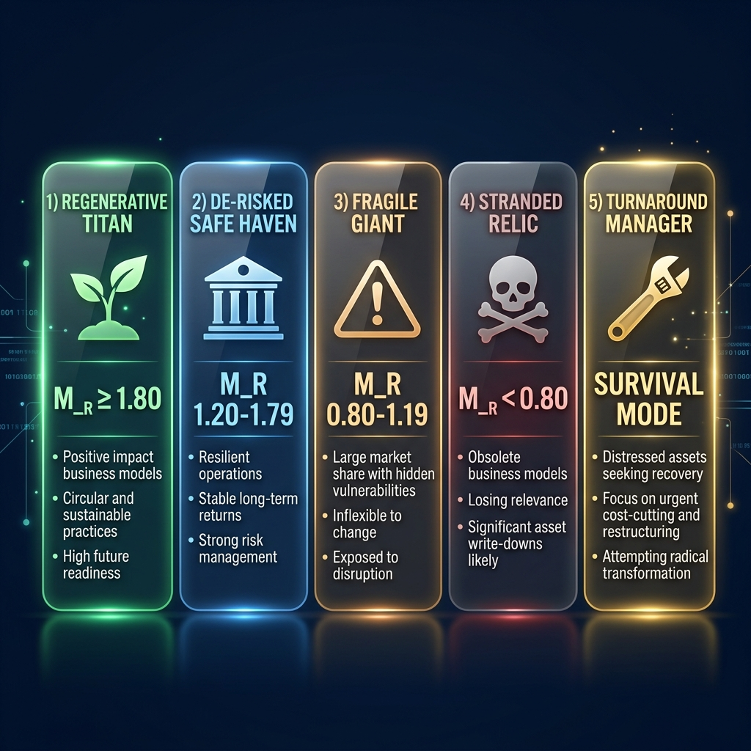
Figure 7.1 — Corporate Archetype Profiles

7.3 Game Over Summary
After Round 10, the simulation presents:
- Terminal Value — Your final corporation valuation
- Regenerative Multiple (M_R) — Your sustainability-adjusted multiplier
- Corporate Archetype — Your strategic profile classification
- Peer Leaderboard — How you rank against other teams
- Balanced Scorecard — Detailed analysis across three tabs (Scorecard/Analysis/Rounds)
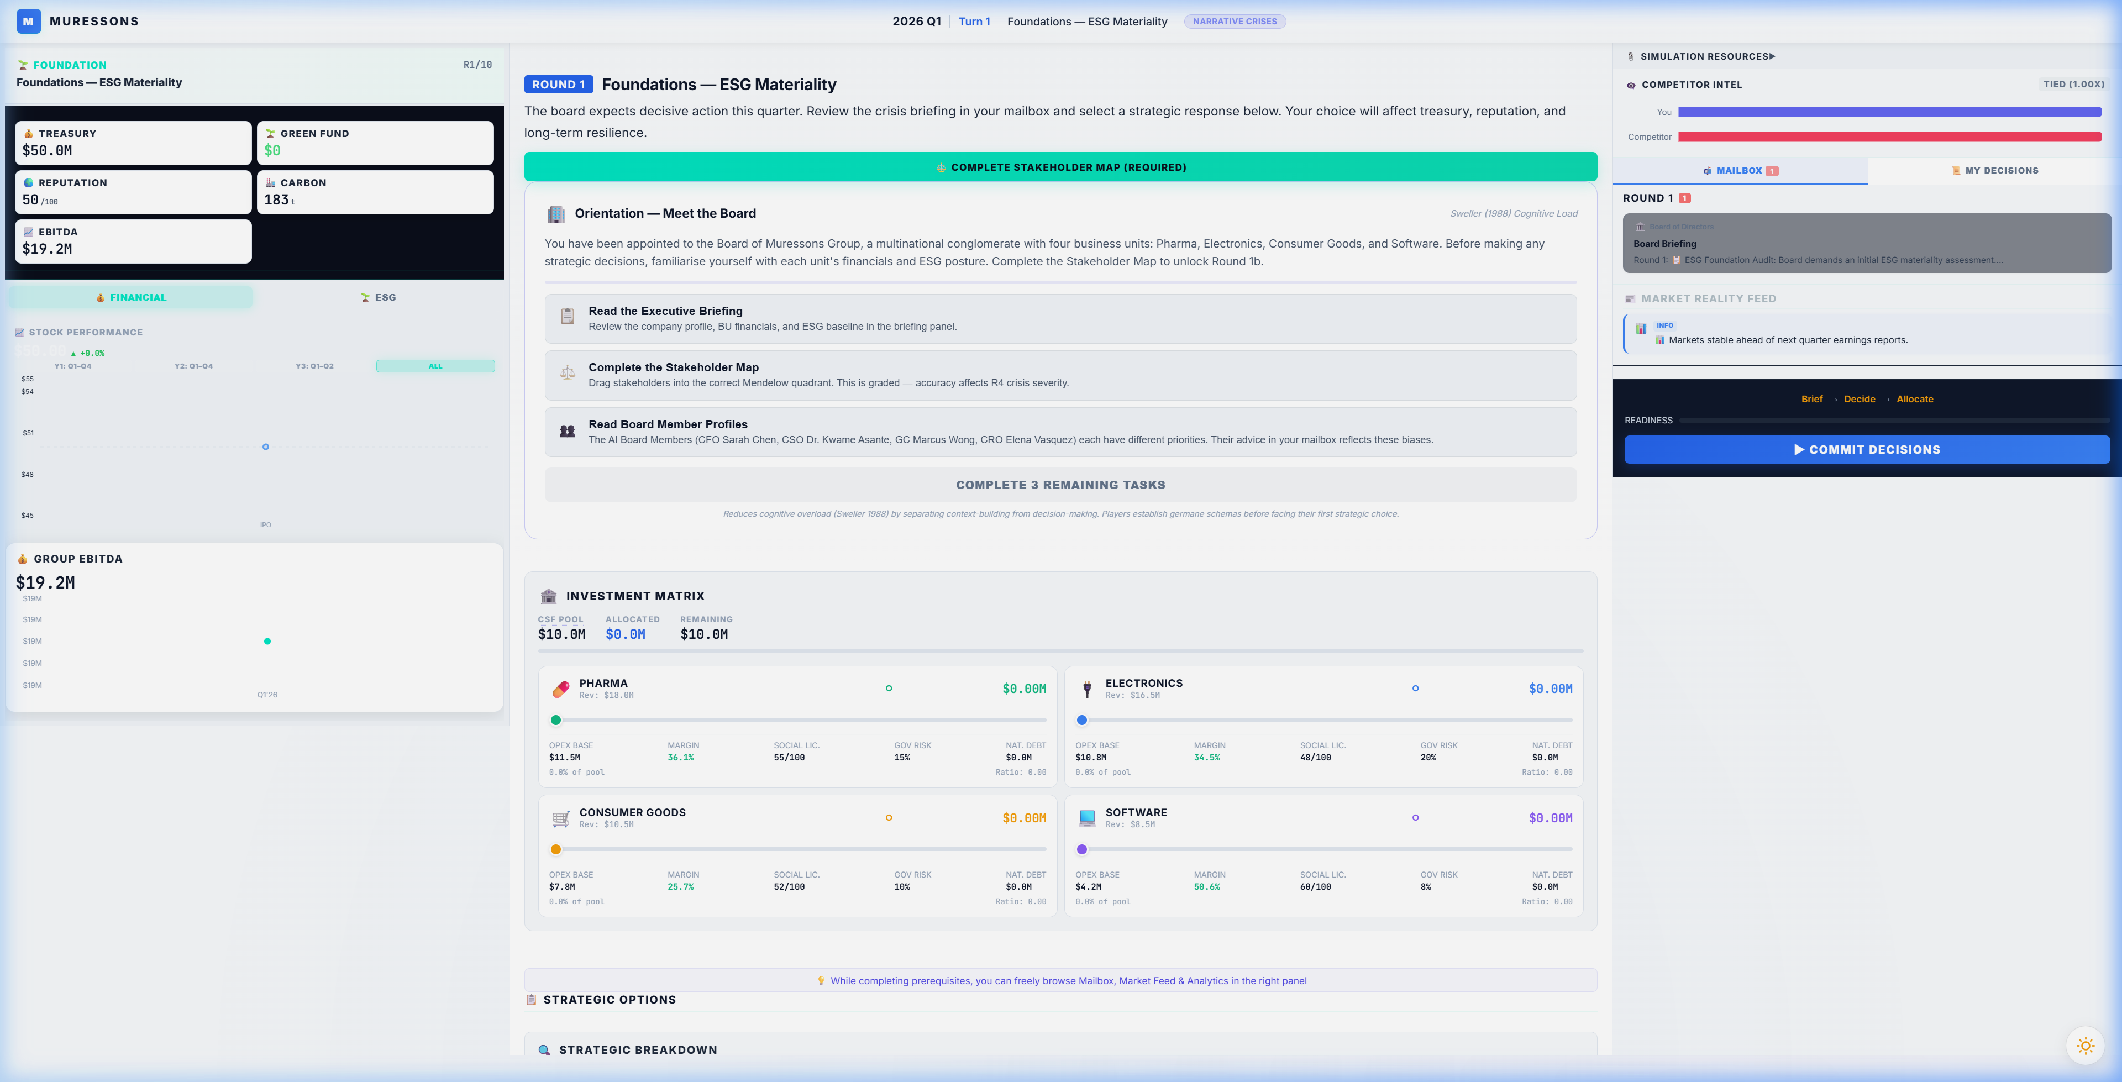
Figure 7.2 — Balanced Scorecard Analysis

PART III: UNDER THE HOOD

8. Mathematical Engines Explained
The simulation is powered by a suite of mathematical engines that process your decisions. Understanding these engines is key to strategic mastery.

8.1 Core Engines

8.1.1 Corporate Strategic Fund (CSF)
Formula: CSF = Σ(Revenue_i - OPEX_i) - Dividends_Paid
Calculates net cash added to treasury each round. If total CAPEX exceeds 20% of treasury, a loan is triggered at 12% interest.
Worked Example:
- Given: Pharma Rev=$18M, OPEX=$11M; Electronics Rev=$22M, OPEX=$14M; CG Rev=$15M, OPEX=$9M; Software Rev=$20M, OPEX=$8M
- Gross Profit = (18-11)+(22-14)+(15-9)+(20-8) = 7+8+6+12 = $33M
- Dividends = $2M → CSF = $33M - $2M = $31M added to treasury

8.1.2 Contagion Engine (Sigmoid Model)
Formula: Group_Rep = AVG(BU_Rep) - 50 × sigmoid((severity - 30) / 15)
Uses an S-curve (sigmoid) centred at severity=30. Low severity (50): saturating damage.
Worked Example:
- Given: BU Reps = [70, 58, 74, 82], Crisis Severity = 40
- AVG Rep = (70+58+74+82)/4 = 71.0
- sigmoid((40-30)/15) = sigmoid(0.667) = 1/(1+e^-0.667) ≈ 0.661
- Group_Rep = 71.0 - 50 × 0.661 = 71.0 - 33.05 = 37.95
- If electronics_blindspot active: severity doubles to 80 → Group_Rep = 71 - 48.4 = 22.6

8.1.3 Synergy Engine (Diminishing Returns)
Formula: effective_ratio = √(ratio) × 0.7; New_OPEX = Old_OPEX × (1 - effective_ratio × Synergy_Mult)
Uses square-root scaling: first dollars yield outsized returns, later dollars hit diminishing marginal efficiency.
Worked Example:
- Given: OPEX=$11M, Investment_Ratio=0.25, Synergy_Mult=1.08
- effective_ratio = √(0.25) × 0.7 = 0.5 × 0.7 = 0.35
- factor = 1 - (0.35 × 1.08) = 1 - 0.378 = 0.622
- New_OPEX = $11M × 0.622 = $6.84M (savings of $4.16M)

8.1.4 Natural Capital Cost of Debt
Formula: Interest_Rate = Base_Rate + (NCD × 0.0001); Debt_Next = Debt + (Debt × Rate)
Environmental debt compounds each round. At NCD=100: rate ≈ 6%. At NCD=500: rate ≈ 10%. At NCD=1000: rate ≈ 15%.
Worked Example:
- Given: NCD=5,200, Base_Rate=0.05
- Rate = 0.05 + (5200 × 0.0001) = 0.57 (57%)
- Debt_Next = 5,200 + (5,200 × 0.57) = 8,164 — compounds aggressively!

8.1.5 VRIO Decay
Formula: Advantage_Next = Advantage_Current × (1 - Decay_Rate)
Prevents synergy from staying permanently high. Default decay = 5% per round.
Worked Example:
- Given: Synergy_Mult=1.38, Decay_Rate=0.05
- Next = 1.38 × 0.95 = 1.311
- After 3 rounds: 1.38 → 1.311 → 1.245 → 1.183

8.1.6 Talent Brain-Drain
Formula: Penalty = 1 + MAX(0, (65-Rep)/100) × 1.5 + burnout_adj
Software BU OPEX inflates when Group Reputation 50 adds further overhead.
Worked Example:
- Given: Group_Rep=55, Software OPEX=$8M, Burnout=60
- Rep Penalty = 1 + ((65-55)/100) × 1.5 = 1.15
- Burnout adj = ((60-50)/100) × 2.0 = 0.20
- Total: 1.35 → New OPEX = $8M × 1.35 = $10.8M (+35%)

8.1.7 Strike Probability (R9)
Formula: P_Strike = Base_Risk + ((1 - SLO/100) × 0.4)
Triggered in R9 with Immediate Closure option. Burnout > 50 adds up to +20%.
Worked Example:
- Given: Base_Risk=0.25, SLO=35, Burnout=65
- P_Strike = 0.25 + ((1 - 0.35) × 0.4) = 0.25 + 0.26 = 0.51
- Burnout boost = 0.06 → Final = 0.57 (57% chance)
- If strike fires: revenue for ALL BUs zeroed for the round

8.1.8 Natural Decay (Entropy)
Formula: If CAPEX = 0: Rep_Next = Rep × 0.98, SLO_Next = SLO × 0.98
BUs receiving zero investment decay 2% per round. Simulates organisational entropy.
Worked Example:
- Given: Rep=70, SLO=65, No investment
- Rep_Next = 70 × 0.98 = 68.6, SLO_Next = 65 × 0.98 = 63.7
- After 5 rounds of neglect: Rep = 70 × 0.98^5 = 63.3

8.2 Advanced Engines (Available in Advanced/Expert Tiers)
- Macroeconomic Inflation: +2.5% OPEX per round — players must invest just to tread water
- Execution Overrun Risk: 25% chance of +15% cost overrun if CAPEX > $3M
- Technical Debt: +4% OPEX after 2+ consecutive zero-investment rounds
- Revenue Cannibalization: Market-overlap matrix penalises dominant BUs stealing sibling revenue
- Stakeholder Fatigue: Trust recovery efficiency = 1/(1 + 0.3 × crisis_count)
- Supply Chain Contagion: High governance risk spreads OPEX surcharges across BUs
- Competitive NPC Index: NPC competitor grows at 6%/round — falling behind loses market share
- Working Capital / Cash Conversion: Governance risk reduces realised cash
- Dividend Ratchet: Cutting dividends >20% triggers -5 reputation penalty
- Talent Allocation Pressure: BUs receiving <15% CAPEX share get 2% OPEX surcharge
- Technology Lock-In: Same BU getting highest CAPEX for 3+ rounds penalises others
- ESG Greenwashing Engine: Green rhetoric without investment (avg ratio < 15%) triggers scandal
- FX Risk Engine: ±5% stochastic currency movements (exposure-weighted by BU)
- Macro Interest Rate Cycles: R1-3: easing (-0.5%), R4-6: neutral, R7-9: tightening (+0.5%), R10: crisis (+1%)

9. KPI Deep Dive
Understanding every Key Performance Indicator is essential for strategic success:
KPI | Range | Good ↑ | Bad ↓ | Why It Matters
Corporate Treasury | $0 → ∞ | > $30M | < $5M | Investment capacity, loan triggers
Group Reputation | 0–100 | > 65 | < 40 | Brain-drain trigger, contagion vulnerability
Carbon Intensity | 0–100 | < 25 | > 50 | Carbon tax cost, climate tipping points
Synergy Multiplier | 0.5–2.0+ | > 1.3 | < 0.8 | OPEX reduction effectiveness, R10 gate
Social License (SLO) | 0–100 | > 75 | < 40 | Strike risk, M_R instability discount
Natural Capital Debt | 0–1M | < 100 | > 500 | Debt compounding, interest surcharge
Governance Risk | 0–100 | < 15 | > 30 | Cash conversion delay, supply chain contagion
Staff Burnout | 0–100 | < 20 | > 70 | OPEX penalty, M_R wellbeing bonus
Workforce Readiness | 0–100 | > 75 | < 40 | Pillar effectiveness, M_R bonus
Critical Thresholds to Monitor:
- Treasury < $5M → Triggers Turnaround Mode (survival phase)
- SLO < 75 across all BUs → Triggers -0.40 Instability Discount on M_R
- Burnout > 70 → Critical OPEX penalties + governance risk increase
- Carbon Intensity > 50 → Triggers stranded asset penalties in Climate pathway

10. Scoring & Terminal Valuation

10.1 Terminal EBITDA Calculation
Formula:
Terminal_EBITDA = Σ(Revenue_i - OPEX_i) - (Carbon_Tonnage × Carbon_Tax_Per_Ton)
Carbon_Tonnage = Σ(BU_Carbon_Intensity × BU_Revenue / 1,000,000)
- Standard Carbon Tax: $250/tonne
- Climate Black Swan pathway: $750/tonne
- Example: Gross Profit=$33M, Carbon=2,850t → Tax=$712,500 → EBITDA=$32.29M

10.2 Regenerative Multiple (M_R)
The M_R is the sustainability-adjusted valuation multiplier that directly multiplies your Terminal Value:
Component | Value | Trigger Condition | Source Round
Base | +1.00 | Always applied | —
CSRD Governance | +0.10 | R2A: materiality_aligned flag | R2
Synergy Excellence | +0.30 | R7C: synergy_unlock + synergy ≥ 0.80 | R7
Resilience Champion | +0.20 | NOT insurance_only AND NOT electronics_water_priority | R5/R8
Truth Premium | +0.15 | R6B: ethical_ai_overhaul flag | R6
Community Champion | +0.18 | R9C: community_fund flag (× JT scaling) | R9
Just Transition | +0.12 | R9B: managed_transition (alternative) | R9
Workforce Excellence | +0.10 | workforce_readiness ≥ 75 at R10 | Cumulative HR
Wellbeing Champion | +0.05 | avg burnout < 20 at R10 | Cumulative HR
Instability Discount | −0.40 | avg Social License < 75 | Cumulative
MAXIMUM ACHIEVABLE | 2.08 | All bonuses, no penalties | —

10.3 Terminal Value Formula
TV = (Terminal_EBITDA + Green_Fund_Balance) × Exit_Multiple × M_R
- Exit Multiple: 12× (standard) — represents investor confidence
- Example Titan: EBITDA=$32.29M, Green Fund=$2M, M_R=2.08 → TV = $34.29M × 12 × 2.08 = $856M
- Example Relic: EBITDA=$28M, Green Fund=$0, M_R=0.60 → TV = $28M × 12 × 0.60 = $202M
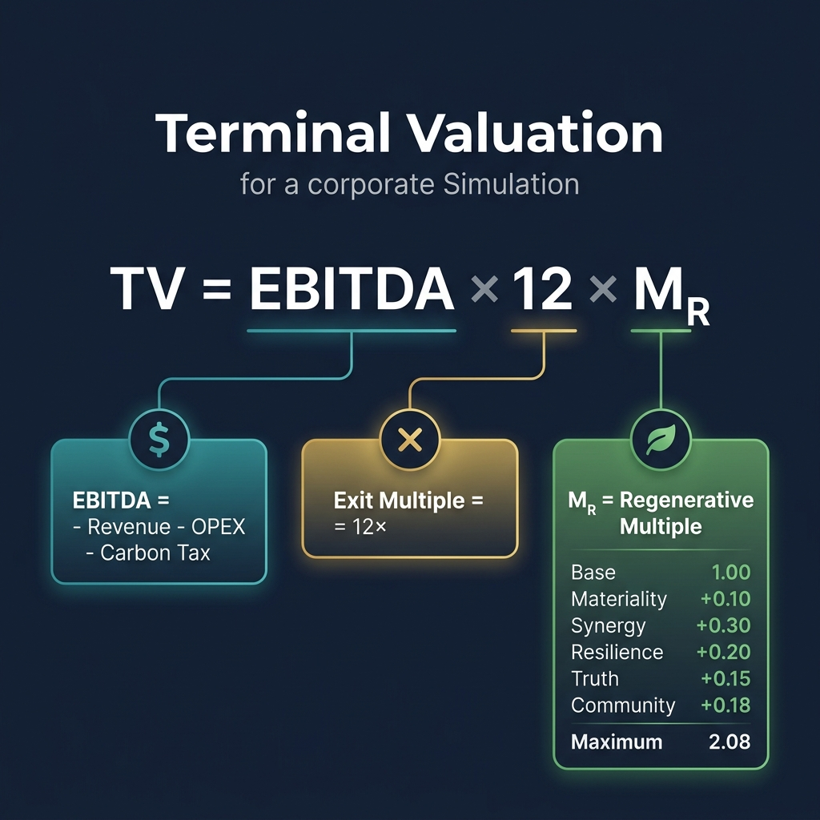
Figure 10.1 — Terminal Valuation Breakdown Screen

10.4 What-If Scenario Comparison
Scenario | M_R | Terminal Value | Delta vs Baseline
Baseline (Fragile Giant) | 1.05 | ~$478M | —
+ Resilient Choices (R5B + R8A) | 1.25 | ~$570M | +$91M
+ Titan Strategy (all bonuses) | 1.65 | ~$752M | +$273M
Maximum Achievable | 2.08 | ~$948M | +$469M

11. Flag Dependencies & Cascades
The "Butterfly Effect" system means early-round decisions compound through cross-round flag dependencies:
Source | Flag | Target | Cascade Effect
R1A | electronics_blindspot | R4 | DOUBLES crisis severity (40→80)
R1B | deep_audit_completed | R4 | HALVES crisis severity
R2A | materiality_aligned | R10 | +0.10 M_R Governance bonus
R3C | greenwash_risk | R5+ | Triggers greenwash if avg inv < 15%
R3A | early_decarboniser | R7 | +0.10 synergy multiplier
R5C | insurance_only | R10 | BLOCKS +0.20 Resilience M_R
R6B | ethical_ai_overhaul | R10 | +0.15 Truth Premium M_R
R6C | ai_monetised | R7+ | EU AI Act costs from R7 onward
R7C | synergy_unlock | R10 | +0.30 Synergy M_R (highest bonus)
R8B | electronics_water_priority | R10 | BLOCKS +0.20 Resilience M_R
R9C | community_fund | R10 | +0.18 Community Champion M_R
R9B | managed_transition | R10 | +0.12 Just Transition M_R
Key Insight: The most impactful flags are set in R1 (blindspot), R6 (ethics), and R7 (synergy). These three rounds alone account for over 60% of M_R variability.

PART IV: REFERENCE

12. Real-World Case Studies
Each simulation round parallels a real corporate event. Studying these cases deepens your understanding of the strategic trade-offs you face in the simulation.

Case 1: 🚗 Volkswagen Dieselgate (2015)
Company: Volkswagen AG | Simulation Parallel: Round 1 — ESG Audit Depth
What Happened:
In 2015, the US Environmental Protection Agency discovered that Volkswagen had installed 'defeat device' software in 11 million diesel vehicles worldwide, enabling them to cheat emissions tests. The scandal revealed systematic governance failures — internal audits had flagged anomalies but were overridden by management. A deeper, forensic audit culture could have surfaced the fraud years earlier.
Connection to the Simulation:
Like Muressons' R1 choice, VW faced a diagnostic decision: invest in thorough compliance checks or accept surface-level assurances. The 'electronics_blindspot' flag in the simulation mirrors VW's willful blindness to defeat devices.
Real-World Outcome:
VW paid over €30 billion in fines, settlements, and recalls. CEO Martin Winterkorn resigned and was later charged with fraud. The company's share price dropped 37% in two days. A $3M audit would have been the best investment in VW's history.
Key Lesson: The cost of not knowing always exceeds the cost of finding out.
Theory: Argyris (1977) Double-Loop Learning: VW's culture suppressed the 'governing variables' that should have triggered alarm.
Reference: United States Environmental Protection Agency. (2015). Notice of Violation to Volkswagen AG. https://www.epa.gov/enforcement/volkswagen-clean-air-act-civil-settlement

Case 2: 🥛 Danone's Double Materiality Journey (2020-2023)
Company: Danone SA | Simulation Parallel: Round 2 — Double Materiality Alignment
What Happened:
Danone became the first listed French company to adopt 'Entreprise à Mission' status in 2020, embedding social and environmental objectives into its corporate charter. CEO Emmanuel Faber championed full materiality alignment — but activist investors argued this came at the expense of shareholder returns.
Connection to the Simulation:
Danone's dilemma mirrors R2's Option A (Full Alignment) vs Option C (Business as Usual). Faber chose full alignment but was ousted in 2021 by activists who felt the company was under-performing on financial materiality.
Real-World Outcome:
Faber was removed as CEO in March 2021. His successor Antoine de Saint-Affrique took a more balanced approach. The case shows that materiality alignment requires both conviction AND financial performance — purpose without profit is unsustainable.
Key Lesson: Double materiality is a lens, not a religion. Align ESG with financial performance or lose your mandate.
Theory: Freeman (1984) Stakeholder Theory: Balancing purpose and profit requires managing competing stakeholder expectations simultaneously.
Reference: Danone SA. (2020). Danone Becomes the First Listed Company to Adopt the Entreprise à Mission Model. https://www.danone.com/media/news-list/danone-becomes-first-listed-company-to-adopt-entreprise-a-mission.html

Case 3: 🌊 Ørsted's Green Transformation (2017-2023)
Company: Ørsted A/S (formerly DONG Energy) | Simulation Parallel: Round 3 — Scope 3 Decarbonisation
What Happened:
In 2017, Danish Oil and Natural Gas (DONG) Energy rebranded as Ørsted and committed to divesting all fossil fuel assets. The company sold its upstream oil and gas business, issued green bonds to fund offshore wind expansion, and reduced carbon intensity by 87% in six years.
Connection to the Simulation:
Ørsted's transformation mirrors R3's Option A (supply chain transformation) combined with Option B (green bond issuance). The company accepted massive short-term disruption for long-term strategic positioning.
Real-World Outcome:
Ørsted's market capitalisation increased from €10B to €60B+ between 2017-2021. The company became the world's largest offshore wind developer. Their green bonds were oversubscribed 3×, demonstrating investor appetite for credible transition stories.
Key Lesson: Genuine decarbonisation creates shareholder value. Carbon offsets (Option C) are not a substitute for structural change.
Theory: Teece (2007) Dynamic Capabilities: Ørsted's sensing, seizing, and transforming of its business model exemplifies strategic agility.
Reference: Ørsted A/S. (2023). Our Green Transformation. https://orsted.com/en/who-we-are/our-purpose/our-green-transformation

Case 4: 👟 Nike's Supply Chain Scandal (1990s)
Company: Nike, Inc. | Simulation Parallel: Round 4 — Crisis Contagion & Reputation
What Happened:
In the 1990s, Nike faced devastating revelations about child labour and sweatshop conditions in its Southeast Asian supplier factories. The crisis began with a single factory exposé but rapidly spread to become a symbol of corporate exploitation. Nike's initial response — denial and deflection — amplified the contagion.
Connection to the Simulation:
Nike's experience mirrors R4's contagion engine. Their initial 'Option C' (deny) approach doubled the crisis severity. When they eventually chose transparency (Option A), publishing factory audits and supplier lists, reputation recovery began.
Real-World Outcome:
Nike lost an estimated $1.5B in market value during the peak crisis. Recovery took nearly a decade. Today, Nike is considered a leader in supply chain transparency — but only because the crisis forced transformation. The company now publishes its complete supplier list and requires third-party audits.
Key Lesson: Reputation contagion follows a sigmoid curve: slow start, rapid middle, saturating end. Early transparency flattens the curve.
Theory: Kahneman (2011) System 1/2: Nike's initial denial was a System 1 (fast, defensive) response. Effective crisis management requires System 2 (slow, analytical) thinking.
Reference: Locke, R.M. (2003). The Promise and Perils of Globalization: The Case of Nike. MIT Working Paper. https://doi.org/10.2139/ssrn.427500

Case 5: 🌿 Unilever's Climate Adaptation (2010-2020)
Company: Unilever PLC | Simulation Parallel: Round 5 — Physical Climate Risk
What Happened:
Unilever's Sustainable Living Plan (2010) included commitments to halve environmental footprint while doubling business size. In Indonesia, the company invested in smallholder farmer resilience programs — nature-based solutions that reduced supply chain disruption from floods and droughts by 30%.
Connection to the Simulation:
Unilever's approach mirrors R5's Option B (nature-based resilience). Rather than hard engineering (Option A) or insurance only (Option C), they invested in ecosystem restoration that provided both climate adaptation and natural capital benefits.
Real-World Outcome:
Unilever's sustainable brands grew 69% faster than the rest of the business. The nature-based approach reduced NCD while building community resilience. Paul Polman's tenure demonstrated that adaptation and growth are compatible.
Key Lesson: Nature-based solutions provide resilience AND reduce natural capital debt. Hard engineering protects assets; ecosystems protect systems.
Theory: Taleb (2012) Antifragility: Unilever's ecosystem approach gets stronger from stress, unlike hard infrastructure which degrades.
Reference: Unilever PLC. (2020). Unilever Sustainable Living Plan 2010-2020: Summary of 10 Years' Progress. https://www.unilever.com/planet-and-society/sustainability-reporting-centre/

Case 6: 🤖 Amazon's AI Recruitment Tool Bias (2018)
Company: Amazon.com, Inc. | Simulation Parallel: Round 6 — Algorithmic Ethics
What Happened:
In 2018, Amazon scrapped an AI recruitment tool after discovering it systematically discriminated against women. The algorithm, trained on 10 years of predominantly male resumes, learned to penalise CVs containing the word 'women's' and downgrade graduates of all-women's colleges.
Connection to the Simulation:
Amazon ultimately chose the equivalent of R6's Option B (ethical overhaul) — scrapping the tool entirely. However, they initially attempted Option C (quiet patch) before the bias was too systemic to fix incrementally.
Real-World Outcome:
Amazon disbanded the team and never deployed the tool. The case became a landmark in AI ethics education. The EU AI Act (2024) now classifies recruitment AI as 'high-risk', requiring conformity assessments and human oversight.
Key Lesson: Algorithmic bias is a leadership problem, not a technical one. The training data reflects the culture that created it.
Theory: Argyris (1977): Amazon's bias was embedded in 'governing variables' — the historical hiring patterns that the AI internalised as 'normal'.
Reference: Dastin, J. (2018). Amazon Scraps Secret AI Recruiting Tool That Showed Bias Against Women. Reuters. https://www.reuters.com/article/us-amazon-com-jobs-automation-insight-idUSKCN1MK08G

Case 7: ♻️ Interface Carpets' Circular Transformation (1994-2020)
Company: Interface, Inc. | Simulation Parallel: Round 7 — Circular Economy
What Happened:
In 1994, Interface founder Ray Anderson had an 'epiphany' after reading Paul Hawken's 'The Ecology of Commerce'. He committed to 'Mission Zero' — zero environmental footprint by 2020. The company redesigned products for disassembly, pioneered carpet tile take-back programs, and achieved 96% waste diversion.
Connection to the Simulation:
Interface chose the equivalent of R7's Option A (full circular redesign). The $10M+ investment seemed radical in 1994 but created lasting competitive advantage through material cost reduction and brand differentiation.
Real-World Outcome:
Interface achieved Mission Zero in 2020. GHG emissions fell 96%, renewable energy reached 89%, and water use dropped 89%. The company's market position strengthened as governments mandated extended producer responsibility.
Key Lesson: Circular economy is not a cost — it's a competitive moat. First-movers set the standards that followers must meet.
Theory: Barney (1991) VRIO: Interface's circular capabilities are Valuable, Rare, Inimitable, and Organisation-embedded — a textbook sustainable competitive advantage.
Reference: Anderson, R.C. (2009). Confessions of a Radical Industrialist. St. Martin's Press. https://www.interface.com/us/en/about/mission-zero

Case 8: 💧 Coca-Cola's Water Crisis in India (2003-2007)
Company: The Coca-Cola Company | Simulation Parallel: Round 8 — Water Stewardship & Social License
What Happened:
Coca-Cola's bottling plant in Plachimada, Kerala, was shut down in 2004 after local communities accused the company of depleting groundwater and contaminating wells. The Kerala High Court ruled that the company had violated the public trust doctrine — groundwater belongs to the community, not the corporation.
Connection to the Simulation:
Coca-Cola initially chose the equivalent of R8's Option B (prioritise high-value operations). The social license collapse in 'left behind' communities mirrors the SLO penalty in the simulation.
Real-World Outcome:
The Plachimada plant remains closed. Coca-Cola subsequently invested $2B+ globally in water stewardship programs, achieving 'water positive' status in 2021. The crisis transformed the company's approach to community water rights.
Key Lesson: Water is a human right before it is a production input. Social license is revoked faster than it is earned.
Theory: Freeman (1984): The Plachimada community shifted from 'Monitor' to 'Manage Closely' overnight — stakeholder salience migration in action.
Reference: Hills, J. & Welford, R. (2005). Coca-Cola and Water in India. Corporate Social Responsibility and Environmental Management, 12(3), 168-177. https://doi.org/10.1002/csr.97

Case 9: ⚡ Enel's Just Transition (2019-2025)
Company: Enel SpA | Simulation Parallel: Round 9 — Just Transition
What Happened:
Italian utility Enel committed to closing all coal plants by 2027, affecting thousands of workers. Rather than mass layoffs, Enel invested €10B in reskilling programs, renewable energy job creation, and community transition funds in coal regions across Italy, Spain, and Chile.
Connection to the Simulation:
Enel's approach combines R9's Option B (managed transition) and Option C (community investment fund). The company explicitly rejected Option A (immediate closure) on ethical grounds, arguing that decarbonisation without justice is 'just another form of extraction'.
Real-World Outcome:
Enel retrained 3,000+ workers and created 5× more jobs in renewables than were lost in coal. Community satisfaction scores in transition regions exceeded pre-closure levels. The ILO cited Enel as a global best practice for just transition.
Key Lesson: Just Transition is not charity — it's risk management. Companies that abandon communities create future regulatory and social liabilities.
Theory: Rawls (1971) Veil of Ignorance + Sen (1999) Capabilities: Would you choose mass layoffs if you didn't know whether you were the CEO or the coal worker?
Reference: Enel SpA. (2022). Just Transition Report 2022. https://www.enel.com/company/stories/articles/2022/09/just-transition

Case 10: 🦈 Danone's Activist Investor Battle (2021)
Company: Danone SA | Simulation Parallel: Round 10 — Activist Pressure & Terminal Valuation
What Happened:
In early 2021, activist investors Bluebell Capital and Artisan Partners forced the ouster of Danone CEO Emmanuel Faber, arguing that his ESG-focused strategy had underperformed peers on financial returns. The campaign culminated in a proxy fight that split the board.
Connection to the Simulation:
Danone's crisis mirrors R10's Activist Ultimatum pathway. The board faced the same three options: defend integration (Option A), spin off underperformers (Option B), or accept the activist's agenda (Option C).
Real-World Outcome:
Faber was removed. New CEO de Saint-Affrique maintained ESG commitments but refocused on operational efficiency. The case demonstrates that sustainability strategy must deliver financial returns to survive activist pressure — M_R without EBITDA is a target, not a fortress.
Key Lesson: Terminal value = EBITDA × Exit Multiple × M_R. All three matter. Purpose without profit is unsustainable; profit without purpose is vulnerable.
Theory: Barney (1991) VRIO + Porter (1985) Value Chain: Synergy is a defensive weapon — conglomerate premium makes break-up less attractive.
Reference: Bluebell Capital Partners. (2021). Open Letter to the Board of Directors of Danone SA. https://www.ft.com/content/cf31353f-19b1-4c89-8a66-d4c36ccd0ed6

13. Strategic Tips & Common Mistakes

13.1 Top 5 Strategic Tips
Tip 1: Invest in R1 Deep Audit (Option B)
Spending $3M in R1 halves R4 crisis damage. This is the highest-ROI decision in the entire simulation — it prevents $6M+ in downstream losses.
Tip 2: Never ignore a BU for 2+ rounds
Technical Debt engine adds 4% OPEX compounding. Combined with Natural Decay (2% reputation/SLO loss), neglect spirals quickly.
Tip 3: Watch Social License carefully
If average SLO drops below 75, the Instability Discount wipes 0.40 from M_R — equivalent to losing ~$180M in terminal value.
Tip 4: Target the Synergy Unlock (R7C)
At +0.30 M_R, this is the single highest bonus. Ensure synergy_multiplier ≥ 0.80 to qualify.
Tip 5: Think in systems, not rounds
Decisions in R1 echo through R10. Map the flag dependency chain before committing.

13.2 Common Mistakes
- Over-investing in one BU — triggers Technology Lock-In and Revenue Cannibalization engines
- Choosing "cheap" options without considering flag consequences (R1A saves money but costs $6M+ at R4)
- Ignoring HR/talent — burnout compounds and triggers brain-drain OPEX inflation
- Cutting dividends sharply — triggers Dividend Ratchet reputation penalty (-5)
- Taking insurance-only path in R5 — permanently blocks +0.20 Resilience M_R bonus
- Choosing R6C (Monetise Algorithm) — triggers EU AI Act costs AND reputation -20

14. Glossary of Key Terms
This glossary contains all 50 terms used across the simulation, organised alphabetically. Where available, academic or regulatory references are provided.
AI Ethics & Algorithmic Bias: R6 crisis: algorithmic bias in recruitment AI. Option B (Ethical AI Overhaul, -$8M) earns Truth Premium (+0.15 M_R). Option C (Monetise) triggers EU AI Act costs. Models the EU AI Act (2024).
Reference: https://artificialintelligenceact.eu/
Brand Equity: Intangible asset value from brand recognition and loyalty. Operationalised via Keller's Customer-Based Brand Equity model (Journal of Marketing, 1993).
Reference: https://doi.org/10.2307/1252054
Business Unit (BU): One of four Muressons divisions: Pharma ($18M), Electronics ($16.5M, highest carbon 72), Consumer Goods ($10.5M), Software ($8.5M). Alternative verticals: Banking, Agriculture, Oil & Gas, Retail, Tech.
CAPEX (Capital Expenditure): One-time investment per BU per round from the CSF pool. CAPEX > 10% of BU revenue triggers a 1-round implementation lag. CAPEX > $3M has a 25% chance of +15% cost overrun.
Reference: https://www.investopedia.com/terms/c/capitalexpenditure.asp
Carbon Intensity: BU-level metric (tCO2-e per $M revenue). Scope 3 supply chain footprint is 4x direct emissions. Carbon tonnage at R10 is taxed at $250/tonne (climate pathway: $750/tonne).
Reference: https://www.ghgprotocol.org/sites/default/files/standards/ghg-protocol-revised.pdf
CAROIC (Carbon-Adjusted Return on Invested Capital): CAROIC = EBITDA × (1 − Tax Rate) / (Invested Capital + Carbon Tonnage × Shadow Carbon Price). Extends traditional ROIC by adding a shadow carbon cost to the denominator, penalising carbon-intensive firms. Grade scale: A+ (≥25%), A (≥15%), B (≥10%), C (≥5%), D (≥0%), F (<0%). Displayed per-round on both player and facilitator dashboards.
CFO Override: Emergency mechanism bypassing the R2 materiality gate for non-Quadrant-1 issues. Incurs -5 Group Reputation. Models tension between financial expedience and governance compliance.
Circular Economy: Economic model eliminating waste through lifecycle redesign. R7 operationalises via Industrial Symbiosis (Option C: Waste-to-Energy), boosting synergy +0.35 and earning +0.30 M_R, the highest single bonus.
Reference: https://ellenmacarthurfoundation.org/topics/circular-economy-introduction/overview
Contagion Engine: Sigmoid-based reputational damage propagation: Group_Rep = AVG(BU_Rep) - 50 x sigmoid((severity-30)/15). If electronics_blindspot active, R4 severity doubles (40 to 80). Models systemic risk cascades.
Corporate Archetypes: Terminal strategy profiles based on M_R: Regenerative Titan (>=1.80, cf. Orsted), De-risked Safe-Haven (>=1.20), Fragile Giant (>=0.80), Stranded Relic (<0.80, cf. post-dieselgate VW).
Corporate Strategic Fund (CSF): The master liquidity pool: CSF = Sum(Revenue_i - OPEX_i) - Dividends. If total CAPEX exceeds 20% of treasury, a loan at 12% interest is auto-triggered. The primary resource constraint for all investment decisions.
Cost of Capital: Investor-required rate of return. Follows macro cycles: R1-3 easing (-0.5%), R4-6 neutral, R7-9 tightening (+0.5%), R10 crisis (+1.0%). Higher rates penalise late-stage treasury recovery.
Reference: https://www.investopedia.com/terms/c/costofcapital.asp
CSRD: Corporate Sustainability Reporting Directive. EU directive mandating double materiality assessments for ~50,000 companies from 2025. The R2 minigame operationalises CSRD through a 6-issue materiality exercise.
Reference: https://finance.ec.europa.eu/capital-markets-union-and-financial-markets/company-reporting-and-auditing/company-reporting/corporate-sustainability-reporting_en
Dividend Ratchet: Board pressure: cutting dividends by more than 20% vs. last round triggers -5 reputation. Models real-world investor expectations for distribution consistency.
Double Materiality: EU CSRD requirement (Article 19a): assess both Financial Materiality (risks to company) and Impact Materiality (company's impact on society/environment). Doubly-material issues are mandatory first-priority.
Reference: https://eur-lex.europa.eu/legal-content/EN/TXT/?uri=CELEX:32022L2464
Dynamic Capabilities: Teece (1997): ability to integrate, build, and reconfigure competencies to address changing environments. Modelled via synergy multiplier and VRIO decay. Continuous reinvestment required.
Reference: https://doi.org/10.1002/(SICI)1097-0266(199708)18:7<509::AID-SMJ882>3.0.CO;2-Z
EBITDA: Earnings Before Interest, Taxes, Depreciation, and Amortization. The primary operational profitability metric. At R10, EBITDA is carbon-adjusted by deducting total carbon tonnage x carbon tax ($250/tonne).
Reference: https://www.investopedia.com/terms/e/ebitda.asp
ESG: Environmental, Social, and Governance. Three pillars for measuring corporate sustainability and ethical impact. First defined by the UN Principles for Responsible Investment (2006).
Reference: https://www.unpri.org/about-us/what-are-the-principles-for-responsible-investment
Flag Dependencies: Persistent boolean state variables encoding past decisions into future engines. Key: electronics_blindspot (R1->R4 severity doubler), ethical_ai_overhaul (R6->M_R +0.15), synergy_unlock (R7->M_R +0.30).
Governance Risk: Score [0-100] reflecting corporate governance quality. High values reduce cash efficiency (revenue x (1 - gov_risk/500)). Feeds supply chain contagion and R9 strike probability.
Reference: https://www.oecd.org/corporate/principles-corporate-governance/
Green Transition Fund (GTF): Ring-fenced capital reserve from early-round ESG decisions, analogous to a green bond issuance (ICMA framework). Drawn down first before corporate treasury for R7-R9 sustainable transition costs.
Reference: https://www.icmagroup.org/sustainable-finance/the-principles-guidelines-and-handbooks/green-bond-principles-gbp/
Greenwashing Engine: Detects green rhetoric without investment. If R3C chosen and avg investment ratio < 15%, ALL BUs lose 8 SLO points. Models regulatory risk from ESG misrepresentation.
Reference: https://www.esma.europa.eu/press-news/esma-news/esma-proposes-rules-use-esg-and-sustainability-terms-funds-names
Group Reputation: Composite [0-100] stakeholder perception score. The Contagion Engine propagates single-BU damage to the group. Below 65 triggers Talent Brain-Drain on Software BU.
Implementation Lag: Investments > 10% of BU revenue are DEFERRED 1 round. Pay NOW, benefit NEXT round. Models real-world capital project J-curve payoff profiles.
Instability Discount: A -0.40 penalty on M_R when average SLO < 75. The single most damaging scoring penalty, equivalent to losing ~$180M in terminal value. Models activist investor impairment pricing (cf. Danone 2021).
Just Transition: ILO/UN framework ensuring the sustainability shift does not leave workers behind. R9: Closure (strike risk) vs. Managed Transition ($12M) vs. Community Fund ($20M, +0.18 M_R). Paris Agreement Art. 4.
Reference: https://www.ilo.org/global/topics/green-jobs/WCMS_432859/lang--en/index.htm
Mendelow's Stakeholder Matrix: 2x2 Power-Interest grid classifying stakeholders by influence and engagement. R1 minigame: drag 10 stakeholders. 80%+ accuracy earns reputation bonus. Mendelow, A.L. (1991).
Natural Capital Debt (NCD): BU-level environmental liability. Interest rate = Base_Rate + NCD x 0.0001, compounds each round. At NCD=5,200 the effective rate is 57%. Models planetary boundaries as financial risk.
Reference: https://naturalcapitalcoalition.org/natural-capital-protocol/
Natural Decay (Entropy): BUs with zero CAPEX lose 2% reputation and 2% SLO per round. Over 5 rounds: Rep 80 decays to 72.3. Models organisational entropy.
OPEX (Operating Expenditure): Ongoing BU operational costs. Reduced by the Synergy Engine (sqrt(ratio) x 0.7 x synergy_multiplier). Increased by inflation (+2.5%/round), burnout, brain-drain, and technical debt.
Reference: https://www.investopedia.com/terms/o/operating_expense.asp
Pending CAPEX Projects: Infrastructure investments maturing over subsequent rounds. Stored with rounds_remaining counter. R5-A Hard Engineering purchases resilience in R7, not R5.
Regenerative Multiple (M_R): Risk-adjusted valuation modifier (range 0.60-2.08). Base 1.0 + bonuses: Synergy +0.30, Resilience +0.20, Truth +0.15, Community +0.18, Governance +0.10, Workforce +0.10, Wellbeing +0.05. Penalty: Instability -0.40.
Round Pacing: Facilitator-controlled timing: Free Play (players advance freely) or Facilitator-Gated (facilitator unlocks each round). Enables synchronised classroom or self-paced individual experiences.
SBTi: Science Based Targets initiative. Framework for emissions reduction aligned with Paris Agreement. R3 decisions on Scope 3 emissions map to SBTi near-term vs. long-term pathways.
Reference: https://sciencebasedtargets.org/
Scope 3 Emissions: Indirect value chain emissions (upstream suppliers, downstream customers). Typically 4x direct emissions per GHG Protocol. R3 decisions directly shape Scope 3 trajectory.
Reference: https://www.ghgprotocol.org/standards/scope-3-standard
Social License to Operate (SLO): BU-level score [0-100] quantifying community and worker acceptance (Thomson & Boutilier, 2011). Below 75 average triggers -0.40 M_R Instability Discount. Below 50 creates R9 strike risk (75%).
Reference: https://socialicense.com/definition.html
Staff Burnout: Global workforce burnout score [0-100]. HR investment reduces (-10 high, -4 medium). No investment adds +3 drift. OPEX penalty above 20. WHO ICD-11 recognised (2019).
Reference: https://www.who.int/news/item/28-05-2019-burn-out-an-occupational-phenomenon-international-classification-of-diseases
Stochastic Climate Event (R5): Category-4 cyclone with 75% probability. Base damage $12M. R5-A Hard Engineering: 85% reduction (2-round delay). R5-B Nature-Based: 60%. R5-C Insurance: no reduction, blocks M_R resilience bonus.
Reference: https://www.fsb-tcfd.org/recommendations/
Strategic Pillars Paradigm: Advanced decision paradigm (multi_toggles) where players configure choices across 5 strategic areas (Energy, Operations, Supply Chain, Offsetting, HR) instead of single A/B/C.
Strike Probability Engine: R9 stochastic event: P_Strike = Base_Risk + ((1-SLO/100) x 0.4). If avg SLO < 50: 75% strike probability. Strike zeroes ALL BU revenue for the round.
Synergy Engine: Diminishing-returns OPEX reduction: effective_ratio = sqrt(ratio) x 0.7; New_OPEX = Old_OPEX x (1 - effective_ratio x synergy_mult). R7C Waste-to-Energy adds +0.35 to synergy multiplier.
Synergy Multiplier: Factor [0.5-2.0+] amplifying CAPEX effectiveness. Decays 5%/round via VRIO. R7-C boosts +0.35. At R10, synergy x 100 must exceed 80 to unlock Resist & Integrate option.
Talent Brain-Drain: OPEX inflation for Software/Telehealth BU when Group Rep < 65. Penalty = 1 + max(0, (65-Rep)/100) x 1.5 + burnout_adj. Models ESG-driven employee exodus.
TCFD: Task Force on Climate-related Financial Disclosures. Framework for disclosing climate risks across Governance, Strategy, Risk Management, Metrics/Targets. The R5 stochastic event models TCFD physical risk scenario analysis.
Reference: https://www.fsb-tcfd.org/recommendations/
Technical Debt: 4% OPEX penalty for BUs with zero investment for 2+ consecutive rounds. Combined with Natural Decay and Brain-Drain, creates a spiralling neglect cascade.
Terminal Value (TV): Simulated market capitalisation at end of the 5-year cycle. TV = (Terminal_EBITDA + Green_Fund) x Exit_Multiple (12x) x Regenerative_Multiple (M_R). Represents what an ESG-informed institutional investor would pay.
Reference: https://www.investopedia.com/terms/t/terminalvalue.asp
Treasury: Corporate cash reserves. Below $5M triggers Turnaround Mode (survival phase). Depleted by investments, crises, loan interest, and operating costs.
VRIO Framework: Value, Rarity, Inimitability, Organisation. Strategic resource analysis per Barney (1991). Implemented as synergy decay: synergy_mult x (1-0.05) per round. Models competitive advantage erosion.
Reference: https://doi.org/10.1177/014920639101700108
Water Dependency Index: BU-level [0-1] score for operational freshwater reliance. Modified exclusively in R8 (Blue Stress). Pharma baseline: 0.85. Maps to TCFD physical climate risk exposures.
Reference: https://www.wri.org/aqueduct
Workforce Readiness: Global competence score [0-100, starts 50]. High HR: +8, Medium: +4, None: -5 per round. Below 40: pillar effectiveness -20%. Above 75: +0.10 M_R bonus.

15. Quick Reference Card
Print this page as a one-page reference during gameplay.
Round Progression:
Round | Theme | Key Flag to Target
R1 | ESG Foundations | Option B → deep_audit_completed
R2 | Double Materiality | Option A → materiality_aligned (+0.10 M_R)
R3 | Scope 3 Emissions | Avoid Option C greenwash_risk
R4 | Contagion Crisis | Full Transparency (Option A) for recovery
R5 | Climate Risk | Nature-Based (Option B) for resilience
R6 | AI Ethics | Option B → ethical_ai_overhaul (+0.15 M_R)
R7 | Circularity | Option C → synergy_unlock (+0.30 M_R)
R8 | Water Scarcity | Avoid electronics_water_priority
R9 | Just Transition | Option C → community_fund (+0.18 M_R)
R10 | Grand Finale | All flags evaluated → Terminal Value
Emergency Signals — When to Worry:
- 🔴 Treasury < $5M → Turnaround Mode imminent
- 🔴 SLO < 40 for any BU → Strike risk + Social Collapse
- 🟡 Burnout > 50 → Brain-drain activating, OPEX rising
- 🟡 Governance Risk > 30 → Cash conversion degrading
- 🟢 M_R > 1.50 → On track for Safe Haven or better
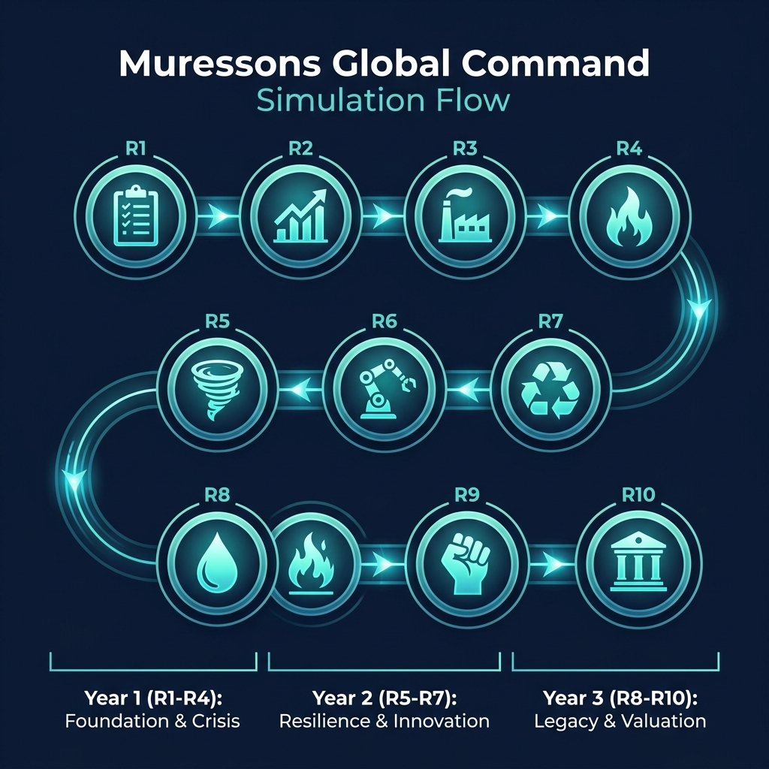
Figure 14.1 — Round Progression Roadmap

APPENDICES

Appendix A: Decision Paradigm Comparison
Feature | Narrative Crisis | Strategic Pillars | Advanced Climate | Healthcare
Decision Style | A/B/C choice | 5-area toggles | Climate-focused | Healthcare network
Complexity | Standard | High | High | Specialised
BU Types | Corporate (4 BUs) | Corporate (4 BUs) | Corporate (4 BUs) | Hospital/Clinic/Telehealth
Best For | First-time players | Experienced teams | Climate-focused courses | Healthcare MBA
Engine Count | 8 core | 8 core + pillars | 8 core + carbon | 8 core + clinical

Appendix B: Industry Vertical Alternatives
Facilitators can substitute the default BUs with industry-specific alternatives:
Vertical | BU 1 | BU 2 | BU 3 | BU 4
Default (Corporate) | Pharma | Electronics | Consumer Goods | Software
Oil & Gas | Upstream | Midstream | Downstream | Renewables
Banking | Retail Banking | Investment Banking | Insurance | Fintech
Retail/FMCG | Food & Beverage | Fashion | Home & Living | E-Commerce
Agriculture | Crop Production | Livestock | AgTech | Distribution
Technology | Cloud Services | Hardware | AI/ML | Cybersecurity

Appendix C: Minigames & Side Activities
The simulation includes several interactive minigames that enhance the learning experience:
Mendelow's Stakeholder Matrix (R1)
Drag-and-drop 10 stakeholders onto a Power-Interest Grid. Achieving 80%+ accuracy earns a reputation bonus. Teaches stakeholder mapping methodology.
CSRD Double Materiality Assessment (R2)
Assess CSRD issues across Financial and Impact materiality dimensions. Includes CFO budget validation gate. Teaches EU sustainability reporting frameworks.
CEO Interview (Post-Game)
AI-powered 5-question competency assessment across 6 dimensions: Strategic Thinking, Stakeholder Empathy, Financial Acumen, Ethical Reasoning, Systems Thinking, and Adaptive Leadership. Produces a spider diagram and narrative feedback.
Boardroom Showdown (R10)
Activist investor negotiation exercise with strategic stake analysis and proxy fight mechanics.

Appendix D: Further Reading & Academic References
The following sources underpin the theoretical frameworks, regulatory models, and case studies used throughout the simulation. Students and facilitators are encouraged to consult these for deeper understanding.
Anderson, R.C. (2009). "Confessions of a Radical Industrialist." St. Martin's Press
Barney, J.B. (1991). "Firm Resources and Sustained Competitive Advantage." Journal of Management, 17(1), 99-120
Carbon Tracker Initiative (2013). "Unburnable Carbon: Are the World's Financial Markets Carrying a Carbon Bubble?." Carbon Tracker
Costanza, R. et al. (1997). "The Value of the World's Ecosystem Services and Natural Capital." Nature, 387, 253-260
Dastin, J. (2018). "Amazon Scraps Secret AI Recruiting Tool That Showed Bias Against Women." Reuters
DiMaggio, P.J. & Powell, W.W. (1983). "The Iron Cage Revisited: Institutional Isomorphism." American Sociological Review, 48(2), 147-160
Dixit, A.K. & Pindyck, R.S. (1994). "Investment Under Uncertainty." Princeton University Press
Ellen MacArthur Foundation (2013). "Towards the Circular Economy." Ellen MacArthur Foundation
European Commission (2022). "Corporate Sustainability Reporting Directive (CSRD)." EUR-Lex, Directive 2022/2464
European Parliament (2024). "EU Artificial Intelligence Act." Regulation 2024/1689
Freeman, R.E. (1984). "Strategic Management: A Stakeholder Approach." Pitman Publishing
GHG Protocol (2011). "Corporate Value Chain (Scope 3) Accounting Standard." World Resources Institute
Hardin, G. (1968). "The Tragedy of the Commons." Science, 162(3859), 1243-1248
ICMA (2021). "Green Bond Principles." International Capital Market Association
ILO (2015). "Guidelines for a Just Transition Towards Sustainable Economies." International Labour Organization
Kahneman, D. & Tversky, A. (1979). "Prospect Theory: An Analysis of Decision Under Risk." Econometrica, 47(2), 263-291
Keller, K.L. (1993). "Conceptualizing, Measuring, and Managing Customer-Based Brand Equity." Journal of Marketing, 57(1), 1-22
Kolb, D.A. (1984). "Experiential Learning." Prentice-Hall
Lieberman, M.B. & Montgomery, D.B. (1988). "First-Mover Advantages." Strategic Management Journal, 9(S1), 41-58
Locke, R.M. (2003). "The Promise and Perils of Globalization: The Case of Nike." MIT Working Paper
Mendelow, A.L. (1991). "Stakeholder Mapping." Proceedings of the 2nd International Conference on Information Systems
Mitchell, R.K., Agle, B.R. & Wood, D.J. (1997). "Toward a Theory of Stakeholder Identification and Salience." Academy of Management Review, 22(4), 853-886
OECD (2015). "G20/OECD Principles of Corporate Governance." OECD Publishing
Porter, M.E. & Kramer, M.R. (2011). "Creating Shared Value." Harvard Business Review, 89(1/2), 62-77
Rawls, J. (1971). "A Theory of Justice." Harvard University Press
Schlosberg, D. (2007). "Defining Environmental Justice." Oxford University Press
Sen, A. (1999). "Development as Freedom." Oxford University Press
Senge, P. (1990). "The Fifth Discipline: The Art and Practice of the Learning Organization." Currency Doubleday
Solomon, R.C. (1992). "Ethics and Excellence: Cooperation and Integrity in Business." Oxford University Press
Suchman, M.C. (1995). "Managing Legitimacy: Strategic and Institutional Approaches." Academy of Management Review, 20(3), 571-610
Taleb, N.N. (2012). "Antifragile: Things That Gain from Disorder." Random House
Teece, D.J. (1997). "Dynamic Capabilities and Strategic Management." Strategic Management Journal, 18(7), 509-533
Thomson, I. & Boutilier, R. (2011). "The Social License to Operate." SME Mining Engineering Handbook
UN PRI (2006). "Principles for Responsible Investment." United Nations Environment Programme
Unilever PLC (2020). "Sustainable Living Plan: 10 Years' Progress." Unilever
US EPA (2015). "Notice of Violation to Volkswagen AG." US Environmental Protection Agency
WHO (2019). "Burn-out: An Occupational Phenomenon (ICD-11)." World Health Organization

Appendix: BRSR NGRBC Deep-Dive Track
The Business Responsibility and Sustainability Reporting (BRSR) Track is a 5-round, rigorous module designed around the Securities and Exchange Board of India (SEBI) guidelines and the National Guidelines on Responsible Business Conduct (NGRBC).

Overview & Mechanics
When your facilitator enables this track, your executive team will navigate complex decision trees covering the nine NGRBC principles. Each round tests your ability to balance Essential Indicators (mandatory compliance) against Leadership Indicators (voluntary excellence).

Round Structure
- Round 1: Governance & Ethics (Principles 1 & 7) - Radical transparency vs. compliance pragmatism.
- Round 2: Workforce Well-being (Principles 3 & 5) - Implementing a living wage across tier-1 suppliers.
- Round 3: Environmental Footprint (Principles 2 & 6) - Circular procurement vs. conventional sourcing.
- Round 4: Value Chain Assurance (Principles 4, 8 & 9) - Addressing greenwash risks in downstream channels.
- Round 5: Integrated Reporting (BRSR Core) - Achieving reasonable assurance on value chain metrics.

Consequences & The Executive Dashboard
You must monitor your BRSR standing via the 'BRSR' dashboard accessed from the Cockpit toolbar. Achieving 'BRSR Pioneer' status unlocks a highly lucrative +0.05 ESG Alpha Dividend that permanently boosts your Regenerative Multiple (M_R). However, triggering 'Governance Fragility' or 'Greenwash Risk' flags will result in dynamic crisis events, directly draining corporate treasury or crashing group reputation.

Appendix: TCFD Climate Scenario Analysis
The Task Force on Climate-related Financial Disclosures (TCFD) provides the globally recognised framework for assessing how climate change affects your portfolio. In the Muressons simulation, the TCFD Scenario Analysis tool projects your company's financial exposure across three distinct climate pathways aligned with the Network for Greening the Financial System (NGFS).

Why TCFD Matters for Your Strategy
Real-world boards and investors increasingly demand TCFD-aligned scenario analysis. Companies that cannot articulate their climate risk exposure face higher cost of capital, investor exit, and regulatory penalties. In Muressons, you can access the Climate Scenario Dashboard from the cockpit's Climate tab to stress-test your portfolio against these futures.

The Three NGFS-Aligned Scenarios
Your analysis runs across three scenarios, each representing a fundamentally different climate–policy–technology trajectory:
Scenario | Temp. Path | NGFS Category | Carbon Price Trajectory | Key Risk | Strategic Implication
Net Zero 2050 | 1.5°C | Orderly | $50 → $250/tCO₂ | HIGH transition risk, LOW physical risk | Front-load decarbonisation CapEx; green tech premium turns negative
Delayed Transition | 2°C | Disorderly | $30 → $350/tCO₂ (shock) | BOTH transition AND physical risks elevated | Build financial buffers; prepare for carbon price shock
Current Policies | 4°C | Hot house world | $20 → $40/tCO₂ | CATASTROPHIC physical risk, low transition risk | Supply chain resilience; healthcare demand surge opportunity

What the Dashboard Shows You
The Climate Scenario Dashboard (accessible via the 🌡️ Climate tab in the right panel) provides:
Revenue Impact by BU: Each business unit is projected forward under the scenario's demand shift. Software may thrive in the 1.5°C world while Consumer Goods contracts; in the 4°C hothouse, Healthcare demand surges but Electronics supply chains collapse.
Annual Carbon Cost: Calculated from your average carbon intensity × estimated emissions × the scenario's carbon price at the analysis horizon. A team with high carbon intensity faces existential costs under the Disorderly 2°C pathway ($350/tCO₂).
Physical Risk Assessment: Multiplied from a 2% baseline loss rate. The Hothouse 4°C scenario applies a 4× multiplier, representing extreme weather, crop failure, and supply chain disruption. Your resilience factor (built through strategic investments) mitigates this.
Stranded Asset Exposure: Estimates what percentage of your property, plant & equipment becomes worthless under each scenario. Under Orderly 1.5°C, 35% of fossil-linked assets are stranded; under Hothouse 4°C, only 10% (because no transition occurs).
Transition Opportunity Score: Composite of your Reputation, Social License, Workforce Readiness, and carbon intensity. A score above 70 means 'well positioned'; below 45 signals 'high vulnerability'.
Nature Risk (TNFD): If biodiversity data is active, the dashboard overlays a Taskforce on Nature-related Financial Disclosures (TNFD) risk assessment showing Ecosystem Health, Biodiversity Dependency, and the recommended LEAP approach.

Compare Mode
Toggle 'Compare' to see all three scenarios side by side with animated bars showing revenue impact, carbon cost, physical loss, and overall risk gauges. This view directly mirrors how TCFD-aligned reports present their multi-scenario comparison matrices.

Strategic Implications
The key TCFD principle is 'strategic resilience under uncertainty'. A robust corporate strategy should perform acceptably across ALL scenarios, not just optimise for one. As you make pillar decisions each round, consider:
- Under 1.5°C: Is your decarbonisation pace fast enough to avoid punitive carbon costs?
- Under 2°C: Do you have sufficient financial buffers to absorb the carbon price shock from $40 to $150/tCO₂?
- Under 4°C: Can your supply chains survive catastrophic physical disruption? Is your healthcare exposure an opportunity?
- Across all: Does your overall M_R (Regenerative Multiple) position you as a leader or a laggard?

Theoretical Foundation
- TCFD (2017): Recommendations of the Task Force on Climate-related Financial Disclosures — the global standard for climate risk disclosure.
- NGFS (2022): Network for Greening the Financial System — provides the central bank-aligned scenario framework (Orderly, Disorderly, Hot House).
- IEA (2023): International Energy Agency World Energy Outlook — scenario projections for energy demand, carbon prices, and technology adoption.
- Carbon Tracker Initiative: Pioneered the 'stranded assets' methodology used to estimate fossil-fuel write-down exposure.

Appendix: Understanding CAROIC
As you navigate the simulation, one of the most critical metrics you will encounter on your Executive Cockpit is CAROIC (Carbon-Adjusted Return on Invested Capital). This metric bridges the gap between financial performance and environmental liability.

The Formula
CAROIC = [EBITDA × (1 − Tax Rate)] / [Invested Capital + (Carbon Tonnage × Shadow Carbon Price)]

Why It Matters
Traditional ROIC only measures the cash return on financial capital. CAROIC introduces a 'shadow carbon cost' (typically set to a high internal carbon price, such as $250/ton). This cost is added directly to your Invested Capital base. If your business unit generates high revenues but relies on heavily pollutive processes, the denominator of the CAROIC equation will balloon, compressing your return percentage.

Grading Scale
- A+ : ≥ 25% (Exceptional carbon-financial efficiency)
- A : ≥ 15%
- B : ≥ 10%
- C : ≥ 5%
- D : ≥ 0%
- F : < 0% (Operating losses compounded by carbon liability)

Strategic Takeaway
To achieve an A+ grade, you cannot simply increase EBITDA. You must concurrently invest in decarbonization (reducing Carbon Tonnage) to shrink the denominator. This makes it impossible to achieve top-tier CAROIC while maintaining a high carbon intensity.

Appendix: The CEO Debrief
At the conclusion of Round 10, your journey does not end. You will face a formal CEO Debrief—a comprehensive competency assessment designed to evaluate your leadership capability beyond raw financial metrics.

How You Are Evaluated
- Your final competency score across six core dimensions is calculated through a blended approach:
- 50% Performance Data: Calculated directly from your decisions, outcomes, and long-term consistency (trajectory) across all 10 rounds.
- 50% Interview Responses: You will answer a series of adaptive questions during the debrief. Your ability to articulate trade-offs, rationale, and systemic awareness is evaluated by an AI CEO persona.

Metacognitive Self-Assessment
Before the interview begins, you will be asked to rate your own performance on a scale of 1 to 10 for each dimension. Be honest. The simulation will measure your 'Calibration Gap'—the difference between how you perceive your performance and how the data actually reflects it. High self-awareness is a critical executive trait.

Evidence-Based Feedback
The debrief is highly personalized. Expect the CEO to pull 'receipts'—citing specific decisions you made in specific rounds to justify the feedback provided. You will also see how your final scores compare to your cohort via Peer Benchmarking.

Appendix: The ESG Impact Constellation
The ESG Impact Constellation is a live 3D visualizer embedded in your Executive Cockpit. It maps every strategic decision you make across all ten simulation rounds into an interactive star-chart, showing how your choices ripple forward — and sometimes loop back — across different ESG dimensions.
Think of it as your decision DNA made visible. After completing the simulation, the Constellation lets you examine which rounds had the biggest financial shocks, where you gained or lost reputation, and which early decisions set the conditions for your final outcome.

What Each Node Represents
Every glowing sphere in the Constellation represents one completed round. The sphere's colour, size, and glow intensity all carry meaning:
Round | Topic | ESG Dimension (Colour)
R1 | ESG Materiality | Environmental 🟢
R2 | Double Materiality | Governance 🟣
R3 | Scope 3 Supply Chain | Environmental 🟢
R4 | ESG Contagion | Social 🔵
R5 | Climate Risk | Environmental 🟢
R6 | AI Ethics | Governance 🟣
R7 | Circular Economy | Environmental 🟢
R8 | Water Stress | Environmental 🟢
R9 | Just Transition | Social 🔵
R10 | Activist Ultimatum | Mixed 🩵

Node Size = Financial Impact
The larger the sphere, the bigger the treasury shock your decision caused in that round. The size is calculated as:
Node Size = |Treasury Change| ÷ $5,000,000 (clamped between 0.15× and 0.5×)
A round where you committed to a costly green infrastructure investment, for example, will produce a noticeably larger sphere than a round where you only made a policy statement.

Understanding the Connection Lines
Two types of curved lines connect the nodes:
- Solid teal curves — Sequential links. Every round automatically connects to the next. The thickness of the line reflects how dramatically your reputation changed between rounds. A reputation swing of ±20 points produces a thick, vivid line; a stable reputation produces a thin, quiet connection.
- Dashed amber lines — Cross-causal links. These are the system's hardcoded memory. They appear between non-adjacent rounds that share a proven causal relationship:
Causal Link | What It Means
R3 → R5 (strength 0.6) | Your Scope 3 Supply Chain decisions in R3 created the conditions for your Climate Risk exposure in R5. Cutting supplier emissions early reduces your R5 penalty.
R4 → R7 (strength 0.4) | ESG Contagion choices in R4 feed into Circular Economy incentives in R7. Social license earned in R4 unlocks higher-return circular options.
R1 → R10 (strength 0.8) | Your very first ESG Materiality framing echoes all the way to the Activist Ultimatum in R10. Groups that under-weighted material risks in R1 are far more vulnerable at the finale.

The Background Nebula = Your Reputation Health
The faint cloud that fills the entire scene is not decorative — it reflects your current reputation score at the end of the visible timeline:
- Green nebula → Reputation ≥ 65 (Thriving — stakeholders trust you)
- Amber nebula → Reputation 40–64 (Cautious — goodwill is fragile)
- Red nebula → Reputation < 40 (Critical — licence to operate at risk)

The Hover Tooltip
Click or hover on any node to reveal its round-level data card:
- Treasury Δ — Cash gained or lost during that round (shown in $K or $M)
- Reputation Δ — Points gained or lost with stakeholders
- Carbon Δ — Change in tCO₂e emissions (green = reduction, red = increase)

The Timeline Slider
The slider at the bottom of the screen lets you replay your journey round by round. Drag it left to remove later rounds from the view, watching the constellation contract to its earlier state. This is especially useful in debrief to trace how a single early decision cascade into later outcomes.

ESG Filter Bar
Use the filter buttons (All / 🌱 E / 👥 S / 🏛️ G) to isolate one ESG dimension at a time. Nodes belonging to the selected dimension will glow at full intensity; all others fade. This reveals whether your strategy was balanced across E, S, and G or concentrated in one pillar.

What to Look For in the Debrief
When reviewing your Constellation after the simulation, ask yourself:
- Are the nodes roughly similar in size, or are one or two rounds dramatically larger? Outliers reveal the moments of highest financial risk-taking.
- Are the sequential links thick or thin? Volatile reputation arcs (thick lines) suggest reactive rather than strategic decision-making.
- Do the amber cross-causal links connect to your largest nodes? If your R5 (Climate Risk) node is large and a dashed line runs from your R3, your supply chain choices directly amplified that financial exposure.
- What colour is the nebula? If it shifted from green to amber to red across the timeline, your reputation was eroding — even if your financials looked healthy.

Appendix: Double Materiality Matrix Calculations
This appendix details the calculations behind the Double Materiality Matrix in Round 2, explaining how the unlocked budget, stakeholder panel fees, and mitigation costs are derived.

1. Unlocked Budget
When submitting the materiality matrix, the system calculates the capital unlocked based on accuracy in Quadrant 1 (High Financial & High Societal Impact).
- Total Available Budget: The base materiality budget defaults to $15,000,000.
- Accuracy Calculation (m_acc): The system evaluates the number of true Q1 issues correctly placed in Q1, divided by the total number of true Q1 issues.
- Formula: Allocated Budget = Total Available Budget × Accuracy
- Clawback Penalty: If Option C (Ignore Framework) was selected in the governance decision, the backend applies a 40% budget clawback to the unlocked amount to reflect the misalignment between the governance posture and the materiality exercise.

2. Stakeholder Panel / Consultant Fee
The cost to 'Commission Stakeholder Panel Survey' scales dynamically based on how many issues are pre-rated.
- Issues 1-4: Base fee of $250,000 per issue.
- Issues 5-8: Extended fee of $500,000 per issue (the cost doubles beyond 4 issues to reflect the complexity of wider engagement).
Examples:
- 1 Issue = $250,000
- 4 Issues = $1,000,000 ($250K × 4)
- 8 Issues = $3,000,000 ($1M for first four + $2M for the next four)

3. Mitigation Costs (Issue Chips)
When an issue chip is dragged on the matrix, it displays a specific cost (e.g., '$1.2M').
- Source: This number is stored as 'mitigation_cost_usd' within each issue's configuration in the backend.
- Prioritise Budget: The sum of these costs for all issues placed in the Q1 container forms the 'Prioritise Budget' shown dynamically at the top of the matrix. The numbers are formatted using division by 1,000,000 to display them with the 'M' suffix.

4. How the CSRD Screen Is Organised
When the CSRD Double Materiality screen opens (Round 2), it replaces the standard cockpit with a full-screen assessment workspace. Understanding its three zones will help you work efficiently.
- Zone 1 — Header Bar (top strip): Shows the session title, a live 'Placed X / Y issues' counter with a progress bar, the 'Q1 Budget' meter (running total of mitigation costs for issues you have placed in Quadrant 1 vs. the total CSF pool), and action buttons (Undo, Reset, Commission Stakeholder Panel Survey, Submit).
- Zone 2 — Left Pane (Issue Bank): Contains all ESG issue chips waiting to be classified. Each chip shows the issue title, a category badge (E = Ecological, S = Social, G = Governance), an ESRS topic tag (e.g., E1, S2), a severity badge (H / M / L), a time-horizon badge (ST / MT / LT), an IRO badge (IMP = Impact, RSK = Risk, OPP = Opportunity), and a cost badge (e.g., $1.2M) showing the mitigation cost that will be charged if the issue is placed in Q1. Hover over any chip to read the full issue description. A Horizon filter (All / ST / MT / LT) lets you focus on issues by time horizon without removing placed issues from the matrix.
- Zone 3 — Right Pane (2x2 Matrix): The matrix is divided into four quadrants based on two axes: Financial Materiality (x-axis, left = Low, right = High) and Impact Materiality / People & Planet (y-axis, bottom = Low, top = High). Drag chips from the Issue Bank into the quadrant where you judge they belong:
• Q1 (Top Right) — 'CFO Approved — Prioritise & Allocate CapEx': doubly material issues. Placing an issue here commits its mitigation cost.
• Q2 (Top Left) — 'Monitor & Engage': high impact, low financial risk. Requires disclosure investment, not capex.
• Q3 (Bottom Right) — 'Watch & Manage': high financial risk, low impact. Financially material but not ESRS impact-material.
• Q4 (Bottom Left) — 'Low Priority': immaterial on both axes. Placing 'greenwashing distractor' issues here is good governance.
- Submit Button behaviour: The 'Submit Matrix to CFO' button is disabled until at least 6 issues have been placed into any quadrant (the minimum for a valid materiality assessment). It is also disabled if the total Q1 mitigation cost exceeds your current CSF pool balance. Once enabled, clicking it sends the assessment to the backend for CFO scoring.

5. How Funds Are Calculated — Step by Step
The CSRD submission triggers a four-step financial calculation in the backend. Understanding this helps you make deliberate trade-off decisions.
- Step 1 — Stakeholder Panel Fee (if commissioned): If you clicked 'Commission Stakeholder Panel Survey' and chose to pre-rate N issues, the fee is deducted from corporate treasury immediately and is non-refundable regardless of matrix accuracy. Fee schedule: Issues 1–4 cost $250,000 each; Issues 5–8 cost $500,000 each (the cost doubles above 4 to reflect wider engagement). Maximum fee (8 issues): $3,000,000. Example: rating 6 issues = (4 × $250K) + (2 × $500K) = $2,000,000.
- Step 2 — CFO Validation Gate: The backend checks whether every issue you placed in Q1 (Top Right) is genuinely doubly material. An issue is doubly material if its severity_score × likelihood_score is ≥ 12 out of 25 on both the financial and societal axes (ESRS 1 §1.51 threshold). If any Q1 issue fails this test and you have not chosen the CFO Override, the submission is rejected with an error message — review your Q1 placements and resubmit. If you choose the CFO Override, the submission proceeds but Group Reputation is reduced by −10 points.
- Step 3 — Accuracy Scoring & Capital Release (M_acc): The backend counts how many of the true Q1 issues (those that genuinely meet the ≥ 12/25 threshold on both axes) you correctly placed in Q1, then divides by the total number of true Q1 issues:
M_acc = Correct Q1 placements ÷ Total true Q1 issues
The CFO then releases:
Allocated Budget = $15,000,000 × M_acc
Example: if 5 of 6 true Q1 issues were correctly placed, M_acc = 83.3%, and the CFO releases $12,500,000. Partial credit is awarded for 'ambiguous' issues placed in adjacent quadrants (e.g., a borderline Q1/Q2 issue placed in Q2 earns 0.5 credit). Note: the allocated budget is a capital commitment — it is deducted from your corporate treasury, not added to it.
- Step 4 — Option C Clawback (if applicable): If you chose Option C (Ignore the Materiality Framework) in the Round 2 governance decision, the backend applies a 40% clawback to the allocated budget before deducting it. This models the governance principle that capital cannot be released for ESG programmes if the board has simultaneously decided to ignore the ESG framework. Example: $12,500,000 × 40% clawback = $5,000,000 forfeited, leaving a net commitment of $7,500,000.
- Bonus — Q2 Disclosure Budget: For every Q2 issue (High Impact / Low Financial) you correctly place in Q2 that carries a 'disclosure_required' flag, the system pro-rates a share of the $1,000,000 Disclosure Investment Budget. This is a separate allocation for data collection, assurance, and stakeholder engagement costs (not capex). It is not deducted from the $15M pool.
- Accuracy Bonus: If your overall placement accuracy across all four quadrants reaches ≥ 80%, you receive a 1,000-point bonus to your simulation score (this is a learning bonus, not a financial figure).

Summary: The Q1 Budget Counter vs. the CFO Allocation
The 'Q1 Budget' counter you see in the header bar while building your matrix is NOT the amount the CFO will release. It is the sum of the mitigation costs of issues you have placed in Q1 — a running cost estimate that tells you whether your selections are affordable within your CSF pool. The actual capital committed at submission is calculated by the backend based on accuracy (M_acc × $15M), independent of the individual chip costs. The chip costs are the 'price tags' on mitigation programmes; the $15M × M_acc is the CFO's governance-based budget release.

Section: Single Business Mode & Regional Localisation
Muressons now supports a Single Business Mode — a focused experience where your executive team manages one company operating in a specific geographic region, rather than a four-division conglomerate. In this mode, every strategic decision, stakeholder interaction, and sustainability challenge is shaped by both the industry vertical your facilitator has selected and the real-world regulatory and risk context of your region.
Whether you are managing an Agriculture company in South Asia, an Oil & Gas operation in Africa, a Retail FMCG brand across Europe, or a Technology firm in ASEAN, the simulation dynamically adjusts its pillar decisions, stakeholder profiles, black swan risks, and ESG reporting requirements to match your industry and region.

What Is Single Business Mode?
In the standard simulation, you manage four business units simultaneously — Pharma, Electronics, Consumer Goods, and Software. In Single Business Mode, your cohort is assigned a single industry vertical and a geographic region. Your treasury, reputation, carbon position, and all five strategic pillars belong to that one business.
Feature | Standard Mode (4-BU) | Single Business Mode
Companies managed | 4 Business Units | 1 Company
Industry focus | Generic conglomerate | Specific vertical (e.g. Agriculture)
Geographic context | Global / generic | Specific region (ASEAN, South Asia, Europe, North America, Africa)
Stakeholder profiles | Universal set | Region & industry specific
Strategic pillars | 5 standard areas | 5 areas — some replaced by industry-specific ones
Black Swan events | Global events only | Region-filtered + new region-specific events
ESG reporting | Generic framework | Region-aligned (BRSR, CSRD, SEC, ASEAN Taxonomy, King IV)

The Five Geographic Regions
Your facilitator selects the region when setting up your cohort. The region determines which stakeholders you must manage, which regulatory frameworks apply, and which black swan events you might face.
Region | Key Regulatory Framework | Sample Stakeholders | Region-Specific Risk
🌏 ASEAN | ASEAN Taxonomy for Sustainable Finance | MAS Regulator, FDI Investors, Supply Chain NGO | 🌀 Typhoon Supply Disruption
🇮🇳 South Asia | SEBI BRSR / NGRBC Principles | SEBI, Smallholder Farmers, AgriNGO, State Gov. | 🌡️ Monsoon Crisis / Heat Stress
🇪🇺 Europe | CSRD / ESRS Directives | EU Regulator, Consumer NGOs, ESG Bond Investors | 🌿 Carbon Border Adjustment Mechanism (CBAM)
🇺🇸 North America | SEC Climate Disclosure Rules / TCFD | SEC, Institutional Investors, Activist Shareholders | 📋 SEC Mandatory Climate Disclosure
🌍 Africa | GRI Standards + King IV | Host Government, Community Leaders, Resource Unions | ⛏️ Resource Nationalisation Risk

Your Executive Cockpit in Single Business Mode
Your dashboard looks and works the same as the standard mode, but with two key differences: you see one company's financials (not four), and one or more of the five strategic pillar areas may be replaced by an industry-specific decision unique to your vertical.
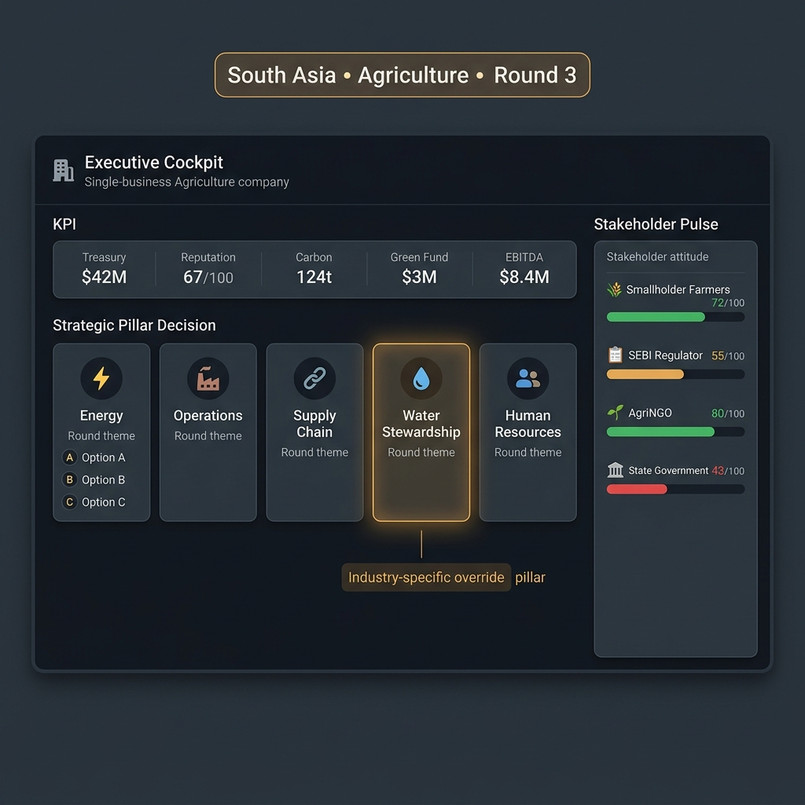
Figure: Executive Cockpit in Single Business Mode (Agriculture, South Asia). Note the 💧 Water Stewardship pillar replacing the standard Offsetting area.
ℹ️ The amber-highlighted pillar tile (💧 Water Stewardship in the example above) is your industry-specific pillar. It has been customised for your vertical by your institution and represents a material ESG issue specific to your industry.

Industry-Specific Strategic Pillars
Depending on your assigned industry vertical, one or more of the five standard pillar areas may be replaced or extended with an industry-specific decision. These replacements reflect the material ESG issues that are most consequential for that sector.
Industry Vertical | Replaced Pillar | Industry-Specific Pillar
🌾 Agriculture | 🌿 Offsetting | 💧 Water Stewardship
🏦 Banking & Finance | 🔗 Supply Chain | 🤝 Financial Inclusion
⛽ Oil & Gas | 🌿 Offsetting | 🛢️ Well Decommissioning
💊 Pharma / Healthcare | 👥 Human Resources | 💊 Medicine Access
💻 Technology | 🏭 Operations | 🔒 Data Privacy & Ethics

Strategic Tip: Your industry-specific pillar typically carries higher weight in your ESG score and is a key signal for regional regulators and stakeholders. Choosing the Status Quo option in your industry pillar carries a higher reputational risk than doing so in the standard pillar areas.

Your Stakeholders — Industry & Region Specific
In Single Business Mode, your stakeholder landscape is drawn from a curated database specific to your industry and region combination. Each stakeholder has a power rating, interest level, and a Mendelow quadrant position reflecting real-world dynamics in your context.
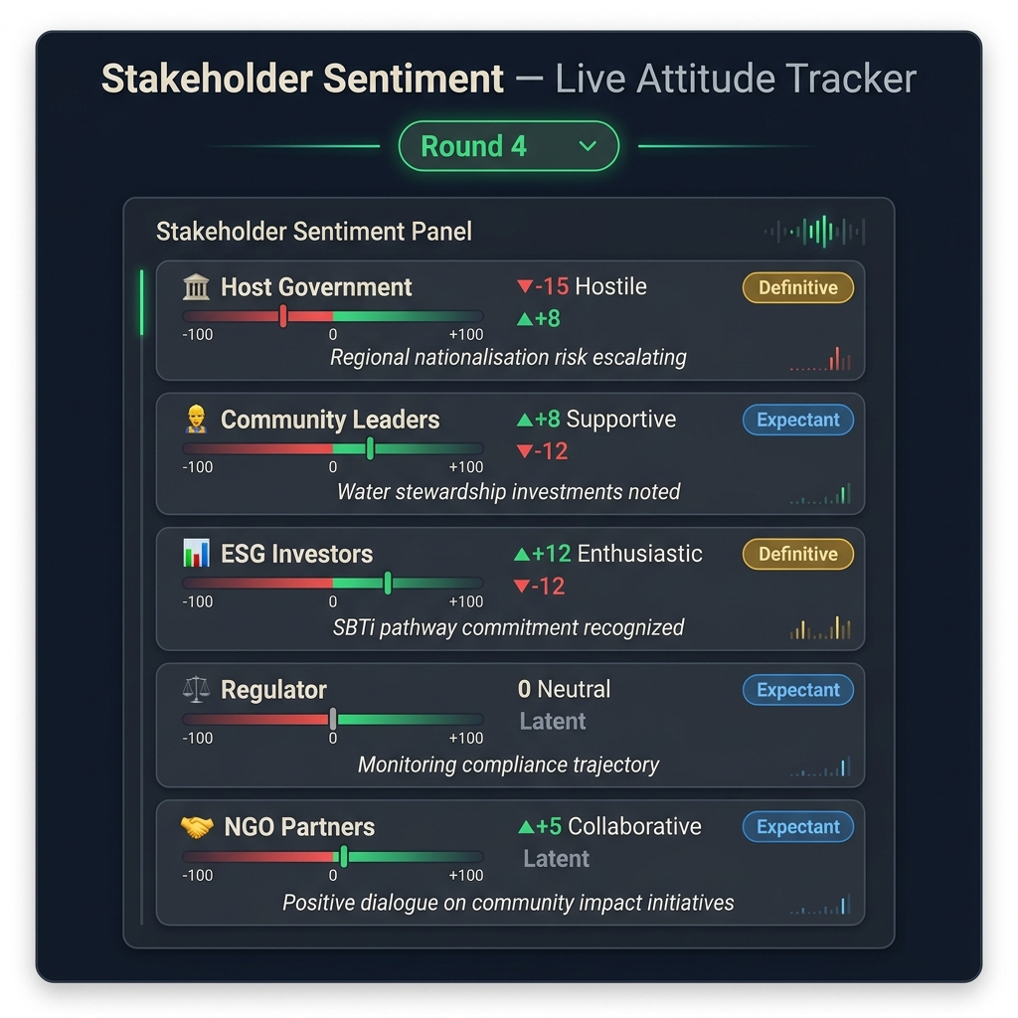
Figure: Stakeholder Sentiment Panel showing live attitude scores per stakeholder. Green ▲ = improving, Red ▼ = deteriorating. Salience badges indicate priority.
Each round, the simulation tracks how your strategic decisions affect each stakeholder's attitude score (−100 Hostile → +100 Enthusiastic). The following factors drive sentiment changes:
- Your pillar decisions: choosing leadership options improves scores for aligned stakeholders
- Black swan events: regional crises can sharply reduce community or regulator sentiment
- Neglect: consistently choosing Status Quo erodes trust over multiple rounds
- Salience matters: high-power 'Definitive' stakeholders amplify both gains and losses
⚠️ Watch for the 🚨 Early Warning badge on the Stakeholder Sentiment panel. This appears when a high-power stakeholder drops below −50 (Hostile territory). Hostile high-power stakeholders trigger reputational crises and regulatory interventions in subsequent rounds.

Region-Specific Black Swan Events
In addition to the global black swan events that can affect any simulation, Single Business Mode activates a set of region-specific disruptions. These events are based on real-world risk patterns in each geography.
Event | Region | Impact
🚢 ASEAN Trade Dispute | ASEAN | Revenue −12%, Treasury −8%, logistics freeze
🌧️ South Asia Monsoon Crisis | South Asia | Factory closures, OPEX +10%, social licence at risk
🌿 Carbon Border Adjustment (CBAM) | Europe | Export revenue −8%, compliance cost spike
📋 SEC Climate Disclosure | North America | Legal fees, Governance risk +12, investor pressure
⛏️ Resource Nationalisation | Africa | Treasury −15%, Revenue −18%, community crisis

Resilience Tip: Black swan events are probabilistic — they are more likely to fire in later rounds (Rounds 4–8) and become more severe if your governance risk score is high or your community trust is low. Strong early investment in governance and community stakeholder engagement reduces both the probability and the impact of these events.

ESG Reporting — Region-Aligned Frameworks
At the end of the simulation, your facilitator may generate a region-aligned ESG report summarising your performance across the frameworks most relevant to your geography. This is a teaching tool — it maps your decisions to the disclosure requirements you would face as a real company operating in your region.
Region | Primary Reporting Framework
🇮🇳 South Asia | SEBI BRSR (Business Responsibility & Sustainability Reporting)
🇪🇺 Europe | CSRD / European Sustainability Reporting Standards (ESRS)
🇺🇸 North America | SEC Climate Rule / TCFD Aligned Disclosure
🌏 ASEAN | ASEAN Taxonomy for Sustainable Finance
🌍 Africa | GRI Standards + King IV Corporate Governance

Strategic Advice for Single Business Mode
- Understand your stakeholder map early. In Single Business Mode, stakeholder salience is concentrated — you have fewer but more contextually powerful stakeholders than in the conglomerate. A hostile Host Government in Africa or a hostile SEBI regulator in South Asia can materially affect your terminal valuation.
- Your industry-specific pillar is your identity. Investors, regulators, and community leaders watch your industry pillar decisions most closely. Consistent leadership choices in this area build a durable stakeholder alliance.
- Regional black swans are correlated with neglect. The probability of a regional black swan increases if your community trust is low. Invest in social licence early to reduce your exposure.
- Think about your ESG reporting framework from Round 1. If you are in Europe, the CSRD requires supply chain due diligence — your Supply Chain pillar choices will directly affect your end-game reporting score. Know your framework.
- The Stakeholder Sentiment panel is a leading indicator. Changes in attitude scores in one round predict crisis events in the next. Monitor it after every decision.

