MURESSONS GLOBAL SIMULATION
Student & Player Guide

A Comprehensive Guide to the 10-Round
ESG Sustainability Strategy Simulation

Version 6.0 — Facilitator-Approved Edition

Table of Contents
- 1. Welcome & Introduction
- 2. Getting Started — Login & Interface
- 3. Your Company at a Glance
- 4. Understanding the Executive Cockpit
- 5. Key Performance Metrics Explained
- 6. Capital Allocation — The Investment Matrix
- 7. Decision Gates — Making Strategic Choices
- 8. The 10-Round Journey — Detailed Guide
- 9. How Decisions Connect — The Flag System
- 10. Terminal Valuation — How You're Scored
- 11. Company Archetypes — Your Final Profile
- 12. Hidden Engines — What's Running Behind the Scenes
- 13. Common Strategic Mistakes & How to Avoid Them
- 14. The CEO Interview — Post-Game Assessment
- 15. Strategic Playbook — Approaches & Considerations
- 16. Quick Reference Glossary
- Appendix A: Formula Quick-Reference Card
- Appendix B: Frequently Asked Questions

1. Welcome & Introduction
Welcome to Muressons Global Command — a multi-round strategic simulation that places you in the role of CSO of Muressons Corporation, a multinational conglomerate with four business units spanning Pharmaceuticals, Electronics, Consumer Goods, and Software.
Over 10 strategic rounds — representing approximately 3 years of corporate stewardship — you will face escalating ESG (Environmental, Social, and Governance) crises, make capital allocation decisions under uncertainty, and navigate the tension between short-term financial performance and long-term enterprise sustainability. Every decision you make creates ripple effects that compound across future rounds.

What Makes This Simulation Unique?
Unlike traditional business simulations that optimise for a single metric (e.g. profit), Muressons Global Command uses a multi-dimensional scoring engine with 20+ mathematical models running simultaneously. Your company is evaluated not just on financial returns, but on how you manage environmental debt, workforce welfare, community relations, and ethical governance. The simulation rewards systems thinking — the ability to see how decisions in one domain affect outcomes in another.

Learning Objectives
By the end of this simulation, you should be able to:
- Apply the Double Materiality framework to real capital allocation decisions, understanding how financial impact and ESG impact must be considered simultaneously.
- Understand how ESG risks compound across interconnected business systems — a supply chain scandal doesn't just affect one unit, it propagates through the entire group.
- Navigate genuine trade-offs between financial performance and stakeholder welfare, recognising that 'winning' means balancing multiple competing objectives.
- Experience first-hand the consequences of short-term vs. long-term strategic thinking, seeing how early cost-saving decisions can create devastating downstream effects.
- Develop adaptive leadership skills under conditions of uncertainty, incomplete information, and crisis pressure.
- Articulate and defend a coherent strategic narrative that connects your decisions to outcomes across all 10 rounds.

Important Ground Rules
- There are no 'right answers' — only trade-offs. The simulation is designed to surface genuine dilemmas, not test whether you can find the 'correct' option.
- Your decisions carry forward permanently. Flags set in Round 1 can unlock or block options in Round 10. You cannot undo past choices.
- The simulation includes stochastic (random) elements. Two teams making identical decisions may experience different outcomes due to climate events, market noise, and FX fluctuations.
- Collaboration and discussion within your team are encouraged. The best outcomes emerge from diverse perspectives and robust debate.
- Your facilitator may adjust crisis parameters, ending pathways, or difficulty settings. The experience may differ from what is described in this guide.

2. Getting Started — Login & Interface

Logging In
When you first access the simulation, you will see the Command Access screen. This is your entry point into the Muressons world.
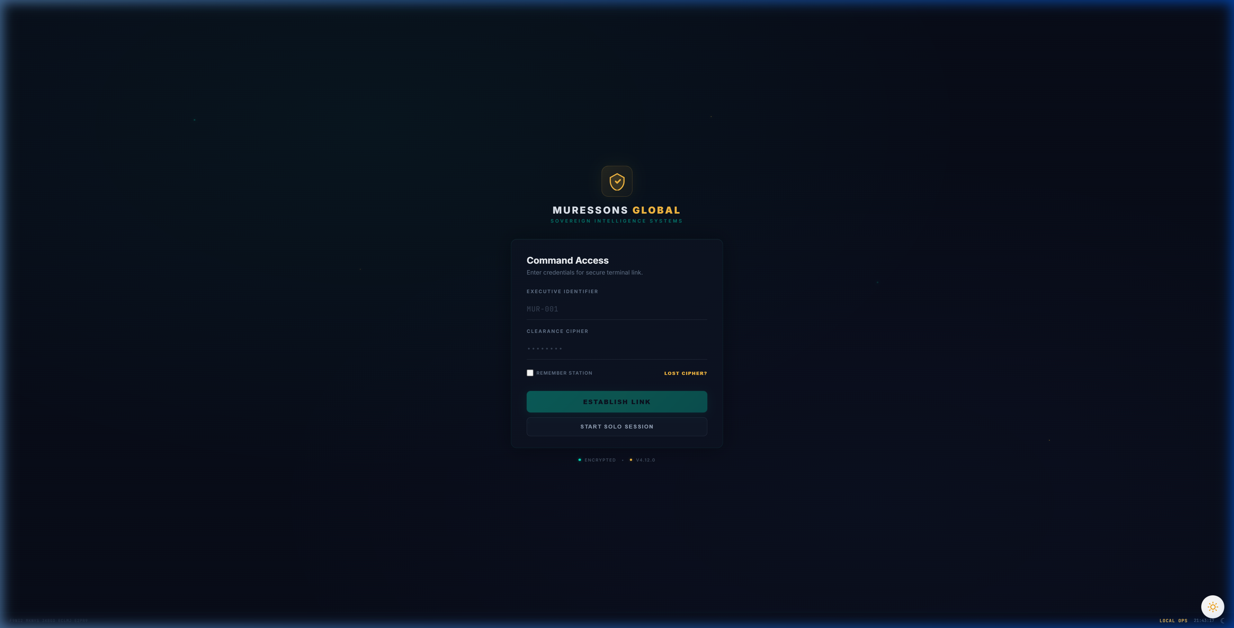
Figure 2.1 — The Command Access (Login) Screen

You have two options for accessing the simulation:

Option 1: Join a Cohort (Multiplayer)
If your facilitator has created a cohort session, you will need two pieces of information:
- Executive Identifier — Your unique player ID (e.g. MUR-001). Your facilitator will assign this.
- Clearance Cipher — The session password shared by your facilitator.
Enter both credentials and click 'ESTABLISH LINK' to join the shared session. In cohort mode, your facilitator controls round pacing — rounds may unlock on a timer or be released manually.

Option 2: Solo Session
Click 'START SOLO SESSION' to begin an individual game. In solo mode, you control your own pacing and can progress through all 10 rounds at your own speed. This is ideal for practice or individual assignments.
Pro Tip: If you get disconnected, your progress is saved automatically. Simply log back in with the same credentials to resume where you left off.

3. Your Company at a Glance
Muressons Corporation is a diversified conglomerate operating across four distinct Business Units (BUs). Each unit has different financial profiles, risk exposures, and ESG characteristics. Understanding these differences is critical to effective capital allocation.

Business Unit Profiles

💊 Pharmaceuticals (Pharma)
Attribute | Value
Starting Revenue | $18.0M
OPEX Base | $11.5M
Margin | 36.1%
Social License | 55/100
Governance Risk | 15%
Carbon Intensity | Moderate
Pharma is your most socially sensitive unit. It produces essential medicines, giving it a natural 'social license' advantage — but this also means any ethical failure here attracts disproportionate public scrutiny. Pharma is water-dependent, making it vulnerable to the Round 8 drought crisis. Its moderate margins mean it contributes reliably but isn't your highest earner.

⚡ Electronics
Attribute | Value
Starting Revenue | $16.5M
OPEX Base | $10.8M
Margin | 34.5%
Social License | 48/100
Governance Risk | 20%
Carbon Intensity | High
Electronics is your highest-revenue unit but also your most problematic. It has complex global supply chains prone to labour-rights issues (Round 4), the highest carbon intensity, and the worst governance risk score. The Round 1 audit decision directly determines whether Electronics' hidden risks are detected early or explode in Round 4.

🛒 Consumer Goods
Attribute | Value
Starting Revenue | $10.5M
OPEX Base | $7.8M
Margin | 25.7%
Social License | 52/100
Governance Risk | 10%
Carbon Intensity | Low-Moderate
Consumer Goods has the lowest margins but also the lowest governance risk. It's your 'safe' unit — unlikely to cause crises but also unlikely to drive breakthrough growth. Its market overlaps with Pharma, meaning the Revenue Cannibalization engine may trigger if one unit significantly outperforms the other.

💻 Software
Attribute | Value
Starting Revenue | $8.5M
OPEX Base | $4.2M
Margin | 50.6%
Social License | 60/100
Governance Risk | 8%
Carbon Intensity | Very Low
Software has the highest margins (>50%) and lowest carbon footprint, making it your most ESG-friendly unit. However, it is extremely talent-sensitive. When group reputation drops below 65, the Talent Brain-Drain Engine inflates Software's OPEX as top engineers leave for competitors. The Round 6 AI bias crisis directly targets this unit.

Group-Level Starting Conditions
Metric | Starting Value | What It Means
Corporate Treasury | $50.0M | Your initial cash reserves for investment
Group Reputation | 50/100 | Neutral starting position — room to improve or decline
Synergy Multiplier | 1.08 | Slight efficiency bonus from cross-BU integration
Group EBITDA | $19.2M | Combined earnings across all four BUs
Carbon Footprint | 183 tCO₂e | Total group emissions baseline
Cost of Capital | 5% | Your borrowing rate (increases with environmental debt)
Workforce Readiness | 50/100 | Neutral workforce competence level
Competitor Intel | TIED (1.00×) | You start level with your NPC competitor

4. Understanding the Executive Cockpit
The Executive Cockpit is your primary interface throughout the simulation. It provides a comprehensive view of your company's financial performance, ESG metrics, and strategic options.
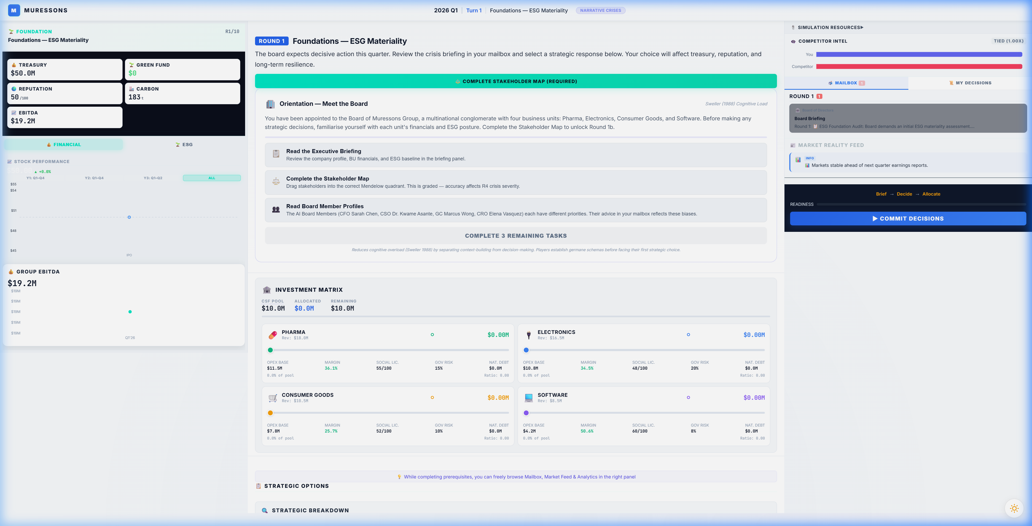
Figure 4.1 — The Executive Cockpit (Round 1 View)

Cockpit Layout — Key Areas

① Top Navigation Bar
Shows the current round number, turn indicator, round theme, and narrative mode toggle. The round counter (R1/10) helps you track your position in the 10-round journey.

② Left Sidebar — Financial Dashboard
Displays your four most critical financial metrics at a glance:
- Treasury ($50.0M) — Your available cash. This is your strategic war chest.
- Green Fund ($0) — Earmarked ESG investment pool (grows through specific decisions).
- Reputation (50/100) — Your public perception score. Below 30 triggers distress mode.
- EBITDA ($19.2M) — Your combined earnings. The foundation of your terminal valuation.
Below the key metrics, you'll find the Stock Performance chart (tracking your share price over time) and the Group EBITDA trend chart.

③ Centre Panel — Mission Briefing & Tasks
The centre panel contains the round's narrative briefing, pedagogical orientation tasks, and — most importantly — the Investment Matrix and Decision Gate. At the start of each round, you may need to complete prerequisite tasks (reading briefings, completing the Stakeholder Map, reading board member profiles) before the Decision Gate unlocks.

④ Right Sidebar — Intelligence & Actions
Contains three key tools:
- Simulation Resources — Links to documentation and reference materials.
- Competitor Intel — Shows whether you're ahead or behind the NPC competitor.
- Mailbox — Board member messages with strategic advice (read these carefully — they contain hints).
- Market Reality Feed — Real-time news items that may foreshadow future crises.
- Commit Decisions — The button that locks in your choices and advances to the next round.

The readiness tracker at the bottom right shows your progress through the round's required steps: Brief → Decide → Allocate. All three must be completed before you can commit your decisions.
Important: The 'COMMIT DECISIONS' button is irreversible. Once you click it, your choices for this round are locked and the simulation engine processes your turn.

5. Key Performance Metrics — Detailed Explanations
Understanding each metric — what drives it up, what drives it down, and why it matters — is essential to making informed strategic decisions.

💰 Corporate Treasury
Your treasury represents the total cash available for investment and operations. It is calculated each round as:
CSF Formula: CSF = Σ(Revenueᵢ − OPEXᵢ) − Dividends_Paid
The Corporate Strategic Fund (CSF) is the net cash generated by your four business units after operating costs and dividend payments. This is the pool you allocate through the Investment Matrix each round.
What increases Treasury: Revenue growth, cost reduction through synergy, dividend cuts, asset sales.
What decreases Treasury: Crisis costs, strategic investments, high OPEX, loan interest.
⚠️ Warning: If your total capital expenditure exceeds 20% of your treasury, a short-term loan is triggered at 12% interest. If you need to invest more than your CSF allows, you can access Emergency Credit (up to 120% of CSF) — but at a 2% premium interest rate.

Danger Zone: Distress Mode
If Treasury hits $0 AND Reputation drops below 30, your company enters the Turnaround Pathway — a 4-phase distress arc with escalating restrictions:
Phase | Entry Conditions | What Happens
Crisis | Treasury ≤ $0 AND Rep < 30 | All investment frozen (0% CapEx). Mᵣ capped at 0.60.
Stabilisation | Treasury > $0 AND Rep > 20 | Investment capped at 50% of normal. Mᵣ capped at 0.80.
Recovery | Treasury > $10M AND Rep > 45 | Full investment restored. Mᵣ cap raised to 1.20.
Exit | Treasury > $20M AND Rep > 55 | Cap lifted. +0.10 Mᵣ bonus for successful turnaround.

📊 Group Reputation (0–100)
Reputation reflects how the market, media, and public perceive Muressons Corporation. It is affected by crisis responses, ethical decisions, and the Contagion Engine.
The Contagion Engine uses a sigmoid (S-curve) function to model how crises spread across your business units. When a crisis hits one BU, the damage propagates non-linearly:
Contagion Model: Group_Rep = Avg_BU_Rep − 50 × σ((severity − 30) / 15)
This means small crises (severity < 15) have minimal group impact, but medium crises (severity 20-40) cause rapid erosion, and severe crises (> 50) saturate the damage curve. The key insight: prevention is exponentially cheaper than cure.
Key Thresholds:
- Below 65: Talent Brain-Drain activates — Software and Healthcare OPEX inflates as top talent leaves.
- Below 30: Combined with Treasury ≤ $0, triggers Turnaround (Survival) mode.
- Above 80: Potential for premium employer bonuses and lower cost of capital.

🤝 Social License to Operate (SLO) — Per BU (0–100)
Social License measures community consent for your business operations. Unlike Reputation (which is group-wide), SLO is tracked per Business Unit. This is arguably the most important metric in the simulation because of the Instability Discount:
⚠️ Warning: If your AVERAGE SLO across all BUs falls below 75 at Round 10, your entire terminal valuation receives a −0.40 Mᵣ penalty. This single penalty often outweighs ALL accumulated bonuses combined.
SLO is affected by workforce decisions (Round 9), community investment, HR investment, and crisis responses. BUs receiving zero investment lose 2% SLO per round through natural decay.

🌿 Natural Capital Debt (NCD)
NCD represents your accumulated environmental liability — pollution, biodiversity loss, carbon emissions, and resource depletion. Unlike other metrics, NCD compounds with interest every round:
NCD Compounding: NCD_{t+1} = NCD_t + (NCD_t × r)
Interest Rate: r = Base_Rate + (NCD × 0.0001)
This creates an exponential curve: small NCD values grow slowly, but large values snowball rapidly. At NCD=100, the rate is ~6%. At NCD=500, it's ~10%. At NCD=1000, it's ~15%. The lesson: address environmental debt early before it becomes unmanageable.

📈 Carbon Intensity
Carbon Intensity measures your emissions per $M revenue. At Round 10's Terminal Valuation, a carbon tax of $250/tonne CO₂e is applied directly to your EBITDA. Higher carbon intensity means a higher carbon tax bill, directly reducing your terminal value.
Reduction levers: Green technology investment, Nature-Based Solutions (R5), Circular Economy (R7), supply chain decarbonisation (R3).

🔥 Workforce Burnout (0–100) — Per BU
Burnout tracks staff exhaustion across each business unit. It rises automatically by +3 points per round when no HR investment is made, and follows a quadratic OPEX penalty curve:
OPEX Penalty: Penalty = ((Burnout − 20)²) × 0.000028125 [when Burnout > 20]
This means burnout below 20 has no penalty, but above 70 it creates severe OPEX inflation and dramatically increases strike probability. In Round 9, high burnout can trigger a workforce strike that zeros all revenue for the round.

⚙️ Workforce Readiness (0–100) — Global
Workforce Readiness measures your employees' skills, training, and ability to execute strategic initiatives. Unlike Burnout (which is per-BU), Readiness is a global metric.
- High HR investment: +8 per round. Medium: +4. No investment: −5 (skills atrophy).
- Below 40: Strategic pillar effectiveness reduced by 20% — your investments are less impactful.
- Above 75: Unlocks +0.10 Mᵣ Workforce Excellence bonus at terminal valuation.
- Above 75 with low burnout: Additional bonuses in Stakeholder Revolt pathway.

6. Capital Allocation — The Investment Matrix
The Investment Matrix is where you distribute your Corporate Strategic Fund across your four business units. This is the most tactically important decision you make each round.
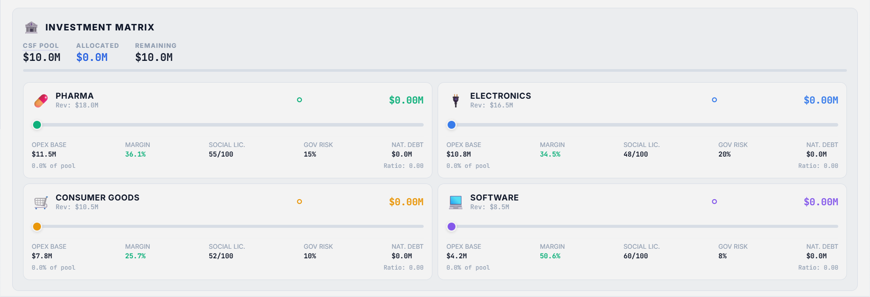
Figure 6.1 — The Investment Matrix showing all four BUs with allocation sliders

Reading the Investment Matrix
The matrix header shows three critical numbers:
- CSF Pool — The total cash available for investment this round (calculated from BU profits).
- Allocated — How much you've assigned so far across all BU sliders.
- Remaining — Unallocated funds. Note: unallocated funds are NOT saved — they are simply not invested.
Each BU card displays:
- Revenue — Current round revenue for this unit.
- Allocation Slider — Drag to set investment amount ($0 to your remaining pool).
- OPEX Base — Operating costs. Investment reduces this through the Synergy Engine.
- Margin — Revenue minus OPEX as a percentage. Higher is better.
- Social License — This BU's community consent score (0-100).
- Governance Risk — This BU's regulatory/ethical risk percentage.
- Natural Capital Debt — Environmental liability accumulated by this BU.
- Investment Ratio — What percentage of the CSF pool is going to this BU.

The Synergy Engine — How Investment Reduces Costs
When you invest in a BU, its OPEX is reduced through the Synergy Engine. However, the relationship follows a square-root curve, creating diminishing returns:
Effective Ratio: r_eff = √(Investment_Ratio) × 0.7
New OPEX: OPEX_new = OPEX_old × (1 − r_eff × Synergy_Multiplier)
This means the first dollar invested in a BU is more impactful than the last. Going from 0% to 25% allocation is more beneficial than going from 75% to 100%. The simulation rewards balanced, diversified investment rather than extreme concentration.

Investment Strategy Framework
Strategy | How It Works | Risk
Balanced (25% each) | Equal distribution across all 4 BUs | Prevents decay but limits breakthrough
Focused (60/20/10/10) | Heavy investment in 1 BU | Tech Lock-In after 3 rounds; decay in others
Triage (40/30/30/0) | Abandon weakest BU | Abandoned BU decays rapidly; Technical Debt penalty
Responsive | Shift allocation based on round threats | Requires strong situational awareness
ESG-Forward | Prioritise BUs by ESG exposure | May sacrifice short-term margin for Mᵣ bonuses

Critical Investment Rules
- Zero-Investment Decay: BUs receiving $0 investment lose 2% Reputation AND 2% Social License per round through natural entropy.
- Technical Debt: BUs with no investment for 2+ consecutive rounds incur an additional 4% OPEX penalty.
- Technology Lock-In: If the same BU receives the highest CAPEX for 3+ consecutive rounds, all other BUs lose 15% synergy efficiency.
- Emergency Credit: You can borrow up to 120% of your CSF pool — but at a 2% premium interest rate. A 🚨 warning appears when emergency credit is activated.
- Talent Allocation Pressure: BUs receiving less than 15% of total CAPEX incur a 2% OPEX surcharge from under-investment effects.
Strategic Advice: A good default is to allocate at least some investment (≥15%) to every BU to prevent decay and Technical Debt penalties, then concentrate the remaining funds on the BU most relevant to the current round's crisis.

7. Decision Gates — Making Strategic Choices
Each round presents a crisis scenario with three strategic options (A, B, C). These are not 'good/bad/neutral' — each represents a genuine strategic trade-off with different cost profiles, risk exposures, and long-term flag implications.

How to Read a Decision Gate
Each option displays: a title describing the strategic approach, a description explaining what happens if you choose it, financial impacts (treasury cost, revenue change), ESG impacts (reputation, SLO, carbon intensity, NCD), and flags set — hidden markers that unlock or block future options.

The Three Archetypes of Choice
Pattern | Typical Option | Character | Long-term Effect
Bold & Expensive | Usually A | Full commitment, high cost | Sets valuable flags, highest Mᵣ potential
Moderate & Balanced | Usually B | Partial action, moderate cost | Fewer flags but less risk
Cheap & Risky | Usually C | Minimal spend, deferred cost | Often creates downstream penalties

⚠️ Cheap options in early rounds often create compounding penalties in later rounds. The simulation systematically punishes short-termism — a $2M saving in Round 1 can cost $20M+ by Round 10.
Decision Framework: Before choosing, ask: (1) What flag does this set? (2) Will I need that flag later? (3) Can my treasury absorb the cost? (4) What happens to my SLO and Reputation?

8. The 10-Round Journey — Detailed Guide
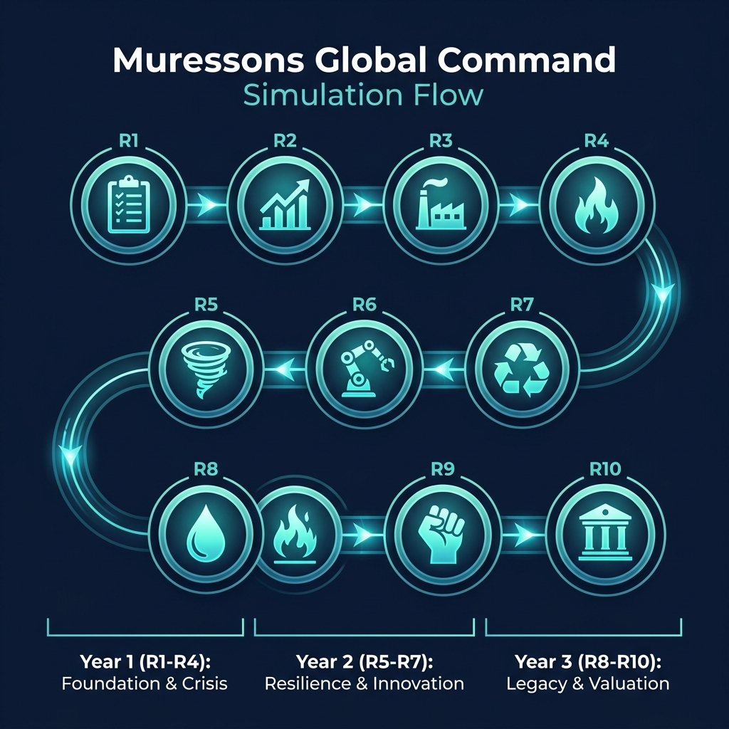
Figure 8.1 — The Simulation Roadmap: 10 Rounds Across 3 Strategic Years

Round 1: Foundations — ESG Baseline Assessment 📋
The board has mandated an initial ESG assessment across all business units. You must decide the depth and scope of the audit.

Options
- Option A — Surface-Level Scan: Fast and cheap ($0 cost), but creates the 'electronics_blindspot' flag. This flag DOUBLES crisis severity in Round 4 from 40 to 80. You gain $500K revenue short-term but lose -2 Reputation and gain +2 Carbon Intensity.
- Option B — Deep Forensic Audit: Costs $3M and reduces short-term revenue by $200K, but gains +5 Reputation, reduces Carbon Intensity by -5, and sets the critical 'deep_audit_completed' flag that protects you in Round 4.
- Option C — Phased Audit Rollout: The middle ground at $1.5M. Audits Pharma and Consumer Goods now but defers Electronics and Software. Partial protection — some blind spots remain.
Key Insight: Round 1 is the most consequential decision in the simulation. The deep audit seems expensive at $3M, but the blindspot penalty in Round 4 typically costs $10-20M in reputation recovery. This is the simulation's first lesson in long-term thinking.

Round 2: Double Materiality — Budget Allocation 📊
The CFO requires all investment proposals to demonstrate alignment with the High Financial Impact / High ESG Impact quadrant per the Double Materiality framework.

Options
- Option A — Full Materiality Alignment: Genuine CSRD compliance with assurance-ready reporting. Costs $2.5M in revenue but gains +5 Reputation, -5 Governance Risk, and sets the 'materiality_aligned' flag worth +0.10 Mᵣ at terminal valuation. In Advanced Climate mode, unlocks NCD forgiveness (+25%).
- Option B — Strategic Exceptions: Allow limited off-quadrant spending with CFO approval. Moderate gains (+2 Rep, -2 Gov Risk) at no revenue cost.
- Option C — Ignore Materiality: Business-as-usual with no materiality filter. Gains $400K revenue but loses -5 Reputation, +10 Governance Risk, and triggers a 40% budget clawback of materiality capital.
Key Insight: The materiality_aligned flag is one of the easiest Mᵣ bonuses to earn (+0.10). The $2.5M cost pays for itself many times over at terminal valuation.

Round 3: Scope 3 Emissions — Supply Chain Decarbonisation 🏭
Regulators have signalled mandatory Scope 3 disclosures. Your supply chain carbon footprint is 4× your direct emissions.

Options
- Option A — Rapid Supplier Switch: Costs $4M treasury and $800K revenue, but achieves -15 Carbon Intensity and sets 'early_decarboniser' flag (strategic advantage in R7). Risk: supply chain disruption.
- Option B — Green Bond Investment: Issue a green bond for $2M. Reduces NCD by -15 and CI by -8 over 3 rounds. Generates $300K revenue. Sets 'green_bond_active' flag.
- Option C — Offset & Defer: Buy carbon offsets for $1M. Minimal CI reduction (-1), increases NCD by +5, and loses -3 Reputation. A delay tactic.
Key Insight: The 'early_decarboniser' flag from Option A provides a synergy multiplier bonus in Round 7. Green bonds (B) are the best risk-adjusted option for most teams.

Round 4: Contagion — Reputation Crisis Cascade 🔥
A labour-rights exposé in your Electronics supply chain has gone viral. The contagion engine propagates reputational damage across ALL business units using a sigmoid curve.

Options
- Option A — Full Transparency & Remediation: Costs $6M but gains +10 Reputation, +8 SLO. Public disclosure, factory audits, worker compensation.
- Option B — Damage Control PR: Costs $2M, gains +2 Rep but loses -3 SLO. Contains narrative but doesn't fix root cause.
- Option C — Deny & Deflect: Free but devastating — loses -15 Reputation, -10 SLO. Highest contagion risk.
Key Insight: If you chose the Surface Scan in R1, crisis severity DOUBLES from 40 to 80 — making all impacts roughly twice as severe. This is where R1 decisions come home to roost.

Round 5: Climate — Physical Risk Event 🌪️
A Category 4 cyclone is projected to hit your primary manufacturing corridor. Base damage: $12M. A stochastic dice roll (75% threshold) determines if it strikes.

Options
- Option A — Hard Engineering Defence: $8M for flood walls. Resilience Factor 0.85, but NO protection this round (completes R7). Adds +10 NCD and +3 Carbon Intensity from construction.
- Option B — Nature-Based Solutions: $5M for mangrove restoration. Resilience Factor 0.60, matures by R7. Reduces NCD by -8 and CI by -6. The eco-friendly choice.
- Option C — Insurance Only: $2M for comprehensive insurance. ZERO physical resilience. Full damage if cyclone strikes. PERMANENTLY BLOCKS the +0.20 Resilience Bonus at terminal valuation.
Key Insight: This is the simulation's biggest 'trap'. Insurance Only is 4× cheaper but permanently sacrifices +0.20 Mᵣ — worth potentially $50M+ in terminal value. Neither A nor B protects you THIS round.

Round 6: AI Bias — Algorithmic Ethics 🤖
Your Software BU's AI recruitment tool has been found to systematically discriminate against minority applicants. The story has reached mainstream media.

Options
- Option A — Monetise the Algorithm: Pivot the AI tool into a commercial product. Gains $10M Software revenue but loses -20 Reputation and spikes the contagion factor. A provocative 'greed' option.
- Option B — Ethical AI Overhaul: Shut down the tool, hire an ethics board, retrain models. Costs $8M but gains +15 SLO, +5 Reputation, and sets the 'ethical_ai_overhaul' flag worth +0.15 Mᵣ Truth Premium.
- Option C — Quiet Patch: Silently fix the algorithm. Costs $1M but loses -5 Reputation, gains +10 Governance Risk. If leaked later, devastating.
Key Insight: The ethical_ai_overhaul flag unlocks the +0.15 Truth Premium — one of the most valuable Mᵣ bonuses. Option A's $10M revenue is tempting but the -20 Reputation often triggers Talent Brain-Drain.

Round 7: Circularity — Circular Economy Transition ♻️
New EU circular economy regulations mandate 60% waste diversion by next year. Non-compliance fines: $15M.

Options
- Option A — Full Circular Redesign: $10M to redesign products for disassembly/reuse. -12 NCD, +8 Rep, -8 CI, +$1M revenue.
- Option B — Extended Producer Responsibility: $5M for take-back programs and recycling. -6 NCD, +4 Rep, -5 CI.
- Option C — Waste-to-Energy Partnership: $7M to build waste-to-energy facility. Sets 'synergy_unlock' flag — the MOST VALUABLE flag in the game, worth +0.30 Mᵣ AND enables R10 Option A.
Key Insight: Option C's synergy_unlock flag is worth +0.30 Mᵣ — the single largest bonus available. It also gates Option A in Round 10 (Resist & Integrate, which requires Synergy ≥ 80). This is arguably the most important round.

Round 8: Blue Stress — Water Scarcity Emergency 🌊
A multi-year drought has depleted the watershed serving Pharma and Electronics. Government water rationing is imminent.

Options
- Option A — Water Efficiency for All: $12M for equitable upgrades across all BUs. -20 Water Dependency, +5 SLO, -3 CI.
- Option B — Prioritise Electronics: $4M to divert water to Electronics (highest margin). Pharma and Consumer Goods suffer -25 SLO each. Sets 'electronics_water_priority' which BLOCKS Resilience bonus.
- Option C — Desalination Mega-Project: $30M for a desalination plant. Massive upfront cost with 2-round delay. -30 NCD, -40 Water Dependency. Generates $5M/round from R10.
Key Insight: Option B is another 'trap' — it saves money but permanently blocks the +0.20 Resilience Bonus AND devastates SLO in two BUs, likely triggering the -0.40 Instability Discount.

Round 9: Just Transition — Workforce & Community Justice ✊
Decarbonisation commitments require closing 3 legacy factories. 2,000 jobs are at risk. Community protests are escalating.

Options
- Option A — Immediate Closure: Gain $5M treasury but lose -20 SLO, -15 Reputation. If SLO is low, 50-75% chance of STRIKE that zeros all revenue for the round.
- Option B — Managed Transition: $12M for 2-year phase-out with retraining. +10 SLO, +8 Reputation. Sets 'managed_transition' flag (+0.12×JT Mᵣ).
- Option C — Community Investment Fund: $20M for community economic development and green jobs. +18 SLO, +12 Reputation. Sets 'community_fund' flag (+0.18×JT Mᵣ).
Key Insight: The JT scaling multiplier rewards sustained HR investment: JT = min(1.5, 1.0 + HR_Rounds × 0.10). If you invested in HR for 5+ rounds, Option C's community_fund bonus scales to +0.27 Mᵣ.

Round 10: Grand Finale — Terminal Valuation 🏛️
An activist investor consortium has acquired a blocking stake. They demand strategic restructuring. Your cumulative decisions determine your final company archetype and valuation.

Options
- Option A — Resist & Integrate: Keep all BUs integrated and leverage synergy. DISABLED if Synergy Score ≤ 80. Costs $5M. Synergy bonus applied.
- Option B — Spin-off: Spin off weakest BU as separate entity. Gains $10M treasury. Moderate risk.
- Option C — Divest: Full divestiture of non-core assets. Gains $25M but wipes synergy multiplier and reduces long-term value.
Key Insight: Option A is the optimal endgame — but it's LOCKED unless you've built Synergy ≥ 80 (primarily through R7's Waste-to-Energy). This is the ultimate test of long-term strategic planning.

9. How Decisions Connect — The Flag System
The flag system is the simulation's core systems-thinking mechanic. Every Option A/B/C sets one or more hidden 'flags' that persist across all remaining rounds. These flags unlock bonuses, block options, or modify crisis severity in future rounds. Understanding flag dependencies is what separates good players from great ones.

Critical Flag Dependencies
Round | Decision | Flag Set | Impact in Later Rounds
R1 | Surface Scan (A) | electronics_blindspot | R4 crisis severity DOUBLES (40→80)
R1 | Deep Audit (B) | deep_audit_completed | R4 crisis severity stays at 40 (normal)
R2 | Full Alignment (A) | materiality_aligned | +0.10 Mᵣ governance bonus at terminal valuation
R2 | Ignore (C) | materiality_ignored | 40% budget clawback this round
R3 | Rapid Switch (A) | early_decarboniser | Synergy bonus in R7 circularity transition
R3 | Green Bond (B) | green_bond_active | NCD reduced over 3 rounds automatically
R5 | Insurance Only (C) | insurance_only | PERMANENTLY BLOCKS +0.20 Resilience Mᵣ bonus
R6 | Ethical Overhaul (B) | ethical_ai_overhaul | +0.15 Truth Premium Mᵣ at terminal valuation
R7 | Waste-to-Energy (C) | synergy_unlock | +0.30 Synergy Mᵣ bonus + enables R10 Option A
R8 | Prioritise Electronics (B) | electronics_water_priority | PERMANENTLY BLOCKS +0.20 Resilience bonus
R9 | Community Fund (C) | community_fund | +0.18×JT Community Champion Mᵣ bonus
R9 | Managed Transition (B) | managed_transition | +0.12×JT Managed Transition Mᵣ bonus
⚠️ Two flags permanently BLOCK the Resilience Bonus: 'insurance_only' (R5-C) and 'electronics_water_priority' (R8-B). These are irreversible. Choose carefully.

The Golden Path — Maximum Mᵣ Flag Sequence
To achieve the theoretical maximum Mᵣ of 2.08, you need this specific flag combination:
- R1-B: deep_audit_completed (protects R4)
- R2-A: materiality_aligned (+0.10)
- R5-A or B: NOT insurance_only (protects +0.20)
- R6-B: ethical_ai_overhaul (+0.15)
- R7-C: synergy_unlock (+0.30)
- R8-A or C: NOT electronics_water_priority (protects +0.20)
- R9-C: community_fund (+0.18×JT)
- R10-A: resist_integrate (synergy bonus)
- Maintain avg SLO ≥ 75 (avoids -0.40 penalty)
- Workforce Readiness ≥ 75 (+0.10)
- Avg Burnout < 20 (+0.05)

10. Terminal Valuation — How You're Scored
At Round 10, the simulation calculates your company's final enterprise value. This is the ultimate measure of your strategic performance across all 10 rounds.
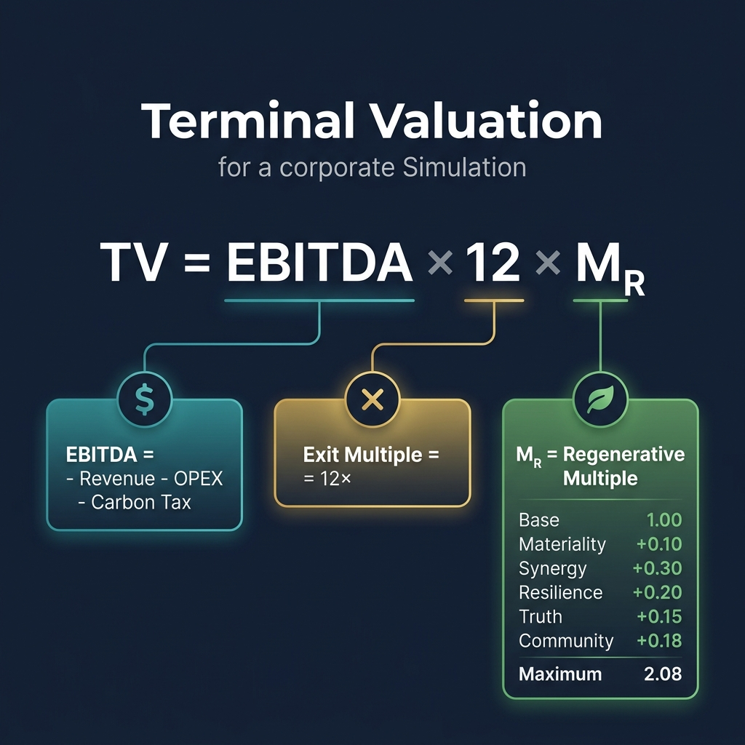
Figure 10.1 — Terminal Valuation Components

The Formula
EBITDA 2050: EBITDA = Σ(Revenueᵢ − OPEXᵢ) − (tCO₂e × $250 Carbon Tax)
Terminal Value: TV = EBITDA × Exit_Multiple(12×) × Mᵣ
The three components work multiplicatively — weakness in any one dimension severely impacts the total:
- EBITDA: Driven by revenue growth, OPEX reduction through synergy, and carbon intensity reduction (lower carbon tax bill).
- Exit Multiple (12×): Standard industry multiple. Can be reduced in certain ending pathways (e.g., Hostile Takeover drops it to 8-10×).
- Mᵣ (Regenerative Multiple): The sustainability-adjusted multiplier. This is where your ESG decisions pay off or punish you.

Mᵣ Breakdown — Complete Component Table
Component | Bonus/Penalty | Condition to Earn | Flag Required
Base | 1.00 | Always applied | —
Materiality Governance | +0.10 | Full materiality alignment in R2 | materiality_aligned
Synergy Excellence | +0.30 | Waste-to-Energy in R7 AND Synergy ≥ 80 | synergy_unlock
Resilience Champion | +0.20 | Avoid both insurance_only AND water_priority | NOT insurance_only, NOT electronics_water_priority
Truth Premium | +0.15 | Ethical AI Overhaul in R6 | ethical_ai_overhaul
Community Champion | +0.18×JT | Community Investment Fund in R9 | community_fund
Just Transition | +0.12×JT | Managed Transition in R9 | managed_transition
Workforce Excellence | +0.10 | Workforce Readiness ≥ 75 at R10 | —
Wellbeing Champion | +0.05 | Average Burnout < 20 at R10 | —
Comeback Kid | +0.05 | Momentum Score > 70 for 2+ consecutive rounds | —
INSTABILITY DISCOUNT | −0.40 | PENALTY: Average SLO < 75 at R10 | —

JT Scaling: JT = min(1.5, 1.0 + HR_Investment_Rounds × 0.10)
The JT scaling rewards sustained HR investment. If you invested in HR pillars for 5 rounds, JT = 1.5, making the Community Champion bonus worth +0.27 Mᵣ instead of +0.18.
Maximum Achievable Mᵣ: 2.08

11. Company Archetypes — Your Final Profile
Your Mᵣ score at Round 10 determines which archetype your company receives. This is your strategic legacy — the narrative outcome of 10 rounds of decisions.
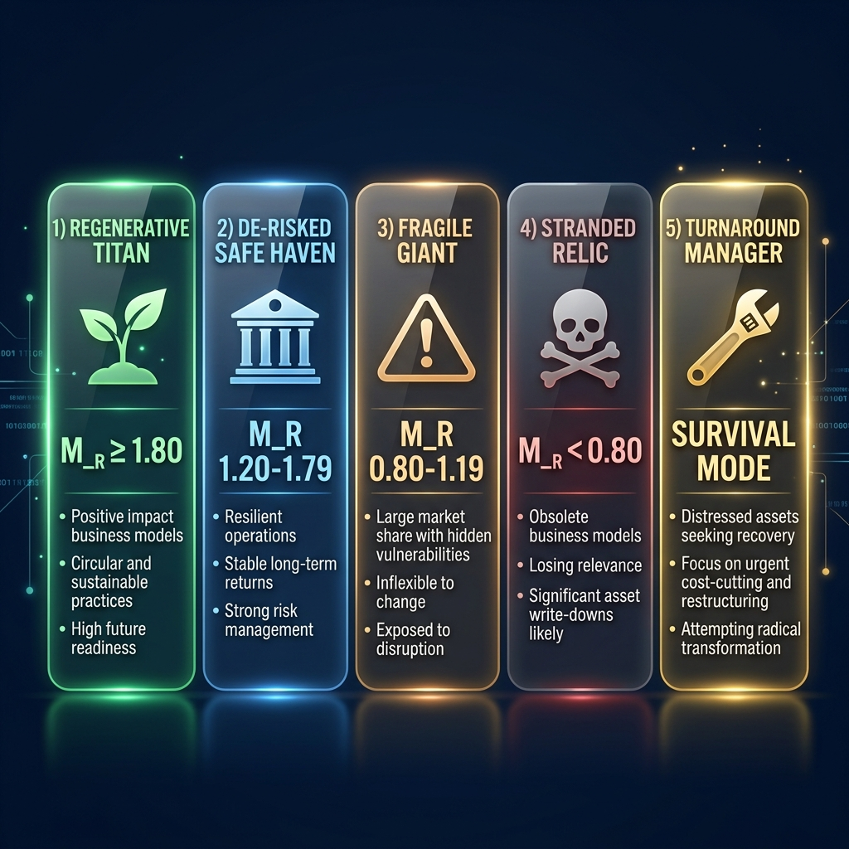
Figure 11.1 — The Five Company Archetypes

Archetype | Mᵣ Range | Description | What It Tells You
🌱 Regenerative Titan | ≥ 1.80 | You built a truly sustainable enterprise that creates value for all stakeholders. | Exceptional — requires near-perfect flag collection and metric management across all 10 rounds.
🏦 De-risked Safe-Haven | 1.20 – 1.79 | Strong ESG integration with solid financial returns. A company built to last. | Very good — the realistic 'best case' for most teams. Demonstrates genuine strategic thinking.
⚠️ Fragile Giant | 0.80 – 1.19 | Profitable but vulnerable. You've managed finances but left ESG risks unaddressed. | Average — you survived but haven't built resilience. Future shocks could be devastating.
💀 Stranded Relic | < 0.80 | The market sees your company as a declining asset with unmanageable ESG liabilities. | Poor — systemic underinvestment in sustainability has eroded your enterprise value.
🔧 Turnaround Manager | Survival Mode | You entered distress mode but demonstrated adaptive leadership in recovery. | Special — awarded when a team successfully navigates the 4-phase turnaround pathway.

Alternative Ending Pathways
Your facilitator may select one of five different ending pathways, each with unique R10 crises, Mᵣ modifiers, and archetype variants:
Pathway | R10 Crisis | Key Mechanic
Activist Ultimatum | Restructuring demand | Standard pathway — synergy-gated options
Climate Black Swan | Stranded asset reckoning | Carbon tax triples to $750/t; CI-based exit multiple haircut
Stakeholder Revolt | Triple stakeholder ultimatum | SLO and Burnout thresholds gate Social Regeneration bonus (+0.35)
Hostile Takeover | Corporate raider bid | Synergy and treasury gate White Knight defence (+0.25)
Regulatory Shutdown | Compliance reckoning | Ethical score gates Regulatory Exemplar bonus (+0.30)

Note: You won't know which pathway your facilitator has selected. The foreshadowing events in Rounds 5-8 provide clues — read the Market Reality Feed carefully.

12. Hidden Engines — What's Running Behind the Scenes
The simulation runs 20+ mathematical engines simultaneously each round. While you don't need to know the exact formulas, understanding what these engines do helps you anticipate consequences and make better decisions.

Financial Engines
Engine | What It Does | Your Lever | Why It Matters
Synergy Engine | Investment reduces OPEX via √ curve | Invest consistently across BUs | Diminishing returns — first dollar most valuable
Natural Capital Debt | Environmental debt compounds with interest each round | Reduce NCD early — it snowballs exponentially | At NCD=500, interest rate hits 10%
Macro Inflation | OPEX rises 2.5% every round automatically | Invest just to tread water | Without investment, BUs slowly become unprofitable
Cash Conversion | Governance risk reduces revenue collection efficiency | Lower governance risk scores | High gov risk means you collect less of your revenue
Dividend Ratchet | Cutting dividends >20% triggers -5 reputation penalty | Maintain steady dividends | Markets punish inconsistency
FX Risk | Currency movements affect export-heavy BUs (±5% random) | Diversify revenue exposure | Software 80%, Electronics 75%, Pharma 60%, Consumer 40% exposed

ESG & Governance Engines
Engine | What It Does | Your Lever | Why It Matters
Contagion Engine | Crises spread across all BUs via sigmoid curve | Maintain reputation above 50 | Non-linear: medium crises cause the most damage
Talent Brain-Drain | Low reputation inflates Software/Healthcare OPEX | Keep Group Reputation above 65 | Top talent leaves when reputation falls
Burnout Accumulation | Staff burnout rises +3/round without HR investment | Invest in HR pillars regularly | Quadratic OPEX penalty above burnout=20
Stakeholder Fatigue | Trust recovery weakens after each crisis | Avoid repeated crises | Each crisis makes the next harder to recover from
ESG Greenwashing | Mismatch between ESG claims and investment triggers SLO penalty | Back your ESG choices with actual investment | Choosing 'green' options without investing = -8 SLO
Technical Debt | 2+ rounds of zero investment → 4% OPEX penalty | Never completely neglect a BU | Accumulated neglect creates structural inefficiency

Competitive & Market Engines
Engine | What It Does | Your Lever | Why It Matters
Revenue Cannibalization | Dominant BUs steal revenue from overlapping units | Balance BU growth | Triggers when BU revenue > 115% of group average
Technology Lock-In | Same BU getting highest CAPEX 3+ rounds → 15% synergy penalty for others | Rotate investment focus | Concentration creates rigidity
Competitive NPC | NPC competitor grows 3%/round automatically | Outperform the baseline | Your relative performance affects market perception
Supply Chain Contagion | Other BUs' governance risk creates OPEX surcharge | Reduce governance risk broadly | Interconnected supply chains share risk
Talent Allocation | BUs receiving <15% of total CAPEX incur 2% OPEX surcharge | Allocate at least 15% to each BU | Under-investment creates workforce pressure
Execution Overrun | CAPEX above $3M per BU has 25% chance of 15% cost overrun | Be cautious with very large investments | Big bets carry hidden execution risk

13. Common Strategic Mistakes & How to Avoid Them
These are the five most frequent errors observed across hundreds of simulation sessions. Each represents a systematic bias that the simulation is designed to surface and correct.

Mistake 1: Skipping the Deep Audit in Round 1
The Psychology: The $3M cost seems excessive when you have $50M in treasury and many rounds ahead. Why spend money on an audit when you could invest in growth?
The Reality: The 'electronics_blindspot' flag doubles R4 crisis severity from 40 to 80. At severity 80, the sigmoid contagion function saturates — meaning ALL BUs suffer near-maximum reputation damage. The typical cost of recovering from a severity-80 crisis is $15-25M in treasury plus months of reputation recovery. The $3M audit is the best ROI investment in the entire simulation.
Lesson: Governance infrastructure is an investment, not a cost. The cheapest option in the first round is often the most expensive option in the fourth.

Mistake 2: Ignoring Social License Throughout
The Psychology: SLO seems like a 'soft' metric compared to treasury and EBITDA. Players focus on financial performance and treat SLO as secondary.
The Reality: The Instability Discount (-0.40 Mᵣ) triggers when average SLO falls below 75 at Round 10. Since Mᵣ is multiplicative with EBITDA and the exit multiple, this single penalty can reduce your terminal value by 20-30%. No combination of financial performance bonuses can fully offset it.
Lesson: Social License is not optional. Monitor it every round and invest in community/workforce welfare to maintain it above 75.

Mistake 3: Choosing Insurance Only in Round 5
The Psychology: It costs $2M vs $5-8M for the alternatives. Your treasury is probably tight after R4's crisis costs. Insurance seems like the rational, risk-managed choice.
The Reality: The 'insurance_only' flag permanently blocks the +0.20 Resilience Champion bonus. At a 12× exit multiple with a typical EBITDA of $20-30M, that 0.20 Mᵣ difference translates to $48-72M in terminal value. You 'saved' $6M to lose $50M+.
Lesson: Always evaluate decisions against their terminal valuation impact, not just their immediate treasury cost.

Mistake 4: Neglecting HR Investment Across Rounds
The Psychology: HR investment doesn't produce visible short-term results. There's no immediate revenue boost or OPEX reduction that you can point to.
The Reality: Burnout rises +3/round automatically without HR investment. By Round 7, burnout reaches 50+, triggering significant OPEX penalties via the quadratic curve. By Round 9, high burnout dramatically increases strike probability — a strike zeros ALL revenue for the round. Additionally, Workforce Readiness falls to below 40, reducing all strategic pillar effectiveness by 20%. Finally, the JT scaling factor for R9's Community Champion bonus requires sustained HR investment to be maximised.
Lesson: Allocate to HR pillars in at least 5 of 10 rounds. The cost of prevention is a fraction of the cost of a strike or burnout-driven OPEX explosion.

Mistake 5: Over-Concentrating Investment in One BU
The Psychology: Software has 50% margins. Why not pour everything into your highest-performing unit?
The Reality: Three penalties trigger simultaneously: (1) Technology Lock-In after 3 rounds reduces other BUs' synergy by 15%, (2) neglected BUs decay 2%/round in Rep and SLO, (3) Technical Debt adds 4% OPEX to any BU with zero investment for 2+ rounds. The compounding effect is severe — by Round 8, your neglected BUs are dragging down group averages enough to trigger the Instability Discount.
Lesson: Diversify. Allocate at least 15% to every BU to prevent decay, then concentrate remaining funds on the round's strategic priority.

14. The CEO Interview — Post-Game Assessment
After completing Round 10, you may be invited to a reflective CEO interview — a 5-question AI-facilitated conversation that assesses your strategic thinking across six competency dimensions.

The Six Competency Dimensions
Dimension | What's Assessed | Data Source | Interview Focus
Strategic Thinking | Long-term vs short-term trade-off awareness | Mᵣ score | Can you articulate WHY you made each trade-off?
Stakeholder Empathy | Ability to balance competing interests | SLO + Burnout | Do you understand how your decisions affected communities and workers?
Financial Acumen | Understanding of value creation mechanics | Treasury + EBITDA | Can you explain the financial logic behind your investment strategy?
Ethical Reasoning | Moral framework sophistication | Decision flags | How do you resolve genuine ethical dilemmas (e.g., R6 AI bias)?
Systems Thinking | Understanding cross-round dependencies | Synergy + VRIO | Can you trace how early decisions cascaded to later outcomes?
Adaptive Leadership | Willingness to change strategy | WR + HR rounds | Did you adjust your approach when circumstances changed?

The 50/50 Blending Framework
Final Score: S_final = S_data × 0.5 + S_interview × 0.5
Your final competency score blends two sources equally: (1) simulation data — what you actually did (metrics, flags, financial outcomes), and (2) interview responses — how you reflect on and articulate your decisions. This means: a team with mediocre metrics but excellent strategic reflection can score well, and a team with excellent metrics but poor self-awareness will be penalised.
⚠️ You cannot 'game' the system through either pure metric optimisation OR interview preparation alone. Both your actions AND your reflections matter equally.

Interview Tips
- Reference specific rounds and decisions in your answers — vague generalities score poorly.
- Acknowledge trade-offs honestly. Saying 'I chose the cheaper option because treasury was low' is better than pretending every decision was ethically optimal.
- Connect early decisions to later outcomes. 'Our R1 deep audit protected us in R4' demonstrates systems thinking.
- Show awareness of what you'd do differently. Reflective learning is scored highly.
- Don't memorise answers. The AI interviewer adapts its questions based on your actual game data.

15. Strategic Playbook — Approaches & Considerations
While there's no single 'correct' strategy, here are three coherent approaches observed in high-performing teams:

Approach A: The Sustainability Pioneer
Philosophy: Invest heavily in ESG from the start, accepting short-term treasury pain for maximum Mᵣ.
Round | Key Choice | Rationale
R1 | Deep Audit (B) | Protect against R4 blindspot
R2 | Full Alignment (A) | Earn materiality_aligned flag
R3 | Green Bond (B) | Steady NCD reduction over time
R4 | Full Transparency (A) | Maximum reputation recovery
R5 | Nature-Based (B) | Eco-friendly resilience + protect Mᵣ
R6 | Ethical Overhaul (B) | Earn Truth Premium
R7 | Waste-to-Energy (C) | Critical synergy_unlock flag
R8 | Water for All (A) | Protect SLO across all BUs
R9 | Community Fund (C) | Maximum community_fund bonus
R10 | Resist & Integrate (A) | Synergy-powered endgame
Expected Mᵣ: 1.80-2.08 (Regenerative Titan territory)
Risk: Very treasury-intensive. Requires disciplined investment to maintain SLO and WR above thresholds.

Approach B: The Balanced Pragmatist
Philosophy: Mix moderate ESG investment with financial prudence. Accept slightly lower Mᵣ for treasury stability.
Key differences: Choose Option B in most rounds (moderate cost, moderate benefit). Skip the most expensive investments (R8-A, R9-C). Focus on protecting the 'blocking' flags (avoid insurance_only, avoid water_priority).
Expected Mᵣ: 1.20-1.60 (De-risked Safe-Haven)

Approach C: The Financial Engineer
Philosophy: Optimise treasury and EBITDA, relying on financial performance to carry the terminal valuation.
Key differences: Choose cheaper options where possible. Prioritise revenue growth over ESG metrics. Accept lower Mᵣ but compensate with higher EBITDA.
Risk: The Instability Discount (-0.40) and blocked Mᵣ bonuses often more than offset the financial gains. This strategy is a 'trap' the simulation is designed to expose.
⚠️ The simulation systematically rewards Approach A over C. Financial performance alone cannot compensate for a low Mᵣ, because Mᵣ is multiplicative — even excellent EBITDA is severely discounted by a low Mᵣ.

16. Quick Reference Glossary
Term | Definition
BU | Business Unit — one of your four operating divisions (Pharma, Electronics, Consumer Goods, Software)
CAPEX | Capital Expenditure — money invested in BU improvements through the Investment Matrix
OPEX | Operating Expenditure — ongoing costs to run a BU. Reduced by synergy investment.
CSF | Corporate Strategic Fund — your investable cash pool each round, calculated from BU profits minus dividends
SLO | Social License to Operate — community consent for operations (0-100, per BU). CRITICAL: avg < 75 = -0.40 Mᵣ
NCD | Natural Capital Debt — accumulated environmental liability. Compounds with interest each round.
Mᵣ | Regenerative Multiple — the sustainability-adjusted valuation multiplier (base 1.0, max 2.08)
EBITDA | Earnings Before Interest, Tax, Depreciation & Amortisation — your combined operating profit
Terminal Value | Final company valuation: TV = EBITDA × 12 × Mᵣ
Contagion | Crisis damage spreading from one BU to the entire group via sigmoid S-curve
Synergy | Cross-BU efficiency gains from coordinated investment. Follows diminishing returns (√ curve).
Flag | A hidden marker set by your A/B/C decisions that affects future rounds. Cannot be undone.
Archetype | Your final company profile (Regenerative Titan / Safe-Haven / Fragile Giant / Stranded Relic)
JT Scaling | Just Transition multiplier: JT = min(1.5, 1.0 + HR_rounds × 0.10). Amplifies R9 bonuses.
Turnaround | 4-phase distress arc triggered when Treasury ≤ $0 AND Reputation < 30
Carbon Tax | $250/tonne CO₂e applied at terminal valuation. Directly reduces EBITDA.
Sigmoid | S-curve function used by contagion engine: small crises = small impact, medium = rapid damage, large = saturating
Foreshadowing | Market Reality Feed hints (R5-R8) that preview the R10 ending pathway

Appendix A: Formula Quick-Reference Card
Keep this page handy during gameplay:
CSF: CSF = Σ(Revenueᵢ − OPEXᵢ) − Dividends
Synergy: OPEX_new = OPEX_old × (1 − √(ratio) × 0.7 × Synergy_Mult)
Contagion: Group_Rep = Avg_Rep − 50 × σ((severity−30)/15)
NCD Interest: r = Base_Rate + NCD × 0.0001
Burnout Penalty: Penalty = ((B−20)²) × 0.000028125 [B>20]
Strike Risk: P = Base_Risk + ((1 − SLO/100) × 0.4)
Terminal Value: TV = (EBITDA − Carbon_Cost) × 12 × Mᵣ
JT Scaling: JT = min(1.5, 1.0 + HR_Rounds × 0.10)
Max Mᵣ: 2.08 (requires all flags + SLO≥75 + WR≥75 + Burnout<20)

Appendix B: Frequently Asked Questions

Q: Can I undo a decision after committing?
A: No. Once you click 'COMMIT DECISIONS', your choices are permanent. This is by design — real CEOs can't undo strategic commitments.

Q: What happens if my treasury goes negative?
A: You enter the Turnaround Pathway — a 4-phase distress arc. Investment is frozen in Phase 1, restricted in Phase 2, and only fully restored in Phase 3/4.

Q: Does the order of investment allocation matter?
A: No. All allocations are processed simultaneously at the end of the round. There's no advantage to allocating to one BU before another.

Q: Can two teams get different outcomes with the same decisions?
A: Yes. Stochastic elements (climate events, FX movements, macro noise) introduce randomness. This simulates real-world uncertainty.

Q: What if I can't afford the 'best' option?
A: Adapt. The simulation rewards creative constraint management. A team that makes thoughtful trade-offs under resource pressure often outscores a team that follows a formulaic 'optimal' path.

Q: How important is the CEO interview vs. game performance?
A: Equally important — 50/50 blend. A team with average metrics but exceptional strategic reflection can score very well.

Q: Do I need to read the board member emails?
A: They contain hints about upcoming crises and strategic advice. Reading them improves your situational awareness significantly.

Q: What is the 'Market Reality Feed'?
A: Foreshadowing events (R5-R8) that preview the R10 ending pathway. These are your early warning system.

Good luck, CSO. The future of Muressons is in your hands.

