Muressons Global Corporation

Student Manual

Comprehensive Guide to the ESG Strategy Simulation

Version 2.0 | 2026

Table of Contents
Part I: Getting Started
1. Welcome & Simulation Overview
2. Joining a Session & Onboarding
3. The Executive Cockpit
Part II: The Game Loop
4. Decision-Making Framework
5. Round-by-Round Walkthrough (Rounds 1-10)
6. Strategic Pillars Paradigm
7. Round 10: Grand Finale & Ending Pathways
Part III: Under the Hood
8. Mathematical Engines Explained
9. KPI Deep Dive
10. Scoring & Terminal Valuation
11. Flag Dependencies & Cascades
Part IV: Reference
12. Strategic Tips & Common Mistakes
13. Glossary of Key Terms
14. Quick Reference Card
Appendices
A. Decision Paradigm Comparison
B. Industry Vertical Profiles
C. Minigames & Side Activities

PART I: GETTING STARTED

1. Welcome & Simulation Overview
Welcome to Muressons Global Corporation — a multi-round ESG strategy simulation where you step into the role of Chief Sustainability Officer of a diversified multinational conglomerate.
Your mission is to navigate 10 rounds (representing 5 years of corporate strategy) of escalating environmental, social, and governance crises while maximising the long-term Terminal Value of the corporation.

1.1 The Simulation Premise
Muressons Global Corporation is a diversified conglomerate with four business units, each facing unique ESG challenges. Every round presents a crisis scenario requiring strategic decisions that have cascading consequences across future rounds.
- Each round represents a 6-month semester of corporate strategy
- 10 rounds = 5 years of strategic decision-making
- Your objective: maximise Terminal Value (TV) = EBITDA × Exit Multiple × Regenerative Multiple
- Decisions are irreversible — once committed, your choices are permanently recorded

1.2 The Four Business Units
Your conglomerate comprises four distinct business units, each with different financial profiles and ESG exposures:
Business Unit | Revenue | OPEX | Key ESG Exposure
💊 Muressons Pharma | $18.0M | $12.0M | High water dependency, clinical compliance
⚡ Muressons Electronics | $16.5M | $11.5M | Highest carbon intensity (72), supply chain risk
🛒 Muressons Consumer Goods | $10.5M | $7.5M | Packaging waste, consumer scrutiny
💻 Muressons Software | $8.5M | $5.5M | Talent retention, AI ethics, lowest footprint

Starting Financial Position: Corporate Treasury = $50.0M | Group Reputation = 50/100 | Synergy Multiplier = 1.00

1.3 Difficulty Tiers
Tier | Advanced Engines | Best For
Standard | 8 core engines only | First-time players, introductory workshops
Advanced | 8 core + 14 advanced engines | MBA students, experienced participants
Expert | All engines + Regulatory Sandbox | Executive education, research sessions

2. Joining a Session & Onboarding

2.1 Accessing the Simulation
Your facilitator will provide you with:
- A URL to access the simulation (e.g., https://muressons.example.com)
- An Executive Identifier (e.g., MUR-001) — your unique player ID
- A Clearance Cipher (password) — provided by the facilitator
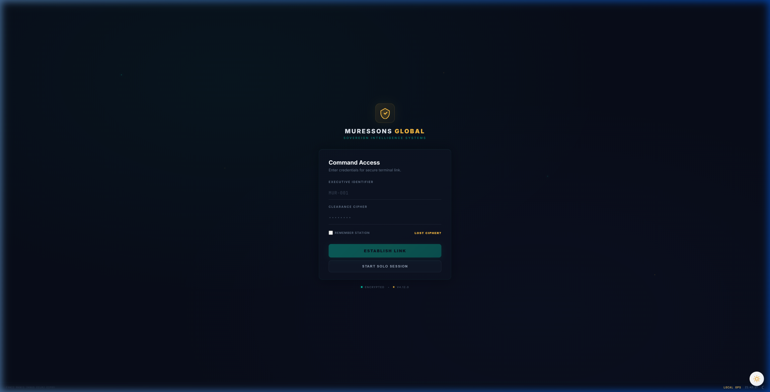
Figure 2.1 — Command Access Login Screen

2.2 Starting a Solo Session
If you are practising individually, click "START SOLO SESSION" on the login screen. This creates a private session where you can explore the simulation at your own pace without needing facilitator credentials.

2.3 The Onboarding Tour
On your first login, an interactive 7-step tour guides you through the Executive Cockpit interface. Key stops include:
- Step 1: Welcome — Your role as Chief Sustainability Officer
- Step 2: KPI Dashboard — Understanding your key performance indicators
- Step 3: Investment Matrix — How to allocate capital across business units
- Step 4: Strategic Options — Navigating A/B/C crisis decisions
- Step 5: Market Ticker — Reading real-time market intelligence
- Step 6: Executive Mailbox — Crisis alerts and foreshadowing events
- Step 7: Commit Button — Submitting your final decisions

3. The Executive Cockpit
The Executive Cockpit is your primary command interface throughout the simulation. Understanding its layout is essential for effective decision-making.
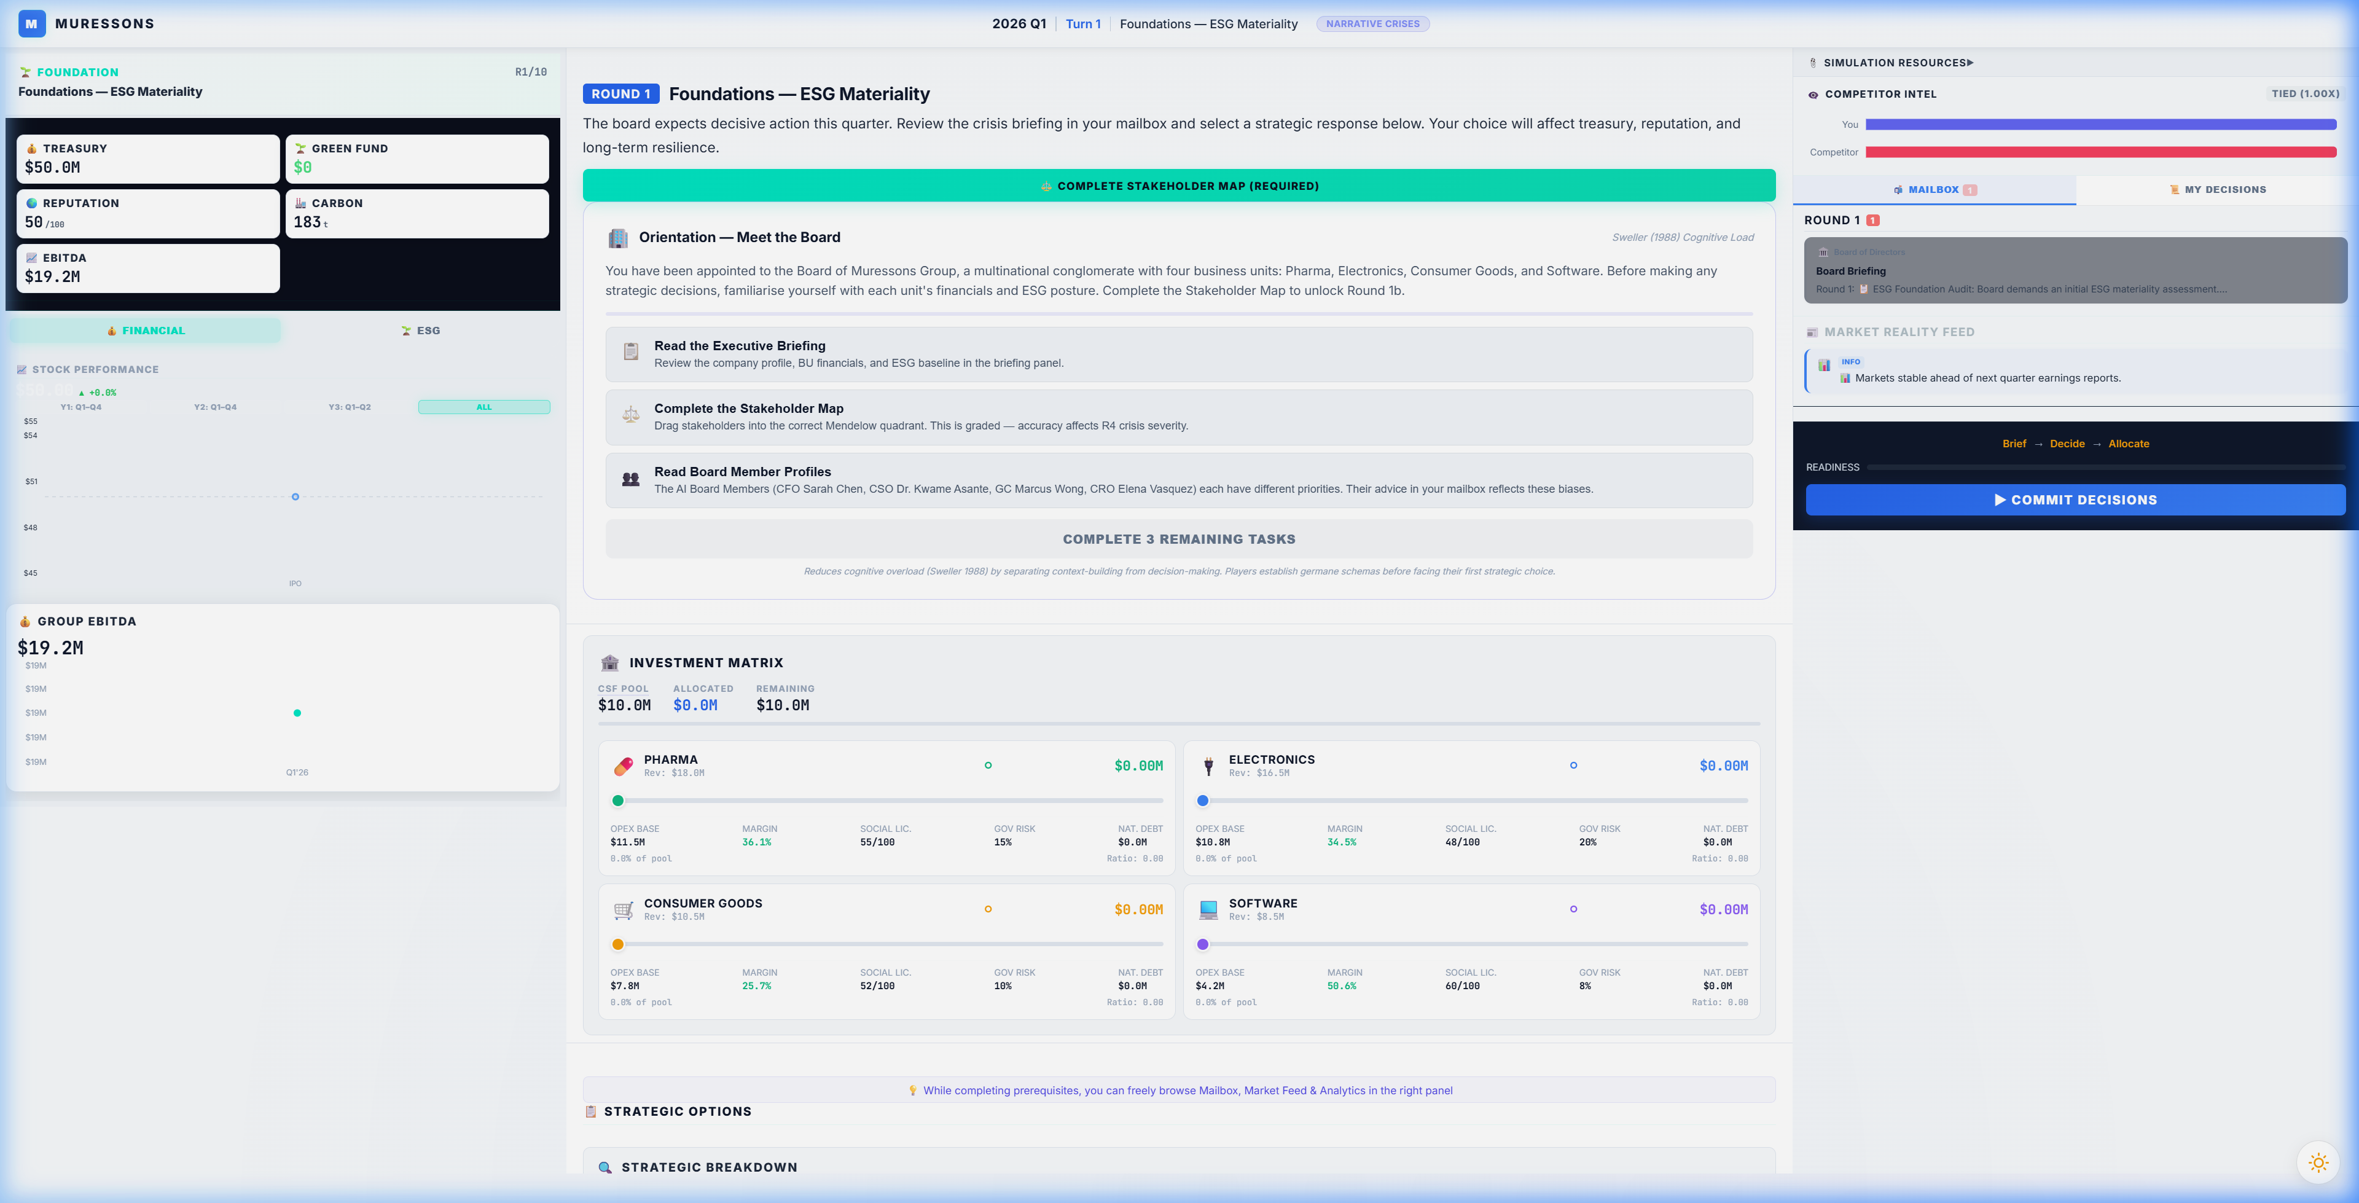
Figure 3.1 — The Executive Cockpit (Full View)

3.1 Header Bar
The top bar displays critical status information:
- Round Indicator — Current round number (R1/10 to R10/10)
- Session Status — "LIVE" indicator with connection status
- Decision Paradigm Badge — Shows active paradigm (NARRATIVE, PILLARS, etc.)
- Logout Button — Exit the simulation (progress is saved)

3.2 KPI Gauges Panel (Left Sidebar)
The left panel shows your critical KPIs with tabs for KPIs, Charts, and Metrics:
KPI | Starting Value | What It Means
💰 Treasury | $50.0M | Your available cash for investments and operations
🌿 Green Fund | $0 | Dedicated environmental investment fund
🌟 Reputation | 50/100 | Corporate reputation across all stakeholders
🏭 Carbon | 2,635t | Total CO₂ emissions in tonnes
📊 EBITDA | $19.2M | Earnings before interest, taxes, depreciation & amortisation

3.3 Investment Matrix
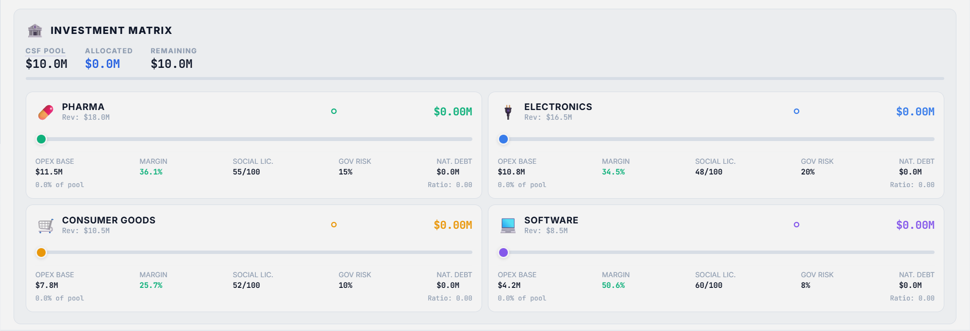
Figure 3.2 — Investment Matrix with BU Sliders
The Investment Matrix is where you allocate capital to each business unit:
- CSF Pool — Total available capital (Corporate Strategic Fund)
- Allocated — Amount currently distributed across BUs
- Remaining — Unallocated funds
- Per-BU Slider — Drag to set investment ratio (0% to 100%)
- BU Metrics — OPEX Base, Margin, Social License, Governance Risk per BU

3.4 Strategic Options Panel
Below the Investment Matrix, the Strategic Options panel presents the A/B/C crisis decision:
- Each option shows its title, description, and cost
- The Comparison Matrix below compares Treasury, Revenue, and Reputation impacts
- Select one option before committing — this choice is final

3.5 Bottom Navigation Bar
The bottom bar provides access to supplementary features:
Button | Function
🎙️ Podcast | Listen to AI-generated round briefing audio
📊 Leaderboard | View peer cohort performance rankings
🏆 Badges | Track achievement badges earned
🤖 Advisor | Consult the AI strategic advisor
📈 Analytics | View detailed analytical dashboards
📖 Glossary | Access the in-game glossary of terms
🔊 Sound | Toggle sound effects and ambient audio
🚪 Log Out | Exit the simulation

3.6 Market Ticker
The scrolling ticker at the bottom displays real-time market data including ESG Index values, Carbon Credit prices, EU Taxonomy compliance percentages, Water Futures, Green Bond yields, and S&P Clean Energy metrics. These provide contextual market intelligence but do not directly affect gameplay.

PART II: THE GAME LOOP

4. Decision-Making Framework

4.1 The Three-Step Decision Cycle
Every round follows a structured decision cycle:
Step 1: REVIEW
- Read the Intelligence Briefing — understand the crisis scenario and context
- Check the Executive Mailbox for market intelligence and foreshadowing events
- Review your current KPIs, treasury balance, and BU health metrics
- Complete any Pre-Requisite Gates (e.g., Stakeholder Map in R1)
Step 2: DECIDE
- Select one Strategic Option (A, B, or C) — read descriptions carefully
- Set Investment Matrix sliders for each BU — allocate your CSF pool
- Consider the Comparison Matrix to understand trade-offs between options
- Use the Confidence Nudge prompt to reflect before committing
Step 3: COMMIT
- Click the Commit button to submit your decisions
- Decisions are IRREVERSIBLE — the simulation uses immutable state recording
- After commit, review the Results Overlay showing KPI deltas and "What Changed"
- Check the Peer Leaderboard to see how you compare to other teams

4.2 Understanding the Investment Matrix
The CSF (Corporate Strategic Fund) is your total available CAPEX each round:
- CSF = Σ(Revenue - OPEX) - Dividends_Paid
- Each BU slider sets its Investment Ratio (0.0 to 1.0)
- CAPEX per BU = Investment Ratio × BU Revenue
- Total allocation cap: 120% of CSF (above 100% triggers a loan at 12% interest)
- Investment affects OPEX reduction via the Synergy Engine (see Section 8)
Key Insight: Investments ≤ 10% apply immediately. Investments > 10% are DEFERRED one round (implementation lag). You pay now but benefit next round.

5. Round-by-Round Walkthrough
This section provides a detailed narrative walkthrough of all 10 rounds in the standard (Narrative Crisis) paradigm. Each round includes the crisis scenario, decision options, strategic considerations, and flag dependencies.

Round 1: 📋 Foundations — ESG Baseline Assessment
Crisis Scenario: 📋 ESG Audit Decision
The board has mandated an initial ESG assessment across all business units. You must decide the depth and scope of the audit.
Decision Options:
Option | Title | Description | Key Impacts
A | Surface-Level Scan | Run a quick compliance check. Fast and cheap, but Electronics BU blind spots will be missed. | treasury: 0  reputation: -2  carbon_intensity_delta: +2  revenue_delta: +500000  social_license_delta: -3  governance_risk_delta: +5  natural_capital_debt_delta: 0
B | Deep Forensic Audit | Commission a full forensic audit across all units. Costly but uncovers hidden risks. | treasury: $-3M  reputation: +5  carbon_intensity_delta: -5  revenue_delta: -200000  social_license_delta: +5  governance_risk_delta: -5  natural_capital_debt_delta: 0
C | Phased Audit Rollout | Audit Pharma and Consumer Goods now; defer Electronics and Software to next period. Balanced cost, but partial blind spots remain. | treasury: $-2M  reputation: +2  carbon_intensity_delta: -2  revenue_delta: 0  social_license_delta: +2  governance_risk_delta: 0  natural_capital_debt_delta: 0
- Option A: Flags: electronics_blindspot
- Option B: Flags: deep_audit_completed
- Option C: Flags: deferred_audit
📚 Teaching Point:
Your R1 audit choice sets the "butterfly effect" — choosing a Surface Scan (Option A) sets the electronics_blindspot flag that DOUBLES crisis severity in Round 4.

Round 2: 📊 Double Materiality — Materiality-Based Budget Allocation
Crisis Scenario: 📊 Double Materiality Matrix
The CFO requires all investment proposals to demonstrate alignment with the High Financial Impact / High ESG Impact quadrant per the Double Materiality framework.
Decision Options:
Option | Title | Description | Key Impacts
A | Full Materiality Alignment | Allocate exclusively to high-impact nodes. Genuine CSRD compliance: assurance-ready report, stakeholder panel, full ESRS disclosure. In Advanced Climate mode: unlocks CSRD/ESRS climate materiality bonus (NCD forgiveness +25%). Compliance cost is real. | treasury: $-2M  reputation: +5  governance_risk_delta: -5  carbon_intensity_delta: -3  revenue_delta: $-2M  social_license_delta: +5  natural_capital_debt_delta: -3
B | Strategic Exceptions | Allow limited off-quadrant spending with CFO approval. Partial compliance. | treasury: 0  reputation: +2  governance_risk_delta: -2  carbon_intensity_delta: -1  revenue_delta: 0  social_license_delta: +2  natural_capital_debt_delta: 0
C | CEO-Only Sign-Off (No Board Committee Oversight) | CEO approves capital allocation without board committee review or endorsement. ⚠️ ESRS 1 §1.51 Violation: The standard requires the management body (board level) to oversee and endorse the materiality assessment process. CEO-only sign-off breaches this requirement. Institutional investors apply a risk premium to your Green Bond — 40% of your materiality budget will be clawed back. Governance posture must match investment rationale under ESRS 2 GOV-1. | treasury: 0  reputation: -5  governance_risk_delta: +10  carbon_intensity_delta: +3  revenue_delta: +400000  social_license_delta: -5  natural_capital_debt_delta: +3
- Option A: Flags: materiality_aligned
- Option B: Flags: materiality_exceptions
- Option C: Flags: materiality_ignored
📚 Teaching Point:
Option A (Materiality-Aligned Budget) sets the materiality_aligned flag worth +0.10 M_R at terminal valuation. This is the governance foundation.

Round 3: 🌍 Scope 3 Emissions — Supply Chain Decarbonisation
Crisis Scenario: 🏭 Scope 3 Supply Chain Crisis
Regulators have signalled mandatory Scope 3 disclosures. Your supply chain carbon footprint is 4x your direct emissions.
Decision Options:
Option | Title | Description | Key Impacts
A | Rapid Supplier Switch | Immediately switch to low-carbon suppliers. Fast reduction but high disruption risk. Early movers gain a strategic advantage in circular economy. | treasury: $-4M  carbon_intensity_delta: -15  supply_chain_disruption: Yes  revenue_delta: -800000  reputation: +3  social_license_delta: +4  governance_risk_delta: -3  natural_capital_debt_delta: -10
B | Green Bond Investment | Issue a green bond to fund supplier transition. Lowers Natural Capital Debt over 3 rounds. | treasury: $-2M  natural_capital_debt_delta: -15  carbon_intensity_delta: -8  revenue_delta: +300000  reputation: +4  social_license_delta: +3  governance_risk_delta: -2
C | Offset & Defer | Buy carbon offsets and wait for regulation clarity. | treasury: $-1M  natural_capital_debt_delta: +5  reputation: -3  carbon_intensity_delta: -1  revenue_delta: +100000  social_license_delta: -4  governance_risk_delta: +3
- Option A: Flags: supply_chain_disruption_risk, early_decarboniser
- Option B: Flags: green_bond_active
- Option C: Flags: carbon_deferred
📚 Teaching Point:
Beware the Marketing-Only Pledge (Option C) — it activates the Greenwashing Engine. If your average investment ratio drops below 15%, ALL BUs lose 8 Social Licence points.

Round 4: 🔥 Contagion — Reputation Crisis Cascade
Crisis Scenario: 🔥 Electronics Supply Chain Scandal
A labour-rights exposé in your Electronics supply chain has gone viral. The contagion engine will propagate reputational damage across all BUs.
Decision Options:
Option | Title | Description | Key Impacts
A | Full Transparency & Remediation | Public disclosure, factory audits, worker compensation. | treasury: $-6M  reputation: +10  social_license: +8  carbon_intensity_delta: -4  revenue_delta: -500000  governance_risk_delta: -5  natural_capital_debt_delta: 0
B | Damage Control PR | Hire crisis PR firm. Contains narrative but doesn't fix root cause. | treasury: $-2M  reputation: +2  social_license: -3  carbon_intensity_delta: -1  revenue_delta: 0  governance_risk_delta: +3  natural_capital_debt_delta: 0
C | Deny & Deflect | Issue a denial. Cheapest option but highest contagion risk. | treasury: 0  reputation: -15  social_license: -10  carbon_intensity_delta: +4  revenue_delta: $-1M  governance_risk_delta: +8  natural_capital_debt_delta: +5
- Option A: Flags: remediation_active
- Option B: Flags: pr_containment
- Option C: Flags: deny_and_deflect
📚 Teaching Point:
This is where R1 decisions cascade. If electronics_blindspot is active, crisis severity DOUBLES from 40 to 80. The Contagion Engine uses a sigmoid function to propagate damage.

Round 5: 🌪️ Climate — Physical Climate Risk Event
Crisis Scenario: 🌪️ Extreme Weather Event
A Category 4 cyclone is projected to hit your primary manufacturing corridor. Base damage: $12M. A stochastic roll determines actual impact.
Decision Options:
Option | Title | Description | Key Impacts
A | Hard Engineering Defence | Build flood walls and reinforced infrastructure. Resilience Factor 0.85 — but construction takes 2 rounds. ⚠️ NO PROTECTION THIS ROUND. Infrastructure completes in Round 7. Adds 10 Natural Capital Debt (concrete/steel environmental cost). 🌡️ CLIMATE WARNING: +3 Carbon Intensity contributes to the Climate Tipping Point (avg CI > 70). In Advanced Climate mode, crossing this threshold doubles NCD costs permanently. | resilience_factor: +0.85  natural_capital_debt_delta: +10  treasury: $-8M  carbon_intensity_delta: +3  revenue_delta: -600000  reputation: +3
B | Nature-Based Solutions | Invest in mangrove restoration and natural buffers. Resilience Factor 0.60 — but ecosystem establishment takes 2 rounds. ⚠️ NO PROTECTION THIS ROUND. Buffers mature by Round 7. Reduces Natural Capital Debt (nature-positive infrastructure). | resilience_factor: +0.6  natural_capital_debt_delta: -8  treasury: $-5M  carbon_intensity_delta: -6  revenue_delta: +500000  reputation: +6
C | Insurance Only | Buy comprehensive insurance. No physical resilience built — full damage if cyclone strikes this round or any future round. ⚠️ Blocks the Resilience Bonus at terminal valuation (−0.20 M_R). | resilience_factor: 0.0  treasury: $-2M  carbon_intensity_delta: +1  revenue_delta: 0  reputation: -5
- Option A: Flags: hard_engineering
- Option B: Flags: nature_based_resilience
- Option C: Flags: insurance_only
📚 Teaching Point:
The stochastic dice roll (75% chance of cyclone) makes this the first round where luck matters. But resilience investments from your choice determine damage absorption.

Round 6: 🤖 AI Bias — Algorithmic Ethics & Brand Risk
Crisis Scenario: 🤖 AI Hiring Bias Scandal
Your Software BU's AI recruitment tool has been found to systematically discriminate against minority applicants. The story has reached mainstream media.
Decision Options:
Option | Title | Description | Key Impacts
A | Monetise the Algorithm | Pivot the AI tool into a commercial product. High revenue but massive reputational risk, spiking the contagion factor. | software_revenue_delta: +$10M  reputation_delta: -20  contagion_spike: Yes  carbon_intensity_delta: +2  social_license_delta: -15  governance_risk_delta: +8  natural_capital_debt_delta: 0
B | Ethical AI Overhaul | Shut down the tool, hire an ethics board, retrain models. Costly but builds social capital. | treasury: $-8M  social_license_delta: +15  reputation_delta: +5  carbon_intensity_delta: -4  revenue_delta: +800000  governance_risk_delta: -5  natural_capital_debt_delta: 0
C | Quiet Patch | Silently fix the algorithm. Low cost but if leaked, devastating. | treasury: $-1M  reputation_delta: -5  governance_risk_delta: +10  carbon_intensity_delta: 0  revenue_delta: -200000  social_license_delta: -3  natural_capital_debt_delta: 0
- Option A: Flags: ai_monetised
- Option B: Flags: ethical_ai_overhaul
- Option C: Flags: quiet_patch
📚 Teaching Point:
Option B (Ethical AI Overhaul at -$8M) earns the Truth Premium (+0.15 M_R). Option C (Monetise the Algorithm) triggers EU AI Act costs from R7 onward.

Round 7: ♻️ Circularity — Circular Economy Transition
Crisis Scenario: ♻️ Waste Regulation Tightening
New EU circular economy regulations mandate 60% waste diversion by next year. Non-compliance fines: $15M.
Decision Options:
Option | Title | Description | Key Impacts
A | Full Circular Redesign | Redesign products for full disassembly and reuse. | treasury: $-10M  natural_capital_debt_delta: -12  reputation: +8  carbon_intensity_delta: -8  revenue_delta: +$1M  social_license_delta: +6  governance_risk_delta: -3
B | Extended Producer Responsibility | Fund take-back programs and recycling partnerships. | treasury: $-5M  natural_capital_debt_delta: -6  reputation: +4  carbon_intensity_delta: -5  revenue_delta: +600000  social_license_delta: +3  governance_risk_delta: -2
C | Waste-to-Energy Partnership | Build waste-to-energy facility. Unlocks high synergy multiplier across BUs. | treasury: $-7M  synergy_multiplier_boost: +0.3  natural_capital_debt_delta: -4  carbon_intensity_delta: -6  revenue_delta: +400000
- Option A: Flags: circular_redesign
- Option B: Flags: epr_program
- Option C: Flags: waste_to_energy, synergy_unlock
📚 Teaching Point:
The Synergy Unlock (Option C) is the single highest M_R bonus available (+0.30). If synergy_multiplier ≥ 0.80, this is the most valuable single decision in the game.

Round 8: 💧 Blue Stress — Water Scarcity Emergency
Crisis Scenario: 🌊 Critical Water Shortage
A multi-year drought has depleted the watershed serving Pharma and Electronics. Government water rationing is imminent.
Decision Options:
Option | Title | Description | Key Impacts
A | Water Efficiency for All BUs | Equitable water-saving upgrades across all units. | treasury: $-12M  water_dependency_delta: -20  social_license_delta: +5  carbon_intensity_delta: -3  revenue_delta: +700000  reputation: +5
B | Prioritise Electronics | Divert water allocation to Electronics (highest margin). Pharma and Consumer Goods take severe social licence hit. | treasury: $-4M  social_license_severe_drop: Yes  social_license_drop_amount: -25  carbon_intensity_delta: +2  revenue_delta: -400000  reputation: -8
C | Desalination Mega-Project | Build a desalination plant. Massive cost ($30M) with a 2-round construction delay before benefits arrive. Reduces Natural Capital Debt by 30 points and water dependency by 40. Generates $5M/round revenue from Round 10 onward (Rounds 8+2) for 3 rounds. | treasury: $-30M  natural_capital_debt_delta: -30  water_dependency_delta: -40  carbon_intensity_delta: +5  revenue_delta: +300000  generates_revenue: +$5M  payback_rounds: +3  reputation: +3
- Option A: Flags: water_efficiency_all
- Option B: Flags: electronics_water_priority
- Option C: Flags: desalination_built
📚 Teaching Point:
Water-dependent BUs (Pharma at 85%) face severe revenue cuts. Choosing to prioritise Electronics water (Option B) BLOCKS the +0.20 Resilience M_R bonus.

Round 9: ⚖️ Just Transition — Workforce & Community Justice
Crisis Scenario: ✊ Factory Closure & Workforce Crisis
Decarbonisation commitments require closing 3 legacy factories. 2,000 jobs are at risk. Community protests are escalating.
Decision Options:
Option | Title | Description | Key Impacts
A | Immediate Closure | Close factories now for maximum cost savings. If Social License is low, 75% chance of a strike that zeros revenue. | treasury: +$5M  social_license_delta: -20  reputation_delta: -15  strike_risk: Yes  carbon_intensity_delta: +3  revenue_delta: $-1M
B | Managed Transition | 2-year phase-out with retraining and severance packages. | treasury: $-12M  social_license_delta: +10  reputation_delta: +8  carbon_intensity_delta: -4  revenue_delta: +600000
C | Community Investment Fund | Create a $20M fund for community economic development and green job training. | treasury: $-20M  social_license_delta: +18  reputation_delta: +12  governance_risk_delta: -5  carbon_intensity_delta: -3  revenue_delta: +400000
- Option A: Flags: immediate_closure
- Option B: Flags: managed_transition
- Option C: Flags: community_fund
📚 Teaching Point:
Option C (Community Fund) earns +0.18 M_R with Just Transition scaling. Option A (Immediate Closure) triggers the Strike Probability Engine — a stochastic revenue-zeroing event.

Round 10: 🏛️ Grand Finale — Year 3 Activist Ultimatum & Terminal Valuation
Crisis Scenario: 🏛️ Activist Ultimatum
An activist investor consortium has acquired a blocking stake. They are demanding a strategic restructuring. The board must decide the company's Year 3 trajectory.
Decision Options:
Option | Title | Description | Key Impacts
A | Resist & Integrate | Fight the activist. Keep all BUs integrated and leverage synergy. DISABLED if Synergy Score ≤ 80. | synergy_bonus: Yes  treasury: $-5M  carbon_intensity_delta: -3  revenue_delta: +$1M  reputation: +5  social_license_delta: +3  governance_risk_delta: -3  natural_capital_debt_delta: 0
B | Spin-off | Spin off the weakest-performing BU as a separate entity. Moderate risk, unlocks partial value. | spinoff_weakest_bu: Yes  treasury: +$10M  carbon_intensity_delta: -1  revenue_delta: -500000  reputation: +2  social_license_delta: -5  governance_risk_delta: +3  natural_capital_debt_delta: 0
C | Divest | Full divestiture of non-core assets. Maximum short-term cash extraction at the cost of long-term value. | divest_all: Yes  treasury: +$25M  synergy_wipe: Yes  carbon_intensity_delta: +2  revenue_delta: $-2M  reputation: -10  social_license_delta: -12  governance_risk_delta: +5  natural_capital_debt_delta: +8
- Option A: Flags: resist_integrate
- Option B: Flags: spinoff
- Option C: Flags: divest
📚 Teaching Point:
All accumulated flags are evaluated. The Regenerative Multiple (M_R) is calculated, Terminal Value is computed, and your Corporate Archetype is revealed.

6. Strategic Pillars Paradigm
In the Strategic Pillars paradigm (multi_toggles), instead of choosing a single A/B/C option, you make decisions across five strategic areas simultaneously: Energy, Operations, Supply Chain, Offsetting, and Human Resources. Each area offers three options with different costs and impacts.

Round 1: ESG Foundation Strategy
Set your initial ESG investment strategy across four key areas.
⚡ Energy Strategy
Option | Cost | Key Impacts
Renewable PPA | -$2.0M | carbon_intensity_delta: -8, reputation: +3
Fossil Fuel Status Quo | Free | carbon_intensity_delta: +2, reputation: -1
Solar CapEx | -$4.0M | carbon_intensity_delta: -12, reputation: +5

🏭 Operational Efficiency
Option | Cost | Key Impacts
Lean Process Optimization | -$1.5M | reputation: +2
Digital Twin Deployment | -$3.0M | reputation: +4, governance_risk_delta: -3
No Operational Change | Free | None

🔗 Supply Chain
Option | Cost | Key Impacts
Full Supplier Audit | -$2.5M | reputation: +4, social_license_delta: +3
Tier-1 Screening Only | -$-500,000 | reputation: +1
Defer Supply Chain Review | Free | reputation: -2, governance_risk_delta: +5

🌱 Carbon Offsetting
Option | Cost | Key Impacts
Nature-Based Offsets | -$2.0M | natural_capital_debt_delta: -5, reputation: +3
Carbon Credit Purchase | -$1.0M | natural_capital_debt_delta: -2, reputation: +1
No Offsetting | Free | natural_capital_debt_delta: +3

👥 Talent & Culture
Option | Cost | Key Impacts
DEI & Inclusion Program | -$2.0M | social_license_delta: +4, reputation: +3, burnout_delta: -8
Leadership Development | -$1.5M | reputation: +2, governance_risk_delta: -2
No HR Investment | Free | social_license_delta: -1

Round 2: Double Materiality Investment
Align capital allocation with double materiality principles.
⚡ Energy Transition
Option | Cost | Key Impacts
Green Energy Tariff | -$1.5M | carbon_intensity_delta: -6, reputation: +2
Energy Efficiency Upgrades | -$2.5M | carbon_intensity_delta: -4, reputation: +3
Maintain Baseline | Free | None

🏛️ Governance & Compliance
Option | Cost | Key Impacts
Materiality Advisory Board | -$2.0M | governance_risk_delta: -8, reputation: +5
Minimum Compliance | -$-500,000 | governance_risk_delta: -2, reputation: +1
Ignore Materiality | Free | governance_risk_delta: +10, reputation: -5

🔗 Supply Chain Transparency
Option | Cost | Key Impacts
Blockchain Traceability | -$3.5M | social_license_delta: +5, reputation: +4, burnout_delta: -10
Annual ESG Report | -$-800,000 | reputation: +2
No Additional Transparency | Free | reputation: -1

🌱 Impact Mitigation
Option | Cost | Key Impacts
Community Impact Fund | -$3.0M | social_license_delta: +8, reputation: +4
Employee Wellbeing Program | -$1.5M | social_license_delta: +3, reputation: +2
No Mitigation | Free | social_license_delta: -2

👥 Workforce Analytics
Option | Cost | Key Impacts
People Analytics Platform | -$2.5M | governance_risk_delta: -4, reputation: +3
Annual Engagement Survey | -$-500,000 | social_license_delta: +2, reputation: +1
No Workforce Analytics | Free | None

Round 3: Scope 3 Decarbonisation
Address Scope 3 supply chain emissions across all areas.
⚡ Energy Decarbonisation
Option | Cost | Key Impacts
Fleet Electrification | -$5.0M | carbon_intensity_delta: -15, reputation: +4
Hybrid Transition | -$2.0M | carbon_intensity_delta: -6, reputation: +2
Keep Diesel Fleet | Free | carbon_intensity_delta: +3, reputation: -2

🏭 Process Redesign
Option | Cost | Key Impacts
Closed-Loop Manufacturing | -$4.0M | natural_capital_debt_delta: -8, reputation: +5
Waste Reduction Program | -$1.5M | natural_capital_debt_delta: -3, reputation: +2
No Process Change | Free | natural_capital_debt_delta: +5

🔗 Supplier Decarbonisation
Option | Cost | Key Impacts
Rapid Supplier Switch | -$4.0M | carbon_intensity_delta: -12, governance_risk_delta: +10
Green Bond Supplier Fund | -$2.0M | natural_capital_debt_delta: -10, carbon_intensity_delta: -6
Offset & Defer | -$1.0M | natural_capital_debt_delta: +5, reputation: -3

🌱 Carbon Neutrality
Option | Cost | Key Impacts
Science-Based Targets | -$3.0M | carbon_intensity_delta: -8, reputation: +6
Voluntary Offset Purchase | -$1.5M | natural_capital_debt_delta: -4, reputation: +2
Marketing-Only Pledge | -$-200,000 | reputation: -3, governance_risk_delta: +5

👥 Green Skills Pipeline
Option | Cost | Key Impacts
Internal Green Skills Academy | -$3.0M | social_license_delta: +5, reputation: +4
Basic OHS Compliance | -$-500,000 | reputation: +1
No Workforce Change | Free | social_license_delta: -2

Round 4: Reputation Crisis Response
A supply chain scandal has gone viral. Manage damage across all fronts.
⚡ Energy Crisis Response
Option | Cost | Key Impacts
Green Energy Pivot | -$3.0M | carbon_intensity_delta: -10, reputation: +5
Maintain Course | Free | None
Cut Energy Spending | +$1.5M | carbon_intensity_delta: +5, reputation: -3

🏭 Operational Response
Option | Cost | Key Impacts
Full Factory Transparency | -$2.0M | reputation: +8, social_license_delta: +5
PR Crisis Management | -$1.5M | reputation: +2, social_license_delta: -2
Deny Allegations | Free | reputation: -15, social_license_delta: -10

🔗 Supplier Remediation
Option | Cost | Key Impacts
Full Supply Chain Remediation | -$5.0M | social_license_delta: +10, reputation: +6
Targeted Fix | -$1.5M | social_license_delta: +3, reputation: +2
Ignore Supply Chain | Free | social_license_delta: -5, governance_risk_delta: +8

🌱 Stakeholder Repair
Option | Cost | Key Impacts
Stakeholder Compensation Fund | -$4.0M | social_license_delta: +8, reputation: +5
NGO Partnership | -$1.0M | social_license_delta: +3, reputation: +3
No Stakeholder Action | Free | reputation: -5

👥 Crisis Workforce Support
Option | Cost | Key Impacts
Employee Crisis Support | -$1.5M | social_license_delta: +4, reputation: +3
Overtime & Crisis Push | +$500,000 | social_license_delta: -4, reputation: -2, burnout_delta: +12
No Employee Support | Free | social_license_delta: -2, reputation: -1

Round 5: Climate Resilience
A severe weather event threatens operations. Build resilience.
⚡ Energy Resilience
Option | Cost | Key Impacts
Distributed Microgrids | -$4.0M | reputation: +3
Diesel Generator Backup | -$1.0M | carbon_intensity_delta: +3
No Energy Backup | Free | None

🏭 Physical Defence
Option | Cost | Key Impacts
Hard Engineering Defence | -$8.0M | natural_capital_debt_delta: +10, resilience_factor: +0.85
Nature-Based Solutions | -$5.0M | natural_capital_debt_delta: -8, reputation: +4, resilience_factor: +0.6
Insurance Only | -$2.0M | resilience_factor: 0.0

🔗 Supply Chain Resilience
Option | Cost | Key Impacts
Geographic Diversification | -$3.0M | governance_risk_delta: -5, reputation: +3
Nearshoring | -$2.0M | carbon_intensity_delta: -3, reputation: +2
Accept Supply Risk | Free | governance_risk_delta: +5

🌱 Adaptation Finance
Option | Cost | Key Impacts
Climate Adaptation Fund | -$3.0M | social_license_delta: +6, reputation: +4, burnout_delta: -10
Parametric Insurance | -$1.5M | reputation: +1
No Adaptation Spending | Free | reputation: -2

👥 Worker Safety & Resilience
Option | Cost | Key Impacts
Emergency Response Training | -$2.0M | social_license_delta: +5, reputation: +3, governance_risk_delta: -3
Basic Safety Gear Upgrade | -$-500,000 | social_license_delta: +1, reputation: +1
No Workforce Safety Investment | Free | social_license_delta: -3

7. Round 10: Grand Finale & Ending Pathways

7.1 The Five Ending Pathways
The simulation features five dynamic R10 crisis scenarios. The facilitator selects the ending pathway at session creation. Players receive subtle foreshadowing hints during Rounds 5-8 but never see the pathway name directly.

🎯 Activist Ultimatum
An activist consortium acquires a blocking stake and forces a strategic review. The board must choose between integration, spin-off, or full divestiture.
Foreshadowing Events:
- R6: Activist Fund Files 13D — 4.9% Stake Acquired
- R7: Analyst Note: 'Muressons Ripe for Restructuring'
- R8: Blocking Stake Reached — Board Engagement Imminent

🎯 Climate Black Swan
A cascading climate event triggers stranded asset write-downs and investor flight. The company faces an existential question: can it decarbonise fast enough to survive?
Foreshadowing Events:
- R5: IPCC Special Report: 1.5°C Overshoot Now 'Likely'
- R6: Carbon Futures Surge 40% — EU ETS Hits Record
- R7: Insurance Consortium Warns: 'Uninsurable Assets by 2035'
- R8: ALERT: 1.5°C Threshold Breached — Carbon Markets in Turmoil
R10 Decision Options:
Option | Title | Description | Key Impacts
A | Emergency Decarbonisation | Accelerated transition to net-zero operations. All BU carbon intensities halved. NCD reduced by 50%. Early movers (avg CI < 25) earn the Climate Leader bonus (+0.30 M_R). | treasury: $-20M  carbon_intensity_halve: Yes  ncd_halve: Yes
B | Climate Adaptation Portfolio | Restructure around climate-resilient BUs only. BUs with CI > 40 are divested at fire-sale prices (50% book value). Remaining BUs receive reallocation capital. | divest_high_ci: Yes  ci_divest_threshold: +40  reallocation_per_bu: +$3M
C | Deny & Delay | Lobby against carbon regulation. Avoid transition costs but carbon tax triples, NCD doubles, and exit multiple drops to 6×. A bet against the climate consensus. | treasury: +$5M  carbon_tax_triple: Yes  ncd_double: Yes  exit_multiple_override: +6.0  mr_penalty: -0.4

🎯 Stakeholder Revolt
Community protests, employee strikes, and supplier boycotts converge. Social capital has eroded to the point where the company's social licence to operate is revoked.
Foreshadowing Events:
- R5: Glassdoor Review: 'Muressons Culture is Toxic'
- R6: Community Coalition Forms Against Industrial Operations
- R7: Consumer Boycott Hashtag Gains 2M Impressions
- R8: #MuressonsExposed — Triple Stakeholder Ultimatum
R10 Decision Options:
Option | Title | Description | Key Impacts
A | Total Stakeholder Compact | Sign a legally binding stakeholder charter: guaranteed living wages, community benefit agreements, and product quality standards. If avg SLO ≥ 70 AND avg burnout < 30: +0.35 M_R Social Regeneration bonus. Revenue +15% (brand loyalty). | treasury: $-18M  revenue_boost_pct: +0.15  social_regeneration_gate: Yes
B | Selective Appeasement | Address the loudest stakeholder group only (auto-selects based on worst metric). Fixes one dimension but remaining groups escalate (−10 SLO for unaddressed). | treasury: $-8M  selective_fix: Yes  unaddressed_slo_penalty: -10
C | Corporate Hardball | Threaten to relocate operations overseas. All BU SLO: −25. All BU burnout: +20. If any BU SLO hits 0, that BU is shuttered. Short-term treasury gain but devastating social cost. | treasury: +$10M  slo_all_penalty: -25  burnout_all_increase: +20  shutter_zero_slo: Yes  mr_penalty: -0.3

🎯 Hostile Takeover
A competitor launches an unsolicited bid, exploiting weak governance and low market capitalisation. The board must defend or negotiate.
Foreshadowing Events:
- R6: Unusual Share Volume Detected in Muressons Stock
- R7: PE Firm 'Cerberus Capital' Denies Acquisition Interest
- R8: Cerberus Files Preliminary Offer with Regulator
R10 Decision Options:
Option | Title | Description | Key Impacts
A | White Knight Defence | Seek a friendly acquirer (strategic partner) who will preserve the integrated strategy. If synergy_multiplier ≥ 1.3 AND treasury > $30M: +0.25 M_R Strategic Integration bonus. Revenue −5% (integration friction). | treasury: $-15M  revenue_drag_pct: -0.05  white_knight: Yes
B | Poison Pill + Crown Jewel Lock-Up | Deploy anti-takeover defences: dilutive share issuance and lock-up agreements on top-performing BUs. Preserves independence but increases debt. Treasury −$25M, exit multiple reduced to 10× (debt overhang). | treasury: $-25M  exit_multiple_override: +10.0  poison_pill: Yes
C | Accept the Bid | Accept Cerberus's offer. Shareholders get the premium, but the conglomerate will be broken up. Exit multiple locked at 8× (breakup discount). M_R capped at 1.0 (no regenerative value recognised). | treasury: +$20M  exit_multiple_override: +8.0  mr_cap: +1.0  mr_penalty: -0.5

🎯 Regulatory Shutdown
A major regulatory authority issues a compliance notice threatening operational shutdown. Years of deferred governance catch up in a single enforcement action.
Foreshadowing Events:
- R5: EU Adopts Corporate Sustainability Due Diligence Directive
- R6: Sector Peers Face €50M+ CSDDD Compliance Costs
- R7: Whistleblower Contacts Environmental Regulator
- R8: Regulator Issues Show Cause Notice to Muressons
R10 Decision Options:
Option | Title | Description | Key Impacts
A | Full Remediation Programme | Voluntarily exceed CSDDD requirements: implement full supply chain traceability, publish impact assessments, and establish a community remediation fund. If ethical score > 7 AND no scandal flags: +0.30 M_R Regulatory Exemplar bonus. Heavy upfront cost ($4M per BU). | compliance_cost_all_bus: Yes  regulatory_exemplar_gate: Yes
B | Negotiate Consent Decree | Negotiate a settlement with the regulator: accept a $30M fine and third-party monitoring for 3 years. Operations continue but exit multiple reduced to 10× (governance discount). Carbon tax increases to $350/t. | treasury: $-30M  exit_multiple_override: +10.0  consent_decree: Yes
C | Contest the Ruling | Challenge the regulator in court. If successful (low chance if ethical score < 5): no fine. If unsuccessful: double fine ($60M), operations suspended for worst-performing BU, exit multiple to 7×. Reputation −30. | legal_challenge: Yes  legal_costs: $-10M  mr_penalty: -0.35

7.2 Corporate Archetypes
Your final M_R score determines your Corporate Archetype:
Archetype | M_R Threshold | Description
🌱 Regenerative Titan | ≥ 1.80 | Gold standard — rebuilt natural capital with superior financial returns
🏦 De-risked Safe Haven | ≥ 1.20 | Avoided tail risks but innovation may be stalling
⚠️ Fragile Giant | ≥ 0.80 | Financially viable but structurally brittle — vulnerable to future shocks
💀 Stranded Relic | < 0.80 | Structural decline — chronic underinvestment in sustainability
🔧 Turnaround Manager | Survival Mode | Entered crisis stabilisation — emergency measures activated
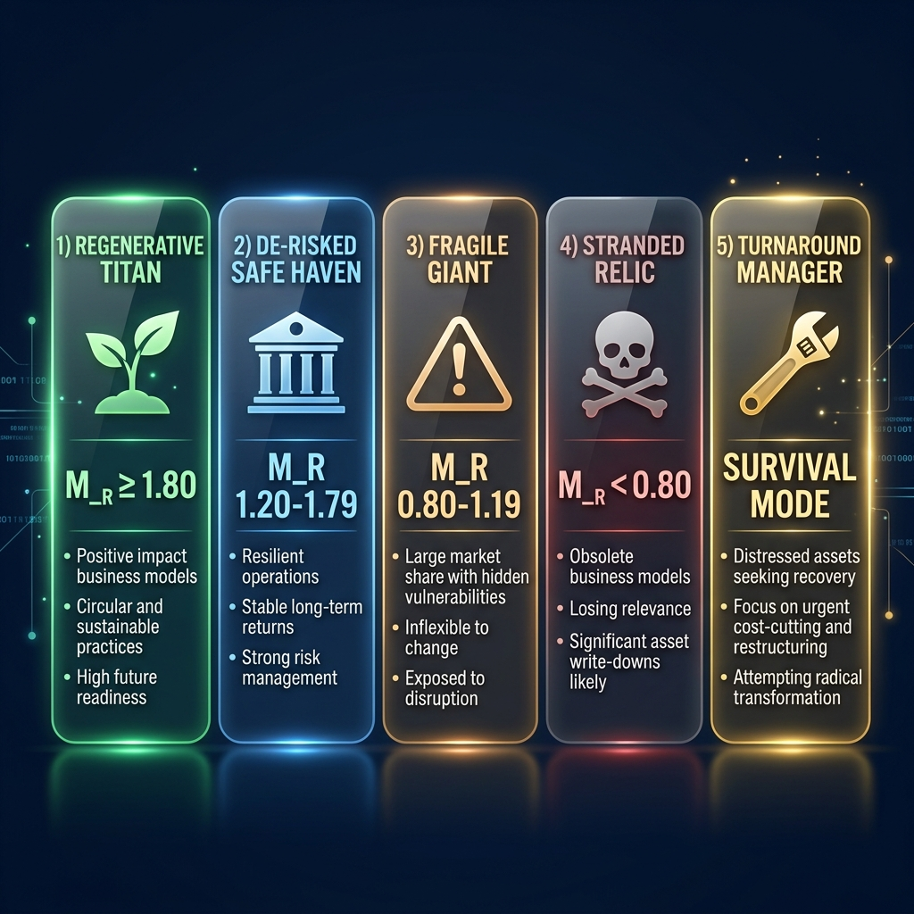
Figure 7.1 — Corporate Archetype Profiles

7.3 Game Over Summary
After Round 10, the simulation presents:
- Terminal Value — Your final corporation valuation
- Regenerative Multiple (M_R) — Your sustainability-adjusted multiplier
- Corporate Archetype — Your strategic profile classification
- Peer Leaderboard — How you rank against other teams
- Balanced Scorecard — Detailed analysis across three tabs (Scorecard/Analysis/Rounds)
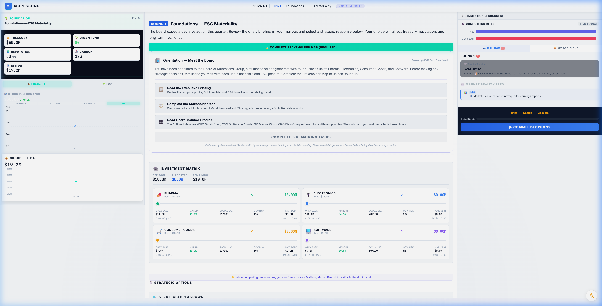
Figure 7.2 — Balanced Scorecard Analysis

PART III: UNDER THE HOOD

8. Mathematical Engines Explained
The simulation is powered by a suite of mathematical engines that process your decisions. Understanding these engines is key to strategic mastery.

8.1 Core Engines

8.1.1 Corporate Strategic Fund (CSF)
Formula: CSF = Σ(Revenue_i - OPEX_i) - Dividends_Paid
Calculates net cash added to treasury each round. If total CAPEX exceeds 20% of treasury, a loan is triggered at 12% interest.
Worked Example:
- Given: Pharma Rev=$18M, OPEX=$11M; Electronics Rev=$22M, OPEX=$14M; CG Rev=$15M, OPEX=$9M; Software Rev=$20M, OPEX=$8M
- Gross Profit = (18-11)+(22-14)+(15-9)+(20-8) = 7+8+6+12 = $33M
- Dividends = $2M → CSF = $33M - $2M = $31M added to treasury

8.1.2 Contagion Engine (Sigmoid Model)
Formula: Group_Rep = AVG(BU_Rep) - 50 × sigmoid((severity - 30) / 15)
Uses an S-curve (sigmoid) centred at severity=30. Low severity (50): saturating damage.
Worked Example:
- Given: BU Reps = [70, 58, 74, 82], Crisis Severity = 40
- AVG Rep = (70+58+74+82)/4 = 71.0
- sigmoid((40-30)/15) = sigmoid(0.667) = 1/(1+e^-0.667) ≈ 0.661
- Group_Rep = 71.0 - 50 × 0.661 = 71.0 - 33.05 = 37.95
- If electronics_blindspot active: severity doubles to 80 → Group_Rep = 71 - 48.4 = 22.6

8.1.3 Synergy Engine (Diminishing Returns)
Formula: effective_ratio = √(ratio) × 0.7; New_OPEX = Old_OPEX × (1 - effective_ratio × Synergy_Mult)
Uses square-root scaling: first dollars yield outsized returns, later dollars hit diminishing marginal efficiency.
Worked Example:
- Given: OPEX=$11M, Investment_Ratio=0.25, Synergy_Mult=1.08
- effective_ratio = √(0.25) × 0.7 = 0.5 × 0.7 = 0.35
- factor = 1 - (0.35 × 1.08) = 1 - 0.378 = 0.622
- New_OPEX = $11M × 0.622 = $6.84M (savings of $4.16M)

8.1.4 Natural Capital Cost of Debt
Formula: Interest_Rate = Base_Rate + (NCD × 0.0001); Debt_Next = Debt + (Debt × Rate)
Environmental debt compounds each round. At NCD=100: rate ≈ 6%. At NCD=500: rate ≈ 10%. At NCD=1000: rate ≈ 15%.
Worked Example:
- Given: NCD=5,200, Base_Rate=0.05
- Rate = 0.05 + (5200 × 0.0001) = 0.57 (57%)
- Debt_Next = 5,200 + (5,200 × 0.57) = 8,164 — compounds aggressively!

8.1.5 VRIO Decay
Formula: Advantage_Next = Advantage_Current × (1 - Decay_Rate)
Prevents synergy from staying permanently high. Default decay = 5% per round.
Worked Example:
- Given: Synergy_Mult=1.38, Decay_Rate=0.05
- Next = 1.38 × 0.95 = 1.311
- After 3 rounds: 1.38 → 1.311 → 1.245 → 1.183

8.1.6 Talent Brain-Drain
Formula: Penalty = 1 + MAX(0, (65-Rep)/100) × 1.5 + burnout_adj
Software BU OPEX inflates when Group Reputation 50 adds further overhead.
Worked Example:
- Given: Group_Rep=55, Software OPEX=$8M, Burnout=60
- Rep Penalty = 1 + ((65-55)/100) × 1.5 = 1.15
- Burnout adj = ((60-50)/100) × 2.0 = 0.20
- Total: 1.35 → New OPEX = $8M × 1.35 = $10.8M (+35%)

8.1.7 Strike Probability (R9)
Formula: P_Strike = Base_Risk + ((1 - SLO/100) × 0.4)
Triggered in R9 with Immediate Closure option. Burnout > 50 adds up to +20%.
Worked Example:
- Given: Base_Risk=0.25, SLO=35, Burnout=65
- P_Strike = 0.25 + ((1 - 0.35) × 0.4) = 0.25 + 0.26 = 0.51
- Burnout boost = 0.06 → Final = 0.57 (57% chance)
- If strike fires: revenue for ALL BUs zeroed for the round

8.1.8 Natural Decay (Entropy)
Formula: If CAPEX = 0: Rep_Next = Rep × 0.98, SLO_Next = SLO × 0.98
BUs receiving zero investment decay 2% per round. Simulates organisational entropy.
Worked Example:
- Given: Rep=70, SLO=65, No investment
- Rep_Next = 70 × 0.98 = 68.6, SLO_Next = 65 × 0.98 = 63.7
- After 5 rounds of neglect: Rep = 70 × 0.98^5 = 63.3

8.2 Advanced Engines (Available in Advanced/Expert Tiers)
- Macroeconomic Inflation: +2.5% OPEX per round — players must invest just to tread water
- Execution Overrun Risk: 25% chance of +15% cost overrun if CAPEX > $3M
- Technical Debt: +4% OPEX after 2+ consecutive zero-investment rounds
- Revenue Cannibalization: Market-overlap matrix penalises dominant BUs stealing sibling revenue
- Stakeholder Fatigue: Trust recovery efficiency = 1/(1 + 0.3 × crisis_count)
- Supply Chain Contagion: High governance risk spreads OPEX surcharges across BUs
- Competitive NPC Index: NPC competitor grows at 6%/round — falling behind loses market share
- Working Capital / Cash Conversion: Governance risk reduces realised cash
- Dividend Ratchet: Cutting dividends >20% triggers -5 reputation penalty
- Talent Allocation Pressure: BUs receiving <15% CAPEX share get 2% OPEX surcharge
- Technology Lock-In: Same BU getting highest CAPEX for 3+ rounds penalises others
- ESG Greenwashing Engine: Green rhetoric without investment (avg ratio < 15%) triggers scandal
- FX Risk Engine: ±5% stochastic currency movements (exposure-weighted by BU)
- Macro Interest Rate Cycles: R1-3: easing (-0.5%), R4-6: neutral, R7-9: tightening (+0.5%), R10: crisis (+1%)

9. KPI Deep Dive
Understanding every Key Performance Indicator is essential for strategic success:
KPI | Range | Good ↑ | Bad ↓ | Why It Matters
Corporate Treasury | $0 → ∞ | > $30M | < $5M | Investment capacity, loan triggers
Group Reputation | 0–100 | > 65 | < 40 | Brain-drain trigger, contagion vulnerability
Carbon Intensity | 0–100 | < 25 | > 50 | Carbon tax cost, climate tipping points
Synergy Multiplier | 0.5–2.0+ | > 1.3 | < 0.8 | OPEX reduction effectiveness, R10 gate
Social License (SLO) | 0–100 | > 75 | < 40 | Strike risk, M_R instability discount
Natural Capital Debt | 0–1M | < 100 | > 500 | Debt compounding, interest surcharge
Governance Risk | 0–100 | < 15 | > 30 | Cash conversion delay, supply chain contagion
Staff Burnout | 0–100 | < 20 | > 70 | OPEX penalty, M_R wellbeing bonus
Workforce Readiness | 0–100 | > 75 | < 40 | Pillar effectiveness, M_R bonus
Critical Thresholds to Monitor:
- Treasury < $5M → Triggers Turnaround Mode (survival phase)
- SLO < 75 across all BUs → Triggers -0.40 Instability Discount on M_R
- Burnout > 70 → Critical OPEX penalties + governance risk increase
- Carbon Intensity > 50 → Triggers stranded asset penalties in Climate pathway

10. Scoring & Terminal Valuation

10.1 Terminal EBITDA Calculation
Formula:
Terminal_EBITDA = Σ(Revenue_i - OPEX_i) - (Carbon_Tonnage × Carbon_Tax_Per_Ton)
Carbon_Tonnage = Σ(BU_Carbon_Intensity × BU_Revenue / 1,000,000)
- Standard Carbon Tax: $250/tonne
- Climate Black Swan pathway: $750/tonne
- Example: Gross Profit=$33M, Carbon=2,850t → Tax=$712,500 → EBITDA=$32.29M

10.2 Regenerative Multiple (M_R)
The M_R is the sustainability-adjusted valuation multiplier that directly multiplies your Terminal Value:
Component | Value | Trigger Condition | Source Round
Base | +1.00 | Always applied | —
CSRD Governance | +0.10 | R2A: materiality_aligned flag | R2
Synergy Excellence | +0.30 | R7C: synergy_unlock + synergy ≥ 0.80 | R7
Resilience Champion | +0.20 | NOT insurance_only AND NOT electronics_water_priority | R5/R8
Truth Premium | +0.15 | R6B: ethical_ai_overhaul flag | R6
Community Champion | +0.18 | R9C: community_fund flag (× JT scaling) | R9
Just Transition | +0.12 | R9B: managed_transition (alternative) | R9
Workforce Excellence | +0.10 | workforce_readiness ≥ 75 at R10 | Cumulative HR
Wellbeing Champion | +0.05 | avg burnout < 20 at R10 | Cumulative HR
Instability Discount | −0.40 | avg Social License < 75 | Cumulative
MAXIMUM ACHIEVABLE | 2.08 | All bonuses, no penalties | —

10.3 Terminal Value Formula
TV = (Terminal_EBITDA + Green_Fund_Balance) × Exit_Multiple × M_R
- Exit Multiple: 12× (standard) — represents investor confidence
- Example Titan: EBITDA=$32.29M, Green Fund=$2M, M_R=2.08 → TV = $34.29M × 12 × 2.08 = $856M
- Example Relic: EBITDA=$28M, Green Fund=$0, M_R=0.60 → TV = $28M × 12 × 0.60 = $202M
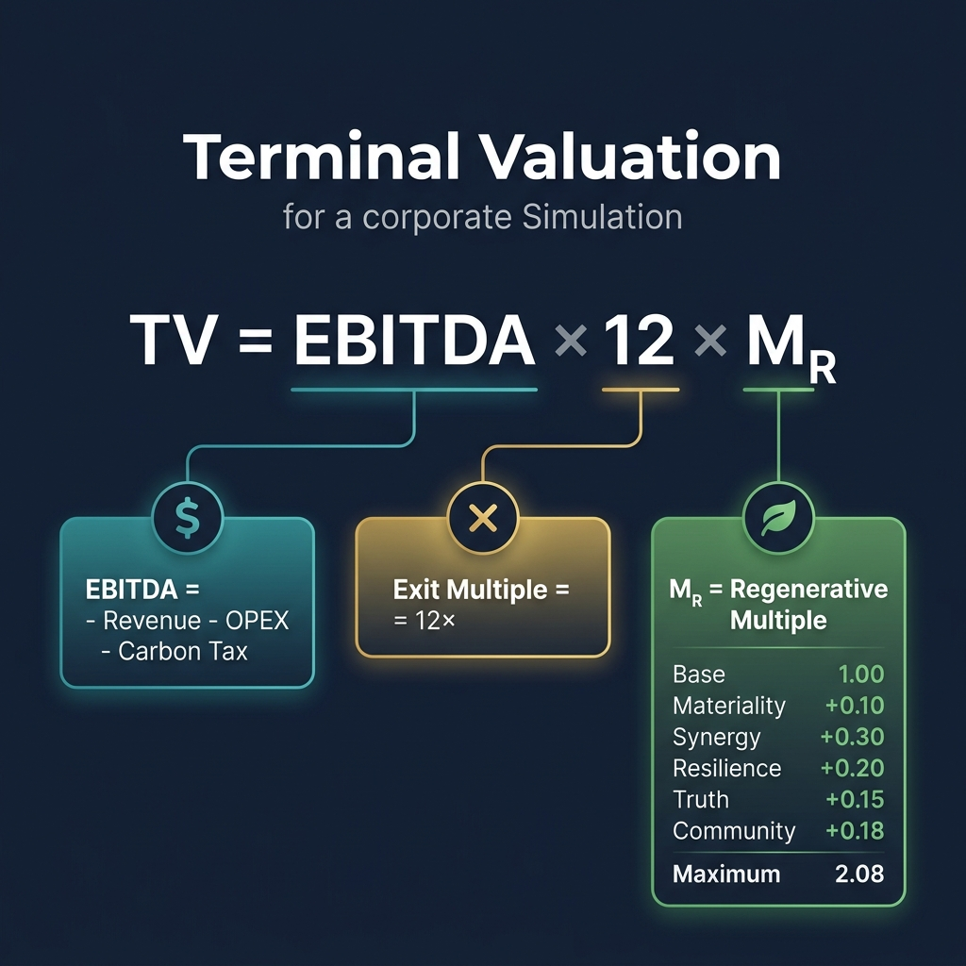
Figure 10.1 — Terminal Valuation Breakdown Screen

10.4 What-If Scenario Comparison
Scenario | M_R | Terminal Value | Delta vs Baseline
Baseline (Fragile Giant) | 1.05 | ~$478M | —
+ Resilient Choices (R5B + R8A) | 1.25 | ~$570M | +$91M
+ Titan Strategy (all bonuses) | 1.65 | ~$752M | +$273M
Maximum Achievable | 2.08 | ~$948M | +$469M

11. Flag Dependencies & Cascades
The "Butterfly Effect" system means early-round decisions compound through cross-round flag dependencies:
Source | Flag | Target | Cascade Effect
R1A | electronics_blindspot | R4 | DOUBLES crisis severity (40→80)
R1B | deep_audit_completed | R4 | HALVES crisis severity
R2A | materiality_aligned | R10 | +0.10 M_R Governance bonus
R3C | greenwash_risk | R5+ | Triggers greenwash if avg inv < 15%
R3A | early_decarboniser | R7 | +0.10 synergy multiplier
R5C | insurance_only | R10 | BLOCKS +0.20 Resilience M_R
R6B | ethical_ai_overhaul | R10 | +0.15 Truth Premium M_R
R6C | ai_monetised | R7+ | EU AI Act costs from R7 onward
R7C | synergy_unlock | R10 | +0.30 Synergy M_R (highest bonus)
R8B | electronics_water_priority | R10 | BLOCKS +0.20 Resilience M_R
R9C | community_fund | R10 | +0.18 Community Champion M_R
R9B | managed_transition | R10 | +0.12 Just Transition M_R
Key Insight: The most impactful flags are set in R1 (blindspot), R6 (ethics), and R7 (synergy). These three rounds alone account for over 60% of M_R variability.

PART IV: REFERENCE

12. Strategic Tips & Common Mistakes

12.1 Top 5 Strategic Tips
Tip 1: Invest in R1 Deep Audit (Option B)
Spending $3M in R1 halves R4 crisis damage. This is the highest-ROI decision in the entire simulation — it prevents $6M+ in downstream losses.
Tip 2: Never ignore a BU for 2+ rounds
Technical Debt engine adds 4% OPEX compounding. Combined with Natural Decay (2% reputation/SLO loss), neglect spirals quickly.
Tip 3: Watch Social License carefully
If average SLO drops below 75, the Instability Discount wipes 0.40 from M_R — equivalent to losing ~$180M in terminal value.
Tip 4: Target the Synergy Unlock (R7C)
At +0.30 M_R, this is the single highest bonus. Ensure synergy_multiplier ≥ 0.80 to qualify.
Tip 5: Think in systems, not rounds
Decisions in R1 echo through R10. Map the flag dependency chain before committing.

12.2 Common Mistakes
- Over-investing in one BU — triggers Technology Lock-In and Revenue Cannibalization engines
- Choosing "cheap" options without considering flag consequences (R1A saves money but costs $6M+ at R4)
- Ignoring HR/talent — burnout compounds and triggers brain-drain OPEX inflation
- Cutting dividends sharply — triggers Dividend Ratchet reputation penalty (-5)
- Taking insurance-only path in R5 — permanently blocks +0.20 Resilience M_R bonus
- Choosing R6C (Monetise Algorithm) — triggers EU AI Act costs AND reputation -20

13. Glossary of Key Terms
Business Unit (BU): One of four operational divisions of Muressons Global Corporation. Default: Pharma, Electronics, Consumer Goods, Software.
CAPEX: Capital Expenditure — investment allocated to each BU per round from the CSF pool.
Carbon Intensity (CI): Measure of CO₂ emissions relative to economic activity (0-100). Determines carbon tax at terminal valuation.
Contagion Engine: Mathematical model propagating reputational damage across BUs using a sigmoid function.
Corporate Strategic Fund (CSF): Total capital pool available for investment each round = gross profit minus dividends.
CSRD: Corporate Sustainability Reporting Directive — EU regulation requiring ESG impact reporting.
Decision Paradigm: Mode of strategic decision-making: Narrative Crisis (A/B/C), Strategic Pillars, Advanced Climate, or Healthcare.
Double Materiality: Framework considering both financial materiality (risks to company) and impact materiality (company impact on society).
EBITDA: Earnings Before Interest, Taxes, Depreciation, and Amortisation — primary profitability metric.
ESG: Environmental, Social, and Governance — the three pillars of sustainable business practice.
Exit Multiple: Valuation multiplier applied to terminal EBITDA (default: 12×). Represents investor confidence.
Flag: Game-state marker set by decisions that carries forward to affect future rounds (e.g., electronics_blindspot).
Foreshadowing: Subtle news hints injected during R5-R8 indicating which R10 ending pathway is approaching.
Governance Risk: Score (0-100) reflecting corporate governance quality. High values reduce cash efficiency.
Greenwashing Engine: Detects green rhetoric without investment (avg ratio < 15%), triggering social licence penalty.
Investment Ratio: Proportion of CSF allocated to a BU (0.0-1.0). Higher ratios = more OPEX reduction.
M_R (Regenerative Multiple): Sustainability-adjusted valuation multiplier (range: ~0.0 to 2.08). Directly multiplies terminal value.
Mendelow's Matrix: 2×2 Power-Interest stakeholder mapping framework used in the R1 minigame.
Natural Capital Debt (NCD): Liability representing unpriced environmental externalities. Compounds each round via interest.
OPEX: Operating Expenditure — ongoing cost of running each BU. Reduced by investment and synergy.
Scope 3 Emissions: Indirect value chain emissions (upstream suppliers, downstream customers). Typically 4× direct emissions.
Sigmoid Function: S-curve mathematical function used in the Contagion Engine for damage propagation.
Social License to Operate (SLO): Score (0-100) reflecting community and stakeholder consent. Below 75 triggers Instability Discount.
Stochastic Event: Probabilistic game event with outcomes determined by random roll (e.g., R5 cyclone).
Synergy Multiplier: Factor (0.5-2.0+) amplifying CAPEX effectiveness in reducing OPEX.
Terminal Value (TV): Final corporation valuation: EBITDA × Exit Multiple × M_R.
VRIO Decay: Mechanism eroding competitive advantage over time (5% per round).
Workforce Readiness: Global competence score (0-100). Below 40: -20% pillar effectiveness. Above 75: +0.10 M_R.

14. Quick Reference Card
Print this page as a one-page reference during gameplay.
Round Progression:
Round | Theme | Key Flag to Target
R1 | ESG Foundations | Option B → deep_audit_completed
R2 | Double Materiality | Option A → materiality_aligned (+0.10 M_R)
R3 | Scope 3 Emissions | Avoid Option C greenwash_risk
R4 | Contagion Crisis | Full Transparency (Option A) for recovery
R5 | Climate Risk | Nature-Based (Option B) for resilience
R6 | AI Ethics | Option B → ethical_ai_overhaul (+0.15 M_R)
R7 | Circularity | Option C → synergy_unlock (+0.30 M_R)
R8 | Water Scarcity | Avoid electronics_water_priority
R9 | Just Transition | Option C → community_fund (+0.18 M_R)
R10 | Grand Finale | All flags evaluated → Terminal Value
Emergency Signals — When to Worry:
- 🔴 Treasury < $5M → Turnaround Mode imminent
- 🔴 SLO < 40 for any BU → Strike risk + Social Collapse
- 🟡 Burnout > 50 → Brain-drain activating, OPEX rising
- 🟡 Governance Risk > 30 → Cash conversion degrading
- 🟢 M_R > 1.50 → On track for Safe Haven or better
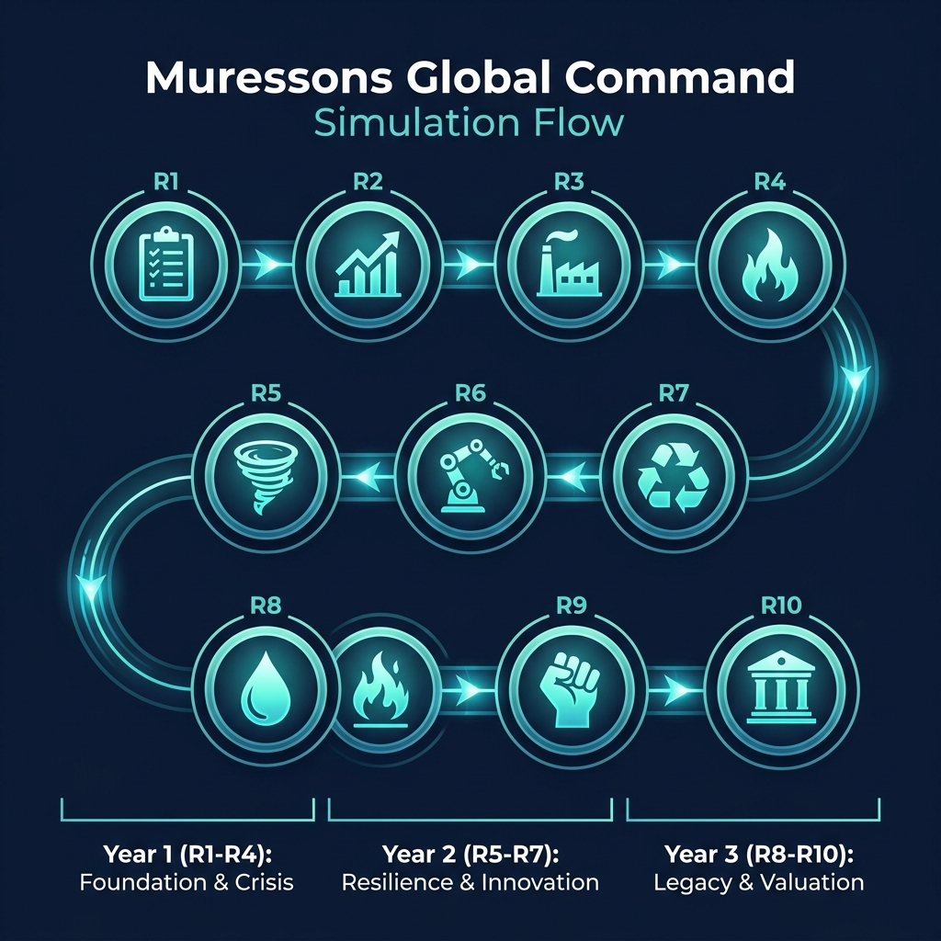
Figure 14.1 — Round Progression Roadmap

APPENDICES

Appendix A: Decision Paradigm Comparison
Feature | Narrative Crisis | Strategic Pillars | Advanced Climate | Healthcare
Decision Style | A/B/C choice | 5-area toggles | Climate-focused | Healthcare network
Complexity | Standard | High | High | Specialised
BU Types | Corporate (4 BUs) | Corporate (4 BUs) | Corporate (4 BUs) | Hospital/Clinic/Telehealth
Best For | First-time players | Experienced teams | Climate-focused courses | Healthcare MBA
Engine Count | 8 core | 8 core + pillars | 8 core + carbon | 8 core + clinical

Appendix B: Industry Vertical Alternatives
Facilitators can substitute the default BUs with industry-specific alternatives:
Vertical | BU 1 | BU 2 | BU 3 | BU 4
Default (Corporate) | Pharma | Electronics | Consumer Goods | Software
Oil & Gas | Upstream | Midstream | Downstream | Renewables
Banking | Retail Banking | Investment Banking | Insurance | Fintech
Retail/FMCG | Food & Beverage | Fashion | Home & Living | E-Commerce
Agriculture | Crop Production | Livestock | AgTech | Distribution
Technology | Cloud Services | Hardware | AI/ML | Cybersecurity

Appendix C: Minigames & Side Activities
The simulation includes several interactive minigames that enhance the learning experience:
Mendelow's Stakeholder Matrix (R1)
Drag-and-drop 10 stakeholders onto a Power-Interest Grid. Achieving 80%+ accuracy earns a reputation bonus. Teaches stakeholder mapping methodology.
CSRD Double Materiality Assessment (R2)
Assess CSRD issues across Financial and Impact materiality dimensions. Includes CFO budget validation gate. Teaches EU sustainability reporting frameworks.
CEO Interview (Post-Game)
AI-powered 5-question competency assessment across 6 dimensions: Strategic Thinking, Stakeholder Empathy, Financial Acumen, Ethical Reasoning, Systems Thinking, and Adaptive Leadership. Produces a spider diagram and narrative feedback.
Boardroom Showdown (R10)
Activist investor negotiation exercise with strategic stake analysis and proxy fight mechanics.

— End of Student Manual —

Muressons Global Corporation © 2026

