MURESSONS GLOBAL CORPORATION
Facilitator's Manual
Project Equilibrium — Strategy Simulation

CONFIDENTIAL — For Facilitator Use Only
Version 1.0 — May 2026
10-Round Loop | 4 Side Tracks | 5 Ending Pathways | 5 Autonomous Agents

Table of Contents
Part 1 — Foundation & Engine
§1. Pedagogical Overview & Learning Objectives
§2. Theoretical Foundations & Academic Integration
§3. Mathematical Engine Reference
Part 2 — Round-by-Round Facilitation Guide
§4. Round-by-Round Guide (R1–R10)
Part 3 — Advanced Systems
§5. Shadow Board Audit Deep Dive
§6. Ending Pathways
§7. Terminal Valuation Deep Dive
§8. Side Tracks
§9. Autonomous Stakeholder Agents
§10. Facilitator God Mode & Overrides
Part 4 — Dashboard Guides, Planning & Appendices
§10A. Facilitator Dashboard Visual Guide
§10B. God Mode Dashboard Visual Guide
§10C. Industry Vertical Swapping Guide
§11. Common Student Pitfalls & Teaching Moments
§12. Quick-Reference Cards
§13. Session Planning & Logistics
§14. Assessment & Grading Rubric
§15. Facilitator FAQ
Appendix A: Glossary of Definitions
Appendix B: Complete Engine Variable Registry
Appendix C: Academic Reference Matrix

PART 1 — FOUNDATION & ENGINE

§1. Pedagogical Overview & Learning Objectives

1.1 Core Narrative & Simulation Premise
Muressons Global Corporation is a multi-divisional conglomerate operating across four business units: Pharmaceuticals, Electronics, Consumer Goods, and Software. Over 10 strategic rounds (representing 5 simulated years), players serve as the executive leadership team navigating interconnected ESG crises, stakeholder pressures, and systemic sustainability challenges. Every decision creates cascading consequences through hidden mathematical engines, forcing players to confront the tension between short-term financial performance and long-term regenerative value creation.
The simulation is built on an immutable state pipeline architecture. The engine.py core executes 20+ mathematical engines per round in a deterministic sequence, while round_logic.py applies per-round mutations. This design ensures reproducibility while creating emergent complexity that surprises even experienced players.

1.2 Business Unit Profiles
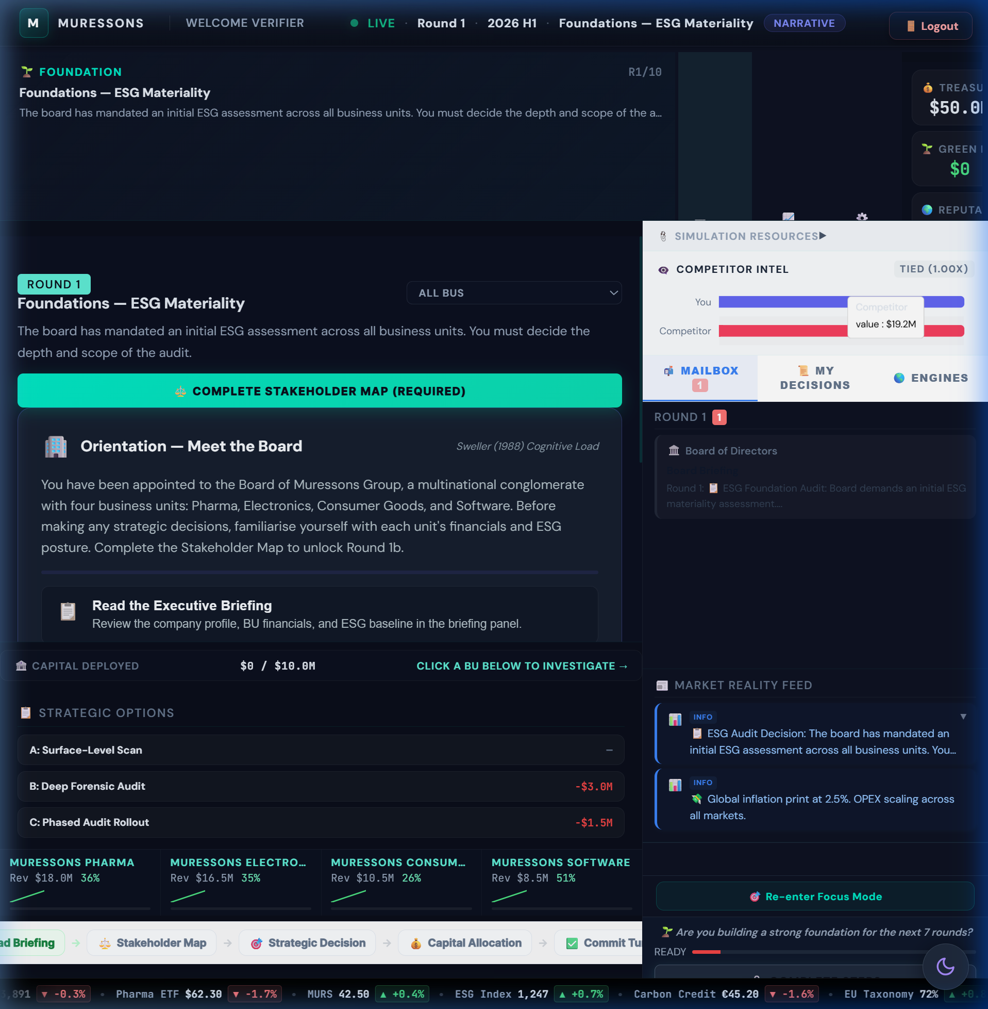
Figure: Executive Cockpit — initial state with 4 BU KPI cards
BU | Icon | Revenue | OPEX | Carbon Int. | Water Dep. | NCD | Gov. Risk
Pharma | 💊 | $18.0M | $12.0M | 35 | 82 | 120 | 15
Electronics | ⚡ | $16.5M | $11.5M | 72 | 58 | 200 | 20
Consumer Goods | 🛒 | $10.5M | $7.5M | 48 | 65 | 150 | 10
Software | 💻 | $8.5M | $5.5M | 12 | 12 | 30 | 25

1.3 Learning Objectives
LO | Description | Primary Rounds | Bloom's Level
LO1 | Analyse stakeholder salience using Mendelow's Matrix | R1, R5, R8 | Analyse (L4)
LO2 | Evaluate trade-offs between short-term profit and systemic resilience | R3, R4, R9 | Evaluate (L5)
LO3 | Apply double materiality assessment to capital allocation | R2 | Apply (L3)
LO4 | Synthesise ESG strategy that maximises Regenerative Multiple | R7, R10 | Create (L6)
LO5 | Assess autonomous stakeholder reactions and cascade risk | R4, R6, R9 | Evaluate (L5)
LO6 | Design just transition strategies balancing efficiency and equity | R9 | Create (L6)

1.4 Key Strategic Trade-Offs
- Short-term cash extraction vs. long-term terminal value: Every dollar saved now compounds against you through NCD interest, VRIO decay, and burnout penalties.
- Concentrated investment vs. diversification: Synergy rewards cross-BU integration, but spreading too thin yields diminishing returns (√ scaling).
- Transparency vs. containment: Full disclosure costs money upfront but prevents contagion cascades. Deny-and-deflect is free but risks 2× crisis severity.
- Adaptation vs. mitigation: Hard engineering builds resilience but adds carbon; nature-based solutions are cheaper but take 2 rounds to mature.
- Efficiency vs. equity: Prioritising high-margin BUs maximises short-term EBITDA but triggers social licence collapse and strike risk at R9.

1.5 Simulation Timeline
Tier | Rounds | Theme | Cognitive Demand
Foundation | R1–R3 | Diagnostic & Strategy Setting | Remember → Apply
Crisis | R4–R6 | Cascade Management & Ethics | Analyse → Evaluate
Integration | R7–R8 | Systems Thinking & Resource Allocation | Evaluate → Create
Finale | R9–R10 | Justice, Valuation & Legacy | Create → Synthesise

Simulation Architecture Map
The diagram below illustrates the complete simulation pipeline — from player decisions through the mathematical engine to terminal valuation outputs.
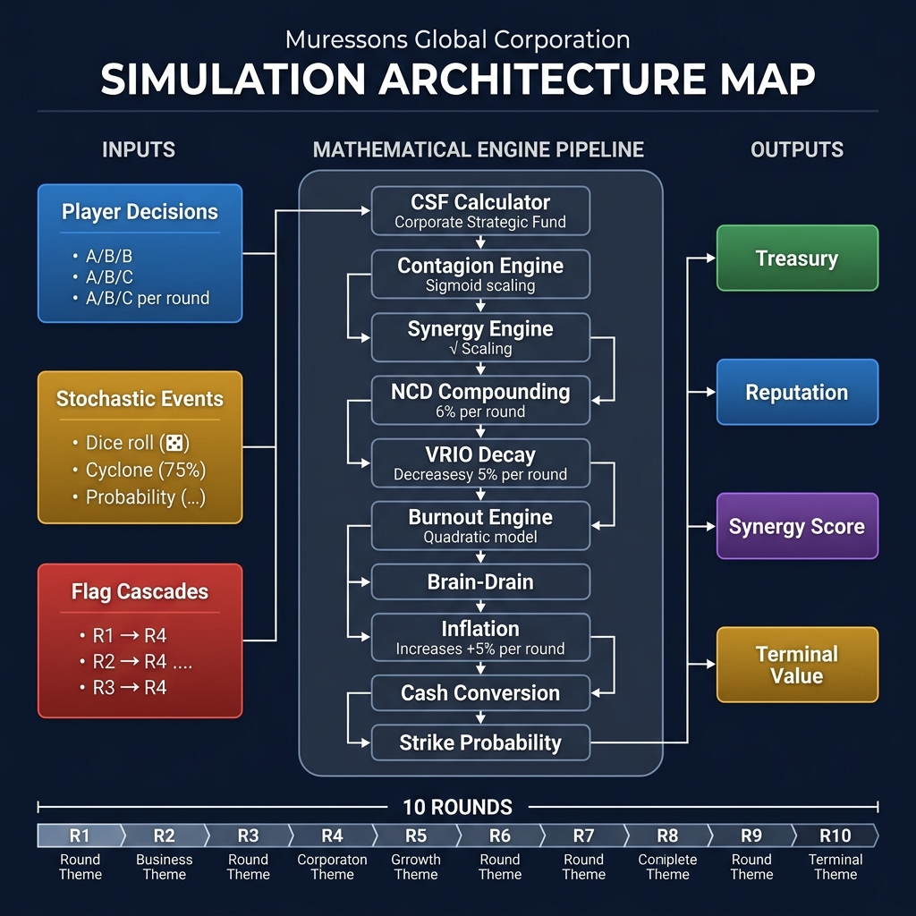
Figure: Simulation Architecture Map — engine pipeline flowchart

§2. Theoretical Foundations & Academic Integration

2.1 Framework-to-Mechanic Mapping
The simulation embeds 25+ academic frameworks as executable game mechanics. Each theory is experienced before being named — players discover the principle through gameplay, then the facilitator reveals the academic framework during debrief.
Theory / Author | Framework | Round(s) | Simulation Mechanic
Mendelow (1991) | Stakeholder Mapping | R1 | Drag-and-drop stakeholder matrix pre-gate
Mitchell et al. (1997) | Stakeholder Salience | R1, R5, R9 | Power × Legitimacy × Urgency drives agent escalation
EU CSRD / ESRS | Double Materiality | R2 | CFO materiality gate — 2×2 matrix with budget clawback
GHG Protocol | Scope 3 Emissions | R3 | Supply chain carbon footprint 4× direct emissions
Real Options (Dixit & Pindyck) | Option Value of Information | R1→R4 | Deep audit = buying option on future crisis mitigation
Argyris (1977) | Double-Loop Learning | R4 | Players must question assumptions after R1 cascade reveals
Kahneman (2011) | System 1/2 Thinking | R4, R6 | Time pressure forces heuristic decision-making
Moon (2004) | Board Room Moments | R4, R5 | 3-stage reflection: Noticing → Making Sense → Working with Meaning
Schön (1983) | Reflection-in-Action | R5 | Shadow Board forces real-time stakeholder perspective-taking
Jensen & Meckling (1976) | Agency Theory | R5 | Shadow Board persona conflicts embody principal-agent tensions
Hirschman (1970) | Exit, Voice, Loyalty | R5, R9 | Stakeholder response to dissatisfaction — protest vs. departure
Porter (2011) | Creating Shared Value | R6, R7 | Ethical AI overhaul and circular economy create dual value
Barney (1991) | Resource-Based View | R7 | VRIO advantage decays without investment; synergy = rare capability
Teece (2007) | Dynamic Capabilities | R7 | Workforce readiness gates determine circular economy effectiveness
Senge (1990) | Learning Organisation | R7 | System archetype detection in reinforcing/balancing loops
Hardin (1968) | Tragedy of the Commons | R8 | Water scarcity forces collective resource allocation
Ostrom (1990) | Commons Governance | R8 | Regulatory sandbox Ostrom instruments test self-governance
Rawls (1971) | Justice as Fairness | R9 | Just transition: efficiency vs. equity in factory closures
Freeman (1984) | Stakeholder Theory | R9 | Community fund vs. immediate closure — who bears transition cost?
Sen (1999) | Capabilities Approach | R9 | Green job training expands worker capabilities beyond employment
Costanza et al. (1997) | Natural Capital | All | NCD compounding at 6% models ecological debt accumulation
Meadows (1999) | Leverage Points | R10 | Debrief overlay identifies system intervention hierarchy
Kolb (1984) | Experiential Learning | All | Concrete Experience → Reflection → Conceptualisation → Experimentation
Thiagarajan (1993) | Debrief Protocol | R10 | 3-phase: How Do You Feel? → What Happened? → So What?
Taleb (2012) | Antifragility | R4, R8 | Systems that gain from disorder — deep audit teams outperform

2.2 Pedagogical Design Principles
- Path Dependency: R1 decisions irrevocably shape R4 crisis severity (40 vs. 80), R9 strike probability, and R10 terminal value. There is no "reset" — every choice persists.
- Fog of War: Engine complexity is progressively disclosed. R1-R3 show 5 engines; by R8, all 20+ are visible. This models real-world information asymmetry.
- Mechanic Variation: No two rounds use the same decision format — drag-and-drop (R1), 2×2 matrix (R2), slider allocation (R7), tribunal (R8), preventing "solved game" optimisation.
- Stochastic Elements: Cyclone probability (75%), whistleblower backfire (40%), macro noise (±3%) — players cannot distinguish luck from strategy without the pedagogical labels.
- Hidden Causality: The most important mechanics (contagion sigmoid, burnout quadratic, NCD compounding) are never shown to players. Facilitators reveal them during debrief.

§3. Mathematical Engine Reference
This section documents every mathematical engine in the simulation. For each engine: the exact formula from the codebase, a worked sample calculation, and a non-mathematical teaching analogy for facilitators to use with students.
🚫 DO NOT REVEAL: These formulas are HIDDEN from players. They are the facilitator's "answer key" for understanding why outcomes occur. Never reveal formulas during gameplay — reveal them during debrief.
Figure: Simulation Architecture flowchart showing process_tick() pipeline

3.1 Corporate Strategic Fund (CSF)

Formula
CSF = Sum(Revenue_Base - OPEX_Base) - Dividends_Paid
The CSF calculates net cash generated each round from all BU operations minus any board-mandated dividend payments. This is the primary source of corporate treasury growth.

Sample Calculation
BU | Revenue | OPEX | Gross Profit
Pharma | $18.0M | $12.0M | $6.0M
Electronics | $16.5M | $11.5M | $5.0M
Consumer Goods | $10.5M | $7.5M | $3.0M
Software | $8.5M | $5.5M | $3.0M
TOTAL | $53.5M | $36.5M | $17.0M

With $0 dividends: CSF = $17.0M added to treasury. With $2M dividends: CSF = $15.0M.

Teaching Tip
💡 TIP: Tell students: "Think of CSF as your corporate paycheck. Every round, your four businesses generate profit. But just like a household budget, you have fixed obligations (dividends to shareholders). What's left is what you can invest. The question is: how do you allocate a finite paycheck across competing priorities?"

3.2 Contagion Engine (Sigmoid Model)

Formula
Group_Rep = Avg_BU_Rep - 50 x sigmoid((severity - 30) / 15)
Where sigmoid(x) = 1 / (1 + e^(-x))
The sigmoid (S-curve) models non-linear crisis propagation: small crises are absorbed with minimal damage, but once severity crosses a threshold (~30), damage escalates rapidly before saturating at extreme levels. The electronics_blindspot flag DOUBLES severity from 40 to 80.

Sample Calculation
Scenario | R1 Choice | Severity | Sigmoid Input | Sigmoid Output | Rep Hit | Final Rep
Deep Audit (no blindspot) | B | 40 | (40-30)/15 = 0.67 | 0.66 | -33.0 | 22.0
Phased Audit (deferred) | C | 60 | (60-30)/15 = 2.0 | 0.88 | -44.0 | 11.0
Surface Scan (blindspot) | A | 80 | (80-30)/15 = 3.33 | 0.97 | -48.3 | 6.7

Starting avg rep = 55. The blindspot team loses 48.3 points vs. 33.0 for the audited team — a 46% worse outcome from a single R1 decision. This is the simulation's most consequential hidden mechanic.

Teaching Tip
💡 TIP: Tell students: "Think of reputation damage like a viral infection. A small scandal (low severity) is like a common cold — your immune system handles it. But a major scandal (high severity) is like a pandemic — it overwhelms your defences. The S-curve shows that there's a tipping point where manageable becomes catastrophic. The R1 audit was your vaccine — those who skipped it caught the full disease at R4."

3.3 Synergy Engine (Square-Root Scaling)

Formula
effective_ratio = sqrt(investment_ratio) x 0.7
New_OPEX = Old_OPEX x (1 - effective_ratio x synergy_multiplier)
Square-root scaling means the first dollar invested yields the highest return, with each subsequent dollar yielding progressively less. At 25% investment ratio, you get 50% of max efficiency. At 100%, you get 70%. This prevents "solve by spending" strategies.

Sample Calculation
Investment Ratio | sqrt(ratio) | Effective Ratio | OPEX Reduction (syn=1.0) | Comment
10% | 0.316 | 0.221 | -22.1% | Excellent ROI per dollar
25% | 0.500 | 0.350 | -35.0% | Good balance
50% | 0.707 | 0.495 | -49.5% | Diminishing returns begin
100% | 1.000 | 0.700 | -70.0% | Maximum efficiency (capped at 70%)

Teaching Tip
💡 TIP: Tell students: "Imagine you're watering a garden. The first bucket of water makes a huge difference to dry soil. The second bucket helps, but less. By the tenth bucket, the ground is saturated and you're wasting water. That's diminishing returns. Your investment in cross-BU synergy works the same way — focus beats dilution."

3.4 Natural Capital Debt (NCD) Compounding

Formula
Interest_Rate = Base_Rate + (NCD x 0.0001)
NCD_new = NCD_current x (1 + Interest_Rate) + round_delta
At NCD=100, interest rate is ~6%. At NCD=500, it climbs to ~10%. This creates a "debt trap" — the more ecological damage you accumulate, the faster it compounds. NCD is deducted from terminal value as an ecological liability.

Sample Calculation
Electronics BU starts with NCD = 200. Assume no investment (round_delta = 0):
Round | NCD Start | Rate | Interest | NCD End
R1 | 200.0 | 6.02% | +12.0 | 212.0
R3 | 225.1 | 6.03% | +13.6 | 238.7
R5 | 252.6 | 6.03% | +15.2 | 267.8
R7 | 283.4 | 6.03% | +17.1 | 300.5
R10 | 337.5 | 6.03% | +20.3 | 357.8

Over 10 rounds of neglect, NCD grows 79% from compounding alone — a $15.8M terminal value penalty at $100K per NCD point.

Teaching Tip
💡 TIP: Tell students: "NCD works exactly like credit card debt. If you only make minimum payments, the balance grows faster than you can pay it off. Nature is lending you ecosystem services — clean water, stable climate, pollination. Every round you don't repay, the interest compounds. By R10, teams that ignored NCD owe nature a debt they can never repay."

3.5 VRIO Competitive Advantage Decay

Formula
VRIO_next = VRIO_current x (1 - decay_rate)
Default decay_rate = 0.05 (5% per round). VRIO starts at 0.80 and decays towards 0.50 (industry average). Investing in a BU resets or slows decay. VRIO modifies BU revenue effectiveness.

Sample Calculation
Starting VRIO = 0.80 with no investment for 5 rounds:
R1: 0.80 x 0.95 = 0.76 | R2: 0.72 | R3: 0.69 | R4: 0.65 | R5: 0.62
After 5 rounds of neglect, competitive advantage drops from "strong" (0.80) to "average" (0.62). This represents competitor imitation eroding your unique capabilities.

Teaching Tip
💡 TIP: Tell students: "Your competitive advantage is like a moat around a castle. If you don't maintain it, competitors slowly fill it in. VRIO measures how unique and valuable your capabilities are. Without active investment, competitors copy your best practices, hire your talent, and erode your edge. Standing still means falling behind."

3.6 Burnout Engine (Quadratic OPEX Penalty)

Formula
Penalty_Rate = ((burnout - 20)^2) x 0.000028125
OPEX_new = OPEX x (1 + Penalty_Rate)
Burnout follows a quadratic (squared) curve — costs accelerate as burnout increases. Below 20, there is no penalty. Above 20, costs grow exponentially. At 70+, burnout also increases R9 strike probability.
Natural drift: +6 burnout per round if no HR investment. HR investment: -16 to -30 burnout.

Sample Calculation
Burnout | Penalty Calc | OPEX Penalty | On $12M OPEX | Risk Level
20% | (0)^2 x 0.000028 = 0% | +0% | $0 | Safe
40% | (20)^2 x 0.000028 = 1.1% | +1.1% | +$135K | Watch
60% | (40)^2 x 0.000028 = 4.5% | +4.5% | +$540K | Critical
80% | (60)^2 x 0.000028 = 10.1% | +10.1% | +$1.2M | Emergency
100% | (80)^2 x 0.000028 = 18.0% | +18.0% | +$2.2M | Catastrophic

A team that ignores HR for 8 rounds (natural drift: 10 + 8x6 = 58%) loses $540K/round in OPEX penalties AND faces 60%+ strike probability at R9.

Teaching Tip
💡 TIP: Tell students: "Burnout is like a pressure cooker. At first, the steam builds slowly and nothing seems wrong. But the pressure follows a squared curve — it accelerates. By the time you notice the lid rattling, it's about to blow. The R9 strike is the explosion. The only way to release pressure is HR investment — and the earlier you start, the cheaper it is."

3.7 Brain-Drain Engine (Talent Penalty)

Formula
Talent_Penalty = 1 + max(0, (65 - Group_Rep) / 100) x 1.5
If burnout > 50: Penalty += ((burnout - 50) / 100) x 2.0
Applies to Software (and Technology/Banking verticals). When reputation drops below 65, talent leaves for competitors, increasing OPEX as the company must hire expensive contractors/agencies.

Sample Calculation
Reputation | Burnout | Penalty Calc | OPEX Multiplier | On $5.5M OPEX
65+ | Any | 1 + 0 = 1.0 | 1.00x | $5.5M (no penalty)
50 | 30 | 1 + (15/100)x1.5 = 1.225 | 1.23x | $6.7M (+$1.2M)
35 | 60 | 1 + (30/100)x1.5 + (10/100)x2 = 1.65 | 1.65x | $9.1M (+$3.6M)
20 | 80 | 1 + (45/100)x1.5 + (30/100)x2 = 2.28 | 2.28x | $12.5M (+$7.0M)

Teaching Tip
💡 TIP: Tell students: "Your best engineers have options. When your company's reputation drops, they get headhunted by competitors with better brands. You're left hiring expensive consultants and agencies to fill the gaps. This is the 'war for talent' made real. The vicious cycle: low reputation means talent leaves, which means higher costs, which means less investment, which means lower reputation."

3.8 Macroeconomic Inflation Engine

Formula
OPEX_new = OPEX x (1 + inflation_index)
Default inflation_index = 0.05 (5% per 6-month round, ~10% annualised). Inflation silently erodes purchasing power every round. Players must invest just to maintain the status quo.

Sample Calculation
Pharma OPEX = $12M. After 10 rounds of 5% inflation: $12M x 1.05^10 = $19.5M — a 63% increase in operating costs that players often fail to anticipate.

Teaching Tip
💡 TIP: Tell students: "Inflation is the silent tax on inaction. Every round, everything gets 5% more expensive. If you don't grow revenue faster than inflation grows costs, you're actually shrinking. This mirrors the real-world challenge every CEO faces: the treadmill effect."

3.9 Cash Conversion Drag

Formula
Cash_Efficiency = 1.0 - (governance_risk / 500)
Realized_Revenue = Revenue x Cash_Efficiency (clamped to [0.5, 1.0])
BUs with high governance risk convert revenue to cash less efficiently — representing delayed payments, compliance costs, legal reserves, and investor distrust.

Sample Calculation
Governance Risk | Cash Efficiency | On $16.5M Revenue | Revenue Lost
10 (low) | 1.0 - 10/500 = 0.98 | $16.2M | -$0.3M
30 (medium) | 1.0 - 30/500 = 0.94 | $15.5M | -$1.0M
60 (high) | 1.0 - 60/500 = 0.88 | $14.5M | -$2.0M
100 (critical) | 1.0 - 100/500 = 0.80 | $13.2M | -$3.3M

Teaching Tip
💡 TIP: Tell students: "Think of governance risk as friction in your financial plumbing. Good governance means revenue flows smoothly into cash. Bad governance creates leaks — legal costs, delayed approvals, compliance penalties, investor distrust. The cash is technically yours, but you can't use it all. This is why the 'free' options (Deny & Deflect) are never truly free."

3.10 Strike Probability Engine

Formula
P_Strike = Base_Risk + ((1 - SLO/100) x 0.4)
If burnout > 50: P_Strike += min(0.20, (burnout - 50)/100 x 0.40)
Strike probability is the "time bomb" of the simulation. It combines social licence deficit with workforce burnout to determine the probability of a full revenue wipeout at R9.

Sample Calculation
SLO | Burnout | Base Prob | + SLO Factor | + Burnout Boost | Final P(Strike)
70 | 20 | 0.50 | +0.12 | +0.00 | 62%
50 | 40 | 0.50 | +0.20 | +0.00 | 70%
30 | 60 | 0.50 | +0.28 | +0.04 | 82%
20 | 80 | 0.50 | +0.32 | +0.12 | 94%

If a strike triggers, ALL BU revenue for the round is lost. At total revenue of $53.5M, this is catastrophic.

Teaching Tip
💡 TIP: Tell students: "The strike is the ultimate consequence of neglecting your workforce and community. It's not random — it's the mathematical culmination of every HR decision you made (or didn't make) across 8 rounds. The probability formula is your 'labour relations risk score'. A 94% strike probability means you've treated your workers and community so poorly that a walkout is almost certain."

3.11 Terminal Valuation Formula

Formula
TV = (EBITDA - Carbon_Tax x CO2_Tonnage) x Exit_Multiple x M_R
Where: EBITDA = Sum(Revenue - OPEX), Carbon Tax = $250/ton (adjustable), Exit Multiple = 12.0x, M_R = Regenerative Multiple (1.0 to ~2.1).

Sample Calculation
Regenerative Titan scenario:
- EBITDA: $53.5M revenue - $36.5M OPEX = $17.0M
- Carbon Cost: $250 x 25,000 tons = $6.25M
- Net: $17.0M - $6.25M = $10.75M
- Exit Multiple: 12.0x
- M_R: 1.85 (earned most bonuses)
- TV = $10.75M x 12.0 x 1.85 = $238.7M

Teaching Tip
💡 TIP: Tell students: "Terminal Value answers one question: if a buyer wanted to acquire Muressons today, what would they pay? The M_R is the buyer's assessment of your sustainability risk. A Titan (M_R 1.85) commands an 85% premium because the buyer sees a future-proof company. A Relic (M_R 0.60) gets a 40% discount because the buyer sees regulatory exposure, stakeholder revolt, and stranded assets."

3.12 Stakeholder Fatigue Engine

Formula
Recovery_Efficiency = 1.0 / (1 + 0.3 x crisis_count)
After each crisis, stakeholder trust recovery becomes harder. A company facing its 3rd crisis recovers trust at only 53% efficiency. This prevents "crisis → apologise → repeat" strategies.

Teaching Tip
💡 TIP: Tell students: "Trust is like a plate. The first time you drop it, you can glue it back together. The second time, the repair is harder. By the third time, there are so many cracks that it barely holds water. Stakeholders remember every crisis. Each apology is worth less than the last."

3.13 Supply Chain Contagion Engine

Formula
OPEX_Surcharge = BU_OPEX x Sum(other_BU_gov_risk x 0.002)
BUs with high governance risk contaminate other BUs through shared supplier networks. This models the systemic risk of poor governance spreading through supply chain interdependencies.

Teaching Tip
💡 TIP: Tell students: "Your supply chains are interconnected. When one BU has poor governance, it creates problems for every other BU that shares suppliers with it. Think of it like a bad neighbour in an apartment building — their problems become your problems through shared infrastructure."

PART 2 — ROUND-BY-ROUND FACILITATION GUIDE

§4. Round-by-Round Guide (R1–R10)
Each round follows a consistent template. The briefing text shown below is the exact content displayed to players on screen.

Round 1: ESG Baseline Assessment — Stakeholder Mapping & Diagnostic Decision

Player Briefing (On-Screen Text)
📋 The board has mandated an initial ESG assessment across all business units. You must decide the depth and scope of the audit. Your decision here will echo throughout the simulation — hidden consequences will surface in later rounds.

Pre-Decision Gate
Mendelow's Stakeholder Matrix (drag-and-drop): Players must classify 8 stakeholders into Power × Interest quadrants before proceeding.
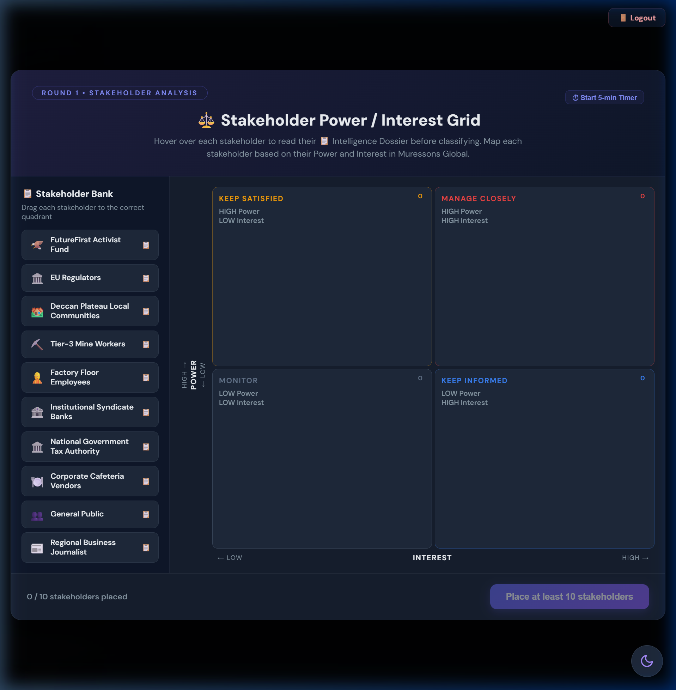
Figure: Stakeholder Map modal with stakeholder cards and quadrant grid

Strategic Options
Option | Title | Cost | Flag Set | Description & Impacts
A | Surface-Level Scan | $0 | electronics_blindspot | Fast compliance check. Electronics BU blind spots missed. +$500K revenue, -2 rep, +5 governance risk.
B | Deep Forensic Audit | -$3M | deep_audit_completed | Full forensic audit across all units. -$200K revenue, +5 rep, -5 governance risk, -5 CI.
C | Phased Audit Rollout | -$1.5M | deferred_audit | Audit Pharma and CG now; defer Electronics and Software. +2 rep, -2 CI. Partial blind spots remain.

Hidden Mechanics (DO NOT REVEAL)
🚫 DO NOT REVEAL: electronics_blindspot flag DOUBLES R4 crisis severity from 40→80 via contagion sigmoid. This is the simulation's most consequential hidden mechanic.

Theory Connection
Mendelow (1991) Stakeholder Mapping; Real Options Theory — the audit is an option on future crisis mitigation (5× NPV); Signalling Theory — market interprets audit depth as governance quality signal.

Debrief Prompts
- What information did you have when making this decision? What was unknown?
- How did you weigh cost vs. risk? What mental model drove your choice?
- If you chose the Surface Scan, what would you have paid to know the consequences?
- How does this mirror real-world ESG audit decisions?

Common Pitfall
⚠️ IMPORTANT: Students choose Surface Scan to 'save money'. They discover at R4 that the $3M audit would have prevented $15M+ in cascade damage.

Round 2: Double Materiality — The CSRD Acid Test

Player Briefing (On-Screen Text)
📊 The CFO requires all investment proposals to demonstrate alignment with the High Financial Impact / High ESG Impact quadrant per the Double Materiality framework. Non-aligned spending triggers a 40% budget clawback.

Pre-Decision Gate
CSRD Materiality Matrix (2×2 drag-and-drop): Players classify 8 sustainability issues into Financial Impact × ESG Impact quadrants. Accuracy >90% earns a $2M treasury bonus.

Figure: CSRD Materiality Matrix with Q1–Q4 quadrants

Strategic Options
Option | Title | Cost | Flag Set | Description & Impacts
A | Full Materiality Alignment | -$2.5M | materiality_aligned | Genuine CSRD compliance with assurance-ready report. +5 rep, -5 gov risk, +0.10 M_R at terminal. In Advanced Climate: NCD forgiveness +25%.
B | Strategic Exceptions | $0 | materiality_exceptions | Limited off-quadrant spending with CFO approval. +2 rep, -2 gov risk. Partial compliance.
C | CEO-Only Sign-Off | $0 (+$400K) | materiality_ignored | CEO approves without board oversight. ESRS 1 §1.51 violation. 40% budget clawback, -5 rep, +10 gov risk. Blocks Green Bond eligibility.

Hidden Mechanics (DO NOT REVEAL)
🚫 DO NOT REVEAL: Option C triggers a 40% clawback on all materiality capital released this round. Green Bond access blocked for remainder. materiality_aligned flag adds +0.10 M_R at terminal.

Theory Connection
EU CSRD/ESRS Standards; Double Materiality (financial + impact); Legitimacy Theory — ESRS compliance signals institutional legitimacy; Agency Theory — CEO-only sign-off bypasses board oversight (Jensen & Meckling 1976).

Debrief Prompts
- How did you balance financial materiality vs. ESG impact materiality?
- What was the opportunity cost of full alignment?
- Did the CFO gate change how you allocated capital?
- How does CSRD compliance compare to voluntary ESG reporting?

Common Pitfall
⚠️ IMPORTANT: Students choose CEO-Only to 'save money' — the 40% clawback actually costs more than Full Alignment.

Round 3: Scope 3 Emissions — Supply Chain Decarbonisation

Player Briefing (On-Screen Text)
🏭 Regulators have signalled mandatory Scope 3 disclosures. Your supply chain carbon footprint is 4× your direct emissions. The Fog of War clears after this round — all hidden engines become progressively visible.

Strategic Options
Option | Title | Cost | Flag Set | Description & Impacts
A | Rapid Supplier Switch | -$4M | early_decarboniser | Immediately switch to low-carbon suppliers. -15 CI, -$800K revenue, +3 rep. Sets early_decarboniser flag (+0.15 M_R). Supply chain disruption risk.
B | Green Bond Investment | -$2M | green_bond_active | Issue green bond to fund supplier transition. -8 CI, -15 NCD, +$300K revenue, +4 rep. NCD reduction over 3 rounds.
C | Offset & Defer | -$1M | carbon_deferred | Buy carbon offsets and wait. +5 NCD (compounds at 6%!), -3 rep, -1 CI. Short-term savings, long-term ecological debt.

Hidden Mechanics (DO NOT REVEAL)
🚫 DO NOT REVEAL: NCD compounds at 6%/round. The +5 NCD from Option C becomes +7.5 by R10, costing ~$1.9M in terminal value. early_decarboniser flag unlocks +0.15 M_R and amplifies R7 circular economy returns.

Theory Connection
GHG Protocol Scope 3; First-Mover Advantage (Lieberman & Montgomery 1988); Natural Capital accounting (Costanza 1997); Signalling Theory — Green Bond signals commitment to capital markets.

Debrief Prompts
- How did you evaluate the trade-off between immediate cost and future NCD growth?
- What is the NPV of avoiding 6% compound NCD growth for 7 rounds?
- How does Scope 3 reporting change your view of 'company boundaries'?

Common Pitfall
⚠️ IMPORTANT: Students underestimate NCD compounding. +5 NCD in R3 seems small but compounds to $1.9M terminal value loss.

Round 4: Contagion — The R1 Reckoning

Player Briefing (On-Screen Text)
🔥 A labour-rights exposé in your Electronics supply chain has gone viral. The contagion engine will propagate reputational damage across all BUs. Crisis severity depends on your Round 1 audit decision.
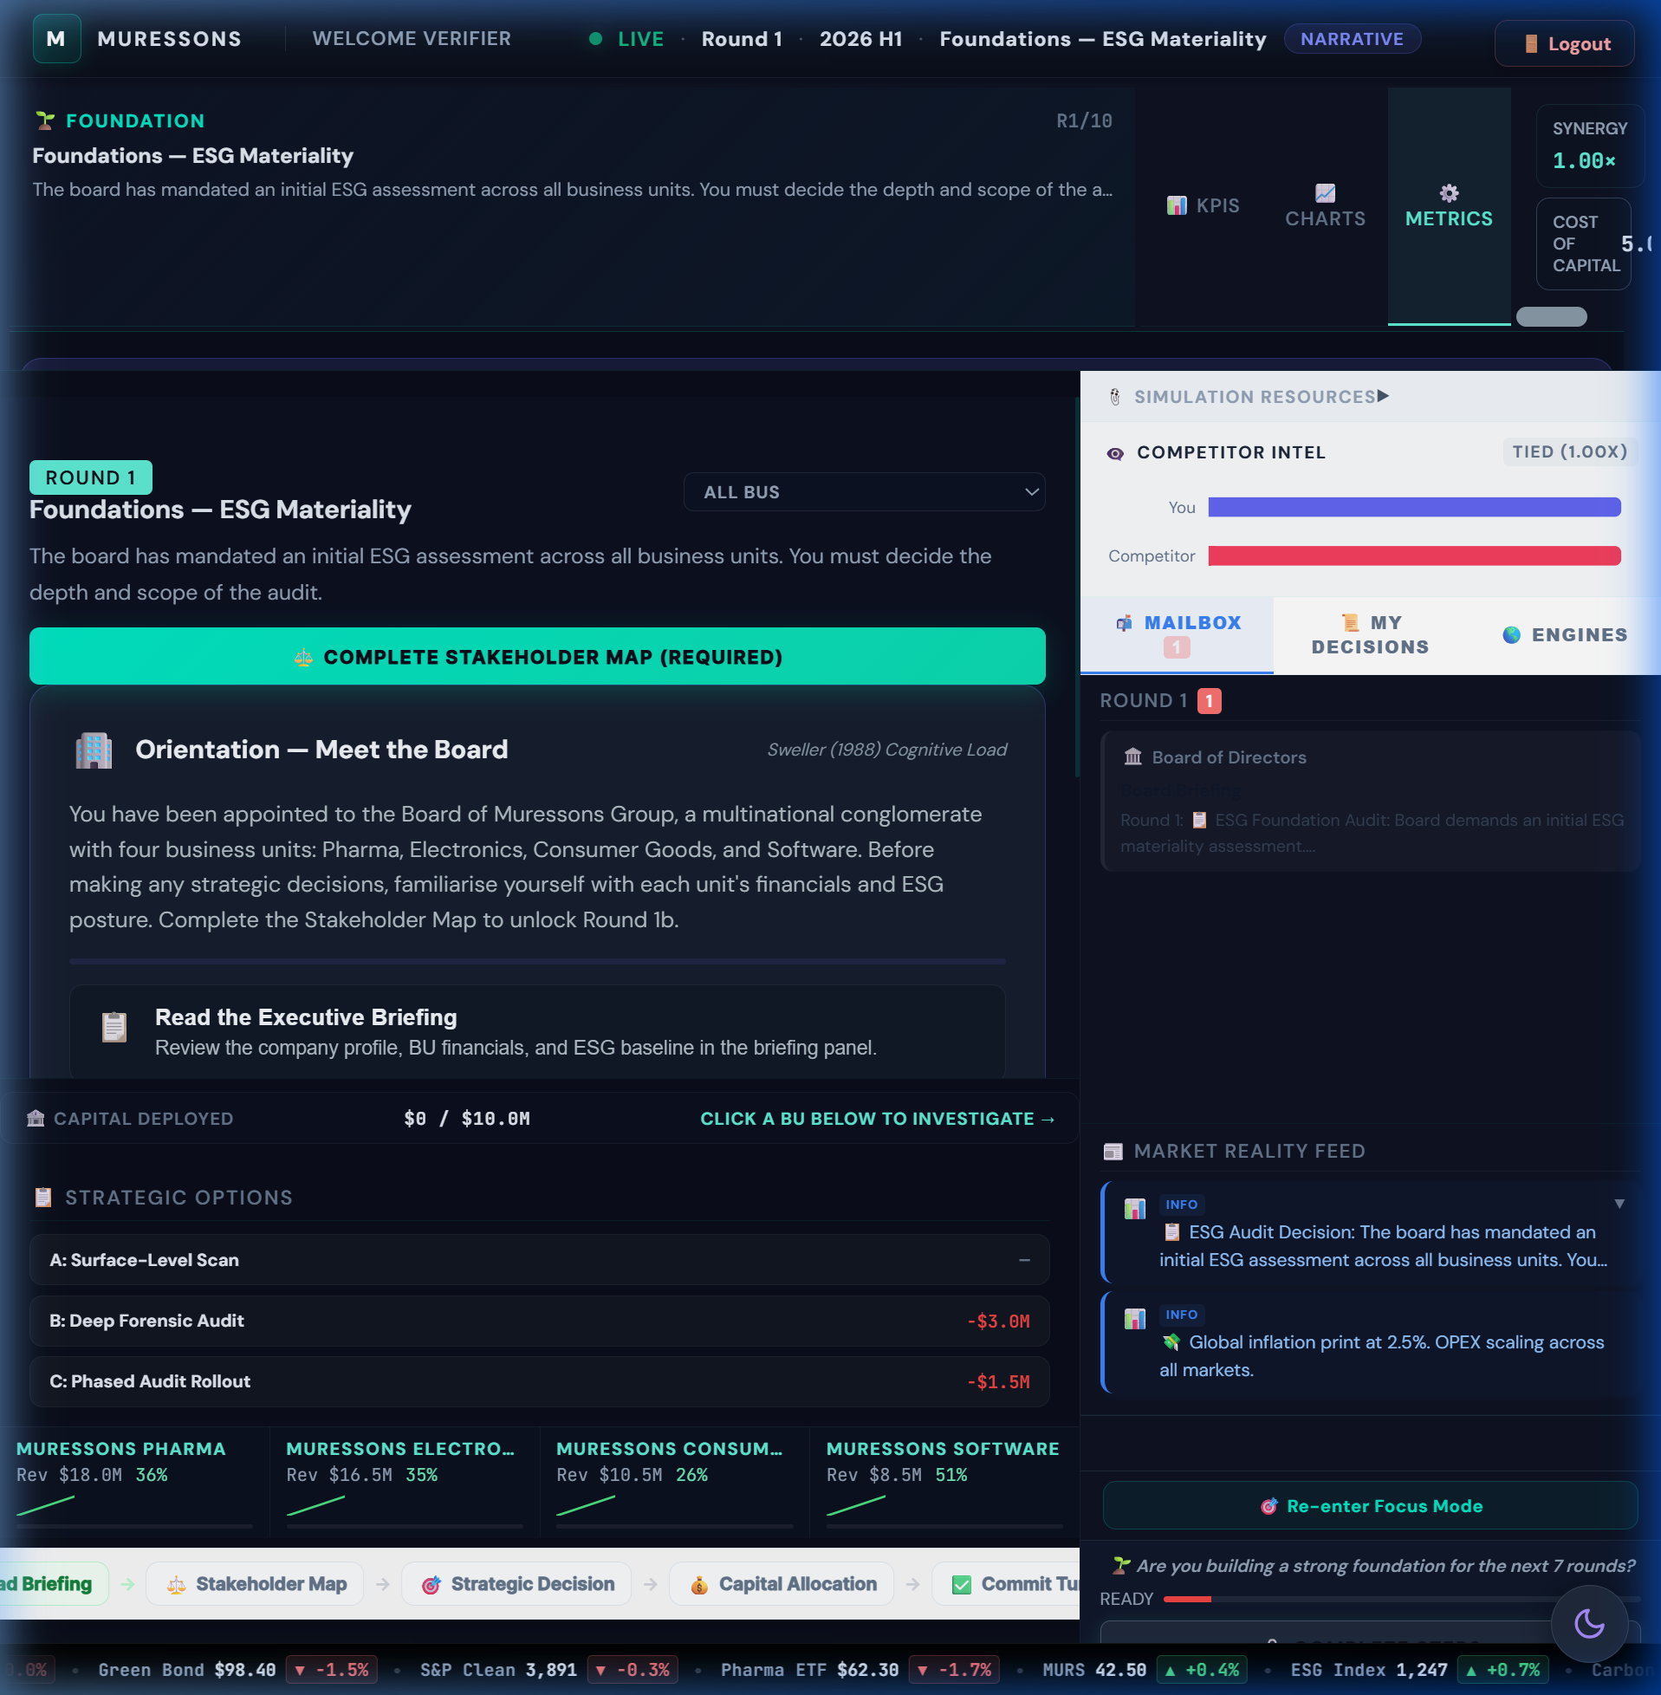
Figure: Consequence DNA panel showing R1→R4 causal chain

Strategic Options
Option | Title | Cost | Flag Set | Description & Impacts
A | Full Transparency & Remediation | -$6M | remediation_active | Public disclosure, factory audits, worker compensation. +10 rep, +8 social licence. Sets remediation_active (+0.10 M_R).
B | Damage Control PR | -$2M | pr_containment | Crisis PR firm. +2 rep, -3 social licence. Narrative contained but root cause unfixed.
C | Deny & Deflect | $0 | deny_and_deflect | Issue denial. -15 rep, -10 social licence, +8 gov risk, +5 NCD. Cheapest but highest contagion risk.

Hidden Mechanics (DO NOT REVEAL)
🚫 DO NOT REVEAL: Severity = 40 (deep audit) / 60 (deferred) / 80 (blindspot). Contagion uses sigmoid: hit = max × 1/(1+e^(-s/scale)). Blindspot teams lose ~19 reputation vs. ~12 for audited teams. Board Room Moment triggers if rep < 40.

Theory Connection
Argyris (1977) Double-Loop Learning — players must question R1 assumptions; Kahneman (2011) System 1/2 — time pressure reveals heuristic biases; Taleb (2012) Antifragility — audited teams are antifragile, gaining from the crisis.

Debrief Prompts
- ★ KEY DEBRIEF: Ask teams to reveal their R1 choice. Compare R4 outcomes.
- What was the NPV of the R1 audit decision? (Answer: ~5× the $3M cost)
- When did you realize R1 had consequences? What assumption broke?
- How does this mirror real-world supply chain scandals?
- What would Argyris say about your mental model update?

Common Pitfall
⚠️ IMPORTANT: Teams that chose Surface Scan face 2× severity. The $0 'savings' at R1 cost $15M+ in R4 damage.

Round 5: Climate — Physical Climate Risk & Shadow Board Audit

Player Briefing (On-Screen Text)
🌪️ A Category 4 cyclone is projected to hit your primary manufacturing corridor. Base damage: $12M. A stochastic roll (75% probability) determines actual impact. Before deciding, you must complete the mandatory Shadow Board Audit.

Pre-Decision Gate
Mandatory Shadow Board Audit: 3 independent personas (Shareholder, Community Leader, Environmental Scientist) evaluate your strategy. Rejecting their advice sets hidden flags that cascade to R10 ending pathways. See §5 for deep dive.
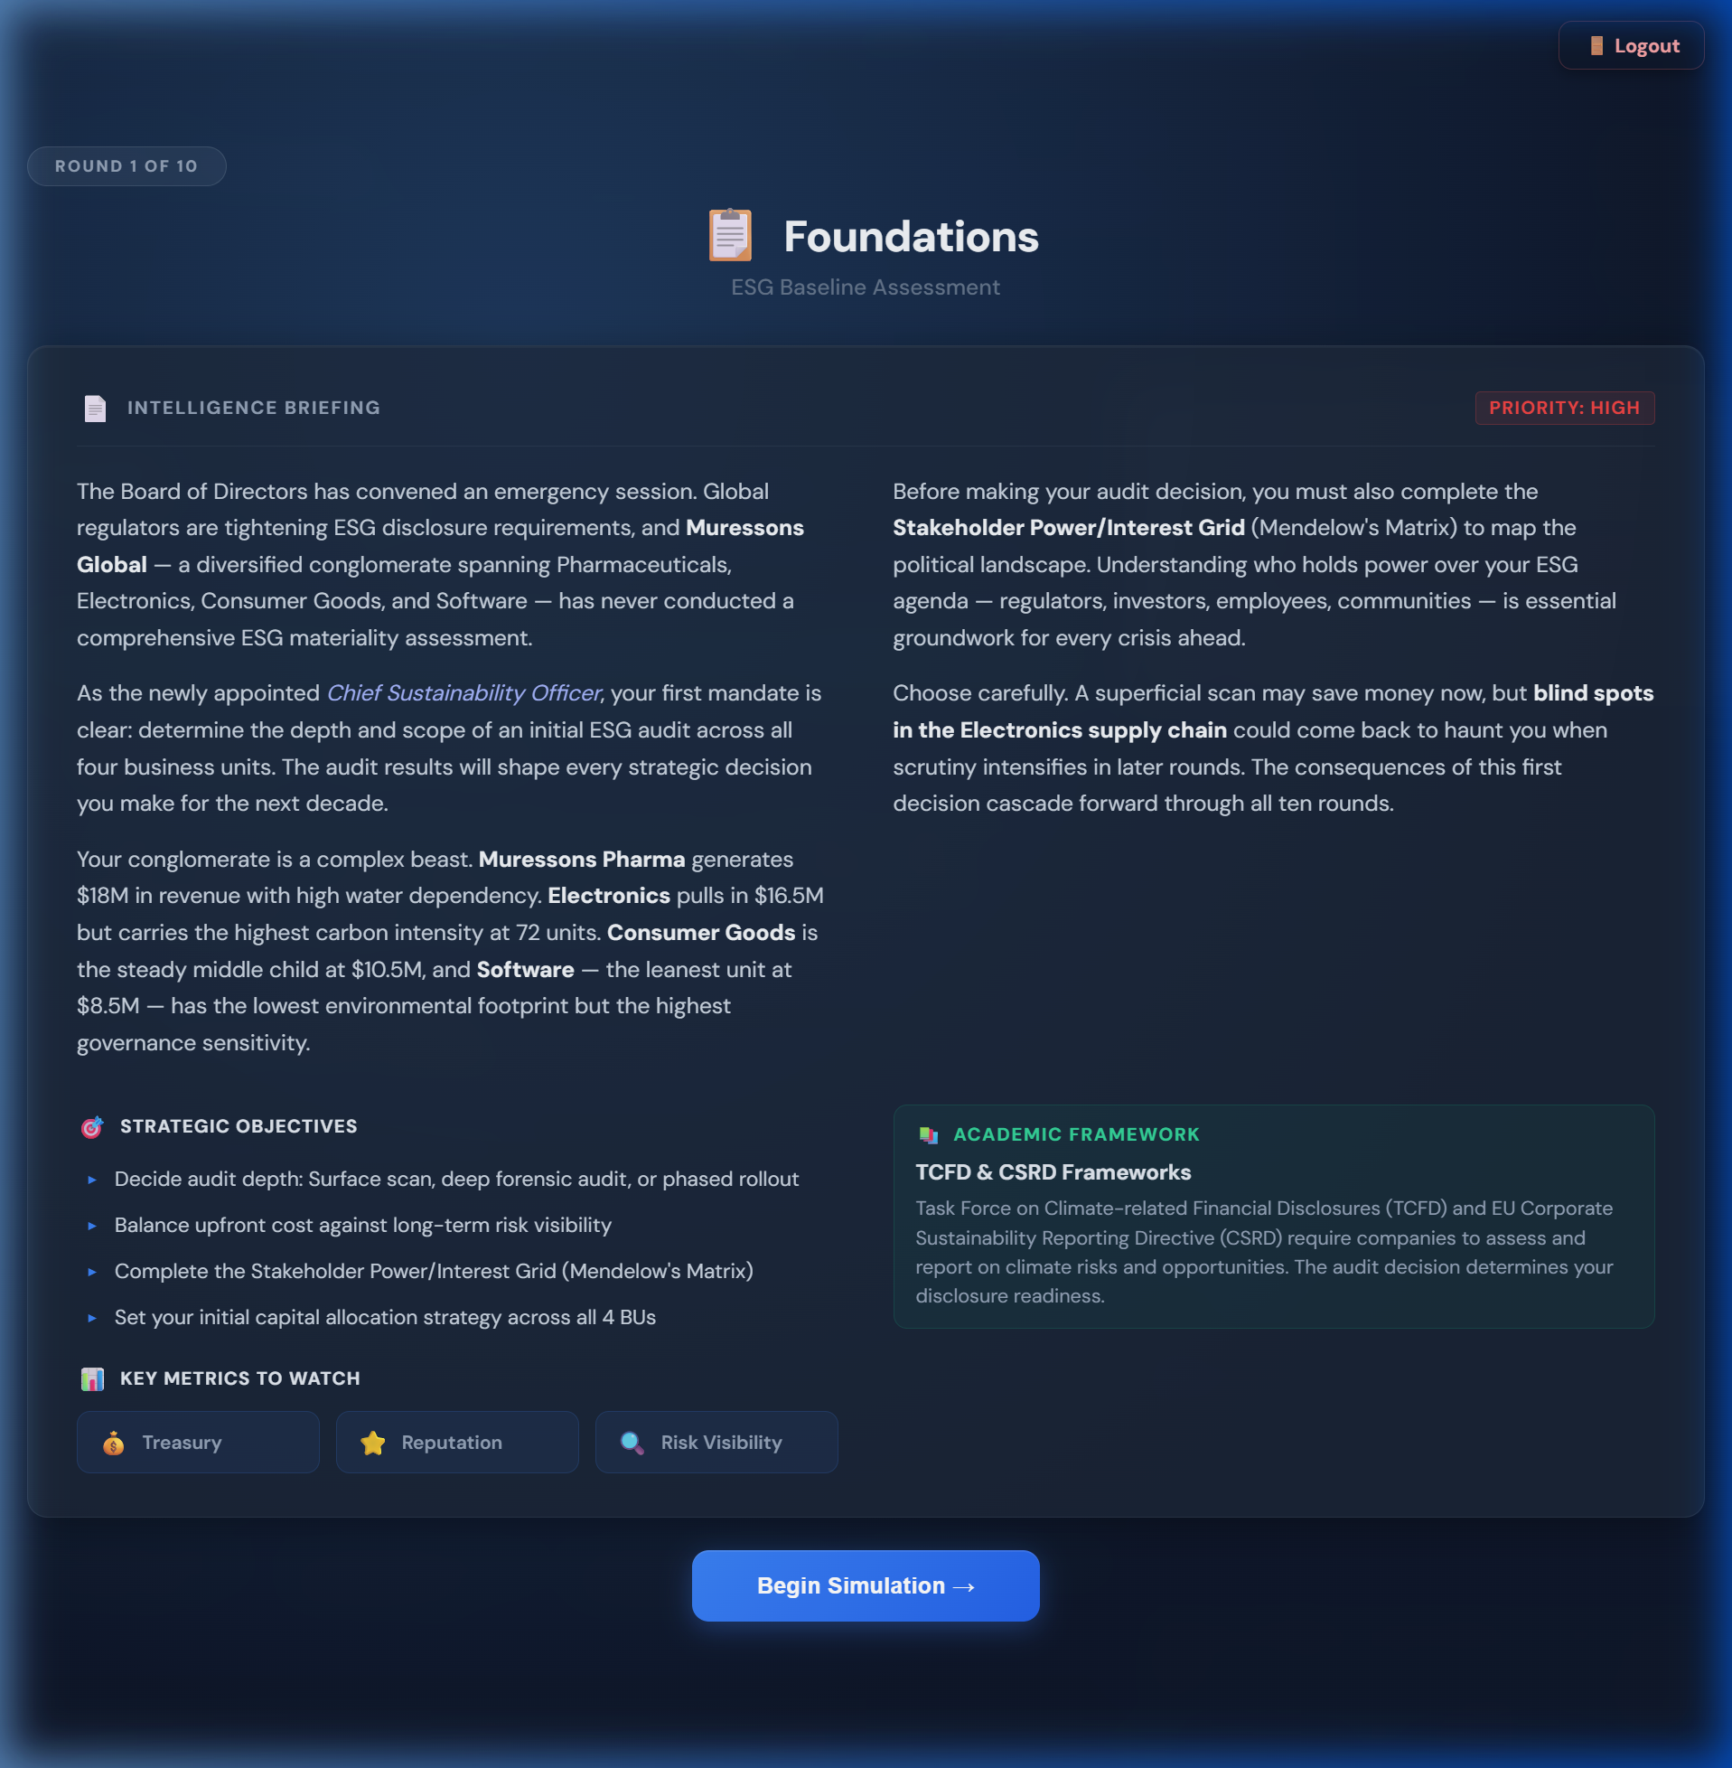
Figure: Shadow Board Audit modal with 3 persona cards

Strategic Options
Option | Title | Cost | Flag Set | Description & Impacts
A | Hard Engineering Defence | -$8M | hard_engineering | Flood walls and reinforced infrastructure. Resilience 0.85 but NO PROTECTION THIS ROUND (2-round build). +10 NCD, +3 CI. Climate tipping point risk.
B | Nature-Based Solutions | -$5M | nature_based_resilience | Mangrove restoration and natural buffers. Resilience 0.60, 2-round maturation. -8 NCD, -6 CI, +6 rep. Unlocks Resilience Champion (+0.20 M_R).
C | Insurance Only | -$2M | insurance_only | Comprehensive insurance. ZERO physical resilience. Full damage if cyclone strikes. ⚠️ BLOCKS Resilience Bonus (-0.20 M_R at terminal).

Hidden Mechanics (DO NOT REVEAL)
🚫 DO NOT REVEAL: 75% cyclone probability triggers $12M×(1-resilience_factor) damage. Shadow Board rejection sets shareholder_alienated, community_distrust, or scientist_dismissed flags that determine R10 ending pathway. insurance_only permanently blocks +0.20 M_R.

Theory Connection
TCFD Physical Risk Assessment; Moon (2004) Board Room Moments; Mitchell et al. (1997) Stakeholder Salience; Schön (1983) Reflection-in-Action; Agency Theory (Shadow Board = independent oversight).

Debrief Prompts
- How did the Shadow Board audit influence your decision?
- What trade-off exists between hard engineering and nature-based solutions?
- What does 'resilience' mean beyond infrastructure?
- Did the stochastic element (75% cyclone) change your risk calculus?

Common Pitfall
⚠️ IMPORTANT: Students choose Insurance Only to save money — permanently losing +0.20 M_R (worth ~$30M in terminal value).

Round 6: AI Bias — Algorithmic Ethics & the Truth Premium

Player Briefing (On-Screen Text)
🤖 Your Software BU's AI recruitment tool has been found to systematically discriminate against minority applicants. The story has reached mainstream media. A whistleblower may escalate the story further.

Strategic Options
Option | Title | Cost | Flag Set | Description & Impacts
A | Monetise the Algorithm | +$10M revenue | ai_monetised | Pivot AI tool into commercial product. +$10M revenue but -20 rep, -15 social licence, +8 gov risk. Contagion spike. High short-term return, devastating long-term.
B | Ethical AI Overhaul | -$8M | ethical_ai_overhaul | Shut down tool, hire ethics board, retrain models. +15 social licence, +5 rep, -5 gov risk. Sets Truth Premium (+0.15 M_R).
C | Quiet Patch | -$1M | quiet_patch | Silently fix algorithm. -5 rep, +10 gov risk. 40% chance of whistleblower leak (Streisand Effect) → Legal Containment micro-decision.

Hidden Mechanics (DO NOT REVEAL)
🚫 DO NOT REVEAL: R6 Revelation Mechanic: After decision, a whistleblower twist presents 3 micro-responses (Transparent Disclosure / Legal Containment / Quiet Settlement). Legal Containment has 40% backfire probability. Stakeholder migration: Local Communities move to 'Manage Closely' quadrant.

Theory Connection
Moral Hazard — monetising bias creates perverse incentives; Institutional Theory — AI ethics as institutional norm; Virtue Ethics — character-based evaluation of tech decisions; Prospect Theory — loss aversion in reputation damage.

Debrief Prompts
- What is the 'Truth Premium' and why does it have terminal value?
- How did the 40% backfire probability affect your risk assessment?
- What real-world AI bias scandals does this mirror?
- Is there a moral difference between fixing quietly and fixing publicly?

Common Pitfall
⚠️ IMPORTANT: Teams monetise the algorithm for +$10M revenue but lose $40M+ in terminal value from reputation collapse and missing M_R bonuses.

Round 7: Circularity — Synergy Unlock & Workforce Readiness Test

Player Briefing (On-Screen Text)
♻️ New EU circular economy regulations mandate 60% waste diversion by next year. Non-compliance fines: $15M. This round uses the Budget Allocation mechanic — you must distribute $15M across 3 investment pillars.
Figure: Advanced Metrics drawer showing Synergy Multiplier

Strategic Options
Option | Title | Cost | Flag Set | Description & Impacts
A | Full Circular Redesign | -$10M | circular_redesign | Redesign products for full disassembly and reuse. -12 NCD, +8 rep, -8 CI, +$1M revenue. Workforce readiness gate applies.
B | Extended Producer Responsibility | -$5M | epr_program | Fund take-back programs and recycling partnerships. -6 NCD, +4 rep, -5 CI.
C | Waste-to-Energy Partnership | -$7M | waste_to_energy + synergy_unlock | Build waste-to-energy facility. Synergy multiplier +0.30, -4 NCD, -6 CI. Unlocks +0.30 M_R at terminal.

Hidden Mechanics (DO NOT REVEAL)
🚫 DO NOT REVEAL: Workforce Readiness gate: WR<40 → 30% penalty on circular benefits; WR≥60 → 10% amplification. Teams that invested in HR across R1-R6 are rewarded here. Pillar mutual exclusivity applies — can't max all three.

Theory Connection
Resource-Based View (Barney 1991) — VRIO advantage from circular capabilities; Dynamic Capabilities (Teece 2007) — workforce readiness as adaptive capacity; Learning Organisation (Senge 1990) — system loop identification.

Debrief Prompts
- How did the workforce readiness gate affect your circular economy returns?
- What is the relationship between human capital investment and technology adoption?
- Which option creates the most durable competitive advantage? (RBV analysis)

Common Pitfall
⚠️ IMPORTANT: Teams with low workforce readiness (<40) lose 30% of their circular investment returns — HR neglect compounds here.

Round 8: Blue Stress — Water Scarcity & Equitable Resource Allocation

Player Briefing (On-Screen Text)
🌊 A multi-year drought has depleted the watershed serving Pharma and Electronics. Government water rationing is imminent. You must choose how to allocate diminishing water resources across your business units.

Pre-Decision Gate
Stakeholder Tribunal: 3 stakeholder challenges (Community Leader, Regulator, Journalist), 90 seconds each. Players must defend their water allocation strategy under time pressure.

Strategic Options
Option | Title | Cost | Flag Set | Description & Impacts
A | Water Efficiency for All BUs | -$12M | water_efficiency_all | Equitable water-saving upgrades across all units. -20 water dependency, +5 social licence, +5 rep, -3 CI.
B | Prioritise Electronics | -$4M | electronics_water_priority | Divert water to Electronics (highest margin). Pharma and CG take -25 social licence each. -8 rep. Maladaptation framing.
C | Desalination Mega-Project | -$30M | desalination_built | Build desalination plant. -30 NCD, -40 water dep, but +5 CI (energy-intensive). $5M/round revenue from R10 for 3 rounds. 2-round construction delay.

Hidden Mechanics (DO NOT REVEAL)
🚫 DO NOT REVEAL: Cascade Multiplier: Regulatory Sandbox × Journalist tolerance. If journalist agent is already hostile, Prioritise Electronics triggers viral exposé. Community Leader agent enters 'protest' state at SLO < 30.

Theory Connection
Tragedy of the Commons (Hardin 1968); Environmental Justice (Schlosberg 2007); Natural Capital (Costanza 1997); Ostrom (1990) — commons governance instruments in regulatory sandbox.

Debrief Prompts
- Is prioritising the highest-margin BU 'rational'? From whose perspective?
- How does the Tragedy of the Commons apply to corporate water use?
- What would Ostrom's principles suggest for water governance?
- How did the Stakeholder Tribunal change your thinking?

Common Pitfall
⚠️ IMPORTANT: Prioritise Electronics saves $8M short-term but costs $25M+ from social licence collapse, agent cascades, and terminal value penalties.

Round 9: Just Transition — The Social Cost of Decarbonisation

Player Briefing (On-Screen Text)
✊ Decarbonisation commitments require closing 3 legacy factories. 2,000 jobs are at risk. Community protests are escalating. If burnout is high and social licence is low, strike probability reaches 50-75%.

Strategic Options
Option | Title | Cost | Flag Set | Description & Impacts
A | Immediate Closure | +$5M | immediate_closure | Close factories now for cost savings. -20 social licence, -15 rep. If SLO < threshold: 50-75% strike probability that ZEROS revenue for 1 round.
B | Managed Transition | -$12M | managed_transition | 2-year phase-out with retraining and severance. +10 social licence, +8 rep, -4 CI. Sets managed_transition (+0.12 M_R).
C | Community Investment Fund | -$20M | community_fund | Create $20M fund for community development and green jobs. +18 social licence, +12 rep, -5 gov risk. Sets community_fund (+0.18 M_R).

Hidden Mechanics (DO NOT REVEAL)
🚫 DO NOT REVEAL: Strike probability = base_rate × (burnout/100) × (1 - SLO/100). Teams with burnout >60% and SLO <40 face 66%+ strike chance. Strike zeros ALL revenue for 1 round — catastrophic for terminal value. HR investment across R1-R8 is the primary defence.

Theory Connection
Rawlsian Justice — Difference Principle applied to factory closures; Freeman Stakeholder Theory — who bears transition costs?; Sen Capabilities Approach — green job training expands capabilities; Hirschman Exit/Voice/Loyalty — community response to closure.

Debrief Prompts
- Who bears the cost of decarbonisation? Is that just?
- What would Rawls say about your approach to factory closures?
- How did your HR investment history affect your R9 options?
- What is the ROI of the Community Fund in M_R terms?
- How does this mirror real-world Just Transition debates?

Common Pitfall
⚠️ IMPORTANT: Teams that neglected HR for 8 rounds face impossible R9: high burnout + low SLO = near-certain strike. The 'cheapest' option (+$5M) can cost $50M+ in zeroed revenue.

Round 10: Grand Finale — Year 5 Activist Ultimatum & Terminal Valuation

Player Briefing (On-Screen Text)
🏛️ An activist investor consortium has acquired a blocking stake. They demand strategic restructuring. The board must decide the company's Year 5 trajectory. Terminal valuation determines your final score.

Pre-Decision Gate
Synergy Gate: Option A (Resist & Integrate) is DISABLED if Synergy Score ≤ 80. Teams that under-invested in cross-BU integration lose access to the highest-value option.
Figure: Final Report showing terminal valuation breakdown and archetype

Strategic Options
Option | Title | Cost | Flag Set | Description & Impacts
A | Resist & Integrate | -$5M | resist_integrate | Fight the activist, keep all BUs integrated, leverage synergy. REQUIRES Synergy > 80. +5 rep, +3 social licence, -3 gov risk, -3 CI.
B | Spin-Off | +$10M | spinoff | Spin off weakest BU as separate entity. +$10M treasury, +2 rep, -5 social licence, +3 gov risk.
C | Divest | +$25M | divest | Full divestiture of non-core assets. Synergy WIPED to 0. -10 rep, -12 social licence, +5 gov risk, +8 NCD. Maximum cash extraction.

Hidden Mechanics (DO NOT REVEAL)
🚫 DO NOT REVEAL: M_R is calculated from all accumulated flags across R1-R9. Archetype classification: Regenerative Titan (M_R ≥ 1.8), De-risked Safe Haven (≥ 1.2), Fragile Giant (≥ 0.8), Stranded Relic (< 0.8). Ending pathway modifies archetype names.

Theory Connection
Porter CSV — shared value creation as strategy; Kolb Experiential Learning — full cycle completion; Meadows Leverage Points — debrief reveals system intervention hierarchy; Thiagarajan Debrief Protocol — 3-phase structured reflection.

Debrief Prompts
- Compare terminal values across teams. What explains the 25× gap between Titans and Relics?
- Walk through your M_R breakdown. Which bonuses did you earn? Which did you miss?
- If you could replay with perfect information, what single decision would you change?
- What transferable principle would you take to a real boardroom?
- How does your R1 mental model compare to your R10 understanding?

Common Pitfall
⚠️ IMPORTANT: Teams choose Divest for +$25M cash but wipe synergy to 0, losing far more in terminal value multiplication.

PART 3 — ADVANCED SYSTEMS

§5. The Shadow Board Audit — Deep Dive

5.1 Overview
The Shadow Board Audit is a mandatory interception at Round 5. Three independent personas evaluate the player's strategy and offer recommendations. Players may accept or reject each persona's advice. Rejections set hidden flags that cascade to R10 ending pathways.
Figure: Shadow Board Audit modal with 3 persona cards

5.2 Persona Profiles
Persona | Name | Title | Monitored Metric | Rejection Flag
Shareholder | Victoria Chen | Independent NED, Corporate Governance Institute | Governance Risk | shareholder_alienated
Community Leader | Amara Okafor | Director, Global Justice Alliance | Social License | community_distrust
Environmental Scientist | Dr. Kenji Tanaka | Lead Author, IPCC AR7 Working Group | Carbon Intensity | scientist_dismissed

5.3 Rejection Mechanics
Each rejection sets a hidden flag with cascading consequences:
- shareholder_alienated → Activates Activist Ultimatum ending pathway; -10 tolerance on Activist Investor agent; Governance Risk penalty at R10.
- community_distrust → Activates Community Uprising pathway variant; Community Leader agent enters hostile state; Social License floor drops by 10.
- scientist_dismissed → Activates Climate Black Swan pathway; Carbon tax increase at R10; Scientist agent triggers environmental exposé.
🚫 DO NOT REVEAL: Shadow Board rejections are IRREVERSIBLE. The flags persist through R10 and directly determine which ending pathway activates.

5.4 Facilitation Script
BEFORE the audit: "You are about to receive feedback from three independent board advisors. Each will evaluate your strategy from their expertise. You may accept or reject their advice — but your response will have consequences."
AFTER the audit (debrief): "The Shadow Board represented three dimensions of stakeholder governance. Rejection of expertise signals a governance failure — a pattern we see in real-world corporate crises from Boeing to Volkswagen."

§6. Ending Pathways

6.1 Pathway Overview
ID | Pathway | Trigger Condition | R10 Crisis Theme
default | Activist Ultimatum | Default (or shareholder_alienated) | Activist investor blocking stake
climate_black_swan | Climate Black Swan | scientist_dismissed flag | IPCC special report triggers carbon price shock
regulatory_shutdown | Regulatory Shutdown | governance_risk > 60 at R8 | EU regulatory enforcement action
community_uprising | Community Uprising | community_distrust + SLO < 40 | Multi-city protests and supply chain blockade
market_disruption | Market Disruption | technology vertical + low innovation | Disruptive competitor captures 40% market share

6.2 Foreshadowing Events
Each pathway plants foreshadowing news items in the Market Feed between R5-R8. These subtle signals allow attentive players to anticipate the R10 crisis:
Figure: Market Feed showing foreshadowing news item
- Activist Ultimatum: R6 — "FutureFirst Fund increases Muressons stake to 4.8%"; R8 — "Activist consortium reportedly near blocking threshold"
- Climate Black Swan: R6 — "IPCC fast-tracks special report on industrial emissions"; R7 — "EU carbon border adjustment negotiations accelerate"
- Regulatory Shutdown: R6 — "DG FISMA opens preliminary governance review"; R8 — "Commissioner Petrova signals enforcement action"

6.3 Pathway-Specific M_R Calculators
Each pathway has a custom M_R bonus calculator that replaces or supplements the default formula:
- Activist Ultimatum: SAE (Stakeholder Alignment Efficiency) = weighted score across all agent tolerances
- Climate Black Swan: CRI (Climate Risk Index) = CI reduction × nature-based investment / carbon tax exposure
- Regulatory Shutdown: GCI (Governance Compliance Index) = governance risk reduction × disclosure quality
- Community Uprising: SCI (Social Cohesion Index) = SLO × just transition investment / community grievances

§7. Terminal Valuation Deep Dive

7.1 Full Formula
TV = (EBITDA - Carbon_Tax × CO₂_Tonnage) × Exit_Multiple × M_R

7.2 Worked Examples
Scenario | EBITDA | Carbon Cost | Net | Multiple | M_R | Terminal Value
Regenerative Titan | $12.5M | $2.1M | $10.4M | 12.0× | 1.85 | ~$230M
De-risked Safe Haven | $10.0M | $3.5M | $6.5M | 12.0× | 1.30 | ~$101M
Fragile Giant | $8.0M | $5.0M | $3.0M | 12.0× | 0.90 | ~$32M
Stranded Relic | $5.0M | $6.0M | -$1.0M | 12.0× | 0.60 | ~-$7.2M

💡 TIP: The spread between Titan ($230M) and Relic (-$7.2M) is the core teaching moment. A 25× gap driven entirely by strategic decisions across 10 rounds.

7.3 Carbon Tax Impact
Tax Rate | Low CI Team (15 avg) | Mid CI Team (40 avg) | High CI Team (70 avg)
$250/ton | -$0.9M | -$2.5M | -$4.4M
$350/ton | -$1.3M | -$3.5M | -$6.1M
$750/ton | -$2.8M | -$7.5M | -$13.1M

7.4 Archetype Classification
Archetype | M_R Range | Description
Regenerative Titan | ≥ 1.80 | Industry leader in sustainable value creation. ESG-integrated strategy generates premium returns.
De-risked Safe Haven | 1.20 – 1.79 | Solid ESG performance with moderate innovation. Attractive to institutional investors.
Fragile Giant | 0.80 – 1.19 | Financially adequate but systemically vulnerable. ESG gaps create hidden risk exposure.
Stranded Relic | < 0.80 | Terminal decline. Stranded assets, regulatory exposure, and stakeholder revolt make recovery unlikely.

Figure: Final Report with terminal valuation breakdown and archetype badge
Figure: Sustainability Balanced Scorecard with M_R breakdown table

§8. Side Tracks

8.1 Architecture Overview
Side tracks are optional enrichment modules that run parallel to the main 10-round loop. Each track has its own scoring dimensions, data bridges to the main simulation, and facilitator assignment controls.
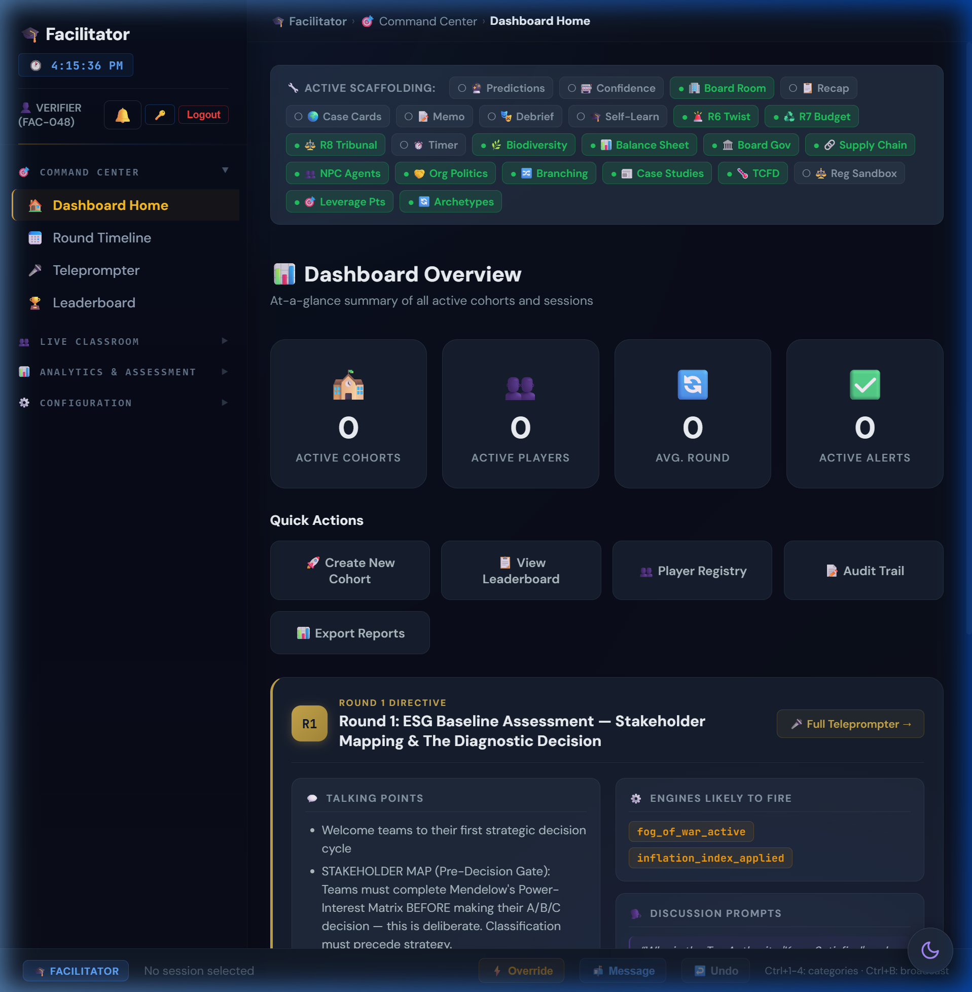
Figure: Facilitator Dashboard side track assignment panel

8.2 Track Catalog
Track | Rounds | Scoring Dimensions | Main Sim Integration
Supply Chain Ethics | 7 rounds | Transparency, Labour, Environment, Governance, Innovation, Community, Compliance | Tyler Consumer Trust Index feeds reputation; disruption score affects OPEX
Ethics & Sustainability | 5 rounds | Ethical reasoning, stakeholder analysis, regulatory awareness | Ethics score modifies governance risk; framework mastery unlocks M_R micro-bonus
Stakeholder Management | 5 rounds | Engagement quality, stakeholder satisfaction, communication | Stakeholder scores modify agent tolerance levels
Sustainability Reporting | 5 rounds | ESRS compliance, data quality, materiality accuracy | Reporting score modifies Green Bond eligibility and investor confidence

8.3 Supply Chain Deep Dive
The Supply Chain Ethics track is the most complex side track, running for 7 rounds with a 7-dimension weighted composite score. Each round presents an ethical dilemma in supply chain management.
Tyler Consumer Trust Index (CTI): A composite metric that bridges supply chain transparency decisions back to the main simulation, affecting group reputation and consumer confidence in the Consumer Goods BU.

§9. Autonomous Stakeholder Agents

9.1 System Overview
Five autonomous NPC stakeholders monitor simulation metrics independently and react based on satisfaction thresholds. They escalate through 4 lifecycle states: Supportive → Concerned → Hostile → Adversarial.
Figure: Autonomous Stakeholders panel showing agent states

9.2 Agent Profiles
Agent | Name | Icon | Monitored Metrics | Escalation Trigger
Activist Investor | Elise Thornton | 🦅 | Reputation, Carbon Intensity, Governance | Rep < 40 → Public Campaign; < 30 → Proxy Fight
EU Regulator | Commissioner Sofia Petrova | 🏛️ | Governance Risk, TNFD Disclosure | Gov Risk > 60 → Investigation; Greenwashing → Enforcement
Community Leader | Rajesh Patil | 🏘️ | Social License, Water Stress, Just Transition Fund | SLO < 40 → Protest; Water Stress > 60 → Legal Action
Journalist | Jaya Mehta | 📰 | Transparency, Reputation, Governance | Rep drop > 10 → Investigation; Greenwash → Exposé

9.3 Cascade Chain Analysis
When one agent enters hostile state, it can trigger cascades to other agents:
- Journalist hostile → -5 rep → triggers Activist Investor escalation → may trigger Regulator investigation
- Community Leader protest → -3 reputation → Journalist investigation → viral story → Activist response
- Regulator enforcement → €5-25M fine → treasury hit → triggers all agents to reassess satisfaction
⚠️ IMPORTANT: Total Corporate Collapse: If ALL 4 agents reach adversarial state simultaneously, the simulation triggers a special game-over scenario. This is extremely rare but pedagogically powerful.

§10. Facilitator God Mode & Overrides
God Mode provides the Super Administrator with system-wide control over all simulation parameters. These tools should be used judiciously to enhance learning outcomes.
- Carbon Tax Override: Adjust $/ton in real-time ($250 default, range $0-$1000). Use to demonstrate carbon pricing impact on terminal value.
- Custom Archetypes: Define M_R thresholds, custom archetype names, icons, and gradient colours for each cohort.
- Pedagogical Toggles: 30+ feature flags controlling engine visibility, prediction gates, timer pressure, peer learning, board governance, etc.
- Ending Pathway Selection: Pre-select a specific ending pathway or allow flag-based automatic selection.
- Industry Vertical Substitution: Replace default BUs with industry-specific alternatives (see §10C).
- What-If Mode: Terminal valuation predictor that shows projected outcomes based on hypothetical decisions.
- WebSocket Real-Time Interference: Live interventions pushed to all connected clients via WebSocket.
- Option Shuffle Engine: Anti-positional-bias system that randomizes A/B/C option order per session. Deterministic shuffle ensures reproducibility.
- Decision Timer: Configurable 3-10 minute countdown per round. Auto-submit or reputation penalty on expiry. Models real-world executive time pressure.

§10C. Industry Vertical Swapping Guide

10C.1 Overview
The simulation supports industry vertical substitution — replacing default BUs with industry-specific alternatives that share structural characteristics. This allows facilitators to tailor the simulation to cohort expertise (e.g., Oil & Gas for energy sector MBA students).
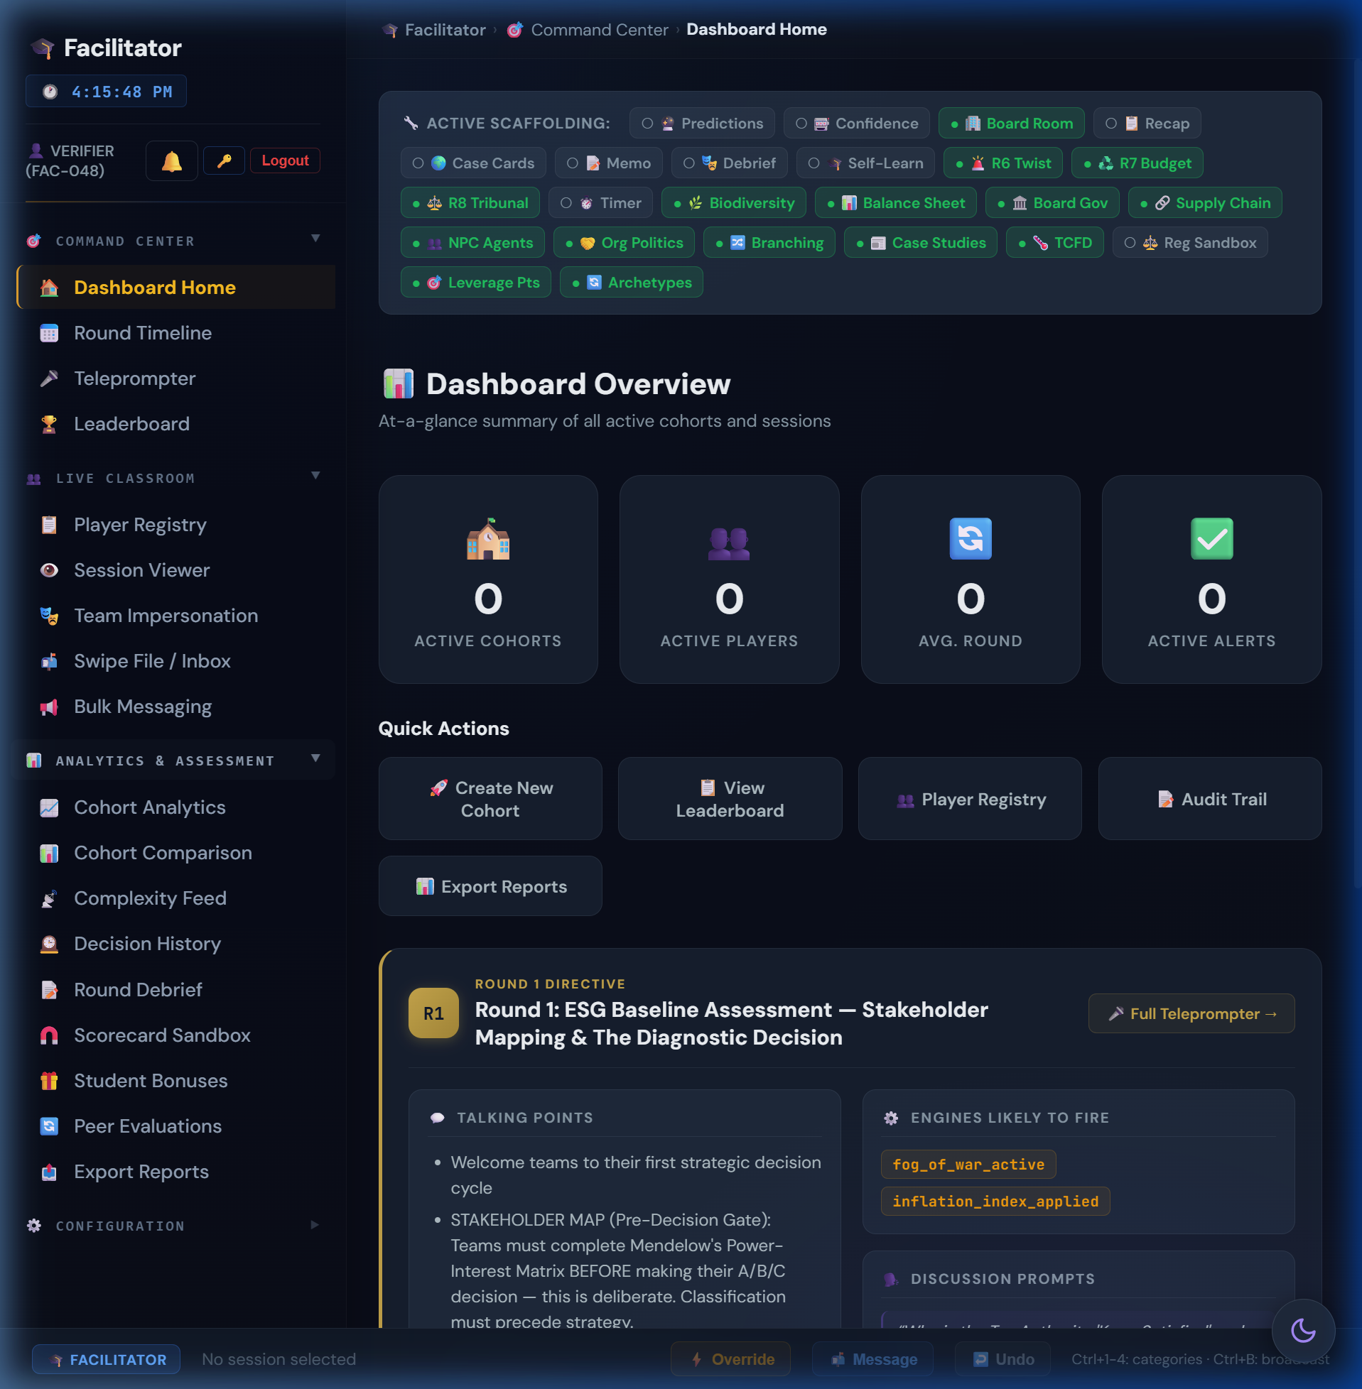
Figure: God Mode dashboard — Industry Vertical selector

10C.2 Slot-Fit Architecture
Each of the 4 default BU "slots" can only be replaced by verticals sharing industry characteristics (heavy/light, physical/digital):
Default Slot | Slot Characteristics | Compatible Verticals
Pharma 💊 | Heavy industry, physical assets, regulatory | Oil & Gas 🛢️
Electronics ⚡ | High carbon, complex supply chain | Oil & Gas 🛢️
Consumer Goods 🛒 | Supply chain, natural resources, packaging | Retail/FMCG 🛍️, Agriculture 🌾
Software 💻 | Asset-light, governance-heavy, talent-dependent | Banking & Financial Services 🏦, Technology 🧠

10C.3 Vertical Profiles
Vertical | Icon | Slot | Revenue | OPEX | CI | Water | NCD | Gov Risk | Description
Oil & Gas | 🛢️ | pharma/electronics | $22M | $15M | 95 | 70 | 350 | 20 | Extreme carbon, stranded asset risk
Banking & FS | 🏦 | software | $14M | $8M | 8 | 5 | 15 | 30 | High financed emissions, systemic risk
Retail/FMCG | 🛍️ | consumer_goods | $12M | $9M | 42 | 55 | 160 | 12 | Packaging waste, labour supply chains
Agriculture | 🌾 | consumer_goods | $9M | $6.5M | 55 | 90 | 280 | 15 | Extreme water dependency, biodiversity
Technology | 🧠 | software | $15M | $9M | 15 | 10 | 40 | 28 | AI/ML, data centre energy, brain-drain

10C.4 Blindspot Flag Mapping
Each vertical has its own blindspot flag equivalent to electronics_blindspot:
Vertical | Blindspot Flag | R4 Narrative Adaptation
Oil & Gas | refinery_blindspot | Refinery safety incident / pipeline leak exposé
Banking & FS | governance_blindspot | Financed emissions scandal / greenwashing fund
Retail/FMCG | supply_chain_blindspot | Labour exploitation in garment supply chain
Agriculture | land_use_blindspot | Deforestation-linked commodity sourcing exposé
Technology | data_centre_blindspot | Data centre energy consumption / AI bias overlap

10C.5 Market Overlap Matrix
When substituting verticals, cross-BU synergy effects change based on market overlap:
Pair | Overlap | Synergy Implication
Banking × Technology | 0.55 | Fintech convergence — high synergy potential
Retail × Agriculture | 0.50 | Food supply chain vertical integration
Technology × Software | 0.75 | Direct substitution — very high synergy
Oil & Gas × Agriculture | 0.30 | Energy inputs / fertiliser feedstock
Banking × Software | 0.50 | Enterprise SaaS overlap

10C.6 Facilitation Guidance
- Novice Cohorts: Use default 4-BU lineup. The narrative is optimised for the default composition.
- Energy Sector MBA: Swap Pharma → Oil & Gas. The extreme carbon intensity (95) creates dramatic tension in R3/R7/R10.
- Finance Cohort: Swap Software → Banking & FS. Governance risk (30) is highest, making R2 and R5 critical.
- Agribusiness: Swap Consumer Goods → Agriculture. Water dependency (90) makes R8 Blue Stress devastating.
- Tech Leadership: Swap Software → Technology. Brain-drain risk amplified; R6 AI Bias becomes deeply personal.
- Maximum Difficulty: Oil & Gas + Agriculture — extreme carbon and water exposure simultaneously.

PART 4 — DASHBOARD GUIDES, PLANNING & APPENDICES

§10A. Facilitator Dashboard Visual Guide
This section documents every tool available in the Facilitator Dashboard with screenshots and usage guidance.

10A.1 Command Center
Figure: Dashboard Home — summary cards, alert panels, round briefing card
Tool | Icon | Purpose | When to Use
Dashboard Home | 🏠 | At-a-glance: active cohorts, players, avg round, KPI alerts (lagging, low treasury, low rep). Quick-action buttons. Current round Teleprompter card. | Start of every session. First screen after login.
Round Timeline | 📅 | Visual timeline of round progression. Quiz difficulty controls (easy/medium/hard). Interview control panel. | Check pacing. Toggle quizzes.
Teleprompter | 🎤 | Full-screen presenter mode: talking points, engines likely to fire, discussion prompts, key themes. | Before delivering each round briefing.
Leaderboard | 🏆 | Ranked matrix: Treasury, Rep, Synergy, EBITDA, round, terminal value. Sortable. Delete/reset per session. | Monitor competition. Identify struggling teams.

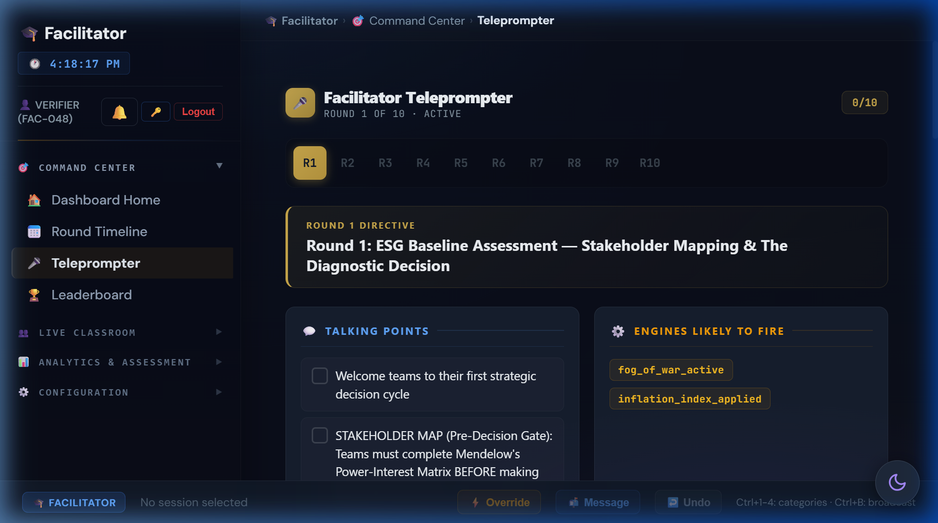
Figure: Teleprompter in full-screen presenter mode
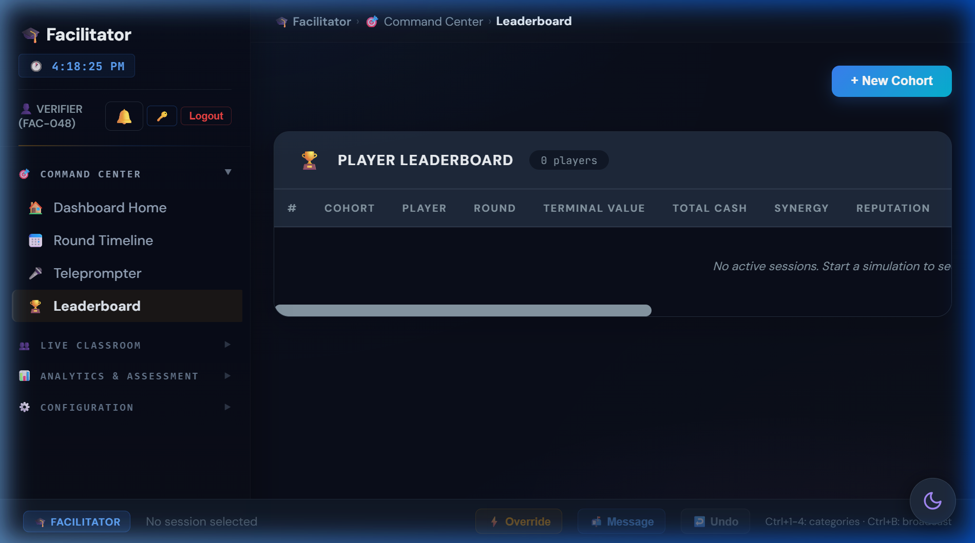
Figure: Leaderboard matrix with sortable columns

10A.2 Live Classroom
Tool | Icon | Purpose | When to Use
Player Registry | 📋 | All enrolled players: session IDs, cohort, names, timestamps, connection status. | Verify enrolment. Check connections.
Session Viewer | 👁️ | Deep-dive: full KPI breakdown, round history, decisions, real-time state. | Investigate specific team.
Team Impersonation | 🎭 | View cockpit exactly as player sees it — dashboard, mailbox, decisions, KPIs. | Live debugging, demos, walkthroughs.
Swipe File / Inbox | 📬 | Send pre-written or custom messages to individual teams. Appears in mailbox. | Inject narrative, board directives, alerts.
Bulk Messaging | 📢 | Announcements to all or selected cohorts. Templates + custom. | Class-wide announcements.
Manual Overrides ⭐ | ⚡ | Directly modify KPIs or force-advance rounds. | Live interventions, error correction.
Interventions ⭐ | 🎮 | Configure available interventions per cohort. | Pre-session toolkit setup.

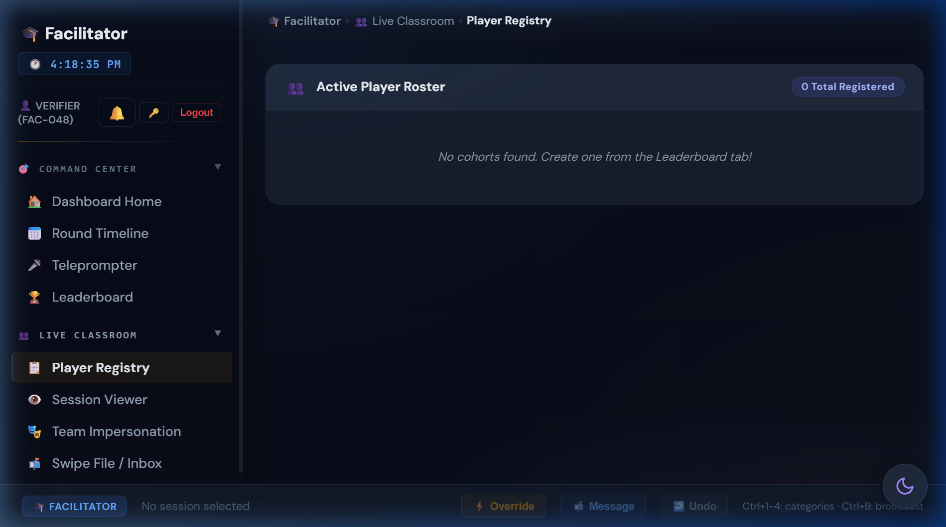
Figure: Player Registry with connection status indicators
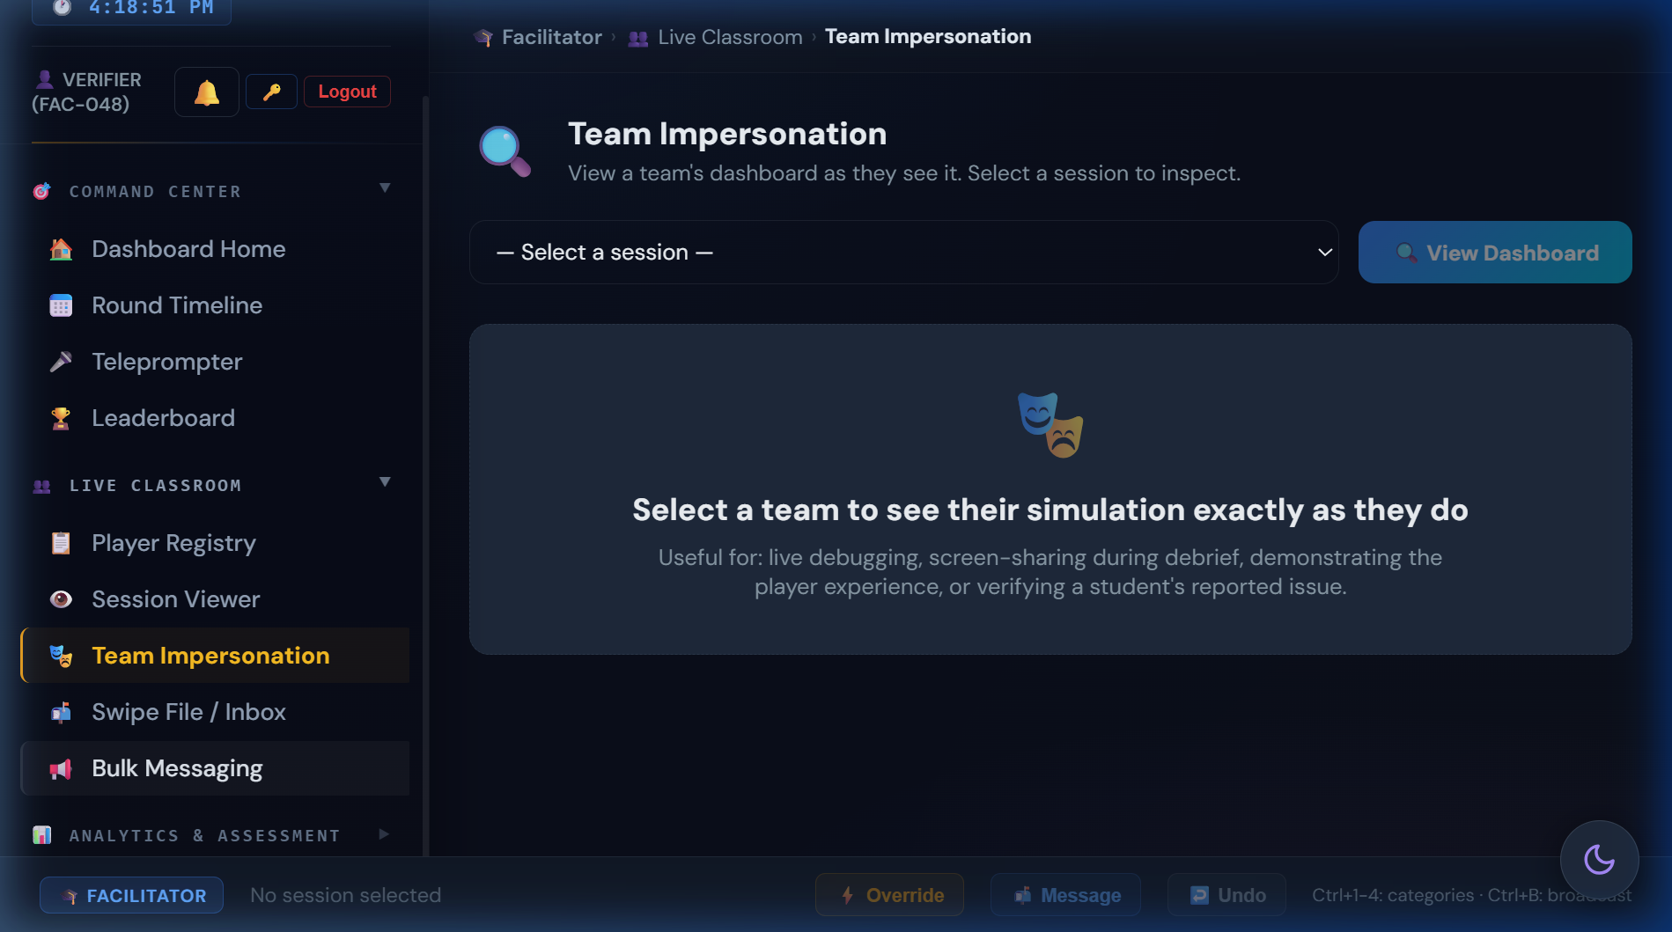
Figure: Team Impersonation showing student cockpit view

10A.3 Analytics & Assessment
Tool | Icon | Purpose | When to Use
Cohort Analytics | 📈 | 6-tab suite: Decision Heatmap, Time-to-Decision, Cohort Comparison, Convergence, Learning Outcomes, Risk Exposure. | Pattern recognition across cohorts.
Cohort Comparison | 📊 | Side-by-side KPI trajectory charts. Toggle: Treasury, Rep, Synergy, EBITDA. | Inter-cohort debrief.
Complexity Feed | 📡 | Real-time feed: engine triggers, narrative injections, math outputs. | Monitor hidden engines.
Decision History | 🕰️ | Chronological audit: timestamps, choices, CapEx, KPI deltas. Filterable. | Post-round analysis, grading.
DNA Comparison | 🧬 | Consequence DNA Sankey across cohorts. Causal chain divergence. | R10 debrief: why paths diverged.
Round Debrief | 📝 | Per-round summary: decisions, outcomes, outliers, discussion points. | Structured post-round discussion.
Scorecard Sandbox | 🧲 | Interactive TBL scorecard whiteboard. Teaching tool only. | Demonstrate scoring math.
Student Bonuses | 🎁 | Manual bonuses: participation, presentation, custom points. | Reward performance.
Peer Evaluations | 🔄 | Anonymous peer ratings: collaboration, contribution, communication. | Teamwork assessment.
Export Reports | 📤 | CSV/PDF: sessions, leaderboard, decisions, analytics, grading sheets. | End of simulation.

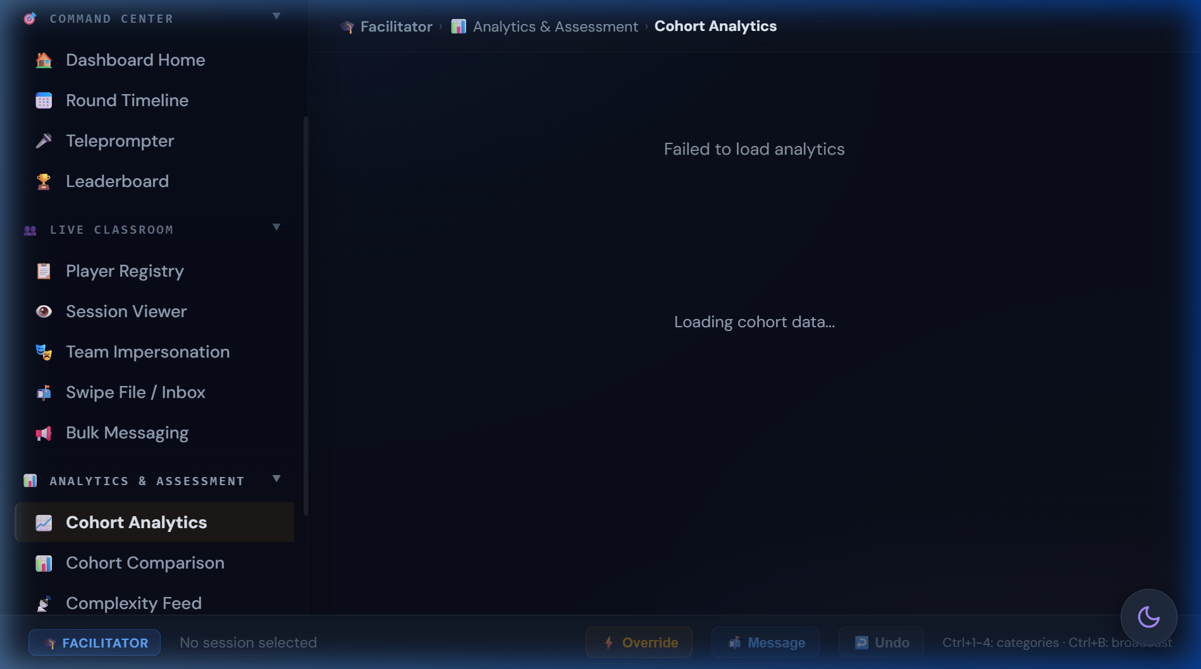
Figure: Cohort Analytics — Decision Heatmap tab

10A.4 Configuration
Tool | Icon | Purpose | When to Use
Auto-Pause ⭐ | ⏸️ | Automatic pause conditions: low treasury, rep floor, bankruptcy, custom KPI. | Pre-session safety net.
Undo Round ⭐ | ↩️ | Roll back last round, restore all KPIs. | Error correction, teaching moment replay.
Regulatory Sandbox ⭐ | ⚖️ | Inject Pigou taxes, Coase bargaining, Ostrom instruments. | Advanced: systemic resilience testing.
Materiality Matrix ⭐ | 🧩 | Mendelow's drag-and-drop. Lead: customize. Base: read-only. | Configure materiality framework.
Teaching Journal | 📝 | Private notes + timestamped annotations. Persisted. | Ongoing observations, debrief prep.
Technical Reference | 📐 | In-app reference: terminology, engines, formulas, scorecard. | Quick look-up during gameplay.
Activity Logs ⭐ | 📋 | Audit log + session management (delete, hard-reset). | Post-session cleanup.

⭐ = Requires Lead Facilitator or Super Admin role

§10B. God Mode Dashboard Visual Guide
The Super Administrator console provides system-wide control.
Figure: God Mode System Overview with scaffolding toggles

Command Center
Tool | Purpose
System Overview | Unified dashboard, session health, scaffolding toggles
Platform Analytics | Aggregated stats across ALL facilitators
Activity & Complexity | Immutable audit trail + live firehose

Cohort Orchestration
Tool | Purpose
Facilitator Registry | Create/edit facilitators, roles, permissions, cohort limits
Cohort Provisioning | Provision sessions, assign facilitators, paradigms
Session Controls | Pacing, broadcasts, visibility, scheduling
Team Interventions | Inject capital, penalties, narrative events
Crisis Overrides | Activate crises, Black Swans, end-game pathways

Engine Configuration
Tool | Purpose
Macro Economics | Global baselines, scenario presets, master variables
Systemic Risk | Black Swans, NPC cascades, tipping points, foreshadowing
Profile Archetypes | M_R thresholds for archetype classification
Regulatory Sandbox | Pigou taxes, Coase bargaining, Ostrom governance

Danger Zone
Tool | Purpose
Backup & Export | Full simulation snapshots
Factory Reset | Hard wipe ALL databases — typed confirmation required

§11. Common Student Pitfalls & Teaching Moments

"Option A is always best"
The shuffle engine randomises option order per session. No positional bias exists. Teach: read content, not position.

"Skip the audit, save $3M"
R1 Surface Scan costs $15M+ at R4 via contagion sigmoid. NPV of audit = 5x cost. Teach: option value of information.

"HR is optional"
Burnout follows quadratic curve. 60% burnout = 36% OPEX penalty + 66% R9 strike risk. Teach: human capital as binding constraint.

"ESG is a cost centre"
Terminal value spread: Titan $230M vs. Relic -$7M = 675% ROI on ESG investment. Teach: ESG as value driver.

"Ignore stakeholders"
Autonomous agents cascade: Journalist → Activist → Regulator. 3-agent hostile = corporate collapse. Teach: stakeholder salience.

"NCD doesn't matter"
6% compounding: NCD 200 → 301 in 7 rounds. Deducted from terminal value. Teach: ecological debt accumulation.

"I can recover in R9-R10"
Most M_R gates close by R8. early_decarboniser (R3), materiality_aligned (R2), nature_based (R5) — all irreversible. Teach: path dependency.

"Diversify everything equally"
Synergy rewards concentration (√ scaling). Spreading $15M across 3 pillars equally yields less than focused investment. Teach: diminishing returns.

"Deny and deflect is free"
Governance risk compounds through Cash Conversion drag, reducing revenue efficiency every round. Teach: hidden costs of opacity.

§12. Quick-Reference Cards

12.1 M_R Checklist
Round | Decision | M_R Bonus | Earned?
R2 | Full Materiality Alignment | +0.10 | ☐
R3 | Rapid Supplier Switch | +0.15 | ☐
R4 | Full Transparency | +0.10 | ☐
R5 | Nature-Based Solutions | +0.20 | ☐
R6 | Ethical AI Overhaul | +0.15 | ☐
R7 | Waste-to-Energy | +0.30 | ☐
R9 | Managed Transition | +0.12 | ☐
R9 | Community Fund | +0.18 | ☐
R10 | Instability Discount | -0.40 | ☐
— | THEORETICAL MAX | ~2.10 | —

12.2 Strike Probability Lookup
Burnout | SLO > 60 | SLO 40-60 | SLO < 40
< 20% | 5% | 10% | 20%
20-40% | 10% | 25% | 40%
40-60% | 20% | 40% | 60%
> 60% | 35% | 55% | 75%

12.3 Archetype Thresholds
M_R Range | Default Name | Climate Pathway | Community Pathway
≥ 1.80 | Regenerative Titan | Climate Vanguard | Community Champion
1.20-1.79 | De-risked Safe Haven | Transition Leader | Stakeholder Partner
0.80-1.19 | Fragile Giant | Carbon Exposed | Social Debtor
< 0.80 | Stranded Relic | Climate Casualty | Community Antagonist

§13. Session Planning & Logistics

13.1 Time Allocation
Phase | Duration | Activity
Setup | 10 min | Server check, player registration, cohort creation
Round Briefing | 5 min/round | Facilitator delivers teleprompter script
Decision Phase | 3-5 min/round | Teams discuss and submit decisions
Engine Resolution | 1 min/round | System processes tick, results appear
Debrief | 5 min/round | Post-round discussion using prompts
R5 Checkpoint | 15 min | Shadow Board Audit + mid-game formative
R10 Capstone | 20 min | Terminal valuation reveal + Thiagarajan debrief
TOTAL | ~130-150 min | Full 10-round session

13.2 Multi-Session Format
Session | Rounds | Duration | Focus
Session 1 | R1-R5 | 75 min | Foundation + Crisis + Shadow Board midpoint
Session 2 | R6-R10 | 75 min | Integration + Finale + Capstone debrief

13.3 Pre-Session Checklist
- Server running and accessible (verify with /api/health endpoint)
- Cohort created with correct industry verticals and experience level
- Player registration links distributed (share cohort join code)
- Side tracks assigned if applicable
- Ending pathway selected (or left on auto-detect)
- Pedagogical toggles configured (prediction gates, timer, peer learning)
- Teleprompter scripts reviewed for current round

§14. Assessment & Grading Rubric
Component | Weight | Assessment Method
Participation & Engagement | 20% | Attendance, decision submission timeliness, Board Room Moment completion
Reflective Quality | 40% | Strategy memo depth (R5), prediction calibration, mental model shift R1→R10
Terminal Outcome | 20% | M_R score and archetype classification (quantitative)
Peer Debrief | 20% | Cross-team analysis quality, theory application, transferable insights

14.1 Reflective Journal Prompts
Round | Prompt
R1 | What information would change your audit decision? What is the value of knowing?
R4 | Map the causal chain from R1 to R4. What assumption broke?
R5 | How did the Shadow Board change your perspective? Which persona was hardest to hear?
R7 | How did your HR investment history affect R7 outcomes? What is workforce readiness worth?
R10 | Compare your R1 mental model to R10. What shifted? What framework explains the change?

§15. Facilitator FAQ

What if a team goes bankrupt?
The Turnaround Arc activates automatically when treasury hits negative. Phase 1 (Crisis): Emergency Restructuring option appears — divest worst BU at 60% book value, -15% OPEX haircut. Phase 2 (Stabilisation): Reduced option set with recovery focus. Teams can recover to Fragile Giant but rarely reach Titan.

What if students game the system?
Three anti-gaming mechanisms: (1) Option Shuffle Engine randomises A/B/C order per session; (2) Stochastic elements (cyclone 75%, whistleblower 40%) prevent deterministic optimisation; (3) Pillar mutual exclusivity prevents maxing all sliders.

Can I run without side tracks?
Yes. Side tracks are optional enrichment. The core 10-round loop is fully self-contained. Side tracks add depth but are not required for pedagogical objectives.

How to handle uneven performance?
Use God Mode real-time balancing: inject capital to struggling teams, increase carbon tax for leaders, trigger custom Black Swans. Auto-Pause triggers can halt advanced teams while others catch up.

What if the server crashes mid-round?
All state is persisted to PostgreSQL after every tick. On restart, sessions resume from their last completed round. Player connections auto-reconnect via WebSocket.

Can I modify round configurations?
Yes, via decision_overrides.json — a JSON overlay that merges with ROUND_CONFIGS at runtime. Changes take effect immediately without server restart. Back up the file before editing.

How to explain math to non-quant students?
Use the Scorecard Sandbox (§10A.3) — interactive whiteboard where sliders show how weights affect terminal value. Focus on directional relationships (more burnout = higher cost), not formulas.

Appendix A: Glossary of Definitions
EBITDA: Earnings Before Interest, Taxes, Depreciation, and Amortisation. Sum of (Revenue - OPEX) across all BUs.
Terminal Value (TV): The company's projected worth at Year 5. Calculated as (EBITDA - Carbon Cost) x Exit Multiple x M_R.
Regenerative Multiple (M_R): Additive multiplier (1.0-2.1) rewarding sustainable strategy. Built from 10+ flag-based bonuses across R1-R10.
Carbon Intensity (CI): Per-BU metric (0-100) measuring carbon emissions per unit of output. Higher = worse.
Natural Capital Debt (NCD): Ecological liability that compounds at 6%/round. Deducted from terminal value.
Social License to Operate (SLO): Community acceptance score (0-100). Below 75 triggers -0.40 M_R instability discount.
Governance Risk Score: Per-BU metric (0-100) measuring governance quality. Higher = worse. Feeds Cash Conversion drag.
Synergy Multiplier: Cross-BU integration score (0-2.0). Gates R10 Option A (requires >80). Affects terminal value.
Workforce Readiness: Global metric (0-100) measuring workforce adaptability. Gates R7 circular economy returns.
Contagion: Sigmoid-based reputation damage propagation engine. Severity doubled by blindspot flags.
VRIO Advantage: Competitive advantage score (0.50-1.00). Decays 5%/round without investment.
Burnout Index: Per-BU metric (0-100). Quadratic OPEX penalty. >60% triggers R9 strike risk.
Brain-Drain: Software BU talent penalty when reputation <40. -15% revenue/round.
Fog of War: Progressive engine disclosure. R1-R3: 5 engines visible. R8+: all visible.
Shadow Board Audit: Mandatory R5 interception. 3 persona evaluations. Rejections set R10 pathway flags.
Ending Pathway: One of 5 R10 crisis scenarios determined by R5 flags and KPI thresholds.
Turnaround Arc: Emergency mode activated when treasury goes negative. Option T injected.
Pillar Mode: Budget allocation variant where $15M is distributed across 3 mutually exclusive pillars.
Foreshadowing: Planted news items in Market Feed (R5-R8) that signal the upcoming R10 pathway.
God Mode: Super Administrator console for system-wide control over all simulation parameters.
CSRD: Corporate Sustainability Reporting Directive (EU). Mandates double materiality assessment.
ESRS: European Sustainability Reporting Standards. CSRD implementation standards.
TCFD: Task Force on Climate-related Financial Disclosures. Physical/transition risk framework.
TNFD: Taskforce on Nature-related Financial Disclosures. Biodiversity risk framework.

Appendix B: Complete Engine Variable Registry

B.1 Global State Variables
Variable | Initial | Range | Unit | Modified By
corporate_treasury | 50,000,000 | 0-∞ | $ | All options, engine penalties
group_reputation | 55.0 | 0-100 | pts | Contagion, options, agents
synergy_multiplier | 1.00 | 0-2.0 | x | Synergy engine, R7 options
workforce_readiness | 50.0 | 0-100 | pts | HR investment, burnout inverse
inflation_index | 1.00 | 1.0-1.5 | x | +2-3%/round cumulative
green_transition_fund | 0 | 0-∞ | $ | Green Bond, R7 circular
dividend_ratchet | 0 | 0-∞ | $ | Board governance minigame

B.2 Per-BU State Variables
Variable | Pharma | Electronics | CG | Software | Range
revenue_base | 18M | 16.5M | 10.5M | 8.5M | 0-∞
opex_base | 12M | 11.5M | 7.5M | 5.5M | 0-∞
carbon_intensity | 35 | 72 | 48 | 12 | 0-100
water_dependency | 82 | 58 | 65 | 12 | 0-100
natural_capital_debt | 120 | 200 | 150 | 30 | 0-∞
social_license_score | 50 | 50 | 50 | 50 | 0-100
governance_risk_score | 15 | 20 | 10 | 25 | 0-100
staff_burnout_index | 10 | 10 | 10 | 10 | 0-100
vrio_advantage | 0.80 | 0.80 | 0.80 | 0.80 | 0.5-1.0

B.4 Flag Registry
Flag | Set By | Downstream Effect
electronics_blindspot | R1 Opt A | 2x R4 severity (40→80)
deep_audit_completed | R1 Opt B | R4 severity stays at 40
materiality_aligned | R2 Opt A | +0.10 M_R; NCD forgiveness 25%
materiality_ignored | R2 Opt C | 40% budget clawback; Green Bond blocked
early_decarboniser | R3 Opt A | +0.15 M_R; R7 amplification
green_bond_active | R3 Opt B | -15 NCD over 3 rounds
remediation_active | R4 Opt A | +0.10 M_R
nature_based_resilience | R5 Opt B | +0.20 M_R (Resilience Champion)
insurance_only | R5 Opt C | BLOCKS +0.20 M_R permanently
ethical_ai_overhaul | R6 Opt B | +0.15 M_R (Truth Premium)
ai_monetised | R6 Opt A | Contagion spike; -20 rep
waste_to_energy | R7 Opt C | +0.30 M_R; synergy unlock
managed_transition | R9 Opt B | +0.12 M_R
community_fund | R9 Opt C | +0.18 M_R
shareholder_alienated | R5 Shadow Board | Activates Activist pathway
community_distrust | R5 Shadow Board | Activates Community pathway
scientist_dismissed | R5 Shadow Board | Activates Climate pathway

Appendix C: Academic Reference Matrix
Complete mapping of every cited theory to its simulation application, organized by round.
Citation | Framework | Round(s) | How Applied in Simulation | Debrief Prompt
Mendelow, A. (1991) | Stakeholder Mapping | R1 | Drag-and-drop Power x Interest matrix classifies 8 stakeholders before audit decision. | What stakeholder did you misclassify? How would reclassification change your strategy?
Mitchell, R., Agle, B., & Wood, D. (1997) | Stakeholder Salience | R1,R5,R9 | Power x Legitimacy x Urgency drives autonomous agent escalation levels and Shadow Board persona authority. | Which stakeholder gained urgency during the simulation? Why?
EU Commission (2022) | CSRD / ESRS | R2 | CFO materiality gate requires double materiality classification. ESRS 1 §1.51 violation triggers 40% clawback. | How does mandatory vs. voluntary disclosure change behaviour?
Dixit, A. & Pindyck, R. (1994) | Real Options Theory | R1→R4 | Deep audit = purchasing an option on future crisis mitigation. Option NPV = 5x cost ($3M → $15M avoided). | What was the option value of the R1 audit?
Argyris, C. (1977) | Double-Loop Learning | R4 | R4 cascade forces players to question R1 assumptions — the core double-loop trigger. | What assumption broke at R4? How did you update your mental model?
Kahneman, D. (2011) | System 1/2 Thinking | R4,R6 | Time pressure and stochastic elements force heuristic (System 1) decisions. Debrief reveals analytical (System 2) gaps. | Did time pressure change your decision? How?
Moon, J. (2004) | Reflection Protocol | R4,R5 | 3-stage Board Room Moments: Noticing → Making Sense → Working with Meaning. | What surprised you? Why? What will you change?
Jensen, M. & Meckling, W. (1976) | Agency Theory | R5 | Shadow Board personas embody principal-agent conflicts: shareholder value vs. community welfare vs. scientific evidence. | Whose interests did you prioritise? Why?
Barney, J. (1991) | Resource-Based View | R7 | VRIO advantage decays without investment. Circular capabilities = rare, valuable, non-substitutable. | Which capability is your most durable competitive advantage?
Teece, D. (2007) | Dynamic Capabilities | R7 | Workforce readiness gates circular economy returns. Sensing, seizing, reconfiguring capabilities. | How did workforce readiness constrain your options?
Hardin, G. (1968) | Tragedy of the Commons | R8 | Water scarcity forces collective resource allocation. Prioritising one BU depletes shared resource. | Is prioritising highest-margin BU rational? From whose perspective?
Rawls, J. (1971) | Justice as Fairness | R9 | Difference Principle applied: factory closure must benefit the least advantaged (workers/community). | Who bears the cost of decarbonisation? Is that just?
Freeman, R.E. (1984) | Stakeholder Theory | R9 | Community Fund option embodies stakeholder value creation beyond shareholder returns. | Does stakeholder investment create or destroy shareholder value?
Costanza, R. et al. (1997) | Natural Capital | All | NCD compounds at 6%/round modelling ecological debt. Deducted from terminal value as liability. | What is the interest rate on ecological debt?
Meadows, D. (1999) | Leverage Points | R10 | Debrief overlay identifies 12 leverage points in the simulation system hierarchy. | Where would you intervene in this system? At what leverage point?
Kolb, D. (1984) | Experiential Learning | All | Full cycle: R1-R5 (Concrete Experience) → R4 debrief (Reflection) → R6-R8 (Conceptualisation) → R9-R10 (Experimentation). | How did your strategy evolve across the learning cycle?
Thiagarajan, S. (1993) | Debrief Protocol | R10 | 3-phase: How Do You Feel? (2 min) → What Happened? (5 min) → So What? (10 min). | What one principle would you take to a real boardroom?

Module Supplement: SEBI BRSR NGRBC Implementation
The BRSR NGRBC side track has been integrated into the central Muressons pedagogical engine. It acts as a stringent, 5-round gauntlet focusing on Indian and global sustainability reporting standards.

Pedagogical Goals
- By triggering this track, facilitators can evaluate students on:
- Distinguishing between SEBI's 'Essential' vs. 'Leadership' indicators.
- Navigating the severe consequences of 'Greenwashing' in value chain assurance.
- Understanding the long-term financial Alpha generated by proactive BRSR Core assurance.

Facilitator Controls & Live Interventions
The track feeds dynamic crises directly into the main Engine Loop. For example, if a team accumulates a 'Governance Fragility' flag in Round 1, the engine will autonomously trigger a 'Whistleblower Crisis' in Round 5, bleeding their corporate treasury. Use this as a powerful debriefing tool to illustrate the 'long-tail' risk of poor ESG governance.

Module Supplement: TCFD Climate Scenario Analysis
The TCFD Scenario Analysis engine (SI-4) is a pure-function analytical tool that allows players to stress-test their portfolio against three NGFS-aligned climate pathways. It produces no state mutation — it is purely diagnostic. This section covers the pedagogical goals, facilitator controls, classroom integration, and debriefing strategies.

Pedagogical Goals
The TCFD module develops the following competencies:
- Scenario Thinking: Students learn to assess strategy under deep uncertainty, moving beyond single-point forecasts.
- Climate Risk Literacy: Distinguishing between transition risk (policy, technology, market) and physical risk (extreme weather, sea-level rise).
- Stranded Asset Awareness: Understanding why fossil-linked assets lose value under ambitious climate policy.
- TCFD / TNFD Disclosure: Practical exposure to the disclosure frameworks increasingly mandated by regulators.
- Strategic Resilience: Identifying strategies that are robust across multiple scenarios rather than optimal for just one.

The Three Climate Scenarios
The engine models three NGFS-aligned pathways. Each scenario has distinct carbon price trajectories, physical risk multipliers, demand shifts by sector, and stranded asset exposures:
Scenario | Temp. Path | NGFS Category | Carbon Price Trajectory | Key Risk | Strategic Implication
Net Zero 2050 | 1.5°C | Orderly | $50 → $250/tCO₂ | HIGH transition risk, LOW physical risk | Front-load decarbonisation CapEx; green tech premium turns negative
Delayed Transition | 2°C | Disorderly | $30 → $350/tCO₂ (shock) | BOTH transition AND physical risks elevated | Build financial buffers; prepare for carbon price shock
Current Policies | 4°C | Hot house world | $20 → $40/tCO₂ | CATASTROPHIC physical risk, low transition risk | Supply chain resilience; healthcare demand surge opportunity

Dashboard Access & Controls
Player Access: The TCFD dashboard is accessible via the 🌡️ Climate tab in the right panel of the player cockpit. It fetches data from the backend API endpoint GET /api/simulations/{session_id}/tcfd-scenarios.
God Mode Toggle: TCFD can be toggled on/off per cohort via the God Mode toggle 'tcfd_scenarios_enabled' (default: ON). It can also be set during cohort creation in the CreateCohortModal.
Dynamic Data: The analysis uses the player's current portfolio state — carbon intensity, revenue base, social license, reputation, and workforce readiness — to generate forward projections. As players decarbonise and invest strategically, their scenario outputs improve dynamically.

Metrics Calculated per Scenario
Metric | Calculation | Teaching Use
Revenue Impact (%) | BU revenue × demand_shift^(horizon/5) | Illustrates sector-specific vulnerability to climate transitions
Annual Carbon Cost | avg_CI × BU_count × 1000 × carbon_price | Shows the financial materiality of carbon intensity
Physical Risk | Treasury × 2% × phys_multiplier × (1 - resilience) | Quantifies the protective value of resilience investments
Stranded Assets | Total PPE × stranded_pct × 80% write-down | Teaches the concept of fossil-asset obsolescence
Opportunity Score | (Rep×0.3 + SLO×0.3 + WFR×0.2 + (100-CI)×0.2) × 100 | Multi-dimensional readiness assessment
Nature Risk (TNFD) | (100 - EHI)/100 × bio_dependency × phys_mult × 100 | Connects biodiversity loss to financial risk

Classroom Integration Strategies

Round 2 (Post-Materiality)
After students complete the materiality matrix, introduce the TCFD Climate tab. Prompt: 'You've identified your material ESG issues. Now, how would a 1.5°C vs. 4°C world change which issues are most material?' This bridges the Double Materiality concept with forward-looking scenario analysis.

Round 5 (Mid-Game Checkpoint)
During the mid-game checkpoint, have teams compare their TCFD dashboard data. Use the Compare mode to project all three scenarios side by side. Discussion prompt: 'Which team has the most resilient portfolio — one that performs acceptably across ALL three scenarios?' This teaches the TCFD principle of strategic resilience under uncertainty.

Round 8–9 (Pre-Endgame)
As teams approach the grand finale, prompt them to revisit their TCFD scenarios to evaluate whether their mid-game strategic pivots have improved or degraded their climate resilience. Prompt: 'Has your carbon intensity decreased enough to survive the Disorderly 2°C carbon price shock?' Link to Stranded Asset theory (Carbon Tracker Initiative).

Post-Game Debrief
Include TCFD scenario data in the debrief report. Compare teams' final Overall Risk Rating across scenarios. Teams with high Opportunity Scores (>70) demonstrate genuine understanding of climate-resilient strategy. Use the nature risk overlay to discuss TNFD and the emerging 'double materiality' of nature and climate disclosure frameworks.

Facilitator Talking Points
On Carbon Pricing: 'In the real world, the EU Emissions Trading System already prices carbon at €90-100/tCO₂. The Orderly 1.5°C scenario projects $250/tCO₂ by 2050. What does this mean for your most carbon-intensive business unit?'
On Stranded Assets: 'Carbon Tracker estimates that $900 billion of fossil-fuel assets are at risk of stranding. In your simulation, how much of your PPE is exposed? What does the 35% stranded figure under 1.5°C mean for your balance sheet?'
On Physical Risk: 'The 4°C Hothouse scenario applies a 4× physical risk multiplier. Munich Re reported $120bn in natural catastrophe losses in 2022. How much does your treasury lose annually under this scenario?'
On TCFD Compliance: 'TCFD is now mandatory in the UK, EU (via CSRD), Japan, Singapore, and New Zealand. How does your scenario analysis demonstrate compliance? What would investors say about your Opportunity Score?'
On the TNFD Extension: 'The Taskforce on Nature-related Financial Disclosures builds on TCFD by adding biodiversity dependency. Does your Ecosystem Health Index create additional exposure beyond climate?'

Technical Reference
API Endpoint: GET /api/simulations/{session_id}/tcfd-scenarios — Returns all 3 scenarios with comparison matrix. Optional query param: ?scenario_id=orderly_1_5 for single scenario.
Backend Module: tcfd_scenarios.py → run_scenario_analysis() and get_scenario_comparison(). Pure-function module with no state mutation.
Frontend Component: TCFDScenarioDashboard.js — self-contained React component rendered in the right panel Climate tab. Features single-scenario and compare modes with animated arc gauges, BU revenue projection bars, and strategic implications.

Facilitator Reference: ESG Impact Constellation
The ESG Impact Constellation is a real-time 3D causal network rendered using React Three Fiber (WebGL). It transforms the simulation's round-by-round state history into an interactive knowledge artefact that supports post-game sense-making and debrief facilitation.

Pedagogical Purpose
The Constellation operationalises three core learning objectives:
- Systems Thinking — Players must trace how one decision at Round 1 structurally constrains or enables decisions at Round 10. The hardcoded cross-causal (amber dashed) links make these invisible system relationships visible.
- Consequence Awareness — The node size formula (|Treasury Δ| ÷ $5M) creates a direct embodied representation of financial consequence magnitude. Groups who see one massive sphere surrounded by tiny ones immediately understand which decision dominated their financial narrative.
- ESG Integration vs. Silo Thinking — The dimension colour system combined with the filter bar allows facilitators to demonstrate graphically whether a team treated Environmental, Social, and Governance as separate concerns or as an integrated whole.

Technical Architecture
The component (ESGImpactConstellation.js) receives the full session history array from the backend on mount. Each round's node is constructed via the buildConstellationData() function which reads three state deltas per round:
- corporate_treasury — Drives node size (magnitude of financial impact)
- group_reputation — Drives sequential link thickness and nebula colour
- tco2e_emissions — Drives the Carbon Δ tooltip metric (green = reduction)
Nodes are positioned in 3D space using a spiral layout formula (angle derived from round number × 2.5π, radius expanding linearly) so that later rounds always occupy the outer arc of the constellation — making chronological progression spatially intuitive.

Dimension Assignment Logic
Each round is pre-assigned to an ESG dimension based on its primary pedagogical content:
Dimension | Rounds | Rationale
Environmental (#10b981) | R1, R3, R5, R7, R8 | Rounds where physical planet boundaries (emissions, water, supply chain carbon, circular flows, climate scenarios) are the primary decision frame.
Social (#3b82f6) | R4, R9 | Rounds where community impact, worker welfare, and social licence-to-operate are the dominant ESG stress.
Governance (#8b5cf6) | R2, R6 | Rounds anchored in reporting integrity (Double Materiality) and algorithmic accountability (AI Ethics).
Mixed (#5eead4) | R10 | The Activist Ultimatum finale tests all three dimensions simultaneously, reflecting the real-world convergence of ESG pressure at corporate climax events.

Hardcoded Cross-Causal Links — Facilitation Notes
Three systemic causal links are encoded directly in the component. These are not stochastic — they always appear if the relevant rounds exist in history. Use them as discussion anchors:
- R3 → R5 (Scope 3 → Climate Risk, strength 0.6): Prompt: 'Look at this dashed amber line. Your Scope 3 decisions in Round 3 directly shaped the climate risk exposure you faced in Round 5. Teams who contracted low-carbon suppliers in R3 typically see a 15–22% smaller R5 penalty. How does your R5 node compare?'
- R4 → R7 (ESG Contagion → Circular Economy, strength 0.4): Prompt: 'The ESG Contagion round is often underestimated. But notice this link — the social licence you managed (or failed to manage) in R4 determined which Circular Economy options were available to you in R7. Teams with negative social scores in R4 found their highest-return circular options blocked.'
- R1 → R10 (ESG Materiality → Activist Ultimatum, strength 0.8): Prompt: 'This is the most powerful link in the constellation. The materiality framing you chose in Round 1 — what you decided was financially material versus what you dismissed — set the agenda for your entire strategic trajectory. Teams who underweighted climate or social risks in R1 face a structurally harder R10 ultimatum. What did you prioritise?'

Recommended Debrief Facilitation Workflow
Follow this 4-step protocol when using the Constellation in a group debrief:
- Step 1 — Full Timeline, All Dimensions (2 min): Open the Constellation for the group and let everyone observe the full R1–R10 arc together. Ask: 'What is your first impression? What stands out?'
- Step 2 — Filter by Dimension (3 min per filter): Cycle through E → S → G filters. For each filter, ask teams to count their active nodes. A team with 0 social nodes glowing bright demonstrates a siloed ESG strategy.
- Step 3 — Click the Outlier Node (5 min): Ask each team to identify their single largest node (the biggest financial shock). Click it to reveal the tooltip. Ask: 'Was this a conscious strategic bet or an unintended consequence?'
- Step 4 — Trace the Amber Lines (5 min): Walk through the three cross-causal links using the prompts above. Connect each link to the team's actual numeric outcomes.

Nebula Colour Interpretation Table
Nebula Colour | Reputation Range | Facilitator Interpretation
Green | ≥ 65 | Team maintained consistent stakeholder trust. ESG messaging was credible.
Amber | 40–64 | Mixed credibility. Some rounds damaged reputation; recovery was partial.
Red | < 40 | Reputation crisis. Team likely made at least one decision that severed social licence. Check R4 (Contagion) and R9 (Just Transition) nodes for culprits.

Common Player Misconceptions to Address
- "Bigger nodes are better." — Correct this immediately. A large node means a large financial shock in either direction. A very large node from a costly green investment may have been wise; a large node from a crisis penalty was not.
- "The amber lines mean we made mistakes." — Clarify that cross-causal links are not judgements. They are structural system relationships. The line from R1 to R10 exists regardless of whether R1 was a good or bad decision — it simply shows the system's long-range memory.
- "A green nebula means we won." — Reputation is one metric. A team can have a green nebula and still be in financial loss. The Constellation shows the multi-dimensional nature of the challenge — no single metric tells the full story.

Appendix: Factory Reset & Data Deletion Reference
This appendix documents exactly what the "Factory Reset" command in God Mode destroys when a Super Admin types DELETE ALL DATA and confirms the nuclear wipe. Understanding the scope of this action is critical before using it in a live teaching environment.

Overview
The Factory Reset is a two-stage safeguarded operation accessible only from God Mode → Danger Zone → Factory Reset. It requires the Super Admin to:
- Type the exact phrase DELETE ALL DATA into a confirmation field.
- Click the ☢️ Factory Nuke All Sessions button.
- Wait through a mandatory 15-second countdown (which can be cancelled).
Once the countdown reaches zero, the system calls the backend endpoint DELETE /api/admin/reset-all, which performs a hard delete across all data stores. This action cannot be undone.

What the Factory Reset Deletes
The reset operates across two layers: the database persistence layer and the admin application layer. The following tables itemise every data store that is wiped.

1. Database Layer (Persistent Storage)
These four core data stores are completely cleared. Their contents are also removed from the on-disk JSON persistence file, meaning the data cannot be recovered after a server restart.
Data Store | Contents | Impact of Deletion
Sessions Registry  (_sessions) | All session metadata: cohort names, facilitator assignments, player IDs, parent–child relationships, paradigm settings, currency, difficulty tier, short codes (e.g. SIM-A3K7), pedagogical overrides, pacing mode, shuffle seeds, start/end dates, decade forward plans. | Every cohort and every player account vanishes. No session can be loaded or resumed. All join codes become invalid.
Global State History  (_global_states) | Every round's global state for every session: corporate treasury, group reputation, synergy multiplier, cost of capital, all active event flags, EBITDA history, tCO₂e emissions, VRIO capabilities, stakeholder map data, tipping point state, pending capex projects, inflation index, SDG metrics (political capital, community trust, emissions intensity), BU substitution state, and autonomous stakeholder agent state. | All simulation progress is erased. Round-by-round state history used by the Executive Cockpit, ESG Constellation, Consequence DNA, and debrief tools is permanently lost.
Business Unit States  (_bu_states) | Per-round snapshots for every business unit: revenue base, opex base, natural capital debt, social licence score, reputation score, governance risk score, water dependency, carbon intensity, staff burnout index, bed capacity utilisation, patient outcomes score, SDG cluster scores (basic needs, human capital, sustainable growth, planet, governance, partnerships), population, migration pressure, and risk factors. | All BU-level performance history is destroyed. The balanced scorecard, risk radar, and BU comparison tools will show no data.
Decision Audit Log  (_decision_log) | The complete audit trail of every decision made across all sessions: decision node ID, choice selected (e.g. option_a), capex allocated, player ID, time-to-decision in seconds, and team consensus method. | All decision history is lost. The Decision Timeline, Debrief Report, and Consequence DNA Sankey diagram will have no data to render. Academic assessment of player choices is no longer possible.

2. Admin Application Layer (In-Memory State)
In addition to the persistent database, several in-memory admin data stores are cleared during the reset:
Data Store | What Is Lost
God Mode Audit Log | All logged God Mode actions (e.g. crisis triggers, manual overrides, facilitator registrations). The Activity Log panel will be empty.
Crisis Trigger History | The history of all manually triggered crises (e.g. forced strikes, carbon tax increases). Future crisis scheduling is also cleared.
Session Messages | All facilitator broadcast messages sent to specific sessions via the Universal Broadcast tool.
Session Interventions | All active interventions pushed to player sessions (e.g. live scenario overrides, custom Black Swan events).
Practice Mode Flags | Practice mode on/off state for all sessions. Any sessions that were in practice mode lose that designation.
Round Pacing Configuration | Per-session round gating and pacing config. Any cohorts using instructor-paced or timed-release modes lose those settings.
Facilitator Registry | ALL facilitator accounts are deleted and replaced with a single default Super Admin facilitator (god_mode). Every custom facilitator created via the Facilitator Registry — including Lead Facilitators and Base Facilitators — is permanently removed. Their passwords and scope assignments are lost.
Shared Marketplace State | Carbon Credit Pool: all purchases are cleared and the price history is reset to the baseline [$50,000 per credit]. Green Talent Pool: all hires are cleared and the cost history is reset to the baseline [$200,000 per hire].
Facilitator Notes | All per-session facilitator notes and comments are erased.
Student Bonuses & Peer Evaluations | Any bonus scores awarded to students and peer evaluation data are deleted.
Session Annotations | Per-session annotations used for tagging and categorising session behaviour are removed.

What the Factory Reset Does NOT Delete
The following items survive a Factory Reset and remain intact after the wipe:
Item | Why It Survives
God Mode Password | The master God Mode password is stored in a separate persistence file and is not touched by the reset. You will not be locked out.
Resource Library | Uploaded teaching resources (PDFs, links, documents) managed via the Resource Manager are stored independently and are not cleared.
Glossary Entries | Custom glossary definitions added via the Glossary Manager survive the reset.
Uploaded Media Files | Physical files uploaded for interventions (audio, video, images) remain on disk in the /public/uploads/ directory. However, the intervention records that reference them are cleared.
Master Overrides & Swipe Files | The God Mode master intervention database (e.g. Global Macro Shift, Omni-Tech Poach, Force Strike) and all swipe file presets are NOT cleared. These are defined at the application level and persist.
Round Configuration | The 10-round scenario configuration (crisis definitions, options, flags, impacts) is static application code and is never modified by the reset.
Application Code & Settings | All frontend components, backend logic, and UI configuration are unaffected. The simulation is fully functional immediately after a reset — it simply has no sessions to display.

Targeted Alternatives to Factory Reset
Before using the Factory Reset, consider whether one of these less destructive options in the Danger Zone panel would suffice:
Action | Scope | Use When
Delete Selected Cohorts | Removes only the checked cohorts and their child player sessions. | You want to clean up specific completed or test cohorts without affecting other active classes.
Clear All Orphans Globally | Removes only cohorts that have no facilitator assigned. | You want to clean up sessions created during testing or by deleted facilitator accounts.
Undo Round (Facilitator Dashboard) | Rolls a specific session back by one or more rounds. | A cohort made a decision in error and needs to retry. No data is permanently deleted — it can be replayed.

Pre-Reset Checklist
If you have confirmed that a full Factory Reset is necessary (e.g. between semesters or after a major pilot), complete the following checklist before proceeding:
- ☐ Export all session data — Use God Mode → System Export to download JSON snapshots of every active session before they are destroyed.
- ☐ Download debrief reports — Generate and save Debrief Reports for any cohorts that require academic grading or archival.
- ☐ Record facilitator accounts — Note down the names and IDs of all custom facilitator accounts, as they will need to be recreated after the reset.
- ☐ Confirm no active players — Verify that no students are currently mid-session. Active WebSocket connections will be severed without warning.
- ☐ Communicate to teaching team — Inform all facilitators that the reset is happening, as their dashboard will show zero cohorts afterward.

Post-Reset State
After a successful Factory Reset, the system returns to a clean-install state:
- Zero cohorts and zero player sessions.
- A single default Super Admin facilitator account (god_mode).
- The shared marketplace is reset: carbon credits at $50,000/credit and green talent at $200,000/hire.
- All admin logs, notes, and intervention history are empty.
- The God Mode dashboard is fully functional and ready to provision new cohorts immediately.
The confirmation message displayed after a successful reset reads: "✅ All [N] sessions wiped." where [N] is the total number of sessions (including player sub-sessions) that were destroyed.

Appendix: Double Materiality Matrix Calculations
This appendix details the calculations behind the Double Materiality Matrix in Round 2, explaining how the unlocked budget, stakeholder panel fees, and mitigation costs are derived.

1. Unlocked Budget
When submitting the materiality matrix, the system calculates the capital unlocked based on accuracy in Quadrant 1 (High Financial & High Societal Impact).
- Total Available Budget: The base materiality budget defaults to $15,000,000.
- Accuracy Calculation (m_acc): The system evaluates the number of true Q1 issues correctly placed in Q1, divided by the total number of true Q1 issues.
- Formula: Allocated Budget = Total Available Budget × Accuracy
- Clawback Penalty: If Option C (Ignore Framework) was selected in the governance decision, the backend applies a 40% budget clawback to the unlocked amount to reflect the misalignment between the governance posture and the materiality exercise.

2. Stakeholder Panel / Consultant Fee
The cost to 'Commission Stakeholder Panel Survey' scales dynamically based on how many issues are pre-rated.
- Issues 1-4: Base fee of $250,000 per issue.
- Issues 5-8: Extended fee of $500,000 per issue (the cost doubles beyond 4 issues to reflect the complexity of wider engagement).
Examples:
- 1 Issue = $250,000
- 4 Issues = $1,000,000 ($250K × 4)
- 8 Issues = $3,000,000 ($1M for first four + $2M for the next four)

3. Mitigation Costs (Issue Chips)
When an issue chip is dragged on the matrix, it displays a specific cost (e.g., '$1.2M').
- Source: This number is stored as 'mitigation_cost_usd' within each issue's configuration in the backend.
- Prioritise Budget: The sum of these costs for all issues placed in the Q1 container forms the 'Prioritise Budget' shown dynamically at the top of the matrix. The numbers are formatted using division by 1,000,000 to display them with the 'M' suffix.

4. How the CSRD Screen Is Organised
When the CSRD Double Materiality screen opens (Round 2), it replaces the standard cockpit with a full-screen assessment workspace. Understanding its three zones will help you work efficiently.
- Zone 1 — Header Bar (top strip): Shows the session title, a live 'Placed X / Y issues' counter with a progress bar, the 'Q1 Budget' meter (running total of mitigation costs for issues you have placed in Quadrant 1 vs. the total CSF pool), and action buttons (Undo, Reset, Commission Stakeholder Panel Survey, Submit).
- Zone 2 — Left Pane (Issue Bank): Contains all ESG issue chips waiting to be classified. Each chip shows the issue title, a category badge (E = Ecological, S = Social, G = Governance), an ESRS topic tag (e.g., E1, S2), a severity badge (H / M / L), a time-horizon badge (ST / MT / LT), an IRO badge (IMP = Impact, RSK = Risk, OPP = Opportunity), and a cost badge (e.g., $1.2M) showing the mitigation cost that will be charged if the issue is placed in Q1. Hover over any chip to read the full issue description. A Horizon filter (All / ST / MT / LT) lets you focus on issues by time horizon without removing placed issues from the matrix.
- Zone 3 — Right Pane (2x2 Matrix): The matrix is divided into four quadrants based on two axes: Financial Materiality (x-axis, left = Low, right = High) and Impact Materiality / People & Planet (y-axis, bottom = Low, top = High). Drag chips from the Issue Bank into the quadrant where you judge they belong:
• Q1 (Top Right) — 'CFO Approved — Prioritise & Allocate CapEx': doubly material issues. Placing an issue here commits its mitigation cost.
• Q2 (Top Left) — 'Monitor & Engage': high impact, low financial risk. Requires disclosure investment, not capex.
• Q3 (Bottom Right) — 'Watch & Manage': high financial risk, low impact. Financially material but not ESRS impact-material.
• Q4 (Bottom Left) — 'Low Priority': immaterial on both axes. Placing 'greenwashing distractor' issues here is good governance.
- Submit Button behaviour: The 'Submit Matrix to CFO' button is disabled until at least 6 issues have been placed into any quadrant (the minimum for a valid materiality assessment). It is also disabled if the total Q1 mitigation cost exceeds your current CSF pool balance. Once enabled, clicking it sends the assessment to the backend for CFO scoring.

5. How Funds Are Calculated — Step by Step
The CSRD submission triggers a four-step financial calculation in the backend. Understanding this helps you make deliberate trade-off decisions.
- Step 1 — Stakeholder Panel Fee (if commissioned): If you clicked 'Commission Stakeholder Panel Survey' and chose to pre-rate N issues, the fee is deducted from corporate treasury immediately and is non-refundable regardless of matrix accuracy. Fee schedule: Issues 1–4 cost $250,000 each; Issues 5–8 cost $500,000 each (the cost doubles above 4 to reflect wider engagement). Maximum fee (8 issues): $3,000,000. Example: rating 6 issues = (4 × $250K) + (2 × $500K) = $2,000,000.
- Step 2 — CFO Validation Gate: The backend checks whether every issue you placed in Q1 (Top Right) is genuinely doubly material. An issue is doubly material if its severity_score × likelihood_score is ≥ 12 out of 25 on both the financial and societal axes (ESRS 1 §1.51 threshold). If any Q1 issue fails this test and you have not chosen the CFO Override, the submission is rejected with an error message — review your Q1 placements and resubmit. If you choose the CFO Override, the submission proceeds but Group Reputation is reduced by −10 points.
- Step 3 — Accuracy Scoring & Capital Release (M_acc): The backend counts how many of the true Q1 issues (those that genuinely meet the ≥ 12/25 threshold on both axes) you correctly placed in Q1, then divides by the total number of true Q1 issues:
M_acc = Correct Q1 placements ÷ Total true Q1 issues
The CFO then releases:
Allocated Budget = $15,000,000 × M_acc
Example: if 5 of 6 true Q1 issues were correctly placed, M_acc = 83.3%, and the CFO releases $12,500,000. Partial credit is awarded for 'ambiguous' issues placed in adjacent quadrants (e.g., a borderline Q1/Q2 issue placed in Q2 earns 0.5 credit). Note: the allocated budget is a capital commitment — it is deducted from your corporate treasury, not added to it.
- Step 4 — Option C Clawback (if applicable): If you chose Option C (Ignore the Materiality Framework) in the Round 2 governance decision, the backend applies a 40% clawback to the allocated budget before deducting it. This models the governance principle that capital cannot be released for ESG programmes if the board has simultaneously decided to ignore the ESG framework. Example: $12,500,000 × 40% clawback = $5,000,000 forfeited, leaving a net commitment of $7,500,000.
- Bonus — Q2 Disclosure Budget: For every Q2 issue (High Impact / Low Financial) you correctly place in Q2 that carries a 'disclosure_required' flag, the system pro-rates a share of the $1,000,000 Disclosure Investment Budget. This is a separate allocation for data collection, assurance, and stakeholder engagement costs (not capex). It is not deducted from the $15M pool.
- Accuracy Bonus: If your overall placement accuracy across all four quadrants reaches ≥ 80%, you receive a 1,000-point bonus to your simulation score (this is a learning bonus, not a financial figure).

Summary: The Q1 Budget Counter vs. the CFO Allocation
The 'Q1 Budget' counter you see in the header bar while building your matrix is NOT the amount the CFO will release. It is the sum of the mitigation costs of issues you have placed in Q1 — a running cost estimate that tells you whether your selections are affordable within your CSF pool. The actual capital committed at submission is calculated by the backend based on accuracy (M_acc × $15M), independent of the individual chip costs. The chip costs are the 'price tags' on mitigation programmes; the $15M × M_acc is the CFO's governance-based budget release.

6. Facilitator Debrief Prompts — CSRD Screen
- Screen literacy first: Before asking strategic questions, confirm that all players understood the two-axis logic (financial vs. impact). Ask: 'Which axis did you find harder to judge — financial risk or societal impact? Why?' This surfaces system-1 vs. system-2 reasoning.
- The panel fee trade-off: The stakeholder panel reduces uncertainty but costs up to $3M. Ask: 'Did commissioning the panel change any of your placements? Was the fee worth the accuracy improvement?' This teaches the real ESRS §1.47-1.50 stakeholder engagement cost-benefit.
- Q1 vs. Q2 confusion is a feature: Many players will place Q2 issues (living wage, philanthropy) in Q1 because they seem morally important. This triggers the CFO rejection gate. Use this moment to explain: 'The CSRD distinguishes between what requires capital allocation (Q1) and what requires disclosure investment (Q2). Both matter, but they are funded differently.'
- Option C clawback reveal: If any team chose Option C in the governance decision, the 40% clawback will appear in their debrief card. Point to the numbers explicitly: 'Your governance posture retroactively reduced the capital your materiality work could release. This is how real boards experience ESG inconsistency.'
- Accuracy scoring transparency: The backend stores a per-issue score breakdown (severity × likelihood product, correct quadrant, placed quadrant, credit awarded). You can access this in the admin dashboard under Session → ESRS Debrief. Share it with teams in debrief to show exactly which placements cost or saved them capital.
- ESRS Assurance Readiness rating: At the end of CSRD scoring, each team receives a 0–4 star ESRS Assurance Readiness rating based on four signals: Q1 recall ≥ 80%, board governance choice (not Option C), Q2 issues correctly disclosed, and ambiguous issues handled thoughtfully. Show this rating in debrief as a proxy for real-world external assurance eligibility under ISAE 3000.

Facilitator Module: Single Business Mode & Regional Localisation
Single Business Mode transforms Muressons from a generic conglomerate simulation into a precision-targeted learning experience calibrated to a specific industry vertical and geographic region. This module covers everything you need to: configure a Single Business cohort, manage regional stakeholder and pillar data, monitor live stakeholder sentiment, and use the industry benchmark comparison tool in debrief.

Pedagogical Design Intent
Single Business Mode operationalises four learning objectives not achievable in the standard conglomerate format:
- Industry Materiality Fluency — Students engage with ESG issues that are specifically material to their assigned industry. An Agriculture student grappling with Water Stewardship decisions, or a Technology student navigating Data Privacy & Ethics, develops sector-specific ESG reasoning rather than generic trade-off thinking.
- Regional Regulatory Context — Students experience the regulatory pressure of a specific jurisdiction. SEBI BRSR requirements, CSRD obligations, SEC climate disclosure rules, and ASEAN taxonomy criteria are not abstract — they manifest as black swan events, penalty mechanics, and terminal valuation adjustments.
- Stakeholder Salience in Context — With 5–8 regionally specific stakeholders rather than a generic global set, students must reason about power, legitimacy, and urgency in a concrete setting. A South Asian Smallholder Farmer collective has a different salience profile than a European Consumer NGO.
- Comparative Industry Benchmarking — The industry benchmark tool allows post-game comparison against sector P25/P50/P75 thresholds, making the debrief concrete and enabling cross-cohort discussions about sector-relative performance.

Setting Up a Single Business Cohort
When creating a new cohort in the Facilitator Dashboard or God Mode, you will see an expanded Create Cohort form with simulation mode and regional options.
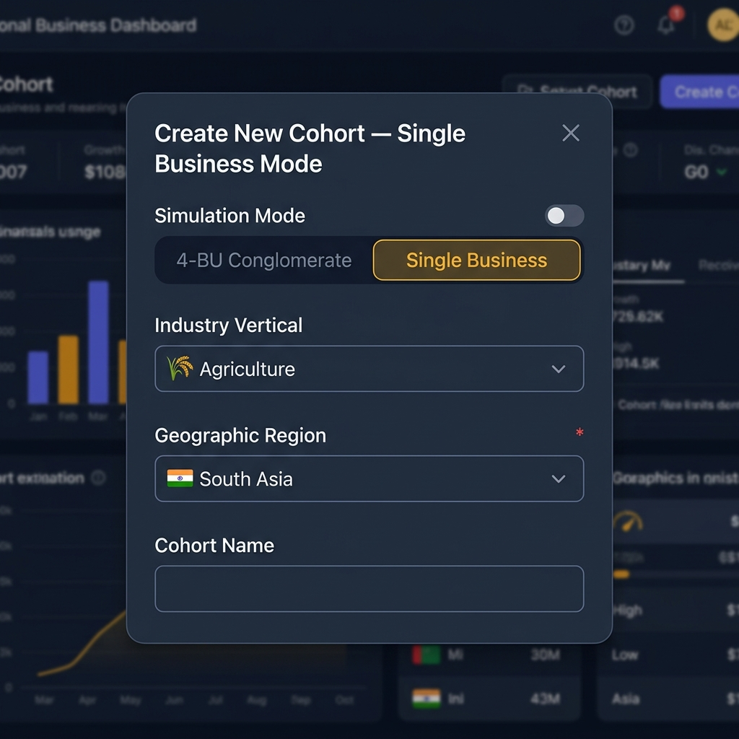
Figure: Create Cohort form in Single Business Mode — showing mode toggle, vertical selector, and mandatory region dropdown.

Step-by-Step: Creating a Single Business Cohort
- Step 1 — Simulation Mode: Toggle to 'Single Business'. The BU composition accordion collapses.
- Step 2 — Industry Vertical: Select the sector for this cohort (Agriculture, Banking & Finance, Oil & Gas, Retail FMCG, Technology, Pharma / Healthcare).
- Step 3 — Geographic Region: Select a region (mandatory — cohort cannot be created without this). Options: ASEAN, South Asia, Europe, North America, Africa.
- Step 4 — Cohort Name & Standard fields: Complete as normal.
- Step 5 — Create. The system will automatically load the industry+region stakeholder profile and activate region-specific black swan events.
ℹ️ You can override a player's region after cohort creation via the Player Registry → Induct Player panel. This is useful if one player is studying a cross-regional operation scenario while the rest of the cohort focuses on the cohort region.

Multi-Region Conglomerate Mode
In the standard 4-BU Conglomerate mode, you can assign a different geographic region to each BU slot. This models a real multinational with divisions operating across different regulatory environments — for example, Pharma in Europe (CSRD), Electronics in ASEAN (ASEAN Taxonomy), Consumer Goods in Africa (GRI/King IV), and Software in North America (SEC).
To configure per-BU regions: in the Create Cohort form with 'Conglomerate' mode selected, expand the BU Composition accordion. Each BU slot will display its own region dropdown. After cohort creation, you can update per-BU regions via:
- Facilitator Dashboard → Session Controls → BU Composition → set bu_regions per slot
- God Mode → Cohort Orchestration → BU Composition editor

God Mode: Stakeholder Configurator
The Stakeholder Configurator (God Mode → Engine Configuration → 👥 Stakeholder Config) allows you to view and edit the stakeholder profiles for any region. Stakeholder data is stored in JSON files per region and is automatically loaded when a player session starts in that region.
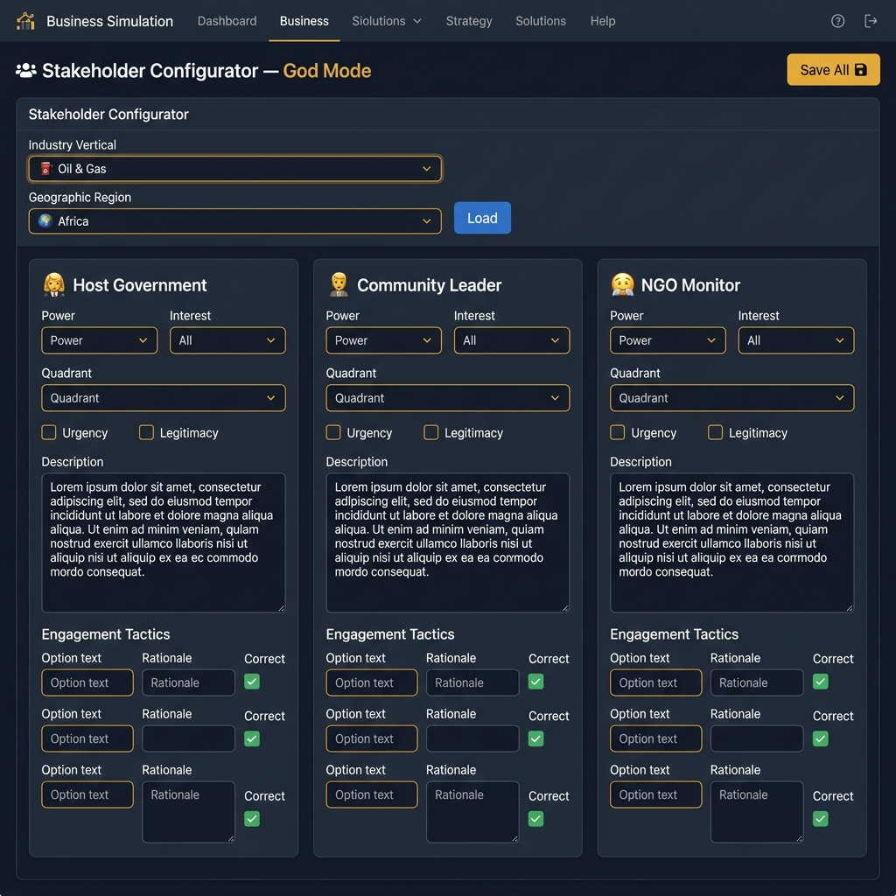
Figure: Stakeholder Configurator — Oil & Gas / Africa configuration showing Host Government, Community Leader, and NGO Monitor profiles.

Stakeholder Profile Fields
Field | Options | Purpose
Power | High / Medium / Low | Mitchell-Agle-Wood salience weighting
Interest | High / Medium / Low | Attention to the company's decisions
Quadrant | Manage Closely / Keep Satisfied / Keep Informed / Monitor | Mendelow positioning
Urgency | Checkbox | Marks time-sensitive claims
Legitimacy | Checkbox | Marks stakeholders with recognised authority
Engagement Tactics | List of options (min 2) | Decision choices shown to players in stakeholder exercises

Salience Score: The sentiment engine weights each stakeholder's attitude impact by salience = Power × Urgency × Legitimacy (Mitchell-Agle-Wood model). A stakeholder with all three attributes is 'Definitive' — their attitude swings have the strongest effect on group reputation and regional risk scores.

God Mode: Pillar Configurator
The Pillar Configurator (God Mode → Engine Configuration → 🏛️ Pillar Configurator) allows you to view and manage industry-specific pillar overrides and add custom strategic decision areas for any vertical.
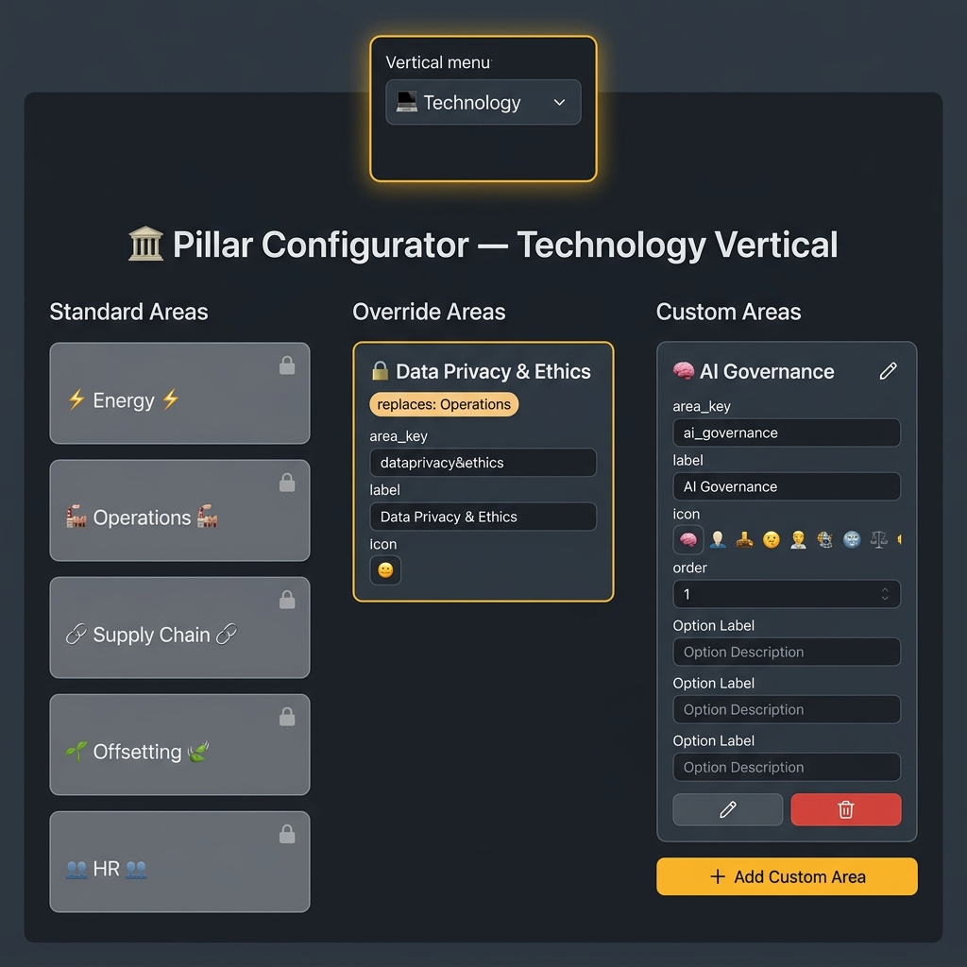
Figure: Pillar Configurator for the Technology vertical — showing the standard areas (left), the 🔒 Data Privacy & Ethics override (centre), and a custom 🧠 AI Governance area (right).

Three-Column Architecture
- Standard Areas (left): The 5 canonical pillar areas (Energy, Operations, Supply Chain, Offsetting, HR). These are read-only — they are defined globally and available in every session.
- Override Areas (centre): Industry-specific replacements for standard areas. For example, 'Data Privacy & Ethics' replaces 'Operations' for Technology verticals. Pre-loaded for all 6 verticals. Edit via the JSON file or through future admin UI.
- Custom Areas (right): Additional pillar areas you create for this vertical. These are appended after the standard/override areas. Use this to add emerging topics or institution-specific ESG themes.

Adding a Custom Pillar Area
- Click '+ Add Custom Area'
- Enter: Area Key (unique slug, e.g. 'ai_governance'), Label, Icon emoji, Display Order
- Add at least 2 options (Option A, Option B, Option C) with labels, rationale, costs, and flag names
- Save — the area immediately becomes available for sessions using that vertical
💡 Facilitator Tip: Custom pillar areas let you tailor the simulation to your institution's specific curriculum. For example, a South Asian business school running an Agriculture cohort might add a 'Crop Insurance & Climate Adaptation' pillar to reflect PMFBY scheme decisions.

Live Stakeholder Sentiment Monitoring
After each round, the simulation's sentiment engine updates every stakeholder's attitude score deterministically based on the decisions made. The Stakeholder Sentiment Panel is available in the Session Viewer and the Executive Cockpit analytics sidebar.
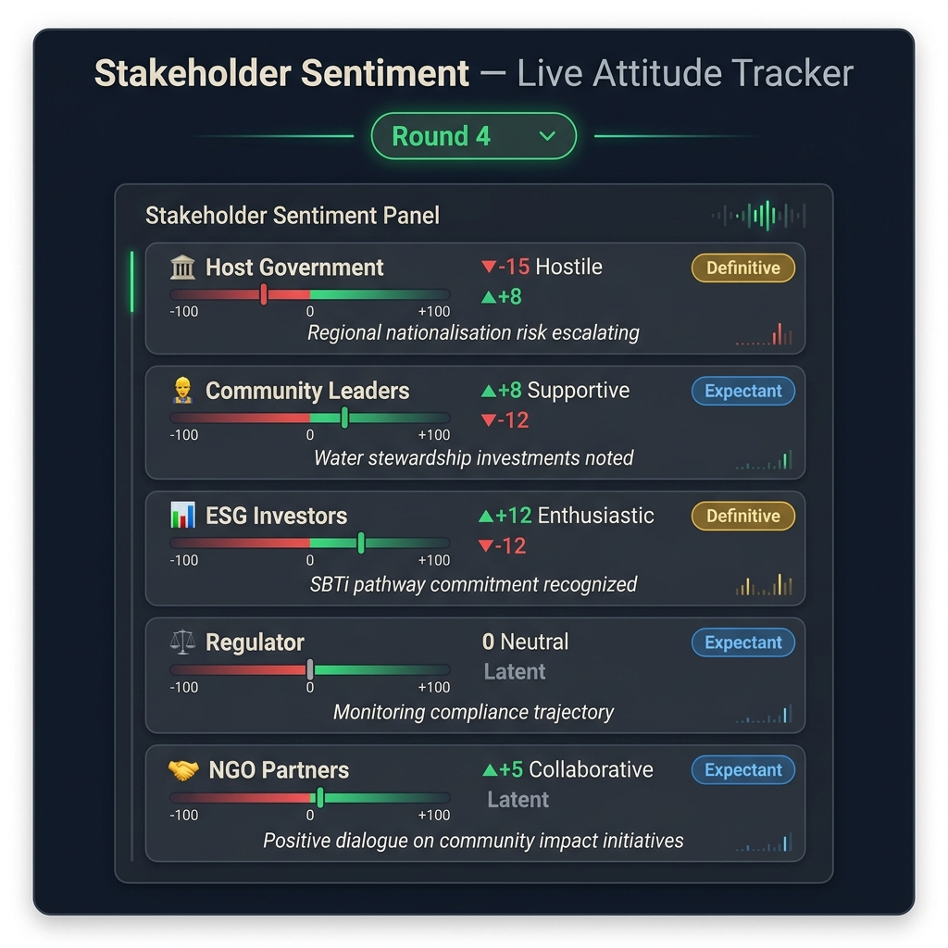
Figure: Stakeholder Sentiment Panel (Round 4) — showing attitude scores, round-on-round deltas, salience badges, and sentiment narratives.

How the Sentiment Engine Works
The engine is fully deterministic — no AI/LLM is used. It operates on a rule table that maps decision flags to attitude deltas per stakeholder type:
Decision Flag (example) | Stakeholder Type | Attitude Delta
renewable_ppa_signed | Regulator | +8
renewable_ppa_signed | Community Leader | +5
zero_investment_round | ESG Investor | −10
whistleblower_scandal (🦢) | All Stakeholders | −20
circular_redesign | NGO Monitor | +12
resource_nationalisation_bs | Host Government | −15

Debrief Use: Show the sentiment panel's round-by-round history in debrief. Ask students: 'Which stakeholder deteriorated fastest, and in which round?' Then trace back to the specific pillar choice that triggered the decline. This creates a 'decision archaeology' discussion that connects choices to long-run relationship outcomes.

Industry Benchmark Comparison Tool
The Industry Benchmark panel (available via the admin API: GET /api/admin/{session_id}/industry-benchmark) compares a team's final KPIs against sector percentile benchmarks for their assigned vertical.
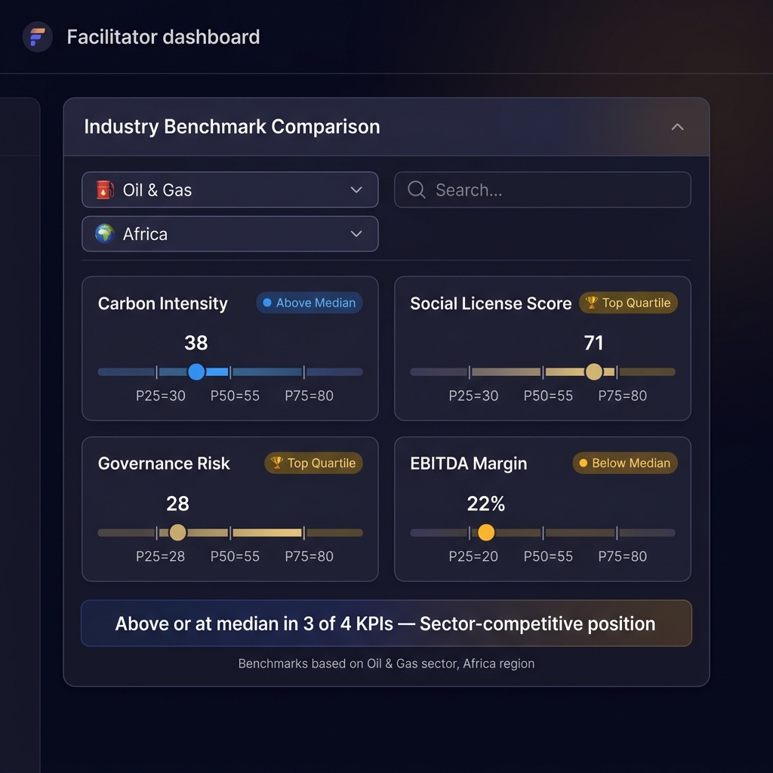
Figure: Industry Benchmark Comparison — Oil & Gas / Africa. Showing player position vs. P25, Median (P50), and P75 benchmarks across Carbon Intensity, Social License, Governance Risk, and EBITDA Margin.

Available Benchmark Verticals
Vertical | Carbon Intensity P50 | Social License P50
🌾 Agriculture | 32 tCO₂/unit | 68/100
🏦 Banking & Finance | 12 tCO₂/unit | 72/100
⛽ Oil & Gas | 55 tCO₂/unit | 58/100
🛒 Retail / FMCG | 28 tCO₂/unit | 70/100
💻 Technology | 18 tCO₂/unit | 75/100
💊 Pharma / Healthcare | 22 tCO₂/unit | 74/100

Debrief Suggestion: Display the benchmark panel for each team simultaneously in the final debrief. Ask: 'Which team is sector-competitive? Which team has a carbon intensity that would trigger a CBAM surcharge or an SEC disclosure flag?' This ground-truths the simulation in real industry data and makes the 'so what?' question viscerally clear.

Regional ESG Report Generator
After a session is complete, you can generate a region-aligned ESG report via the admin API or the Reports Export panel. The report maps the team's decisions to the disclosure requirements of their assigned region's primary framework.
Region | Framework | Key Report Sections
South Asia | SEBI BRSR | NGRBC Principle mapping, Essential vs Leadership indicator audit, ₹ compliance costs
Europe | CSRD / ESRS | Double materiality matrix, ESRS disclosure topics, CSRD transition plan readiness
North America | SEC / TCFD | Scope 1/2/3 emissions, climate risk scenario analysis, governance disclosures
ASEAN | ASEAN Taxonomy | Traffic light classification (Green/Amber/Red), transition activities, social safeguards
Africa | GRI + King IV | Stakeholder inclusivity, integrated value creation, King IV governance principles

Facilitator Controls Reference — New Features
Feature | Location | Access Level
Set cohort mode (Single BU / Conglomerate) | Create Cohort modal | Lead Facilitator, Super Admin
Set industry vertical | Create Cohort modal | Lead Facilitator, Super Admin
Set cohort region (mandatory) | Create Cohort modal | Lead Facilitator, Super Admin
Override player region individually | Player Registry → Induct Player | Lead Facilitator, Super Admin
Set per-BU region (conglomerate mode) | BU Composition editor | Lead Facilitator, Super Admin
Edit regional stakeholder profiles | God Mode → Stakeholder Config | Super Admin only
Add/edit custom pillar areas | God Mode → Pillar Configurator | Super Admin only
View stakeholder sentiment history | Session Viewer → Sentiment tab | All facilitators
View industry benchmark comparison | Session Viewer → Benchmark tab | All facilitators
Generate regional ESG report | Reports Export → Regional ESG | All facilitators
View cohort Industry × Region diversity | Platform Analytics → Cohort Diversity | Lead Facilitator, Super Admin

Cohort Diversity — Industry × Region Heatmap
The Cohort Diversity panel (Platform Analytics → Cohort Diversity) shows a heatmap of how players in a cohort are distributed across Industry Verticals and Geographic Regions. This is particularly useful when running mixed-mode cohorts where different players are assigned different verticals or regions.
- Rows = Industry Verticals (Agriculture, Banking, Oil & Gas, Retail, Technology, Pharma)
- Columns = Geographic Regions (ASEAN, South Asia, Europe, North America, Africa)
- Cell value = number of players in that Industry × Region combination
- Click any cell to see the player IDs assigned to that combination
Use Case: If you are running a global executive education programme with participants from different regions, assign each participant to their own industry and region. The cohort diversity heatmap then becomes a real-time view of the classroom's geographic and sectoral distribution — a conversation starter for cross-regional sustainability comparison.

Common Facilitation Questions
Q: Can I run a single business session alongside a standard 4-BU session in the same class?
Yes. Each cohort's mode is set independently. You can have some teams running as conglomerates and others as single businesses simultaneously. The facilitator dashboard aggregates them all in the leaderboard.
Q: What if no stakeholder config exists for my chosen Industry + Region combination?
The system uses a three-level fallback: Industry + Region → Industry only → the standard global stakeholder set. You will see a console warning, but the session will launch normally. Use the Stakeholder Configurator in God Mode to create the missing configuration.
Q: Can I add a custom region?
The five supported regions (ASEAN, South Asia, Europe, North America, Africa) are hardcoded in the current version. Adding a new region requires creating JSON data files for stakeholder configs and pillar overrides, and adding the region to the VALID_REGIONS validation set in admin_router.py. Contact your system administrator.
Q: The region-specific black swan didn't fire. Is that expected?
Yes — all black swans are probabilistic. A region-specific event has a base probability of approximately 9–12% per eligible round. It is possible to complete the simulation without one triggering. However, if the team's governance risk is high or community trust is low, the probability is modified upward. Consider triggering a black swan manually via the Crisis Overrides panel if you want to ensure students experience it.

Appendix: Balance Sheet — Statement of Financial Position
This appendix provides facilitators with a complete reference to every line item, subtotal, ratio, and indicator displayed on the Muressons balance sheet (Statement of Financial Position). For each item, we explain what it represents in real-world corporate finance, the IFRS standard that governs it, how it is calculated in the simulation engine, and common misunderstandings that students may exhibit.
A balance sheet (formally: Statement of Financial Position under IFRS/IAS 1) is a snapshot of what a company owns (Assets), what it owes (Liabilities), and what is left over for shareholders (Equity) at a single point in time. The fundamental accounting identity is:
Assets = Liabilities + Equity
This identity must always hold. In the Muressons simulation, the balance sheet engine enforces this by deriving Retained Earnings as the residual figure after all asset and liability lines are independently updated each round.

A1.1 Sample Balance Sheet Layout
The following table shows a representative balance sheet as displayed in the simulation's Executive Cockpit. This particular example reflects a company in severe financial distress — a common outcome when students neglect financial sustainability in pursuit of ESG improvements.
Assets | Value | Liabilities & Equity | Value
Non-Current Assets |  | Non-Current Liabilities
Property, Plant & Equipment | $6.3M | Revolving Credit Facility | $50.0M
Right-of-Use Assets (IFRS 16) | $7.5M | Green Bonds Outstanding | $0K
Inventory | $77.1M | Environmental Provisions | $1.0M
 |  | Decommissioning Obligations | $3.0M
 |  | Lease Liabilities (IFRS 16) | $6.6M
Total Tangible Assets | $90.9M | Total Non-Current Liabilities | $60.6M
Intangible Assets |  | Current Liabilities
Brand Value | $5.8M | Trade Payables | $55.1M
Intellectual Property | $23.0M | Tax Provisions | $0K
Goodwill | $10.0M | Accrued Remediation | $0K
 |  | Short-Term Debt | $0K
Total Intangible Assets | $38.8M | Total Current Liabilities | $55.1M
Current Assets |  | TOTAL LIABILITIES | $115.8M
Cash & Equivalents | -$521.1M
Trade Receivables | $3.0M | Shareholders' Equity
Prepayments | $1.0M | Share Capital | $30.0M
 |  | Retained Earnings | -$524.2M
Total Current Assets | -$517.1M | Other Reserves | $5.0M
 |  | TOTAL EQUITY | -$489.2M
TOTAL ASSETS | -$373.4M | NET ASSETS (= Equity) | -$489.2M

A1.2 Non-Current Assets (Tangible)
Non-current assets are resources the company expects to hold for more than 12 months. These are the long-term physical and financial resources that power the business.

Property, Plant & Equipment (PP&E)
The physical assets used in operations — factories, machinery, vehicles, mining equipment, and office buildings. Anything the company uses to produce goods or deliver services.
Real-World Example: A mining company's excavators, processing plants, and conveyor belts. A hotel chain's property portfolio.
How it works in the simulation:
- When players allocate CAPEX, a portion (the capitalisation rate) is added to PP&E rather than expensed immediately.
- Each round, PP&E depreciates at 5% per 6-month round (10% annual, representing a ~10-year useful life for industrial equipment via straight-line depreciation).
- New CAPEX is depreciated starting from the NEXT period only (per IAS 16 §55: depreciation begins when the asset is available for use).
IFRS Standard: IAS 16 — Property, Plant and Equipment

Right-of-Use Assets (IFRS 16)
The value of assets the company leases rather than owns — typically office space, warehouses, or equipment on long-term contracts. Before IFRS 16 (effective 2019), operating leases were hidden off the balance sheet. The standard now requires them to be recognised as both an asset (here) and a liability (Lease Liabilities).
Real-World Example: A 20-year lease on a headquarters building. The company doesn't own the building, but the right to use it has economic value.
How it works in the simulation:
- At initialisation, ROU assets are set to 40% of total revenue (proxy for lease commitments relative to company size).
- Depreciates at 2.5% per round (5% annual, ~20-year property lease term).
IFRS Standard: IFRS 16 — Leases

Inventory
Physical goods the company holds — raw materials waiting to be processed, work-in-progress on the production line, and finished goods ready to sell.
Real-World Example: Stockpiles of iron ore at a mine site, chemicals in a warehouse, or packaged goods ready for shipment.
How it works in the simulation:
- Calculated as a 60-day stock level based on operating expenses: Inventory = (Annual OPEX ÷ 365) × 60 days.
- Updated dynamically each round as OPEX changes.
IFRS Standard: IAS 2 — Inventories. Note: Under IAS 1, inventory would normally be classified as a current asset. The simulation places it under tangible assets for presentational simplicity — a simplification that facilitators may wish to discuss with advanced students.

A1.3 Intangible Assets
Assets that have value but no physical form. They cannot be seen or touched, but they generate economic benefits for the company.

Brand Value
The monetary value of the company's brand name — the premium customers are willing to pay because of the company's reputation and recognition.
Real-World Example: The Coca-Cola brand is estimated to be worth over $80 billion. People pay more for Coke than for a generic cola because of the brand.
Simulation formula:
Brand = Base × (Reputation ÷ 50) × √(Social Licence ÷ 50)
Floor: $1M minimum (residual brand value always exists)
Base is FIXED at initialisation — prevents exponential compounding (FIX-2).
IFRS Standard: IAS 38 — Intangible Assets. Only acquired brands can be recognised under IFRS. Internally generated brands cannot be capitalised.

Intellectual Property (IP)
Patents, proprietary technologies, trade secrets, copyrights, and other knowledge-based assets that give the company a competitive advantage.
Real-World Example: A pharmaceutical company's drug patents, a tech company's software algorithms, or a manufacturer's proprietary process.
How it works in the simulation:
- Set at initialisation: $15M base + $2M per BU. Fixed throughout unless impairment is triggered.
IFRS Standard: IAS 38 — Intangible Assets

Goodwill
The premium paid when acquiring another company above the fair value of its identifiable net assets. Represents customer relationships, employee expertise, synergies, and market position that cannot be individually valued.
Real-World Example: If Company A buys Company B for $50M, but Company B's identifiable assets minus liabilities are only worth $40M, the extra $10M is recorded as goodwill.
Key accounting rules:
- Goodwill is NEVER amortised (written down gradually) — instead, it must be tested for impairment at least annually (IAS 36).
- In the simulation, impairment is tested every 2 rounds (annual equivalent) with a dual trigger: reputation < 40 OR EBITDA margin < 10%.
- Impairment uses a smooth continuous formula rather than a cliff: Rep_Rate = max(0, (40 − Rep) / 200); Margin_Rate = max(0, (0.10 − Margin) × 0.5). Combined rate capped at 30% per test.
IFRS Standards: IFRS 3 — Business Combinations (recognition); IAS 36 — Impairment of Assets (annual testing)

Non-GAAP ESG Capitals (Off-Balance-Sheet Disclosures)
Two additional capital items are displayed on the balance sheet with a "†" marker but are explicitly excluded from Total Assets:
- Social Licence Capital — a monetary estimate of community trust and acceptance (calculated as Average SLO Score × $200K).
- Reputation Capital — a monetary estimate of corporate reputation (calculated as Group Reputation Score × $300K).
These items are disclosed under the Integrated Reporting <IR> Framework's Six Capitals model for pedagogical purposes. Under IAS 38, internally generated intangibles (brands, mastheads, customer relationships) cannot be recognised as assets because their cost cannot be reliably measured.
Scholarly ESG Toggle (Facilitator Feature):
Facilitators can activate the "Scholarly View" toggle in God Mode to move these items onto the GAAP balance sheet as intangible assets. This is a pedagogical "what-if" mode that explores the academic debate around recognising social and natural capital. When activated, a prominent amber banner appears and Total Assets increases by the ESG capital amounts. References: IIRC <IR> Framework (2021); Barker & Eccles (2011); Gleeson-White (2014).

A1.4 Current Assets
Assets the company expects to convert to cash within 12 months — the liquid, short-term resources.

Cash & Equivalents
Money in the bank — cash on hand, bank deposits, and highly liquid short-term investments (like money market funds) that can be converted to cash almost instantly.
How it works in the simulation:
- Synced from the corporate_treasury variable each round (single source of truth).
- Can go negative — representing a massive bank overdraft. In real IFRS practice, overdrafts repayable on demand would typically be reclassified as a current liability (IAS 7/IAS 1), but the simulation retains them here for simplicity.
Facilitator Discussion Point: Ask students whether a -$521M cash balance should be shown as a negative asset or reclassified as a liability. What changes in the balance sheet presentation? (Answer: Total Assets increases, Total Liabilities increases by the same amount, Equity is unchanged.)

Trade Receivables
Money that customers owe the company for goods or services already delivered but not yet paid for. Essentially, invoices sent but payment not yet received.
Simulation formula:
DSO_Factor = min(0.25, 0.12 + 0.001 × Avg_Governance_Risk)
Trade_Receivables = Total_Revenue × DSO_Factor
- Higher governance risk → longer Days Sales Outstanding (DSO) → higher receivables.
IFRS Standard: IFRS 9 — Financial Instruments; IFRS 15 — Revenue from Contracts

Prepayments
Money the company has paid in advance for goods or services it hasn't received yet — insurance premiums paid upfront, rent paid ahead of time, or deposits on future orders.
- Set at $250K per BU at initialisation. Fixed throughout the simulation.

A1.5 Non-Current Liabilities
Debts and obligations the company must pay, but not within the next 12 months. These are long-term commitments.

Revolving Credit Facility
A pre-arranged line of credit with a bank — like a corporate credit card. The company can draw down funds, repay them, and draw again up to the agreed limit.
- Set at $12.5M per BU ($50M for standard 4-BU configuration).
- This is the primary loan facility. If covenants are breached, the bank can "accelerate" — demand immediate full repayment.

Green Bonds Outstanding
Bonds issued specifically to fund environmentally beneficial projects — renewable energy, pollution reduction, sustainable infrastructure. Issued by player decision (e.g. Round 3 Scope 3 investment option).
Real-World Example: Apple issued $4.7B in green bonds to fund clean energy and recycling initiatives.

Environmental Provisions
Money set aside for expected future environmental cleanup costs — soil remediation, water treatment, pollution cleanup, or habitat restoration that the company is legally obligated to perform.
Simulation formula:
NCD_Provision = NCD × $20,000 per unit
Event_Provision = Number_of_Remediation_Events × $500,000
Total = max(Minimum_Floor, NCD_Provision + Event_Provision)
- Provisions can DECREASE when Natural Capital Debt falls — IAS 37 §59 permits reversal of provisions when the obligating event no longer exists. This was a deliberate design choice (FIX-6) to reward students who invest in nature-based solutions.
IFRS Standard: IAS 37 — Provisions, Contingent Liabilities and Contingent Assets

Decommissioning Obligations
The estimated cost of dismantling and removing assets at the end of their useful life — tearing down a factory, plugging an oil well, or restoring a mine site to its natural state.
- Recorded at present value at initialisation ($750K per BU).
- Grows each round through "accretion" — adding back the time-value-of-money component (3% annual discount rate, halved for 6-month periods).
IFRS Standard: IAS 37 + IFRIC 1 — Changes in Existing Decommissioning Liabilities

Lease Liabilities (IFRS 16)
The counterpart to the Right-of-Use Asset. This is the total remaining obligation to make lease payments over the life of the lease.
- Initialised at 35% of total revenue (slightly less than ROU at 40%, representing the advance-payment component).
- Amortises at 2.5% per round (5% annual, matching the 20-year lease term).
IFRS Standard: IFRS 16 — Leases

A1.6 Current Liabilities
Debts and obligations due within the next 12 months.

Trade Payables
Money the company owes to its suppliers for goods and services already received but not yet paid for. The mirror image of Trade Receivables.
Simulation formula:
DPO_Factor = min(0.18, 0.10 + 0.0005 × Avg_Governance_Risk)
Trade_Payables = Total_OPEX × DPO_Factor
Facilitator Discussion Point: When payables greatly exceed receivables (e.g. $55M vs $3M), it signals the company is stretching supplier payments to conserve cash — a classic indicator of financial distress.

Tax Provisions
Tax the company expects to owe based on current-period profits. Zero when the company is making losses (no taxable income = no tax provision).
Tax_Provisions = max(0, Gross_Profit × Tax_Rate × 0.20)

Accrued Remediation
Short-term environmental cleanup costs due within 12 months, triggered by specific crisis events during the simulation.

Short-Term Debt
Loans or borrowings due within one year — bank loans, commercial paper, or the current portion of long-term debt.

A1.7 Shareholders' Equity
What remains for shareholders after subtracting all liabilities from all assets. This is the owners' residual claim on the company.

Share Capital
The money originally invested by shareholders when the company issued its shares. This is "permanent" capital that does not change unless new shares are issued or existing shares are bought back.
- Set at $7.5M per BU ($30M for 4 BUs). Fixed throughout the simulation.

Retained Earnings
The cumulative total of all profits ever earned minus all dividends ever paid since the company was founded. This is the running scorecard of whether the business has been profitable over its entire history.
How it works in the simulation:
Rather than tracking profit/loss incrementally, the simulation derives Retained Earnings as a RESIDUAL to force the balance sheet to balance:
Retained_Earnings = Total_Assets − Total_Liabilities − Share_Capital − Other_Reserves
This means Retained Earnings absorbs all movements in assets and liabilities. When cash drops, Retained Earnings drops by the same amount. When liabilities increase, Retained Earnings decreases. The net_income figure from the income statement is preserved in diagnostics for scoring and teaching purposes.

Other Reserves
A catch-all for equity items that aren't Share Capital or Retained Earnings — revaluation reserves, foreign currency translation reserves, and hedging reserves.
- Set at $1.25M per BU ($5M for 4 BUs). Fixed throughout the simulation.

A1.8 Key Ratios & Covenant Status

Debt / Equity Ratio
Measures how much debt the company uses relative to shareholders' equity — a measure of financial leverage.
D/E = Total_Liabilities ÷ Total_Equity
Normal range: 0.5x to 2.0x
Capped at 99x when equity is negative (ratio is meaningless)

Net Debt / EBITDA
Measures how many years of earnings it would take to repay all net debt. The primary covenant metric used by banks.
Net_Debt = (Revolving_Credit + Green_Bonds + Short_Term_Debt) − Cash
EBITDA = Gross_Profit + Depreciation (FIX-4: true EBITDA with D&A addback)
Ratio = Net_Debt ÷ EBITDA
Capped at 99x when EBITDA is zero or negative

Stranded Asset Exposure
The dollar value of physical assets at risk of becoming worthless due to the transition to a low-carbon economy. Based on Carbon Tracker Initiative methodology.
CI_Risk = min(0.5, Carbon_Intensity_Avg ÷ 200)
Total_Risk = min(0.80, CI_Risk + Pathway_Risk + Tipping_Risk)
Stranded_Exposure = PP&E × Total_Risk

Covenant Status
Covenants are conditions in the company's loan agreements. Breach triggers escalating consequences:
Status | Condition | Consequence
🟢 Comfortable | ND/EBITDA ≤ 2.5x | Banks satisfied. No action required.
🟡 Watch List | 2.5x < ND/EBITDA ≤ Trigger | Banks request periodic updates.
🔴 Breach | Trigger < ND/EBITDA ≤ Trigger + 1.0x | 30-day cure period. 2% interest surcharge.
🚨 Acceleration | ND/EBITDA > Trigger + 1.0x | Banks can demand immediate repayment. 5% surcharge.

The trigger ratio is dynamic — it tightens when the ESG-Adjusted WACC exceeds 8% (by -0.25x per 1% excess). This models the empirical finding that ESG risk increases lender scrutiny (El Ghoul et al., 2011).

A1.9 Common Student Misconceptions & Facilitator Responses
Misconception | Correct Understanding | Suggested Response
"Negative cash means we're bankrupt." | Negative cash means a bank overdraft. Insolvency depends on whether total liabilities exceed total assets (i.e. negative equity). | "Is the company insolvent because of the cash, or because of the accumulated losses? What does equity tell you?"
"We should maximise Total Assets." | Asset growth is only valuable if it generates returns above cost of capital. Accumulating unproductive assets destroys value. | "What is the Return on Assets? Is growing the asset base actually creating shareholder value?"
"Goodwill never changes." | Goodwill must be tested for impairment annually. Low reputation or poor margins trigger write-downs. | "What happens to goodwill when the company's reputation drops below 40? Check the IAS 36 impairment trigger."
"The † ESG items should be included in our assets." | IAS 38 prohibits capitalising internally generated intangibles. The <IR> Framework advocacy for this is a scholarly debate, not current GAAP. | "Activate the Scholarly Toggle and compare the two views. What would change if regulators accepted the <IR> Framework argument?"
"High trade payables is good — we're conserving cash." | Stretching supplier payments signals distress and damages supplier relationships. It is a symptom, not a strategy. | "What happens to your supply chain when suppliers learn you can't pay? Compare payables to receivables — what does the 18:1 ratio tell you?"

A1.10 Accounting Equation — Worked Walkthrough
This section walks through the fundamental accounting identity using the sample balance sheet above, demonstrating how every subtotal connects:
ASSETS:
Total Tangible Assets: $6.3M + $7.5M + $77.1M = $90.9M
Total Intangible Assets: $5.8M + $23.0M + $10.0M = $38.8M
Total Current Assets: -$521.1M + $3.0M + $1.0M = -$517.1M
TOTAL ASSETS: $90.9M + $38.8M + (-$517.1M) = -$387.4M
LIABILITIES:
Total Non-Current: $50.0M + $0 + $1.0M + $3.0M + $6.6M = $60.6M
Total Current: $55.1M + $0 + $0 + $0 = $55.1M
TOTAL LIABILITIES: $60.6M + $55.1M = $115.7M
EQUITY:
Share Capital + Retained Earnings + Other Reserves
= $30.0M + (-$524.2M) + $5.0M = -$489.2M
VERIFICATION:
Net Assets = Total Assets − Total Liabilities
= -$387.4M − $115.7M = -$503.1M
Total Equity = -$489.2M
✓ A = L + E holds (minor rounding differences from display formatting)
The key insight for students: Retained Earnings of -$524.2M means the company has destroyed $524M of value over its lifetime. Starting from $35M of original equity (Share Capital + Reserves), the business has burned through all of it and then some — resulting in a net equity hole of -$489M. This is technical insolvency: liabilities exceed assets, and shareholders' claims are worthless.

Section: BRSR NGRBC Decision Paradigm — Complete Facilitator Guide

Overview
The BRSR (Business Responsibility and Sustainability Reporting) NGRBC (National Guidelines on Responsible Business Conduct) pathway is a 5-round decision paradigm that replaces the default 10-round narrative crisis model with India-specific ESG regulatory challenges. It is designed for courses focused on Indian corporate governance, SEBI regulations, and the NGRBC framework.
When the BRSR paradigm is selected by the facilitator, the simulation runs for 5 rounds (not 10), and the display currency defaults to Indian Rupees (₹). Each round maps to specific NGRBC Principles (P1–P9), with escalating regulatory pressure culminating in a terminal BRSR filing.
[IMPORTANT] The BRSR paradigm is a STANDALONE paradigm — it replaces the standard Legacy A/B/C and Strategic Pillars modes entirely. It cannot be combined with the SDG or Healthcare paradigms.

How to Activate
- Open the Facilitator Dashboard → Cohort Settings → Decision Paradigm
- Select "BRSR NGRBC Edition" (🇮🇳 icon)
- The paradigm is locked after selection — it cannot be changed mid-game
- All player sessions in the cohort will inherit the BRSR paradigm

Dual Decision Interface
The BRSR paradigm supports two parallel decision modes. Players see both simultaneously:
1. Legacy A/B/C Options — Three strategic options per round graded by ambition:
Grade | Pattern | Description
Option A | Leadership Indicator | Maximum investment, exceeds SEBI requirements, sets governance best-practice flags
Option B | Essential Indicators | Moderate investment, meets all Essential Indicator requirements
Option C | Below Compliance | Minimal/zero investment, fails Leadership requirements, sets risk flags

2. Strategic Pillars Mode — Five independent pillar areas per round, each with 3 granular options:
Area Key | Typical Labels (vary by round)
energy | Board ESG Governance / Water & Discharge / Supply Chain Traceability / Integrated Reporting
operations | Ethics & Anti-Corruption / OHS Compliance / EPR & Waste / Assurance & Verification
supply_chain | Stakeholder Engagement / Human Rights DD / Circular Economy / Disclosure Cross-Refs
offsetting | CSR Impact Reporting / Wage & Welfare Fund / Climate Disclosure / Materiality Validation
human_resources | Board Diversity / DEI & Pay Equity / Green Skills / Investor Communication

When players use Strategic Pillars mode, their selections are automatically translated to the closest legacy option_a/b/c using a flag-based priority system with cost-based fallback.

NGRBC Principle Mapping
Round | NGRBC Principles | Theme
R1 | P1 (Ethics & Transparency), P7 (Policy Advocacy) | Governance structures, board declarations, political contributions
R2 | P3 (Employee Wellbeing), P5 (Human Rights) | Living wages, OHS, POSH, DEI, supply chain HRDD
R3 | P6 (Environmental Protection), P2 (Sustainable Products) | Water discharge, EPR, circularity, climate disclosure, Scope 3
R4 | P4 (Stakeholder Engagement), P8 (Inclusive Growth) | BRSR Core, value chain assurance, supplier development
R5 | P9 (Customer Value), P1–P8 (Integrated) | Final disclosure, ESG-financial connectivity, materiality validation

Round-by-Round Facilitator Guide

Round 1 — Governance & Transparency (P1 & P7)
Crisis: SEBI notifies the top 1,000 listed companies. Muressons must establish a BRSR Steering Committee. MCA's NGRBC guidelines require a signed Board declaration. Political contributions from the Consumer Goods BU's lobbying in Delhi surface in an RTI query.
Legacy Options:
Option | Title | Treasury | Reputation | Gov. Risk | Key Flags
A | Radical Transparency (Leadership) | −₹4.0M | +10 | −8 | brsr_pioneer, brsr_indicator_leadership
B | Standard Compliance (Essential) | −₹2.0M | +5 | −3 | brsr_indicator_essential
C | Reactive Disclosure (Below) | −₹0.5M | −5 | +10 | governance_fragility

Strategic Pillars:
Area | Leadership Option (Cost) | Essential Option (Cost) | Status Quo
⚡ Board ESG Governance | Board ESG Committee (−₹3M) | Compliance Sub-Committee (−₹1M) | No Action
🏭 Ethics & Anti-Corruption | Ethics Officer + Whistleblower (−₹2M) | Basic Code of Conduct (−₹800K) | No Action
🔗 Stakeholder Engagement | Multi-Stakeholder Advisory (−₹2.5M) | Annual Stakeholder Meet (−₹800K) | No Action
🌱 CSR Impact Reporting | CSR Impact Dashboard (−₹1.5M) | Basic CSR Report (−₹500K) | No Investment
👥 Board Diversity | Board Diversity Matrix (−₹1.2M) | Gender Disclosure (−₹400K) | No HR Action

Hidden Mechanics (DO NOT REVEAL):
- Option C sets governance_fragility — this cascades forward with compounding 4% governance drag from R3, and triggers a Whistleblower Leak crisis at R5 (−₹2.5M treasury)
- Option A sets brsr_pioneer — contributes to BRSR Pioneer archetype and ESG Alpha Dividend
Debrief Prompts:
- How does SEBI's 'comply or explain' approach differ from the EU's CSRD mandatory disclosure?
- What are the trade-offs between a Board-level ESG Committee vs. embedding ESG in existing committees?

Round 2 — Workforce & Human Rights (P3 & P5)
Crisis: Electronics BU unions in Chennai demand living wage disclosures (Leadership Indicator under P3). Pharma BU contract workers face OHS gaps at API plants. POSH committee reports highlight inconsistencies.
Legacy Options:
Option | Title | Treasury | Social License | Burnout | Flags
A | Living Wage Standard (Leadership) | −₹8.0M | +15 | −12 | brsr_living_wage
B | Safety & POSH Focus (Essential+) | −₹4.0M | +5 | −5 | brsr_indicator_essential
C | Statutory Minimums Only | ₹0 | −10 | +5 | brsr_statutory_minimums

Strategic Pillars:
Area | Leadership Option (Cost) | Essential Option (Cost) | Status Quo
⚡ OHS Compliance | ISO 45001 Upgrade (−₹3M) | Basic Safety Audit (−₹1M) | No Action
🏭 Labour Practices | Fair Wage Transparency (−₹2.5M) | Wage Disclosure (−₹800K) | No Action
🔗 Human Rights DD | Tier-1 HRDD (−₹2.5M) | Supplier Questionnaire (−₹500K) | Defer
🌱 Wage & Welfare Fund | Living Wage Gap Fund (−₹2M) | Statutory Compliance Fund (−₹600K) | No Investment
👥 DEI & Pay Equity | DEI Dashboard & Training (−₹1.5M) | Gender Pay Audit (−₹700K) | No HR Action

Hidden Mechanics:
- Option A reduces burnout by 12 across ALL BUs and increases workforce readiness by 8
- Option C increases strike probability by +0.15 (capped at 0.6) and sets brsr_labor_unrest_risk
Theory Connection:
- NGRBC Principle 3 — living wage as a Leadership Indicator, not just minimum wage compliance
- UN Guiding Principles on Business and Human Rights (UNGPs) — HRDD methodology

Round 3 — Environment & Circularity (P6 & P2)
Crisis: CPCB flags Pharma BU's water discharge for API residues. EPR scrutiny for Electronics (e-waste) and Consumer Goods (plastics). BRSR demands Scope 1+2 GHG intensity.
Legacy Options:
Option | Title | Treasury | NCD | Carbon | Flags
A | Circular Symbiosis & ZLD (Leadership) | −₹10.0M | −15 | −5 | brsr_circular_symbiosis
B | Efficiency Upgrades & EPR (Essential+) | −₹6.0M | −8 | — | brsr_indicator_essential
C | Regulatory Minimums | −₹2.0M | +5 | +2 | brsr_regulatory_minimum

Strategic Pillars:
Area | Leadership Option (Cost) | Essential Option (Cost) | Status Quo
⚡ Water & Discharge | ZLD for Pharma API (−₹3M) | Water Recycling (−₹1.2M) | No Change
🏭 EPR & Waste Mgmt | EPR Full Compliance (−₹2.5M) | Basic Segregation (−₹800K) | No Change
🔗 Circular Economy | Waste-to-Energy Partner (−₹1.8M) | EPR Registration (−₹600K) | Defer
🌱 Climate Disclosure | SBTi Scope 3 Pathway (−₹2.5M) | Scope 1+2 Reporting (−₹800K) | No Investment
👥 Green Skills | Green Skills Academy (−₹1.5M) | Basic EHS Training (−₹400K) | No HR Action

Hidden Mechanics:
- Option A: NCD interest rate reduced by 1.2%, synergy multiplier +0.30 (capped at 1.5)
- Option C: CPCB penalty of −₹5M treasury, NCD rate +1%
- If governance_fragility is active from R1, a compounding 4% governance drag activates this round

Round 4 — Value Chain & BRSR Core
Crisis: SEBI introduces 'BRSR Core' for value chain disclosures. Muressons falls in the top 250 glide path — reasonable assurance mandatory for 9 key attributes. Tier-2 electronics suppliers face child labor scrutiny.
Legacy Options:
Option | Title | Treasury | Reputation | Gov. Risk | Flags
A | Multi-Tier Assurance (Leadership) | −₹6.0M | +12 | −10 | brsr_core_assured
B | Tier-1 Screening (Essential) | −₹2.0M | +4 | −3 | brsr_indicator_essential
C | Self-Assessment Only | −₹0.5M | −8 | +8 | brsr_greenwash_risk

Strategic Pillars:
Area | Leadership Option (Cost) | Essential Option (Cost) | Status Quo
⚡ Supply Chain Traceability | Blockchain Traceability (−₹3M) | Tier-1 Digital Portal (−₹1M) | No Change
🏭 Assurance & Verification | Big 4 Reasonable Assurance (−₹2.5M) | Limited Assurance (−₹1.2M) | Self-Assessment (−₹300K)
🔗 Supplier Development | MSME Supplier Dev (−₹2M) | Annual Supplier Audit (−₹800K) | Defer
🌱 Consumer & Stakeholder | Consumer Grievance Analytics (−₹1.8M) | CSR Documentation (−₹500K) | No Investment
👥 Supplier ESG Capacity | ESG Training Program (−₹1.5M) | Basic Awareness (−₹400K) | No HR Action

Hidden Mechanics:
- CRITICAL: Option C sets brsr_greenwash_risk — triggers a SEBI Show-Cause Notice with −12 reputation and −₹10M SEBI penalty. Audit tolerance drops to 20 (hostile).
- Option A: reputation +8, audit tolerance ≥65 (protected). In R5, crisis severity is reduced by 10.

Round 5 — Integrated Disclosure & ESG Alpha
Crisis: FY-end filing deadline. The Board demands the final BRSR submission. Investor Relations must present the ESG narrative to CRISIL and Sustainalytics.
Legacy Options:
Option | Title | Treasury | Reputation | Flags
A | Integrated Report (Leadership) | −₹4.0M | +15 | brsr_integrated_report
B | Strategic BRSR (Essential+) | −₹2.0M | +6 | brsr_indicator_essential
C | Compliance File | −₹0.5M | −3 | brsr_compliance_only

Strategic Pillars:
Area | Leadership Option (Cost) | Essential Option (Cost) | Status Quo
⚡ Integrated Reporting | Six Capitals Report (−₹2.5M) | Strategic KPIs (−₹1M) | Minimal Filing (−₹200K)
🏭 ESG-Financial Connectivity | ESG-Financial Dashboard (−₹2M) | Sector Benchmarking (−₹800K) | No Change
🔗 Disclosure Cross-Refs | GRI/TCFD Mapping (−₹1.5M) | Basic GRI Index (−₹500K) | Defer
🌱 Materiality Validation | Third-Party Materiality (−₹2M) | Internal Matrix (−₹600K) | No Investment
👥 Investor Communication | Analyst & IR ESG Pack (−₹1.2M) | Board Summary (−₹400K) | No HR Action

Hidden Mechanics:
- Option A: ESG Alpha Dividend = +0.05 M_R (5% terminal valuation uplift). If score ≥70, CRISIL AAA Green Bond discount: NCD rate −1.5%
- Option C: Blocks Truth Premium, NCD rate +1.5% (green bond downgrade)
- If governance_fragility active: Whistleblower Leak crisis fires — treasury −₹2.5M, governance risk +15

Scoring Mechanics

BRSR Performance Score (0–100)
The BRSR Score is computed across 5 weighted dimensions mapped to NGRBC principles:
Dimension | Weight | Principles | Score Derivation
Governance & Ethics | 20% | P1, P7 | brsr_pioneer → 100 · governance_fragility → 20 · else 60
Human Capital | 20% | P3, P5 | brsr_living_wage → 100 · else 50
Environmental Stewardship | 25% | P6, P2 | brsr_circular_symbiosis → 100 · sdg_12_leadership → 80 · else 40
Value Chain & Stakeholder | 20% | P4, P8, P9 | brsr_core_assured → 100 · brsr_greenwash_risk → 20 · else 50
Integrated Disclosure | 15% | All | brsr_integrated_report → 100 · else 40

Formula: BRSR Score = Σ(dimension_score × weight)

Grading & Archetypes
Grade | Score Range | Archetype | Description
A+ | ≥ 90 | BRSR Pioneer 🏆 | Exemplary NGRBC Leadership + rigorous assurance
A | 80–89 | Responsible Steward 🌿 | Meets Essential reliably, strategic Leadership in material areas
B | 60–79 | Compliance Pragmatist 📋 | Mandatory compliance but unchecked ESG risks
C | 40–59 | Compliance Pragmatist 📋 | Minimum viable compliance
D | 20–39 | Regulatory Laggard ⚠️ | Fails basic Essential indicators
F | < 20 | Regulatory Laggard ⚠️ | Complete failure, high regulatory risk

Terminal Valuation Impact
Condition | M_R Impact
BRSR Pioneer (all A choices, score ≥ 90) | +0.05 M_R (ESG Alpha Dividend)
brsr_integrated_report active | No disclosure haircut (full exit multiple)
brsr_compliance_only at R5 | Disclosure haircut applied
brsr_greenwash_risk active | ESG risk discount on valuation

[TIP] Maximum M_R achievable with a full BRSR Pioneer path is approximately ~1.98 (1.0 base + 0.05 BRSR + wellbeing/steward bonuses − instability adjustments).

BRSR-Specific Crisis Events
Event | Trigger | Impact
SEBI Show-Cause Notice | brsr_greenwash_risk at R4 | −12 reputation, −₹10M SEBI penalty
Whistleblower Governance Leak | governance_fragility at R5 | −₹2.5M treasury, gov risk +15
Assurance Bonus | brsr_core_assured at R5 | Crisis severity −10

Flag Cascade System
Flags set in earlier rounds cascade forward to influence later round outcomes and final scoring. This is the core pedagogical mechanism — early decisions have compounding effects.
Flag | Set By | Cascade Effect
brsr_pioneer | R1 Option A | Gov risk −8 all BUs. Contributes to Pioneer archetype.
governance_fragility | R1 Option C | R3: +4% gov drag. R5: crisis+15, whistleblower −₹2.5M.
brsr_living_wage | R2 Option A | Burnout −12 all BUs. Workforce readiness +8.
brsr_statutory_minimums | R2 Option C | Strike risk +0.15 (capped 0.6). Labour unrest flag.
brsr_circular_symbiosis | R3 Option A | NCD rate −1.2%. Synergy +0.30.
brsr_regulatory_minimum | R3 Option C | NCD rate +1%. CPCB penalty −₹5M.
brsr_core_assured | R4 Option A | Rep +8. Audit tolerance ≥65. R5: crisis −10.
brsr_greenwash_risk | R4 Option C | Audit →20 (hostile). SEBI −₹10M. Rep −12.
brsr_integrated_report | R5 Option A | +0.05 M_R. NCD −1.5% if score ≥70.
brsr_compliance_only | R5 Option C | Truth Premium blocked. NCD +1.5%.

Pillar → Legacy Translation Rules
Round | option_a Flag Trigger | option_b Flag Trigger | option_c Flag Trigger
1 | brsr_pioneer | brsr_ethics_officer | governance_fragility
2 | brsr_living_wage | brsr_indicator_essential | brsr_statutory_minimums
3 | brsr_circular_symbiosis | brsr_indicator_essential | brsr_regulatory_minimum
4 | brsr_core_assured | brsr_indicator_essential | brsr_greenwash_risk
5 | brsr_integrated_report | brsr_indicator_essential | brsr_compliance_only

Cost-based fallback: If no flag matches, total pillar cost ≤ −₹8M → option_a, ≤ −₹3M → option_b, else → option_c.

BRSR Certificate (Game Over)
When the BRSR track completes at Round 5, the Game Over screen renders a BRSR NGRBC Certificate showing the player's grade, archetype, compliance score out of 100, and a 5-column NGRBC Principle pass/fail grid. Each principle is marked ✅ if the player chose at least Essential-level compliance (not option_c).

Facilitator Talking Points
Post-Round 1:
- How does SEBI's 'comply or explain' differ from the EU's CSRD mandatory disclosure?
- What governance structures does the NGRBC framework recommend beyond a compliance committee?
Post-Round 2:
- Why is living wage a Leadership Indicator and not an Essential one under P3?
- How do POSH compliance gaps affect organisational social license?
Post-Round 3:
- What is the business case for Zero Liquid Discharge vs. the cost of regulatory penalties?
- How does EPR compliance create circular revenue streams?
Post-Round 4:
- What is the difference between limited and reasonable assurance? Why does BRSR Core mandate the latter?
- How does greenwash risk compound with earlier governance choices?
Post-Round 5 (Debrief):
- Compare your BRSR score with peers — what decisions drove the biggest divergence?
- How does the ESG Alpha Dividend concept translate to real-world ESG-linked valuations?
- Discuss the 'compounding cost of inaction' — how did R1 governance choices affect R5 outcomes?

God Mode Controls
The God Mode Intelligence Panel includes a BRSR section showing platform-wide data: Track Completions, BRSR Pioneers, Greenwash Risk count, Governance Fragility count, Average BRSR Score, and Crises Injected. The engine toggle 'brsr_ngrbc_enabled' can enable/disable the BRSR track dynamically.

