MURESSONS GLOBAL CORPORATION
Facilitator's Manual
Project Equilibrium — Strategy Simulation

CONFIDENTIAL — For Facilitator Use Only
Version 1.0 — May 2026
10-Round Loop | 4 Side Tracks | 5 Ending Pathways | 5 Autonomous Agents

Table of Contents
Part 1 — Foundation & Engine
§1. Pedagogical Overview & Learning Objectives
§2. Theoretical Foundations & Academic Integration
§3. Mathematical Engine Reference
Part 2 — Round-by-Round Facilitation Guide
§4. Round-by-Round Guide (R1–R10)
Part 3 — Advanced Systems
§5. Shadow Board Audit Deep Dive
§6. Ending Pathways
§7. Terminal Valuation Deep Dive
§8. Side Tracks
§9. Autonomous Stakeholder Agents
§10. Facilitator God Mode & Overrides
Part 4 — Dashboard Guides, Planning & Appendices
§10A. Facilitator Dashboard Visual Guide
§10B. God Mode Dashboard Visual Guide
§10C. Industry Vertical Swapping Guide
§11. Common Student Pitfalls & Teaching Moments
§12. Quick-Reference Cards
§13. Session Planning & Logistics
§14. Assessment & Grading Rubric
§15. Facilitator FAQ
Appendix A: Glossary of Definitions
Appendix B: Complete Engine Variable Registry
Appendix C: Academic Reference Matrix

PART 1 — FOUNDATION & ENGINE

§1. Pedagogical Overview & Learning Objectives

1.1 Core Narrative & Simulation Premise
Muressons Global Corporation is a multi-divisional conglomerate operating across four business units: Pharmaceuticals, Electronics, Consumer Goods, and Software. Over 10 strategic rounds (representing 5 simulated years), players serve as the executive leadership team navigating interconnected ESG crises, stakeholder pressures, and systemic sustainability challenges. Every decision creates cascading consequences through hidden mathematical engines, forcing players to confront the tension between short-term financial performance and long-term regenerative value creation.
The simulation is built on an immutable state pipeline architecture. The engine.py core executes 20+ mathematical engines per round in a deterministic sequence, while round_logic.py applies per-round mutations. This design ensures reproducibility while creating emergent complexity that surprises even experienced players.

1.2 Business Unit Profiles
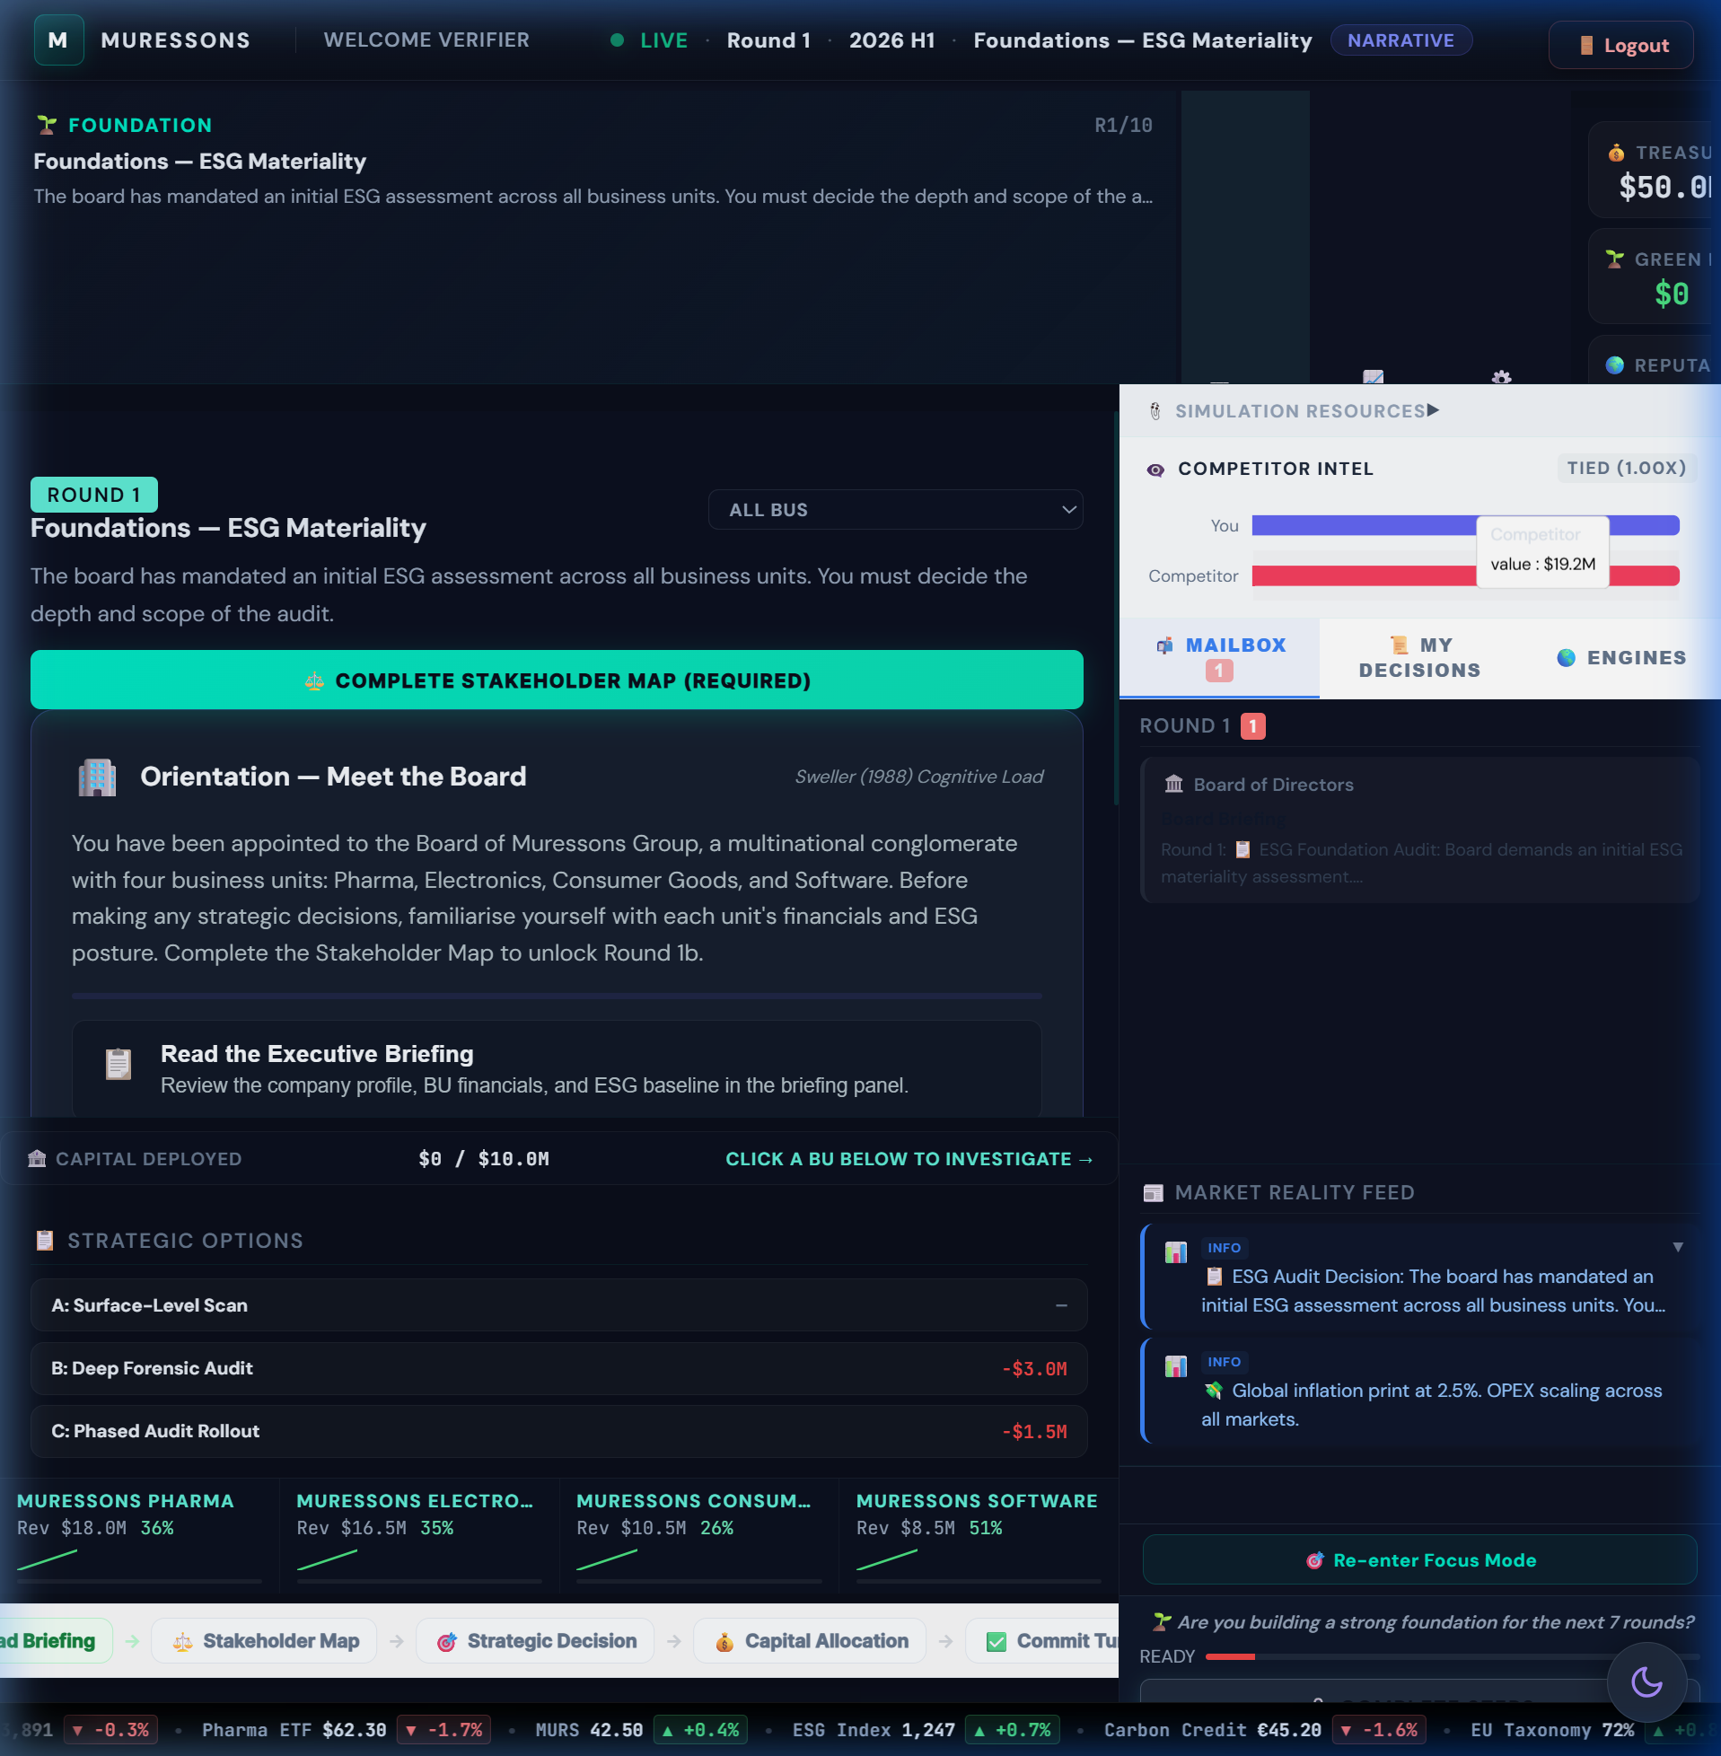
Figure: Executive Cockpit — initial state with 4 BU KPI cards
BU | Icon | Revenue | OPEX | Carbon Int. | Water Dep. | NCD | Gov. Risk
Pharma | 💊 | $18.0M | $12.0M | 35 | 82 | 120 | 15
Electronics | ⚡ | $16.5M | $11.5M | 72 | 58 | 200 | 20
Consumer Goods | 🛒 | $10.5M | $7.5M | 48 | 65 | 150 | 10
Software | 💻 | $8.5M | $5.5M | 12 | 12 | 30 | 25

1.3 Learning Objectives
LO | Description | Primary Rounds | Bloom's Level
LO1 | Analyse stakeholder salience using Mendelow's Matrix | R1, R5, R8 | Analyse (L4)
LO2 | Evaluate trade-offs between short-term profit and systemic resilience | R3, R4, R9 | Evaluate (L5)
LO3 | Apply double materiality assessment to capital allocation | R2 | Apply (L3)
LO4 | Synthesise ESG strategy that maximises Regenerative Multiple | R7, R10 | Create (L6)
LO5 | Assess autonomous stakeholder reactions and cascade risk | R4, R6, R9 | Evaluate (L5)
LO6 | Design just transition strategies balancing efficiency and equity | R9 | Create (L6)

1.4 Key Strategic Trade-Offs
- Short-term cash extraction vs. long-term terminal value: Every dollar saved now compounds against you through NCD interest, VRIO decay, and burnout penalties.
- Concentrated investment vs. diversification: Synergy rewards cross-BU integration, but spreading too thin yields diminishing returns (√ scaling).
- Transparency vs. containment: Full disclosure costs money upfront but prevents contagion cascades. Deny-and-deflect is free but risks 2× crisis severity.
- Adaptation vs. mitigation: Hard engineering builds resilience but adds carbon; nature-based solutions are cheaper but take 2 rounds to mature.
- Efficiency vs. equity: Prioritising high-margin BUs maximises short-term EBITDA but triggers social licence collapse and strike risk at R9.

1.5 Simulation Timeline
Tier | Rounds | Theme | Cognitive Demand
Foundation | R1–R3 | Diagnostic & Strategy Setting | Remember → Apply
Crisis | R4–R6 | Cascade Management & Ethics | Analyse → Evaluate
Integration | R7–R8 | Systems Thinking & Resource Allocation | Evaluate → Create
Finale | R9–R10 | Justice, Valuation & Legacy | Create → Synthesise

Simulation Architecture Map
The diagram below illustrates the complete simulation pipeline — from player decisions through the mathematical engine to terminal valuation outputs.
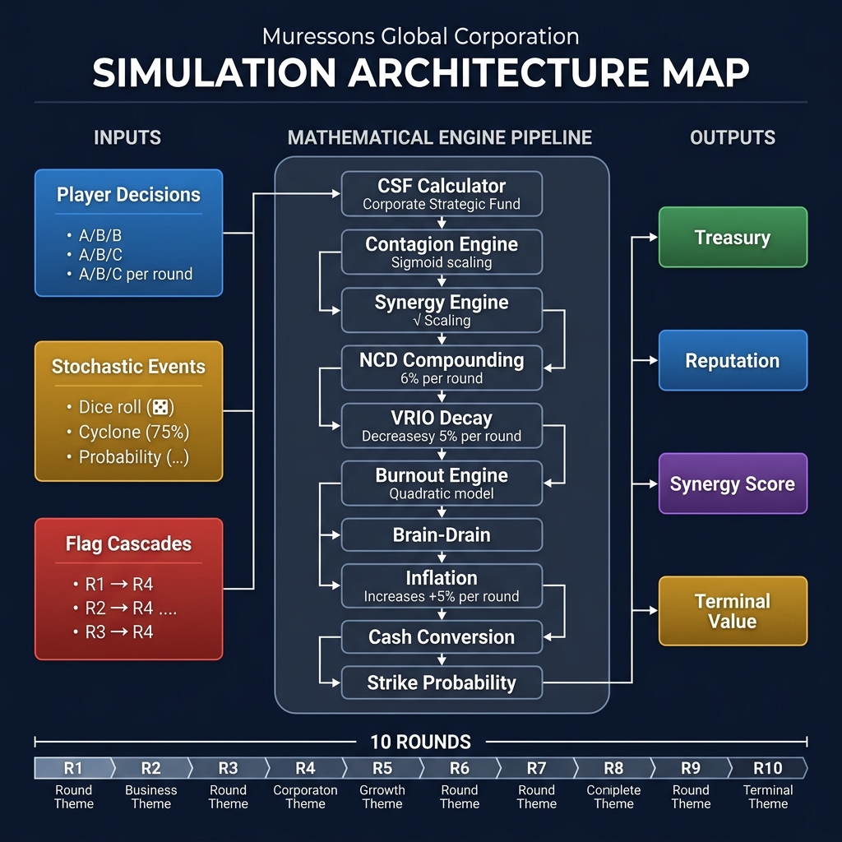
Figure: Simulation Architecture Map — engine pipeline flowchart

§2. Theoretical Foundations & Academic Integration

2.1 Framework-to-Mechanic Mapping
The simulation embeds 25+ academic frameworks as executable game mechanics. Each theory is experienced before being named — players discover the principle through gameplay, then the facilitator reveals the academic framework during debrief.
Theory / Author | Framework | Round(s) | Simulation Mechanic
Mendelow (1991) | Stakeholder Mapping | R1 | Drag-and-drop stakeholder matrix pre-gate
Mitchell et al. (1997) | Stakeholder Salience | R1, R5, R9 | Power × Legitimacy × Urgency drives agent escalation
EU CSRD / ESRS | Double Materiality | R2 | CFO materiality gate — 2×2 matrix with budget clawback
GHG Protocol | Scope 3 Emissions | R3 | Supply chain carbon footprint 4× direct emissions
Real Options (Dixit & Pindyck) | Option Value of Information | R1→R4 | Deep audit = buying option on future crisis mitigation
Argyris (1977) | Double-Loop Learning | R4 | Players must question assumptions after R1 cascade reveals
Kahneman (2011) | System 1/2 Thinking | R4, R6 | Time pressure forces heuristic decision-making
Moon (2004) | Board Room Moments | R4, R5 | 3-stage reflection: Noticing → Making Sense → Working with Meaning
Schön (1983) | Reflection-in-Action | R5 | Shadow Board forces real-time stakeholder perspective-taking
Jensen & Meckling (1976) | Agency Theory | R5 | Shadow Board persona conflicts embody principal-agent tensions
Hirschman (1970) | Exit, Voice, Loyalty | R5, R9 | Stakeholder response to dissatisfaction — protest vs. departure
Porter (2011) | Creating Shared Value | R6, R7 | Ethical AI overhaul and circular economy create dual value
Barney (1991) | Resource-Based View | R7 | VRIO advantage decays without investment; synergy = rare capability
Teece (2007) | Dynamic Capabilities | R7 | Workforce readiness gates determine circular economy effectiveness
Senge (1990) | Learning Organisation | R7 | System archetype detection in reinforcing/balancing loops
Hardin (1968) | Tragedy of the Commons | R8 | Water scarcity forces collective resource allocation
Ostrom (1990) | Commons Governance | R8 | Regulatory sandbox Ostrom instruments test self-governance
Rawls (1971) | Justice as Fairness | R9 | Just transition: efficiency vs. equity in factory closures
Freeman (1984) | Stakeholder Theory | R9 | Community fund vs. immediate closure — who bears transition cost?
Sen (1999) | Capabilities Approach | R9 | Green job training expands worker capabilities beyond employment
Costanza et al. (1997) | Natural Capital | All | NCD compounding at 6% models ecological debt accumulation
Meadows (1999) | Leverage Points | R10 | Debrief overlay identifies system intervention hierarchy
Kolb (1984) | Experiential Learning | All | Concrete Experience → Reflection → Conceptualisation → Experimentation
Thiagarajan (1993) | Debrief Protocol | R10 | 3-phase: How Do You Feel? → What Happened? → So What?
Taleb (2012) | Antifragility | R4, R8 | Systems that gain from disorder — deep audit teams outperform

2.2 Pedagogical Design Principles
- Path Dependency: R1 decisions irrevocably shape R4 crisis severity (40 vs. 80), R9 strike probability, and R10 terminal value. There is no "reset" — every choice persists.
- Fog of War: Engine complexity is progressively disclosed. R1-R3 show 5 engines; by R8, all 20+ are visible. This models real-world information asymmetry.
- Mechanic Variation: No two rounds use the same decision format — drag-and-drop (R1), 2×2 matrix (R2), slider allocation (R7), tribunal (R8), preventing "solved game" optimisation.
- Stochastic Elements: Cyclone probability (75%), whistleblower backfire (40%), macro noise (±3%) — players cannot distinguish luck from strategy without the pedagogical labels.
- Hidden Causality: The most important mechanics (contagion sigmoid, burnout quadratic, NCD compounding) are never shown to players. Facilitators reveal them during debrief.

§3. Mathematical Engine Reference
This section documents every mathematical engine in the simulation. For each engine: the exact formula from the codebase, a worked sample calculation, and a non-mathematical teaching analogy for facilitators to use with students.
🚫 DO NOT REVEAL: These formulas are HIDDEN from players. They are the facilitator's "answer key" for understanding why outcomes occur. Never reveal formulas during gameplay — reveal them during debrief.
Figure: Simulation Architecture flowchart showing process_tick() pipeline

3.1 Corporate Strategic Fund (CSF)

Formula
CSF = Sum(Revenue_Base - OPEX_Base) - Dividends_Paid
The CSF calculates net cash generated each round from all BU operations minus any board-mandated dividend payments. This is the primary source of corporate treasury growth.

Sample Calculation
BU | Revenue | OPEX | Gross Profit
Pharma | $18.0M | $12.0M | $6.0M
Electronics | $16.5M | $11.5M | $5.0M
Consumer Goods | $10.5M | $7.5M | $3.0M
Software | $8.5M | $5.5M | $3.0M
TOTAL | $53.5M | $36.5M | $17.0M

With $0 dividends: CSF = $17.0M added to treasury. With $2M dividends: CSF = $15.0M.

Teaching Tip
💡 TIP: Tell students: "Think of CSF as your corporate paycheck. Every round, your four businesses generate profit. But just like a household budget, you have fixed obligations (dividends to shareholders). What's left is what you can invest. The question is: how do you allocate a finite paycheck across competing priorities?"

3.2 Contagion Engine (Sigmoid Model)

Formula
Group_Rep = Avg_BU_Rep - 50 x sigmoid((severity - 30) / 15)
Where sigmoid(x) = 1 / (1 + e^(-x))
The sigmoid (S-curve) models non-linear crisis propagation: small crises are absorbed with minimal damage, but once severity crosses a threshold (~30), damage escalates rapidly before saturating at extreme levels. The electronics_blindspot flag DOUBLES severity from 40 to 80.

Sample Calculation
Scenario | R1 Choice | Severity | Sigmoid Input | Sigmoid Output | Rep Hit | Final Rep
Deep Audit (no blindspot) | B | 40 | (40-30)/15 = 0.67 | 0.66 | -33.0 | 22.0
Phased Audit (deferred) | C | 60 | (60-30)/15 = 2.0 | 0.88 | -44.0 | 11.0
Surface Scan (blindspot) | A | 80 | (80-30)/15 = 3.33 | 0.97 | -48.3 | 6.7

Starting avg rep = 55. The blindspot team loses 48.3 points vs. 33.0 for the audited team — a 46% worse outcome from a single R1 decision. This is the simulation's most consequential hidden mechanic.

Teaching Tip
💡 TIP: Tell students: "Think of reputation damage like a viral infection. A small scandal (low severity) is like a common cold — your immune system handles it. But a major scandal (high severity) is like a pandemic — it overwhelms your defences. The S-curve shows that there's a tipping point where manageable becomes catastrophic. The R1 audit was your vaccine — those who skipped it caught the full disease at R4."

3.3 Synergy Engine (Square-Root Scaling)

Formula
effective_ratio = sqrt(investment_ratio) x 0.7
New_OPEX = Old_OPEX x (1 - effective_ratio x synergy_multiplier)
Square-root scaling means the first dollar invested yields the highest return, with each subsequent dollar yielding progressively less. At 25% investment ratio, you get 50% of max efficiency. At 100%, you get 70%. This prevents "solve by spending" strategies.

Sample Calculation
Investment Ratio | sqrt(ratio) | Effective Ratio | OPEX Reduction (syn=1.0) | Comment
10% | 0.316 | 0.221 | -22.1% | Excellent ROI per dollar
25% | 0.500 | 0.350 | -35.0% | Good balance
50% | 0.707 | 0.495 | -49.5% | Diminishing returns begin
100% | 1.000 | 0.700 | -70.0% | Maximum efficiency (capped at 70%)

Teaching Tip
💡 TIP: Tell students: "Imagine you're watering a garden. The first bucket of water makes a huge difference to dry soil. The second bucket helps, but less. By the tenth bucket, the ground is saturated and you're wasting water. That's diminishing returns. Your investment in cross-BU synergy works the same way — focus beats dilution."

3.4 Natural Capital Debt (NCD) Compounding

Formula
Interest_Rate = Base_Rate + (NCD x 0.0001)
NCD_new = NCD_current x (1 + Interest_Rate) + round_delta
At NCD=100, interest rate is ~6%. At NCD=500, it climbs to ~10%. This creates a "debt trap" — the more ecological damage you accumulate, the faster it compounds. NCD is deducted from terminal value as an ecological liability.

Sample Calculation
Electronics BU starts with NCD = 200. Assume no investment (round_delta = 0):
Round | NCD Start | Rate | Interest | NCD End
R1 | 200.0 | 6.02% | +12.0 | 212.0
R3 | 225.1 | 6.03% | +13.6 | 238.7
R5 | 252.6 | 6.03% | +15.2 | 267.8
R7 | 283.4 | 6.03% | +17.1 | 300.5
R10 | 337.5 | 6.03% | +20.3 | 357.8

Over 10 rounds of neglect, NCD grows 79% from compounding alone — a $15.8M terminal value penalty at $100K per NCD point.

Teaching Tip
💡 TIP: Tell students: "NCD works exactly like credit card debt. If you only make minimum payments, the balance grows faster than you can pay it off. Nature is lending you ecosystem services — clean water, stable climate, pollination. Every round you don't repay, the interest compounds. By R10, teams that ignored NCD owe nature a debt they can never repay."

3.5 VRIO Competitive Advantage Decay

Formula
VRIO_next = VRIO_current x (1 - decay_rate)
Default decay_rate = 0.05 (5% per round). VRIO starts at 0.80 and decays towards 0.50 (industry average). Investing in a BU resets or slows decay. VRIO modifies BU revenue effectiveness.

Sample Calculation
Starting VRIO = 0.80 with no investment for 5 rounds:
R1: 0.80 x 0.95 = 0.76 | R2: 0.72 | R3: 0.69 | R4: 0.65 | R5: 0.62
After 5 rounds of neglect, competitive advantage drops from "strong" (0.80) to "average" (0.62). This represents competitor imitation eroding your unique capabilities.

Teaching Tip
💡 TIP: Tell students: "Your competitive advantage is like a moat around a castle. If you don't maintain it, competitors slowly fill it in. VRIO measures how unique and valuable your capabilities are. Without active investment, competitors copy your best practices, hire your talent, and erode your edge. Standing still means falling behind."

3.6 Burnout Engine (Quadratic OPEX Penalty)

Formula
Penalty_Rate = ((burnout - 20)^2) x 0.000028125
OPEX_new = OPEX x (1 + Penalty_Rate)
Burnout follows a quadratic (squared) curve — costs accelerate as burnout increases. Below 20, there is no penalty. Above 20, costs grow exponentially. At 70+, burnout also increases R9 strike probability.
Natural drift: +6 burnout per round if no HR investment. HR investment: -16 to -30 burnout.

Sample Calculation
Burnout | Penalty Calc | OPEX Penalty | On $12M OPEX | Risk Level
20% | (0)^2 x 0.000028 = 0% | +0% | $0 | Safe
40% | (20)^2 x 0.000028 = 1.1% | +1.1% | +$135K | Watch
60% | (40)^2 x 0.000028 = 4.5% | +4.5% | +$540K | Critical
80% | (60)^2 x 0.000028 = 10.1% | +10.1% | +$1.2M | Emergency
100% | (80)^2 x 0.000028 = 18.0% | +18.0% | +$2.2M | Catastrophic

A team that ignores HR for 8 rounds (natural drift: 10 + 8x6 = 58%) loses $540K/round in OPEX penalties AND faces 60%+ strike probability at R9.

Teaching Tip
💡 TIP: Tell students: "Burnout is like a pressure cooker. At first, the steam builds slowly and nothing seems wrong. But the pressure follows a squared curve — it accelerates. By the time you notice the lid rattling, it's about to blow. The R9 strike is the explosion. The only way to release pressure is HR investment — and the earlier you start, the cheaper it is."

3.7 Brain-Drain Engine (Talent Penalty)

Formula
Talent_Penalty = 1 + max(0, (65 - Group_Rep) / 100) x 1.5
If burnout > 50: Penalty += ((burnout - 50) / 100) x 2.0
Applies to Software (and Technology/Banking verticals). When reputation drops below 65, talent leaves for competitors, increasing OPEX as the company must hire expensive contractors/agencies.

Sample Calculation
Reputation | Burnout | Penalty Calc | OPEX Multiplier | On $5.5M OPEX
65+ | Any | 1 + 0 = 1.0 | 1.00x | $5.5M (no penalty)
50 | 30 | 1 + (15/100)x1.5 = 1.225 | 1.23x | $6.7M (+$1.2M)
35 | 60 | 1 + (30/100)x1.5 + (10/100)x2 = 1.65 | 1.65x | $9.1M (+$3.6M)
20 | 80 | 1 + (45/100)x1.5 + (30/100)x2 = 2.28 | 2.28x | $12.5M (+$7.0M)

Teaching Tip
💡 TIP: Tell students: "Your best engineers have options. When your company's reputation drops, they get headhunted by competitors with better brands. You're left hiring expensive consultants and agencies to fill the gaps. This is the 'war for talent' made real. The vicious cycle: low reputation means talent leaves, which means higher costs, which means less investment, which means lower reputation."

3.8 Macroeconomic Inflation Engine

Formula
OPEX_new = OPEX x (1 + inflation_index)
Default inflation_index = 0.05 (5% per 6-month round, ~10% annualised). Inflation silently erodes purchasing power every round. Players must invest just to maintain the status quo.

Sample Calculation
Pharma OPEX = $12M. After 10 rounds of 5% inflation: $12M x 1.05^10 = $19.5M — a 63% increase in operating costs that players often fail to anticipate.

Teaching Tip
💡 TIP: Tell students: "Inflation is the silent tax on inaction. Every round, everything gets 5% more expensive. If you don't grow revenue faster than inflation grows costs, you're actually shrinking. This mirrors the real-world challenge every CEO faces: the treadmill effect."

3.9 Cash Conversion Drag

Formula
Cash_Efficiency = 1.0 - (governance_risk / 500)
Realized_Revenue = Revenue x Cash_Efficiency (clamped to [0.5, 1.0])
BUs with high governance risk convert revenue to cash less efficiently — representing delayed payments, compliance costs, legal reserves, and investor distrust.

Sample Calculation
Governance Risk | Cash Efficiency | On $16.5M Revenue | Revenue Lost
10 (low) | 1.0 - 10/500 = 0.98 | $16.2M | -$0.3M
30 (medium) | 1.0 - 30/500 = 0.94 | $15.5M | -$1.0M
60 (high) | 1.0 - 60/500 = 0.88 | $14.5M | -$2.0M
100 (critical) | 1.0 - 100/500 = 0.80 | $13.2M | -$3.3M

Teaching Tip
💡 TIP: Tell students: "Think of governance risk as friction in your financial plumbing. Good governance means revenue flows smoothly into cash. Bad governance creates leaks — legal costs, delayed approvals, compliance penalties, investor distrust. The cash is technically yours, but you can't use it all. This is why the 'free' options (Deny & Deflect) are never truly free."

3.10 Strike Probability Engine

Formula
P_Strike = Base_Risk + ((1 - SLO/100) x 0.4)
If burnout > 50: P_Strike += min(0.20, (burnout - 50)/100 x 0.40)
Strike probability is the "time bomb" of the simulation. It combines social licence deficit with workforce burnout to determine the probability of a full revenue wipeout at R9.

Sample Calculation
SLO | Burnout | Base Prob | + SLO Factor | + Burnout Boost | Final P(Strike)
70 | 20 | 0.50 | +0.12 | +0.00 | 62%
50 | 40 | 0.50 | +0.20 | +0.00 | 70%
30 | 60 | 0.50 | +0.28 | +0.04 | 82%
20 | 80 | 0.50 | +0.32 | +0.12 | 94%

If a strike triggers, ALL BU revenue for the round is lost. At total revenue of $53.5M, this is catastrophic.

Teaching Tip
💡 TIP: Tell students: "The strike is the ultimate consequence of neglecting your workforce and community. It's not random — it's the mathematical culmination of every HR decision you made (or didn't make) across 8 rounds. The probability formula is your 'labour relations risk score'. A 94% strike probability means you've treated your workers and community so poorly that a walkout is almost certain."

3.11 Terminal Valuation Formula

Formula
TV = (EBITDA - Carbon_Tax x CO2_Tonnage) x Exit_Multiple x M_R
Where: EBITDA = Sum(Revenue - OPEX), Carbon Tax = $250/ton (adjustable), Exit Multiple = 12.0x, M_R = Regenerative Multiple (1.0 to ~2.1).

Sample Calculation
Regenerative Titan scenario:
- EBITDA: $53.5M revenue - $36.5M OPEX = $17.0M
- Carbon Cost: $250 x 25,000 tons = $6.25M
- Net: $17.0M - $6.25M = $10.75M
- Exit Multiple: 12.0x
- M_R: 1.85 (earned most bonuses)
- TV = $10.75M x 12.0 x 1.85 = $238.7M

Teaching Tip
💡 TIP: Tell students: "Terminal Value answers one question: if a buyer wanted to acquire Muressons today, what would they pay? The M_R is the buyer's assessment of your sustainability risk. A Titan (M_R 1.85) commands an 85% premium because the buyer sees a future-proof company. A Relic (M_R 0.60) gets a 40% discount because the buyer sees regulatory exposure, stakeholder revolt, and stranded assets."

3.12 Stakeholder Fatigue Engine

Formula
Recovery_Efficiency = 1.0 / (1 + 0.3 x crisis_count)
After each crisis, stakeholder trust recovery becomes harder. A company facing its 3rd crisis recovers trust at only 53% efficiency. This prevents "crisis → apologise → repeat" strategies.

Teaching Tip
💡 TIP: Tell students: "Trust is like a plate. The first time you drop it, you can glue it back together. The second time, the repair is harder. By the third time, there are so many cracks that it barely holds water. Stakeholders remember every crisis. Each apology is worth less than the last."

3.13 Supply Chain Contagion Engine

Formula
OPEX_Surcharge = BU_OPEX x Sum(other_BU_gov_risk x 0.002)
BUs with high governance risk contaminate other BUs through shared supplier networks. This models the systemic risk of poor governance spreading through supply chain interdependencies.

Teaching Tip
💡 TIP: Tell students: "Your supply chains are interconnected. When one BU has poor governance, it creates problems for every other BU that shares suppliers with it. Think of it like a bad neighbour in an apartment building — their problems become your problems through shared infrastructure."

PART 2 — ROUND-BY-ROUND FACILITATION GUIDE

§4. Round-by-Round Guide (R1–R10)
Each round follows a consistent template. The briefing text shown below is the exact content displayed to players on screen.

Round 1: ESG Baseline Assessment — Stakeholder Mapping & Diagnostic Decision

Player Briefing (On-Screen Text)
📋 The board has mandated an initial ESG assessment across all business units. You must decide the depth and scope of the audit. Your decision here will echo throughout the simulation — hidden consequences will surface in later rounds.

Pre-Decision Gate
Mendelow's Stakeholder Matrix (drag-and-drop): Players must classify 8 stakeholders into Power × Interest quadrants before proceeding.
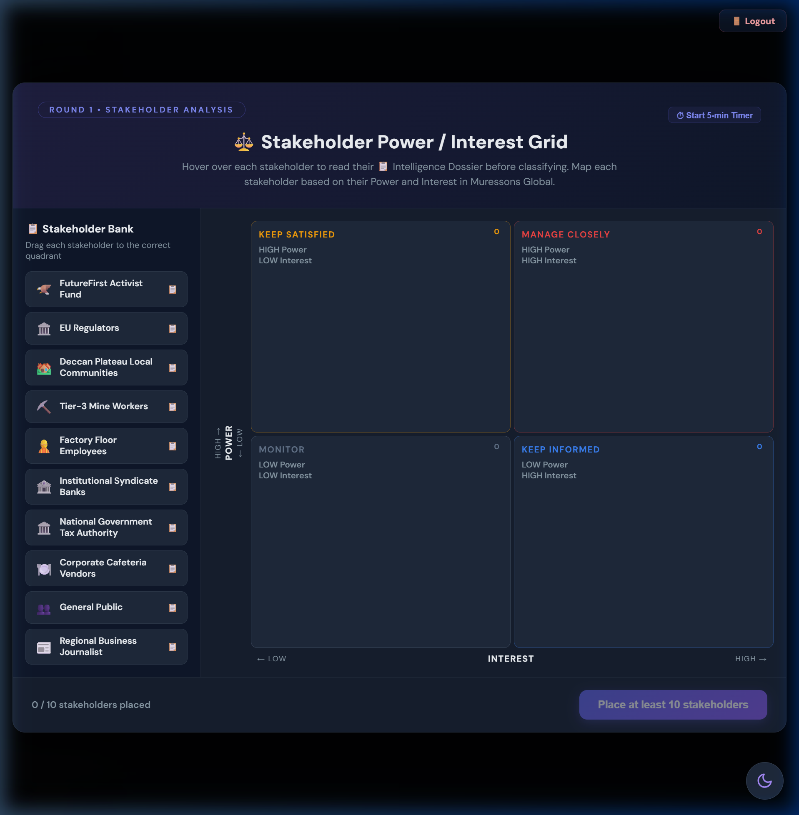
Figure: Stakeholder Map modal with stakeholder cards and quadrant grid

Strategic Options
Option | Title | Cost | Flag Set | Description & Impacts
A | Surface-Level Scan | $0 | electronics_blindspot | Fast compliance check. Electronics BU blind spots missed. +$500K revenue, -2 rep, +5 governance risk.
B | Deep Forensic Audit | -$3M | deep_audit_completed | Full forensic audit across all units. -$200K revenue, +5 rep, -5 governance risk, -5 CI.
C | Phased Audit Rollout | -$1.5M | deferred_audit | Audit Pharma and CG now; defer Electronics and Software. +2 rep, -2 CI. Partial blind spots remain.

Hidden Mechanics (DO NOT REVEAL)
🚫 DO NOT REVEAL: electronics_blindspot flag DOUBLES R4 crisis severity from 40→80 via contagion sigmoid. This is the simulation's most consequential hidden mechanic.

Theory Connection
Mendelow (1991) Stakeholder Mapping; Real Options Theory — the audit is an option on future crisis mitigation (5× NPV); Signalling Theory — market interprets audit depth as governance quality signal.

Debrief Prompts
- What information did you have when making this decision? What was unknown?
- How did you weigh cost vs. risk? What mental model drove your choice?
- If you chose the Surface Scan, what would you have paid to know the consequences?
- How does this mirror real-world ESG audit decisions?

Common Pitfall
⚠️ IMPORTANT: Students choose Surface Scan to 'save money'. They discover at R4 that the $3M audit would have prevented $15M+ in cascade damage.

Round 2: Double Materiality — The CSRD Acid Test

Player Briefing (On-Screen Text)
📊 The CFO requires all investment proposals to demonstrate alignment with the High Financial Impact / High ESG Impact quadrant per the Double Materiality framework. Non-aligned spending triggers a 40% budget clawback.

Pre-Decision Gate
CSRD Materiality Matrix (2×2 drag-and-drop): Players classify 8 sustainability issues into Financial Impact × ESG Impact quadrants. Accuracy >90% earns a $2M treasury bonus.

Figure: CSRD Materiality Matrix with Q1–Q4 quadrants

Strategic Options
Option | Title | Cost | Flag Set | Description & Impacts
A | Full Materiality Alignment | -$2.5M | materiality_aligned | Genuine CSRD compliance with assurance-ready report. +5 rep, -5 gov risk, +0.10 M_R at terminal. In Advanced Climate: NCD forgiveness +25%.
B | Strategic Exceptions | $0 | materiality_exceptions | Limited off-quadrant spending with CFO approval. +2 rep, -2 gov risk. Partial compliance.
C | CEO-Only Sign-Off | $0 (+$400K) | materiality_ignored | CEO approves without board oversight. ESRS 1 §1.51 violation. 40% budget clawback, -5 rep, +10 gov risk. Blocks Green Bond eligibility.

Hidden Mechanics (DO NOT REVEAL)
🚫 DO NOT REVEAL: Option C triggers a 40% clawback on all materiality capital released this round. Green Bond access blocked for remainder. materiality_aligned flag adds +0.10 M_R at terminal.

Theory Connection
EU CSRD/ESRS Standards; Double Materiality (financial + impact); Legitimacy Theory — ESRS compliance signals institutional legitimacy; Agency Theory — CEO-only sign-off bypasses board oversight (Jensen & Meckling 1976).

Debrief Prompts
- How did you balance financial materiality vs. ESG impact materiality?
- What was the opportunity cost of full alignment?
- Did the CFO gate change how you allocated capital?
- How does CSRD compliance compare to voluntary ESG reporting?

Common Pitfall
⚠️ IMPORTANT: Students choose CEO-Only to 'save money' — the 40% clawback actually costs more than Full Alignment.

Round 3: Scope 3 Emissions — Supply Chain Decarbonisation

Player Briefing (On-Screen Text)
🏭 Regulators have signalled mandatory Scope 3 disclosures. Your supply chain carbon footprint is 4× your direct emissions. The Fog of War clears after this round — all hidden engines become progressively visible.

Strategic Options
Option | Title | Cost | Flag Set | Description & Impacts
A | Rapid Supplier Switch | -$4M | early_decarboniser | Immediately switch to low-carbon suppliers. -15 CI, -$800K revenue, +3 rep. Sets early_decarboniser flag (+0.15 M_R). Supply chain disruption risk.
B | Green Bond Investment | -$2M | green_bond_active | Issue green bond to fund supplier transition. -8 CI, -15 NCD, +$300K revenue, +4 rep. NCD reduction over 3 rounds.
C | Offset & Defer | -$1M | carbon_deferred | Buy carbon offsets and wait. +5 NCD (compounds at 6%!), -3 rep, -1 CI. Short-term savings, long-term ecological debt.

Hidden Mechanics (DO NOT REVEAL)
🚫 DO NOT REVEAL: NCD compounds at 6%/round. The +5 NCD from Option C becomes +7.5 by R10, costing ~$1.9M in terminal value. early_decarboniser flag unlocks +0.15 M_R and amplifies R7 circular economy returns.

Theory Connection
GHG Protocol Scope 3; First-Mover Advantage (Lieberman & Montgomery 1988); Natural Capital accounting (Costanza 1997); Signalling Theory — Green Bond signals commitment to capital markets.

Debrief Prompts
- How did you evaluate the trade-off between immediate cost and future NCD growth?
- What is the NPV of avoiding 6% compound NCD growth for 7 rounds?
- How does Scope 3 reporting change your view of 'company boundaries'?

Common Pitfall
⚠️ IMPORTANT: Students underestimate NCD compounding. +5 NCD in R3 seems small but compounds to $1.9M terminal value loss.

Round 4: Contagion — The R1 Reckoning

Player Briefing (On-Screen Text)
🔥 A labour-rights exposé in your Electronics supply chain has gone viral. The contagion engine will propagate reputational damage across all BUs. Crisis severity depends on your Round 1 audit decision.
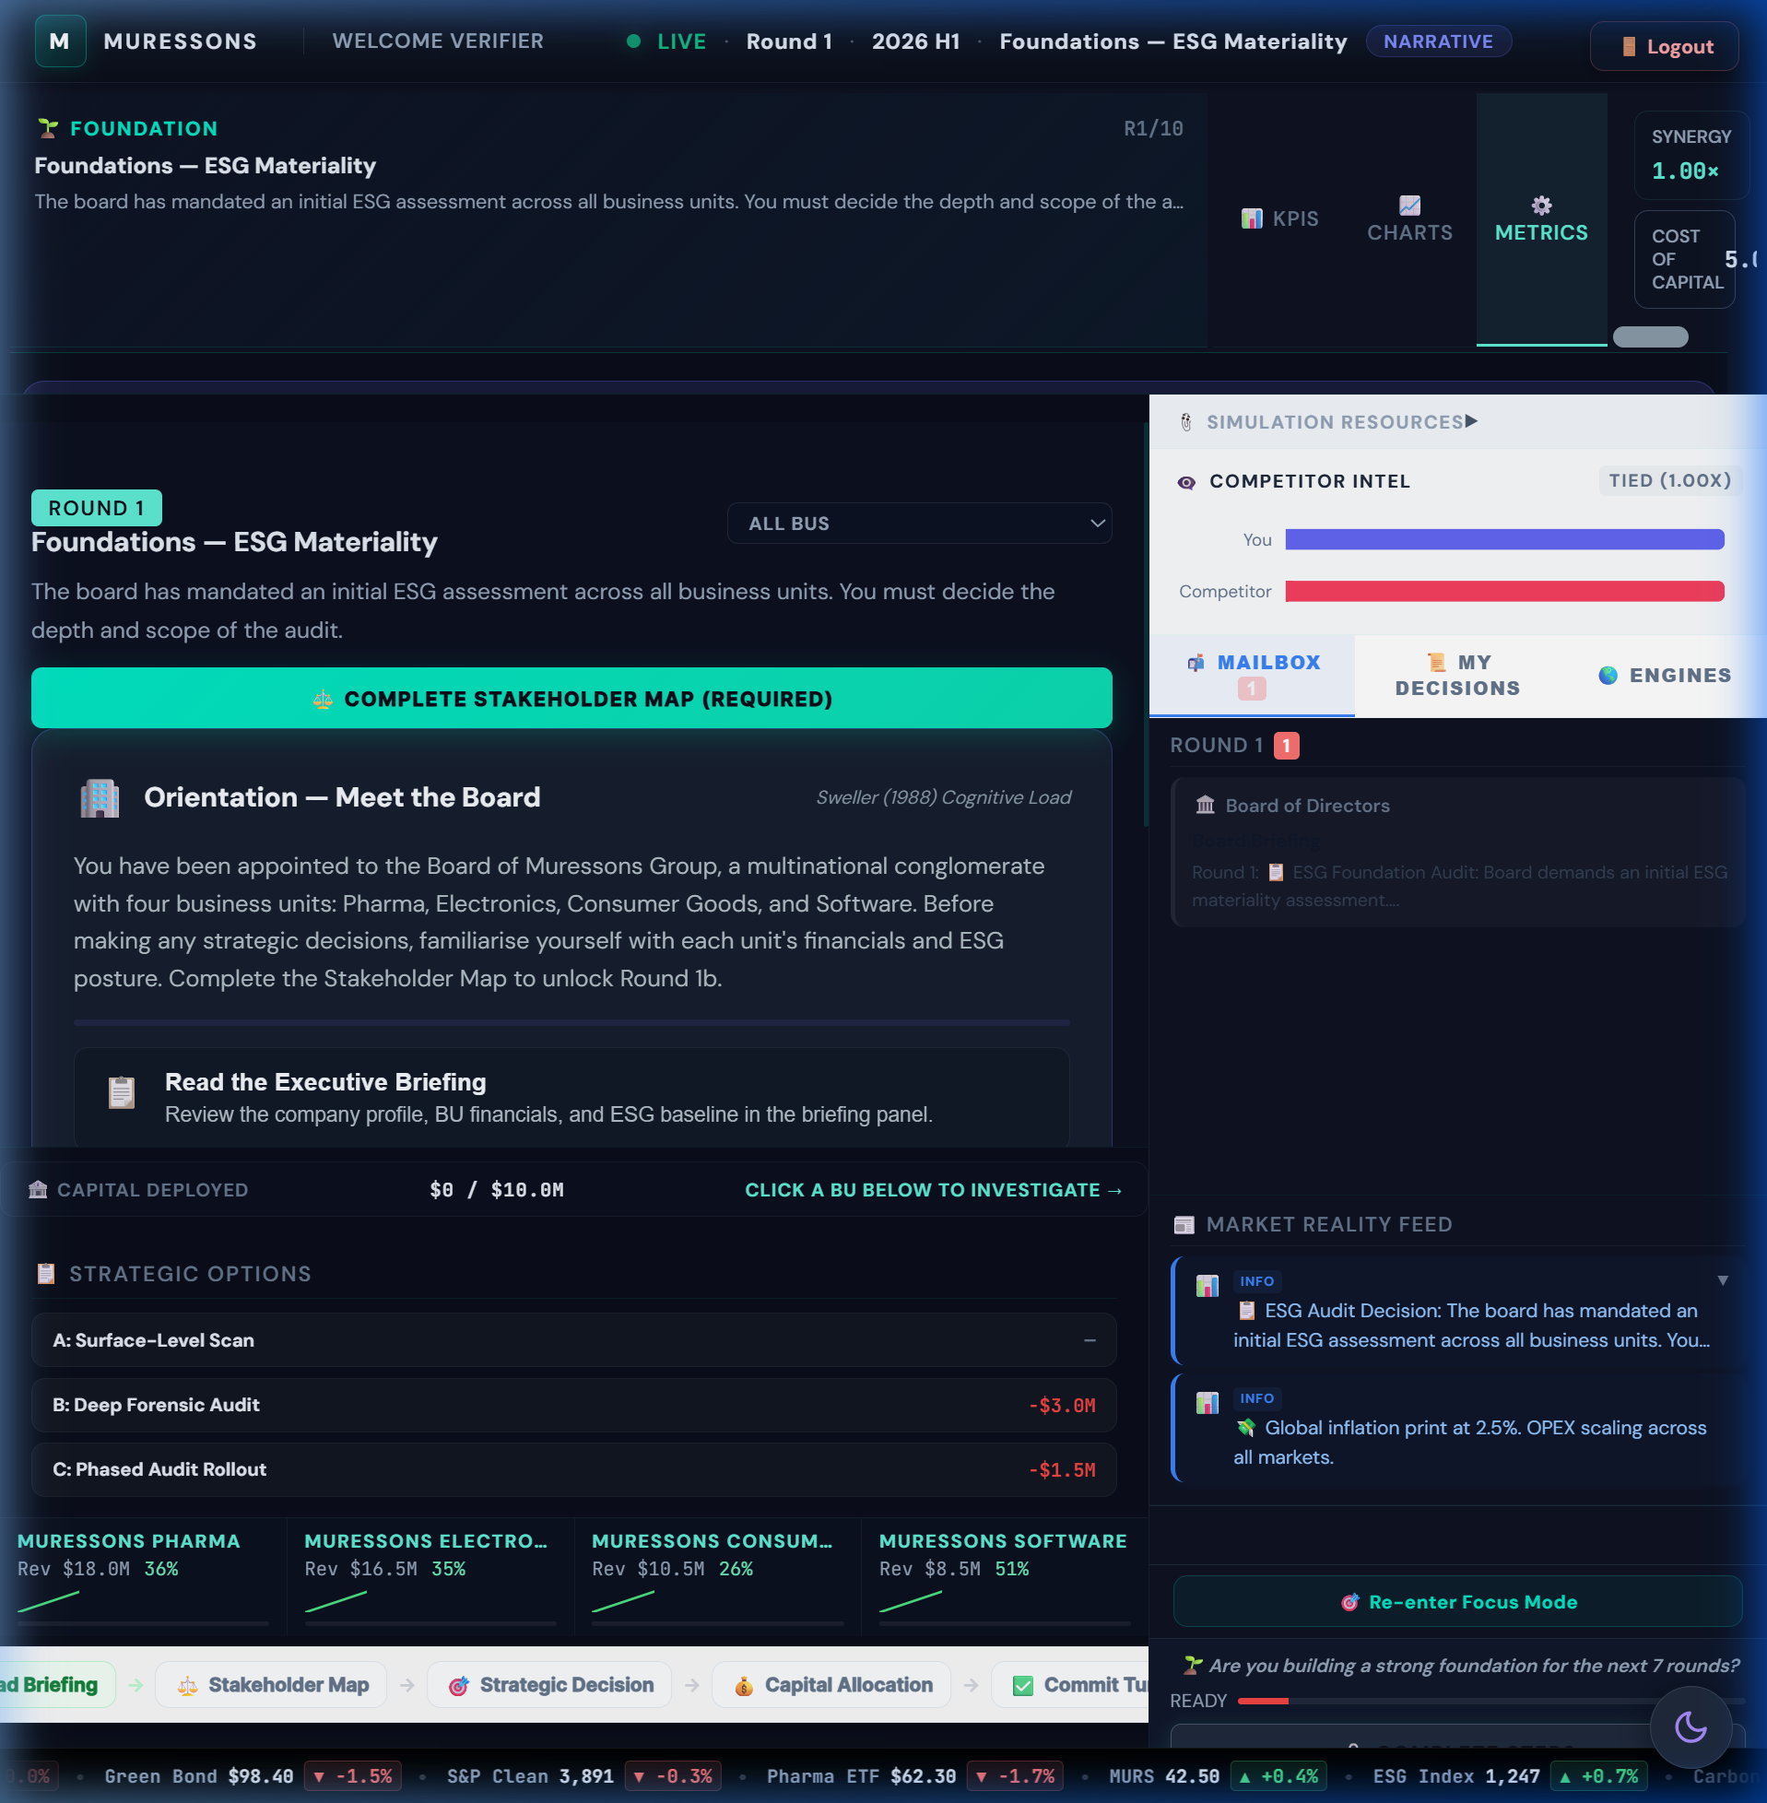
Figure: Consequence DNA panel showing R1→R4 causal chain

Strategic Options
Option | Title | Cost | Flag Set | Description & Impacts
A | Full Transparency & Remediation | -$6M | remediation_active | Public disclosure, factory audits, worker compensation. +10 rep, +8 social licence. Sets remediation_active (+0.10 M_R).
B | Damage Control PR | -$2M | pr_containment | Crisis PR firm. +2 rep, -3 social licence. Narrative contained but root cause unfixed.
C | Deny & Deflect | $0 | deny_and_deflect | Issue denial. -15 rep, -10 social licence, +8 gov risk, +5 NCD. Cheapest but highest contagion risk.

Hidden Mechanics (DO NOT REVEAL)
🚫 DO NOT REVEAL: Severity = 40 (deep audit) / 60 (deferred) / 80 (blindspot). Contagion uses sigmoid: hit = max × 1/(1+e^(-s/scale)). Blindspot teams lose ~19 reputation vs. ~12 for audited teams. Board Room Moment triggers if rep < 40.

Theory Connection
Argyris (1977) Double-Loop Learning — players must question R1 assumptions; Kahneman (2011) System 1/2 — time pressure reveals heuristic biases; Taleb (2012) Antifragility — audited teams are antifragile, gaining from the crisis.

Debrief Prompts
- ★ KEY DEBRIEF: Ask teams to reveal their R1 choice. Compare R4 outcomes.
- What was the NPV of the R1 audit decision? (Answer: ~5× the $3M cost)
- When did you realize R1 had consequences? What assumption broke?
- How does this mirror real-world supply chain scandals?
- What would Argyris say about your mental model update?

Common Pitfall
⚠️ IMPORTANT: Teams that chose Surface Scan face 2× severity. The $0 'savings' at R1 cost $15M+ in R4 damage.

Round 5: Climate — Physical Climate Risk & Shadow Board Audit

Player Briefing (On-Screen Text)
🌪️ A Category 4 cyclone is projected to hit your primary manufacturing corridor. Base damage: $12M. A stochastic roll (75% probability) determines actual impact. Before deciding, you must complete the mandatory Shadow Board Audit.

Pre-Decision Gate
Mandatory Shadow Board Audit: 3 independent personas (Shareholder, Community Leader, Environmental Scientist) evaluate your strategy. Rejecting their advice sets hidden flags that cascade to R10 ending pathways. See §5 for deep dive.
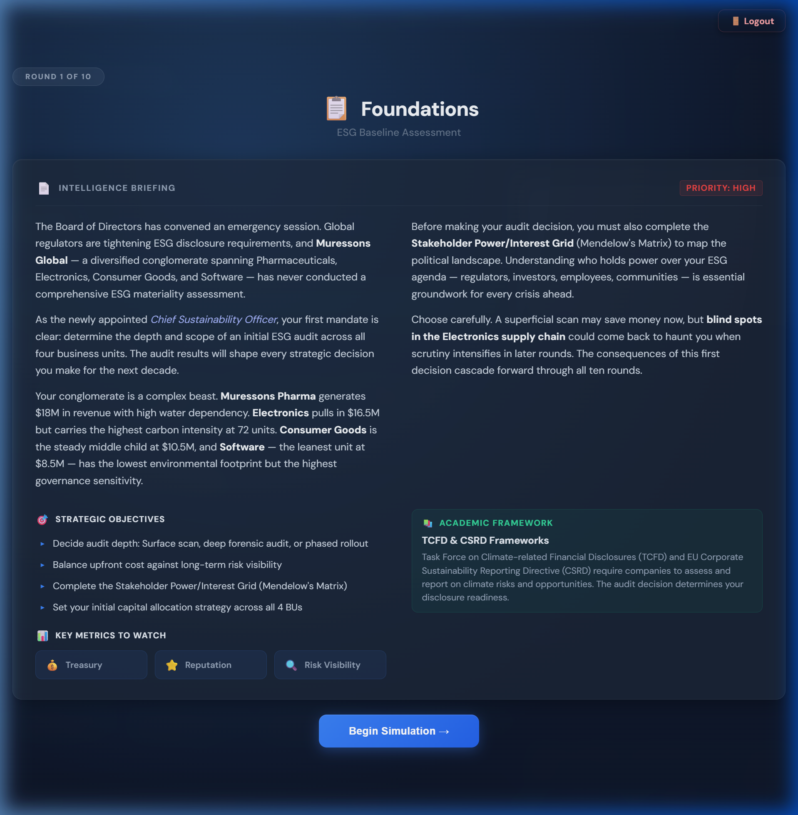
Figure: Shadow Board Audit modal with 3 persona cards

Strategic Options
Option | Title | Cost | Flag Set | Description & Impacts
A | Hard Engineering Defence | -$8M | hard_engineering | Flood walls and reinforced infrastructure. Resilience 0.85 but NO PROTECTION THIS ROUND (2-round build). +10 NCD, +3 CI. Climate tipping point risk.
B | Nature-Based Solutions | -$5M | nature_based_resilience | Mangrove restoration and natural buffers. Resilience 0.60, 2-round maturation. -8 NCD, -6 CI, +6 rep. Unlocks Resilience Champion (+0.20 M_R).
C | Insurance Only | -$2M | insurance_only | Comprehensive insurance. ZERO physical resilience. Full damage if cyclone strikes. ⚠️ BLOCKS Resilience Bonus (-0.20 M_R at terminal).

Hidden Mechanics (DO NOT REVEAL)
🚫 DO NOT REVEAL: 75% cyclone probability triggers $12M×(1-resilience_factor) damage. Shadow Board rejection sets shareholder_alienated, community_distrust, or scientist_dismissed flags that determine R10 ending pathway. insurance_only permanently blocks +0.20 M_R.

Theory Connection
TCFD Physical Risk Assessment; Moon (2004) Board Room Moments; Mitchell et al. (1997) Stakeholder Salience; Schön (1983) Reflection-in-Action; Agency Theory (Shadow Board = independent oversight).

Debrief Prompts
- How did the Shadow Board audit influence your decision?
- What trade-off exists between hard engineering and nature-based solutions?
- What does 'resilience' mean beyond infrastructure?
- Did the stochastic element (75% cyclone) change your risk calculus?

Common Pitfall
⚠️ IMPORTANT: Students choose Insurance Only to save money — permanently losing +0.20 M_R (worth ~$30M in terminal value).

Round 6: AI Bias — Algorithmic Ethics & the Truth Premium

Player Briefing (On-Screen Text)
🤖 Your Software BU's AI recruitment tool has been found to systematically discriminate against minority applicants. The story has reached mainstream media. A whistleblower may escalate the story further.

Strategic Options
Option | Title | Cost | Flag Set | Description & Impacts
A | Monetise the Algorithm | +$10M revenue | ai_monetised | Pivot AI tool into commercial product. +$10M revenue but -20 rep, -15 social licence, +8 gov risk. Contagion spike. High short-term return, devastating long-term.
B | Ethical AI Overhaul | -$8M | ethical_ai_overhaul | Shut down tool, hire ethics board, retrain models. +15 social licence, +5 rep, -5 gov risk. Sets Truth Premium (+0.15 M_R).
C | Quiet Patch | -$1M | quiet_patch | Silently fix algorithm. -5 rep, +10 gov risk. 40% chance of whistleblower leak (Streisand Effect) → Legal Containment micro-decision.

Hidden Mechanics (DO NOT REVEAL)
🚫 DO NOT REVEAL: R6 Revelation Mechanic: After decision, a whistleblower twist presents 3 micro-responses (Transparent Disclosure / Legal Containment / Quiet Settlement). Legal Containment has 40% backfire probability. Stakeholder migration: Local Communities move to 'Manage Closely' quadrant.

Theory Connection
Moral Hazard — monetising bias creates perverse incentives; Institutional Theory — AI ethics as institutional norm; Virtue Ethics — character-based evaluation of tech decisions; Prospect Theory — loss aversion in reputation damage.

Debrief Prompts
- What is the 'Truth Premium' and why does it have terminal value?
- How did the 40% backfire probability affect your risk assessment?
- What real-world AI bias scandals does this mirror?
- Is there a moral difference between fixing quietly and fixing publicly?

Common Pitfall
⚠️ IMPORTANT: Teams monetise the algorithm for +$10M revenue but lose $40M+ in terminal value from reputation collapse and missing M_R bonuses.

Round 7: Circularity — Synergy Unlock & Workforce Readiness Test

Player Briefing (On-Screen Text)
♻️ New EU circular economy regulations mandate 60% waste diversion by next year. Non-compliance fines: $15M. This round uses the Budget Allocation mechanic — you must distribute $15M across 3 investment pillars.
Figure: Advanced Metrics drawer showing Synergy Multiplier

Strategic Options
Option | Title | Cost | Flag Set | Description & Impacts
A | Full Circular Redesign | -$10M | circular_redesign | Redesign products for full disassembly and reuse. -12 NCD, +8 rep, -8 CI, +$1M revenue. Workforce readiness gate applies.
B | Extended Producer Responsibility | -$5M | epr_program | Fund take-back programs and recycling partnerships. -6 NCD, +4 rep, -5 CI.
C | Waste-to-Energy Partnership | -$7M | waste_to_energy + synergy_unlock | Build waste-to-energy facility. Synergy multiplier +0.30, -4 NCD, -6 CI. Unlocks +0.30 M_R at terminal.

Hidden Mechanics (DO NOT REVEAL)
🚫 DO NOT REVEAL: Workforce Readiness gate: WR<40 → 30% penalty on circular benefits; WR≥60 → 10% amplification. Teams that invested in HR across R1-R6 are rewarded here. Pillar mutual exclusivity applies — can't max all three.

Theory Connection
Resource-Based View (Barney 1991) — VRIO advantage from circular capabilities; Dynamic Capabilities (Teece 2007) — workforce readiness as adaptive capacity; Learning Organisation (Senge 1990) — system loop identification.

Debrief Prompts
- How did the workforce readiness gate affect your circular economy returns?
- What is the relationship between human capital investment and technology adoption?
- Which option creates the most durable competitive advantage? (RBV analysis)

Common Pitfall
⚠️ IMPORTANT: Teams with low workforce readiness (<40) lose 30% of their circular investment returns — HR neglect compounds here.

Round 8: Blue Stress — Water Scarcity & Equitable Resource Allocation

Player Briefing (On-Screen Text)
🌊 A multi-year drought has depleted the watershed serving Pharma and Electronics. Government water rationing is imminent. You must choose how to allocate diminishing water resources across your business units.

Pre-Decision Gate
Stakeholder Tribunal: 3 stakeholder challenges (Community Leader, Regulator, Journalist), 90 seconds each. Players must defend their water allocation strategy under time pressure.

Strategic Options
Option | Title | Cost | Flag Set | Description & Impacts
A | Water Efficiency for All BUs | -$12M | water_efficiency_all | Equitable water-saving upgrades across all units. -20 water dependency, +5 social licence, +5 rep, -3 CI.
B | Prioritise Electronics | -$4M | electronics_water_priority | Divert water to Electronics (highest margin). Pharma and CG take -25 social licence each. -8 rep. Maladaptation framing.
C | Desalination Mega-Project | -$30M | desalination_built | Build desalination plant. -30 NCD, -40 water dep, but +5 CI (energy-intensive). $5M/round revenue from R10 for 3 rounds. 2-round construction delay.

Hidden Mechanics (DO NOT REVEAL)
🚫 DO NOT REVEAL: Cascade Multiplier: Regulatory Sandbox × Journalist tolerance. If journalist agent is already hostile, Prioritise Electronics triggers viral exposé. Community Leader agent enters 'protest' state at SLO < 30.

Theory Connection
Tragedy of the Commons (Hardin 1968); Environmental Justice (Schlosberg 2007); Natural Capital (Costanza 1997); Ostrom (1990) — commons governance instruments in regulatory sandbox.

Debrief Prompts
- Is prioritising the highest-margin BU 'rational'? From whose perspective?
- How does the Tragedy of the Commons apply to corporate water use?
- What would Ostrom's principles suggest for water governance?
- How did the Stakeholder Tribunal change your thinking?

Common Pitfall
⚠️ IMPORTANT: Prioritise Electronics saves $8M short-term but costs $25M+ from social licence collapse, agent cascades, and terminal value penalties.

Round 9: Just Transition — The Social Cost of Decarbonisation

Player Briefing (On-Screen Text)
✊ Decarbonisation commitments require closing 3 legacy factories. 2,000 jobs are at risk. Community protests are escalating. If burnout is high and social licence is low, strike probability reaches 50-75%.

Strategic Options
Option | Title | Cost | Flag Set | Description & Impacts
A | Immediate Closure | +$5M | immediate_closure | Close factories now for cost savings. -20 social licence, -15 rep. If SLO < threshold: 50-75% strike probability that ZEROS revenue for 1 round.
B | Managed Transition | -$12M | managed_transition | 2-year phase-out with retraining and severance. +10 social licence, +8 rep, -4 CI. Sets managed_transition (+0.12 M_R).
C | Community Investment Fund | -$20M | community_fund | Create $20M fund for community development and green jobs. +18 social licence, +12 rep, -5 gov risk. Sets community_fund (+0.18 M_R).

Hidden Mechanics (DO NOT REVEAL)
🚫 DO NOT REVEAL: Strike probability = base_rate × (burnout/100) × (1 - SLO/100). Teams with burnout >60% and SLO <40 face 66%+ strike chance. Strike zeros ALL revenue for 1 round — catastrophic for terminal value. HR investment across R1-R8 is the primary defence.

Theory Connection
Rawlsian Justice — Difference Principle applied to factory closures; Freeman Stakeholder Theory — who bears transition costs?; Sen Capabilities Approach — green job training expands capabilities; Hirschman Exit/Voice/Loyalty — community response to closure.

Debrief Prompts
- Who bears the cost of decarbonisation? Is that just?
- What would Rawls say about your approach to factory closures?
- How did your HR investment history affect your R9 options?
- What is the ROI of the Community Fund in M_R terms?
- How does this mirror real-world Just Transition debates?

Common Pitfall
⚠️ IMPORTANT: Teams that neglected HR for 8 rounds face impossible R9: high burnout + low SLO = near-certain strike. The 'cheapest' option (+$5M) can cost $50M+ in zeroed revenue.

Round 10: Grand Finale — Year 5 Activist Ultimatum & Terminal Valuation

Player Briefing (On-Screen Text)
🏛️ An activist investor consortium has acquired a blocking stake. They demand strategic restructuring. The board must decide the company's Year 5 trajectory. Terminal valuation determines your final score.

Pre-Decision Gate
Synergy Gate: Option A (Resist & Integrate) is DISABLED if Synergy Score ≤ 80. Teams that under-invested in cross-BU integration lose access to the highest-value option.
Figure: Final Report showing terminal valuation breakdown and archetype

Strategic Options
Option | Title | Cost | Flag Set | Description & Impacts
A | Resist & Integrate | -$5M | resist_integrate | Fight the activist, keep all BUs integrated, leverage synergy. REQUIRES Synergy > 80. +5 rep, +3 social licence, -3 gov risk, -3 CI.
B | Spin-Off | +$10M | spinoff | Spin off weakest BU as separate entity. +$10M treasury, +2 rep, -5 social licence, +3 gov risk.
C | Divest | +$25M | divest | Full divestiture of non-core assets. Synergy WIPED to 0. -10 rep, -12 social licence, +5 gov risk, +8 NCD. Maximum cash extraction.

Hidden Mechanics (DO NOT REVEAL)
🚫 DO NOT REVEAL: M_R is calculated from all accumulated flags across R1-R9. Archetype classification: Regenerative Titan (M_R ≥ 1.8), De-risked Safe Haven (≥ 1.2), Fragile Giant (≥ 0.8), Stranded Relic (< 0.8). Ending pathway modifies archetype names.

Theory Connection
Porter CSV — shared value creation as strategy; Kolb Experiential Learning — full cycle completion; Meadows Leverage Points — debrief reveals system intervention hierarchy; Thiagarajan Debrief Protocol — 3-phase structured reflection.

Debrief Prompts
- Compare terminal values across teams. What explains the 25× gap between Titans and Relics?
- Walk through your M_R breakdown. Which bonuses did you earn? Which did you miss?
- If you could replay with perfect information, what single decision would you change?
- What transferable principle would you take to a real boardroom?
- How does your R1 mental model compare to your R10 understanding?

Common Pitfall
⚠️ IMPORTANT: Teams choose Divest for +$25M cash but wipe synergy to 0, losing far more in terminal value multiplication.

PART 3 — ADVANCED SYSTEMS

§5. The Shadow Board Audit — Deep Dive

5.1 Overview
The Shadow Board Audit is a mandatory interception at Round 5. Three independent personas evaluate the player's strategy and offer recommendations. Players may accept or reject each persona's advice. Rejections set hidden flags that cascade to R10 ending pathways.
Figure: Shadow Board Audit modal with 3 persona cards

5.2 Persona Profiles
Persona | Name | Title | Monitored Metric | Rejection Flag
Shareholder | Victoria Chen | Independent NED, Corporate Governance Institute | Governance Risk | shareholder_alienated
Community Leader | Amara Okafor | Director, Global Justice Alliance | Social License | community_distrust
Environmental Scientist | Dr. Kenji Tanaka | Lead Author, IPCC AR7 Working Group | Carbon Intensity | scientist_dismissed

5.3 Rejection Mechanics
Each rejection sets a hidden flag with cascading consequences:
- shareholder_alienated → Activates Activist Ultimatum ending pathway; -10 tolerance on Activist Investor agent; Governance Risk penalty at R10.
- community_distrust → Activates Community Uprising pathway variant; Community Leader agent enters hostile state; Social License floor drops by 10.
- scientist_dismissed → Activates Climate Black Swan pathway; Carbon tax increase at R10; Scientist agent triggers environmental exposé.
🚫 DO NOT REVEAL: Shadow Board rejections are IRREVERSIBLE. The flags persist through R10 and directly determine which ending pathway activates.

5.4 Facilitation Script
BEFORE the audit: "You are about to receive feedback from three independent board advisors. Each will evaluate your strategy from their expertise. You may accept or reject their advice — but your response will have consequences."
AFTER the audit (debrief): "The Shadow Board represented three dimensions of stakeholder governance. Rejection of expertise signals a governance failure — a pattern we see in real-world corporate crises from Boeing to Volkswagen."

§6. Ending Pathways

6.1 Pathway Overview
ID | Pathway | Trigger Condition | R10 Crisis Theme
default | Activist Ultimatum | Default (or shareholder_alienated) | Activist investor blocking stake
climate_black_swan | Climate Black Swan | scientist_dismissed flag | IPCC special report triggers carbon price shock
regulatory_shutdown | Regulatory Shutdown | governance_risk > 60 at R8 | EU regulatory enforcement action
community_uprising | Community Uprising | community_distrust + SLO < 40 | Multi-city protests and supply chain blockade
market_disruption | Market Disruption | technology vertical + low innovation | Disruptive competitor captures 40% market share

6.2 Foreshadowing Events
Each pathway plants foreshadowing news items in the Market Feed between R5-R8. These subtle signals allow attentive players to anticipate the R10 crisis:
Figure: Market Feed showing foreshadowing news item
- Activist Ultimatum: R6 — "FutureFirst Fund increases Muressons stake to 4.8%"; R8 — "Activist consortium reportedly near blocking threshold"
- Climate Black Swan: R6 — "IPCC fast-tracks special report on industrial emissions"; R7 — "EU carbon border adjustment negotiations accelerate"
- Regulatory Shutdown: R6 — "DG FISMA opens preliminary governance review"; R8 — "Commissioner Petrova signals enforcement action"

6.3 Pathway-Specific M_R Calculators
Each pathway has a custom M_R bonus calculator that replaces or supplements the default formula:
- Activist Ultimatum: SAE (Stakeholder Alignment Efficiency) = weighted score across all agent tolerances
- Climate Black Swan: CRI (Climate Risk Index) = CI reduction × nature-based investment / carbon tax exposure
- Regulatory Shutdown: GCI (Governance Compliance Index) = governance risk reduction × disclosure quality
- Community Uprising: SCI (Social Cohesion Index) = SLO × just transition investment / community grievances

§7. Terminal Valuation Deep Dive

7.1 Full Formula
TV = (EBITDA - Carbon_Tax × CO₂_Tonnage) × Exit_Multiple × M_R

7.2 Worked Examples
Scenario | EBITDA | Carbon Cost | Net | Multiple | M_R | Terminal Value
Regenerative Titan | $12.5M | $2.1M | $10.4M | 12.0× | 1.85 | ~$230M
De-risked Safe Haven | $10.0M | $3.5M | $6.5M | 12.0× | 1.30 | ~$101M
Fragile Giant | $8.0M | $5.0M | $3.0M | 12.0× | 0.90 | ~$32M
Stranded Relic | $5.0M | $6.0M | -$1.0M | 12.0× | 0.60 | ~-$7.2M

💡 TIP: The spread between Titan ($230M) and Relic (-$7.2M) is the core teaching moment. A 25× gap driven entirely by strategic decisions across 10 rounds.

7.3 Carbon Tax Impact
Tax Rate | Low CI Team (15 avg) | Mid CI Team (40 avg) | High CI Team (70 avg)
$250/ton | -$0.9M | -$2.5M | -$4.4M
$350/ton | -$1.3M | -$3.5M | -$6.1M
$750/ton | -$2.8M | -$7.5M | -$13.1M

7.4 Archetype Classification
Archetype | M_R Range | Description
Regenerative Titan | ≥ 1.80 | Industry leader in sustainable value creation. ESG-integrated strategy generates premium returns.
De-risked Safe Haven | 1.20 – 1.79 | Solid ESG performance with moderate innovation. Attractive to institutional investors.
Fragile Giant | 0.80 – 1.19 | Financially adequate but systemically vulnerable. ESG gaps create hidden risk exposure.
Stranded Relic | < 0.80 | Terminal decline. Stranded assets, regulatory exposure, and stakeholder revolt make recovery unlikely.

Figure: Final Report with terminal valuation breakdown and archetype badge
Figure: Sustainability Balanced Scorecard with M_R breakdown table

§8. Side Tracks

8.1 Architecture Overview
Side tracks are optional enrichment modules that run parallel to the main 10-round loop. Each track has its own scoring dimensions, data bridges to the main simulation, and facilitator assignment controls.
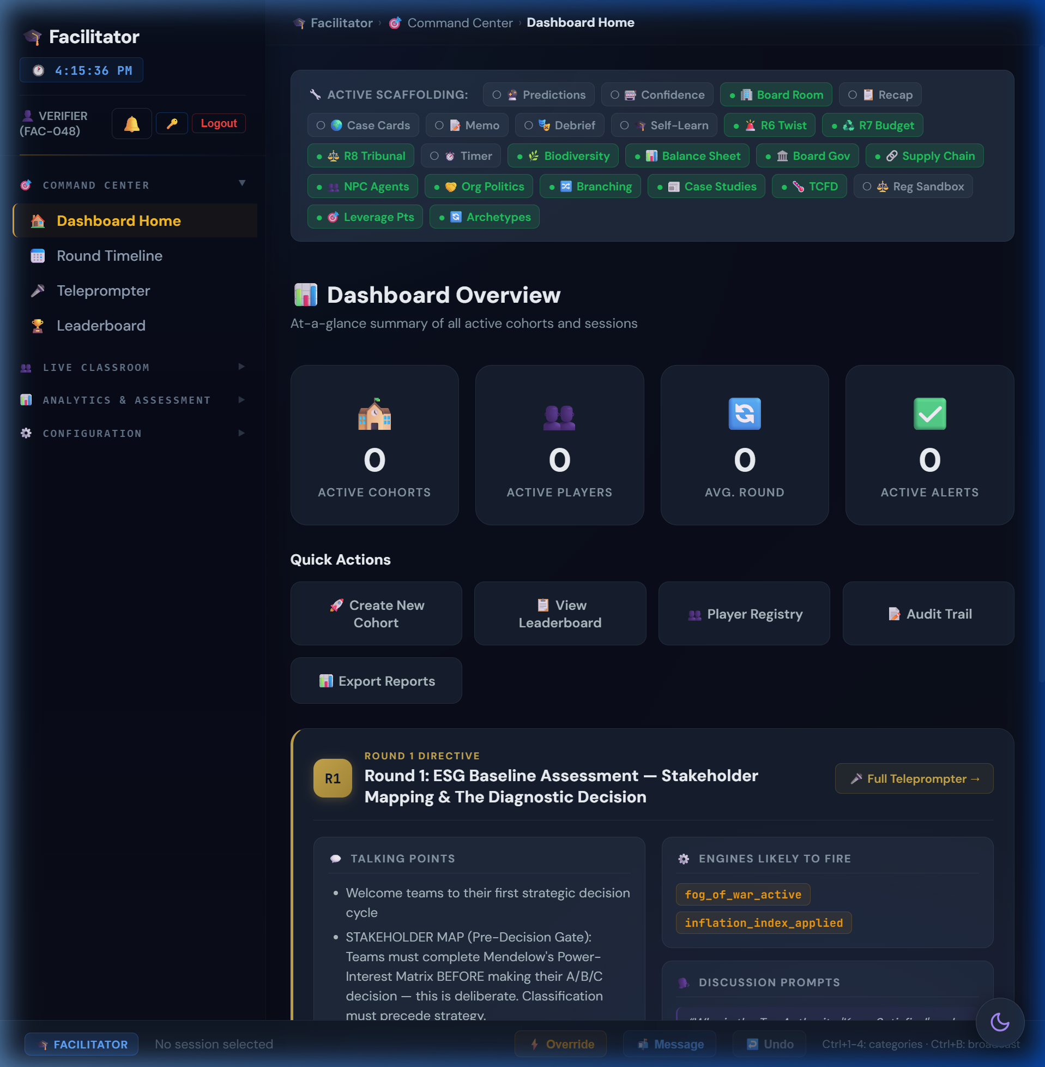
Figure: Facilitator Dashboard side track assignment panel

8.2 Track Catalog
Track | Rounds | Scoring Dimensions | Main Sim Integration
Supply Chain Ethics | 7 rounds | Transparency, Labour, Environment, Governance, Innovation, Community, Compliance | Tyler Consumer Trust Index feeds reputation; disruption score affects OPEX
Ethics & Sustainability | 5 rounds | Ethical reasoning, stakeholder analysis, regulatory awareness | Ethics score modifies governance risk; framework mastery unlocks M_R micro-bonus
Stakeholder Management | 5 rounds | Engagement quality, stakeholder satisfaction, communication | Stakeholder scores modify agent tolerance levels
Sustainability Reporting | 5 rounds | ESRS compliance, data quality, materiality accuracy | Reporting score modifies Green Bond eligibility and investor confidence

8.3 Supply Chain Deep Dive
The Supply Chain Ethics track is the most complex side track, running for 7 rounds with a 7-dimension weighted composite score. Each round presents an ethical dilemma in supply chain management.
Tyler Consumer Trust Index (CTI): A composite metric that bridges supply chain transparency decisions back to the main simulation, affecting group reputation and consumer confidence in the Consumer Goods BU.

§9. Autonomous Stakeholder Agents

9.1 System Overview
Five autonomous NPC stakeholders monitor simulation metrics independently and react based on satisfaction thresholds. They escalate through 4 lifecycle states: Supportive → Concerned → Hostile → Adversarial.
Figure: Autonomous Stakeholders panel showing agent states

9.2 Agent Profiles
Agent | Name | Icon | Monitored Metrics | Escalation Trigger
Activist Investor | Elise Thornton | 🦅 | Reputation, Carbon Intensity, Governance | Rep < 40 → Public Campaign; < 30 → Proxy Fight
EU Regulator | Commissioner Sofia Petrova | 🏛️ | Governance Risk, TNFD Disclosure | Gov Risk > 60 → Investigation; Greenwashing → Enforcement
Community Leader | Rajesh Patil | 🏘️ | Social License, Water Stress, Just Transition Fund | SLO < 40 → Protest; Water Stress > 60 → Legal Action
Journalist | Jaya Mehta | 📰 | Transparency, Reputation, Governance | Rep drop > 10 → Investigation; Greenwash → Exposé

9.3 Cascade Chain Analysis
When one agent enters hostile state, it can trigger cascades to other agents:
- Journalist hostile → -5 rep → triggers Activist Investor escalation → may trigger Regulator investigation
- Community Leader protest → -3 reputation → Journalist investigation → viral story → Activist response
- Regulator enforcement → €5-25M fine → treasury hit → triggers all agents to reassess satisfaction
⚠️ IMPORTANT: Total Corporate Collapse: If ALL 4 agents reach adversarial state simultaneously, the simulation triggers a special game-over scenario. This is extremely rare but pedagogically powerful.

§10. Facilitator God Mode & Overrides
God Mode provides the Super Administrator with system-wide control over all simulation parameters. These tools should be used judiciously to enhance learning outcomes.
- Carbon Tax Override: Adjust $/ton in real-time ($250 default, range $0-$1000). Use to demonstrate carbon pricing impact on terminal value.
- Custom Archetypes: Define M_R thresholds, custom archetype names, icons, and gradient colours for each cohort.
- Pedagogical Toggles: 30+ feature flags controlling engine visibility, prediction gates, timer pressure, peer learning, board governance, etc.
- Ending Pathway Selection: Pre-select a specific ending pathway or allow flag-based automatic selection.
- Industry Vertical Substitution: Replace default BUs with industry-specific alternatives (see §10C).
- What-If Mode: Terminal valuation predictor that shows projected outcomes based on hypothetical decisions.
- WebSocket Real-Time Interference: Live interventions pushed to all connected clients via WebSocket.
- Option Shuffle Engine: Anti-positional-bias system that randomizes A/B/C option order per session. Deterministic shuffle ensures reproducibility.
- Decision Timer: Configurable 3-10 minute countdown per round. Auto-submit or reputation penalty on expiry. Models real-world executive time pressure.

§10C. Industry Vertical Swapping Guide

10C.1 Overview
The simulation supports industry vertical substitution — replacing default BUs with industry-specific alternatives that share structural characteristics. This allows facilitators to tailor the simulation to cohort expertise (e.g., Oil & Gas for energy sector MBA students).

Figure: God Mode dashboard — Industry Vertical selector

10C.2 Slot-Fit Architecture
Each of the 4 default BU "slots" can only be replaced by verticals sharing industry characteristics (heavy/light, physical/digital):
Default Slot | Slot Characteristics | Compatible Verticals
Pharma 💊 | Heavy industry, physical assets, regulatory | Oil & Gas 🛢️
Electronics ⚡ | High carbon, complex supply chain | Oil & Gas 🛢️
Consumer Goods 🛒 | Supply chain, natural resources, packaging | Retail/FMCG 🛍️, Agriculture 🌾
Software 💻 | Asset-light, governance-heavy, talent-dependent | Banking & Financial Services 🏦, Technology 🧠

10C.3 Vertical Profiles
Vertical | Icon | Slot | Revenue | OPEX | CI | Water | NCD | Gov Risk | Description
Oil & Gas | 🛢️ | pharma/electronics | $22M | $15M | 95 | 70 | 350 | 20 | Extreme carbon, stranded asset risk
Banking & FS | 🏦 | software | $14M | $8M | 8 | 5 | 15 | 30 | High financed emissions, systemic risk
Retail/FMCG | 🛍️ | consumer_goods | $12M | $9M | 42 | 55 | 160 | 12 | Packaging waste, labour supply chains
Agriculture | 🌾 | consumer_goods | $9M | $6.5M | 55 | 90 | 280 | 15 | Extreme water dependency, biodiversity
Technology | 🧠 | software | $15M | $9M | 15 | 10 | 40 | 28 | AI/ML, data centre energy, brain-drain

10C.4 Blindspot Flag Mapping
Each vertical has its own blindspot flag equivalent to electronics_blindspot:
Vertical | Blindspot Flag | R4 Narrative Adaptation
Oil & Gas | refinery_blindspot | Refinery safety incident / pipeline leak exposé
Banking & FS | governance_blindspot | Financed emissions scandal / greenwashing fund
Retail/FMCG | supply_chain_blindspot | Labour exploitation in garment supply chain
Agriculture | land_use_blindspot | Deforestation-linked commodity sourcing exposé
Technology | data_centre_blindspot | Data centre energy consumption / AI bias overlap

10C.5 Market Overlap Matrix
When substituting verticals, cross-BU synergy effects change based on market overlap:
Pair | Overlap | Synergy Implication
Banking × Technology | 0.55 | Fintech convergence — high synergy potential
Retail × Agriculture | 0.50 | Food supply chain vertical integration
Technology × Software | 0.75 | Direct substitution — very high synergy
Oil & Gas × Agriculture | 0.30 | Energy inputs / fertiliser feedstock
Banking × Software | 0.50 | Enterprise SaaS overlap

10C.6 Facilitation Guidance
- Novice Cohorts: Use default 4-BU lineup. The narrative is optimised for the default composition.
- Energy Sector MBA: Swap Pharma → Oil & Gas. The extreme carbon intensity (95) creates dramatic tension in R3/R7/R10.
- Finance Cohort: Swap Software → Banking & FS. Governance risk (30) is highest, making R2 and R5 critical.
- Agribusiness: Swap Consumer Goods → Agriculture. Water dependency (90) makes R8 Blue Stress devastating.
- Tech Leadership: Swap Software → Technology. Brain-drain risk amplified; R6 AI Bias becomes deeply personal.
- Maximum Difficulty: Oil & Gas + Agriculture — extreme carbon and water exposure simultaneously.

PART 4 — DASHBOARD GUIDES, PLANNING & APPENDICES

§10A. Facilitator Dashboard Visual Guide
This section documents every tool available in the Facilitator Dashboard with screenshots and usage guidance.

10A.1 Command Center
Figure: Dashboard Home — summary cards, alert panels, round briefing card
Tool | Icon | Purpose | When to Use
Dashboard Home | 🏠 | At-a-glance: active cohorts, players, avg round, KPI alerts (lagging, low treasury, low rep). Quick-action buttons. Current round Teleprompter card. | Start of every session. First screen after login.
Round Timeline | 📅 | Visual timeline of round progression. Quiz difficulty controls (easy/medium/hard). Interview control panel. | Check pacing. Toggle quizzes.
Teleprompter | 🎤 | Full-screen presenter mode: talking points, engines likely to fire, discussion prompts, key themes. | Before delivering each round briefing.
Leaderboard | 🏆 | Ranked matrix: Treasury, Rep, Synergy, EBITDA, round, terminal value. Sortable. Delete/reset per session. | Monitor competition. Identify struggling teams.

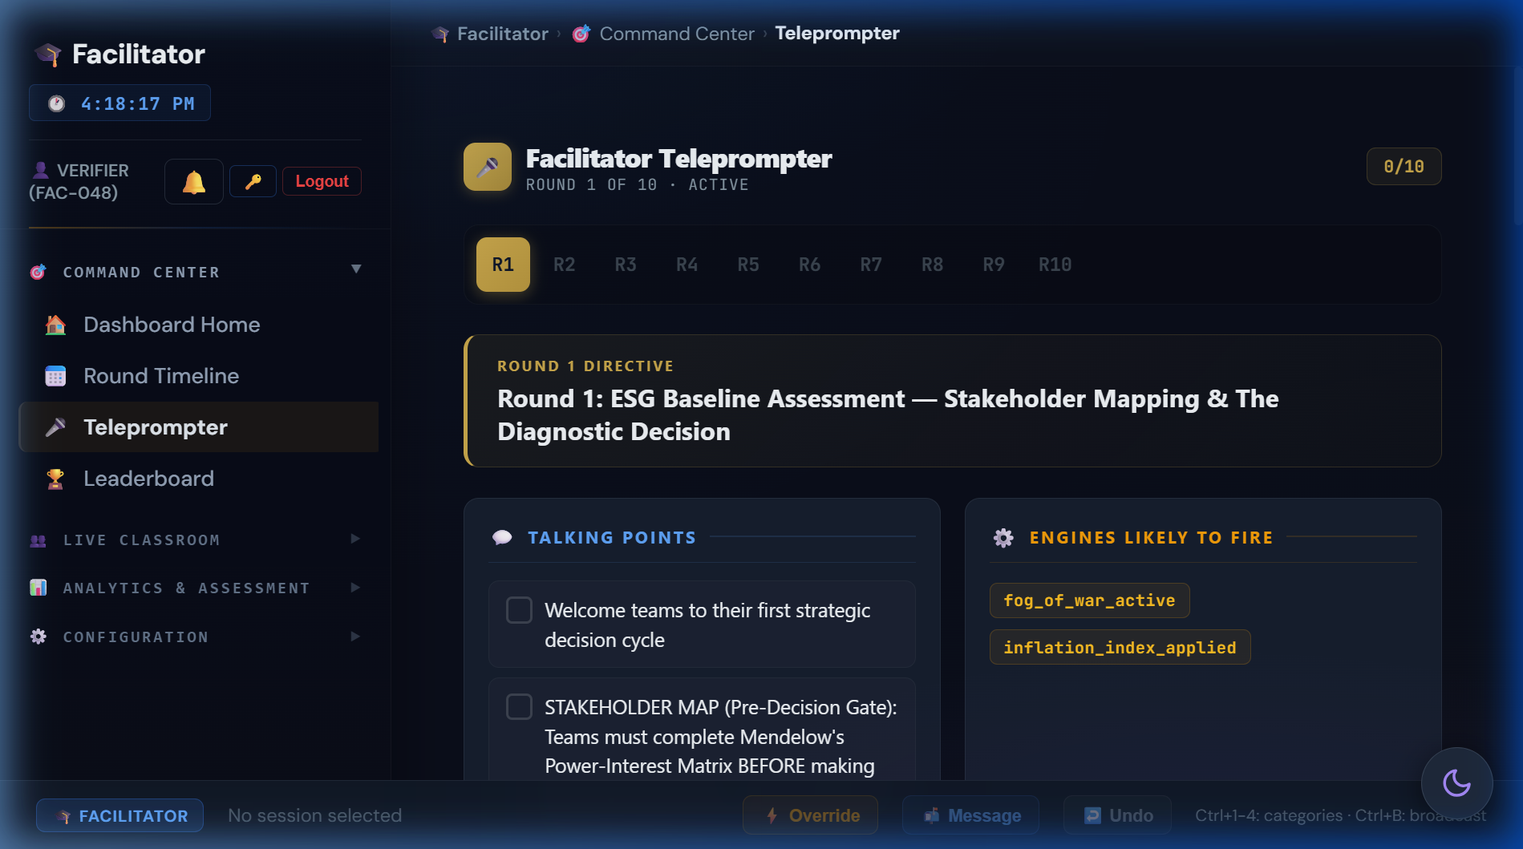
Figure: Teleprompter in full-screen presenter mode
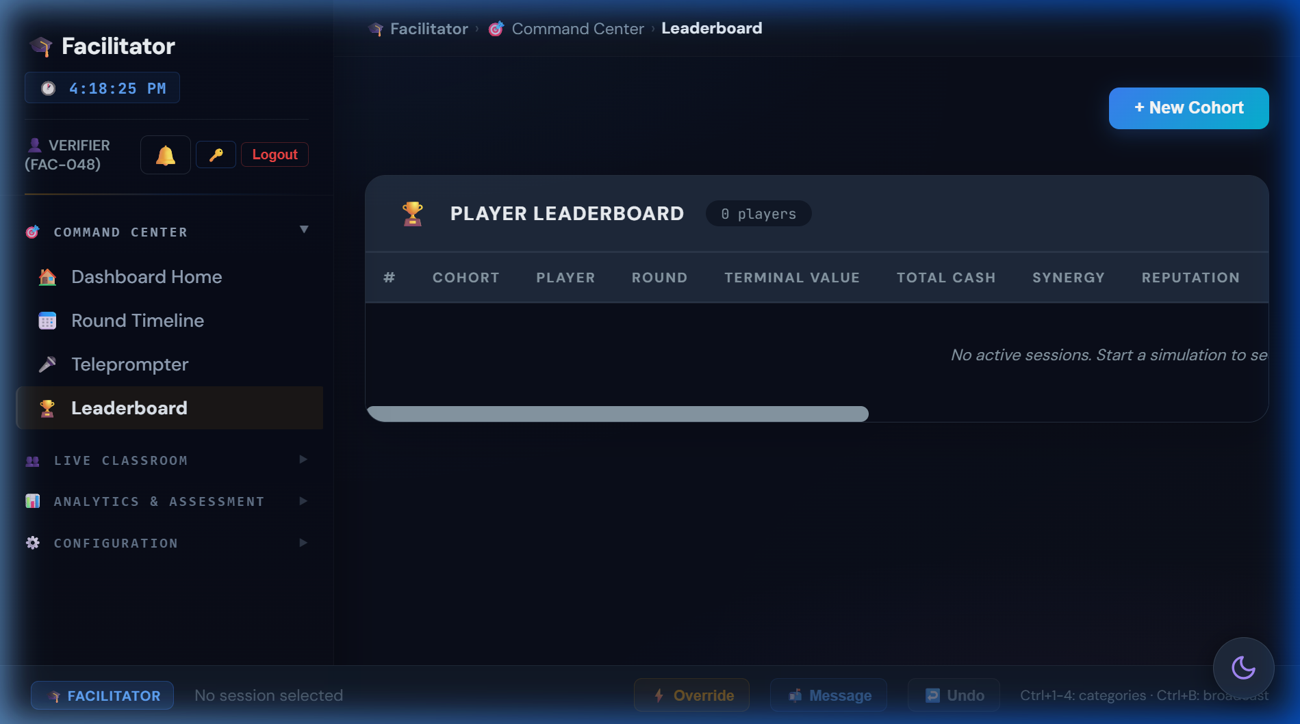
Figure: Leaderboard matrix with sortable columns

10A.2 Live Classroom
Tool | Icon | Purpose | When to Use
Player Registry | 📋 | All enrolled players: session IDs, cohort, names, timestamps, connection status. | Verify enrolment. Check connections.
Session Viewer | 👁️ | Deep-dive: full KPI breakdown, round history, decisions, real-time state. | Investigate specific team.
Team Impersonation | 🎭 | View cockpit exactly as player sees it — dashboard, mailbox, decisions, KPIs. | Live debugging, demos, walkthroughs.
Swipe File / Inbox | 📬 | Send pre-written or custom messages to individual teams. Appears in mailbox. | Inject narrative, board directives, alerts.
Bulk Messaging | 📢 | Announcements to all or selected cohorts. Templates + custom. | Class-wide announcements.
Manual Overrides ⭐ | ⚡ | Directly modify KPIs or force-advance rounds. | Live interventions, error correction.
Interventions ⭐ | 🎮 | Configure available interventions per cohort. | Pre-session toolkit setup.

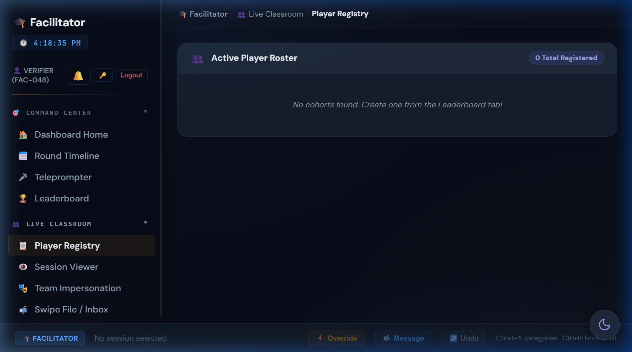
Figure: Player Registry with connection status indicators
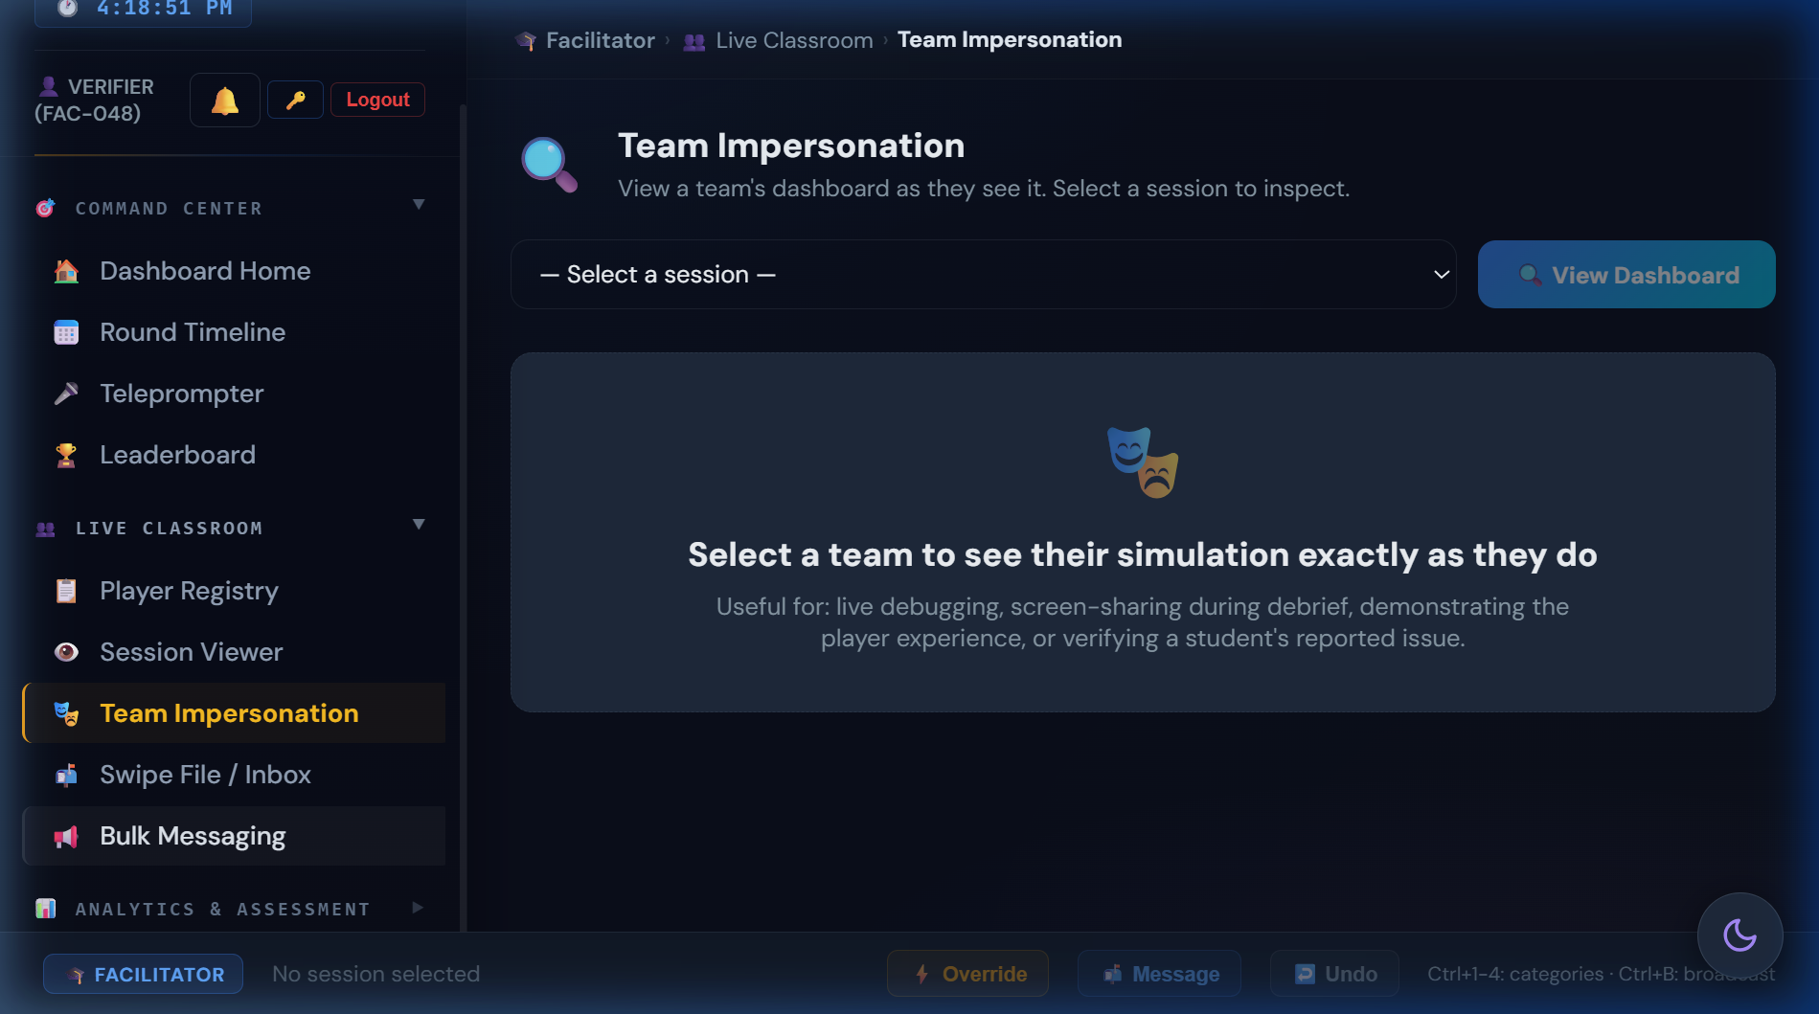
Figure: Team Impersonation showing student cockpit view

10A.3 Analytics & Assessment
Tool | Icon | Purpose | When to Use
Cohort Analytics | 📈 | 6-tab suite: Decision Heatmap, Time-to-Decision, Cohort Comparison, Convergence, Learning Outcomes, Risk Exposure. | Pattern recognition across cohorts.
Cohort Comparison | 📊 | Side-by-side KPI trajectory charts. Toggle: Treasury, Rep, Synergy, EBITDA. | Inter-cohort debrief.
Complexity Feed | 📡 | Real-time feed: engine triggers, narrative injections, math outputs. | Monitor hidden engines.
Decision History | 🕰️ | Chronological audit: timestamps, choices, CapEx, KPI deltas. Filterable. | Post-round analysis, grading.
DNA Comparison | 🧬 | Consequence DNA Sankey across cohorts. Causal chain divergence. | R10 debrief: why paths diverged.
Round Debrief | 📝 | Per-round summary: decisions, outcomes, outliers, discussion points. | Structured post-round discussion.
Scorecard Sandbox | 🧲 | Interactive TBL scorecard whiteboard. Teaching tool only. | Demonstrate scoring math.
Student Bonuses | 🎁 | Manual bonuses: participation, presentation, custom points. | Reward performance.
Peer Evaluations | 🔄 | Anonymous peer ratings: collaboration, contribution, communication. | Teamwork assessment.
Export Reports | 📤 | CSV/PDF: sessions, leaderboard, decisions, analytics, grading sheets. | End of simulation.

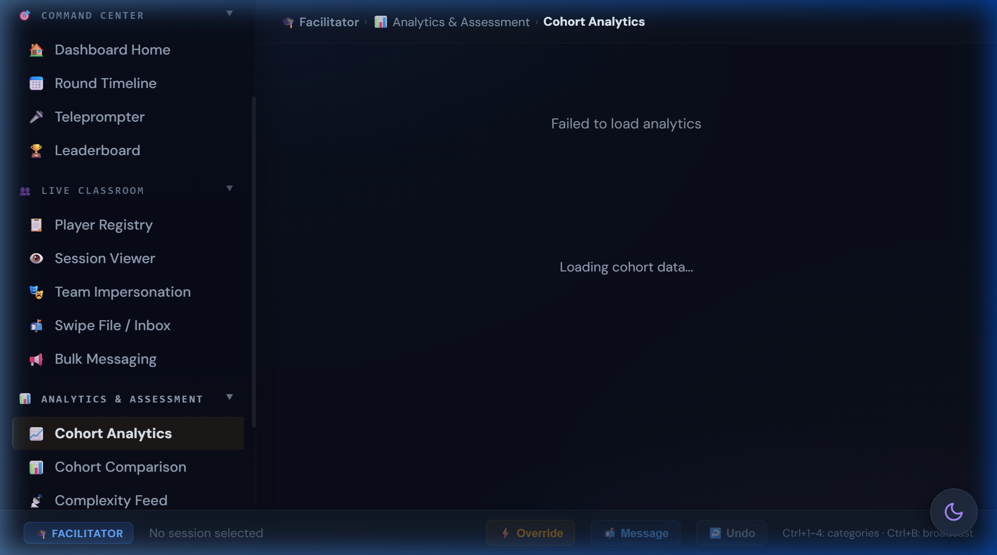
Figure: Cohort Analytics — Decision Heatmap tab

10A.4 Configuration
Tool | Icon | Purpose | When to Use
Auto-Pause ⭐ | ⏸️ | Automatic pause conditions: low treasury, rep floor, bankruptcy, custom KPI. | Pre-session safety net.
Undo Round ⭐ | ↩️ | Roll back last round, restore all KPIs. | Error correction, teaching moment replay.
Regulatory Sandbox ⭐ | ⚖️ | Inject Pigou taxes, Coase bargaining, Ostrom instruments. | Advanced: systemic resilience testing.
Materiality Matrix ⭐ | 🧩 | Mendelow's drag-and-drop. Lead: customize. Base: read-only. | Configure materiality framework.
Teaching Journal | 📝 | Private notes + timestamped annotations. Persisted. | Ongoing observations, debrief prep.
Technical Reference | 📐 | In-app reference: terminology, engines, formulas, scorecard. | Quick look-up during gameplay.
Activity Logs ⭐ | 📋 | Audit log + session management (delete, hard-reset). | Post-session cleanup.

⭐ = Requires Lead Facilitator or Super Admin role

§10B. God Mode Dashboard Visual Guide
The Super Administrator console provides system-wide control.
Figure: God Mode System Overview with scaffolding toggles

Command Center
Tool | Purpose
System Overview | Unified dashboard, session health, scaffolding toggles
Platform Analytics | Aggregated stats across ALL facilitators
Activity & Complexity | Immutable audit trail + live firehose

Cohort Orchestration
Tool | Purpose
Facilitator Registry | Create/edit facilitators, roles, permissions, cohort limits
Cohort Provisioning | Provision sessions, assign facilitators, paradigms
Session Controls | Pacing, broadcasts, visibility, scheduling
Team Interventions | Inject capital, penalties, narrative events
Crisis Overrides | Activate crises, Black Swans, end-game pathways

Engine Configuration
Tool | Purpose
Macro Economics | Global baselines, scenario presets, master variables
Systemic Risk | Black Swans, NPC cascades, tipping points, foreshadowing
Profile Archetypes | M_R thresholds for archetype classification
Regulatory Sandbox | Pigou taxes, Coase bargaining, Ostrom governance

Danger Zone
Tool | Purpose
Backup & Export | Full simulation snapshots
Factory Reset | Hard wipe ALL databases — typed confirmation required

§11. Common Student Pitfalls & Teaching Moments

"Option A is always best"
The shuffle engine randomises option order per session. No positional bias exists. Teach: read content, not position.

"Skip the audit, save $3M"
R1 Surface Scan costs $15M+ at R4 via contagion sigmoid. NPV of audit = 5x cost. Teach: option value of information.

"HR is optional"
Burnout follows quadratic curve. 60% burnout = 36% OPEX penalty + 66% R9 strike risk. Teach: human capital as binding constraint.

"ESG is a cost centre"
Terminal value spread: Titan $230M vs. Relic -$7M = 675% ROI on ESG investment. Teach: ESG as value driver.

"Ignore stakeholders"
Autonomous agents cascade: Journalist → Activist → Regulator. 3-agent hostile = corporate collapse. Teach: stakeholder salience.

"NCD doesn't matter"
6% compounding: NCD 200 → 301 in 7 rounds. Deducted from terminal value. Teach: ecological debt accumulation.

"I can recover in R9-R10"
Most M_R gates close by R8. early_decarboniser (R3), materiality_aligned (R2), nature_based (R5) — all irreversible. Teach: path dependency.

"Diversify everything equally"
Synergy rewards concentration (√ scaling). Spreading $15M across 3 pillars equally yields less than focused investment. Teach: diminishing returns.

"Deny and deflect is free"
Governance risk compounds through Cash Conversion drag, reducing revenue efficiency every round. Teach: hidden costs of opacity.

§12. Quick-Reference Cards

12.1 M_R Checklist
Round | Decision | M_R Bonus | Earned?
R2 | Full Materiality Alignment | +0.10 | ☐
R3 | Rapid Supplier Switch | +0.15 | ☐
R4 | Full Transparency | +0.10 | ☐
R5 | Nature-Based Solutions | +0.20 | ☐
R6 | Ethical AI Overhaul | +0.15 | ☐
R7 | Waste-to-Energy | +0.30 | ☐
R9 | Managed Transition | +0.12 | ☐
R9 | Community Fund | +0.18 | ☐
R10 | Instability Discount | -0.40 | ☐
— | THEORETICAL MAX | ~2.10 | —

12.2 Strike Probability Lookup
Burnout | SLO > 60 | SLO 40-60 | SLO < 40
< 20% | 5% | 10% | 20%
20-40% | 10% | 25% | 40%
40-60% | 20% | 40% | 60%
> 60% | 35% | 55% | 75%

12.3 Archetype Thresholds
M_R Range | Default Name | Climate Pathway | Community Pathway
≥ 1.80 | Regenerative Titan | Climate Vanguard | Community Champion
1.20-1.79 | De-risked Safe Haven | Transition Leader | Stakeholder Partner
0.80-1.19 | Fragile Giant | Carbon Exposed | Social Debtor
< 0.80 | Stranded Relic | Climate Casualty | Community Antagonist

§13. Session Planning & Logistics

13.1 Time Allocation
Phase | Duration | Activity
Setup | 10 min | Server check, player registration, cohort creation
Round Briefing | 5 min/round | Facilitator delivers teleprompter script
Decision Phase | 3-5 min/round | Teams discuss and submit decisions
Engine Resolution | 1 min/round | System processes tick, results appear
Debrief | 5 min/round | Post-round discussion using prompts
R5 Checkpoint | 15 min | Shadow Board Audit + mid-game formative
R10 Capstone | 20 min | Terminal valuation reveal + Thiagarajan debrief
TOTAL | ~130-150 min | Full 10-round session

13.2 Multi-Session Format
Session | Rounds | Duration | Focus
Session 1 | R1-R5 | 75 min | Foundation + Crisis + Shadow Board midpoint
Session 2 | R6-R10 | 75 min | Integration + Finale + Capstone debrief

13.3 Pre-Session Checklist
- Server running and accessible (verify with /api/health endpoint)
- Cohort created with correct industry verticals and experience level
- Player registration links distributed (share cohort join code)
- Side tracks assigned if applicable
- Ending pathway selected (or left on auto-detect)
- Pedagogical toggles configured (prediction gates, timer, peer learning)
- Teleprompter scripts reviewed for current round

§14. Assessment & Grading Rubric
Component | Weight | Assessment Method
Participation & Engagement | 20% | Attendance, decision submission timeliness, Board Room Moment completion
Reflective Quality | 40% | Strategy memo depth (R5), prediction calibration, mental model shift R1→R10
Terminal Outcome | 20% | M_R score and archetype classification (quantitative)
Peer Debrief | 20% | Cross-team analysis quality, theory application, transferable insights

14.1 Reflective Journal Prompts
Round | Prompt
R1 | What information would change your audit decision? What is the value of knowing?
R4 | Map the causal chain from R1 to R4. What assumption broke?
R5 | How did the Shadow Board change your perspective? Which persona was hardest to hear?
R7 | How did your HR investment history affect R7 outcomes? What is workforce readiness worth?
R10 | Compare your R1 mental model to R10. What shifted? What framework explains the change?

§15. Facilitator FAQ

What if a team goes bankrupt?
The Turnaround Arc activates automatically when treasury hits negative. Phase 1 (Crisis): Emergency Restructuring option appears — divest worst BU at 60% book value, -15% OPEX haircut. Phase 2 (Stabilisation): Reduced option set with recovery focus. Teams can recover to Fragile Giant but rarely reach Titan.

What if students game the system?
Three anti-gaming mechanisms: (1) Option Shuffle Engine randomises A/B/C order per session; (2) Stochastic elements (cyclone 75%, whistleblower 40%) prevent deterministic optimisation; (3) Pillar mutual exclusivity prevents maxing all sliders.

Can I run without side tracks?
Yes. Side tracks are optional enrichment. The core 10-round loop is fully self-contained. Side tracks add depth but are not required for pedagogical objectives.

How to handle uneven performance?
Use God Mode real-time balancing: inject capital to struggling teams, increase carbon tax for leaders, trigger custom Black Swans. Auto-Pause triggers can halt advanced teams while others catch up.

What if the server crashes mid-round?
All state is persisted to PostgreSQL after every tick. On restart, sessions resume from their last completed round. Player connections auto-reconnect via WebSocket.

Can I modify round configurations?
Yes, via decision_overrides.json — a JSON overlay that merges with ROUND_CONFIGS at runtime. Changes take effect immediately without server restart. Back up the file before editing.

How to explain math to non-quant students?
Use the Scorecard Sandbox (§10A.3) — interactive whiteboard where sliders show how weights affect terminal value. Focus on directional relationships (more burnout = higher cost), not formulas.

Appendix A: Glossary of Definitions
EBITDA: Earnings Before Interest, Taxes, Depreciation, and Amortisation. Sum of (Revenue - OPEX) across all BUs.
Terminal Value (TV): The company's projected worth at Year 5. Calculated as (EBITDA - Carbon Cost) x Exit Multiple x M_R.
Regenerative Multiple (M_R): Additive multiplier (1.0-2.1) rewarding sustainable strategy. Built from 10+ flag-based bonuses across R1-R10.
Carbon Intensity (CI): Per-BU metric (0-100) measuring carbon emissions per unit of output. Higher = worse.
Natural Capital Debt (NCD): Ecological liability that compounds at 6%/round. Deducted from terminal value.
Social License to Operate (SLO): Community acceptance score (0-100). Below 75 triggers -0.40 M_R instability discount.
Governance Risk Score: Per-BU metric (0-100) measuring governance quality. Higher = worse. Feeds Cash Conversion drag.
Synergy Multiplier: Cross-BU integration score (0-2.0). Gates R10 Option A (requires >80). Affects terminal value.
Workforce Readiness: Global metric (0-100) measuring workforce adaptability. Gates R7 circular economy returns.
Contagion: Sigmoid-based reputation damage propagation engine. Severity doubled by blindspot flags.
VRIO Advantage: Competitive advantage score (0.50-1.00). Decays 5%/round without investment.
Burnout Index: Per-BU metric (0-100). Quadratic OPEX penalty. >60% triggers R9 strike risk.
Brain-Drain: Software BU talent penalty when reputation <40. -15% revenue/round.
Fog of War: Progressive engine disclosure. R1-R3: 5 engines visible. R8+: all visible.
Shadow Board Audit: Mandatory R5 interception. 3 persona evaluations. Rejections set R10 pathway flags.
Ending Pathway: One of 5 R10 crisis scenarios determined by R5 flags and KPI thresholds.
Turnaround Arc: Emergency mode activated when treasury goes negative. Option T injected.
Pillar Mode: Budget allocation variant where $15M is distributed across 3 mutually exclusive pillars.
Foreshadowing: Planted news items in Market Feed (R5-R8) that signal the upcoming R10 pathway.
God Mode: Super Administrator console for system-wide control over all simulation parameters.
CSRD: Corporate Sustainability Reporting Directive (EU). Mandates double materiality assessment.
ESRS: European Sustainability Reporting Standards. CSRD implementation standards.
TCFD: Task Force on Climate-related Financial Disclosures. Physical/transition risk framework.
TNFD: Taskforce on Nature-related Financial Disclosures. Biodiversity risk framework.

Appendix B: Complete Engine Variable Registry

B.1 Global State Variables
Variable | Initial | Range | Unit | Modified By
corporate_treasury | 50,000,000 | 0-∞ | $ | All options, engine penalties
group_reputation | 55.0 | 0-100 | pts | Contagion, options, agents
synergy_multiplier | 1.00 | 0-2.0 | x | Synergy engine, R7 options
workforce_readiness | 50.0 | 0-100 | pts | HR investment, burnout inverse
inflation_index | 1.00 | 1.0-1.5 | x | +2-3%/round cumulative
green_transition_fund | 0 | 0-∞ | $ | Green Bond, R7 circular
dividend_ratchet | 0 | 0-∞ | $ | Board governance minigame

B.2 Per-BU State Variables
Variable | Pharma | Electronics | CG | Software | Range
revenue_base | 18M | 16.5M | 10.5M | 8.5M | 0-∞
opex_base | 12M | 11.5M | 7.5M | 5.5M | 0-∞
carbon_intensity | 35 | 72 | 48 | 12 | 0-100
water_dependency | 82 | 58 | 65 | 12 | 0-100
natural_capital_debt | 120 | 200 | 150 | 30 | 0-∞
social_license_score | 50 | 50 | 50 | 50 | 0-100
governance_risk_score | 15 | 20 | 10 | 25 | 0-100
staff_burnout_index | 10 | 10 | 10 | 10 | 0-100
vrio_advantage | 0.80 | 0.80 | 0.80 | 0.80 | 0.5-1.0

B.4 Flag Registry
Flag | Set By | Downstream Effect
electronics_blindspot | R1 Opt A | 2x R4 severity (40→80)
deep_audit_completed | R1 Opt B | R4 severity stays at 40
materiality_aligned | R2 Opt A | +0.10 M_R; NCD forgiveness 25%
materiality_ignored | R2 Opt C | 40% budget clawback; Green Bond blocked
early_decarboniser | R3 Opt A | +0.15 M_R; R7 amplification
green_bond_active | R3 Opt B | -15 NCD over 3 rounds
remediation_active | R4 Opt A | +0.10 M_R
nature_based_resilience | R5 Opt B | +0.20 M_R (Resilience Champion)
insurance_only | R5 Opt C | BLOCKS +0.20 M_R permanently
ethical_ai_overhaul | R6 Opt B | +0.15 M_R (Truth Premium)
ai_monetised | R6 Opt A | Contagion spike; -20 rep
waste_to_energy | R7 Opt C | +0.30 M_R; synergy unlock
managed_transition | R9 Opt B | +0.12 M_R
community_fund | R9 Opt C | +0.18 M_R
shareholder_alienated | R5 Shadow Board | Activates Activist pathway
community_distrust | R5 Shadow Board | Activates Community pathway
scientist_dismissed | R5 Shadow Board | Activates Climate pathway

Appendix C: Academic Reference Matrix
Complete mapping of every cited theory to its simulation application, organized by round.
Citation | Framework | Round(s) | How Applied in Simulation | Debrief Prompt
Mendelow, A. (1991) | Stakeholder Mapping | R1 | Drag-and-drop Power x Interest matrix classifies 8 stakeholders before audit decision. | What stakeholder did you misclassify? How would reclassification change your strategy?
Mitchell, R., Agle, B., & Wood, D. (1997) | Stakeholder Salience | R1,R5,R9 | Power x Legitimacy x Urgency drives autonomous agent escalation levels and Shadow Board persona authority. | Which stakeholder gained urgency during the simulation? Why?
EU Commission (2022) | CSRD / ESRS | R2 | CFO materiality gate requires double materiality classification. ESRS 1 §1.51 violation triggers 40% clawback. | How does mandatory vs. voluntary disclosure change behaviour?
Dixit, A. & Pindyck, R. (1994) | Real Options Theory | R1→R4 | Deep audit = purchasing an option on future crisis mitigation. Option NPV = 5x cost ($3M → $15M avoided). | What was the option value of the R1 audit?
Argyris, C. (1977) | Double-Loop Learning | R4 | R4 cascade forces players to question R1 assumptions — the core double-loop trigger. | What assumption broke at R4? How did you update your mental model?
Kahneman, D. (2011) | System 1/2 Thinking | R4,R6 | Time pressure and stochastic elements force heuristic (System 1) decisions. Debrief reveals analytical (System 2) gaps. | Did time pressure change your decision? How?
Moon, J. (2004) | Reflection Protocol | R4,R5 | 3-stage Board Room Moments: Noticing → Making Sense → Working with Meaning. | What surprised you? Why? What will you change?
Jensen, M. & Meckling, W. (1976) | Agency Theory | R5 | Shadow Board personas embody principal-agent conflicts: shareholder value vs. community welfare vs. scientific evidence. | Whose interests did you prioritise? Why?
Barney, J. (1991) | Resource-Based View | R7 | VRIO advantage decays without investment. Circular capabilities = rare, valuable, non-substitutable. | Which capability is your most durable competitive advantage?
Teece, D. (2007) | Dynamic Capabilities | R7 | Workforce readiness gates circular economy returns. Sensing, seizing, reconfiguring capabilities. | How did workforce readiness constrain your options?
Hardin, G. (1968) | Tragedy of the Commons | R8 | Water scarcity forces collective resource allocation. Prioritising one BU depletes shared resource. | Is prioritising highest-margin BU rational? From whose perspective?
Rawls, J. (1971) | Justice as Fairness | R9 | Difference Principle applied: factory closure must benefit the least advantaged (workers/community). | Who bears the cost of decarbonisation? Is that just?
Freeman, R.E. (1984) | Stakeholder Theory | R9 | Community Fund option embodies stakeholder value creation beyond shareholder returns. | Does stakeholder investment create or destroy shareholder value?
Costanza, R. et al. (1997) | Natural Capital | All | NCD compounds at 6%/round modelling ecological debt. Deducted from terminal value as liability. | What is the interest rate on ecological debt?
Meadows, D. (1999) | Leverage Points | R10 | Debrief overlay identifies 12 leverage points in the simulation system hierarchy. | Where would you intervene in this system? At what leverage point?
Kolb, D. (1984) | Experiential Learning | All | Full cycle: R1-R5 (Concrete Experience) → R4 debrief (Reflection) → R6-R8 (Conceptualisation) → R9-R10 (Experimentation). | How did your strategy evolve across the learning cycle?
Thiagarajan, S. (1993) | Debrief Protocol | R10 | 3-phase: How Do You Feel? (2 min) → What Happened? (5 min) → So What? (10 min). | What one principle would you take to a real boardroom?

