The Muressons Stakeholder Module
Comprehensive Reference — architecture, archetypes, and decision flow
Business & Sustainability simulation · stakeholder ↔ Social-License-to-Operate (SLO) system

Contents
Open in Word and right-click → Update Field to populate the table of contents.

Part I — Conceptual Overview
This part is written for facilitators and designers: what the stakeholder module represents, who the stakeholders are, and how the system behaves. Part II goes to code level for engineers.

1. Purpose: why the module exists
Muressons is a conglomerate-management simulation in which players run four business units across ten six-month rounds. Financial success alone is not the point — the goal is that players learn to manage the company's Social Licence to Operate (SLO): the ongoing acceptance a business earns from the communities, regulators, investors and media around it. The stakeholder module makes that licence feel earned rather than scored: stakeholders remember how they were treated, escalate when neglected, form coalitions, hold the company to its promises, and — when pushed far enough — strike, sue, divest, or expose.

2. The core idea in one loop
Everything in the module is one reinforcing loop. Player decisions move SLO; SLO decides how each stakeholder feels; feeling becomes escalation and action; those actions hit revenue, reputation, treasury and SLO itself — which constrains the next round. Neglect compounds, and 'stakeholder fatigue' makes each recovery harder.
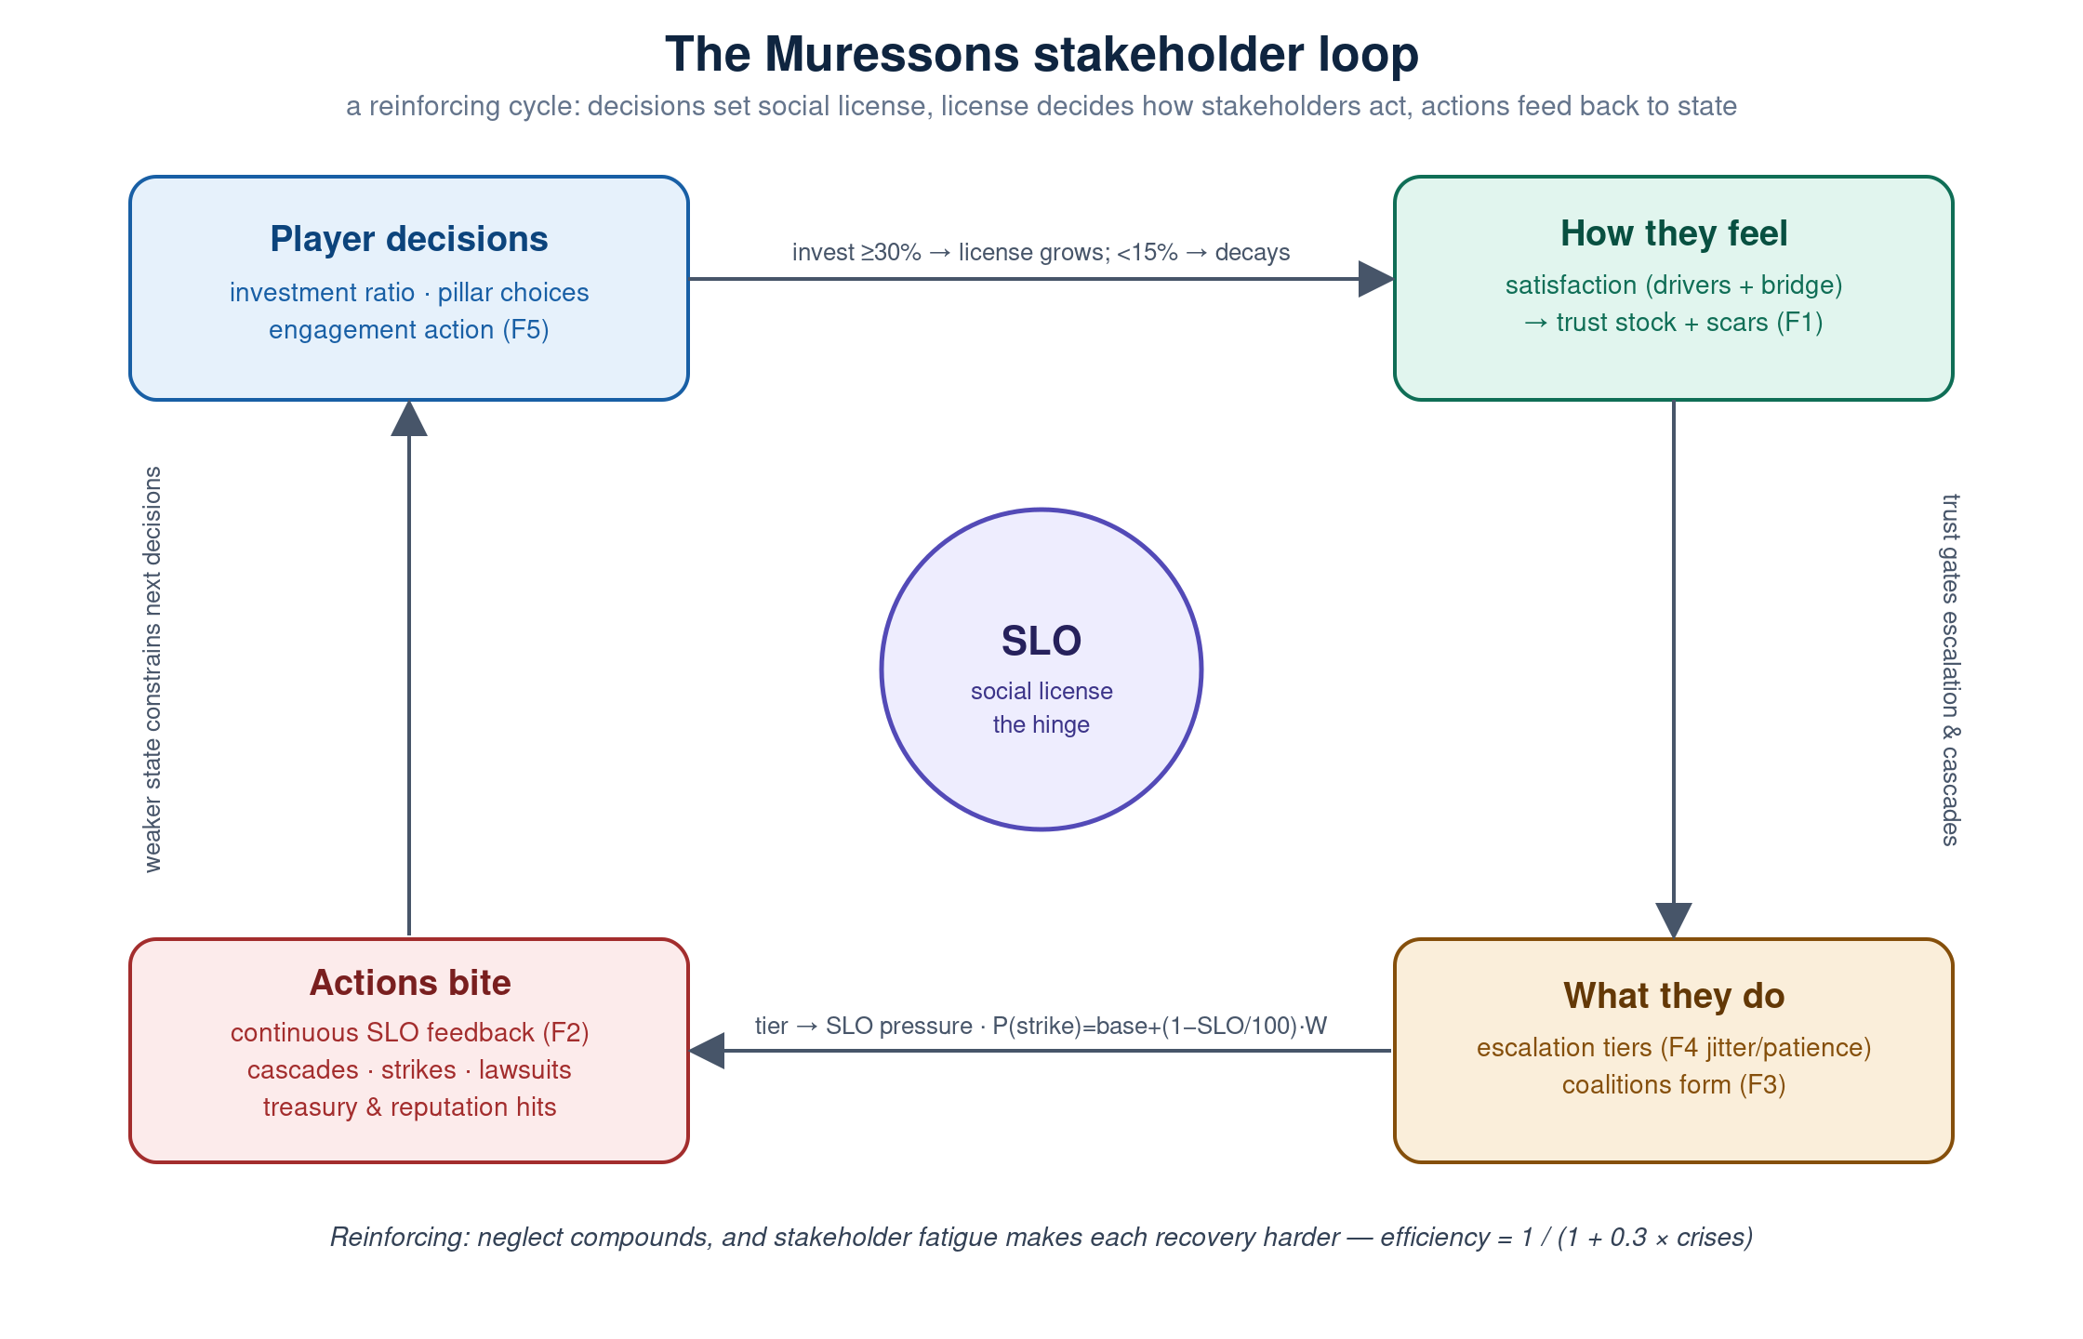
Figure 1 — the stakeholder feedback loop. SLO is the hinge; F1–F6 label the behaviour waves.

3. The stakeholder landscape
Players first meet the stakeholders as a Mendelow power/interest mapping exercise in Round 1. Ten stakeholders surround the company; power and interest are to be inferred from behaviour, not labels. The Regional Business Journalist is deliberately ambiguous (latent power activated by urgency) and accepts two quadrants.
Stakeholder | Quadrant | Signal in the brief
FutureFirst Activist Fund | Manage closely | 7% blocking stake; three climate-disclosure resolutions; AGM proxy threat
EU Regulators | Manage closely | CSRD compliance notice; Düsseldorf site inspection
Deccan Plateau Local Communities | Keep informed | Groundwater protest at Pune; Right-to-Water petition
Tier-3 Mine Workers | Keep informed | DRC cobalt supply chain; ILO flag; no PPE
Factory Floor Employees | Keep informed | Overtime grievance; rising unionisation
Institutional Syndicate Banks | Keep satisfied | €2.1B revolving credit with covenant triggers
National Government Tax Authority | Keep satisfied | Transfer pricing; CBAM on the horizon
Corporate Cafeteria Vendors | Monitor | Low-influence supplier
General Public | Monitor | 4% brand awareness (B2B)
Regional Business Journalist | Monitor / Keep informed | Investigative reporter (J. Mehta, Deccan Herald)

4. The reactive archetypes
Four of the mapped stakeholders come alive as AI-driven NPCs that react round to round, each voiced by a named representative and modelled on the Mitchell, Agle & Wood (1997) salience framework — power (can they hurt you?), legitimacy (is their claim valid?) and urgency (how fast must you respond?). The persona names are the voices; the organizations are the stakeholders.

4.1 FutureFirst Activist Fund — voiced by Elise Thornton
managing director · assertive · 🦅
- Leverage (salience): high power, high urgency, moderate legitimacy
- What moves them: Climate disclosure, board diversity, stranded assets. Rewards rising reputation, ESG-linked pay and low carbon; punished by governance risk.
- Escalation ladder: Supportive → Concerned letter to the board → Public campaign → Proxy fight / AGM challenge.
- At breaking point: At breaking point launches a divestment campaign (share price −5%, reputation −8, drags the media in) or a proxy fight (−$2M AGM cost, governance improves, and the regulator starts watching).
“We’ve been patient, but your governance shortfall is becoming a liability.”

4.2 EU Regulators — Commissioner Sofia Petrova
EU DG FISMA, Corporate Sustainability Division · methodical · 🏛️
- Leverage (salience): very high power and legitimacy, lower urgency (slow but decisive)
- What moves them: CSRD compliance, taxonomy alignment, audit quality. Rewards low governance risk and strong disclosure.
- Escalation ladder: Compliant (no action) → Enhanced monitoring → Formal investigation → Enforcement action / fine.
- At breaking point: At breaking point issues an enforcement action: a fine worth ~4% of revenue plus mandatory enhanced disclosure, pulling both media and activist investor in behind it.
“Persistent non-compliance is not acceptable.”

4.3 Deccan Plateau Local Communities — Rajesh Patil
head panchayat · passionate · 🏘️
- Leverage (salience): high legitimacy, low power — pressure builds slowly but is morally weighty
- What moves them: Water rights, employment, environmental justice. Rewards social licence, water stewardship and a funded just-transition; punished by water stress.
- Escalation ladder: Community partnership → Community monitoring → Community protest → Legal action / injunction.
- At breaking point: At breaking point files a court injunction against facility operations (SLO −10, reputation −5) and the press covers the story.
“Our water, our land, our lives! Muressons takes everything and gives nothing.”

4.4 Regional Business Journalist — Jaya Mehta
Deccan Herald Business · curious · 📰
- Leverage (salience): moderate across the board — the amplifier rather than the initiator
- What moves them: Transparency, greenwashing, worker conditions. Rewards openness and reputation; punished by governance risk.
- Escalation ladder: Positive feature story → Balanced coverage → Critical investigation → Viral exposé.
- At breaking point: Has no cascade of its own, but is the amplification target other stakeholders’ cascades reach for — a hostile press multiplies every other reputational hit.
“Documents reveal systematic failures. Investors are demanding answers.”
A fifth archetype, the Gen-Z Employee, exists in the reaction catalogue (a coordinated mass resignation that spikes burnout +15, OPEX +8% and reputation −5) but does not yet carry a full satisfaction/escalation profile — it is a defined extension point rather than an active reactive NPC.

5. The six behaviour waves at a glance
On top of the base reactions, six optional waves deepen the realism. Each is independently switchable per cohort and ships off by default, so a facilitator can dial the richness up as a class matures.
Wave | What it adds
F1 — Memory | A persistent trust stock that rises slowly, falls fast, and scars on betrayal; a sentiment bridge keeps named NPCs consistent with the portfolio view.
F2 — SLO feedback | Each stakeholder's escalation tier continuously nudges the social licence of the units it is attached to.
F3 — Coalitions | Two or more hostile stakeholders combine into a coalition that amplifies SLO pressure and strike risk.
F4 — Uncertainty | Escalation thresholds are jittered per cohort (fair but unknown) and a patience clock forces escalation.
F5 — Promises | Town halls, public pledges and private commitments, tracked in a ledger — kept promises pay off, broken ones scar.
F6 — Intel | An intent-forward view of what each stakeholder wants, its leverage and its trend — numbers kept to the facilitator view.

Part II — Technical Deep-Dive
This part is written for engineers and system designers: modules, state, the round pipeline, the governing formulas, configuration and safety.

6. Architecture & modules
Module | Responsibility
npc_stakeholders.py | The four reactive NPCs: satisfaction, the trust integrator (F1), escalation with jitter/patience (F4), continuous SLO feedback (F2), and the intent intel emitter (F6).
stakeholder_sentiment.py | Portfolio-level sentiment: per-stakeholder attitude_score, flag-driven deltas, black-swan shocks, and salience-weighted scoring.
systemic_risk_engine.py | Discrete reaction cascades (STAKEHOLDER_REACTION_GATES), coalitions & contagion (F3), materiality shocks, and systemic tipping points.
stakeholder_engagement.py | Engagement actions and the promise ledger (F5).
round_logic.py :: run_new_engines | Orchestration and gating — each engine in a toggle-guarded try/except so no stakeholder engine can block a tick.
engine.py :: process_tick | SLO natural decay, pillar deltas, strike probability, sentiment update, and the whitelisted next-round state assembly.
config.py | All tunables, resolved from the config-Excel pipeline.

7. State model & persistence
All reactive-NPC state lives in one sub-dict, global_state["npc_stakeholders"], holding each NPC's profile, satisfaction, trust, escalation level, interaction history, scar window, threshold offsets, and the promise ledger. process_tick rebuilds the next-round state from an explicit whitelist that historically dropped this sub-dict; it is now carried forward via a named ENGINE_STATE_KEYS passthrough so trust, promises and patience persist. The sub-dict never surfaces through the typed GlobalStateOut response; per-round UI data flows through the diagnostics channel.

8. Decision flow — order of operations
A single player commit produces a single tick. The stakeholder work happens in a fixed order, chosen so SLO is finalised for the round's economics before the stakeholder engines read it, and so cascades, coalitions and continuous feedback compose without double-counting.
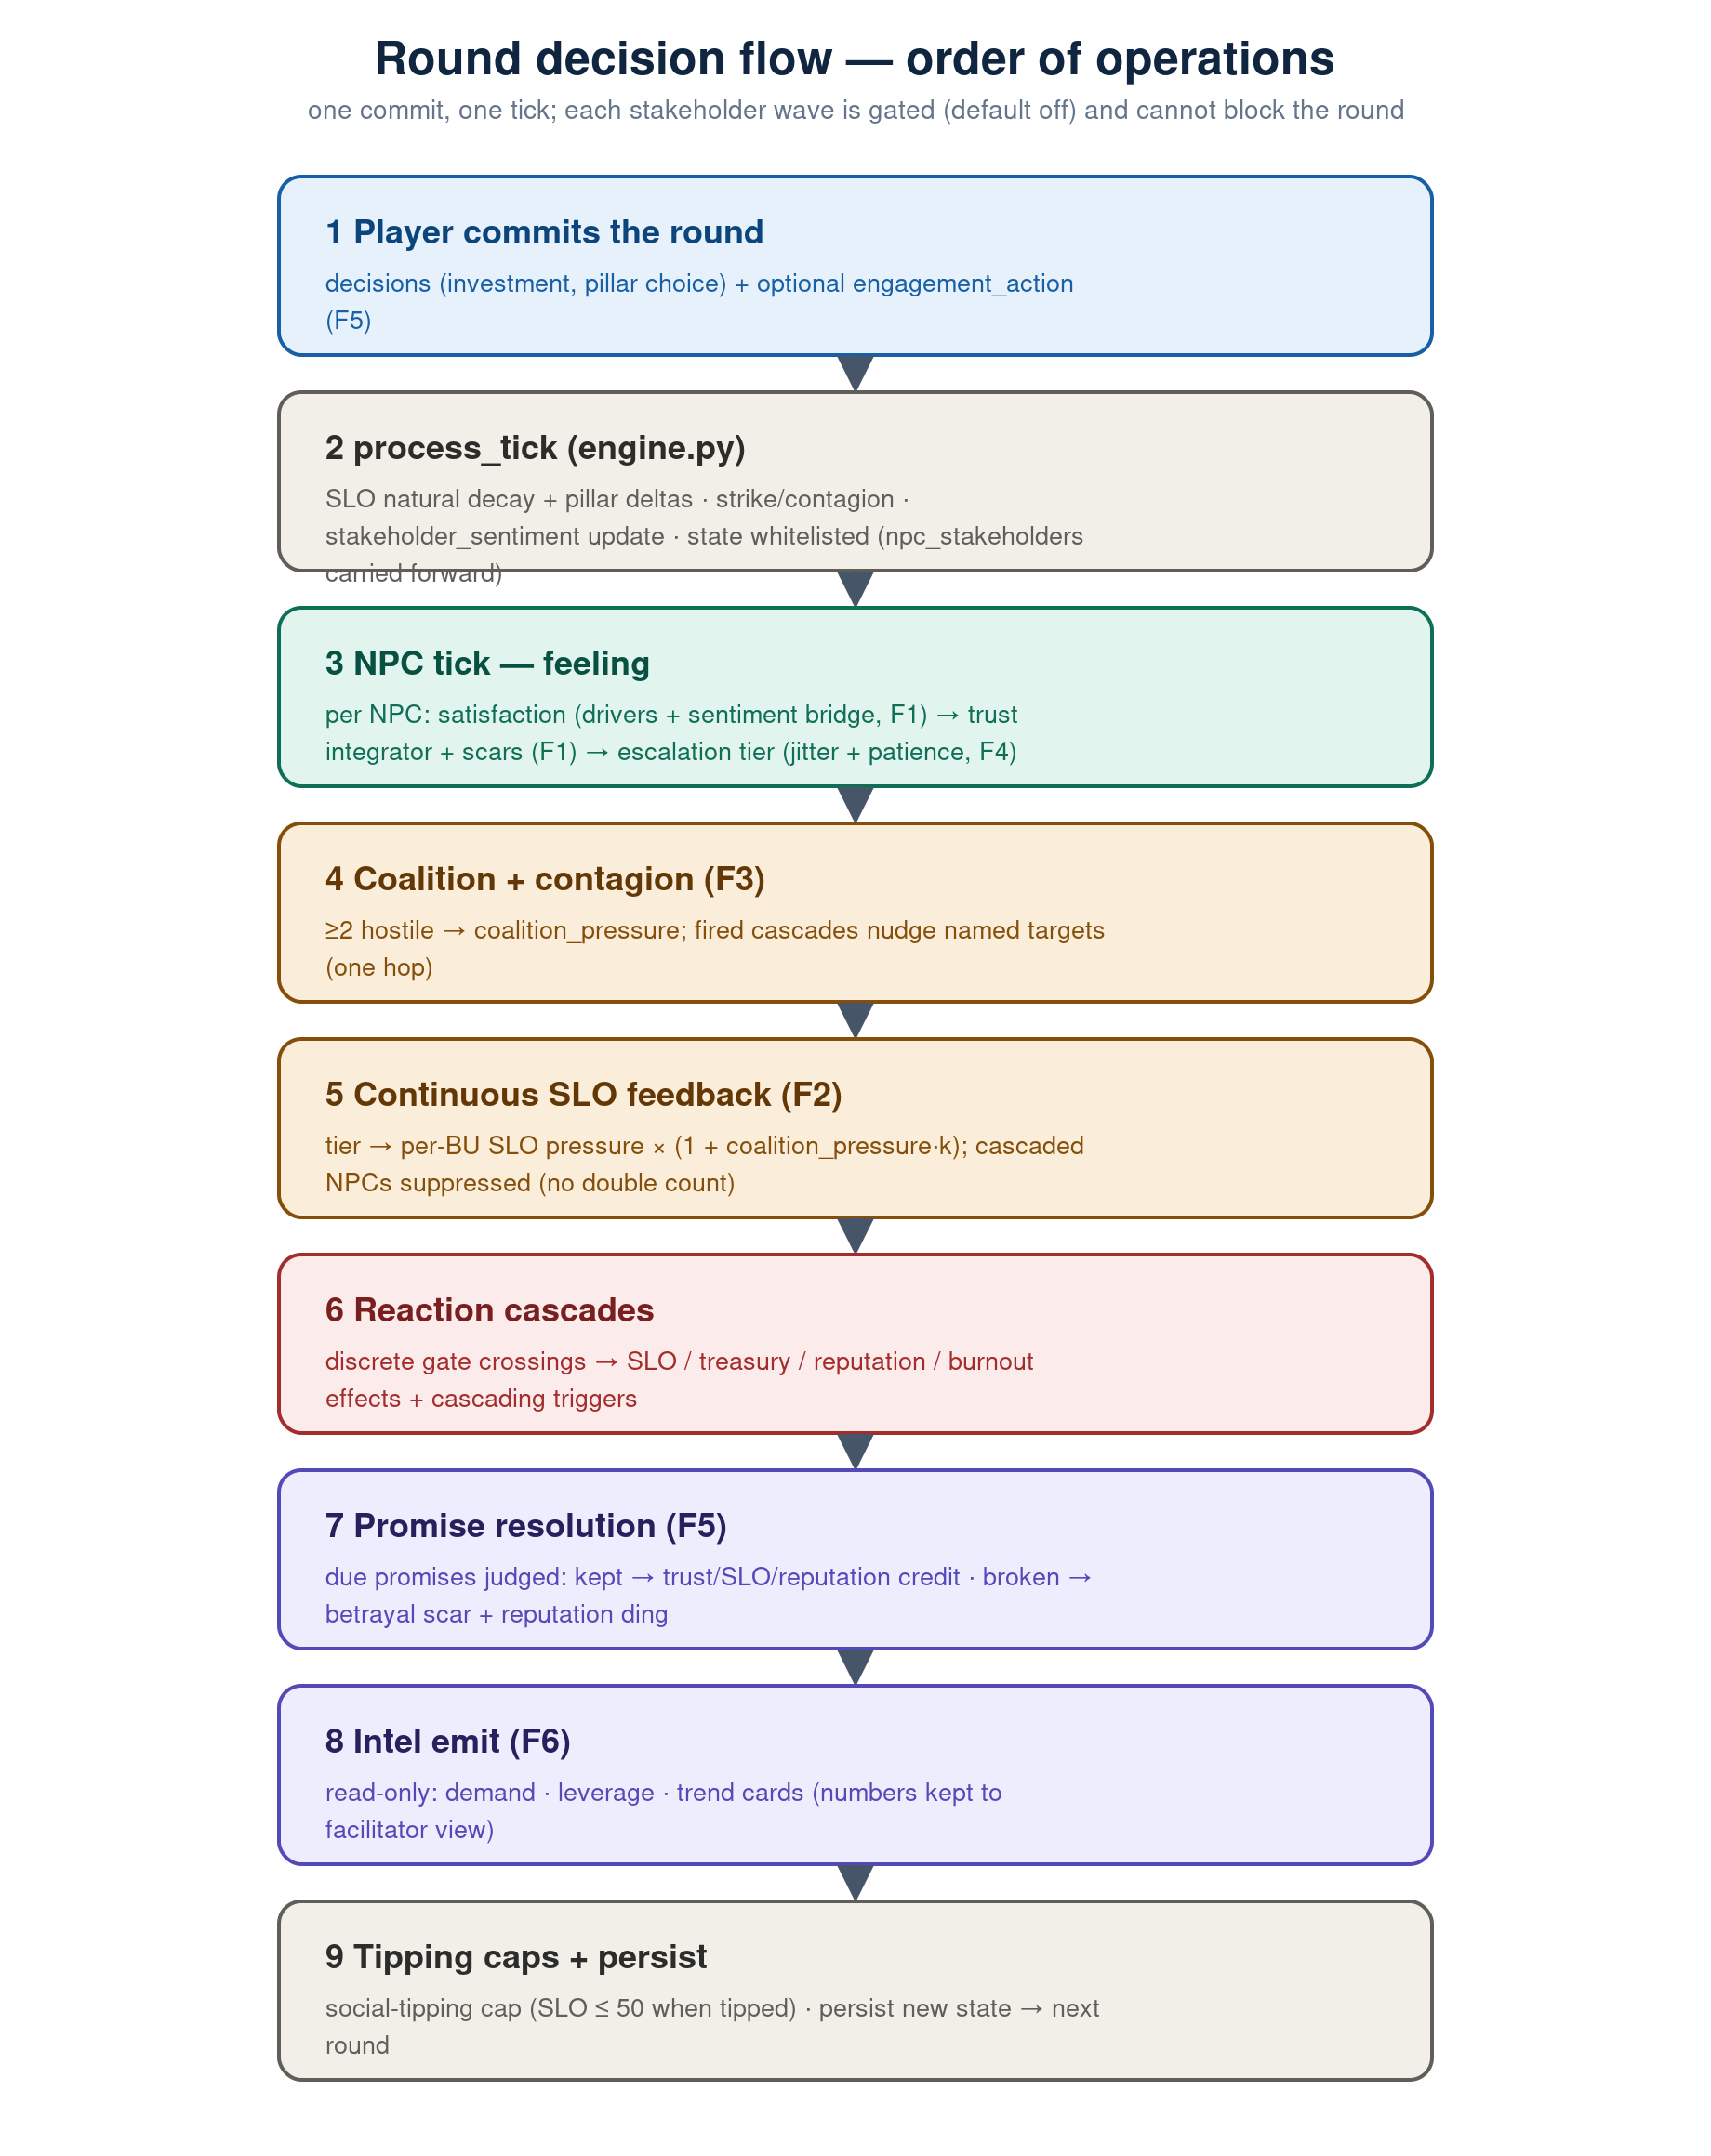
Figure 2 — the round pipeline. Steps 3–8 are the stakeholder engines, each gated and non-fatal.
The double-count guard: continuous SLO feedback (step 5) runs after cascade detection but before cascade effects, and suppresses any NPC that cascades this round. The later social-tipping cap still clamps SLO.

9. The governing mechanics

9.1 Natural decay & satisfaction
An unattended SLO drifts: investment ratio ≥ 0.30 grows it (+3 to +10), ≥ 0.15 holds it, below 0.15 decays it ~4% (×0.96). Satisfaction for each NPC is a weighted sum of its drivers:
satisfaction = clamp(50 + Σ weight·(value − baseline), 0, 100)
With F1 memory on, satisfaction is blended toward the matching sentiment cohort's attitude_score at bridge_weight 0.30, so the named NPC and the portfolio view cannot drift.

9.2 Trust integrator & scars (F1)
gap = satisfaction − trust_prev
rate = 0.25 if gap ≥ 0 else 0.55
trust = trust_prev + rate·gap
# betrayal: trust −= 12 ; recovery capped at 60 for 3 rounds

9.3 Escalation tiers & uncertainty (F4)
Escalation selects the worst tier whose threshold the gating metric clears — trust when memory is on, else satisfaction. Thresholds are jittered ±4 (seeded once per cohort); a patience clock escalates any NPC held at a wary tier for three rounds.

9.4 Continuous SLO feedback (F2)
pressure = [+1.0, 0.0, −2.0, −3.5][tier] × coupling × (1 + coalition_pressure·0.5)

9.5 Reaction cascades
At lower thresholds, stakeholders cross discrete gates with hard effects — divestment, enforcement, injunction, mass resignation — each carrying deltas and a list of cascading_triggers. See Appendix A.

9.6 Coalitions & contagion (F3)
coalition_pressure = min(1.0, mean_salience · (member_count − 1))
The pressure amplifies F2 and next round's strike risk; each fired cascade nudges its named targets by −5, one hop only, so a chain can never run away.

9.7 Strike probability
P(strike) = base_risk + (1 − SLO/100)·0.4·(1 + coalition_pressure·0.5) # clamped [0,1]
# base_risk = governance_risk / 100 ; fatigue: recovery = 1 / (1 + 0.3·crises)

9.8 Promises & engagement (F5)
A town hall (+3 trust, no promise), public pledge (+6, promise) or private commitment (+4, promise), each with a treasury cost. Kept → +8 trust, +4 SLO, +3 reputation; broken → the F1 scar (−12 trust) and −6 reputation. The ledger lives in the carried-forward npc_stakeholders sub-dict.

9.9 Intent intel (F6)
A read-only emitter turns each NPC into a card: its top unmet demand in plain language, its leverage (salience in words), and its trend. The demand phrasing is authored on the backend as the single source of truth, so the front-end rail cannot drift.

10. Configuration & toggles
Toggle (default off) | Wave / effect
stakeholder_memory_enabled | F1 — trust stock, scars, sentiment bridge
stakeholder_slo_feedback_enabled | F2 — continuous tier → SLO feedback
stakeholder_engagement_enabled | F5 — engagement actions + promise ledger
stakeholder_coalitions_enabled | F3 — coalitions & salience contagion
stakeholder_uncertainty_enabled | F4 — seeded thresholds + patience
stakeholder_intel_ui_enabled | F6 — intent-forward intel rail

Recommended order: Memory → SLO feedback → Promises, then Coalitions, Uncertainty and Intel. Enabling F1–F5 changes the golden trace (trust and SLO now evolve) — that diff is the signal the wave works; re-baseline deliberately. All tunables resolve through config.py's config-Excel pipeline.

11. Testing & safety
- Golden oracle: A seeded golden round-trace oracle pins SLO, reputation, governance risk and NPC state across a fixed 10-round run; with every wave off it stays byte-identical to the prior baseline.
- Per-wave tests: Trust asymmetry/scars, the sentiment bridge, the F2 guards, coalition/strike coupling, jitter/patience, promise kept/broken, and the intel drift tripwire.
- Determinism: All randomness flows through the seeded per-cohort stream.
- Non-fatal: Every engine runs in a toggle-guarded try/except that logs and continues.

Appendix A — Reactive-archetype specification

Salience (Mitchell–Agle–Wood)
Stakeholder (voice) | Power | Legitimacy | Urgency
FutureFirst Activist Fund (Thornton) | 0.85 | 0.70 | 0.90
EU Regulators (Petrova) | 0.95 | 0.95 | 0.60
Deccan Communities (Patil) | 0.30 | 0.90 | 0.75
Regional Journalist (Mehta) | 0.50 | 0.60 | 0.40

Satisfaction drivers (weight, baseline)
Stakeholder | Drivers
FutureFirst Activist Fund | reputation (+0.3/50), carbon intensity (−0.3/50), ESG-linked pay (+0.2/20), governance risk (−0.2/30)
EU Regulators | governance risk (−0.4/30), reputation (+0.2/50), TNFD disclosure (+0.2/0)
Deccan Communities | social licence (+0.4/50), water stress (−0.3/40), just-transition fund (+0.2/0)
Regional Journalist | transparency (+0.3/50), reputation (+0.2/50), governance risk (−0.3/30)

Reaction-cascade gates
Stakeholder → action | Trigger | Effects
FutureFirst → divestment campaign | trust < 25 | treasury −5%, reputation −8, drags in journalist (persists 2 rounds)
FutureFirst → proxy fight | trust < 15 | −$2M, governance risk −10 (improves), board change, regulator watches
EU Regulators → enforcement action | trust < 20 | treasury −4% fine, mandatory disclosure, drags in journalist + investor
Deccan Communities → court injunction | trust < 20 | SLO −10, reputation −5, drags in journalist
Gen-Z employee → mass resignation | trust < 20 | burnout +15, OPEX +8%, reputation −5, drags in journalist

Appendix B — Key configuration constants
Constant | Default | Meaning
TRUST_GAIN_RATE / LOSS_RATE | 0.25 / 0.55 | Asymmetric trust integration (rise / fall)
TRUST_SCAR_IMMEDIATE / DURATION / CEILING | 12 / 3 / 60 | Betrayal hit, scar window, capped recovery
NPC_SENTIMENT_BRIDGE_WEIGHT | 0.30 | Pull of the portfolio cohort on named-NPC satisfaction
STAKEHOLDER_SLO_COUPLING | 1.0 | Scales the F2 per-tier SLO pressure
COALITION_TIER_MIN / F2_GAIN / STRIKE_GAIN | 2 / 0.5 / 0.5 | Hostile-tier threshold; coalition amplification
CONTAGION_SAT_NUDGE | 5.0 | One-hop nudge to a cascade's named targets
THRESHOLD_JITTER / PATIENCE_LIMIT | 4.0 / 3 | Threshold band; rounds-at-tier before forced escalation

Muressons stakeholder module — reference v1.1. Canonical roster with reactive personas; mechanics gated behind per-cohort toggles; all tunables config-Excel adjustable.

