Survey engine Application

Laurian Staicu 1696177

php

The survey engine will allow the company during events to collect information and feedback from people interested in our company. The interaction will be a such way designed that it has to be performed in no more than 5 minutes.

The application will collect first the names , email and phone number of the Surveyee. The software will send an email to the customer. The next phase of the survey will include multiple choices questions that the customer will answer. Then the next page will contain a feedback section.

The survey platform also have management and marketing functionalities. Sending promotional emails to surveyed customers , analysis of the collected information. Analytical metrics will be defined by the company. Such metrics could be:

1. The number of people surveyed per event
2. What services they are interested in.

On the administration side of the application, the user will be able to create, edit, modify, and delete surveys. User will be able to select the survey from a list and use it for a survey or modify it for the requirements of the event.

Technologies will be used in the project:

Facebook login

Admin panel

Google map

Links used in the application :

Administrator side:

1- admin login(no registration)

2-create survey

3-add question to survey

4-edit survey

5- delete survey

6-promotion marketing email campaign

7-analize survey by location, number of surveyed attendees

Surveyee side:

1-register with name, email, phone number, occupation

2- answer the questions from the survey(2 pages with multiple choices)

3-leave feedback

3-receive email confirmation from registration process

**Teacher’s solution:**

**/login (for admin only)**

**/surveys/:id/{add,list,edit,delete,promote,analyze}**

**/questions/:surveyId/{list, add, edit, delete}**

**/take/:surveyId/:pageId**

The database surveydb schema will include 5 tables:

1. Users
2. Surveys
3. Questions
4. Reponses
5. Events

We will define the database attributes for each table:

Users:

1. Id
2. Name
3. Email
4. Phone
5. Company
6. Position

Surveys:

1)id int

2)name varchar(200)

2)dateofsurveys

3)idquestion1 int

4)idquestion2 int

Questions:

1)id int

2)question varchar (400)

3)answer1 varchar (200)

5)answer2 varchar (200)

6)answer3 varchar (200)

7)answer4 varchar (200)

Reponses:

1)id

2)userid

3)surveyid

3)eventId

4) answernumber 1, 2, 3 or 4

Events:

1)EventId

2)DateEvent

3)Eventlocation

4)eventdescription

Mock up windows:

Admin login:

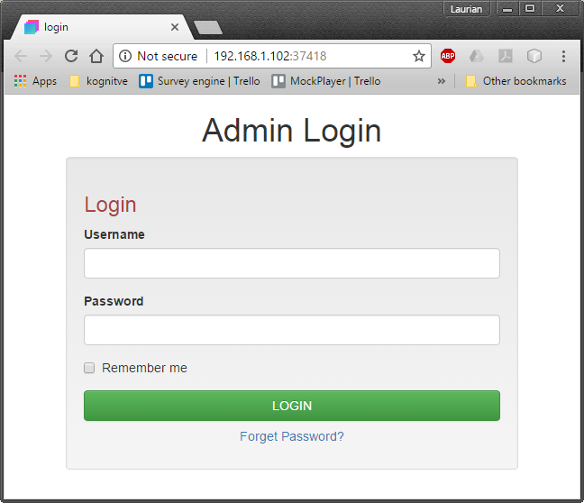

Register Surveyee:

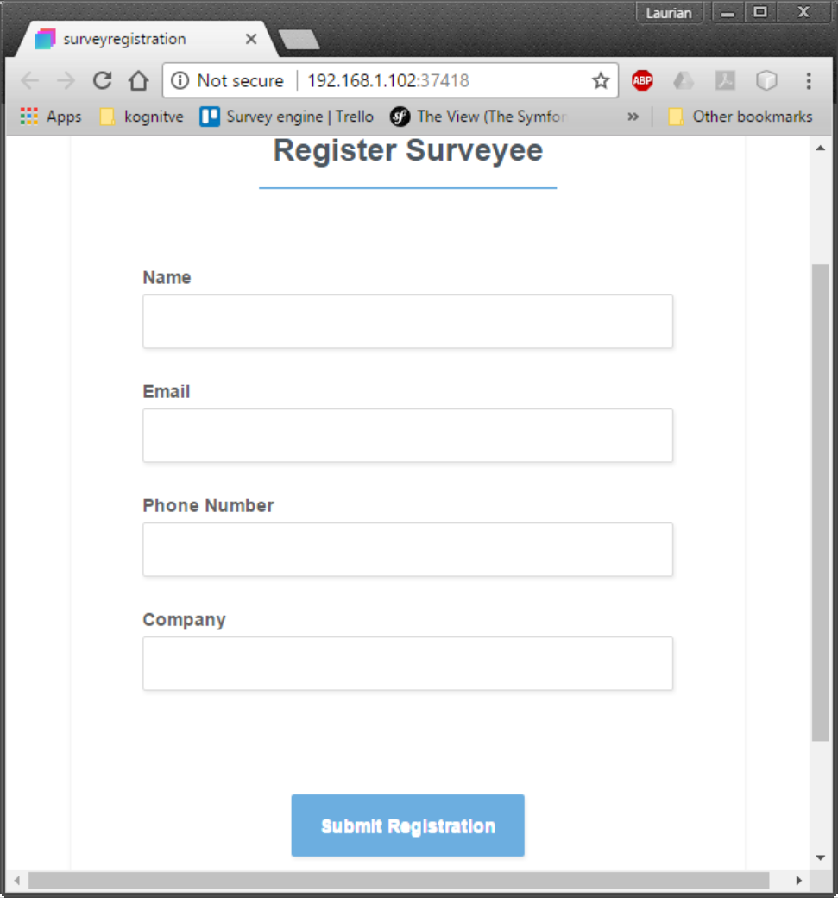

Surveys:

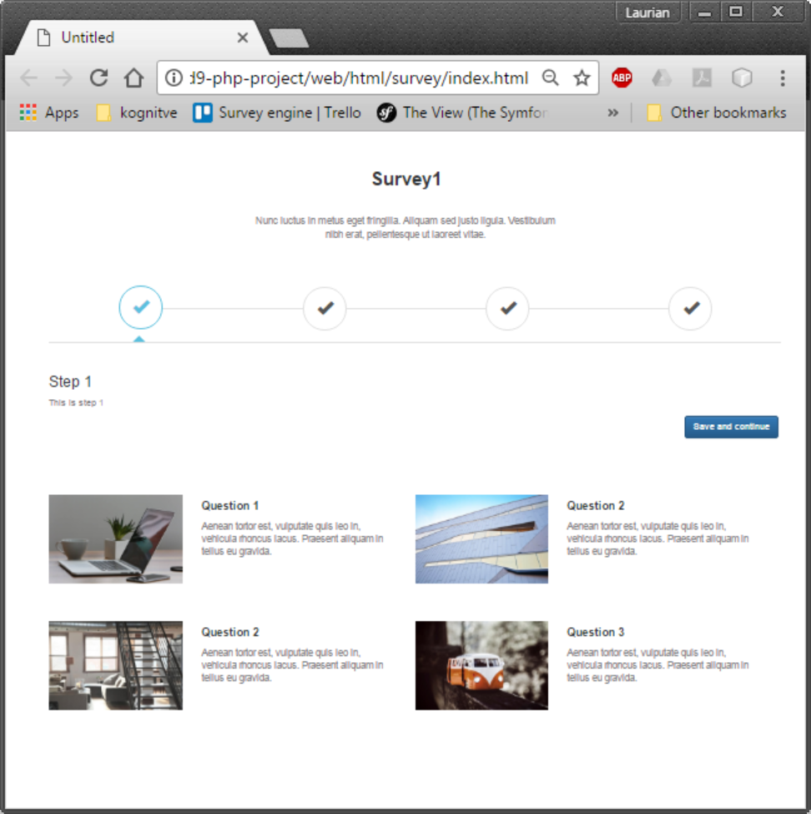

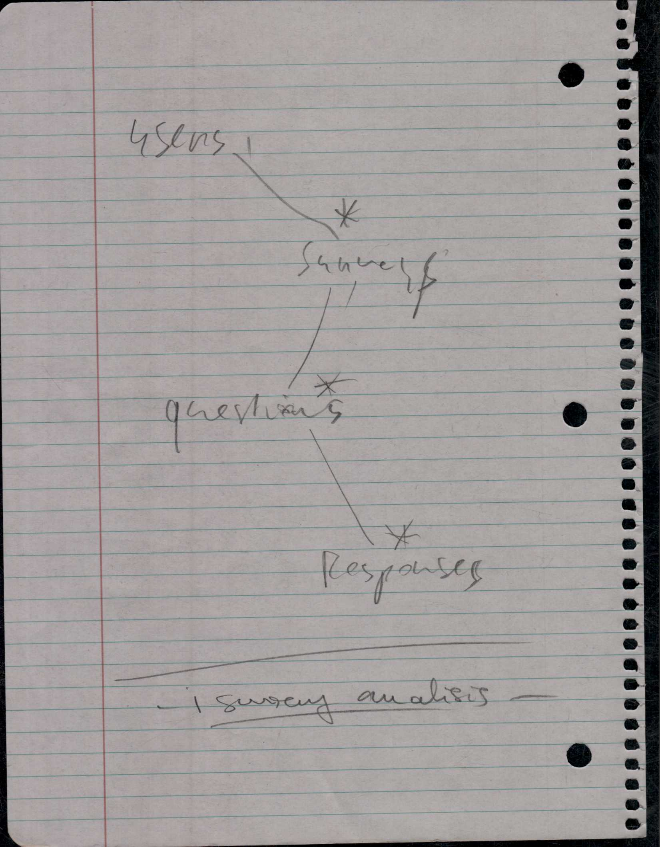

Survey monkey website demo – we notice the simplicity and clarity of the window.

In our design we will make sure the surveyee will navigate with ease.

