**Contents**

**Chapter 1: Introduction** 2

**1.1** **Introduction** 2

**1.2** **Background of the project** 2

**1.3** **Problem statement** 2

**1.4 Description of the project** 2

**1.4.1 Features of the project** 2

**1.5 Overview of the project** 2

**Chapter 2: Scope of the project** 2

**2.1 Scope** 2

**2.2 Limitation** 2

**2.3 Aim** 2

**2.4 Objectives** 2

**2.5 Overview of the scope** 3

**Chapter 3: Development methodology** 3

**3.1 Description of the methodology chosen** 3

**3.2 Design pattern** 3

**3.3 Architecture** 3

**Chapter 4: Project planning** 4

**Chapter 5: Risk management** 4

**Chapter 6: Configuration management** 4

**Chapter 7: Conclusion** 4

**Chapter 8: Reference and Bibliography** 4

# **Chapter 1: Introduction**

## **Introduction**

Bus ticket booking system is a web-based application where people can book seats easily with less effort and time. This system is built for managing and computerizing the traditional database, ticket booking and travel made. It maintains all the customer details, bus details and booking (reservation) details.

## **Background of the project**

## **Problem statement**

At the present time, the system used in the counter is an internal system which is manually used in the selling the tickets. The main problem with the current system is customer have to go to the counter and ask for the tickets which is very time-consuming. Sometimes, they have to queue up for long time and have to pay cash while buying tickets.

## **1.4 Description of the project**

### **1.4.1 Features of the project**

* Online booking of ticket
* Online payment

## **1.5 Overview of the project**

# **Chapter 2: Scope of the project**

## **2.1 Scope**

The scope of this system is people can book/reserve seats online. They don't have to go to counter in order to buy tickets and can do online payment instead of cash. Booking can be done anytime, from anywhere.

## **2.2 Limitation**

The limitation of this system is there might be problem while cancelling the reserved seats. This function is only available to the company staffs. So, for cancelling the ticket, customers have to communicate with the staffs. Currently, this service is available only in computer not in the smartphones.

## **2.3 Aim**

* To design the web-based application for booking the bus tickets.
* To design system which is user-friendly, time and effort saving.

## **2.4 Objectives**

* Observation techniques is performed during analysis phase to get better view of what people want.
* Scheduling is done in order to finish project in time.
* To make it user-friendly, good and simple GUI is designed.
* Testing is performed to find out bugs in the system.
* Documentation of the project is done for the future reference.

## **2.5 Overview of the scope**

# **Chapter 3: Development methodology**

## **3.1 Description of the methodology chosen**

Among the many methodology, I have decide to use Waterfall model. It is a linear, sequential and traditional approach to the software development life cycle. It consists of different stages and each stages is performed serially.

**Stages of the waterfall model**:

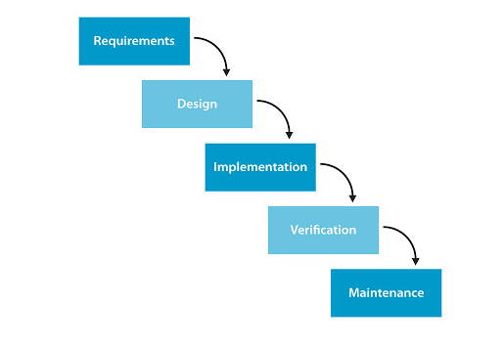

I have chosen Waterfall model because of the following reasons:

* It is simple and easy to understand and use.
* Each stages are performed serially. So, no delay in development of the system.
* It facilities in scheduling.
* It is easy to arrange the tasks.
* Process and results are well documented.

## **3.2 Design pattern**

## **3.3 Architecture**

# **Chapter 4: Project planning**

# **Chapter 5: Risk management**

# **Chapter 6: Configuration management**

# **Chapter 7: Conclusion**

# **Chapter 8: Reference and Bibliography**