# **Chapter 5: Testing**

## **5.1 Introduction**

## Testing is the phase where we focus on investigation and discovery. This phase comes after the implementation phase. In this phase, the coding done in implementation phase is tested to ensure that it is working accordingly to the customer requirements. This phase helps to make the system bug-free, more user-friendly, and more efficient. It ensures the quality of the software and the functionalities developed are working as requirements.

## There are many types of testing like Integration testing, Usability testing, user-acceptance testing and so on. Among them, I am preforming Black box testing and unit testing for the project.

## **5.2 Testing types**

### **Black box testing**

Black box testing as known as "**Behavioral Testing**" is the method of software testing where testing is done on the basis of input and output. In this testing, tester does not know what is going inside the system as the internal structure of code is not known to tester.

**Test Case: Empty field testing**

|  |  |  |  |  |
| --- | --- | --- | --- | --- |
| **Form/Object** | **Input** | **Expected result** | **Actual result** | **Remarks** |
| Bus registration | empty | Error message should be displayed. | Error message is displayed. | Pass |

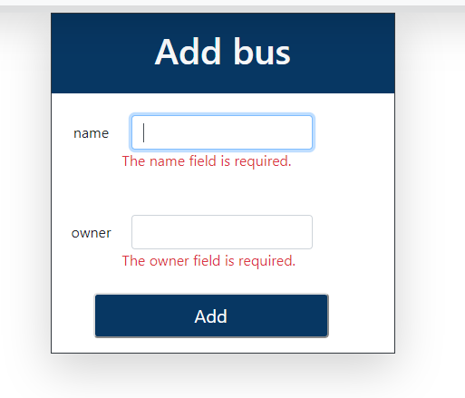

Fig: Actual result

**Test Case: Invalid email testing**

|  |  |  |  |  |
| --- | --- | --- | --- | --- |
| **Form/Object** | **Input** | **Expected result** | **Actual result** | **Remarks** |
| User registration | Invalid email format | Error message should be displayed. | Error message is displayed. | Pass |

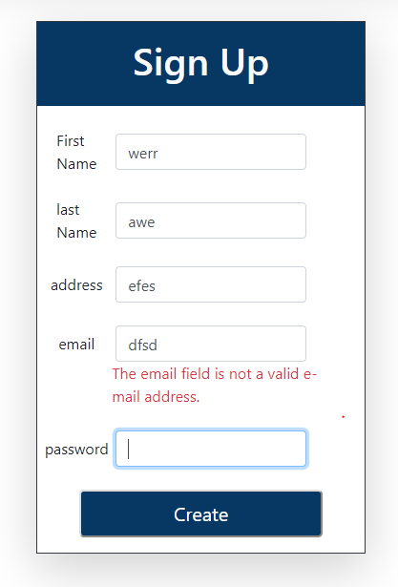

Fig: Actual result

**Test Case: Admin Login**

|  |  |  |  |  |
| --- | --- | --- | --- | --- |
| **Form/Object** | **Input** | **Expected result** | **Actual result** | **Remarks** |
| Login | Username and password | After entering valid input, redirect to admin profile. | After entering valid input, it is redirected to admin profile. | Pass |

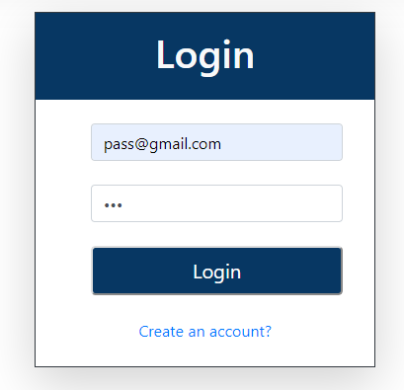

Fig: Input

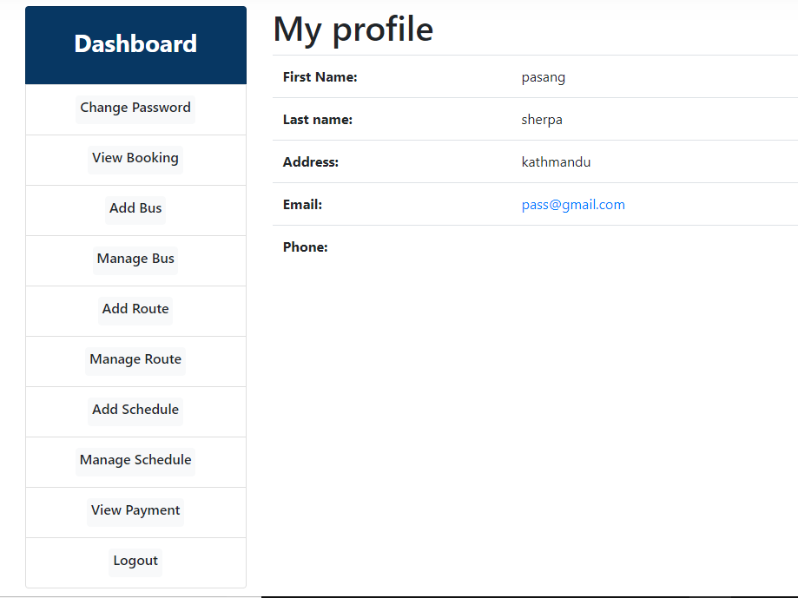

Fig: Actual result

**Test Case: User Login**

|  |  |  |  |  |
| --- | --- | --- | --- | --- |
| **Form/Object** | **Input** | **Expected result** | **Actual result** | **Remarks** |
| Login | Username and password | After entering valid input, redirect to user profile. | After entering valid input, it is redirected to user profile. | Pass |

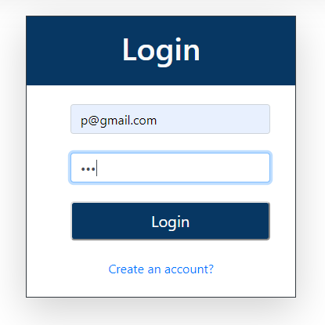

Fig: Input

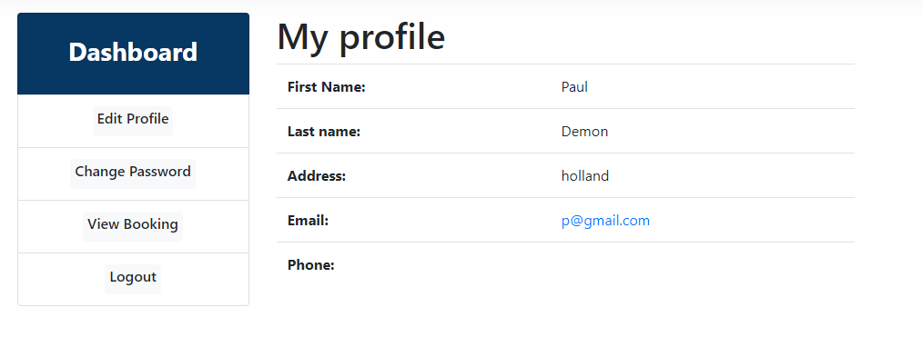

Fig: Actual result

**Test Case: Edit Profile**

|  |  |  |  |  |
| --- | --- | --- | --- | --- |
| **Form/Object** | **Input** | **Expected result** | **Actual result** | **Remarks** |
| Edit Profile | Required details | After submitting required details, profile should be updated. | Profile is update successfully. | Pass |

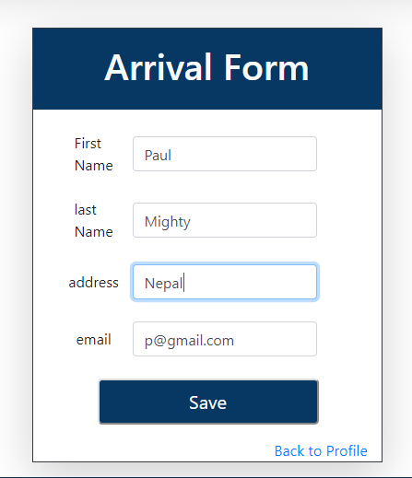

Fig: Input for edit profile

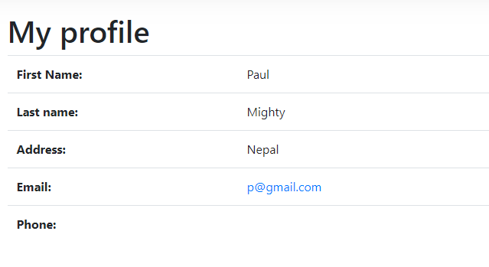

Fig: Actual Output

**Test Case: Add Route**

|  |  |  |  |  |
| --- | --- | --- | --- | --- |
| **Form/Object** | **Input** | **Expected result** | **Actual result** | **Remarks** |
| Add route | Required details | After submitting required details, route should be added. | Route is added. | Pass |

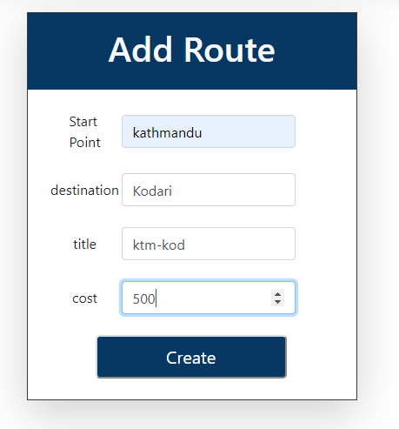

Fig: Input

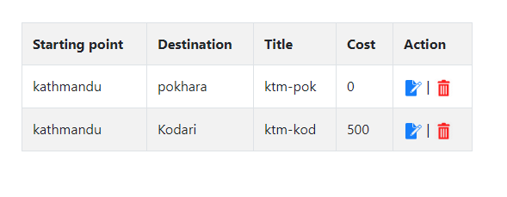

Fig: Actual output

**Test Case: Edit Route**

|  |  |  |  |  |
| --- | --- | --- | --- | --- |
| **Form/Object** | **Input** | **Expected result** | **Actual result** | **Remarks** |
| Edit route | Required details | After submitting required details, route should be updated. | Route is updated successfully. | Pass |

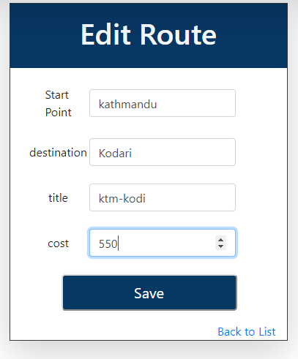

Fig: Input for edit

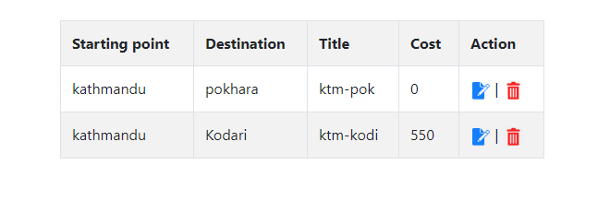

Fig: Actual result

### **Unit testing**

Unit testing is the method of testing in which individual components of the system are being tested. The main purpose of this testing is to validate each unit of the system performs as designed. It is performed by using **White box testing**.

* **Booking Per User**

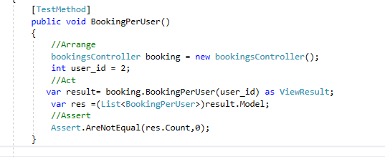

**Output:**

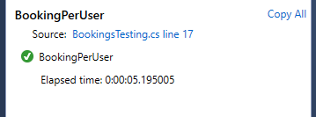

* **Booking Per User is null**

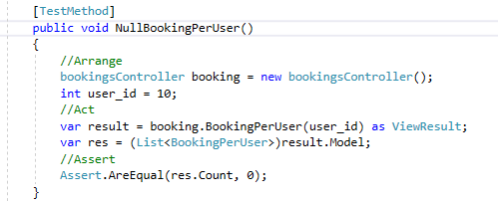

**Output:**

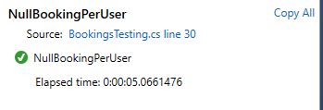

* **Create bus**

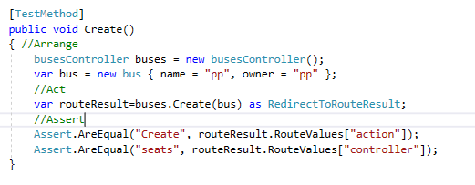

**Output:**

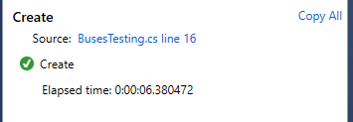

* **Create route**

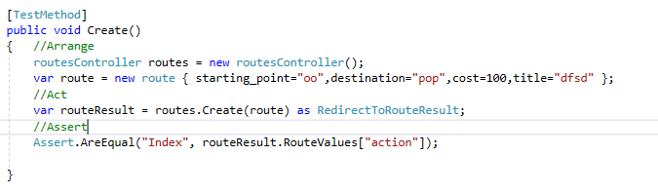

**Output:**

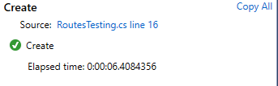

* **View Schedule**

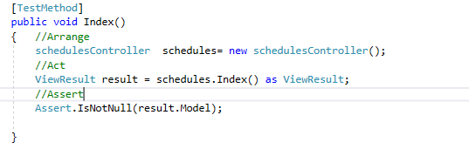

**Output:**

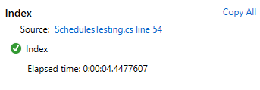

* **Schedule search found**

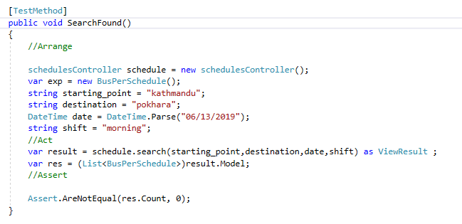

**Output:**

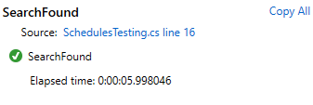

* **Schedule search null**

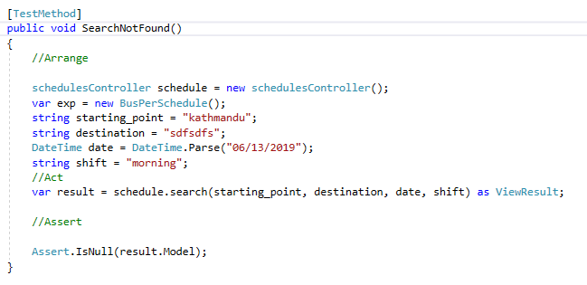

**Output:**

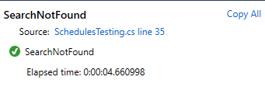

* **Change seat**

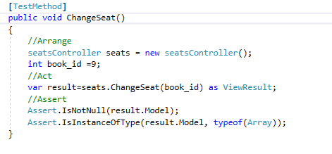

**Output:**

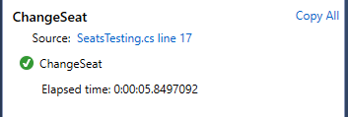

* **Login successful**

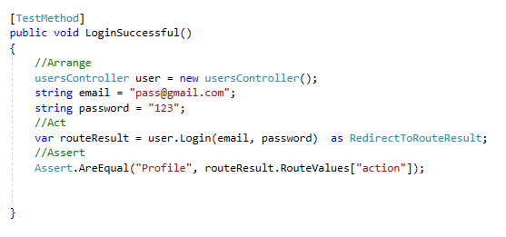

**Output:**

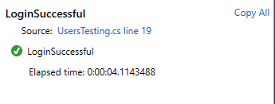

* **Login Unsuccessful**

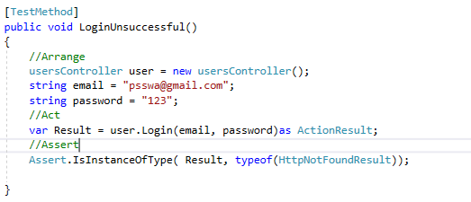

**Output:**

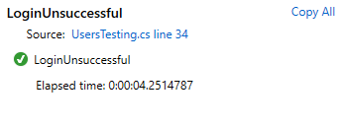

* **View Routes**

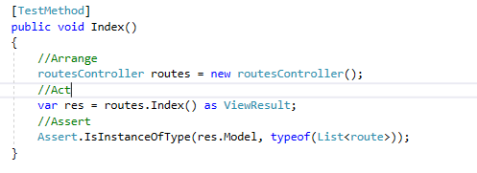

**Output:**

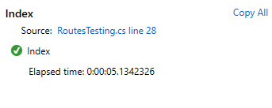

* **View Buses**

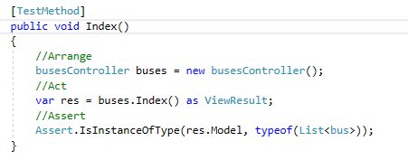

**Output:**

