
Logistics Optimization for Delivery Routes – FedEx
A SQL-Based Data Analysis Project

LAKSHITA

INTRODUCTION

This project focuses on analyzing logistics operations using SQL to identify inefficiencies in delivery routes, shipment delays, warehouse performance, and delivery agent efficiency. The analysis is performed on multiple datasets including orders, shipments, routes, warehouses, and delivery agents.
The main objective of this project is to clean and validate the data, analyze delivery delays, evaluate route performance, assess warehouse and agent efficiency, and generate meaningful insights using structured SQL queries. MySQL Workbench was used to execute all queries and analyze the results.
This project aims to demonstrate practical SQL skills and logical problem-solving through real-world logistics data.

INDEX
1. Introduction
2. Task 1: Data Cleaning and Preparation
3. Task 2: Delivery Delay Analysis
4. Task 3: Route Optimization
5. Task 4: Warehouse Performance
6. Task 5: Delivery Agent Performance
7. Task 6: Shipment Tracking Analytics
8. Task 7: KPI Reporting
9. Key Insights and Recommendations
10. Summary and video explanation

FedEx logistics

Task 1: Data Cleaning & Preparation

Task 1.2: Handle NULL Delay_Hours

Task 1.2a
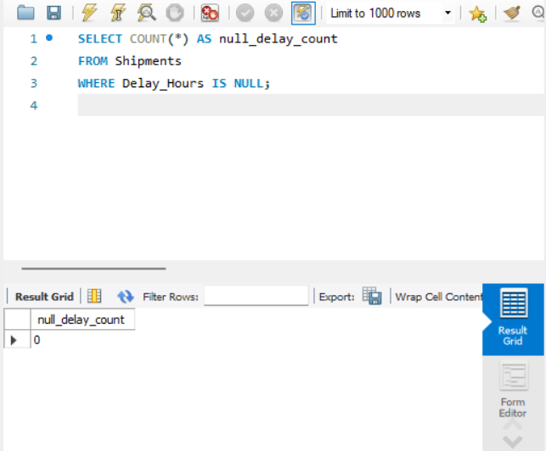
Checked the number of records where Delay_Hours was NULL to understand missing data.
Task 1.2b
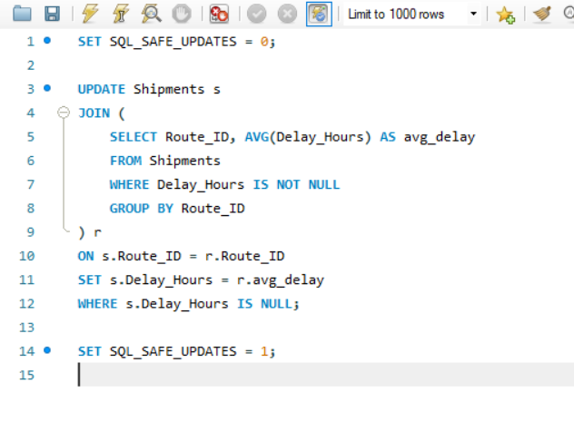
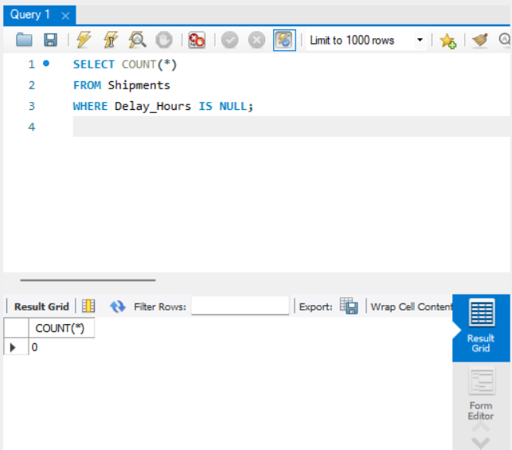
Updated NULL Delay_Hours values using the average delay calculated per Route_ID.

Task 1.3: Date Validation
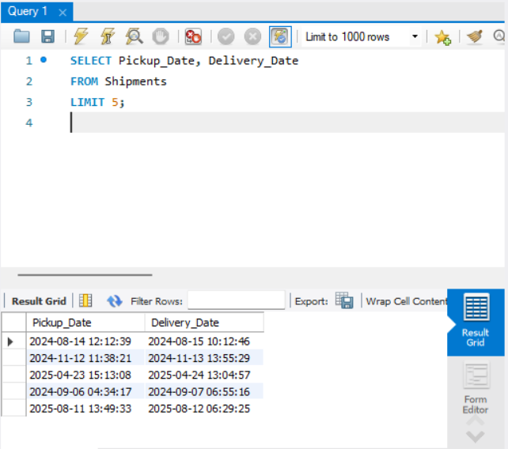
Validated Pickup_Date and Delivery_Date fields to ensure logical date order.

Task 1.4: Flag Invalid Dates
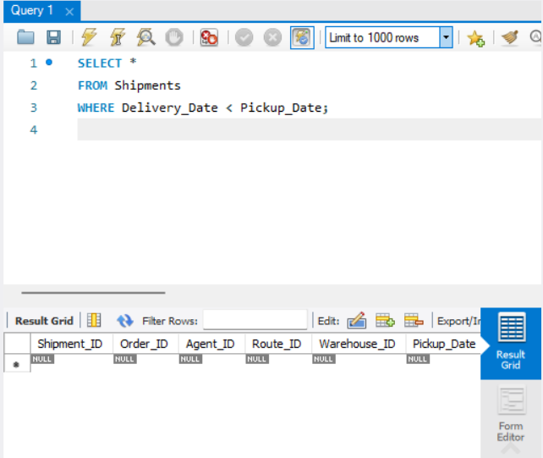
Identified records where Delivery_Date was earlier than Pickup_Date.

Task 1.5: Referential Integrity
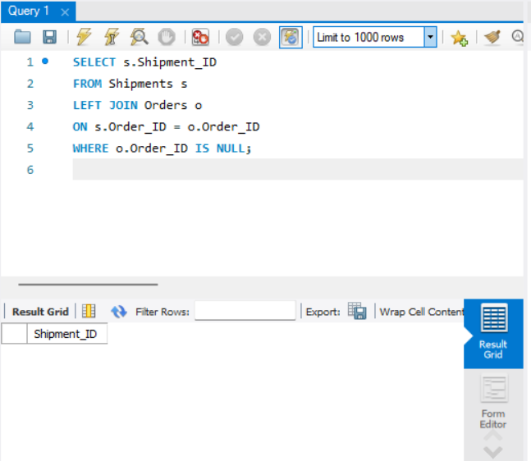
Checked for shipments that do not have a matching Order_ID in the Orders table.

Task 2: Delivery Delay Analysis

Task 2.1: Calculate Actual Delivery Delay
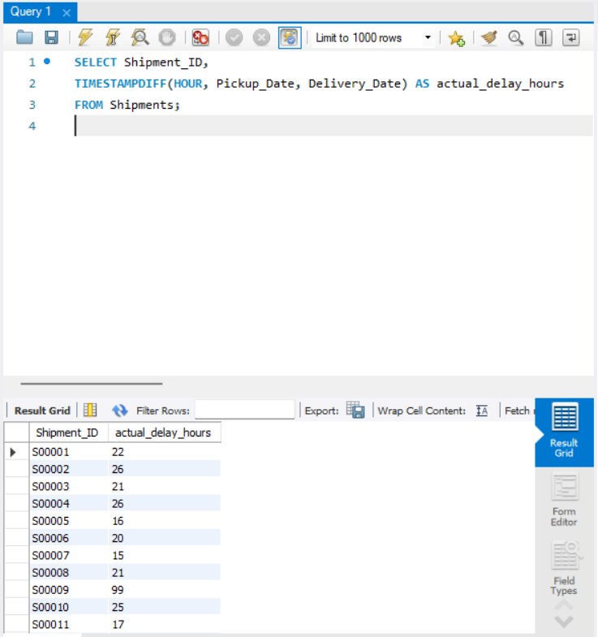
Calculated actual delivery delay in hours using pickup and delivery timestamps.

Task 2.2: Top 10 Delayed Routes
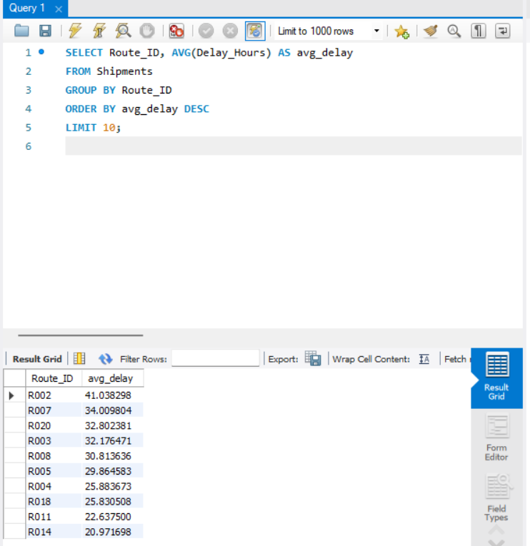
Identified top 10 routes with the highest average delivery delays.

Task 2.3: Rank Shipments by Delay per Warehouse
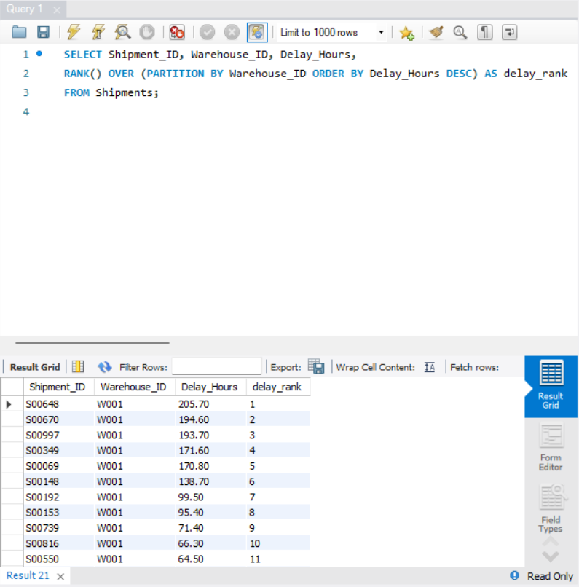
Ranked shipments within each warehouse based on delay duration.

Task 2.4: Delay by Delivery Type
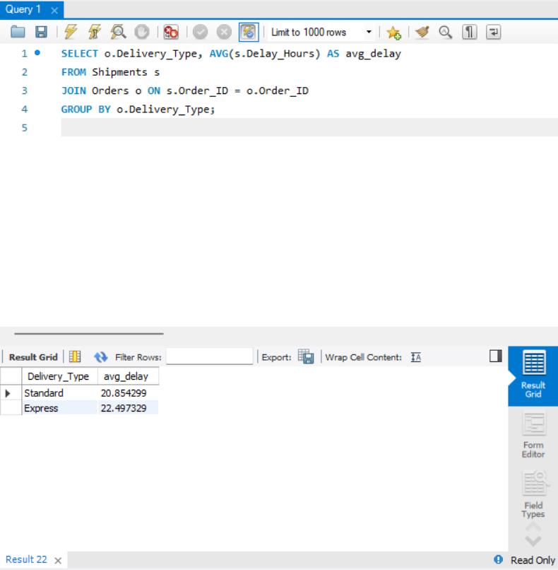
Analyzed average delivery delay by delivery type.

Task 3: Route Optimization

Task 3.1: Route Performance Metrics
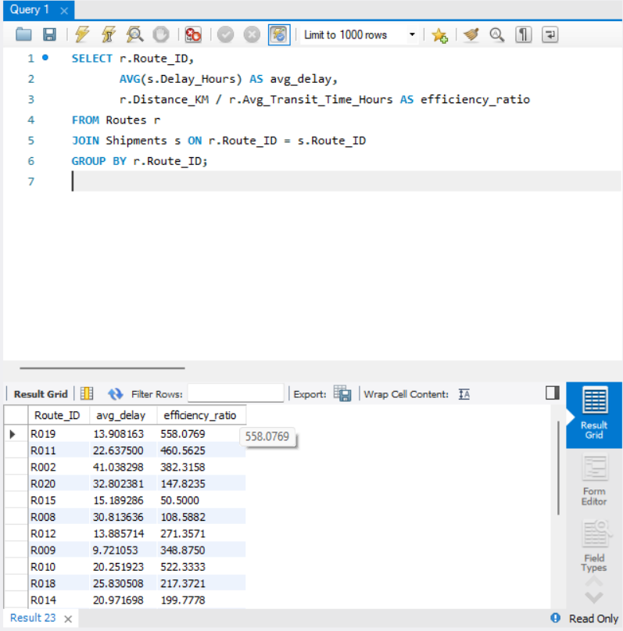
Evaluated route performance using average delay and efficiency ratio.

Task 3.2: Worst Efficiency Routes
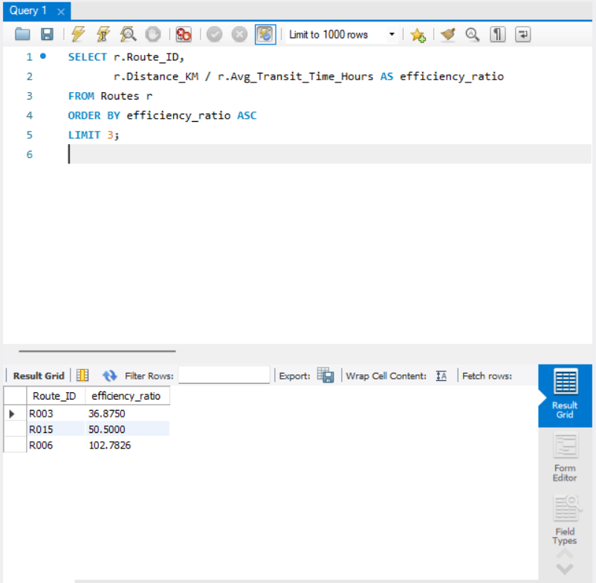
Identified routes with the lowest efficiency ratios indicating poor performance.

Task 3.3: Routes with >20% Delayed Shipments
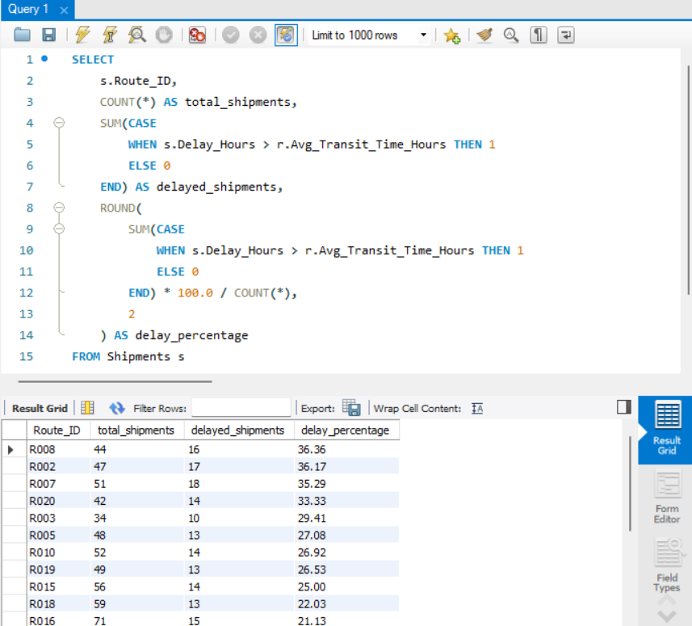
Calculated delay percentage per route and identified routes exceeding 20% delayed shipments.

Task 4: Warehouse Performance

Task 4.1: Top 3 Warehouses with Highest Avg Delay
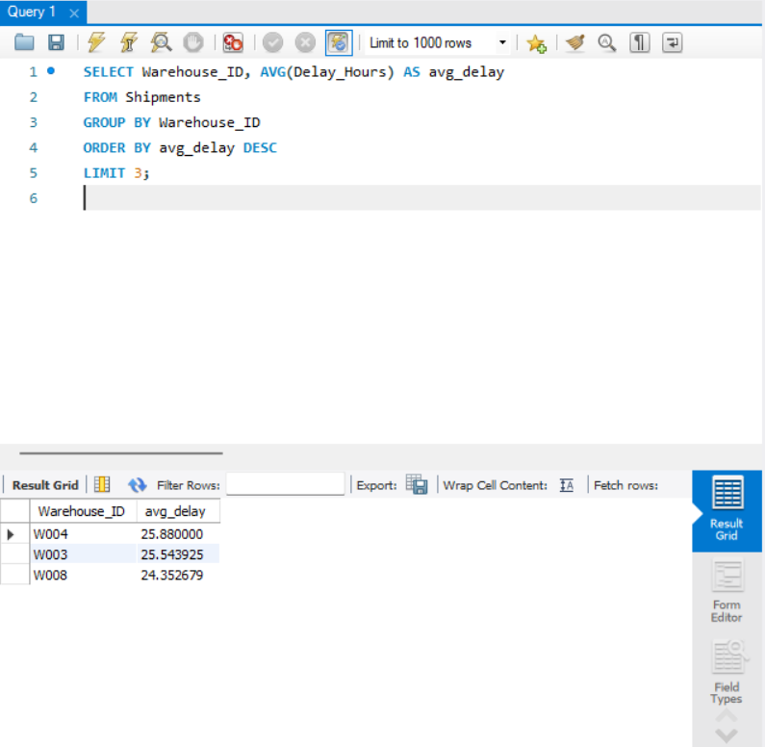
Identified the top three warehouses with the highest average delivery delays.

Task 4.2: Total vs Delayed Shipments per Warehouse
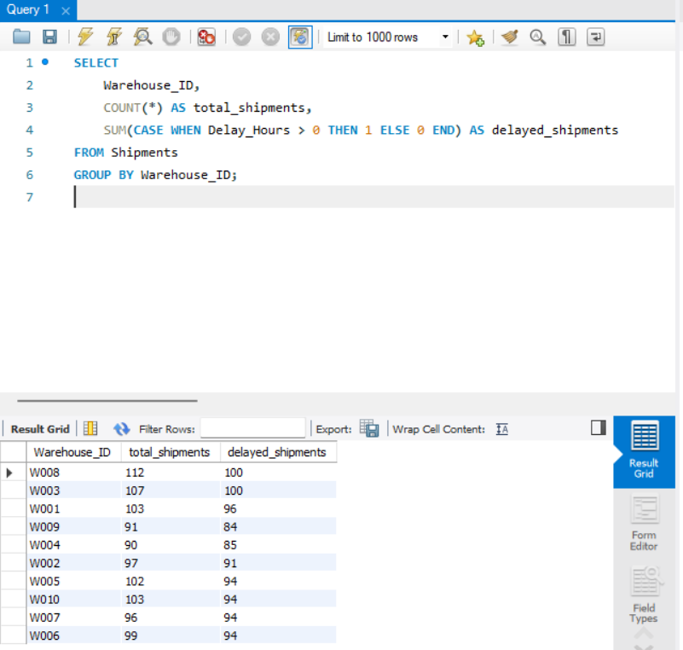
Compared total shipments with delayed shipments for each warehouse.

Task 4.3: Warehouses Exceeding Global Avg Delay (CTE)
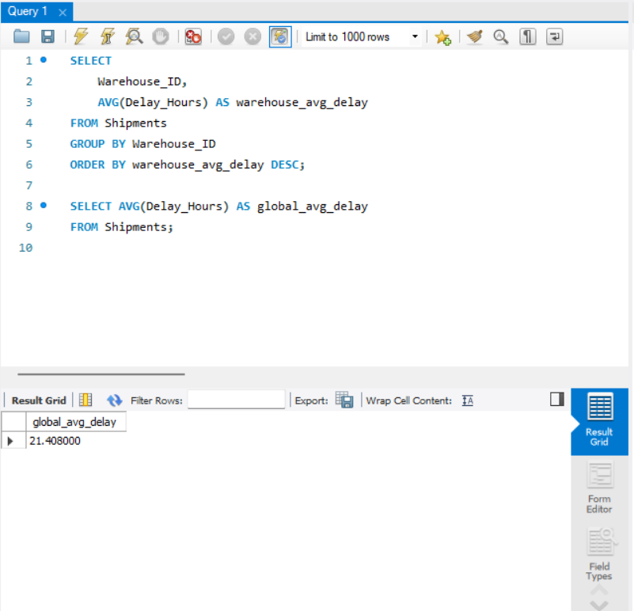
Used a CTE to identify warehouses with average delay above the global average.

Task 4.4: Rank Warehouses by On-Time Delivery %
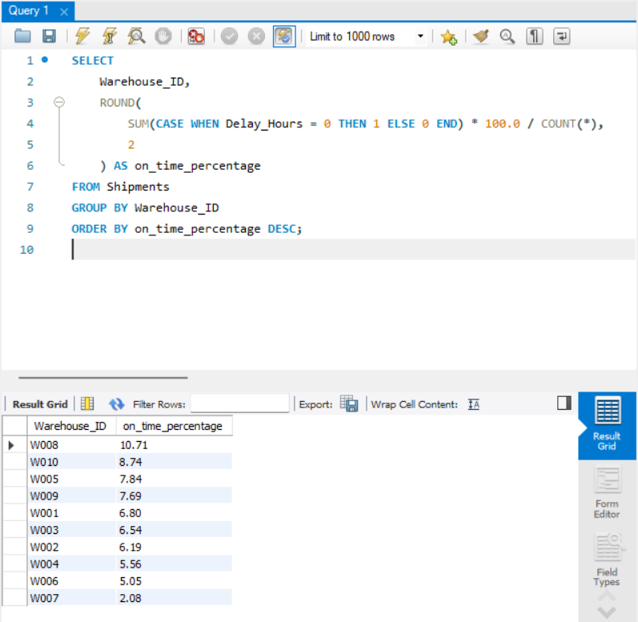
Ranked warehouses based on their on-time delivery performance.

Task 5: Delivery Agent Performance

Task 5.1: Agent Ranking by On-Time %
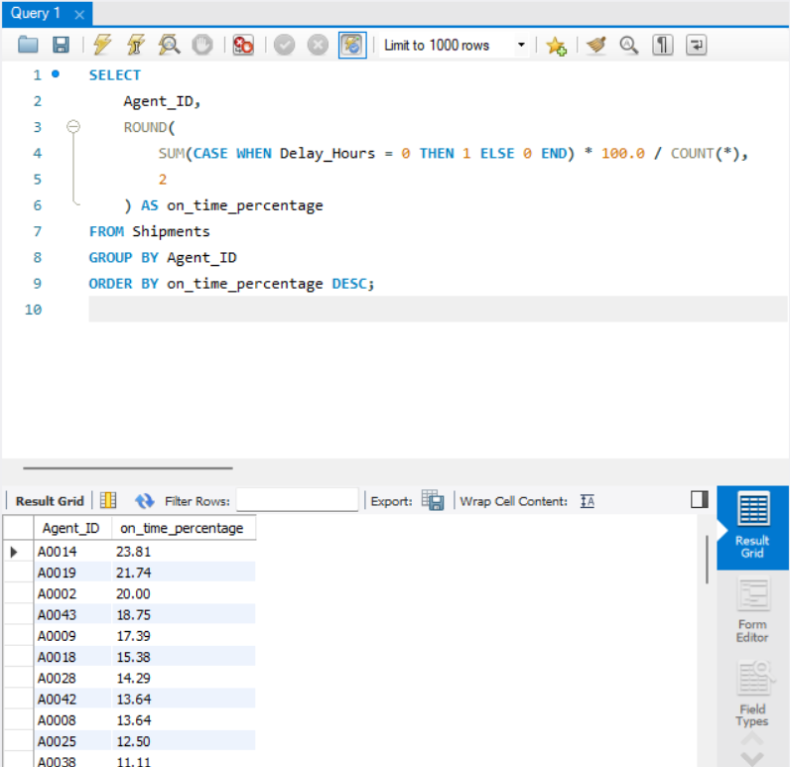
Ranked delivery agents based on their on-time delivery percentage.

Task 5.2: Agents Below 85% On-Time Delivery
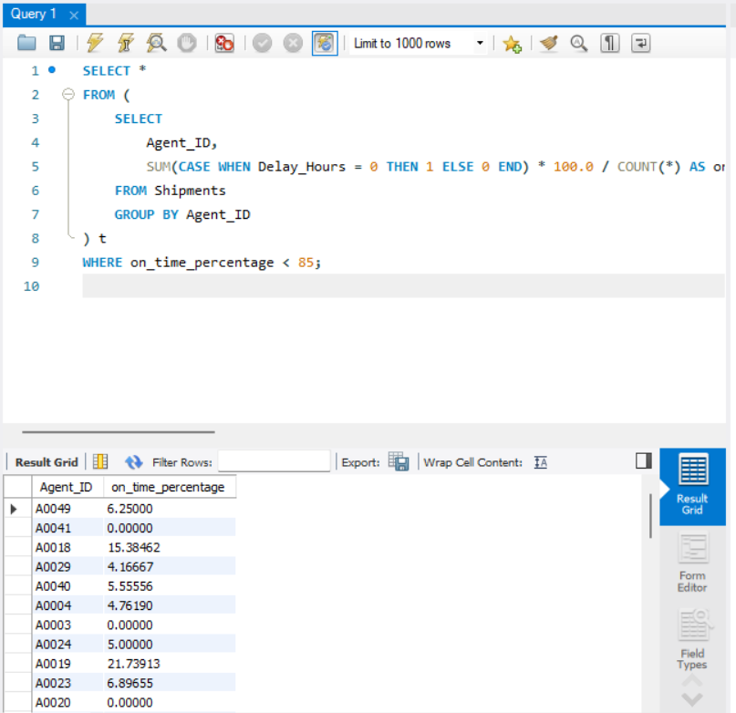
Identified delivery agents whose on-time delivery rate is below 85%.

Task 5.3: Top 5 vs Bottom 5 Agents (Rating & Experience)
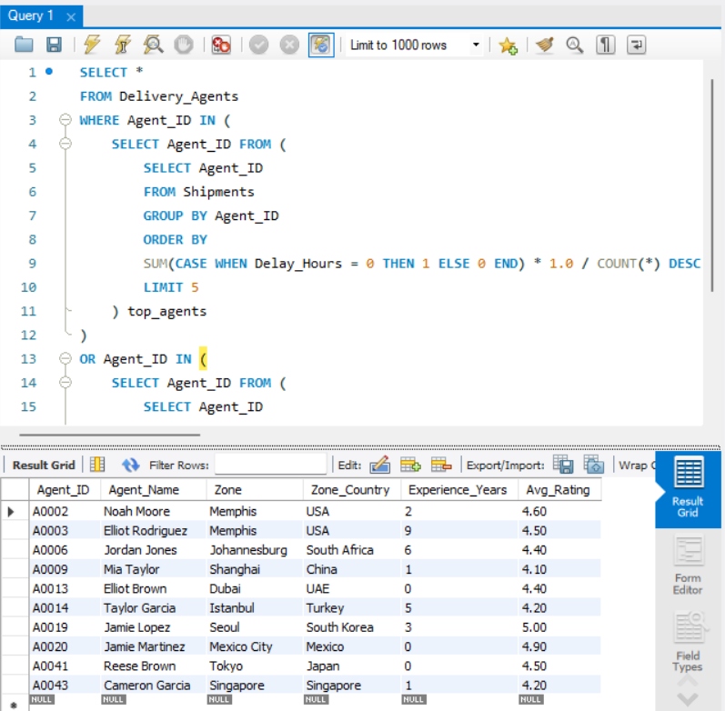
Compared top-performing and bottom-performing agents based on ratings and experience.

Task 6: Shipment Tracking Analytics

Task 6.1: Latest Shipment Status
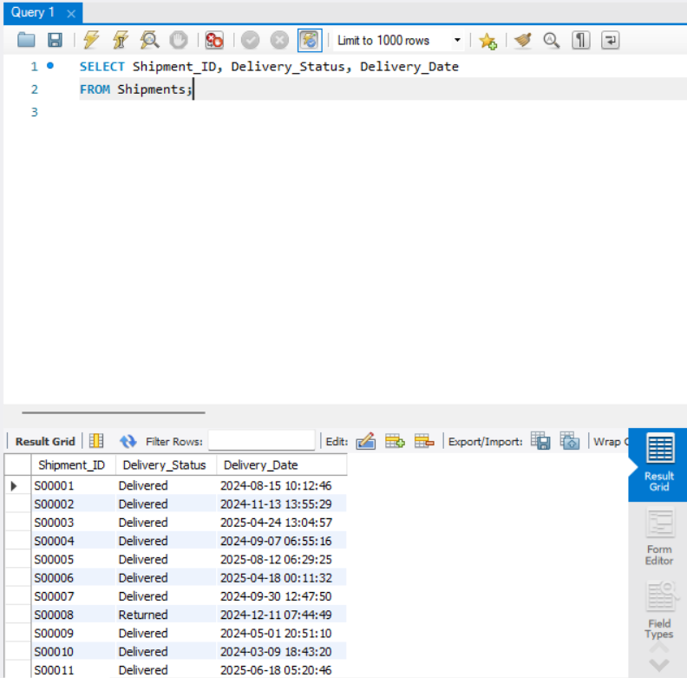
Retrieved the latest delivery status and delivery date for each shipment.

Task 6.2: Routes with High In-Transit / Returned Shipments
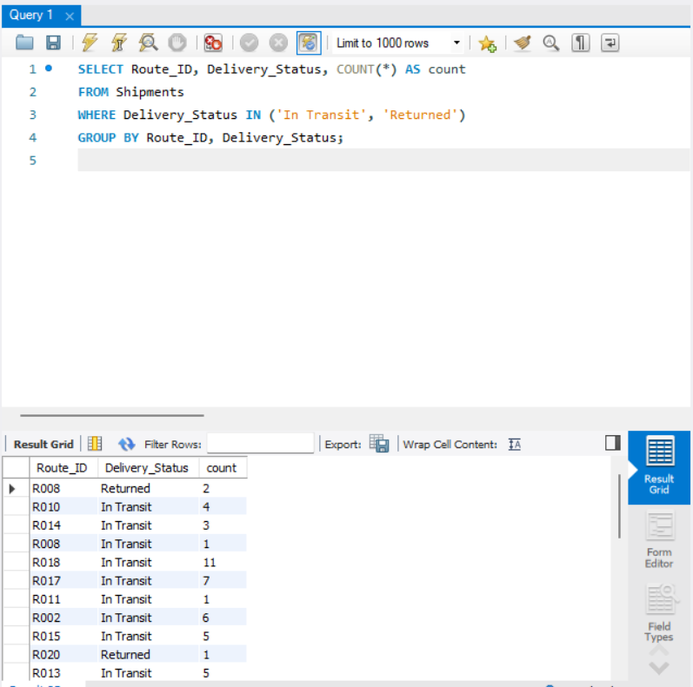
Identified routes having a high number of shipments marked as In Transit or Returned.

Task 6.3: Most Frequent Delay Reasons
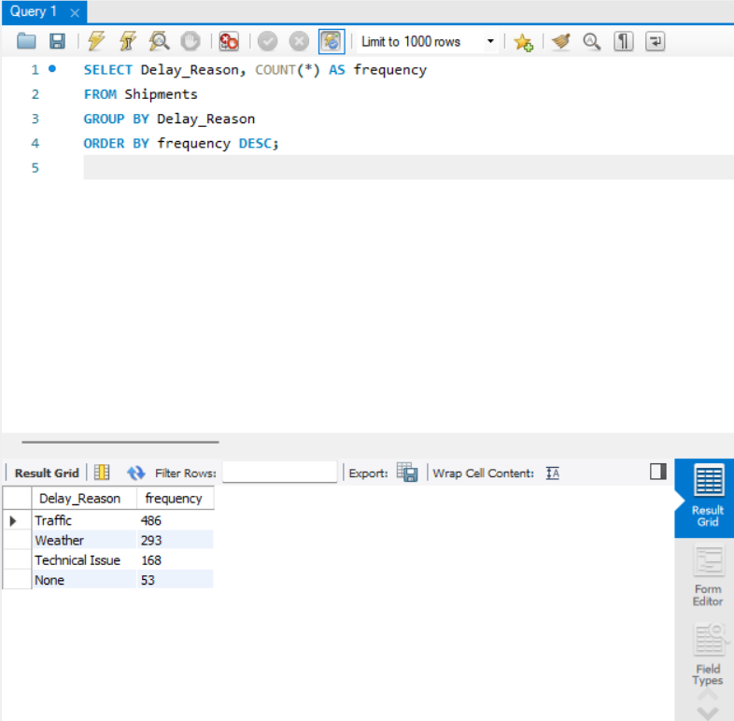
Analyzed and ranked the most common reasons for shipment delays.

Task 6.4: Shipments Delayed More Than 120 Hours
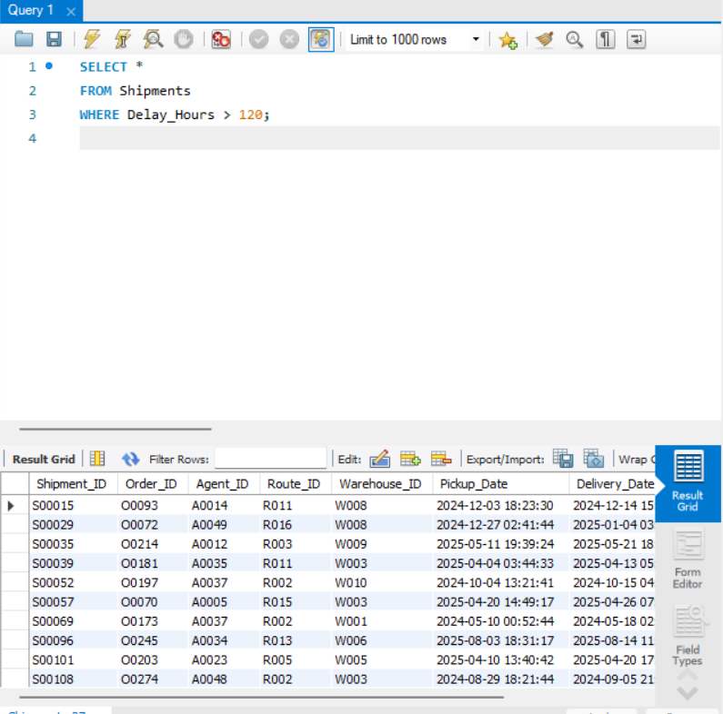
Filtered shipments experiencing extreme delays exceeding 120 hours.

Task 7: KPI Reporting

Task 7.1: Average Delay per Source Country
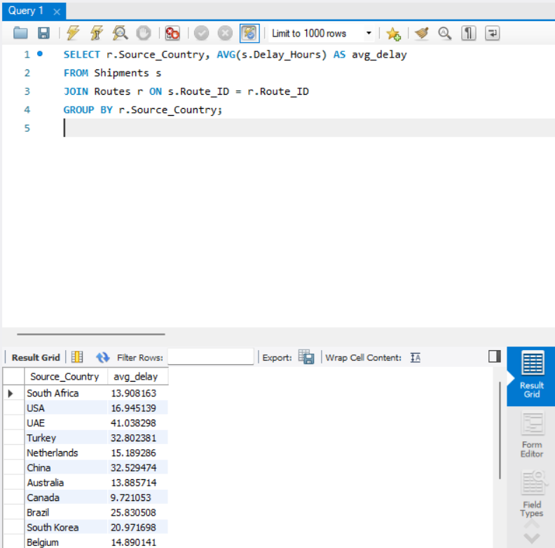
Calculated average shipment delay grouped by source country.

Task 7.2: On-Time Delivery Percentage
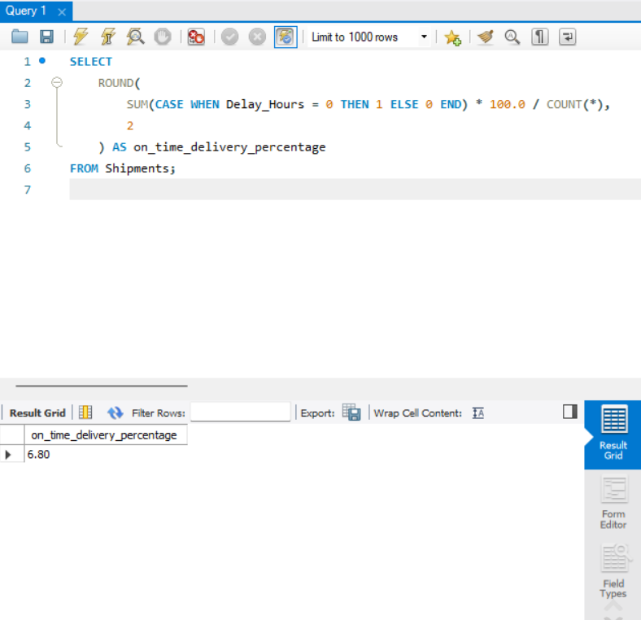
Computed the overall on-time delivery percentage across all shipments.

Task 7.3: Average Delay per Route
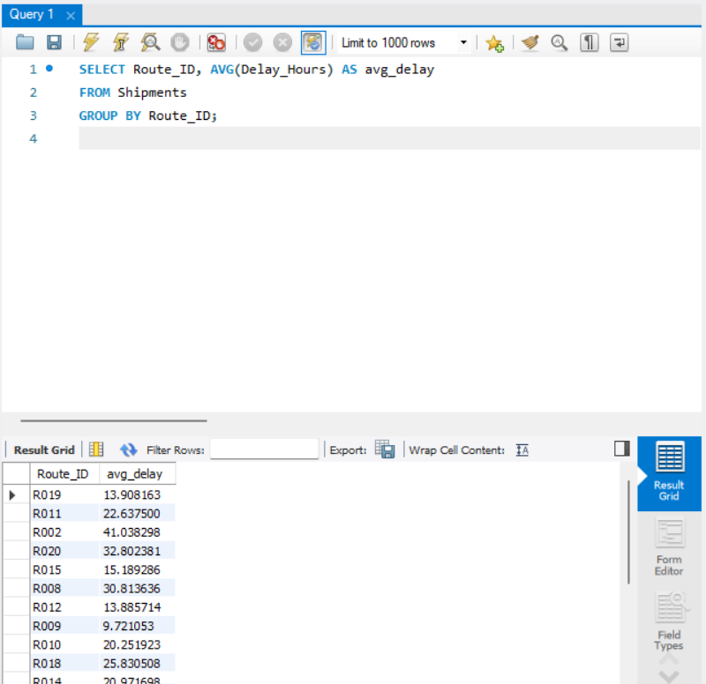
Calculated the average delivery delay for each route.

Task 7.4: Warehouse Utilization Percentage
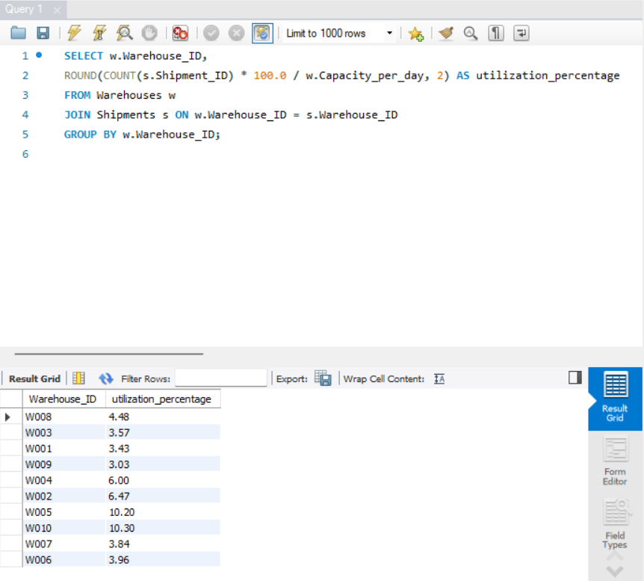
Measured warehouse utilization based on shipment volume and capacity.

Key Insights and Recommendations

- Some delivery routes showed lower efficiency and higher delays, indicating a need for route optimization.
- Express deliveries performed better than standard deliveries, showing the impact of priority-based services.
- Warehouse performance was generally balanced, with no major delay outliers.
- A few delivery agents had lower on-time delivery rates, suggesting the need for targeted improvement.

Recommendations

- Review and optimize routes with lower efficiency ratios.
- Monitor routes with relatively higher delays to prevent future issues.
- Provide training or workload adjustments for low-performing delivery agents.
- Continue regular performance monitoring using key KPIs.

Summary and Conclusion

This project successfully analyzed logistics and delivery operations using SQL-based techniques. The data was first cleaned and validated to ensure accuracy, followed by detailed analysis of delivery delays, route efficiency, warehouse performance, delivery agent effectiveness, and key operational KPIs.
Although some analytical conditions did not produce specific outputs, these results were correctly interpreted and indicate balanced performance across certain areas. The insights derived from this analysis can help improve delivery efficiency, optimize routes, and enhance overall logistics performance.
Overall, this project demonstrates the practical application of SQL in solving real-world logistics problems and highlights the importance of data-driven analysis in operational decision-making.

Video Summary: - https://drive.google.com/file/d/10Z978NwMgl_ima4WomjS4YaLEPV13tg8/view?usp=sharing

