Walmart Project Report
Power BI Presentation Report
Name: LAKSHITA

Table of Contents
- Task 1 — Data Modeling and Cleaning
- Task 2 — Churn and Retention Analysis
- Task 3 — Repeat Purchase Analysis
- Task 4 — Promotion & Loyalty Impact
- Task 5 — Store & Channel Insights
- Task 6 — Customer Segmentation / CLV
- Task 7 — Final Dashboard & Recommendations
- Conclusion & Key Learnings
- Summary video

Task 1 — Data Modeling and Cleaning
This task involves importing and cleaning Walmart’s datasets. Using Power Query, unnecessary columns were removed, missing data was handled, and relationships between tables were created. This step ensured that all data was properly structured for accurate analysis in Power BI.
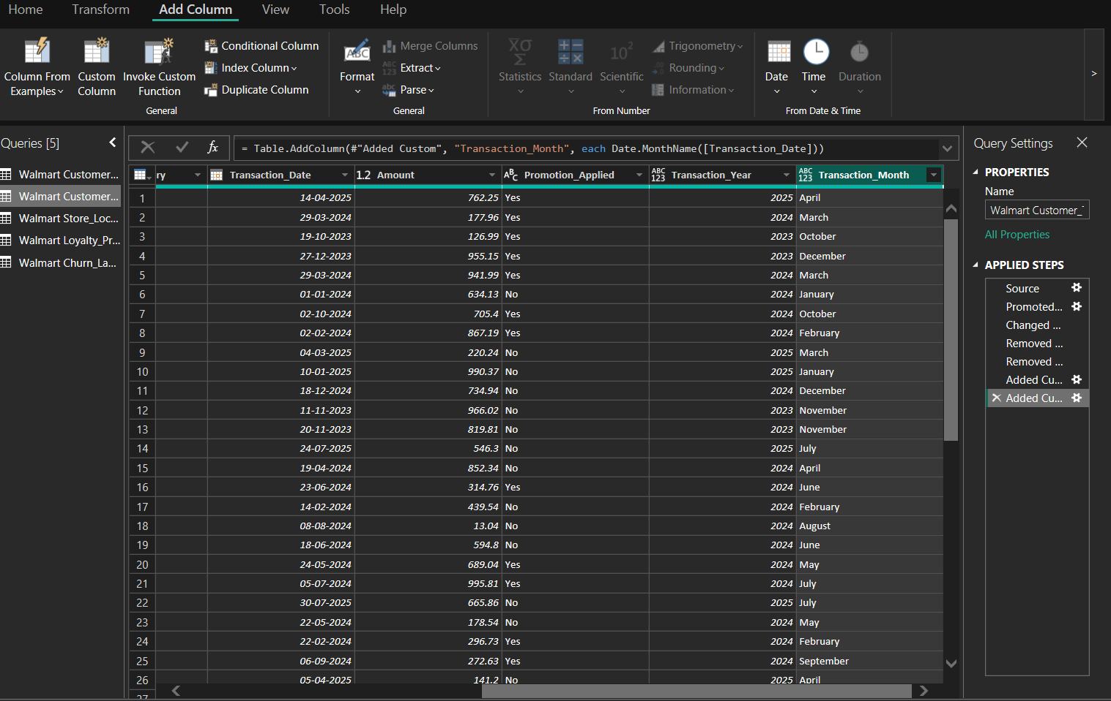
(Figure-1)
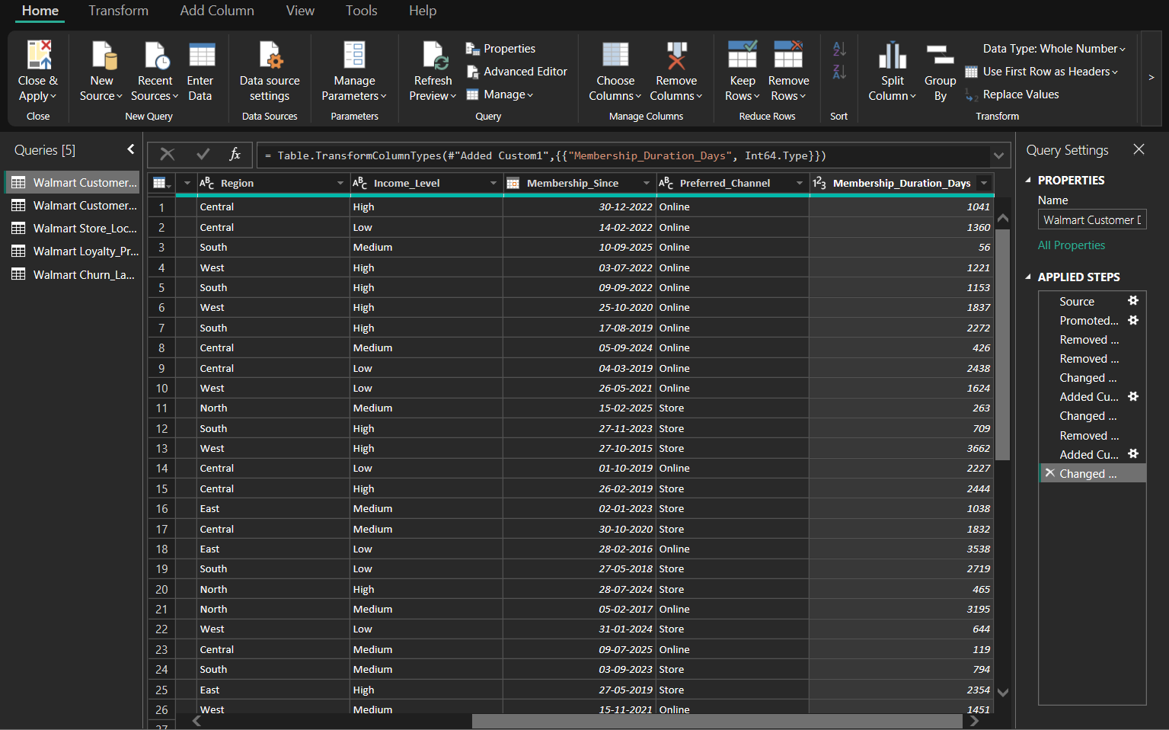
(Figure-1.1)
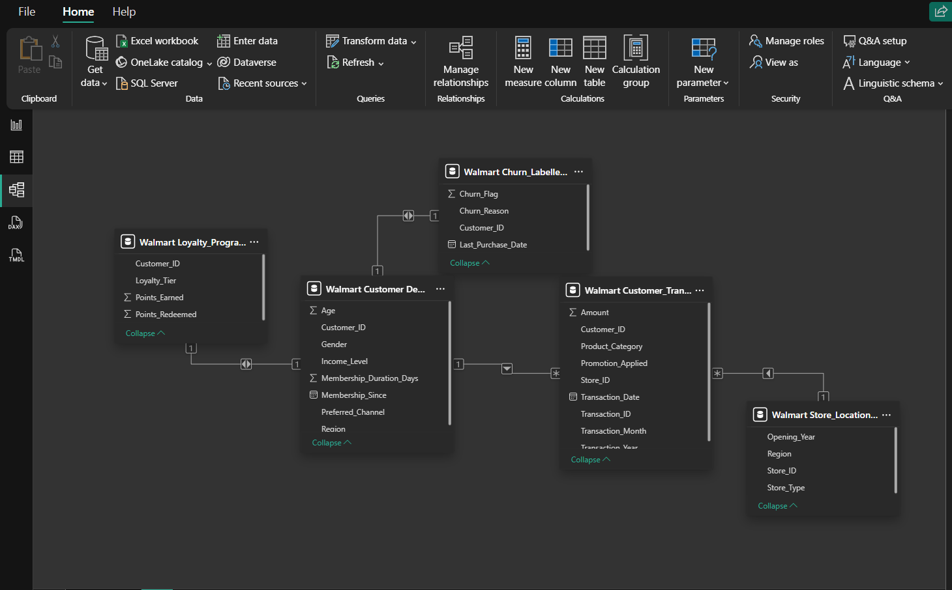
(Figure-1.2 Data Model)

Task 2 — Churn and Retention Analysis
This section focuses on understanding customer churn and retention. Using the DAX measures, I identified total customers, churned customers, and repeat customers to calculate churn rate. These visuals highlight how effectively the company retains its customers.
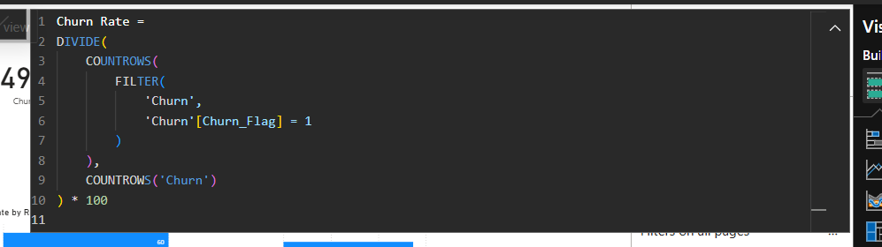
(Churn rate DAX- Figure-2)

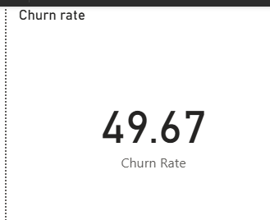
(Figure-1.1-Churn Rate KPI)
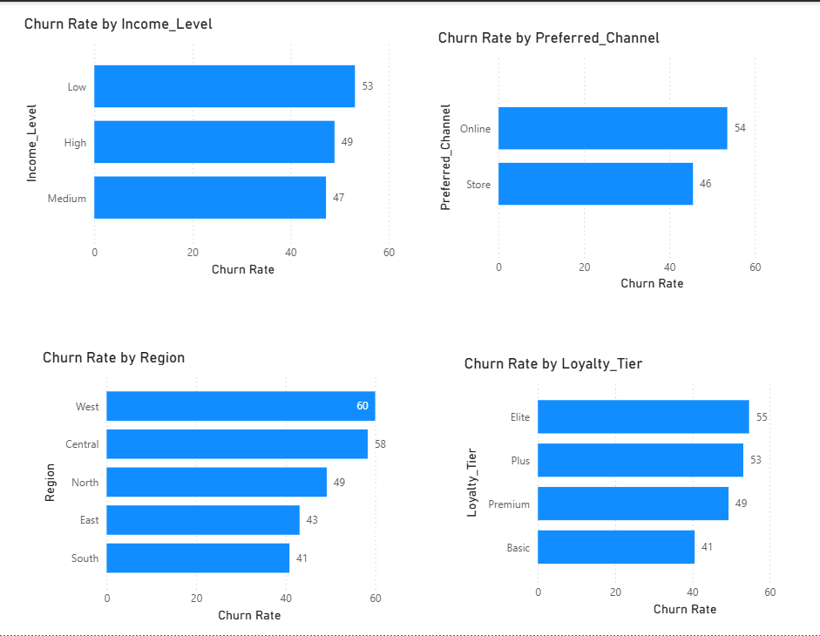
(Figure-1.2- Churn Rate visulaize)

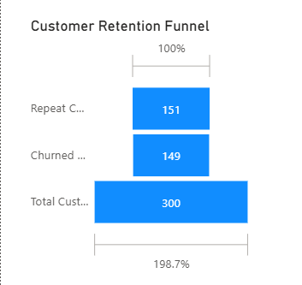
(Figure-1.3- Funnel chart)

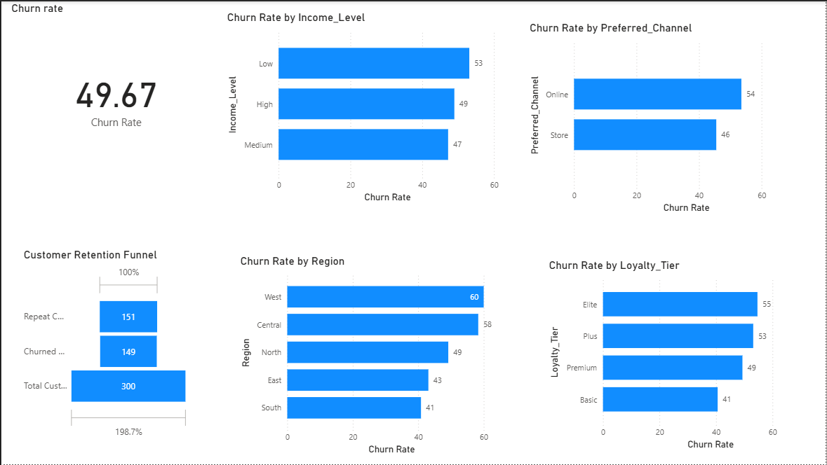
(Figure- 1.4- Final overview)

Task 3 — Repeat Purchase Analysis
This section analyzes customer purchase behavior and frequency. It helps identify customers with high repeat purchases and loyalty trends.
SEGMENT CUSTOMERS:
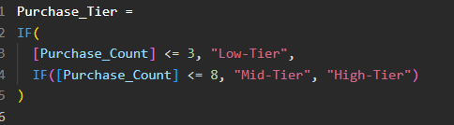
(Figure 2, Purchase Tier DAX)

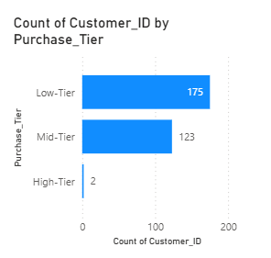
(Figure2.1, Segment customer)
AVG. PURCHASE FREQUENCY:
(Figure 2.2, Avg. purchase tier DAX)
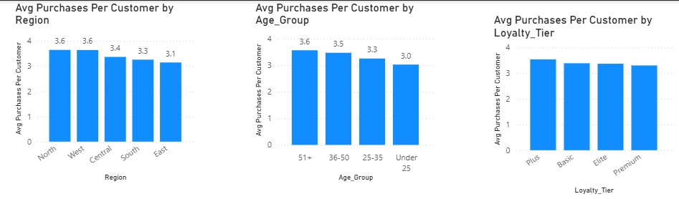
(Figure 2.2a, avg. purchase tier by region, avg group and loyalty tier)

MOST PURCHASED PRODUCT CATEGORY:
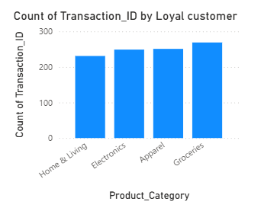
(Figure 3, Loyal customers)
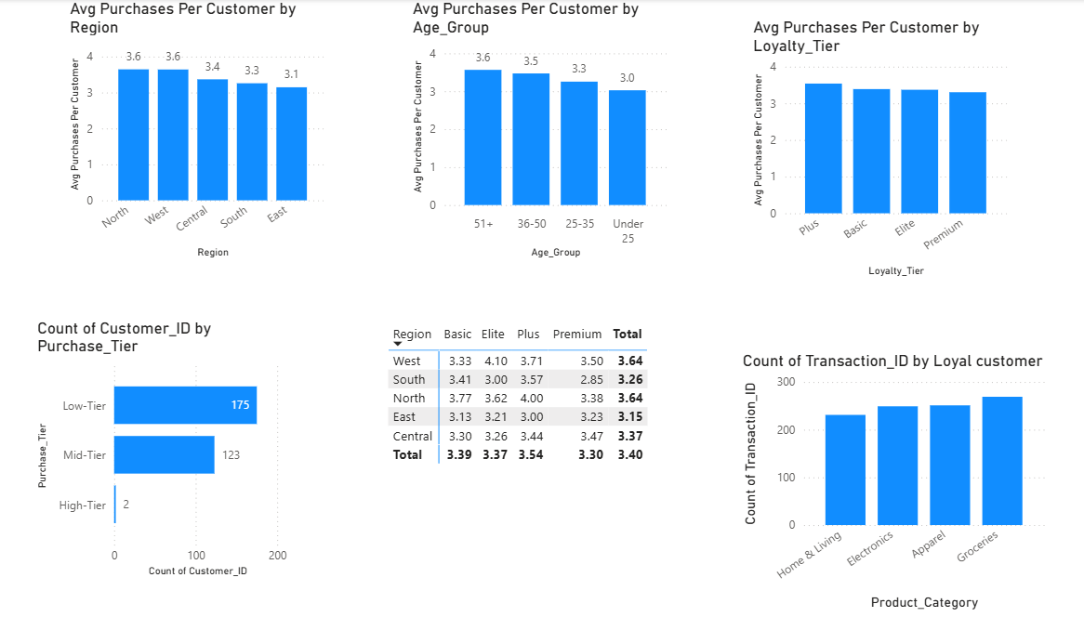
(Final view of TASK- 3)

Task 4 — Promotion & Loyalty Impact
This section explores how promotions and loyalty programs affect spending. Visuals show that promotional offers and higher loyalty tiers increase customer engagement and spending.
% OF TRANSACTIONS WITH PROMOTION APPLIED:
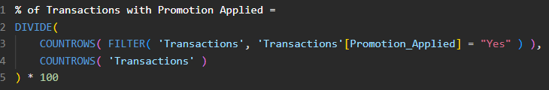
(Figure 4, DAX-% of transactions with promotion applied)

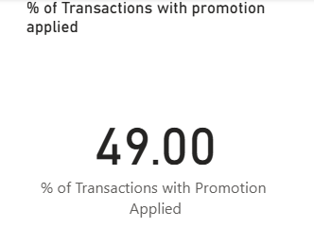
(Figure 4.1)

AVG. PURCHASE AMOUNT WITH AND WITHOUT PROMOTIONS:
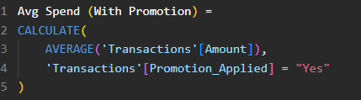
(Figure 4.2, Avg. spend with promotion DAX)

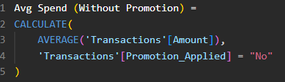
(Figure 4.2a, Avg. spend without promotion DAX)

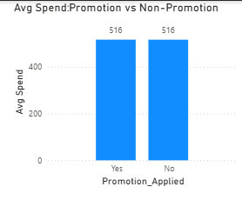
(Figure 4.3)
CHURN RATE ACROSS LOYALITY:
(Figure 4.4 Churn rate% DAX)

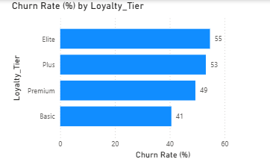
(Figure 4.5)

POINTS EARNED AND REEDEMED BY TIER:
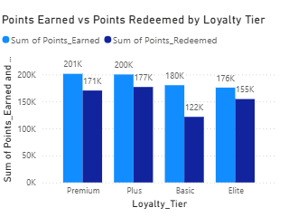
(Figure 4.6)
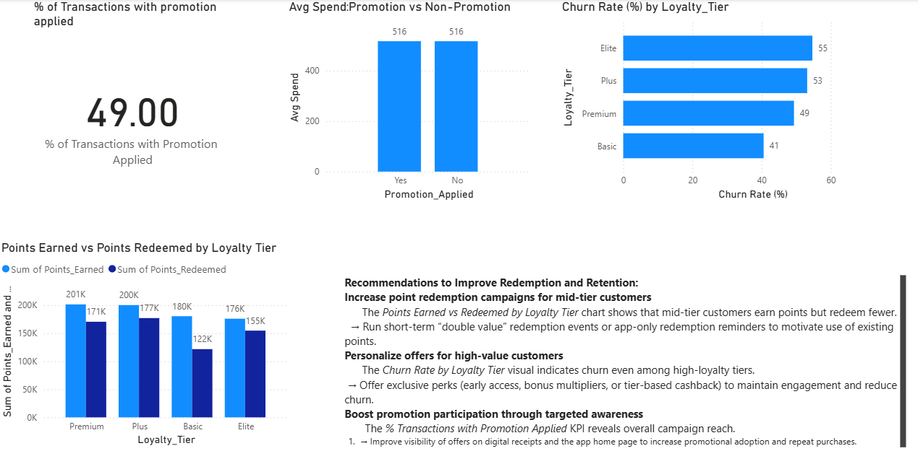
(Final view of TASK-4)

Task 5 — Store & Channel Insights
This section compares customer behavior across different store types and channels. It identifies underperforming store channels and highlights where retention improvements are needed.
MERGE STORE DATA WITH TRANSACTION:
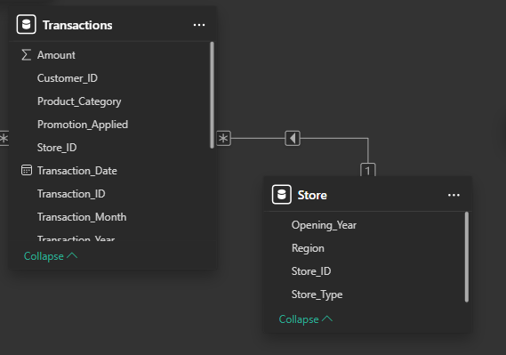
(Figure 5, Model view for store with transaction)

AVG. TRANSACTION AMOUNT BY STORE TYPE:
(Figure 5.1, Avg. transaction amount DAX)

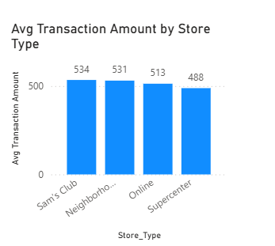
(Figure 5.1 a)

CHURN RATE BY STORE TYPE:
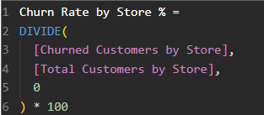
(Figure 5.2, Churn rate by store % DAX and visual)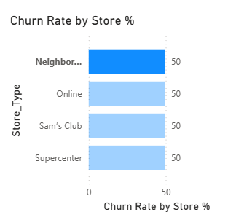
CORRELATION BETWEEN OPENING YEAR AND RETENTION:
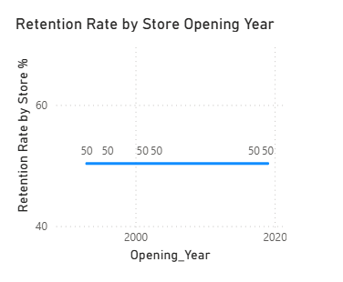
(Figure 5.3, retention rate by opening year and DAX)

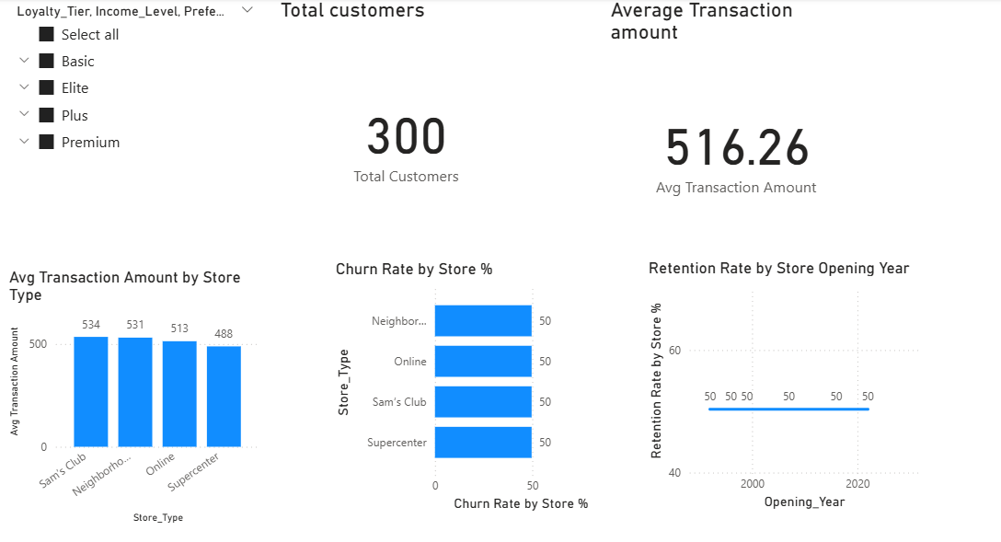
(Final view TASK-5)

Task 6 — Customer Segmentation / CLV
In this section, customers are segmented using RFM (Recency, Frequency, Monetary) and CLV analysis. This helps identify high-value customers and target them for retention strategies.
CLV:
(Figure 6, CLV DAX)
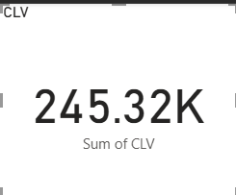

SEGMENT CUSTOMERS INTO LOW, HIGH CLV:
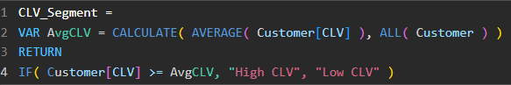
(Figure 6.1, CLV segment DAX)
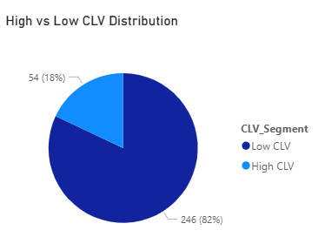
CLV VS DAYS_SINCE_LAST_PURCHASE:
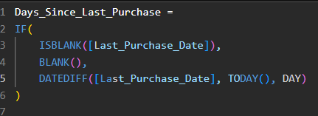
(Figure 6.2, days_since_last_purchase DAX)
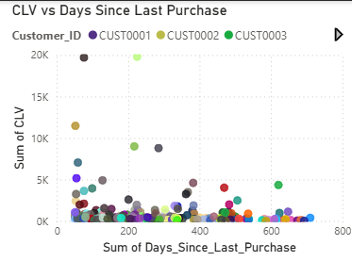
(Figure 6.3, Scatter plot)
CLV BY LOYALITY TIER AND REGION: 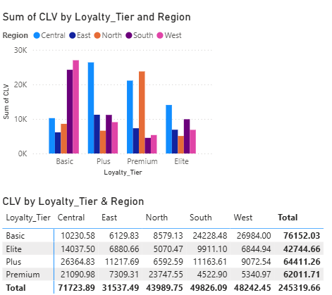
(Figure 6.4)
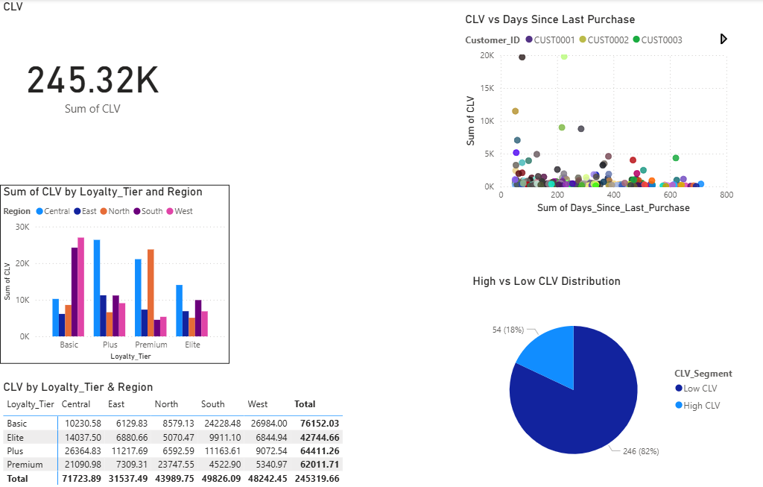
(Final view of TASK-6)

Task 7 — Final Dashboard & Recommendations
This is the final interactive dashboard summarizing all KPIs and visuals. It includes slicers, KPIs, and core charts for churn, retention, loyalty, and spending.
Top 3 Recommendations for Walmart
1. Which customers to prioritize for retention?
Medium-value and online customers show higher churn.
Focus retention campaigns and targeted offers on these groups.
2. Which channels are underperforming?
Online channels have lower retention and higher churn —
enhance app experience, faster delivery, and loyalty points online.
3. How to strengthen loyalty program engagement?
Reward consistent spending with tier-based bonuses,
seasonal double points, and exclusive promotions for Elite/Plus members.

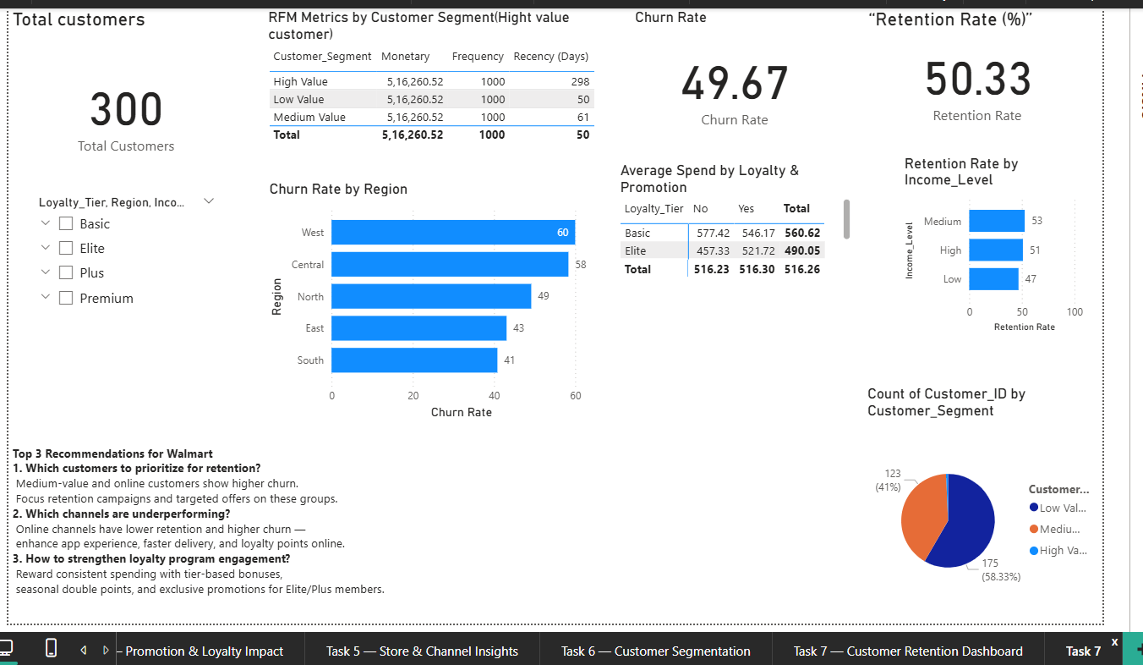
(Final view of TASK-7)

Conclusion & Key Learnings
This Power BI project on Walmart’s customer data provided valuable insights into churn, retention, loyalty, and spending patterns. Through DAX measures, data modeling, and visualization, I learned how to connect multiple tables, create calculated measures, and build interactive dashboards.
Key Learnings:
- Improved understanding of DAX functions and their application in real-world analysis.
- Learned how to clean, model, and visualize data effectively in Power BI.
- Gained practical experience in designing KPI dashboards and deriving business insights.

Summary Video:
https://drive.google.com/file/d/10b6yF2NqdTw9BH96ZClh1YW8fC7F02mF/view?usp=sharing

