Your publications acknowledge the use or contribution made by the software to your research using the following citation: Wei-Chen Cheng, Stanley Kok, and Hoai Vu Pham (Singapore University of Technology and Design), Hai Leong Chieu, and Kian Ming A. Chai (DSO National Labs), "Language Modeling with Sum-Product Networks", INTERSPEECH, 2014, Singapore.

Manual

Scripts

- Perplexity_G4.sh
Evaluate the perplexity of SPN that using previous three words to predict next words on training, validation, and testing dataset.
- Perplexity_G5.sh
Evaluate the perplexity of SPN that using previous four words to predict next words on training, validation, and testing dataset.
- Perplexity_G5_iG4.sh
Evaluate the perplexity of SPN that using previous four words to predict next word on training, validation, and testing dataset. The initial weights of the SPN is trained using previous three words.
- Perplexity_BLLIP99_G5.sh
Evaluate the perplexity of SPN that using previous four words to predict next word on larger training dataset, and validation, and testing dataset.
- interpolate_G4.sh
Evaluate the mixture perplexity of SPN that using previous three words and KN5 on testing dataset.
- interpolate_G5.sh
Evaluate the mixture perplexity of SPN that using previous four words and KN5 on testing dataset.
- interpolate_ G5_iG4.sh
Evaluate the mixture perplexity of SPN that using previous four words and KN5 on testing dataset. The initial weights of the SPN is trained using previous three words.
- interpolate_BLLIP99.sh
Evaluate the mixture perplexity of SPN that using previous four words and KN5 on testing dataset. The training dataset is the larger dataset, BLLIP99.

To compile the code
./compile.sh

To train the model

- To traing SPN that using previous three words
./spn_train configs/Treebank_G4.ini
- To traing SPN that using previous four words
spn_train configs/Treebank_G5.ini
- To traing SPN that using previous four words and using the initial weights trained by previous three words.
./spn_train configs/Treebank_G5_iG4.ini
- To traing SPN that using previous four words and using the initial weights trained by previous three words.
./spn_train configs/BLLIP99.ini

Preprocessing data

Preprocessing data of Penn treebank:

Switch to Penn treebank folder and CAT all files in the combined folder in Penn Treebank CD into three files, wsj_train.parsed, wsj_valid.parsed, and wsj_test.parsed.

Commands: (suppose the corpus is in the directory ~/data/Treebank)
home$ cat ~/data/Treebank/Treebank_R2/combined/wsj/0*/* ~/data/Treebank/Treebank_R2/combined/wsj/1*/* ~/data/Treebank/Treebank_R2/combined/wsj/20/* > wsj_train.parsed
home$ cat ~/data/Treebank/Treebank_R2/combined/wsj/21/* ~/data/Treebank/Treebank_R2/combined/wsj/22/* > wsj_valid.parsed
home$ cat ~/data/Treebank/Treebank_R2/combined/wsj/23/* ~/data/Treebank/Treebank_R2/combined/wsj/24/* > wsj_test.parsed

Step 1. Open TIGERSearchTools by executing “./runTRegistry.sh”

TIGERSearch is available under the GNU Public License. To use the TIGERSearch tools on your computer you need an installation of the Java Runtime Environment.
The website of the software: http://www.ims.uni-stuttgart.de/forschung/ressourcen/werkzeuge/TIGERSearch/download/index.html

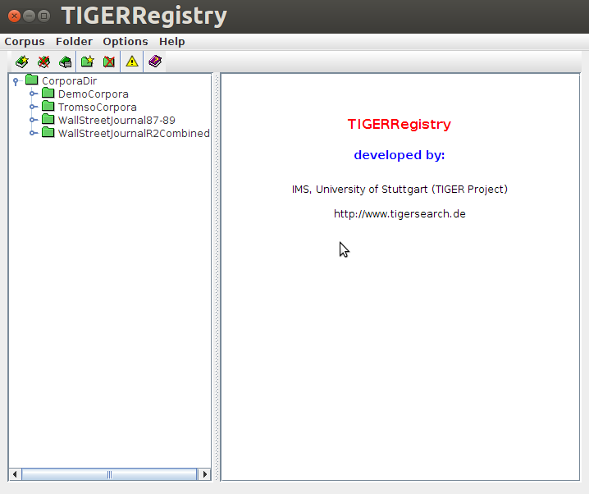
“Folder” -> “Insert Folder” -> name it “WSJ”

Step 2. Generate training data

“Corpus” -> “Insert Corpus” ->
unselect “GZIP XML file” and “Delete XML file after indexing”, so that the generated XML will be remained.
input the Corpus ID = “R2C_train”
Select import filter -> “general Penn treebank format filter”
import file -> wsj_train.parsed
press “start” button

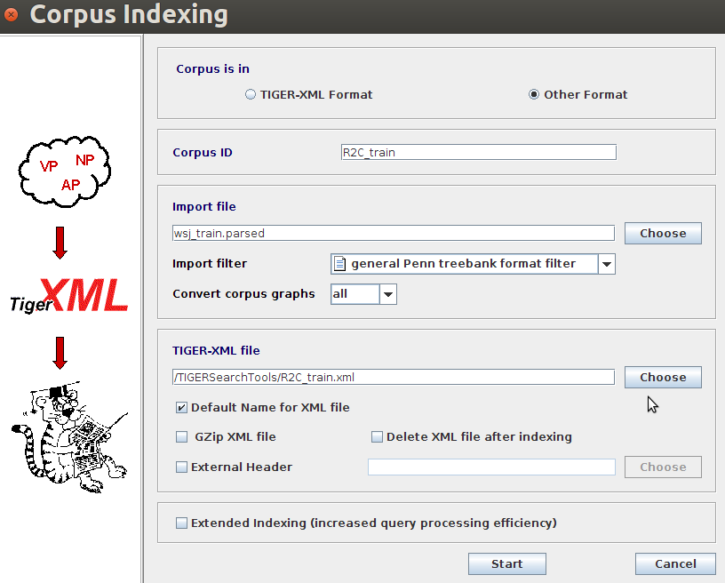

This will generate R2C_train.xml in the TIGERSearchTools folder.

Step 3. Generating validation data

input the Corpus ID = “R2C_valid”
select import filter -> “general Penn treebank format filter”
import file -> wsj_valid.parsed
press “start” button

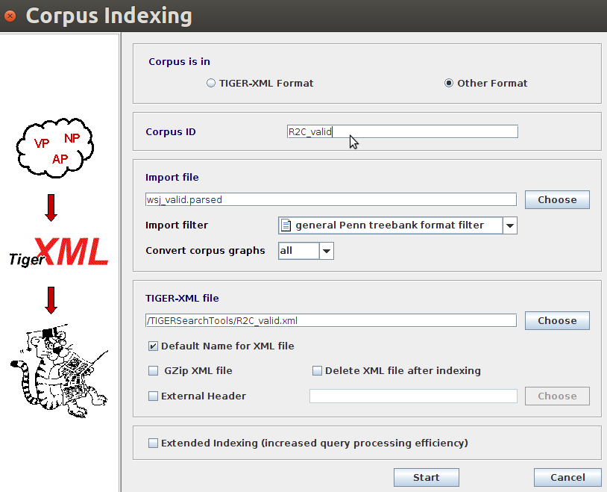

This will generate R2C_valid.xml in the TIGERSearchTools folder.

Step 4. Generating testing data

input the Corpus ID = “R2C_test”
select import filter -> “general Penn treebank format filter”
import file -> wsj_test.parsed
press “start” button

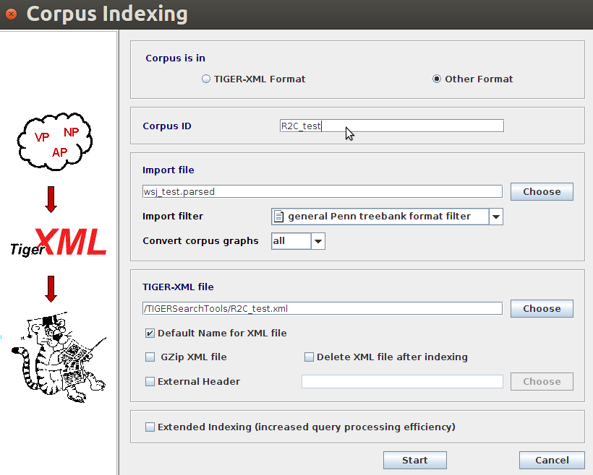

This will generate R2C_test.xml in the TIGERSearchTools folder.

Step 5. move the R2C_train.xml, R2C_valid.xml, and R2C_test.xml to folder “Penn_Treebank” in the same folder with ExtractSentences.java. The function of the ExtractSentences.java is to parse the xml file and extract the sentences for sum-product network.
Commands:
mv /TIGERSearchTools/R2C_train.xml SPNLM/Penn_Treebank/
mv /TIGERSearchTools/R2C_valid.xml SPNLM/Penn_Treebank/
mv /TIGERSearchTools/R2C_test.xml SPNLM/Penn_Treebank/

Step 6. Complie and run ExtractSentences.java
Command:
cd SPNLM/Penn_Treebank
./ExtractPennTreebank.sh
Step 7. The previous step will generate three data R2C_train.idx, R2C_valid.idx, and R2C_test.idx for train the SPN.
Step 8. Move the R2C_train.idx, R2C_valid.idx, and R2C_test.idx to the folder “LM_data”.
Command:
cd ..
mv SPNLM/Penn_Treebank/R2C_train.idx SPNLM/LM_data/
mv SPNLM/Penn_Treebank/R2C_valid.idx SPNLM/LM_data/
mv SPNLM/Penn_Treebank/R2C_test.idx SPNLM/LM_data/

Preprocessing data of BLLIP99 (Wall Street Journal 1987-1989)

Step 1. Concatenate the corpus into a big file.
Command:
cat BLLIP99_1/1987/* /* BLLIP99_2/1988/* /* BLLIP99_2/1989/* /* > 198x.dat
Step 2. use TigerSearch to process 198x.dat to generate XML file “198x.xml”.

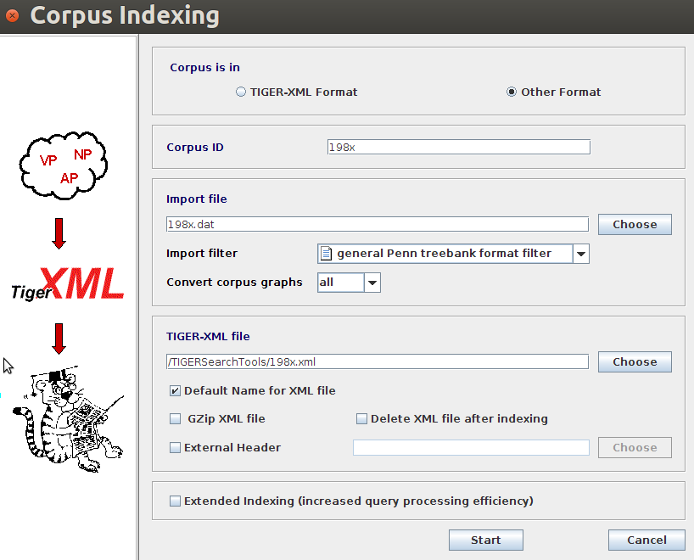
(There are some corrupt data in the corpus, therefore, we ignore partial of the corpus, which is a very small ratio in the corpus.
The ignored file number is w7_032.167 ~ w7_032.200
The ignored folder number is w7_032 )
Step 3. move the 198x.xml to the folder “Penn_Treebank”.
Command:
mv /TIGERSearchTools/198x.xml SPNLM/Penn_Treebank
Step 4. Preparing the data for SPN (This will require 256GB RAM to process the data)
Command:
./ExtractBLLIP99.sh
Step 5. move the BLLIP99_train.idx, R2C_valid.idx, R2C_test.idx to the folder “LM_data”.
Command:
mv SPNLM/BLLIP99_train.idx SPNLM/LM_data/
mv SPNLM/R2C_valid.idx SPNLM/LM_data/
mv SPNLM/R2C_test.idx SPNLM/LM_data/

