**QC Results Automation with Westgard Rule Analysis**

**Clinical Chemistry Process Automation Demo**

**Project Overview**

Automates aggregation and QC analysis of daily clinical chemistry results using Westgard rules. Reduces error-prone manual work, instantly flags failed QC parameters—critical for lab quality and compliance.

**Quick Start**

1. Download code and sample data.
2. Install [Python 3](https://www.python.org/) and pandas (pip install pandas).
3. Put daily QC .csv files in the Daily_QC_Results/ folder.
4. Run: python qc_weekly_summary.py
5. Review outputs:
   * weekly_qc_summary.csv
   * weekly_qc_report.txt

**Folder Structure**

CopyEdit

project_folder/

├── qc_weekly_summary.py

├── Daily_QC_Results/

│ ├── qc_2024-05-20.csv

│ ├── qc_2024-05-21.csv

│ └── qc_2024-05-22.csv

└── README.md

**Westgard Rules Implemented**

* **1-2s**: Result >2SD from mean (warning)
* **1-3s**: Result >3SD from mean (fail)
* **2-2s**: Two consecutive >2SD, same side (fail)
* **R-4s**: One >+2SD, next <-2SD (fail)
* **4-1s**: Four >1SD, same side (warning)
* **10x**: Ten consecutive one side of mean (warning)

**Why This Matters**

* **Lab compliance:** Instantly spots QC failures for audit and patient safety.
* **Efficiency:** Zero manual collation, instant flagging.
* **Portfolio Value:** Proves technical AND domain skills.

**Example Input & Output**

* **Input:**

sql

CopyEdit

Date,TestName,Result,Mean,SD,ReferenceLow,ReferenceHigh,WestgardRuleViolated,Pass,Comments

2024-05-20,Glucose,98,100,5,70,110,None,Pass,Within 2SD

* **Output:**
  + weekly_qc_summary.csv
  + weekly_qc_report.txt (flags all failures/warnings for the week)

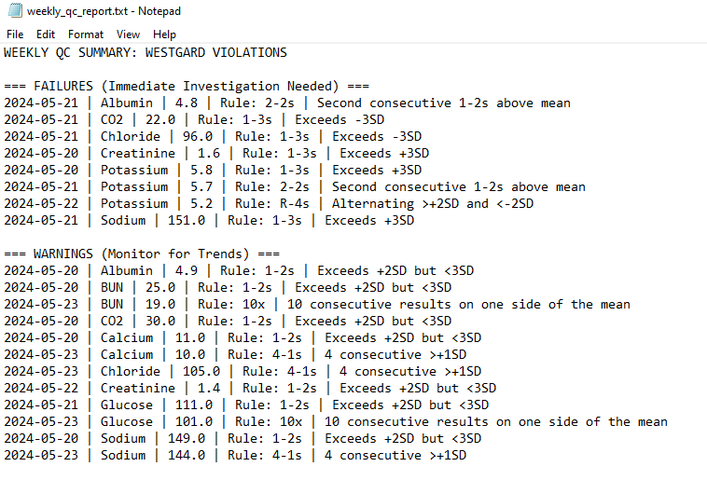

**Tech Stack**

* Python 3
* pandas

**Credits**

Designed and implemented by Allen Stalcup as part of a clinical data/process automation portfolio.

**Contact:** [allen.stalc@gmail.com]