Web and Social Media Search and Analysis
Machine Translation Discourse on Bluesky
Bachelor of Science in Artificial Intelligence
Web and Social Media Search and Analysis — Prof. Marco Viviani
Authors: Linda Stalidzane 525366, Pelinsu Topaloglu 533792

1. Objective
Machine translation (MT) tools such as DeepL and Google Translate, along with LLM-based translation, are now used by casual social media users, professional translators, and developers alike. This project studies how Bluesky talks about MT — as a helpful tool, a threat to professional translators, or both — and whether that framing differs between people who work in translation/localization and the general public. Posts were collected around a fixed set of MT-related keywords and hashtags over a 12-month window, and analyzed along two complementary axes: Network Analysis (who talks to whom) and Content Analysis (what is actually being said).
Guiding research questions:
- RQ1 — Sentiment & framing: do people talk about MT as a tool, a threat, or both?
- RQ2 — Professional impact discourse: how do working translators discuss MT's effect on their careers, compared to the general public?
- RQ3 — Utility vs. displacement tension: do people acknowledge MT's utility while lamenting professional erosion?
- RQ4 — Network structure: do professional translators and general users form distinct communities in the follow/reply networks, and which accounts bridge them?

2. Data

2.1 Collection strategy
Data was collected from Bluesky via the official API (Python atproto client):
- Seed search: a fixed list of text queries, compound queries, and hashtags (below) searched over the last 12 months, sorted by recency.
- Thread crawl: each seed post's full reply thread is crawled and walked in memory. Reply edges aren't collected at crawl time — every post already stores its parent URI, so edges are derived from the posts table during preprocessing instead, which also captures seed posts that are themselves replies.
- Author/follower crawl: for authors with ≥ 2 posts, up to 100 followers were fetched to build the follow network; profiles were fetched for essentially all post authors (not just top ones), so bio-based labeling isn't biased toward frequent posters.
- Deduplication across all sources into the final dataset.
Seed queries:
- Text: "machine translation", "AI translation", "post-editing", "human translation", "translation quality", "translator jobs", "translation industry", "DeepL", "MTPE", "neural machine translation"
- Compound: "post-editing" AI, "AI translation" threat, scraped translation, "machine translation" slop, "human translator" AI, "translation industry" AI
- Hashtags: #machinetranslation, #MTPE, #localization, #l10n, #SlowTranslation, #HumanTranslation, #PauseAI, #NoAI
Preprocessing is idempotent. Every output, including graph.csv, is rebuilt fresh from the raw inputs each run, so re-running a step cannot corrupt the data.

2.2 Preprocessing and labeling
Cleaning: URLs stripped, whitespace normalized, posts under 10 characters and placeholder (handle.invalid) accounts dropped.
Topical relevance: a keyword filter (translat*, interpret*, locali*e*, deepl, mtpe, post-edit, language model, nlp, multilingual, linguist, terminology, glossary) removes off-topic posts pulled in by broad seed queries (e.g. #localization, #PauseAI). A second filter removes a specific collision: "MTPE" also abbreviates Peru's Ministry of Labor, so MTPE + Spanish employment/ministry terms together are dropped as noise.
Author-type labeling: general / professional / tech, by keyword match on bio (professional: translator/interpreter/localizer/linguist/terminology/lexicographer/subtitler/transcriber terms; tech: developer/engineer/NLP/ML/researcher terms, checked only if no professional terms matched). Authors with a fetched profile but no bio text are labeled unknown rather than general, so "no information" isn't silently treated as "ordinary user" (see Section 4.2).

2.3 Final dataset
After collection, cleaning, and topical filtering, the dataset used for analysis is:
Artifact | Rows | Description
posts_clean.csv | 3,864 | Final cleaned, topically-filtered posts (Jul 2025 – Jul 2026)
author_profiles.csv | 2,303 | Author profiles (bio, followers, following, post count)
follow_edges.csv | 127,890 | Follow relationships (before invalid-handle cleanup)
reply_edges.csv | 7,116 | Reply relationships derived from posts_raw (before target resolution)
graph.csv | 133,428 | Combined network: 127,597 follow edges + 5,831 resolved reply edges
seeds.csv | 3,751 | Seed posts returned directly by the search queries
posts_raw.csv | 9,349 | All posts before topical filtering (seeds + thread crawl)

Author-type breakdown of the 3,864 posts:
User type | Posts | Share
general | 2,843 | 73.6%
professional | 610 | 15.8%
unknown | 218 | 5.6%
tech | 193 | 5.0%

2,261 posts (58.5%) are replies. Note the strong class imbalance between user types — all cross-group comparisons in this report use rates/proportions rather than raw counts for this reason. All 218 unknown-labeled posts come from a fetched profile with an empty bio, not a missing profile (profile coverage was 100% of post authors).

3. Models

3.1 Network Analysis Models
Network analysis is carried out in 02_network_analysis.ipynb using networkx. Placeholder accounts (handle.invalid, Bluesky’s marker for deleted or unresolvable accounts) are excluded, and two graphs are built and kept separate — following and replying are different social relations, and merging them into a single directed graph would silently collapse duplicate source–target pairs:
- Follow graph — directed, from the crawled follow edges (86,162 nodes, 127,597 edges).
- Reply graph — directed and weighted: repeated replies between the same pair of users are preserved as edge weights, and 2,117 self-replies (users continuing their own threads) are removed (2,642 nodes, 2,912 edges, 3,714 interactions).
The full follow graph is an ego-network sample: it only contains follow edges crawled around the post authors, capped per account by API pagination. Global statistics on it would reflect the crawl design as much as Bluesky’s actual structure, so all structural analysis is restricted to the post-authors subgraph (1,339 nodes, 1,320 edges), in which every node was sampled the same way.

Centrality measures
Five complementary measures are used on the follow and reply graphs:
- In-degree / out-degree centrality — being followed within the sample (visibility) vs. following others (engagement).
- PageRank (α = 0.85) — influence: being followed by well-followed accounts counts more than raw follower count.
- Betweenness centrality — accounts lying on many shortest paths, i.e., bridges between parts of the network (directly relevant to RQ4).
- Closeness centrality — computed on the largest connected component only, since it is meaningless on disconnected graphs.
- Weighted in-degree on the reply graph — total replies received, a measure of conversational attention.

Community detection
Four algorithms are compared: Louvain, Greedy Modularity, FluidC (k fixed to the number of non-trivial Louvain communities) and Girvan–Newman (best partition by modularity over the first splits). All four are run on the same graph, which is the undirected largest connected component of the post-authors follow subgraph. This is done so that their modularity scores are directly comparable. Running detection on the full fragmented graph instead would inflate modularity with hundreds of disconnected 2–5-node fragments; communities smaller than 5 nodes are treated as noise throughout. Louvain (seeded for reproducibility) is used as the primary partition downstream.

3.2 Content Analysis Models
Sentiment and emotion each use two methodologically different tools, cross-checked against each other rather than trusting a single method — this surfaced real limitations in the lexicon-based tools (see Results).

Sentiment analysis
- VADER — lexicon- and rule-based, tuned for social media text. Compound score in [-1, 1], bucketed into positive (≥0.05) / neutral / negative (≤-0.05).
- cardiffnlp/twitter-roberta-base-sentiment — a RoBERTa transformer fine-tuned on tweet sentiment (negative/neutral/positive), reading full sentences rather than scoring words independently.

Emotion analysis
- NRCLex — dictionary-based (NRC Word-Emotion Association Lexicon, Plutchik's 8 basic emotions). Dominant emotion = argmax of per-word affect frequencies.
- j-hartmann/emotion-english-distilroberta-base — a DistilRoBERTa transformer (anger, disgust, fear, joy, neutral, sadness, surprise), sharing 6 of NRCLex's 8 labels.
Comparing the two by restricting both to the shared 6 labels would introduce selection bias, since trust/anticipation are NRCLex's most common calls. Instead, the comparison conditions only on the transformer's output, then checks what NRCLex independently says about those same posts.

Named entity recognition
- spaCy (en_core_web_sm) extracts ORG, PRODUCT, PERSON, and GPE entities from post text.
- A curated list of known MT tools/companies (DeepL, Google Translate, Google, Amazon, Microsoft, YouTube, Mozilla Localization, ChatGPT, OpenAI, GPT, Meta, Claude) is cross-referenced against the raw NER output, since the generic model mis-tags several domain acronyms (see Limitations).

4. Results

4.1 Network Analysis Results

4.1.1 Graph structure
The post-authors follow subgraph is very sparse and fragmented: 1,339 nodes and 1,320 edges (density 0.0007), split into 535 weakly connected components, with the largest connected component (LCC) covering 676 nodes, about half the authors.
Reciprocity is low (0.162), as expected in follow networks, where attention flows toward visible accounts rather than being mutual. The average clustering coefficient (0.035) is much higher than what a random graph of the same density would produce, but the LCC’s average shortest path (6.49) and diameter (20) are in line with a comparable random graph. There is modest local cohesion above chance, but no strong small-world structure. The MT discourse on Bluesky is a loosely connected space, not one tight community.
The degree distribution of the post-authors subgraph is heavy-tailed (approximately linear CCDF on log-log axes): attention concentrates on a few accounts. The spike at in-degree ≈ 100 in the full crawl is the follower-crawl pagination cap — a collection artifact, not a property of Bluesky (Figure 1).
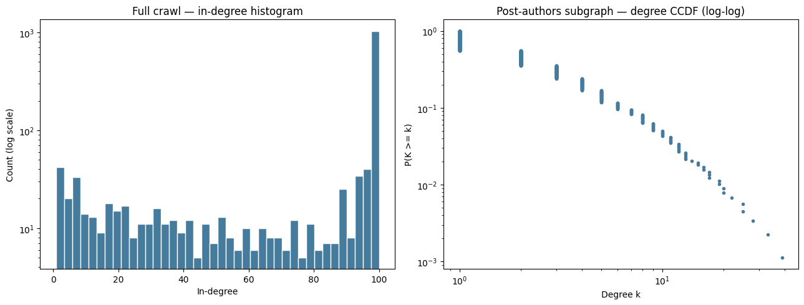
Figure 1 — Left: in-degree histogram of the full follow crawl (log scale). Right: degree CCDF of the post-authors subgraph (log-log).

4.1.2 Centrality
Follow attention concentrates overwhelmingly on professional translators: 13 of the top 15 accounts by in-degree centrality and 10 of the top 15 by closeness centrality are professionals. PageRank is more mixed, adding general-audience and institutional accounts (journalism, MT research, professional associations) to the top ranks. Betweenness centrality splits exactly 5/5 between professional and general accounts among its top 10: professional translators occupy bridging positions between the professional and general parts of the network, but do not monopolize them (RQ4). Top 10 accounts by in-degree centrality:

Handle | In-degree centrality | User type
subtleuk.bsky.social | 0.0127 | professional
creative-xl8.bsky.social | 0.0112 | professional
gametranslator.bsky.social | 0.0105 | professional
palavrillo.bsky.social | 0.0090 | professional
narush15.bsky.social | 0.0090 | professional
linguacaps.bsky.social | 0.0082 | professional
alyssaweldon.bsky.social | 0.0082 | professional
brivaiglesias.bsky.social | 0.0067 | professional
mistygaltees.bsky.social | 0.0067 | professional
avue.bsky.social | 0.0067 | professional

The reply network inverts this picture: the most replied-to accounts are mostly general users, led by a single viral outlier (tobyfox.undertale.com, 364 replies received — about 5.6× the runner-up), a one-off thread that attracted replies from far outside the translation community. Professionals are followed; virality happens around general accounts. The outlier is treated as an event, and the visualization below is restricted to post authors with degree ≥ 2 so the viral spike does not swamp the layout (Figure 2).
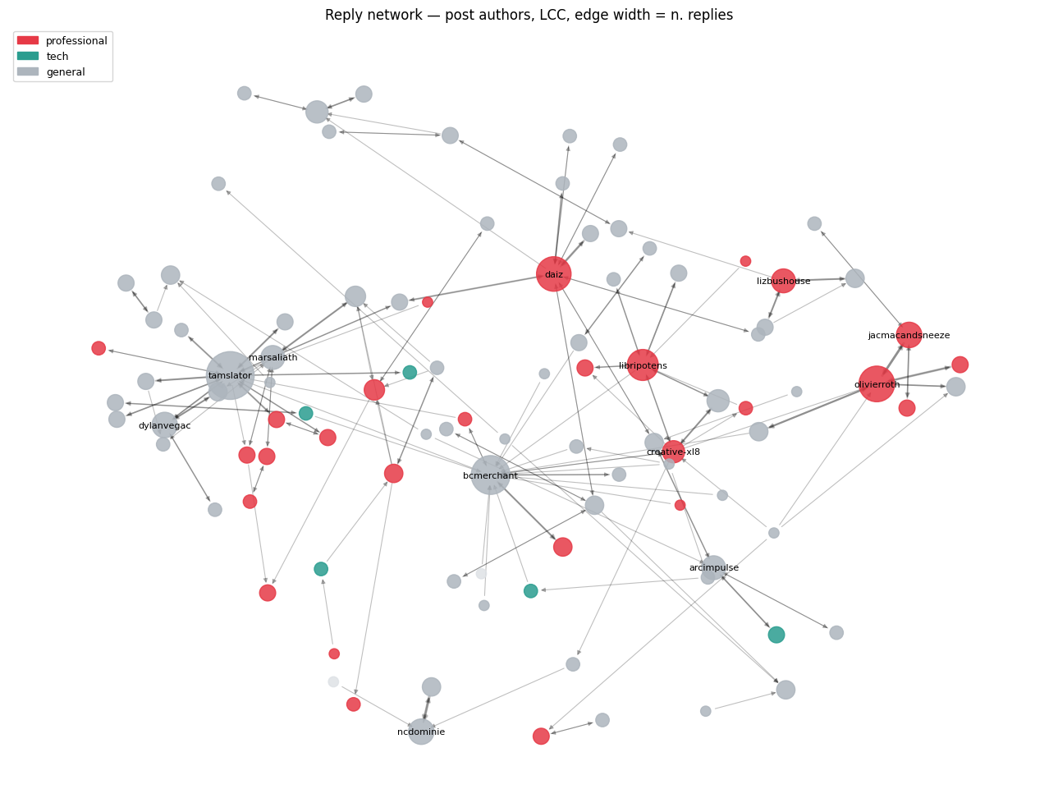
Figure 2 — Reply network among post authors (largest component, degree ≥ 2, self-replies removed). Node size = replies received, edge width = number of replies, color = user type.

4.1.3 Community detection
All four algorithms were run on the undirected LCC of the post-authors follow subgraph (676 nodes, 1,082 edges), so their modularity scores are directly comparable:

Method | Communities (k) | Communities (size ≥ 5) | Modularity
Louvain | 17 | 16 | 0.728
Greedy Modularity | 21 | 18 | 0.735
FluidC | 16 | 16 | 0.687
Girvan–Newman | 19 | 18 | 0.705
The partition is robust in quality but not in exact numbers: Louvain, Greedy Modularity and Girvan–Newman agree closely, and FluidC is not far behind despite its fixed k. Louvain and FluidC are not exactly reproducible run-to-run in this environment, even with a fixed seed. Louvain (16 non-trivial communities, modularity 0.728, this run) is used as the primary partition. Of these, two communities are professional-majority rather than a single one: an industry-focused cluster of 98 nodes (134 professional vs. 112 general posts) centered on MTPE rates, working conditions and translation-industry news, with a visible Spanish-language contingent, plus a smaller, more heterogeneous cluster of 57 nodes leaning professional by a narrower margin (57 vs. 49 general posts). The remaining large communities are general-dominated and organized by topic and fandom rather than by profession: game localization and store translations, DeepL/ChatGPT use in game development, fan translation, and developer/localization tooling. Only 1,566 of 3,864 posts (≈40%) fall inside non-trivial communities — the rest belong to authors outside the LCC or in tiny fragments — so this characterization describes the connected core of the discourse.
The answer to RQ4 is therefore asymmetric but more qualified than a single hub: professional translators concentrate in a small number of communities (two of the five largest in this run) rather than one, while general users do not form a single opposing bloc — they scatter across many consumer/fandom pockets in which MT is discussed in the context of specific products. The MT debate on Bluesky is less “professionals vs. the public” and more “a small set of professional-leaning hubs surrounded by many independent fan and consumer conversations”, with a mixed set of professional and general accounts bridging the two (Figure 3). Exactly how many professional hubs there are is not a stable number across runs.

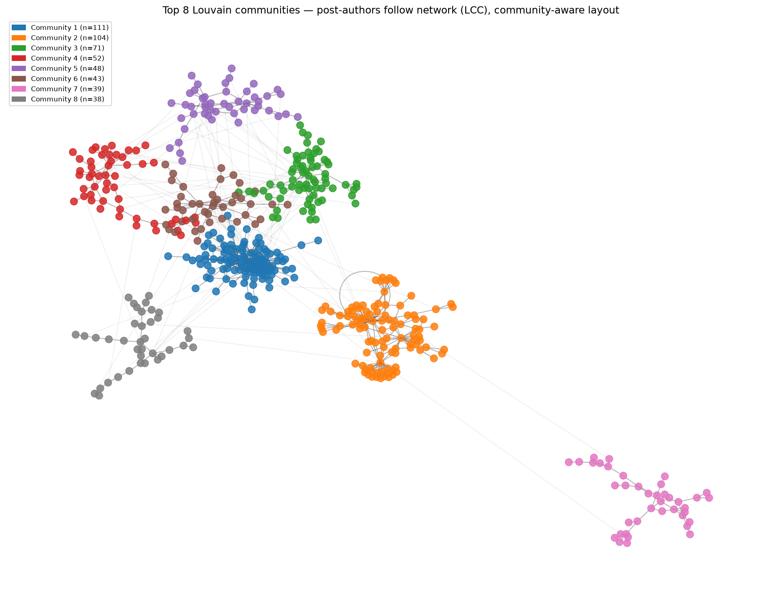
Figure 3 — Top 8 Louvain communities in the post-authors follow network (LCC), community-aware layout. Intra-community edges are drawn darker than inter-community edges.

4.2 Content Analysis Results

4.2.1 Sentiment Analysis
Overall, VADER classifies the discourse as 51.5% positive, 20.8% neutral, 27.7% negative:
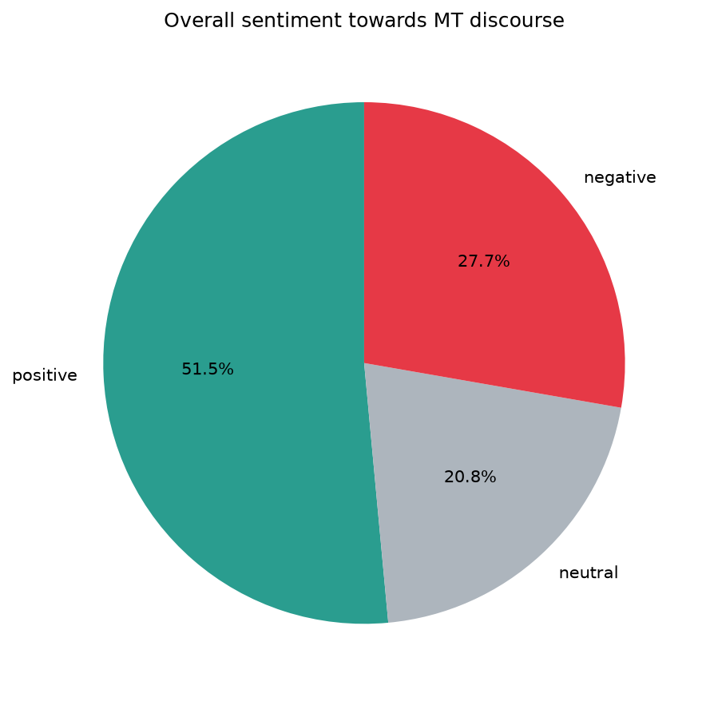
Figure 4 — Overall VADER sentiment distribution (n = 3,864 posts).
Professionals and tech users are (slightly) the most positive groups, not the most negative — consistent with acknowledging MT's day-to-day utility despite being most exposed to its downsides:
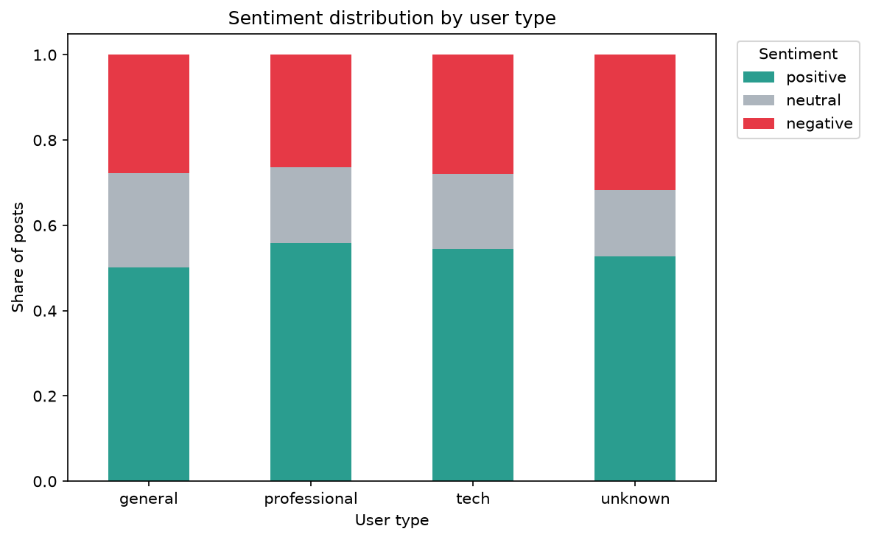
Figure 5 — VADER sentiment distribution by user type.
User type | Mean compound | Median compound | Posts
general | 0.139 | 0.052 | 2,843
professional | 0.201 | 0.250 | 610
tech | 0.173 | 0.214 | 193
unknown | 0.112 | 0.077 | 218

VADER and RoBERTa disagree substantially — only 54.1% agreement, with 458 posts (11.9%) in outright opposite-polarity disagreement. RoBERTa's distribution is markedly less positive (23.1% / 46.0% / 31.0%):
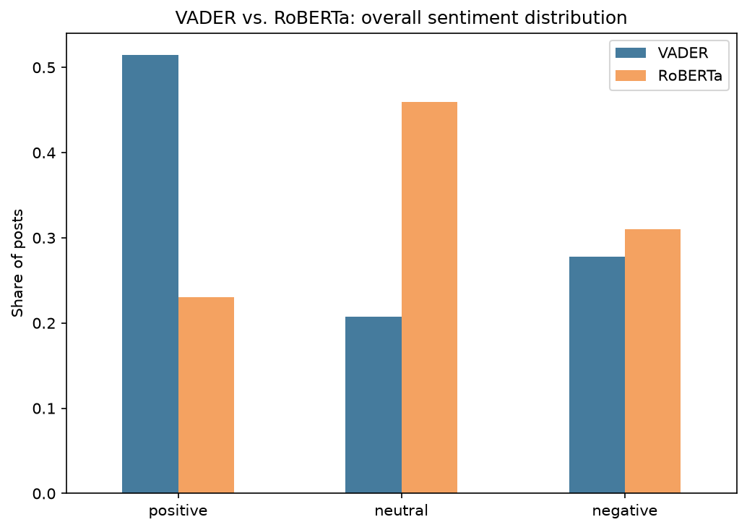
Figure 6 — VADER vs. RoBERTa overall sentiment distribution.
VADER is consistently fooled by individually-positive words in otherwise critical posts — e.g. it scored “Perfect example of how machine translation is totally untrustworthy” as strongly positive (+0.57, from “perfect” alone), while RoBERTa correctly read it as negative. RoBERTa's more balanced distribution is the more trustworthy read: the framing of MT is genuinely mixed, not predominantly positive.
Sentiment also varies over the collection window (VADER, monthly mean compound score):
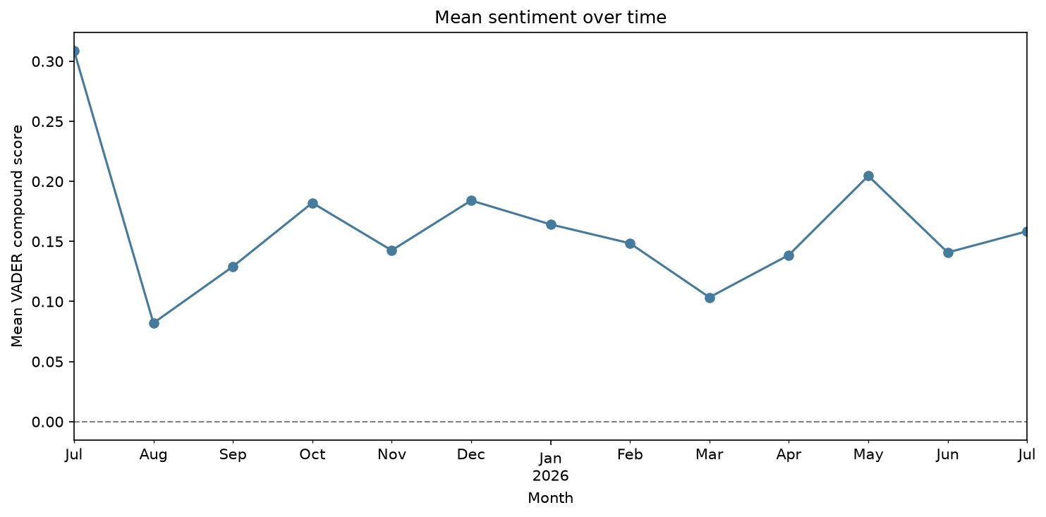
Figure 7 — Mean VADER sentiment by month.

4.2.2 Emotion Analysis
NRCLex's overall emotion profile is dominated by trust (mean affect frequency 0.260), well above every other category:
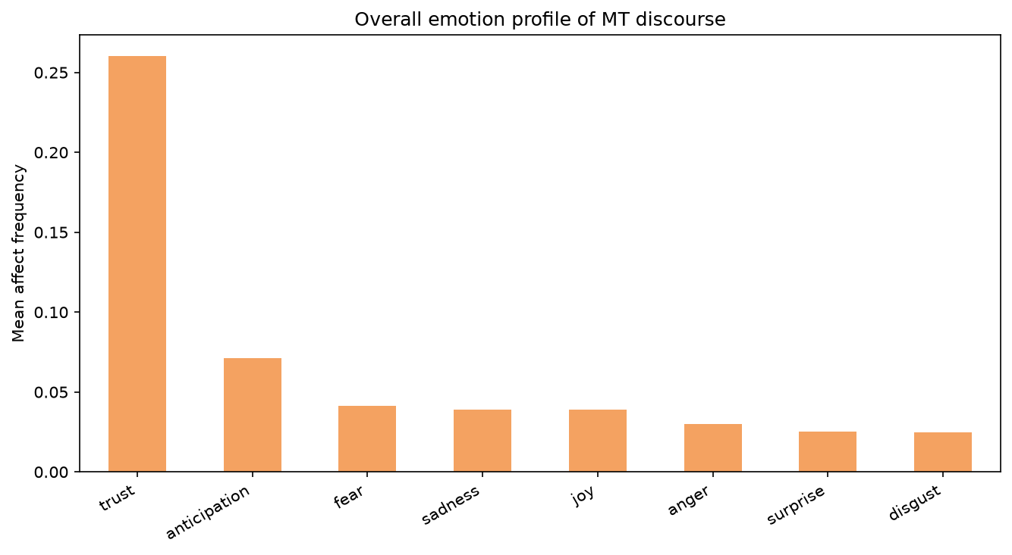
Figure 8 — Overall NRCLex emotion profile (mean affect frequency).
Differences between user types are small relative to the tool-to-tool differences below — which emotion detector is used matters more here than which audience is examined:

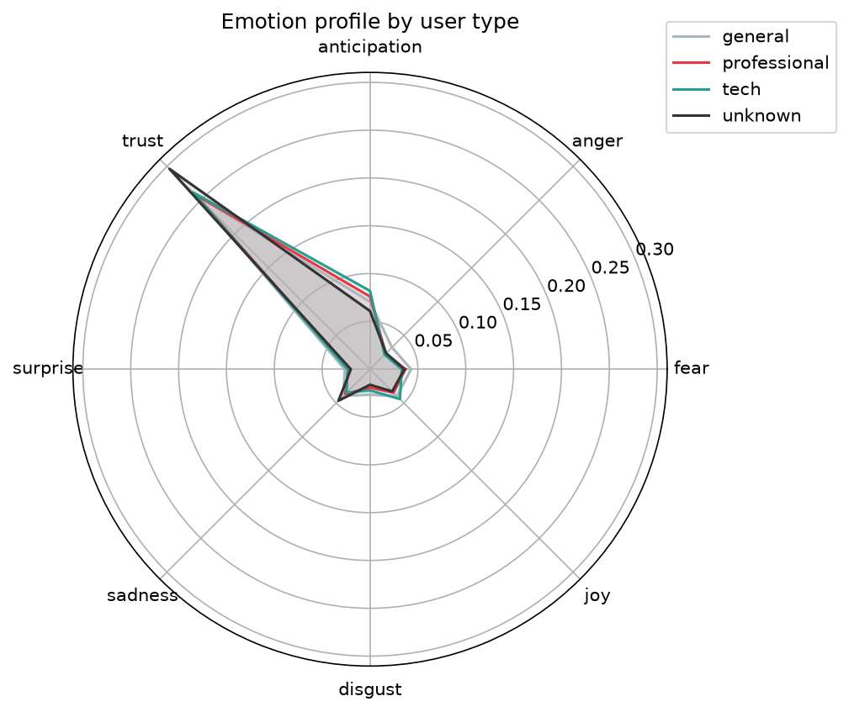
Figure 9 — NRCLex emotion profile by user type.

NRCLex's per-post dominant emotion is trust (49.0%) or fear (31.8%) for the large majority of posts. Conditioning on posts where DistilRoBERTa is confident enough to name a specific non-neutral emotion (44.5% of posts) barely changes this — NRCLex still calls trust 46.5% and fear 30.3% of the time there, and the two tools agree on only 15.6% of posts:

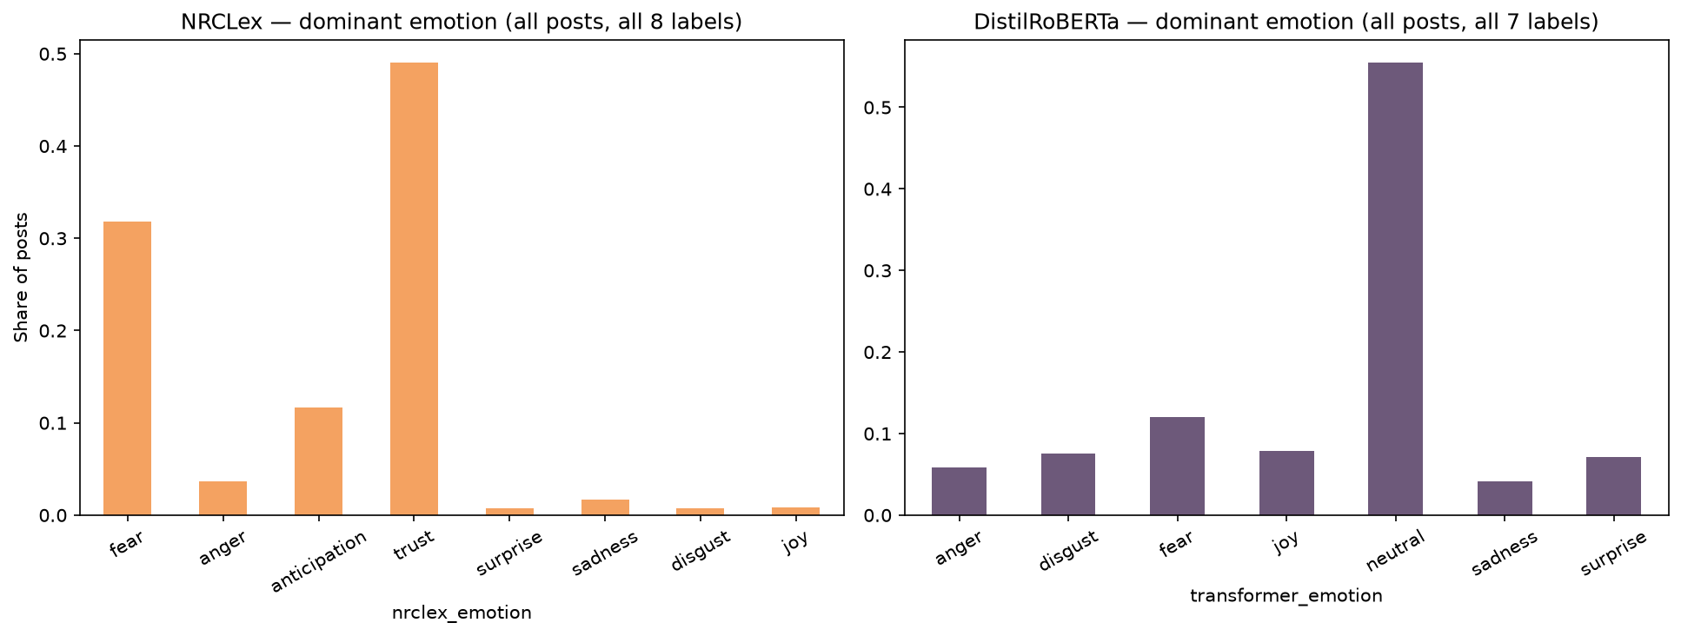
Figure 10 — NRCLex vs. DistilRoBERTa dominant-emotion distributions (each on its own full label set).

NRCLex's dominant-emotion output is close to invariant to what a post actually says — consistent with “trust” being an oversized NRC lexicon category that fires on ordinary vocabulary. This report therefore treats the sentiment comparison (RQ1) as the more reliable evidence for framing, and emotion as exploratory/secondary.

4.2.3 Named Entity Recognition
spaCy extracted 5,523 entities (ORG 2,568, PERSON 1,840, GPE 979, PRODUCT 136). Several top "entities" below (MTPE, LLM, MTL, MT, NMT, CAT, UI, NLP, L10N, QA) are domain acronyms mis-tagged as organizations by the generic model, reported as-is rather than filtered out:
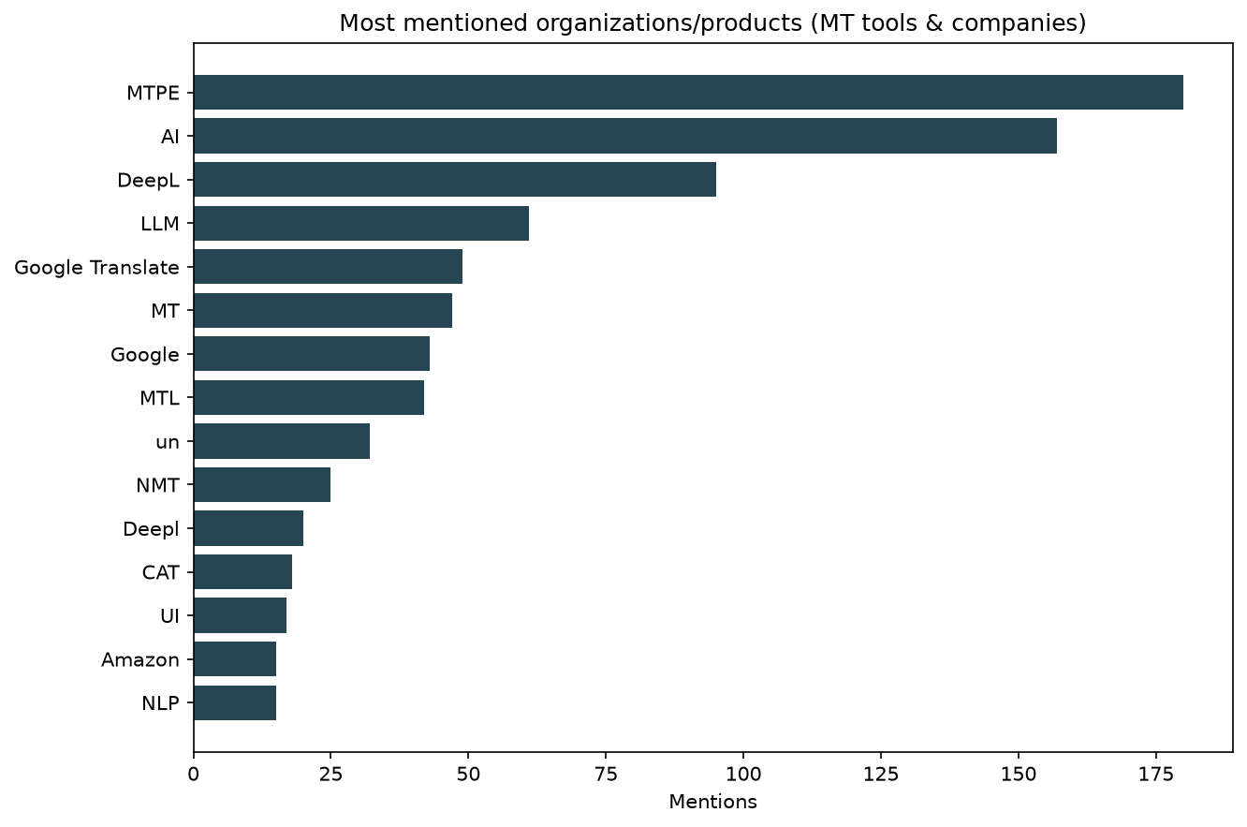
Figure 11 — Most-mentioned raw entities (ORG/PRODUCT), including acronym noise.
For a cleaner answer to which specific tools each group discusses, mentions of a curated tool/company list were normalized per 1,000 posts within each user type (raw counts would just reflect that general has far more posts than the other groups):
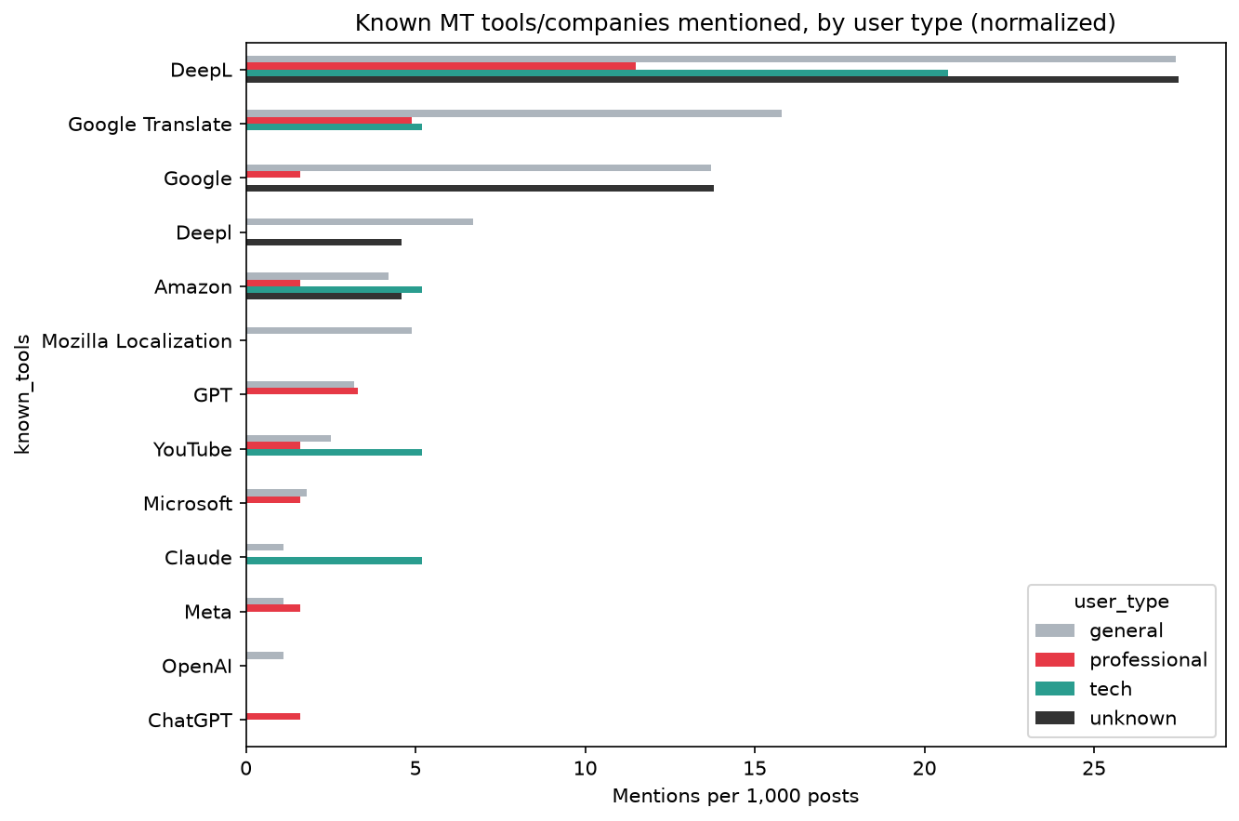
Figure 12 — Known MT tools/companies mentioned, per 1,000 posts, by user type.
Tool | General | Professional | Tech | Unknown
DeepL | 27.4 | 11.5 | 20.7 | 27.5
Google Translate | 15.8 | 4.9 | 5.2 | 0.0
Google | 13.7 | 1.6 | 0.0 | 13.8
Deepl | 6.7 | 0.0 | 0.0 | 4.6
Amazon | 4.2 | 1.6 | 5.2 | 4.6
Mozilla Localization | 4.9 | 0.0 | 0.0 | 0.0
GPT | 3.2 | 3.3 | 0.0 | 0.0
YouTube | 2.5 | 1.6 | 5.2 | 0.0
Microsoft | 1.8 | 1.6 | 0.0 | 0.0
Claude | 1.1 | 0.0 | 5.2 | 0.0
Meta | 1.1 | 1.6 | 0.0 | 0.0
OpenAI | 1.1 | 0.0 | 0.0 | 0.0
ChatGPT | 0.0 | 1.6 | 0.0 | 0.0

DeepL and Google Translate dominate across all groups. Tech users mention Claude and Amazon at a notably higher rate relative to group size, suggesting a lean toward LLM-based translation. These counts are small in absolute terms for professional/tech/unknown (193–610 posts total) — suggestive, not conclusive.

4.2.4 Word clouds by sentiment
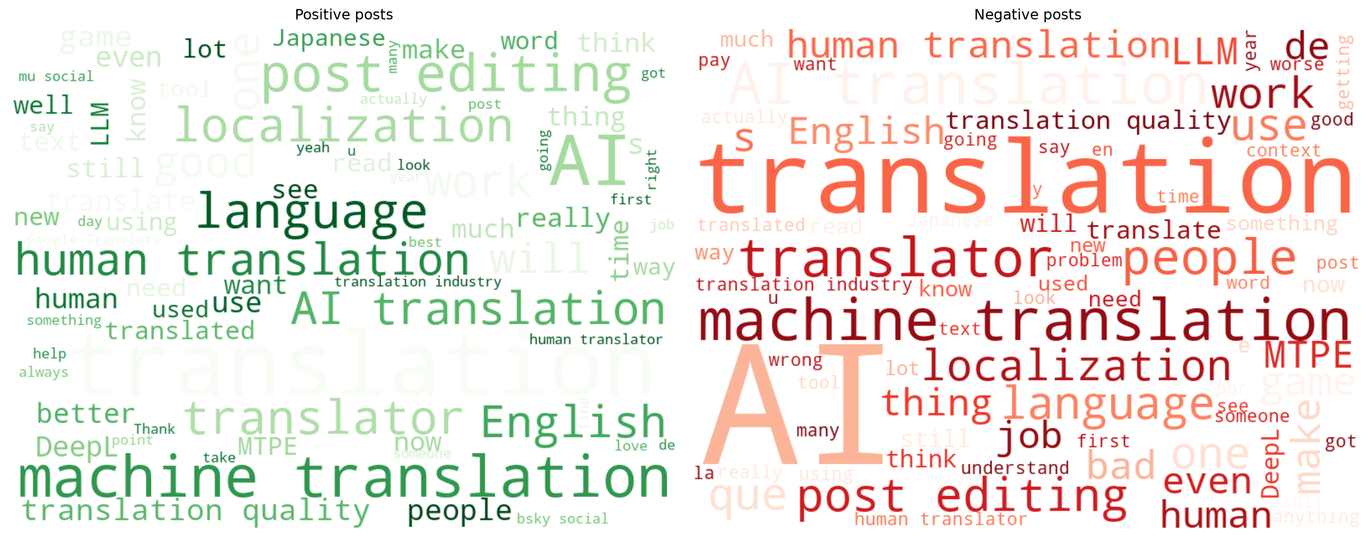
Figure 13 — Word clouds for VADER-positive (left) and VADER-negative (right) posts.

5. Discussion & Conclusions

5.1 Content analysis conclusions
RQ1 (tool vs. threat): the two sentiment tools disagree on 45.9% of posts. Taking the context-aware RoBERTa model as the more reliable signal, the discourse is genuinely mixed (23.1% / 46.0% / 31.0%) rather than predominantly positive — MT is discussed as both a useful tool and, in a substantial minority of posts, critically.
RQ2/RQ3 (professional vs. general, utility vs. displacement): professionals score most positive on average (VADER mean compound 0.201 vs. 0.139 general, 0.173 tech, 0.112 unknown), consistent with acknowledging MT's day-to-day utility rather than uniformly framing it as a threat. The emotion analysis didn't meaningfully support or refute this — differences between user types were small next to the NRCLex/DistilRoBERTa disagreement, which is itself the more notable finding there.
Named entity recognition shows DeepL and Google Translate as the dominant tools discussed by all groups, with tech users discussing Claude/Amazon disproportionately given their group size.

5.2 Overall project conclusion
The network results reframe the content-analysis findings: the MT debate on Bluesky is not a confrontation between two opposing camps. Professional translators concentrate in a small number of cohesive, highly-followed communities rather than one. They dominate in-degree and closeness centrality and hold half of the top bridging positions. Meanwhile, general users scatter across many product- and fandom-centered pockets (game localization, fan translation, developer tooling) in which MT is discussed in the context of specific products. This matches the entity-level finding that DeepL and Google Translate dominate the conversation for every group: the discourse is organized around concrete tools and products, not around an abstract pro/anti divide.
Against this structure, the sentiment findings become more legible. Professionals are the most visible, most-followed group, and they are also the most positive on average. This is consistent with the tool-and-threat duality of RQ1–RQ3: the community most exposed to displacement discusses MT with the most nuance, acknowledging its utility while contesting working conditions (MTPE rates, credit, quality). Conversational attention, by contrast, is event-driven and centers on general accounts, as the single viral thread that dominates the reply network shows: public engagement with MT flares around specific incidents, such as a game shipping machine-translated text or an uncredited translation, rather than around the professional community’s ongoing debate. In conclusion, there is a small set of stable professional hubs with sustained, nuanced discourse, surrounded by episodic consumer conversations triggered by product-level encounters with machine translation.

6. Limitations
- Ego-network sample: follow edges exist only around authors with ≥ 2 posts, so centrality comparisons are only valid within the post-authors subgraph. A 100-follower cap per author (visible as a spike in the in-degree distribution) and the followers-not-following crawl direction further shape the network's structure.
- Single platform (Bluesky), one ~12-month window, and a multilingual corpus filtered by keyword rather than language — findings may not generalize, and non-English posts are intentionally kept rather than the corpus being presented as English-only.
- Topical relevance filtering and author-type labeling are keyword-matching heuristics, not validated classifiers; no manual accuracy check was performed. The unknown category (Section 2.3) mitigates one failure mode — treating "no bio" as "general public" — but doesn't validate the labels that are assigned.
- spaCy's en_core_web_sm was trained on general news text and mis-tags several domain acronyms as organizations (Section 4.2.3, reported rather than filtered out).
- VADER and NRCLex are lexicon-based and diverge substantially from transformer alternatives (RoBERTa, DistilRoBERTa). Without gold-standard annotation we can't call either "correct" in absolute terms, only that they disagree — qualitative inspection favored the transformer models.
- Professional (610), tech (193), and unknown (218) groups are much smaller than general (2,843); comparisons use rates rather than raw counts, but per-entity counts for the smaller groups are still small enough to be noisy.
- Nodes are identified by Bluesky handle, not the more stable DID (stored as a fallback only). Only public posts and follower lists were collected, at polite request rates, via the official API.
- Louvain and FluidC community detection are not exactly reproducible run-to-run in this environment: the exact community count, modularity, and even which communities are professional-majority can shift between runs of the identical seeded code, due to Python’s per-process hash randomization affecting Louvain’s greedy optimization order. Greedy Modularity and Girvan–Newman do not have this issue. Numbers reported in Section 4.1.3 are from one specific run.

7. Tools and Libraries Used
Task | Tool / Model | Type
Data collection | Atproto (Bluesky API client) | API client
Network analysis | Networkx | —
Sentiment analysis | VaderSentiment | Lexicon-based
Sentiment analysis | Cardiffnlp/twitter-roberta-base-sentiment | Transformer
Emotion analysis | NRCLex | Dictionary-based
Emotion analysis | J-hartmann/emotion-english-distilroberta-base | Transformer
Named entity recognition | SpaCy (en_core_web_sm) | Pretrained pipeline
Visualization | Matplotlib, wordcloud | —
Code generation and debugging | Claude code | —
Grammar and writing check | Claude | —

Full source code, data dictionary, and setup instructions are in the project README and in 01_data_collection.ipynb / 02_network_analysis.ipynb / 03_content_analysis.ipynb.

